New York, NY

LOCATION:
26 Federal Plaza
New York, NY 10278

HOTELS:

The hotels listed below participate in GSA’s governmentwide lodging program, FedRooms® – which provides Federal Travel Regulation (FTR) compliant hotel rooms at or below per diem rates for federal government travelers while on official business.

You may find program information and a current list of all FedRooms® preferred properties at: http://www.fedrooms.com (a non-federal website). Also, per diem rates may be found at: http://www.gsa.gov/perdiem

FedRooms® Rates are available using all booking channels: TMC, E-Gov Travel Service, FedRooms® website, and hotel reservation centers.

You MUST ASK for the FedRooms® Rate (NOT the government rate) when you contact the hotels. FedRooms® properties are listed by proximity to the New York location (closest to farthest).

CTRL + click on any highlighted property below to bring you to booking link:

MILLENIUM HILTON 1.1 miles
55 CHURCH STREET
New York NY 10007

EMBASSY SUITES HOTEL NEW YORK CITY 1.1 miles
102 NORTH END AVENUE
New York NY 10281

CLUB QUARTERS DOWNTOWN 1.2 miles
52 WILLIAM ST
New York NY 10005

THE ROGER WILLIAMS 1.8 miles
131 MADISON AVENUE
New York NY 10016
1-212-448-7000

AFFINIA MANHATTAN 1.9 miles
371 7TH AVENUE
New York NY 10001
1-212-563-1800

HAMPTON INN MANHATTAN-MADISON SQUARE 1.9 miles
116 WEST 31ST ST
New York NY 10001

HOLIDAY INN EXPRESS NYC – MADISON SQUARE 1.9 miles
232 WEST 29TH STREET
New York NY 10001

RADISSON MARTINIQUE-BROADWAY 1.9 miles
49 WEST 32ND ST
New York NY 10001

HOTEL 373 FIFTH AVE 2.0 miles
373 FIFTH AVENUE
New York NY 10016

HAMPTON INN -35TH ST. EMPIRE STATE BLDG 2.0 miles
59 WEST 35TH STREET
NEW YORK NY 10001

If you have any further questions please feel free to contact us for immediate assistance at:
FedRooms
Phone: 800-226-1741
E-mail: hotels@fedrooms.com
Updated March 2009

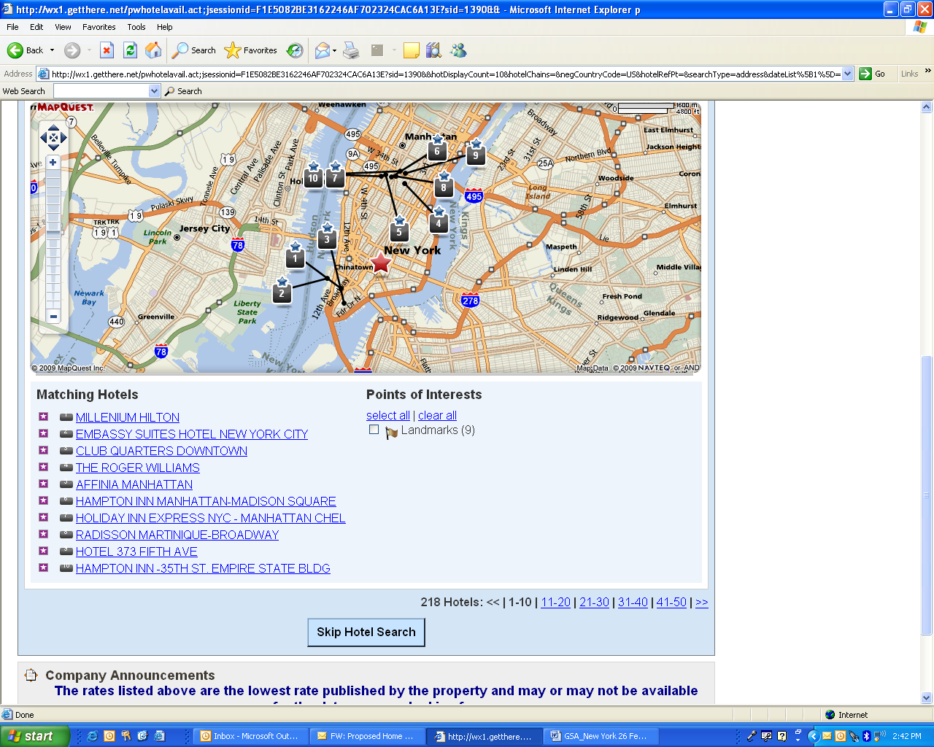

- MILLENIUM HOTEL
- EMBASSY SUITES HOTEL NEW YORK CITY
- CLUB QUARTERS DOWNTOWN
- THE ROGER WILLIMS
- AFFINIA MANHATTAN
- HAMPTON INN MANHATTAN-MADISON SQUARE
- HOLDIAY INN EXPRESS NYC-MANHATTAN CHEL
- RADISSON MARTINIQUE-BROADWAY
- HOLTE 373 FIFTH AVE
- HAMPTON IN-35TH ST. EMPIRE STATE BLDG

