INDIAN HEALTH SERVICE CLINICAL SUPPORT CENTER
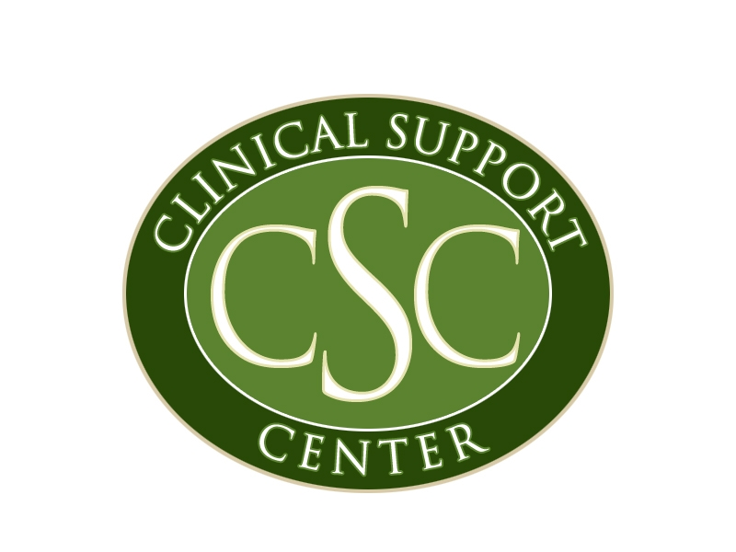
40 North Central Avenue, Suite, 780 ▪ Phoenix, AZ 85004 ▪ P: (602) 364-7777 ▪ F: (602) 364-7788
Website: http://www.csc.ihs.gov/

PROPOSAL FOR A REGULARLY SCHEDULED SERIES

Please complete this form and send it to us as soon as you begin thinking about an activity.
1. New Activity |  |  |  |  |  |  |  |  | Renewal |  |  |  |  | Previous File #:
2. Date of first presentation:
3. Frequency: |  |  |  | Weekly |  |  |  |  |  |  | Monthly |  |  |  |  | Bi-Monthly |  |  |  |  |  |  |  | Other:
List first 1 – 3 dates if known and/or attach promotional literature w/ details:
4. Delivery Methods (check all that apply):
 | Live in Person |  |  |  |  |  |  | Live Internet/Video |  |  |  |  |  |  |  |  |  | Enduring Material |  |  |  |  |  |  |  |  |  |  | Other:
5. Primary Teaching/Learning Strategies (check all that apply):
 | Didactic Lecture  Case Studies  Questions and Answers  Hands-on Practice |  |  |  |  |  |  |  |  |  |  | Workshops/Seminar  Demonstration  Panel Discussion  Roundtable |  |  |  |  |  |  |  |  |  |  |  |  | Other:  Other:  Other:  Other:
6. Meeting Site:
 |  |  |  | Will the meeting site accommodate the teaching needs of the meeting? Yes No
7. Title of the Series:
8. List the primary goals of the series
(Ex: to increase knowledge, skills and attitudes; to improve competence; to enhance patient health status, etc.):
9. Describe how you will determine the overall learning needs of your audience:
10. List the Sources from which you will choose presenters:
11. Contact Person: |  |  |  |  |  |  |  |  |  |  |  |  |  |  |  |  |  |  |  |  |  |  |  |  |  |  | Title:
E-mail Address: |  |  |  |  |  |  |  |  |  |  |  |  |  |  |  |  |  |  |  |  |  |  |  |  |  |  | Phone:
Address: |  |  |  |  |  |  |  |  |  |  |  |  |  |  |  |  |  |  |  |  |  |  |  |  |  |  | Fax:
City/State/Zip:
Supporting Service Unit/Organization:
IHS |  |  | Tribal/638 |  |  |  |  |  |  | Urban Program |  |  |  |  |  |  |  |  |  | Other (explain):
12. CE Target Audience (i.e. physicians, nurses, etc.) :
Expected number of participants: |  |  |  |  |  |  |  |  |  |  |  |  |  |  | Physicans |  |  |  |  |  |  |  |  |  |  | Nurses |  |  |  |  |  |  | APNs |  |  | PAs |  |  | Dental
 |  |  |  |  |  |  |  |  |  |  |  |  | Other:
13. Type(s) of credit you are requesting:
CME (Continuing Medical Education – AMA)
CNE (Continuing Nursing Education – ANCC)
ADA (American Dental Association – CERP/DANB)
AAFP (American Academy of Family Physicians) – *Fees apply.
Since October 1, 2005, the American Academy of Family Physicians has been charging the Indian Health Service for the review process for AAFP Prescribed Credit. The fees are as follows: $125 for a regularly scheduled series for one year. CSC may invoice your facility or program so please make sure that your audience will use this AAFP credit before you check this box.
ACPE (Accreditation Council for Pharmacy Education):
We are unable to sponsor activities for pharmacy credit because the redesign of the Indian Health Service has required changes in the role of the Clinical Support Center (CSC) pharmacy program. Additional duties assigned to CSC now require changes in the sponsorship of continuing education (CE) activities that will offer Accreditation Council for Pharmacy Education (ACPE) credit. The CSC will continue to sponsor the “IHS Pharmacy Practice Training Program” and the “SW Regional Pharmacy CE Seminar”, as well as programs developed in conjunction with the IHS Primary Pharmacy Consultant and the Area Pharmacy Consultants. However, we will have to decline requests for sponsorship of programs that are coordinated primarily outside of this office. The goal is to focus continued sponsorship activities that have a national or regional impact on the IHS and Indian health program pharmacists, and suspend the sponsorship of activities that have local impact and require a significant time commitment that CSC can no longer make. Pharmacists who attend your course will receive certificates reflecting AMA credit.

14. Planning Committee: Any person who contributes to the planning and course content and/or can influence the goals or
objectives of the course. NOTE: The Planning Committee MUST include at least one representative from each profession
for which you plan to offer continuing education credit – Please provide actual names and credentials.

 | Name AND Credentials: | Title: | Attached
 | Name AND Credentials: | Title: | Disclosure | Bio
Ex: | John Saari, MD | Physician Educator
15. Checklist: Please attach or send in the following necessary documentation to complete your file for review:
Annual Evaluation Summary from Previous File (if this is a renewal)
Evaluation Plan/Tool for this activity
Topics, Dates, Speakers/Credentials, and Objectives for the first (3) Presentations (Required for AAFP application)
Speaker and Planner Disclosure Forms
Speaker and Planner Biographic Data
Promotional Material (Flyers, brochures, schedule, calendar, etc.)

