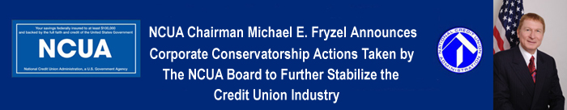

NCUA Chairman Michael E. Fryzel Announces Corporate Conservatorship Actions Taken by the NCUA Board to Further Stabilize the Credit Union Industry

Click here to view and listen to the Chairman's Announcement
National Credit Union Administration
1775 Duke Street
Alexandria, VA 22314-3428
703-518-6300

