RESOURCES + REFORMS = RESULTS
PRESIDENT BUSH’S COMMITMENT TO
OUR NATION’S SCHOOL CHILDREN

U.S. Department of Education
Office of the Deputy Secretary
October 2002

RESOURCES + REFORMS = RESULTS
PRESIDENT BUSH’S COMMITMENT TO
OUR NATION’S SCHOOL CHILDREN

There has been partisan rhetoric from some Members of Congress regarding the President’s commitment to education funding and quality. The reality is that under the No Child Left Behind Act, the President promised that we will reform our schools with the resources necessary to achieve results—improved student achievement for all our children.

On January 8, 2002, President George W. Bush signed the No Child Left Behind Act into law ending the gridlock on education reform. We have entered a new era—an era that measures success by whether every child is learning not solely by the amount of dollars spent. We cannot afford to go back to the politics of blame and division. The American people want schools accountable for delivering a world-class education for every child. And with this President’s leadership they will get it.

Overall, the President’s 2003 budget was driven by the overriding concern of defending our nation and people from the threat of terrorism following September 11. Most of the new resources in the President’s budget are committed to defense, fighting the war on terrorism, and homeland security. In addition, education continues to be the President’s highest domestic priority. We don’t believe anyone would argue with those priorities.

The increase requested for the Education Department for 2003 will build upon an extraordinary and unprecedented $15 billion or 41 percent increase since fiscal year 2000. Since much of the new money is just reaching our schools for the first time―the massive increase for 2002 is for this fall’s school year—it is disingenuous to make the case that the federal government isn’t doing its share when it comes to dollars for education.

The No Child Left Behind Act was not just about the federal investment in education, but rather about getting a return on that investment—improved student achievement for all our children.

It is sad but true that we don’t have a lot to show for the $321 billion that has been spent since 1965 by the Federal government on the Elementary and Secondary Education Act. The dramatic growth in state and local funding for education over the past decade has also failed to raise overall student achievement or to close the achievement gap for poor and minority students.

Even with limited resources, economic concerns and many additional important national priorities as a result of our nation’s war on terrorism, the President’s budget proposes significant increases in the areas that most directly affect the neediest children:

- The President recognizes that the Title I program is at the very heart of both the Federal investment in improving elementary and secondary education and the reforms called for in the No Child Left Behind Act. So, building on the historic increase last year, the President requested a $1 billion increase in 2003 that will result in a $3.4 billion or 43 percent increase since 2000. This means an estimated 15 million students in 46,500 schools will receive Title I services in 2003.

- For special education, President Bush has asked for the largest level of Federal support for IDEA of any President in history—a billion dollar increase to a total of $8.5 billion dollars.

- The President believes that a well-prepared teacher leads to a child’s success in school. However, millions of children do not have the benefit of a qualified teacher in their classrooms. That is why President Bush is asking for over $3 billion this year to support our nation’s teachers.

- The President’s budget asks for an increase of $100 million for the Reading First program for a total of $1 billion and for $75 million for the Early Reading program. These funds will improve reading instruction for K-3 students and ensure that all children learn to read well by the end of the third grade. This represents the largest Federal investment in literacy ever.

We believe the combination of the very substantial new funding provided over the past three years and the reforms in the No Child Left Behind Act will make a real difference in improving the performance of our schools and the achievement of all students.

Furthermore, the President’s 2003 budget opens the door to college for millions of Americans by proposing the highest level of funding for student aid in the history of these programs and builds on recent growth in the department's budget. The President has requested funds to provide $55 billion in new grants, loans, and work-study opportunities to more than 8.4 million college students.

The keystone of President Bush’s higher education agenda is the Pell Grant program which, under the President’s plan, would be increased by over half a billion dollars over last year’s level and more than four times the current level of inflation. Furthermore, in the fiscal year 2002 emergency spending bill, the Bush administration took the lead in fighting for the inclusion of an additional $1 billion for Pell Grants to address the growing number of independent students who depend on Pell Grants for their education.

Since taking office, President Bush has proposed nearly $3 billion in increased funds for the Pell Grant program—the largest amount proposed by any president—and this has resulted in nearly half a million more students receiving Pell Grants.

In addition, the President’s 2001 tax relief bill lets working families keep more of the money they earn right now. It targets tax relief to encourage savings for postsecondary education, makes student loan repayments more affordable, and encourages the private sector to offer higher education assistance to employees. The President’s tax relief package totals over $22.7 billion in savings for working families who are struggling to meet the skyrocketing cost of college.

The President has also taken steps to help Americans repay student loans. The administration is working hard to ensure loans are affordable and available to the millions of students and families who depend on them to finance their education. Today, interest rates are at a historic low at 4.06 percent.

Finally, the President supported and signed into law a bipartisan measure that would maintain stability in the student loan marketplace and ensure that access to low-cost education financing was not interrupted. This law builds $8.2 billion of new money into the loan programs over the next 10 years.

The President’s record on making college more affordable for students is clear—the largest Pell grant increase in history going to a record number of students; record low interest rates at 4.06%, plus billions of new money invested to ensure low rates into the future; and new tax relief to help millions of students save and pay for college.

Record Growth In Major Education Programs
(in millions of dollars)

 |  |  |  |  |  |  |  | 2003
 | 1996 | 1997 | 1998 | 1999 | 2000 | 2001 | 2002 | President's
Major Programs | Appro. | Appro. | Appro. | Appro. | Appro. | Appro. | Appro. | Budget
ESEA Title I, LEA Grants | 6,730 | 7,295 | 7,375 | 7,732 | 7,941 | 8,762 | 10,350 | 11,353
Reading | 0 | 0 | 0 | 260 | 260 | 286 | 975 | 1,075
Teacher Quality | 275 | 310 | 335 | 1,535 | 1,635 | 2,108 | 2,850 | 2,850
21st Century Community Learning Centers | 0 | 1 | 40 | 200 | 453 | 846 | 1,000 | 1,000
Special Education, IDEA Part B | 2,324 | 3,109 | 3,801 | 4,311 | 4,990 | 6,340 | 7,529 | 8,529
Federal Pell Grants | 4,914 | 5,919 | 7,345 | 7,704 | 7,640 | 8,756 | 10,314* | 10,863
Other | 8,793 | 10,011 | 11,007 | 11,780 | 12,687 | 15,133 | 15,919 | 14,662
Discretionary Funds | 23,036 | 26,644 | 29,903 | 33,521 | 35,606 | 42,231 | 48,937* | 50,332

*Does not reflect additional $1 billion supplemental appropriation to address the Pell grant shortfall.

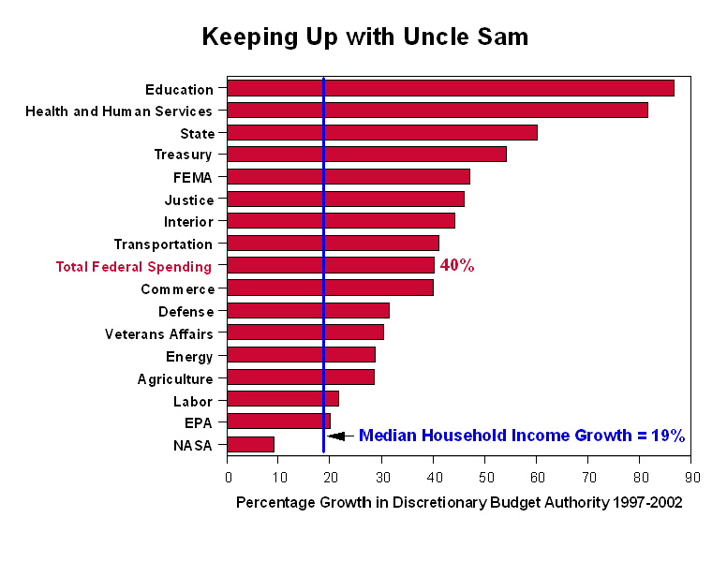
DEMOCRATS’ TRUE RECORD ON EDUCATION SPENDING

The Democrats have spent a lot of time criticizing the President’s wartime budget while calling for increases in education funding without explaining how they would pay for the increases.

In fact, when the House of Representatives debated the budget resolution, the Democrats did not even offer an alternative. And in the Democrat-controlled Senate, they didn’t even pass a budget resolution this year - the first time since 1974 that the Senate has failed to do so.

Democrats claim that only if they were in charge, education funding would go beyond the record increases President Bush is calling for in his budget.

For a reality check, let’s take a look at a time when they really were in charge. In Fiscal Years 1994 and 1995, the Democrat-led Congress and President Clinton ran the budget process in Washington. Democrats controlled the House of Representatives with an 82-seat majority and had a 14-seat majority in the Senate.

One would think that the Democrats with all their talk about education spending would have enacted historic funding for education.

But what happened:
In 1994, President Clinton requested $26.8 billion, but the Democrats in Congress only appropriated $24.7 billion. And again in 1995, the Democrats underfunded Clinton’s request by almost $1 billion.
Discretionary Funds
(dollars in thousands)
Fiscal Year | Amount Requested | Amount Appropriated
1994 | 26,753,354 | 24,709,034
1995 | 26,281,483 | 24,712,210

And when you look at key education programs the facts are even more revealing:

For Title I, the Clinton administration requested $6.5 billion for fiscal year 1994 but the Democrat Congress could only come up with $6.33 billion.

This year, President Bush’s budget nearly doubles the last Democrat-controlled budget for Title I to $11.4 billion.

For teacher quality, for both 1994 and 1995, the Democrats had only $251 million in their budget.

This year, President Bush is asking for over $3.2 billion to support our Nation’s teachers—twelve times the amount Democrats spent when they controlled the budget.

For Special Education, in 1994, the budget request was $2.164 billion, but the Democrats shortchanged the request by $14 million. And in 1995, they again could not match the President’s request—and cut his request by $30 million.

On the other hand, Republicans have made funding special education one of their top priorities. Their persistence has lead to a tripling of special education funding—from $2.3 billion in 1996 to $7.5 billion in 2002. President Bush’s 2003 budget calls for a $1 billion increase—or 13.3 percent—the highest level of federal support ever provided for children with disabilities.

For the overall education budget, in the six years since Republicans have controlled at least part of the budget process, it has more than doubled from $23 billion (discretionary) to $50.3 billion requested by the President.

Among all the Departments, Education has received the biggest increase.

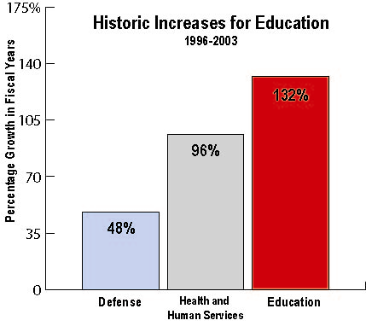
Despite these record increases, the Democrats are still complaining about money.

But Republicans match budget increases with a demand for results. We believe the signing of the No Child Left Behind Act began a new era in education—an era that measures success by whether every child is learning.

For some politicians, higher spending, even record spending, will never be enough because they focus only on what is being spent, not on how.

President Bush hasn’t just given our schools record spending on education—he is focusing education on academic results.

DEMOCRATS’ TRUE RECORD ON EDUCATION SPENDING

Clinton Budget Requests  Fiscal Years 1994-2001 |  |  | Bush Budget Requests  Fiscal Years 2002-2003
Program | Average Annual Increase  Requested | Total Increase Requested Over 8 Years | Average Annual Increase Requested | Total Increase Requested Over 2 Years
Title I | $386 million | $3.1 billion | $650 million | $1.3 billion
Reading | $45 million | $362 million | $395 million | $789 million
Teacher Quality  Teacher Relief* | $466 million | $3.7 billion | $246 million  $220 million | $492 million  $2.2 billion
Special Education | $212 million | $1.7 billion | $1 billion | $2 billion
*Includes proposals for loan forgiveness and tax deductions for out-of-pocket expenses for teachers for a total of $2.2 billion in savings over ten years.

Total Democratic Control Of Spending  Fiscal Years (FY) 1994-1995 In Billions Of Dollars |  |  |  |  |  | Democratic Result
Program | Base Year  (FY’93) | Clinton 1994 Request  (FY’94) | First All- Democrat Budget  (FY’94) | Clinton 1995 Request  (FY’95) | Second Year Total of an All-Democrat Budget (FY’95) | Average Annual Increase
Title I | $6.126 | $6.500 | $6.336 | $7.000 | $6.698 | $286 million
Reading | 0 | 0 | 0 | 0 | 0 | 0
Teacher Quality | $.246 | $.253 | $.251 | $.752 | $.251 | $3 million
Special Education | $2.075 | $2.164 | $2.150 | $2.353 | $2.323 | $124 million
Pell Grants | $6.462 | $8.330 | $6.637 | $6.514 | $6.147 | -$158 million
Pell Maximum Award (in whole dollars) | $2,300 | $2,300 | $2,300 | $2,400 | $2,340 | $20

Resources + Reforms = Results

“Complaining about money just gets in the way of authentic reform.” Secretary Rod Paige

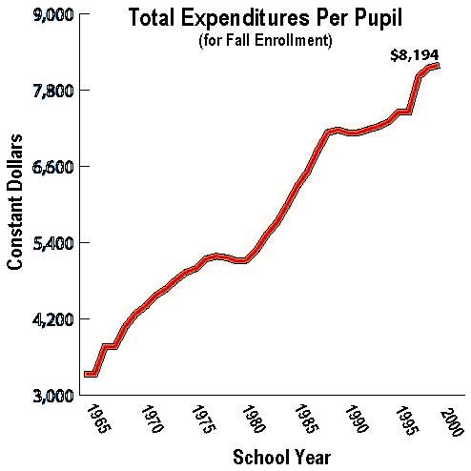
On January 8, 2002, President George W. Bush signed the No Child Left Behind Act into law ending the gridlock on education reform.

We have entered a new era—an era that measures success by whether every child is learning not only by the amount of dollars spent. We cannot afford to go back to the politics of blame and division. The American people want schools accountable for delivering a world-class education for every child. And with this President’s leadership they will get it.

Those who believe money and only money is the answer have had their chance—for more than 30 years. American taxpayers have more than doubled spending per pupil since 1965 and our Nation has little to show for it. This is the era of accountability and results.

We need to improve how our schools spend money because too many children are being left behind.

  - According to the most recent National Assessment of Educational Progress (NAEP), only 32 percent of fourth-graders can read proficiently at grade level.
  - SAT scores are stagnant, reading and math achievement is flat, and millions of kids drop out every year.
  - American 12th graders scored ahead of only Cyprus and South Africa in math and behind 18 other nations in the Third International Mathematics and Science Study.

- Some believe that leadership requires nothing more than to attack those who wish to measure success and demand results. Success isn’t measured by dollar signs. It is measured by results for our children.

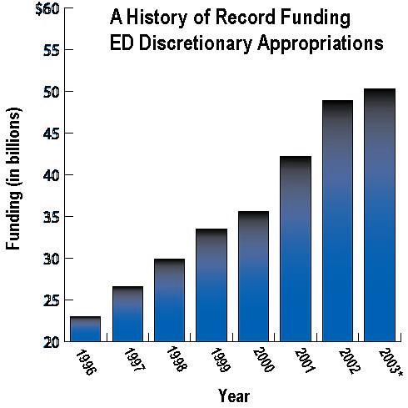
It is important to remember that America is still spending more than ever before on education.
- More than 35 years after Congress passed the first Elementary and Secondary Education Act, public school spending per-pupil has more than doubled—even when adjusted for inflation—from $3,331 in 1965-66 to $8,194 in 2000-01.

- Since 1965, the Federal Government has spent more than $321 billion on K-12 education.

- At every level of government, America has spent more than $10 trillion on K-12 education over the last half century.

- Total spending at all levels of government for K-12 education is approaching $450 billion this school year.

Resources + Reforms for TITLE I

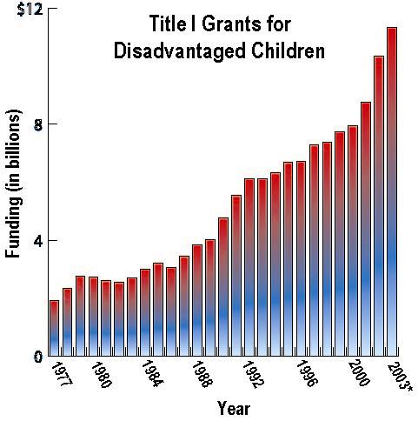
President Bush hasn’t just given our schools record spending on education. He is focusing education on academic achievement and funding those programs that work and that help our neediest children.

- The Title I program is at the very heart of both the Federal investment in improving elementary and secondary education and the reforms called for in the No Child Left Behind Act.
- Under Title I, States and school districts receive resources to turn around low-performing schools, improve teacher quality, and ensure that no child is trapped in a failing school.
- Building on the historic increase last year, the President requested a $1 billion increase in 2003 that will result in a $3.4 billion or 43 percent increase since 2000.
- An estimated 15 million students in 46,500 schools will receive Title I services in 2003.

Resources + Reforms for SPECIAL EDUCATION

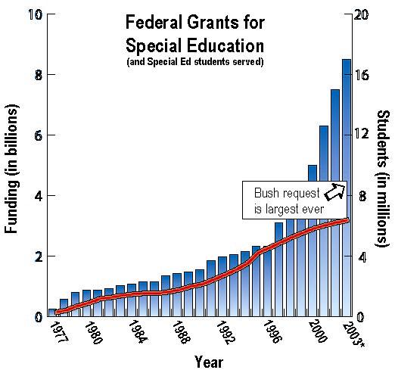
The President believes in funding special education with reforms.
- President Bush has asked for the largest increase in Federal funding for IDEA of any President in history, a billion dollar increase for a total of $8.5 billion dollars.

The upcoming reauthorization of IDEA will bring an opportunity to enact promising reforms.
- As part of the reauthorization process, the Administration is looking at a broad range of issues in IDEA that need to be addressed including:
  - the need for qualified personnel;
  - identification of the right children and at the right time;
  - reduction of unnecessary paperwork; and
  - accountability for results.

- A majority of parents with children in special education (52%) agree that “better programs and policies, not more money, is the best way to improve special education.”

- As the President’s Commission on Excellence in Special Education put it, “Children with disabilities are now being served in public schools alongside their nondisabled brothers, sisters and friends. And, new opportunities abound. This Commission is optimistic that our nation can build on the successes of the past and do even better in meeting the needs of children with disabilities and their families. But, we will do so only through a focus on educational achievement and excellence, teacher quality and support, and rigorous research. We will succeed if we work to create a culture of high expectations, accountability and results that meets the unique needs of every child. Only then can the promise of No Child Left Behind truly be fulfilled.”

Resources + Reforms for TEACHERS

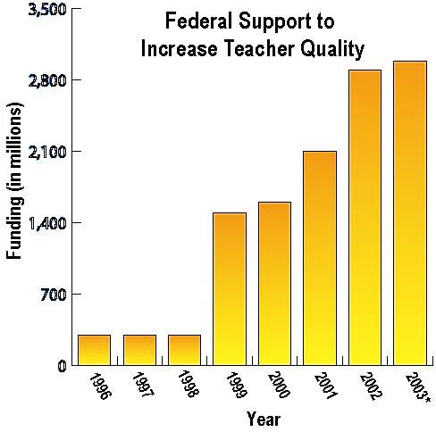
Nothing is more important to a child’s success in school than finding well-prepared teachers. But millions of children do not have the benefit of a well-prepared teacher in their classrooms--one that knows what to teach, how to teach, and has command of the subject matter being taught.
- The Department is spending more than $3 billion this year on teacher support and recruitment programs.
- The President’s 2003 budget calls on Congress to expand loan forgiveness for highly qualified math, science and special education teachers serving low-income communities from $5,000 to $17,500. Schools in these communities often are forced to hire unqualified teachers. This proposal would help these schools recruit and retain highly qualified teachers.

“There are still some guardians of mediocrity out there fighting to maintain the status quo. We need to open up our schools to the thousands of American citizens with the heart, experience, and willingness to teach children.” Secretary Rod Paige

No Child Left Behind gives States and school districts the flexibility to find innovative ways to improve teacher quality including:
- alternative ways of becoming a teacher, so that experienced professionals can become teachers faster;
- encouraging retiring military personnel to teach in high-poverty school districts through the Troops-to-Teachers program;
- merit pay authorization which enables States and districts to reward good teachers and encourage them to stay in the profession; and
- authorization to States and districts to give bonuses to teachers in high-need subject areas like math and science to ensure that America remains competitive with the rest of the world in the 21st century.
Resources + Reforms for READING

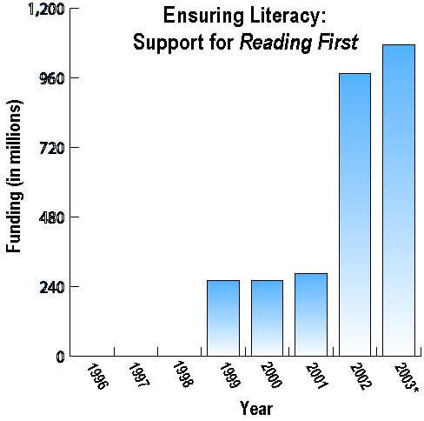
Success in school starts with reading. When children become good readers in the early grades, they are more likely to become better learners throughout their school years and beyond. However, far too many young people are struggling through school without having mastered the most essential and basic skills in reading.
- On the 2000 National Assessment for Educational Progress (NAEP), over 85 percent of all fourth-graders in high-poverty schools scored below the "proficient" reading level. Fortunately, scientifically based reading research has identified the critical components that are essential for teaching young children to read.
- As part of the No Child Left Behind Act, President Bush put forward a new comprehensive effort called Reading First, which will provide assistance to State and local educational agencies to apply scientifically based reading research in order to improve reading instruction for K-3 students and to ensure that all children learn to read well by the end of third grade.
- Additionally, the Early Reading First program provides competitive grants to develop and support school readiness of preschool-aged children in high poverty communities.
- The President’s request for a $100 million increase in the Reading First program and $75 million for the Early Reading program will result in the largest Federal investment in literacy ever.
Resources + Reforms for ENGLISH FLUENCY

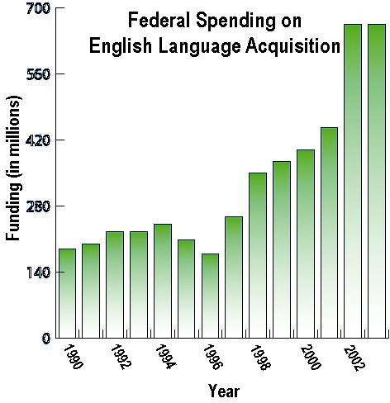
The No Child Left Behind Act focuses support on enabling all limited English proficient (LEP) students to learn English as quickly and effectively as possible.
- Additionally, it provides funding to increase the number of highly qualified teachers prepared to serve these students.
- President Bush has also requested research to identify and implement in the classroom the best ways for students whose first language is not English to learn to speak, read, and write English in a fluent manner.

Nineteen States have reported an increase of more than 50 percent in English language learners over the last three years—and that growth is expected to continue. America's schools need help.

In response, the President requested a record $665 million for English Language Acquisition which represents a phenomenal increase of $487 million since 1996.
- That’s an increase of 273%—far greater than even the growing enrollment rate of bilingual education students.

Resources + Reforms for HIGHER EDUCATION

The President’s 2003 budget opens the doors of opportunity to millions of college students.
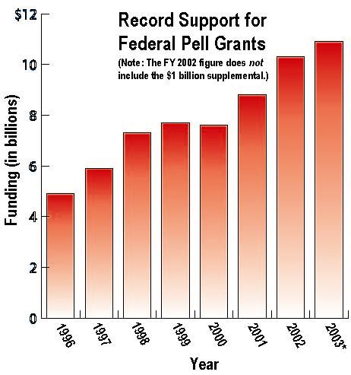
- The president’s FY 2003 budget proposes the highest level of funding for student aid in the history of these programs and builds on recent growth in the Department's budget, which has more than doubled since 1996.
- The President has requested funds to provide $55 billion in new grants, loans, and work-study opportunities to over 8.4 million students. The keystone of the President’s higher education agenda is the Pell Grant program.
- Under the President’s plan, funding for Pell Grants would be increased by over half a billion dollars over last year’s level and more than four times the current level of inflation.
- Since taking office, President Bush has proposed nearly $3 billion in increased funds for the Pell Grant program—the largest amount proposed by any president—which will result in nearly half a million more students receiving Pell Grants.

The administration has also supported changes in the tax code to support higher education.
- The president’s victorious passage of the first significant tax cuts in two decades lets working families keep more of their money.
- In addition, it targets tax relief to encourage savings for postsecondary education, make student loan repayment more affordable, and encourage the private sector to offer higher education assistance to employees.
- The president’s tax relief package totals over $22.7 billion in savings over the next five years for working families.

Interest Rate Compromise Ensures Access of Student Loans
- The President supported and signed into law a bipartisan measure that would maintain stability in the student loan marketplace and ensure that access to low-cost education financing was not interrupted.
- This law builds $8.2 billion of new money into the loan programs over the next 10 years.

