
Management Services Center News You Can Use

January 2009 Volume 5, Number 1

In This Issue:  - Think Simplified (Not FAR Part 15)  - Delex Case Won’t Hurt Schedules!  - Podcast Training Information  - MSC Point of Contacts  Do you need Government Information?  Here is a great place to start!  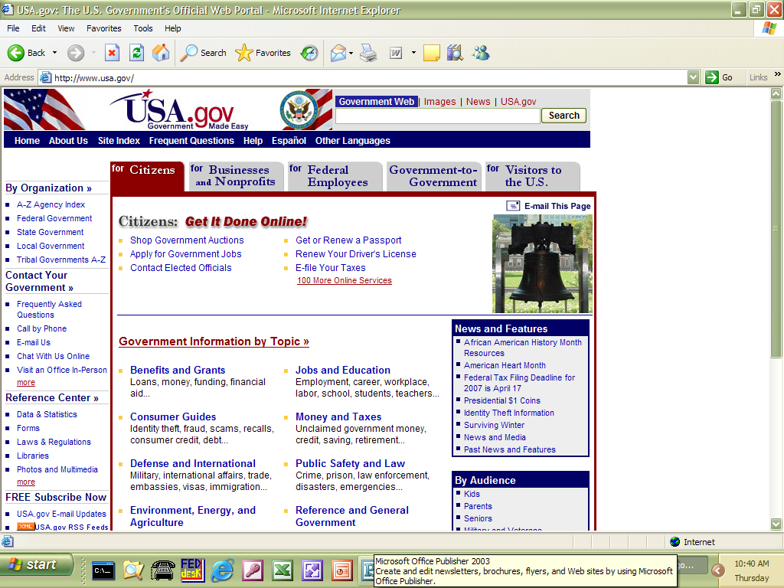  USA.gov is the website for access to government agencies. Some of the categories you will find are:  - Benefits and Grants  - Consumer Guides  - Defense and International  - Environment, Energy and Agriculture  - Family, Home and Community  - Health and Nutrition  - History and Arts  - Jobs and Education  - Money and Taxes  - Public Safety and Law  - Reference and General Government  - Science and Technology  - Voting and Elections  Users are encouraged to use the search engine for everything from taxes, passports, federal benefits and countless other topics from multiple federal, state, local, territorial and tribal government sources. This website used to be FirstGov.gov but is improved with greater search capacity.    Points of Contact  Professional Engineering Services (PES)  Language Services  Tammy Lindsley  (253)931-7627  tam.lindsley@gsa.gov  MOBIS  Debbie Gamble  (253) 931-7895  debbie.gamble@gsa.gov  Environmental Services  Carolyn DiCugno  (253) 931-7042  carolyn.dicugno@gsa.gov  LOGWORLD Services  Maureen Duckworth  (253) 931-7514  maureen.duckworth@gsa.gov  Consolidated  Maureen Duckworth  (253) 931-7514  maureen.duckworth@gsa.gov  MSC Newsletter Information:  Staci Oetting  (253) 931-7611  Staci.oetting@gsa.gov | Think Simplified (Not FAR Part 15)  If you use FAR part 15-like terminology and procedures for schedule procurements, courts and GAO will hold you to those Part 15 standards!  Far Part 15 does not govern orders placed against the GSA Schedules. However, when an agency issues a Schedule order using Part 15-like terminology and procedures, the GAO and the courts will look to FAR Part 15 to assess the propriety of agency action in the event of a protest against the order.  For Schedule orders/BPAs, agencies need not:  - Comply with anything in FAR Part 15  - Conduct a formal “negotiated procurement”  - Issue a “solicitation” for thirty days (or any other pre-determined time)  - Conduct a “competition”  - Conduct a formal evaluation  - Undertake a cost/price realism analysis  - Seek contractors outside the Schedules program  - Synopsize the requirement  - Conduct a price evaluation on quotes Schedule rates (e.g., hourly rates)  - Conduct “discussions”  - Prepare extensive documentation  - Conduct a formal debriefing  - Determine the “competitive range” (FAR 15.3)  The cost of proposal preparation is a major consideration in the Schedule contractor’s decision to quote. With the fully-loaded (ceiling) hourly rates GSA has negotiated, the contractor has assumed only the “normal” bid and proposal costs expected for a fully-streamlined procedure. Asking for more in a task order/BPA quotes risks a “no-quote” from a Schedule contractor unable to recover those costs. Examples of quote obstacles to be removed include:  - Unnecessarily short proposal response times  - Unduly burdensome proposal instructions (oral and written)  - Excessive number of evaluation factors/subfactors  - Acronym filled statements of work only the incumbent can understand  - Asking for cost proposals, cost and pricing date, or anything requiring an audit  - Using FAR 15.3 concepts and procedures  Not using FAR 15.3 concepts and procedures has the following implications for your task order selection process:  - There is no requirement to set a “competitive range” using all the published evaluation factors. This means that you can save yourself and the Schedule contractor considerable time and money by phasing your procurement in a manner that uses the least costly factors to initially down-select the quotes. For example, after providing your RFQ, you could initially down-select based upon a 10 minute telephonic presentation of an “overall concept.” Then, in a subsequent phase, you could obtain more detailed information such as a price quote (or, in a BPA, simply an offered discount below the Advantage! price for all orders) or technical description for those contractors remaining.  - Since a competitive range is not established, there is no need to be overly focused on the nature of exchanges with the offerors. Ordinarily, in a FAR 15.3 procurement, the Contracting Officer draws a distinction between “communications” and “discussions”. There need be no such caution on a Schedule order. You can engage in detailed exchanges about any aspect of a quote at any time. Naturally, you should make every effort to treat each quote equitably. You must not be biased, arbitrary, or capricious, and your decisions must be adequately (but no overly) documented. Protests are possible, but the risks are lower if your streamline the procurement as much as possible. The biggest risk is that the Schedule contractor will simply refuse to quote if you are perceived as undermining the integrity of the procurement process.  - There is no requirement to capture “The relative strengths, deficiencies, significant weaknesses, and risks supporting proposal evaluation”, as required in FAR 15.305. This means your evaluation system can be very streamlined. For example, you can use any evaluation system you wish such as pluses and minuses or simply narrative statements as long as you fully justify your ultimate selection.  - You are not bound by rules in FAR 15.3 for evaluating past performance, such as the requirement to provide a neutral rating to a quote without any past performance. Further, if you choose not to use past performance as an evaluation factor, there is no requirement to document the file with your rationale.  - There is no requirement to follow the FAR 15.305 requirement to “evaluate competitive proposals and then assess their relative qualities”. In other words, your evaluation system can immediately compare (and remember, we don’t say “compete” because the CICA requirements have already been met) one quote to another in order to determine the rank ordering for selection. There is no need to first spend time rating each quote independently against the evaluation factors before making a comparison. This significantly speeds the evaluation process. Of course, you must evaluate the way you said you would in your task order BPA/RFQ.  DELEX CASE WON’T HURT SCHEDULES  GAO decision shows advantages of schedules program.  By Larry Allen and Carolyn Alston  The Government Accountability Office recently issued a protest decision that has sent supporters of the General Services Administration schedules racing for their copies of the Federal Acquisition Regulation and other guidance. (See, Delex Systems Inc., B-400403, Oct. 28).  Although GAO’s decision in the Delex case is noteworthy, it is important to know that it does not have a direct effect of GSA Schedule orders. If anything, a key lesson to be learned is why GSA Schedule contracts can sometimes be a better alternative than agency multiple-award contracts.  In Delex, GAO sustained a protest brought by the company that claimed the Navy failed to comply with the set-aside provisions of FAR 19.502.2(b) when it issued an unrestricted solicitation for a delivery order under a Navy multiagency contract (MAC). The FAR 19 provisions state that contracts must be set aside for small businesses when there is a reasonable expectation that at least two responsible small businesses can perform the work contemplated. This is commonly know as the “rule of two.”  Because the underlying Navy MAC, the Training Systems Contract II (TSC II), had been awarded to four small firms and four large businesses, it could reasonably be assumed, GAO concluded, that the Navy would receive at least two offers from qualified small businesses. As such, the Navy should have set aside the task order for small businesses.  FAR 19.502-2(b) provides that the rule of two applies to acquisitions worth more than $100,000. In GAO’s view, the essential legal question in this protest was whether the rule applies to individually competed tasks or deliver orders under multiple-award contracts. GAO concluded that for purposes of the rule of two, multiple-award task and delivery orders are acquisitions.  We do not believe that GAO could logically reach the same conclusion for orders against the GSA Schedule for several reasons. First, the FAR is clear in stating the Part 19 does not apply to the GSA Schedules. The only exception is the Part 19 requirement that agencies must justify a bundled procurement. Specifically, 8.404 (a) states:  “Parts 13 (except 13.303-2(c)(3), 14,15 and 19 (except for the requirement at 19.202-1(e)(1)(iii), do not apply to Blanket Purchase Agreements or orders placed against Federal Supply Schedule Contracts.”  This language is similar but notably different from FAR provisions applicable to orders against multiple-award Schedule (MAS) contracts awarded pursuant to FAR Part 16. Note that 16.505(b) provides in part that, “The competition requirements in Part 6 and the policies in Subpart 15.3 do not apply to the ordering process. “ There is no specific exemption for Part 19. Secondly, GAO has previously considered whether orders against the GSA Schedule are subject to statutory and regulatory requirements associated with a competitive acquisition and concluded that they are not. In Vion Corp., B-283804.2, issued Jan. 24, 2000, GAO stated:  “Agencies properly may place an order under the Federal Supply Schedules without meeting any of the usual statutory and regulatory requirements associated with conducting a competitive procurement, because the award of an FSS delivery order, by statutory definition, satisfies the requirements for full and open competition. 41 U.S.C. 259 (b)(3). When awarding as FSS delivery order, agencies instead are governed by FAR subpart 8.4, which sets forth the requirements for issuing as FSS delivery order.”  Although it is clear from the FAR that the rule of two does not apply to GSA Schedule task orders, some in the schedules community nevertheless expressed concern that the ruling could lead to a new interpretation of set-aside rules.  Contributing to that concern was the recent FitNet protest and accompanying petition to the Office of Federal Procurement Policy.  The FitNet actions were direct attempts to set aside schedule purchase orders under the $100,000 Simplified Acquisition Threshold for small businesses. Although those efforts failed, the combination of those actions along with the Delex protest have led schedule proponents to wonder whether GAO or a court rule that at least some schedule orders could become set-asides for small businesses. GAO officials have discussed the possibility in open forums, adding to the speculation.  The FAR 19 exclusions seem clear enough, but what about purchases under the simplified threshold? Here again, a good case can be made that schedule orders were never intended to be affected.  Before the Federal Acquisition Streamlining Act (FASA) the threshold was $25,000. Although, the schedules program was smaller, no orders were ever set aside for small businesses. As is the case today, certain schedules are set aside for small firms. However, on all other schedules, firms of any size were, and are, eligible to receive orders.  When FASA raised the threshold to $100,000, schedule companies became concerned that the new limit would result in task orders being set aside. The Coalition for Government Procurement took these concerns to Congress along with suggested language clarifying congressional intent.  In meetings with the staff of the Senate Government Affairs Committee, one of the two primary congressional committees of jurisdiction, it was clear that the authors of FASA did not intend to create a new set-aside where non currently existed. Simply put, there was no intent to set-aside GSA MAS orders worth less than $100,000 for small firms. Although this explanation of intent was not added to the text of the legislation, it was included in the report accompanying the final measure.  The language is essentially identical to the phrasing used in FAR 19 that exempts schedule purchases from the rule of two. The intent is clear: Schedule orders worth less than $100,000 were never intended to be set aside for small businesses.  However, FASA is now 14 years old, and few people remember these discussions or know enough to look at the statute’s report language. Such language is routinely used by GAO and the courts to discern congressional intent. Should GAO or another court of jurisdiction consider a schedule set-aside case in the future, this little-known but important passage should be given considerable weight.  This creates a small but potentially important interpretation precedent.  Another point unintentionally made by this case is that the MACs, the flavor of the month recently among some government contracting officials, might not always be a better alternative than GSA MAS contracts. Many agencies set up MACs because they felt they could get a better deal and have more control over the acquisition process. In this case, however, the Navy would have saved considerable time, money and frustration using the GSA Schedule. Instead, of defending its actions with GAO, it would have been able to implement the training systems simulation solution.  Too frequently, GSA MAS contracts get lumped in with other MACs and government wide acquisition contracts. The legislative and regulatory history shows, however, that schedule contracts are unique. It is important to understand and remember that, whether you’re considering new legal precedents or contemplating an acquisition.  *Allen is president of the Coalition for Government Procurement. Alston is general counsel for the Washington Management Group.  Podcast Training: “Services Ordering Solutions: Avoiding MAS Confusion”  The Management Services Center had posted several podcasts on the web to provide in-depth training to customer agencies seeking knowledge about the GSA Multiple Award Schedules to order professional services. Although the target audience is Federal Agencies, we are confident that industry partners will find the sessions very helpful.  Currently there are 6 episodes available at http://www.schedulesolutions.net/. They are:  - Acquisition Planning for Schedule Services  - Scope and Market Research for Schedule Orders  - The Request for Quotations  - Ordering Procedures for Service Task Orders  - Socioeconomic Programs & Schedule Orders  - What does GSA do to award/administer a GSA Schedules Contract?  The podcasts are hosted by Brad Powers and Dave Clemens, Contracting Officers at the GSA FAS Management Services Center. Dave and Brad have been working for GSA for just over four years. Before coming to GSA, they were Navy Contracting Officers.  The website also includes a blog and all comments posted are the personal opinions of their respective authors. According to the blog, “we don’t speak for GSA policy-makers and GSA policy makers don’t speak for us”.  The podcasts are fairly short in duration-ranging from 30 minutes to one-hour. You don’t have to leave your desk-just log in, sit back, and listen.  In addition to podcasts, you will find a plethora of miscellaneous information on this website. Most of the postings are in a Q&A format and represent questions we frequently receive from Federal Agencies. This wealth of information can help you be more effective as you guide agencies to utilize the GSA Schedules.  So, when you get a chance, go ahead and take a look! Spend some time listening to the various episodes, and let us know what you think.

