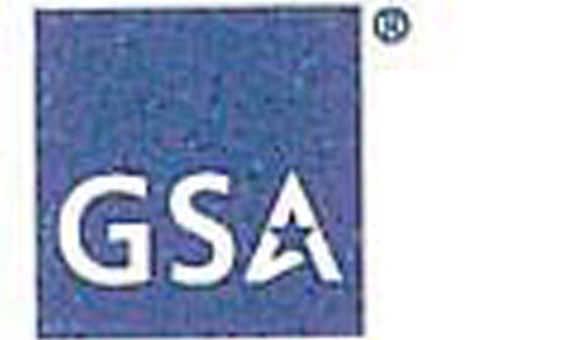 GSA Office of the Chief Acquisition Officer

SEP 29 2005 GSA ACQUISITION LETTER V-05-19

MEMORANDUM FOR ALL GSA ACQUISITION ASSOCIATES

FROM: DAVID A. DRABKIN 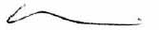
SENIOR PROCUREMENT EXECUTIVE
OFFICE OF THE CHIEF ACQUISITION OFFICER

SUBJECT: Class GSAM Deviation Applicable to Leasehold Interests in Real Property in Support of Hurricane Katrina Rescue and Relief Efforts

1. Purpose. This acquisition letter establishes a class GSAM deviation to the simplified lease acquisition threshold for leasehold interests in real property entered into in support of Hurricane Katrina rescue and relief efforts.

2. Background. Hurricane Katrina caused significant damage to Government real property. As a result, GSA has had to find emergency space quickly. For example, GSA has had to find replacement office space for displaced Federal employees, and new or additional space for emergency workers from FEMA and other agencies. Authorizing a higher threshold for use of simplified lease acquisition procedures will allow GSA to more readily fill this need.

3. Effective date: September 6, 2005.

4. Termination date. September 6, 2006, unless terminated sooner.

5. Applicability: This deviation applies only to leases entered into as a direct result of damage caused by Hurricane Katrina to Government-owned or leased property. Property can be considered to have been damaged as a direct result of Hurricane Katrina if the property is located in one of the following jurisdictions:

- all parishes in the State of Louisiana;
- all counties in the State of Mississippi;
- the counties of Baldwin, Choctaw, Clarke, Mobile, Sumter and Washington in the State of Alabama; and
- the counties of Broward, Miami-Dade, and Monroe in the State of Florida.

U.S. General Services Administration 1800 F Street, NW
Washington, DC 20405-0002 www.gsa.gov
-2
6. Instructions.

a. The definition of "Simplified lease acquisition threshold" at GSAM 570.102 is changed to read:

"Simplified lease acquisition threshold" means $250,000 average annual rent for the term of the lease, including option periods and excluding the cost of operational services.

b. If you hold a warrant for Leasing/Simplified Acquisition, you are currently limited to entering into leases not exceeding $100,000 average net annual rent. Consequently, the head of your contracting activity must issue a memorandum temporarily raising that limitation to the higher threshold.

c. Leases entered into using this procurement authority must have a clear and direct relationship to the support of the current national emergency. Consequently, you must make your determination(s) in writing by a brief memorandum to the lease file specifying how it supports the Hurricane Katrina rescue and relief efforts.

d. Each region that enters into a lease using this authority must keep a record of all such leases. The record shall include the location of the lease; the name and address of the lessor; if the lessor is a small business, other than small business, woman-owned, disadvantaged, HUBzone, etc.; the lease number; and the average annual dollar value of the lease, including option periods and excluding the cost of operational services.

If you have any questions, please contact Gerald Zaffos, 202-208-6091, or email at jerry.zaffos@gsa.gov.

