GENERAL SERVICES ADMINISTRATION September 15, 2005

Washington, DC 20405

FEDERAL TRAVEL REGULATION
Amendment 2005-04

TO: Heads of Federal Agencies

SUBJECT: Amendment 2005-04, FTR Case 2005-307, Privately Owned
Vehicle Mileage Reimbursement

1. Purpose. This final rule amends the mileage reimbursement rate for use of a privately owned vehicle (POV) on official travel to reflect recent gas price increases. The governing regulation is revised to increase the cost of operating a privately owned automobile from 40.5 to 48.5 cents per mile.

2. Background. Pursuant to 5 U.S.C. 5707(b), the Administrator of General Services has the responsibility to establish the privately owned vehicle (POV) mileage reimbursement rates.
In recognition of recent gasoline price increases, the Administrator of General Services has determined the per-mile operating costs of a POV to be 48.5 cents for automobiles. As provided in 5 U.S.C. 5704(a)(1), the automobile reimbursement rate cannot exceed the single standard mileage rate established by the Internal Revenue Services (IRS). The IRS announced on September 9, 2005, a new single standard mileage rate for automobiles of 48.5 cents effective from September 1 to
December 31, 2005.

3. Effective date. Applicability Date: This final rule is effective from September 1 to December 31, 2005, and applies to travel performed during that time period.

4. Explanation of changes. Page 301-10-9 is amended to reflect the change noted to privately owned vehicle (POV) mileage reimbursement rates.
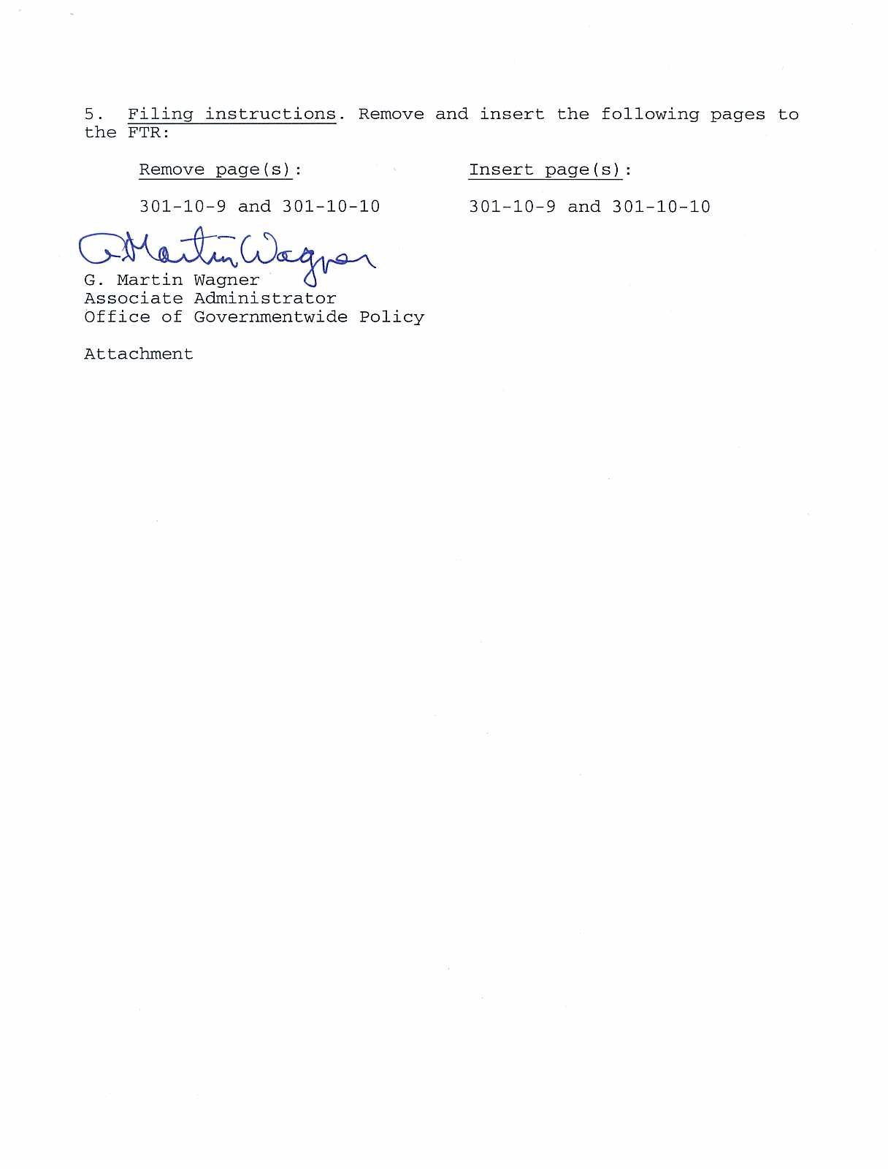
AMENDMENT 2005–04 SEPTEMBER 1, 2005

Chapter 301—Temporary Duty (TDY) Travel Allowances
Part 301-10—Transportation Expenses §301-10.303

taken over the full coach fare for the flights that you would exempt from disclosure under that Act (such as classified
have taken had you not engaged in personal activities during information).
the trip, i.e., for a wholly personal trip, you must pay the full
coach fare for the entire trip; Subpart D—Privately Owned Vehicle (POV)
(2) For travel authorized under 10 U.S.C. 4744 and reg-
ulations implementing that statute, or when you or your §301-10.300 When may I use a POV for official travel?
dependents are stationed by the Government in a remote loca- When authorized by your agency.
tion with no access to regularly scheduled commercial airline
service and are authorized to use Government aircraft, you do §301-10.301 How do I compute my mileage
not have to reimburse the Government. reimbursement?
(c) For political travel on a Government aircraft (i.e., for You compute mileage reimbursement by multiplying the
any trip or part of a trip during which you engage in political distance traveled, determined under §301-10.302 of this sub-
activities), the Government must be reimbursed the excess of part by the applicable mileage rate prescribed in §301-10.303
the full coach fare for all flights taken on the trip over the full of this subpart.
coach fare for the flights that you would have taken had you
not engaged in political activities, except if other law or reg- §301-10.302 How do I determine distance measurements
ulation specifies a different amount (see, e.g., 11 CFR 106.3, for my travel?
“Allocation of Expenses between Campaign and Non-cam-
paign Related Travel.”), in which case the amount reimbursed The distance between your origin and
is the amount required by such law or regulation. If you travel by destination is
Privately owned As determined from aeronautical charts issued
Note to §301-10.264: Except for required use travel, any automobile or by the Federal Aviation Administration (FAA).
privately owned
use of Government aircraft for personal or political activities motorcycle.
shall not cause an increase in the actual costs to the Govern- Privately owned As determined from airway charts issued by the
ment of operating the aircraft. aircraft. National Oceanic and Atmospheric
Administration, Department of Commerce. You

§301-10.265 Will my travel on Government aircraft be may include in your travel claim with an explanation any additional air mileage resulting
reported? from a detour necessary due to adverse weather,
Your travel on Government aircraft will not be reported mechanical difficulty, or other unusual
unless you are a senior Federal official, or a non-Federal trav- conditions. If a required deviation is such that
eler. (Travel under 10 U.S.C. 6744 is not reported.) If you are airway mileage charts are not adequate to

a senior Federal official or a non-Federal traveler, any use you determine distance, you may use the formula of flight time multiplied by cruising speed of the
make of Government aircraft, i.e., as a passenger, crewmem- aircraft to determine distance.
ber, or qualified non-crewmember, will be reported to the
General Services Administration (GSA) by the agency that §301-10.303 What am I reimbursed when use of a POV is
owns or hires the Government aircraft. (Agencies must main- determined by my agency to be advantageous to the
tain information on classified trips, but do not report classi- Government?
fied trips to GSA.)
For use of a Your reimbursement is
§301-10.266 Is information available to the public about Privately owned aircraft Actual cost of operation
travel on Government aircraft by senior Federal (e.g., helicopter, except an (i.e., fuel, oil, plus the additional
officials and non-Federal travelers? airplane). expenses listed in §301-10.304).
Yes, an agency that authorizes travel on Government air- Privately owned airplane. 11.07
craft and an agency that owns or hires Government aircraft Privately owned automobile. 10.485
must make records about travelers on those aircraft available
to the public in response to written requests under the Free- Privately owned motorcycle. 10.305
dom of Information Act (5 U.S.C. 552), except for portions 1 Per mile.

301-10-9
§301-10.304 FEDERAL TRAVEL REGULATION

§301-10.304 What expenses are allowable in addition to §301-10.310 What will I be reimbursed if I am authorized
the allowances prescribed in §301-10.303? to use a Government automobile and I use a privately
Following is a chart listing the reimbursable and non-reim- owned automobile instead?
bursable expenses: (a) Reimbursement based on Government costs—Unless you are committed to using a Government vehicle as provided
Non-reimbursable expenses in paragraph (b) of this section, your reimbursement will be
Reimbursable expenses in included in the mileage limited to the cost that would be incurred for use of a Govern-
addition to mileage allowance allowance ment automobile, which in CONUS is 27.0 cents per mile. If
Parking fees; ferry fees; bridge, Charges for repairs, depreciation, your agency determines the cost of providing a Government
road, and tunnel fees; and aircraft replacements, grease, oil, automobile would be higher because of unusual circum-
or airplane parking, landing, and antifreeze, towage and similar
tie-down fees. speculative expenses, gasoline, stances, it may allow reimbursement not to exceed the mile-
insurance, state and Federal taxes. age rate provided in §301-10.303 for a privately owned automobile.
§301-10.305 How is reimbursement handled if another In addition, you may be reimbursed other allowable
person(s) travels in a POV with me? expenses as provided in §301-10.304.
If another employee(s) travels with you on the same trip in (b) Partial reimbursement when you are committed to use
the same POV, mileage is payable to only one of you. No a Government owned automobile—When you are committed
deduction will be made from your mileage allowance if other to use a Government automobile or would not ordinarily be
passengers contribute to defraying your expenses. authorized to use a privately owned automobile due to the availability of a Government automobile, but nevertheless
§301-10.306 What will be reimbursed if I am authorized request to use a privately owned automobile, you will be
to use a POV instead of a taxi for round-trip travel reimbursed 10.5 cents per mile. This is the approximate cost
between my residence and office on a day of travel of operating a Government automobile, fixed costs excluded.
requiring an overnight stay? In addition, parking fees, bridge, road and tunnel fees are
If determined advantageous to the Government, you will reimbursable.
be reimbursed on a mileage basis plus other allowable costs
for round-trip travel on the beginning and/or ending of travel Subpart E—Special Conveyances
between the points involved.
§301-10.400 What types of special conveyances may my
§301-10.307 What will I be reimbursed if I use a POV to agency authorize me to use?
transport other employees? Your agency may authorize/approve use of:
Using a POV to transport other employees is strictly vol- (a) Taxicabs as specified in §§301-10.420 through
untary and you may be reimbursed in accordance with 301-10.421 of this chapter;
§301-10.305. (b) Commercial rental automobiles as specified in
§§301-10.450 through 301-10.453 of this chapter; or
§301-10.308 What will I be reimbursed if I park my POV (c) Any other special conveyance when determined to be
at a common carrier terminal while I am away from my advantageous to the Government.
official station?
Your agency may reimburse your parking fee as an allow- §301-10.401 What types of charges are reimbursable for
able transportation expense not to exceed the cost of taxi fare use of a special conveyance?
to/from the terminal. Actual expenses that your agency determines are neces- sary, including, but not limited to:
§301-10.309 What will I be reimbursed if I am authorized (a) Gasoline and oil;
to use common carrier transportation and I use a POV (b) Rental of a garage, hangar, or boathouse;
instead? (c) Feeding and stabling of horses;
You will be reimbursed on a mileage basis (see (d) Per diem of operator; and
§301-10.303), plus per diem, not to exceed the total construc- (e) Ferriage, tolls, etc.
tive cost of the authorized method of common carrier trans-
portation plus per diem. Your agency must determine the §301-10.402 What will I be reimbursed if I am authorized
constructive cost of transportation and per diem by common to use a special conveyance and I use a POV instead?
carrier under the rules in §301-10.310. You will be reimbursed the mileage cost for the use of your
POV, and additional expenses such as parking fees, bridge,

301-10-10 (Amendment 2005-04)

