Nautical Chart Challenge

Best for Ages: 9-14

Introduction:

Boaters need to know a lot of information to travel safely. Charts tell travelers:
- the direction they need to go to get where they are going,
- names of harbors and other features,
- depths of waterways,
- locations of wrecks and obstructions.

This activity introduces you to some of the features of a nautical chart. The section of chart here is from a nautical chart that was made for a region off the coast of Massachusetts. Hint: You may want to locate the state on a map of the United States before you begin.

Directions:

Use the section of nautical chart below to answer the questions that follow. Although there is lots of information on the chart, the questions will help you find the answers.

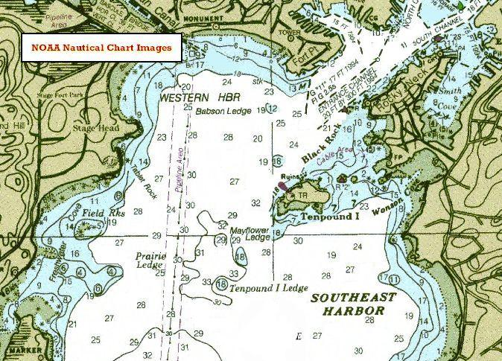

Questions:

- How many harbors are located on the nautical chart? (Hint: HBR is sometimes used as a shorter way to write “harbor”).

- Assuming that North is at the top of the chart and South is at the bottom, what direction is Tenpound I from Tenpound Ledge 1?

- Mayflower Ledge is located just below the center of the chart. Are there any rocks in the area around the ledge? (Hint: Small star shaped symbols surrounded by a circle of dots tell us where rocks are located).

- Take a look at Freshwater Cove in the lower left part of the chart. What is the shoalest (the
most shallow) depth you can find in the Cove? (Hint: Depths are all the small numbers floating around the chart).

- Locate Babson Ledge and Prairie Ledge. What are some of the depths within the channel that runs between the two ledges? (Hint: Dashed vertical lines tell us where a channel is).

- Look at the top right of the chart to find the major water channel that lies between the coastal land areas of Fort Point and Rocky Neck.

How many feet does the chart say the channel measures?

What year was this measurement taken?

Are you Ready for a Challenge?

In question 6 you found the depth of the channel between Fort Point and Rocky Neck. You also looked at the year that the measurement was taken. Imagine that, since then, the depth has changed due to a severe storm in the area. Do you think it is possible that the information on the chart could be incorrect now? How might that affect those who must travel through the channel?

Could a boat with a hull of 31 feet deep travel safely from the Eastern portion of Southeast Harbor to Prairie Ledge? What could happen if the boat doesn’t use a nautical chart and tries to go to the ledge?

