 | Relocation Mandates - Question 5 Ref: FTR 302-9.502, FTR 302-9.504
A | Agencies are required to have internal policies determining who authorizes shipment of privately owned vehicles and when it is in the best interest of the government.  Do you have a documented agency policy enforcing this mandate? Yes No  Do you ensure your employees are aware of the mandate? Yes No  Do you verify adherence with the mandate, e.g., via performance measures? Yes No  How familiar are you with this mandate? Very Familiar  What is the biggest challenge to adherence? Unaware of requirement  Please provide evidence and an explanation for each criteria.  Please provide evidence and an explanation for each criteria.  My agency has established a policy governing how shipment of privately owned vehicles will be authorized. This information is published in our Standard Operating Procedures and on our internal Web site. Requests for funding transfers must be approved by the program office Division Director.  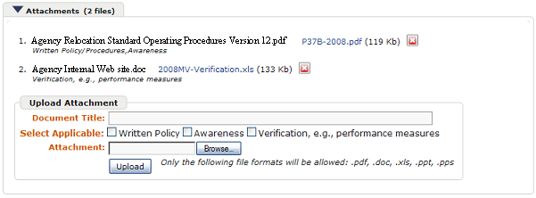
B | Overall Score:  Effective  Moderately Effective  Ineffective  View Details  GSA interim response (if necessary)  Written Policy Yes No  Awareness Yes No  Verification Yes No  Thank you for the information provided above. The policy is clearly delineated in your Agency Relocation SOP, but that is only two of the three evaluation criterion establish in the PRT. The criteria used by GSA to evaluate agency responses are located on the GSA Center for Policy Evaluation website (www.gsa.gov/cpe) - see the tab on the left entitled "DCF Parts, Instructions & Scoring. We request that you provide (via an attachment or website reference, for example) documented evidence that: affected employees are actually made aware of this requirement. If your agency is not currently performing this activity, please address how your agency plans to do awareness in the future.
C | Agency follow-up response (if necessary)  Our agency has a “Relocation” web page that can be accessed by all employees at www.agency.gov/relo. Whenever there are significant changes to content, we send out an email notice identifying the changes and encouraging employees to see the content on the relocation web page.  Attachments (0 files)  Agency Relocation Standard Operating Procedures Version 12.pdf
D | GSA final response  Overall Score:  Effective  Moderately Effective  Ineffective  View Details  Written Policy Yes No  Awareness Yes No  Verification Yes No  Thank you for providing the additional information. Your agency is considered as effective on this mandate.

