Donation Success Story - Colorado

Columbine Counseling Center
The Colorado Surplus Property Agency informed GSA that several Jefferson County organizations were working with the Jefferson Center for Mental Health in establishing a counseling center and drop-in center for students to gather and receive support in coping with the Columbine tragedy.
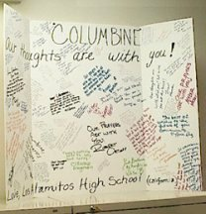

GSA reviewed what the Center needed and was able to assist. Fifty-eight chairs were located and offered through the Colorado State Agency for Surplus Property. There was a need for six office type cubicles to be used in the counseling center, and GSA was able to provide excess systems furniture parts needed to build the site.
GSA made contact with Business Interiors to request assistance in designing the units and installing the system. The staff at Business Interiors was extremely cooperative and worked quickly to design the system and requested volunteers to install the units. Eight installers volunteered the day the notice was posted and within 2 hours, the units were assembled.


