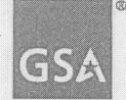 GSA Office of the Chief Acquisition Officer

DEC 22 2005 GSA Acquisition Letter V-05-23

MEMORANDUM FOR ALL GSA CONTRACTING ACTIVITIES

FROM: For EMILY MURPHY 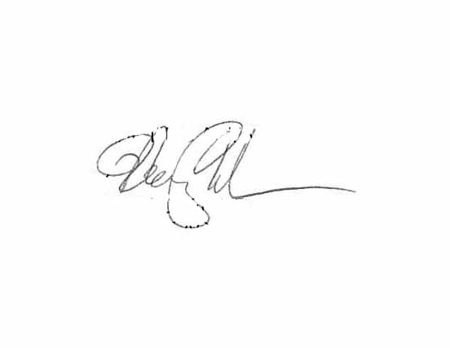
CHIEF ACQUISITION OFFICER
OFFICE OF THE CHIEF ACQUISITION OFFICER

SUBJECT: Use of GSA Form 300 for the Acquisition of Utility Services
1. Purpose. The purpose of this acquisition letter is to provide guidance for the use of the GSA Form 300 when acquiring utility services.
2. Introduction. GSA is authorized to enter into utility contracts for a period not to exceed 10 years (40 U.S.C. 501.)
3. Effective date. Date of signature.

4. Termination Date. This Acquisition Letter will expire one year from issuance unless cancelled or extended, or upon incorporation into the General Services Administration Acquisition Manual, whichever occurs first.
5. Applicability. This Acquisition Letter applies to all GSA contracting activities involved in the acquisition of utility services (electric, gas, water, steam and sewage).
6. References. FAR Part 41, GSAM Part 541.

7. Instructions. The GSA Form 300 may be used to acquire utility services in three separate instances:
a. For obligation purposes only (i.e., not as a contractual document) when the supplier refuses to execute a required bilateral contract. When the GSA Form 300 is clearly marked "for obligation purposes only," the period of performance may be any period, not exceeding 10 years, over which the service is required. Limitations on the total dollar value of the acquisition, such as those described below, do not apply when the GSA Form 300 is marked "for obligation purposes only."
U.S. General Services Administration 1800 F Street, NW
Washington, DC 20405-0002 www.gsa.gov

-2-
b. As a contract when the estimated annual value of the regulated utility services procured does not exceed the simplified acquisition threshold. The GSA Form 300 is appropriate for use as a contractual document when the estimated total annual value of the regulated utility services procured, including amounts associated with service connection, does not exceed the simplified acquisition threshold limitation (see FAR 41.201(b)). FAR Part 13 currently sets this limitation at $100,00a OeGSAForm300 may be used as long as the annual value of the utility services procured does not exceed this limit.

c. In conjunction with the authorization form, to order services from a GSA area wide utility contract . When combined with an area-wide authorization form for service that is executed by both the utility company and the contracting officer, the GSA Form 300 may be attached to the authorization form and used as the obligating document for the executed authorization. The GSA Form 300 shall be issued for the same term as the accompanying authorization form (i.e. up to 10 years).

