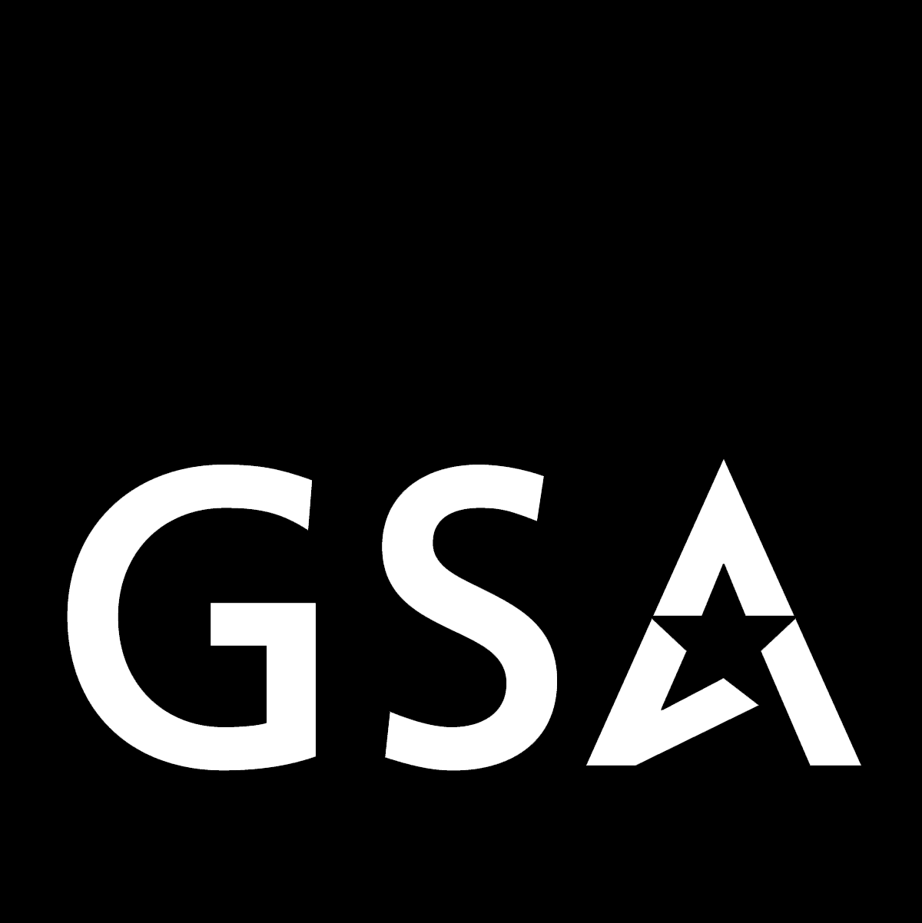 Federal Acquisition Service

Disposition
THE NEWSLETTER DEDICATED TO THE INITIATIVES OF THE GSA PROPERTY MANAGEMENT PROGRAM
“The first source of supply!”
Spring 2009 DN-No. 42
>>>>>>>>>>>>>>>>>>>>>>>>>>>>>>>>>>>>>>>>>>>>>>>>>>>>>>>>>>

It’s Green They Say In GSA
“Green green, it’s green, they say
On the far side of the hill . . . “
This oft used line, originally coined in a song by Nick Cave and the Bad Seeds, is a universally expressed yearning by people for the hope of happiness that lies—magically—just over the next horizon. Of course, many of us have learned that some forms of contentment can be found quite close at hand. In fact, sometimes happiness can lie right in front of us—and it is within our ability to grasp. We in the GSA Property Management program would like to remind our customers that they can feel sure about grasping a form of “green” happiness that possesses both “hope” and a close proximity—and it is not of the crass, materialistic kind either. This kind of “green” can bring a feeling of contentment as well: it is a greener America. That’s right! We are talking about a more environmentally-friendly country that starts right here with you and me—through use of the reutilization and recycling initiatives of the GSA Property Management program. It may come as a surprise to some people to think that their everyday tasks, both big and small, can have an affect on the greater good of the nation—but they do! All efforts out there to reuse equipment, reduce waste, and recycle materials in federal, state, and non-profit programs play an integral part that can and do transcend our ordinary day-to-day job activities. That’s because these efforts in reporting and acquiring used federal property in concert produce results that contribute to the greening of America. In fact, the over $1 billion worth of transfers and donations of property that took place in the 2008 fiscal year attest to the effectiveness of these combined efforts. These activities help to support many organizations that are a part of the GSA Property Management program. In fact, to some entities out there, these efforts are not only “green,” but essential to their operations. And why not? Isn’t our country built upon a cosmopolitan framework that allows us to work together for the greater good of all? We in GSA think so. That’s why we offer so many “green” solutions as fostered by our Office of Personal Property Management. Yes! We would like to get to that “far side of the hill” and we would like you along for the ride. Join us today! Go to gsaxcess.gov for more information on how to get to the “green” side of property management.
GSA Has Allocation On Its Mind
If there was one recurrent theme that dominated the recent Donation Allocation Training held by the GSA Property Division in Atlanta, Georgia, it was “communication.” For an agency like GSA that prides itself on delivering products and services effectively, there is no better way to ensure the continued success of these endeavors than to maintain good lines of communication—both internally and externally. That’s why the training hosted by the Southeast Sunbelt Region for GSA property allocation personnel was held to begin with—to get it right! As GSA sees it, the conduit that this communication flows through is not only the relationship between the various GSA regions that allocate federal surplus property to eligible “donation” organizations, but—more importantly—the con-nection between GSA and its customers who receive and reutilize this property. As such, communication—and by that we mean “good” communication—is the key bond that links the efforts of GSA personnel to the various State Agencies for Surplus Property (SASP’s), non-profit organizations, service/educational activities, and other recipients of federal surplus property. Although GSA utilizes a host of criteria for the allocation of this property—from emergency situation guidelines to state per capita data—GSA enhances its service to customers by being proactive in coordinating its activities between regions and maintaining consistency in its efforts. Of course, these coordinated efforts have one target highest in mind—customer satisfaction. It is with this in mind that led the GSA trainees to resolve to link past practices to the present; develop new “user-friendly” facets in GSAXcess®; convey, effectively, the “reasons” for allocation decisions; and translate the “fair and equitable” and “partnering” qualities of the program into the best process possible. It’s no small job. but we think our customers are worth it. That’s why GSA will be communicating with customers now and in the future to ensure that together we “get it right” and that customer satisfaction stays uppermost on our mind.
The “Green” Issue
It’s Green In GSA
Speaking of Green . . .
USCG Tribute
Lend Me Your Ear
And more
(See page 3 for more on GSA’s “allocation” efforts.)

And Speaking Of Green . . .

A Tree Grows In Springfield
Area Property Officers (APO’s) and managers from the GSA Mid-Atlantic Region brought new meaning to the expression, “The grass is always greener on the other side,” when they gathered in Springfield, Virginia, in early December 2008 to develop initiatives designed to meet the “green” interests of customers and country alike. Despite the wintry landscape, the annual meeting had a definite “green” tone to it in its relation to the GSA Business Action Plan for Fiscal Year 2009. The meeting acted as a key springboard for putting the GSA property program at the forefront of agency-wide initiatives. These included efforts that featured plans for polishing GSA’s already “green” image: by improving property sales cycle time; avoiding costs through enhanced property recycling efforts; stimulating property sales by networking with internal and external customers; and enhancing customer service by “partnering” with federal and state programs. Whether these initiatives were being measured by gauges that meant green for “high performance” or green for “recycling,” they were put forth as the barometers that would lend support to the overall success of GSA in 2009. The initiatives were bolstered at the meeting by visits from the Transportation Security Administration (TSA) and the State Agencies for Surplus Property (SASP’s) for Pennsylvania and Virginia. The TSA and SASP programs play key parts in the reutilization efforts of GSA, nationwide. Still other issues focused on enhancing already successful initiatives of the “utilization and donation” program, which is coming off a $1 billion dollar year in FY 2008. These included efforts to accentuate popular programs at the “regional” level that have a “national” impact, including the promotion of the Disposition newsletter; the continued partnering with the Department of Education for the Computers for Learning (CFL) program; the enhancement of a “greener environment” through the use of special “green” events, like the “CFL Day” held in Springfield; the exploring of new interactions with the Federal Prison Industries for increased IT-recycling outlets; and the scheduling of more Customer Appreciation Days. At a time when combining resources is essential, the Mid-Atlantic Property Program is reaching out to other regions and customers alike to create a “greener culture” today that will serve the best interests of America tomorrow.

The Color of Learning
If “green” means recycling, then the Computers For Learning (CFL) program must be a luminous, emerald hue! For the latest tints and tones about CFL system enhancements or school eligibility guidelines, you can call 703-605-2873 or contact www.computersforlearning.gov so you can learn how your agency can donate used computer equipment to schools. It’s all about that color of learning. Brilliant!

Computers Go With “Green”
The virtues of the Computers for Learning (CFL) program were outlined in full by GSA Program Specialist Gary Duffala at the “Buying Green and Computers for Learning” workshop in Albuquerque, New Mexico, on January 28, 2008. The workshop, sponsored by the Federal Executive Board, was attended by federal agency personnel who learned how to search for eligible schools, how to donate computers to these schools, and how to help schools register for the CFL program. That’s a “green” way to do things!

“Green” Is In The Air
That’s right—this spring! That’s because the GSA Area Property Officer in Ohio, Doug Janka, is partnering with GSA Public Building Service personnel at the Bricker Federal Building and Kinneary Courthouse to support an E-Cycling event being held for tenants of the buildings. Doug is not letting the green grow under his feet either, as he is being proactive in his partnering efforts by pre-screening questions and answers on IT disposal in advance of the E-Cycling event scheduled for April 22. The hope here is to have all the agency tenants report their IT equipment far enough in advance so that any property not utilized, donated, or sold via GSAXcess® or GSA Auctions® can be released during the “E-Sweep” that defines the event. You could say that if you miss this event, you’ll be definitely “green” with envy.

GSA Auctions® Celebrates 8th Birthday
One of the flagship programs of the GSA Office of Personal Property Management, nationwide, celebrated its 8th birthday this past January with—wouldn’t you know it—a “working” meeting that featured issues from property system updates to Memorandums of Understanding. It’s not that the people at GSA Auctions®—including director, Lynn Price, and col-laborators Melissa Brown, Iris Wright-Simpson, Debbie Leith, and Denise Hicks—should not try to lighten up (“heavy/earth moving equipment” was on the agenda—no kidding), but they should at least learn how to stand up and cheer for the tremendous success of the program over the past eight years—a success that is measured by over $475 million in sales proceeds during that time. Well, we can all celebrate for them. And, you know folks, the recycling of government assets is the (green) icing on the cake!

Green Skies At Night: Sailors Delight!
Yes! It’s “green” skies not “red” anymore—thanks to the Pacific Rim Region Property Division! The Rim’s Utilization & Donation Branch recently transferred an S3-B aircraft from the US Navy to the National Aeronautical Space Administration much to the delight of NASA and American taxpayers. The aircraft, valued at $25.9 million, will be used by NASA for research and represents the ultimate in “green” asset management coordination by GSA and the agencies.

To: They That Go Down To The Sea In Ships
Many people will recognize this phrase from Psalms in the bible or in places like Mystic, Connecticut, or New Bedford and Gloucester, Massachusetts (where it graces the Fisherman’s Memorial), as it pays tribute to those noble souls who have braved the sea for their livelihood. GSA Area Property Officers recently paid a kind of tribute to another group of noble seafarers, the United States Coast Guard (USCG), when they visited the USCG station in Groton, Connecticut. They were there to assist in the disposal of excess property at the vacated USCG (Department of Homeland Security) site on the University of Connecticut campus (Maritime Sciences) at Groton. Although much of the “sea” memorabilia of the USCG personnel at Groton was gone, many were the book shelves, map tables, research cabinets, storage lockers, and miscellaneous “tools of the trade” left behind at this research and development site to signify—even if by a fleeting glance—the great job that was done by people who are often taken for granted by we landlubbers. With a reinvigorated effort in New England (led by a new APO, Michael Wade, New Hampshire) the GSA property division got a chance to see just the ‘tip’ of the iceberg that is the mission of the USCG at places like Groton where fighting foul weather, stormy seas, and fog-shrouded harbors are just in a day’s work. And, they do it well! While several federal and state agencies attended the two-day screening event held by GSA at Groton—including the U.S. Navy, the Department of Labor-Job Corps, the Connecticut State Agency for Surplus Property, and others—the success of the event was not measured in the amount of tables carried, desks hoisted, or cabinets loaded for property reutilization purposes. That success was gauged by all of us who could appreciate the awesome presence of the sea juxtaposed next to the dedicated service of the USCG at Groton—and at other sites just like it. So, to Lynn, Kristin, Daren and Vance who welcomed the APO’s to Groton and to the USGC folks who served there and elsewhere, this article is for you. A hearty “Thanks!” From: Your landlubber friends at GSA.

Speaking Of New England . . .
GSA would like to welcome Michael Chella to the federal surplus property ranks in New England.
Michael can be contacted by writing, Director, Rhode Island State Agency for Surplus Property, c/o State Fire Marshal's Office, 118 Parade Street, Providence, RI 02907. He can also be contacted by phoning 401-641-3260 and by faxing 401-462-4250. His e-mail address is MChella@Admin.RI.Gov. Welcome aboard, mate!
NASASP Meets In Arlington With A Green Focus
The National Association of the State Agencies for Surplus Property (NASASP) held a “green” winter meeting in Arlington, Virginia, in February 2009, to discuss issues affecting its SASP programs nationwide and in U.S. territories. The national group meets twice annually to share ideas and coordinate the efforts of the respective state programs that manage federal surplus property obtained through the auspices of GSA. Each year, millions of dollars of federal property is processed through the SASP’s for donation to public agencies, non profit organizations, and other eligible entities. With an eye on the economy, the NASASP this year focused on ideas to market its services efficiently—including placing ads in the National Leagues of Cities directory; grooming relationships with newspapers; using videos to “tell our story” at events; using “free” tools offered on internet outlets, like Facebook and Google; and even cutting national meetings to once a year. It also looked at “opportunities” to enhance its portfolio by tapping into key surplus property resources like NASA, the GSA Computers for Learning (CFL) program, and others. Overall, the NASASP wants to move forward with an open eye on the future that is colored “green” for efficiency.

Regions Partnering To Form Allocation Board
Some GSA Office of Personal Property Management regions are partnering in an effort to ensure consistency and collaborative excellence in the allocation of property to federal and state customers. The so-called Allocation Board concept was born of ideas arising from a special Allocation Training Workshop held in Atlanta in February 2009 that was attended by GSA allocation personnel, nationwide. It was envisioned that through the new board both communications (between GSA and customers) and consistency (between allocation regions) could be improved and maintained and that the linkage between the federal and state allocation processes would be better managed and refined through on-going enhancements. The Allocation Board is expected to get started sometime this spring.

A State of Mind In New York
Regions 2 and 3 property personnel have the State Depart-ment on their minds, as a special team of Area Property Officers have been dispatched to manage a key relocation involving the U.S. Mission to the United Nations, the Office of International Visitors, the Foreign Press Center, and the Office of Foreign Missions—all by June of 2010. GSA will manage the “move” by identifying excess property at State’s current New York site, posting the property on GSAXcess®, screening the reusable items, transferring and donating these items to eligible federal and state agencies, and storing the residual amount for future recycling purposes. The “move” is expected to be managed during “in session” dates of the UN General Assembly and result in $1 million per month savings in rental fees for the department.
Friends, Roman(s), Countrymen—lend me your ear!
Actually, it’s Roman’s “voice”—as in the voice of Roman Marciniak, the head of special projects for our Office of Personal Property Management—that we crave here in our own rendition of a famous speech by Julius Caesar. That’s because our good, old Roman was at it again recently when he outlined the importance of the GSA Personal Property Program in today’s day and age as the ultimate “green” solution that cries out to be heard. Here is an excerpt with some key “green” points:

-When GSA was established in 1949, the Federal Property and Administrative Services Act provided the purpose of the Personal Property Management Program that remains the same as codified in Title 40 United States Code—“to provide the Federal Government with an economical and efficient system for . . . disposing of surplus property.” [40 USC101]

-This same law directs the Administrator of GSA to “In order to minimize expenditures for property . . . prescribe policies and methods to promote the maximum use of excess property by executive agencies, and provide for the transfer of excess property.” [40 USC 521]

-Title 41 of the Code of Federal Regulations (CFR) implements the law and states that “using excess personal property to the maximum extent practicable maximizes the return on Government dollars spent.”

-The GSA Personal Property Management Program is recognized by the Council on Environmental Quality as being an example of green stewardship of electronic products.

-Instructions for implementing Executive Order 13423, Strengthening Federal Environmental, Energy, and Transportation Management, states that federal agencies should “ensure that all non-usable electronic products are reused, donated, sold, or recycled using environ-mentally sound management practices . . .” and specifically “agencies shall comply with GSA procedures for the transfer, donation, sale and recycling of electronic equipment . . .”

-This same executive order indicates further that “agencies shall comply with GSA’s Computers for Learning Program (CFL) under E.O. 12999 when transferring their computers and other eligible equipment and shall use GSA’s CFL website.”

Well, these are outstanding “green” points and they just go to show that our Roman, indeed, may be “the noblest Roman of them all.” Veni, vidi, vici!
Let it Flow, Let It Flow . . .
Water, that is! And there was plenty of it! What we’re splashing about was the wave of excitement that washed our way when the Federal Emergency Management Agency appealed to GSA for help in mid-November 2008 to stem the tide of excess water that FEMA had at storage sites at Orlando, Florida, and Purvis, Mississippi. It seems that FEMA was up to its neck here because of the planned closure of these sites effective December 15. You could say that the agency also was up a creek without a paddle at that point—with over 2,200 pallets of bottled water to deal with—until the GSA Southeast Sunbelt Region came to the rescue with a splash. Not only did Sunbelt property personnel plunge right in to assist their mates at FEMA by scheduling a joint federal-state one-week screening period to “fathom” interest, but they also managed to meet the “high tide” of the December 15 deadline by having “all” of the liquid—at both sites—either transferred to federal agencies, donated to state agencies, or sold via GSA Auctions®. Overall, the Sunbelt personnel accomplished the unfathomable by proving that their efforts in the end would hold water—Here are the results:

FEMA Water (Orlando):
Federal Agencies 797 pallets $351,110
State Agencies 86 pallets $37,836
Sales/GSA Auctions® 216 pallets $29,200

FEMA Water (Purvis):
Federal Agencies 986 pallets $434,372
State Agencies 250 pallets $110,135
Sales/GSA Auctions® 0 pallets None

*The water had an assigned value of $440.54 per pallet.

Needless to say, FEMA officials were thrilled by the results and gave testament to the fact that, despite doubts, the glass was really “half full” all along—thanks to the help of the Southeast Sunbelt Region:

“I must admit, I had my doubts about getting all of this product moved . . . but you did an excellent job . . . I thank you both (GSA and the local FEMA offices) on behalf of Eric Smith, Associate Administrator for Logistics. He greatly appreciates you sticking to the task . . . and making it work when things looked bleak only a few weeks ago.”
-Stephen White, Chief-Property Management Division

≡ Disposition Newsletter ≡ 
Robert Kitsock, Editor, Hummelstown, PA
Phone: (717) 566-1064, Fax: (717) 566-1065
bob.kitsock@gsa.gov

