Characterization of Plant Community
Structure and Abiotic Conditions on
Climbed and Unclimbed Cliff Faces in the
Obed River Gorge

Gary Walker, Ph.D., Department of Biology, Appalachian State University

Emily Parisher, M.S. Candidate, Department of Biology, Appalachian State University

Peter Smith, M.S., Department of Biology, Appalachian State University, North Carolina Natural Heritage Program

David Whitlock, B.S., Department of Geography and Planning, Appalachian State University, Earth Satellite Corporation

David Kramar, B.S., Department of Geography and Planning, Appalachian State University; M.S., Department of Geography, Virginia Tech

Uta Matthes, Ph.D., Department of Botany, University of Guelph

Leslie Morefield, B.S. Candidate, Department of Biology, Appalachian State University

Technical support provided by:

Keith Bowman
William Farrell
Lara Souza
Josh Bixley
Karen Ritchie
Justin Wynns

Abstract:

Many rare or endemic species have been found on cliff faces around the world, but most of the world’s cliff ecosystems remain unexplored by biologists and little is known about ecosystem processes on cliffs. There is a growing concern however, that biodiversity on cliffs may be threatened by impacts from recreational rock climbing. Several recent studies have validated this concern. The Obed River Gorge in Tennessee boasts one of the richest floras in the southeastern United States and is also a popular rock climbing destination. Vascular plants, bryophytes, and lichens were sampled on cliff faces, cliff edges and on talus slopes along sixteen climbed and sixteen unclimbed transects in six different cliff areas of the Obed River Gorge and its tributary, Clear Creek. Cliff-face flora was sampled from pairs of 1m² plots located at three-meter intervals along the transect. Unclimbed transects were paired with and adjacent to climbed transects. Abiotic factors including aspect, slope, surface heterogeneity, and light were measured for each pair of plots. Canonical Correspondence Analysis (CCA) was performed to determine the relative importance of each of these abiotic factors, as well as the impact of rock climbing, in shaping the cliff-face plant communities of the Obed River cliffs. Results indicate some impacts of foot traffic in the talus slopes of climbed areas on vascular and non-vascular species. Habitat and site were the most important variables accounting for variation in the vegetation. In addition, preliminary sectioning of a Juniperus virginiana snag in the talus slopes yielded eight-hundred annual rings.

Statement of Problem:

Recent research done by the Cliff Face Ecology Research Group at the University of Guelph, Canada and at Appalachian State University (ASU), North Carolina, has demonstrated that cliff-face plant communities represent ancient forests, with trees dated in excess of 1000 years of age (Larson et al. 1999) (Larson et al. 2000). New species of lichens have been discovered on cliff faces in Canada and North Carolina and the plants on cliff-faces in the Southern Appalachians have been found to represent glacial relict species from the last ice age (Walker 1987). Additionally, these relict plants have also been determined to contain levels of genetic variation far in excess of those in their main range, potentially representing a genetic reservoir in interglacial periods (Walker 1987).

Horizontal rock outcrop plant communities have been the subject of investigation for many decades, and have been found to contain a wealth of rare, endemic plant species. While ecologists have devoted much attention to these communities, vertical cliff faces have been largely ignored due to their inaccessibility and the idea that cliff faces represent geological features, not biological habitats (Larson 2000).

With rock climbing as an increasingly popular sport, vegetational surveys for areas heavily impacted by rock climbing, such as the Obed River Gorge, are crucial for sound management practices. As we discover new species on cliff faces, realize that cliff-face forests may represent the remnants of old-growth forests undisturbed by fire and humans for thousands of years, and see cliff-face communities as genetic and species refugia since the last ice age, their study and protection becomes of immediate concern to both scientists, land managers, and environmentally concerned members of the rock-climbing community. Collaborative research by cliff-face researchers at the University of Guelph, Department of Botany, and Appalachian State University, Department of Biology, have developed consistent techniques to answer questions regarding community composition and to measure the impact of human disturbance in cliff-face systems (Larson et al. 2000) (Smith 1999). By working with local rock-climbing groups and management agencies, cliff-face ecologists have been able to develop strategies that serve both public access to climbing areas as well as protecting the fragile and rare cliff-face ecological communities.

Background Information:

Recognized for its free-flowing condition, rugged terrain, and pristine waters, the Obed River was included into the Wild and Scenic Rivers System in 1976 and established as a unit of the National Park Service. The Obed is one of only nine Wild and Scenic Rivers authorized in the Southeastern United States. The Obed River flows over 45 miles through some of the most rugged, and undeveloped terrain in eastern Tennessee. It offers a vast array of both cultural and natural resources. A complex network of streams drain park and adjacent lands supporting diverse flora and fauna as well as providing numerous recreational opportunities.

Limited studies of the vegetative communities in the Obed have been completed. In 1982, Paul Schmalzer completed the Final Report - Vegetation, Endangered and Threatened Plants, Critical Plant Habitats and Vascular Flora of the Obed Wild and Scenic River (Schmalzer et al. 1985), (Schmalzer. 1988), Schmalzer. 1989). This study covered the entire park and did not specifically address cliff-face ecology. Recently a short study of the cliff face and cliff base area was completed. This study revealed that numerous bryophytes are found along the cliff face and cliff base. A large number of these have not been reported in other areas of the Cumberland Plateau (Risk, 1998). A new species of lichen, Canoparmelia amablilis was discovered in 1999. Canoparmelia amablilis was discovered within the climbing area and at this time due to its recent discovery it is the only known location of this lichen (Heiman 1999).

Several old growth trees have been discovered within the climbing area. In 1999, four red cedars (Juniperus virginiana) were cored to determine age. These trees ranged in age from 287 years to 381 years. Several other trees that had been cut at the base of several climbs were studied, their ages ranged from 150 to 200 years old (Heiman 1999). In light of this information, the National Park Service determined that an in-depth study of the vegetation on the cliff face, cliff base and cliff edges was necessary to assist in managing climbing within Obed Wild and Scenic River.

Cliff-face ecological investigations:

Research on cliff-face plant and lichen communities in Linville Gorge Wilderness Area in Western North Carolina, conducted by researchers from ASU, demonstrated that cliff-face vegetational communities are significantly different in species composition from those on rock outcrops (Smith 1999). Further, a significant difference in species composition between the upper and lower reaches of cliff faces, with shifts in community composition along this gradient was shown to occur. The implications of these findings are that cliff-face vegetation represent a community type previously undescribed quantitatively in the plant ecological literature. They also represent very complex spatial associations that have been suggested in British literature but previously undescribed in North America.

Lichens are symbiotic organisms with components consisting of fungi associated with algae or cyanobacteria. They are important colonizers of bare rock and often the initiators of primary succession in such habitats. Since lichens are an important component of cliff-face and rock-outcrop vegetational assemblages it is crucial that they are included in such surveys. In a comparison of climbed and unclimbed cliff faces in Linville Gorge, as expected, there was a significant difference between disturbed and undisturbed cliff faces in lichen and plant community composition. Unexpected was the finding that as disturbance from climbing apparently removes some groups of lichens and plants, one group, the crustose lichens, actually increase in abundance following such disturbances, likely resulting from competitive release from species that would otherwise shade them out. A new species of lichen was discovered and is being described in this same study (Smith 1999). Similar results have been reported from the Niagra Escarpment cliff faces in Ontario, Canada, (Larson 2000).

Physical Features:

Geomorphology of Cumberland Plateau:

The Cumberland Plateau is a physiographic province of the Southern Appalachians east of the eastern Highland Rim and west of the Ridge and Valley Provinces. It is a broad upland that extends northeast from its Tennessee portion across Kentucky and into West Virginia and Pennsylvania where it is known as the Allegheny Plateau, and to the southwest into Alabama. The Cumberland Plateau of Tennessee is the southern extension of the Appalachian Plateaus Province (Fenneman 1938). In Tennessee it is recognized as a true tableland, with gently sloping uplands throughout most of its extent. It its Tennessee portion it averages 35 to 40 miles in breadth with upland elevations from 1500 feet near Kentucky to nearly 2000 feet in the south. The two large river systems of the Plateau are the Clear Fork-Big South Fork and the Obed-Emory, both with similar morphologies. Unlike many stream channels these systems flow in shallow gorges in their upper reaches and are increasingly entrenched downstream. At the lower ends these rivers cut 300 to 400 feet below the surface of the Plateau. Much of this vertical depth is accounted for by bluffs, making up to 100 feet of the basin depth. While the larger tributaries join the stream at grade, the smaller ones often enter as waterfalls and seeps (Mayfield 1984) The bluffs of these two river systems are attractive as rock climbing destinations, particularly in the Obed-Emory basin.

Geology of the Emory basin:

Because the rock strata of the Cumberland Plateau dip northeastward while its surface elevations are generally constant, the older Mississippian limestone rock units are exposed in the valley walls of entrenched streams of these areas. In the Emory basin the lithology consists of mainly near-horizontal sedimentary strata of Pennsylvanian age with alternate layers of sandstone, siltstone, and shale composing the bed rock. The Rockcastle Sandstone-Conglomerate is the most commonly exposed outcrop at the surface while older shales and sandstones are exposed in the cliff faces of the gorges. This conglomerate has a very low intergranular permeability that is somewhat enhanced by fractures in the unit (Newcombe and Smith 1958). Springs are commonly formed where sandstone layers contact shale beds (Newcombe and Smith 1958).

Hydrology of the Obed basin:

It has been established that the streamflow of the Obed basin is able to move water rapidly through shallow but highly permeable soils with runoff ocurring over a short period of time (Mayfield 1979). This results in a streamflow regime that consists of great extremes which is anomalous when compared to other watersheds in the Cumberland Plateau. Although the watershed of the Obed has low drainage density, gentle to moderate slopes, heavy forest cover, permeable soils and less intense rainfall than other watersheds that are found in its vicinity, the impermeable bedrock and shallow soils of the basin provide minimal storage, thus water exits the watershed rapidly as stream flow.

Soils of the Obed-Emory basin:

The natural fertility of the Cumberland Plateau soils is low, ranging from 2-4 feet deep, well-drained, loamy, and relatively acidic (Springer and Elder 1980). Most of these soils are formed from sandstone and shale parent material on gentle slopes and are the most favorable soils of the Plateau for agricultural use (Springer and Elder 1980). The steeper slopes, such as those in the Obed-Emory basin range from deep, stony colluvium, to rocky, shallow soils. Permeability is moderately rapid to rapid (Springer and Elder 1980). Most of the soils in the Obed basin are Ultisols and Inceptisols (Hubbard et al 1950, USDA Soil Conservation Service 1978).

Climate of the Obed-Emory Basin:

The Obed River climate is humid and mesothermal (Thornthwaite 1948). Because of the higher elevations of the Cumberland Plateau relative to adjacent physiographic regions in its Tennessee portion, it experiences relatively lower temperatures and higher amounts of precipitation. This results in a greater water surplus. For example, in Crossville, the surplus is 25 inches of water, while in Knoxville the surplus is 17.7 inches. Most of the precipitation for the Plateau comes in winter with the fall being quite a bit drier. Total precipitation varies from about 52 inches to 61 inches (Mayfield 1984).

Biotic features, Vascular Plants:

Previous investigations:

The areas within the southern extent of the Cumberland Plateau of Tennessee has been the subject of several floristic studies including Fall Creek Falls State Park (Caplenor 1955, Shaw 2002, Bowman 2003), Fiery Gizzard gorge (Clark 1966), Savage Gulf Natural Area (Wofford et al, 1979), Frozen Head State Natural Area (Holtzclaw 1977), and several areas in the Upper Cumberland River Basin (Patrick 1979). Within the Obed River gorge Schmalzer (1985), reported 734 taxa within 393 genera and 122 families. 102 of these taxa were within the largest represented family, the Asteraceae, with 82 taxa in the Poaceae, the next best represented family. Schmalzer (1985) also reported fifty-nine introduced taxa that made up 8 percent of his total species list. Sixteen of Schmaltzer’s (1985) taxa were listed on the Tennessee list of rare plants (Tennessee Natural Heritage Program 1982) or have been proposed for Federal listing (U.S. Dept. of the Interior 1980). One species of grass collected, Sporobolus junceus, was a state record for Tennessee (Patrick et al. 1983). Among those species listed as of special concern or threatened in the Schmalzer study are included Adlumia fungosa, Allegheny vine or climbing fumitory, from a single population in a boulder field on a south-facing slope along the lower Obed River, Polymnia laevigata, (now also known by the synonym Smallanthus uvedalius), hairy leafcup, from a single population among sandstone boulders on a south-facing slope along the lower Obed River, and Talinum teretifolium, quill fame flower, from a sandstone outcrop above Clear Creek. The relevance of the presence of these species for the present study is that they are in areas that could potentially impacted by rock climbing activities.

Species of special concern or threatened:

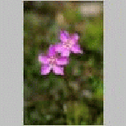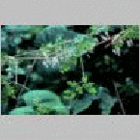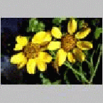
Talinum teretifolium
Quill fame flower
Adlumia fungosa
Allegheny vine or climbing fumitory
Smallanthus uvedalius
Hairy leafcup

Community types:

Habitat types listed by Schmaltzer (1985) that are pertinent to the present study are Xeric upland oak or oak-pine forests, Sandstone cliffs and rockhouses, Sandstone boulder fields, Wet sandstone or shale cliffs and Sandstone outcrops. The community descriptions below are directly taken or paraphrased from Schamaltzer (1985).

Xeric upland oak or oak-pine forests are dominated by Quercus alba, Q. prinus, and Pinus stobus with Carya spp. and other taxa occurring on middle to upper slopes. Typical herbs include Geranium maculatum, Solidago caesia, Bromus pubescens, and Agrostis perennans.

Sandstone cliffs and rockhouses form unique plant habitats. Plants restricted to these sites include Heuchera parviflora and Silene rotundifolia.

Sandstone boulder fields in certain areas are extensive and have developed on gorge slopes. When these are on south-facing slopes, the canopy vegetation is composed of Quercus prinus and Q. alba. Herbaceous plants restricted to these sites include Adlumia fungosa and Polymnia laevigata (now known under the synonym Smallanthus uvedalius).

Wet sandstone or shale cliffs are kept moist by seepage and form a habitat distinct from the more common dry sandstone cliffs. Plants restricted to these sites include Thalictrum clavatum and Cystoperis protrusa.

Sandstone outcrops occur where exposed sandstone bedrock occurs near some cliff-edges. Deeper pockets of soil on the outcrop support dwarf Pinus virginiana, shrubs (e.g., Gaylussacia baccata, Kalmia latifolia, Sorbus arbutifollia), grasses (e.g., Chasmanthium laxum, Danthonia compressa, D. sericea), and forbs (e.g., Liatris microcephala). Shallow pockets of soil support the outcrop plants, Arenaria glabra and Talinum teretifolium. Vegetation of Cumberland Plateau sandstone outcrops has been considered in detail by Perkins (1981).

Species of special interest:

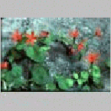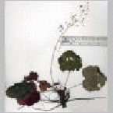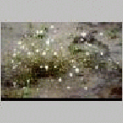
Silene rotundifolia
Roundleaf catchfly

Heuchera parviflora
Littleflower alumroot

Arenaria glabra
Appalachian Sandwort

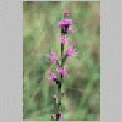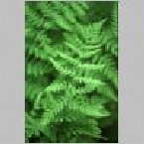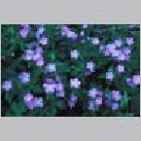
Liatris microcephala
Smallhead blazing star
Cystopteris protrusa
Lowland bladder fern
Geranium maculatum
Wild geranium

Cliff-face ecology

Definition of Cliff Faces:

While there is no critical angle that delineates cliff faces from other topographical features climbers often describe a face as a surface needing at least three points of contact for a human to stabilize themselves. Slope angles of cliffs may range from the 180º surface of an underhang to vertical 90º are all considered cliff features. Slopes less than 90º are usually not considered cliffs (Larson 2000).

Physical features

The various units of a cliff area are referred to as the plateau, cliff face, and talus. In this study we will refer to the plateau as cliff edge. Soils are thin to absent. Rooting space for plants in limited. Cliff faces are buffered from direct insolation, talus is usually more shaded and cliff edge may be open or under canopy.

Flora

Cliff face vegetation has been insulated from human impact and natural and anthropogenic fires through the course of most of human history. The vegetation may often be composed of elements of surrounding plant communities but may also consist of glacial relicts and species otherwise impacted by humans and domesticated animals on the rest of the landscape. Certain species reoccur on cliff faces throughout the temperate zone, regardless of hemisphere, especially ferns, lichens and mosses. For example several species of Asplenium are found on cliff faces both in North America and in Europe. Likewise Pellaea and Polypodium ferns are frequently found on cliffs. Oaks and a variety of conifers such as Juniperus, Thuja, Taxus and Pinus reoccur on temperate cliff faces.

Ancient trees

What have been described as old-growth forests or ancient stands of trees have been found on cliff faces throughout the temperate region (Larson and Kelly 1991, Larson et al. 2000). Trees in excess of a thousand years in age have been found in several cliff faces throughout the world.

Fauna

Cliff faces serve as roosts for many species of birds. There have been relatively few studies done on fauna, other than birds, on cliff faces. Microarthropods were examined in leaf litter on the ledges of cliff faces in Linville Gorge, N.C. (Plezewski, 2003).

Human Impacts on Cliff Faces:

Until recently cliff faces have been relatively unimpacted by humans other than for mining operations. But in the past few decades rock climbing has become a popular sport throughout the western world. A few studies have been conducted on the impacts of cliff-face vegetation by climbers (McMillan, 2000, Smith P. 1998, Camp, R.J. and Knight, R.L. 1998, Larson, D.W. and Kelly, P.E. 1997, Nuzzo, V.A. 1995). In each study climbing has been described as having a detrimental effect on cliff-face vegetation to varying extents. Disturbance has included a reduction of vegetational cover, shifts in lichen community composition, the local extirpation of species sensitive to disturbance and skewed size and age distributions of some vascular plants. Few of these studies has considered the impact of the physical environment on species composition. Nuzzo, V.A. (1995) was criticized for not considering the impact of overhangs on cliff face vegetation with regard to rock climbing disturbance (Larson, D.W. 2000).

Methods and Materials

Site Descriptions

Within the Obed National Wild and Scenic River, six major climbing areas were sampled. These include the Lilly Bluffs, the Lilly Boulders, North Clear Creek, South Clear Creek, the Obed Wall, and the Y12 Wall. These areas are located along the Obed River and Clear Creek.
The Lilly Bluffs climbing area, located on the south side of Clear Creek opposite the Lilly Bridge parking area, is a north-east facing cliff band approximately twenty to thirty meters in height. There are forty-two bolted sport climbing routes on this cliff band (Watford 1999). The base of the cliff is surrounded by hemlock forest that includes Betula lenta, Liriodendron tulipifera, Rhododendron maximum, and others. The plateau above the cliff line is characterized by hemlock and subxeric oak forests (Tsuga canadensis, Quercus alba, Q. prinus, Carya spp.)
The Lilly Boulders area is situated uphill from the Lilly Bridge, past the Lilly Bluffs, on the right side of the road. It consists of a long low band of rock surrounded by numerous boulders, which are scattered among mesic deciduous and hemlock forest. The tops of these boulders are covered in thick mats of soil, bryophytes, lichens, and vascular plants. A network of trails provides access to the boulders.
The North and South Clear Creek climbing areas are located on the north-east side of Clear Creek, which is accessed via a privately owned parking area and trailhead off Doc Howard Road. The portion of the cliff band that is designated North Clear Creek lies north of an obvious oxbow in the creek, and the portion below the oxbow is designated South Clear. These cliffs are south or south-west facing and are an average of thirty meters high. The surrounding forest may be described as xeric upland oak forest or oak-pine forest, including Quercus alba, Quercus coccinea, and Pinus virginiana (Schmalzer et al. 1985).
The Y12 Wall is located on the south-west side of Clear Creek, directly across the creek from the point between the North and South Clear Creek climbing areas. The Y12 is accessed from the Lilly Bluff overlook parking area via the Point Trail and rope ladders leading from the plateau down to the talus. This steep, north-facing section of cliff-band is perennially shady and moist. This area is characterized by mesic deciduous forest and hemlock forest.
The Obed Wall climbing area is located in the Obed River gorge on the north side of the river, just above the confluence of the Obed River and Clear Creek. It is the most remote of all the areas in the study. This south-facing cliff-line, which is approximately twenty to thirty meters tall, is surrounded by xeric oak and oak-pine forests.

Transect and Quadrat Construction

A climbing guidebook (Watford 1999) was used to assign numbers to all the routes in each of the six climbing areas described above, and a random number table was used to choose three climbing routes from each site. For each climbed transect chosen, an unclimbed transect was designated directly adjacent to it and marked with biodegradable lawn paint. Therefore, three climbed and three unclimbed transects were chosen for each area, for a total of 36 transects. Due to time constraints in the fall, we combined North and South Clear Creek, only sampling four transects (two climbed, two unclimbed) at North Clear and two (one climbed and one unclimbed) at South Clear. In addition, we were only able to complete four transects at the Y12 Wall (two climbed and two unclimbed).
Using the rappel rope as the center line, we sampled from a 1 m² quadrat on each side of the rope (one plot to the left of the rope and one to the right of the rope, labeled A and B, respectively), at three meter intervals along the face of the cliff. Therefore, the number of face plots sampled per transect varied with the height of the cliffs. The quadrat was constructed of one-half inch PVC pipe and nylon twine. The nylon twine was threaded through holes drilled in the pipe so that it formed a five-by-five grid of subplots within the quadrat, each of which represented four percent of the area of the quadrat. The talus was always sampled using two pairs of plots; one pair was located directly adjacent to the cliff face at the base of the cliff and the second pair was located between four and five meters away from the cliff base. The plateau (edge) was sampled in a similar manner, with a pair of plots located on the edge of the plateau, directly adjacent to the top of the cliff face, and another pair between four and five meters straight back from the edge. Each of these were labeled A (left of transect) and B (right of transect).

Climbing Equipment

Sixty meter rock climbing ropes were used in conjunction with climbing harnesses, grigris, webbing, carabiners, quickdraws, ‘frogs’, and helmets to access the cliff faces. In some cases the system was secured to an anchor on the plateau, such as a large tree, and the cliff face was accessed by rappelling down from the top. In areas where access to the plateau was difficult, the system was set up from the talus area. In these instances an experienced climber climbed the cliff face and either placed the rope along the climbing route using quickdraws, which were clipped to the bolts in the rock, or, in the case of an unclimbed transect, placed traditional climbing protection pieces called cams, along with quickdraws, as they ascended the cliff. A grigri was used as a braking system when rappelling down from the tops of the cliffs, and an ascender (also called a Jumar) was used to move up the rope from the bases of the cliffs. ‘Frogs’, a relatively new type of protection used in traditional climbing, were attached to a two meter pole and used in areas where the cliff face was overhung in order to pull the researcher closer in to the face. In addition, an extra rope was secured to an anchor and attached to the researcher as a safety line. All sampling equipment was attached to the researcher’s climbing harness with carabiners.

Sampling Technique

In each plot, each species present was described and the percent of the plot that it covered was recorded. Species that covered less than one percent of the plot were recorded as less than one percent. In addition, environmental data including aspect, slope, surface heterogeneity of the rock face, presence or absence of temporary or perennial seeps, presence or absence of overhanging roofs, relative amount of visibly evident disturbance (chalk, soil compaction, etc.) and cliff area (edge, face, or talus) were recorded for each plot.

Processing of Plant Samples

All vascular plant, bryophyte, and lichen species that occurred in plots were collected in the field and placed in a plant press (vascular) or a paper bag (bryophytes and lichens) in the field. All specimens were dried in a drying cabinet for at least one week. Plants were identified using the nomenclature of Wofford (1989) and Radford (1968) and by consulting specimens in the vascular plant herbarium at Appalachian State University. Moss and liverwort identification was performed by Keith Bowman according to the nomenclature of Stotler and Crandall-Stotler (1977) and Anderson et al. (1990) . Lichen specimens were identified by Karen Ritchie according to the nomenclature of Kirk et al. (2004).

Statistical Analysis

All data were entered into an excel spreadsheet. Detrended Correspondence Analysis (DCA) was performed, followed by Canonical Correspondence Analysis (CCA), by Dr. Uta Matthes, Ph.D., using CANOCO© statistical software. Analyses were performed on the entire data set as a whole (referred to as the large data set), on each of the face, edge, and talus data sets alone, and on each of the six sites separately.

Ancient Tree Analysis

Two stands of ancient Eastern red cedar trees (Juniperus virginiana L.) were found in the talus areas of both the North Clear Creek climbing area and the Obed Wall climbing area. Preliminary sampling of the North Clear Creek stand consisted of the removal of a section of a large snag using a small pruning saw. The section was sanded and then the rings were counted in the field using a 10x hand lens, yielding approximately eight-hundred annual rings. The snag section was then brought to the dendrochronology lab at Appalachian State University, Department of Geography and Planning, and was found to have eight-hundred sixty-three annual rings. That finding prompted subsequent increment coring of five different living trees, two from the Obed Wall talus and three from the North Clear Creek talus. The extracted cores were placed in drinking straws and brought to the dendrochronology lab at Appalachian State University, Department of Geography and Planning.
Dendrochronological analysis was performed by Ms. Leslie Morefield. Each core was mounted in a core tray with wood glue, which was then placed in a vice for sanding. Cores were sanded down using at least three grades of sand paper: coarse (320), fine (P400), and extra fine (15µ). Core samples were then rubbed with natural wool, which leaves a film of lanolin on the wood, which in turn renders the annual growth rings more easily distinguishable. Next, the rings were counted by hand using a National® brand biocular dissecting microscope. Years for each core were placed in a spreadsheet and especially wide or narrow ring years were noted. During manual counting, dots were placed on the wood using a pencil to indicate decade, fifty year, and one-hundred year increments of annual growth rings. After manual counting, the cores were cross-dated and their annual growth-rings measured using a dissecting microscope connected to a computer equipped with Measure J2X © software. This process involves centering the microscope crosshairs on the edge of an annual growth ring, pushing a button, and then moving to the next ring edge and pushing the button again. This allows the computer to record width, to cross-reference the different trees, and to calculate the variance between years.

Results

CCA of Large Data Set

Climbing and disturbance were statistically significant factors influencing the vegetation in the large data set. However, they were the second and third least significant variables of those measured. Disturbance was highest in talus plots, regardless of climbing status. Habitat, site, and the presence of a roof were also significant variables organizing the vegetation (Table 1). The presence of a seep was insignificant. Habitat was the most important variable accounting for variation in the vegetation, with the edge habitat having the most unique community assemblage. Site was the next most important variable, indicating that the vegetation varies between the six sites sampled.

Table 1. CCA of Large Data Set
Variable | P | F
Edge | 0.002 | 7.81
SCC | 0.002 | 5.08
OBE | 0.002 | 5.01
Roof | 0.002 | 4.94
Face | 0.002 | 3.80
LBO | 0.002 | 3.19
LBL | 0.002 | 3.57
NCC | 0.002 | 2.67
Seep | 0.130 | 1.40
Climbing | 0.030 | 1.31
Disturbance | 0.002 | 1.95

CCA of Face Data Set

Climbing and disturbance were insignificant for the cliff-face data set (Table 2). Site, the presence of a roof, vertical position, and the north-south component of aspect were all statistically significant variables organizing the cliff-face vegetation. Of the six sites that were sampled, the South Clear Creek site had the most unique community assemblage. The east-west component of aspect, the presence of a seep, slope, and surface heterogeneity were all insignificant for the cliff faces. Since site differences were the most important factor accounting for variation in the vegetation on the cliff faces, a second run of the CCA was performed on the face data set, in which sites were defined as covariables. This allows us to answer the question, ‘Once differences among sites are accounted for, how much of the remaining variation in the vegetation can be accounted for by the variables measured?’ For the second run, the north-south component of aspect,

Table 3. CCA of Face Data Set (Run 2)
Variable | P | F
Northness | 0.002 | 5.62
Position | 0.002 | 3.50
Roof | 0.008 | 3.53
Eastness | 0.002 | 3.48
Seep | 0.150 | 1.56
Slope | 0.022 | 1.48
Climbing | 0.326 | 0.96
Disturbance | 0.462 | 0.93
Surfacehet | 0.602 | 0.80
Table 2. CCA of Face Data Set (Run 1)
Variable | P | F
SCC | 0.002 | 7.99
Roof | 0.002 | 6.29
OBE | 0.002 | 5.71
Y12 | 0.002 | 4.39
Position | 0.002 | 4.39
Northness | 0.002 | 3.45
LBL | 0.002 | 3.45
LBO | 0.002 | 2.95

vertical position, the presence of a roof, the east-west component of aspect, and slope were all significant (Table 3). The presence of a seep, climbing, disturbance, and surface heterogeneity were all insignificant. However, it is important to note that the eigenvalues were much lower for the second run, meaning that once variation among sites is removed, the remaining variables have relatively less influence on the vegetation.

CCA of Face Data Set – Vascular Plants Only

Climbing and disturbance were insignificant variables for cliff-face vascular plants. The north-south and east-west components of aspect were the most important variables influencing the distribution of vascular plants on the cliff faces, followed by site differences (Table 4). Several variables were omitted due to negligible variance. These include roof, the Lilly Boulders site (LBO), and the North Clear Creek site (NCC). This is because there were no vascular plants on the cliff faces beneath roofs, nor on the cliff faces sampled at Lilly Boulders and North Clear Creek.

Table 4. CCA of Face Data Set - Vascular Plants Only
Variable | P | F
Northness | 0.002 | 2.84
Eastness | 0.002 | 2.29
Slope | 0.076 | 2.07
SCC | 0.028 | 1.85
OBE | 0.008 | 1.87
LBL | 0.092 | 1.86
Disturbance | 0.070 | 1.78
Position | 0.132 | 1.42
Climbing | 0.366 | 1.07
Seep | 0.446 | 1.03
Surfacehet | 0.442 | 1.06

CCA of Face Data Set – Bryophytes Only

Climbing was not a significant influence on bryophyte distribution on the cliff faces. Site, both the north-south component and the east-west component of aspect, disturbance, slope, surface heterogeneity, the presence of a seep, and vertical position on the face were all statistically significant variables organizing the bryophyte communities on the cliff faces (Table 5). The Y12 site had the most unique assemblage of bryophyte species, followed by the Lilly Boulders site.

Table 5. CCA of Face Data Set - Bryophytes Only |  |  |  | Table 6. CCA of Face Data Set - Lichens Only
Variable | P | F |  | Variable | P | F
Y12 | 0.002 | 6.10 |  | SCC | 0.002 | 15.53
Northness | 0.002 | 5.60 |  | Roof | 0.002 | 12.65
LBO | 0.002 | 5.77 |  | OBE | 0.002 | 10.36
Disturbance | 0.004 | 3.48 |  | Position | 0.002 | 9.69
OBE | 0.018 | 2.56 |  | Y12 | 0.002 | 8.27
Slope | 0.008 | 2.12 |  | Northness | 0.002 | 5.72
Surfacehet | 0.016 | 1.96 |  | LBL | 0.002 | 5.53
LBL | 0.044 | 1.90 |  | LBO | 0.002 | 4.27
Eastness | 0.004 | 2.86 |  | Slope | 0.042 | 2.11
Seep | 0.002 | 3.32 |  | Climbing | 0.016 | 2.10
Position | 0.016 | 1.95 |  | Seep | 0.084 | 1.93
Climbing | 0.358 | 1.06 |  | Eastness | 0.136 | 1.72
NCC | 0.974 | 0.26 |  | Disturbance | 0.172 | 1.41
 |  |  |  | Surfacehet | 0.270 | 1.26

CCA of Face Data Set – Lichens Only

Climbing had a statistically significant influence on cliff-face lichens (Table 6). Disturbance was insignificant. Site, the presence of a roof, vertical position on the face, and the north-south component of aspect were all significant variables influencing lichen distribution on the cliff faces. Slope was marginally significant. The presence of a seep, the east-west component of aspect, and surface heterogeneity were all insignificant for cliff-face lichens.

CCA of Edge Data Set

Climbing was statistically insignificant for the top edges of the cliffs sampled (Table 7). Disturbance, however, was a significant factor accounting for variation in edge vegetation distribution. Site was the most important variable accounting for differences in edge vegetation, with the Obed Wall (OBE) site having the most unique species composition. The presence of a seep was insignificant. Eigenvalues for this analysis were slightly lower than those for the other data sets, meaning that less of the variation in edge vegetation can be explained by the variables measured. A second run of the CCA of edge data was conducted, with sites defined as covariables. Once variation among sites was accounted for, disturbance and the presence of a seep were the most important variables (Table 8). However, since the eigenvalues for the second run of the CCA were very low, these variables actually have a minimal influence on the vegetation. Climbing remained insignificant.

Table 7. CCA of Edge Data Set |  |  |  | Table 8. CCA of Edge Data Set (Run 2)
Variable | P | F |  | Variable | P | F
OBE | 0.002 | 3.08 |  | Disturbance | 0.018 | 1.70
NCC | 0.002 | 2.85 |  | Seep | 0.014 | 1.31
LBL | 0.002 | 2.34 |  | Climbing | 0.120 | 1.13
LBO | 0.006 | 2.32
Disturbance | 0.004 | 1.70
Seep | 0.144 | 1.31
Climbing | 0.240 | 1.13

CCA of Talus Data Set

Disturbance was the second most important variable influencing talus vegetation (Table 9). Climbing was also significant for the talus, though it was the least important significant variable measured. Site was the most important significant variable for the talus. The presence of a seep was also significant. A second run of the CCA for the talus was conducted to account for site variation. Once sites were defined as covariables, the presence of a seep and disturbance were the most important variables accounting for variation in the talus vegetation (Table 10). Climbing remained an insignificant influence on talus vegetation.

Table 9. CCA of Talus Data Set |  |  |  | Table 10. CCA of Talus Data Set (Run 2)
Variable | P | F |  | Variable | P | F
LBO | 0.016 | 1.98 |  | Seep | 0.002 | 1.67
Y12 | 0.006 | 1.97 |  | Disturbance | 0.010 | 1.38
Disturbance | 0.002 | 1.95 |  | Climbing | 0.086 | 1.31
OBE | 0.002 | 1.94
Seep | 0.002 | 1.91
LBL | 0.002 | 1.87
Climbing | 0.006 | 1.59

CCA of Individual Sites

Since the vegetation of the Obed cliffs is fairly site specific, we ran CCA analyses on each of the six sites individually. These analyses were conducted on the cliff-face data for each site (edge and talus data were excluded). Both the north-south and east-west components of aspect, as well as the presence of seeps were excluded from individual site analyses because they have high variance inflation factors.

Lilly Bluffs

Climbing and disturbance were insignificant for the Lilly Bluffs face data set (Table 11). Slope, the only significant variable for Lilly Bluffs, was only marginally significant. Vertical position on the cliff face and surface heterogeneity were both insignificant.

Lilly Boulders

Climbing was statistically insignificant for the Lilly Boulders site (Table 12). Disturbance was the most important significant variable measured, although the eigenvalues for this analysis were very low. This is primarily due to low sample size, since there were only a total of twenty-five face samples for the Lilly Boulders site. Slope was marginally significant. Vertical position and surface heterogeneity were insignificant for the Lilly Boulders.

Table 11. CCA of LBL Face Data Set |  |  |  | Table 12. CCA of LBO Face Data Set
Variable | P | F |  | Variable | P | F
Slope | 0.03 | 2.04 |  | Disturbance | 0.036 | 2.15
Position | 0.144 | 1.34 |  | Slope | 0.048 | 1.93
Surfacehet | 0.73 | 0.66 |  | Position | 0.506 | 0.91
Climbing | 0.588 | 0.84 |  | Surfacehet | 0.694 | 0.70
Disturbance | 0.174 | 1.43 |  | Climbing | 0.786 | 0.55

North Clear Creek

Both climbing and disturbance were statistically significant for the North Clear Creek site (Table 13). Although climbing is not included in the forward selection table for this analysis, it has a 1.0 correlation with disturbance, meaning these two variables are identical for this site. Slope is the most important variable accounting for variation in the vegetation on the cliff faces at North Clear Creek, followed by disturbance (and climbing). The eigenvalues for the first two axes of the CCA are high enough for these results to be considered reliable. Vertical position on the face was also significant for North Clear Creek. Surface heterogeneity was insignificant.

Table 13. CCA of NCC Face Data Set |  |  |  | Table 14. CCA of SCC Face Data Set
Variable | P | F |  | Variable | P | F
Slope | 0.002 | 4.40 |  | Surfacehet | 0.012 | 2.70
Disturbance | 0.004 | 4.31 |  | Disturbance | 0.004 | 2.53
Position | 0.002 | 4.09 |  | Slope | 0.03 | 1.91
Surfacehet | 0.77 | 0.54 |  | Postion | 0.012 | 1.91
 |  |  |  | Climbing | 0.23 | 1.33

South Clear Creek

Disturbance was the second most important significant variable
organizing the cliff-face vegetation at South Clear Creek (Table 14). Although climbing was insignificant according to the forward selection results, it is highly correlated with disturbance. Surface heterogeneity was the most important significant variable for the South Clear Creek site, followed by disturbance, slope, and vertical position on the face. The first two axes of the CCA have acceptable eigenvalues.

Obed Wall

Climbing was significant for the Obed Wall site, and was the second most important variable influencing the distribution of cliff-face vegetation there (Table 15). Vertical position on the face was the most important variable. Disturbance was marginally significant. Surface heterogeneity and slope were both insignificant. The first axis eigenvalue is fairly high and the second axis eigenvalue is still respectable.

Table 15. CCA of OBE Face Data Set |  |  |  | Table 16. CCA of Y12 Face Data Set
Variable | P | F |  | Variable | P | F
Position | 0.002 | 2.54 |  | Disturbance | 0.002 | 4.82
Climbing | 0.008 | 2.33 |  | Climbing | 0.002 | 4.43
Disturbance | 0.048 | 2.03 |  | Slope | 0.044 | 1.88
Surfacehet | 0.788 | 0.66 |  | Position | 0.354 | 1.12
Slope | 0.746 | 0.52 |  | Surfacehet | 0.654 | 0.72

Y12

Disturbance and climbing were the two most important variables accounting for variation in the cliff-face vegetation at the Y12 site (Table 16). Slope was marginally significant. Vertical position on the face and surface heterogeneity were insignificant for the Y12 site. The first axis eigenvalue is fairly high but the other three are quite low.

Discussion

Habitat (edge, face, or talus) and site were by far the most important variables accounting for variation in the vegetation in the large data set, indicating that the vegetative communities in each habitat are distinct, and that the communities differ between the six sites. The variation in species composition between habitats is illustrated by the ordination attribute plots for habitat (Fig. 1, 2, and 3). The clustering of points within each habitat demonstrates the relative similarity of species composition within a particular habitat, as well as the dissimilarity between habitats. By comparing figure 1 with figures 2 and 3, it is evident that the plots separate out across the first axis based on habitat type, and that edge habitats are the most unique with respect to species composition, since the edge cluster is further away from the other two clusters (face and talus plots). This is also supported by the forward selection results, in which the edge habitat had the highest F-value (Table 1).
The edge habitat also had the highest species richness, which can be seen by comparing figure 1 with figure 4. In the species richness diagram (fig. 4), each point represents a sample plot and the size of the point corresponds to the number of species in

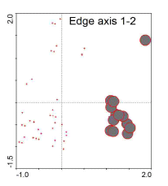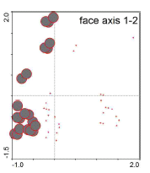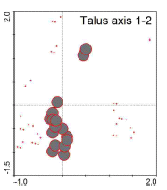
Fig. 1.Large data set edge habitat attribute plot
(Axis 1, 2)
Fig. 2. Large data set face habitat attribute plot
(Axis 1, 2)
Fig. 3. Large data set talus habitat attribute plot
(Axis 1, 2)

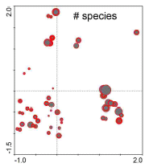
Fig. 4. Large data set species richness attribute plot (Axis 1, 2)

that plot. Most of the plots with the highest species richness are clustered together in the lower right quadrant of the diagram in figure 4, which corresponds to the edge plots shown in figure 1.
According to the forward selection results for the large data set, site was the second most important variable organizing the vegetation. This means that the Obed cliff vegetation is fairly site-specific. This trend can be seen in the attribute plots for the individual sites, in which the plots from each site seem to separate out on the second axis. (Fig. 5-10). Plots within each site are clustered closely together and away from the plots from other sites. The separation of plots from different habitats across axis 1 can also be seen in the site diagrams.
Fig. 1. Edge attribute plot
Fig. 1. Edge attribute plot
Although climbing and disturbance were statistically significant variables according to the forward selection results (Table 1), they were the least influential of the significant variables, and examination of the ordination attribute plots for these variables
reveals no clear pattern (Fig. 11 and 12). This can be interpreted to mean that, for the
large data set at least, variation in the vegetation among sample plots is not correlated to the climbing status (climbed or unclimbed) or the observed level of disturbance in those plots.
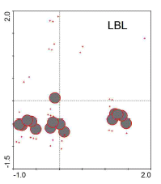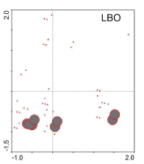
Fig. 5. Lilly Bluffs attribute plot - large data set (Axis 1,2)
Fig. 6. Lilly Boulders attribute plot - large data set (Axis 1,2)

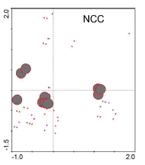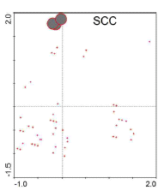
Fig. 7. North Clear Creek attribute plot - large data set (Axis 1,2)
Fig. 8. South Clear Creek attribute plot – large data set (Axis 1,2)

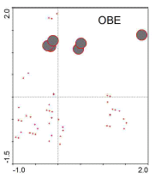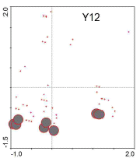
Fig. 10. Y12 attribute plot – large data set (Axis 1,2)
Fig. 9. Obed Wall attribute plot – large data set
(Axis 1,2)

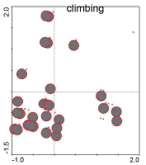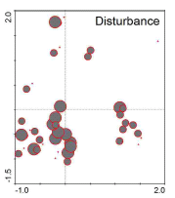
Fig. 11. Climbing attribute plot (Axis 1,2)
Fig. 12. Disturbance attribute plot (Axis 1,2)

Since habitat was the most important variable accounting for variation in the vegetation in the large data set, we conducted CCA analysis on each habitat type individually, beginning with the cliff-face plots only (face data set). Site was the most important significant variable for the face data set, meaning that most of the variation in cliff-face vegetation can be attributed to differences between the six sites (Table 2). The South Clear Creek (SCC) site had the most unique community assemblage, as indicated by its F-value relative to the other significant variables. The variability between sites is reiterated by the attribute plots for individual sites in the face data set (Fig. 13-18), in which the plots within any particular site are tightly clustered together.

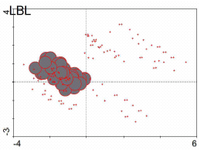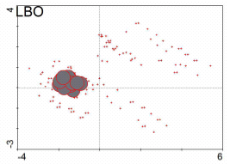
Fig. 13. Lilly Bluffs attribute plot – face data set (Axis 1, 2)

Fig. 14. Lilly Boulders attribute plot – face data set (Axis 1, 2)

Fig. 1. Edge attribute plot

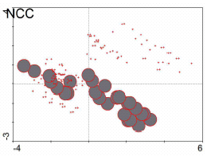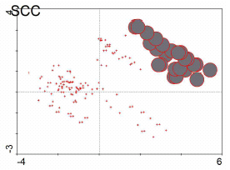
Fig. 15. North Clear Creek attribute plot – face data set (Axis 1, 2)

Fig. 16. South Clear Creek attribute plot – face data set (Axis 1, 2)

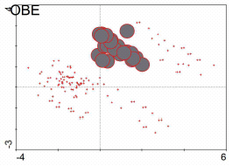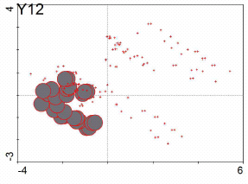
Fig. 17. Obed Wall attribute plot – face data set (Axis 1, 2)

Fig. 18. Y12 attribute plot – face data set
(Axis 1, 2)

The presence of an overhang (roof) was the second most important significant variable accounting for variation in the cliff-face vegetation. By comparing the attribute plots for roofs (fig. 19) and for species richness (fig. 20), it is clear that the plots occurring beneath an overhang have the lowest species richness.

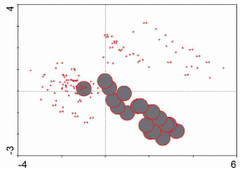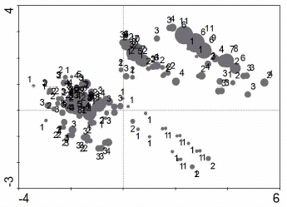
Fig. 19. Roof attribute plot – face data set
(Axis 1, 2)

Fig. 20. Species richness attribute plot – face data set (Axis 1, 2)

The second run of the face data set CCA allowed us to ask the question, ‘once variation among sites is accounted for, how much of the remaining variation in the vegetation is due to the other variables measured?’ Since the eigenvalues are notably lower for the second run, we may conclude that a large portion of the variation in the cliff-face vegetation is due to variation among sites. However, these eigenvalues are still considered respectable by statisticians, and the next two most important variables influencing the cliff-face vegetation are the north-south component of aspect (called northness) and the vertical position on the face. This indicates that species composition on the cliff faces differs between north- and south-facing areas and from the bottom to the top of the faces. This is further supported by the ordination diagram of environmental variables (fig. 21), in which northness seems to be correlated with axis 1 (the most important gradient) and vertical position with axis 2 (the second most important gradient).
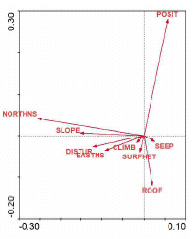
Fig. 21. Environmental variables ordination diagram – face data set
(Axis 1, 2)

Based on the forward selection results and ordination diagrams for the face data set, it is quite clear that climbing and disturbance are among the least important factors influencing species composition in the vertical cliff-face habitat. The attribute plots for climbing (fig. 22) and disturbance (fig. 23) on the cliff faces show no discernible pattern, indicating that changes in species composition are not correlated with climbing or disturbance.
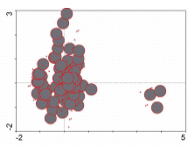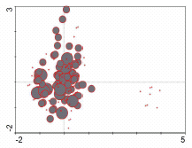
Fig. 22. Climbing attribute plot – face data set run 2 (Axis 1, 2)

Fig. 23. Disturbance attribute plot – face data set run 2 (Axis 1, 2)

CCA was also conducted on the face data set for individual vegetation types (vascular plants, bryophytes, and lichens). Climbing and disturbance were insignificant for cliff-face vascular plants, suggesting that there is no difference in vascular plant species composition or species richness between climbed and unclimbed cliff faces.
Aspect is the most important variable influencing the distribution of vascular plants on cliffs, even more important than variation among sites, and both the north-south and east-west components are significant. This result differs from the analysis for the large data set, indicating that aspect is more important in determining vascular plant community composition than it is in determining the composition of the vegetation as a whole, and that vascular plants are relatively more similar among sites than the vegetation as a whole. Comparison of the attribute plot for cliff-face vascular plant species richness (fig. 24) and the environmental variables diagram (fig. 25) appear to indicate that vascular plant species richness is higher in the south-facing plots.

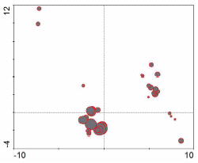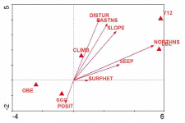
Fig. 24. Species richness attribute plot – face data set vascular plants only (Axis 1, 2)

Fig. 25. Environmental variables ordination diagram – face data set vascular plants only (Axis 1, 2)

Climbing was not a significant influence on bryophyte communities on the cliff faces, but the level of disturbance was significant in this analysis. Since the amount of climber traffic is highly variable between routes, a categorical value of anthropogenic disturbance was assigned to each plot, in an attempt to assess the intensity of climbing (this also allowed us to assess impacts in the talus where disturbance is not restricted to areas directly beneath a climbed route). The attribute plots for bryophyte species richness on the faces (fig. 26) and for disturbance on the faces (fig. 27) seem to indicate fewer bryophyte species in the most disturbed plots. However, it remains unclear if these differences in species richness are actually correlated with disturbance level or if the pattern is merely an artifact of variation among sites.

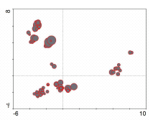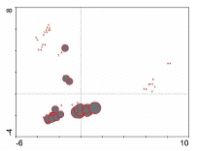
Fig. 26. Species richness attribute plot – face data set bryophytes only (Axis 1, 2)

Fig. 27. Disturbance attribute plot – face data set bryophytes only
(Axis 1, 2)

Site was the most important variable for cliff-face bryophytes, and the site attribute plots for bryophytes indicate that they are the most site-specific type of vegetation there, since plots within sites are clustered very tightly and far apart from those from other sites (fig. 28-33). The Y12 site had the most unique bryophyte community assemblage, as indicated by the forward selection results. Northness was the second most important variable influencing bryophyte distribution on the cliff faces, indicating that bryophyte community composition is also driven by aspect.

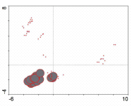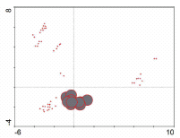
Fig. 28. Lilly Bluffs attribute plot – face data set bryophytes only
(Axis 1, 2)

Fig. 29. Lilly Boulders attribute plot – face data set bryophytes only
(Axis 1, 2)

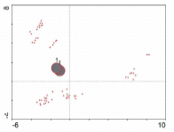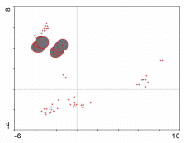
Fig. 30. North Clear Creek attribute plot – face data set bryophytes only
(Axis 1, 2)

Fig. 31. South Clear Creek attribute plot – face data set bryophytes only
(Axis 1, 2)

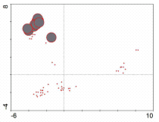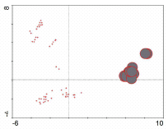
Fig. 32. Obed Wall attribute plot – face data set bryophytes only
(Axis 1, 2)

Fig. 33. Y12 attribute plot – face data set bryophytes only
(Axis 1, 2)

Climbing was a statistically significant variable influencing the cliff-face lichen communities of the Obed. However, it was the fifth most important significant variable for lichens, suggesting that its influence on lichen distribution and species composition is low relative to the other variables (Table 9). The cliff-face lichen attribute plots for climbing reveal no obvious pattern, with the exception that the unclimbed plots/transects (the small points on the diagrams) seem to lie above the climbed plots/transects (large circles) (fig. 34 and 35). This is suggestive of a slight shift in lichen species composition in response to climbing.

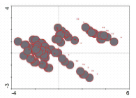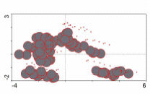
Fig. 34. Climbing attribute plot – face data set lichens only (Axis 1, 2)

Fig. 35. Climbing attribute plot – face data set lichens only (Axis 1, 3)

Site was again the most influential variable for cliff-face lichens, meaning that lichen species composition varies between sites. Roof was the second most important variable accounting for variation in lichen distribution and species composition on the cliff faces, and the lichen attribute plots for roof (fig. 36) and for species richness (fig. 37) clearly show that lichen species richness is lowest in plots beneath an overhang/roof.

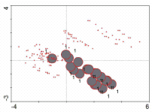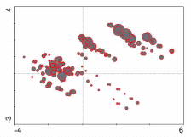
Fig. 36. Roof attribute plot – face data set lichens only (Axis 1, 2)

Fig. 37. Species richness attribute plot – face data set lichens only (Axis 1, 2)

The insignificance of climbing for the edge data set was expected due to the ‘no top-out’ policy. Disturbance, however, was statistically significant for the edge habitat, indicating that the edge vegetative communities, which are the most unique with respect to species composition, are sensitive to disturbance. These areas have very thin soils that require long periods of time to accumulate, so it is not surprising that the vegetation there is quite intolerant of disturbance in the form of trampling. The high levels of disturbance observed at a few of the edge sites (e.g. North Clear Creek) can most likely be attributed to hikers seeking a nice view rather than to climbing. The only threatened plant species observed, Talinum teretifolium, a state threatened species in Tennessee, occurs on the edge habitat above the Lilly Bluffs climbing area, which is mostly protected from trampling thanks to the no top-out policy and the boardwalk at the overlook area. Site was the most important influence on edge community composition, again indicating that the vegetation in this habitat type is site-specific. When the analysis was conducted a second time with sites defined as covariables, disturbance became the most important variable accounting for variation in the edge vegetation, supporting the conclusion that cliff-edge vegetation is quite sensitive to disturbance. However, the eigenvalues for the second run of the edge data set CCA are very low, indicating that most of the variation in edge species composition is attributable to site differences.
The results for the talus are similar, since site was the most important variable organizing the vegetation, followed by disturbance. Climbing was insignificant for the talus, which makes sense because impacts in the talus are not restricted to areas directly beneath a climbing route. Climbers and non-climbing hikers alike walk along the cliff bands in the talus areas, so many talus plots that were sampled along an ‘unclimbed’ transect were actually impacted by climbers and/or hikers. This was one of the reasons for recording the level of disturbance in addition to the climbing status for each sample plot. Sites were defined as covariables in the second run of the edge data set CCA, with the result that disturbance became the most important variable influencing the distribution of vegetation in the talus. However, it must be noted that the eigenvalues are very low for the second run of the edge analysis, indicating that most of the variation was due to sites and that less was due to disturbance. Even so, disturbance remains a statistically significant factor. Climbing remained insignificant in the second run.
Since the vegetation is so consistently site-specific, CCA was performed on each site individually in an attempt to understand what drives variation in the vegetation within a given site. Climbing became significant for some of the individual site analyses, whereas it was insignificant for the data set as a whole. There are two main reasons for this. First, there are few sources of variation left in the data for an individual site. Recall that only the face plots were included in these analyses and both aspect and seep were excluded from the analysis due to high variance inflation factors, meaning they are highly correlated with site. In other words, differences in aspect and seep are related to site differences, and are therefore irrelevant to the analysis of any single site. At some sites there is little overall variation left, as indicated by low eigenvalues (e.g. Lilly Bluffs and Lilly Boulders). The CCA must use the variables supplied, so it extracts whatever little pattern there is left.
The second reason climbing appears to play a more important role in the individual sites analyses is small sample size. There are a limited number of climbed and unclimbed transects within any given site. Furthermore, the vegetation is fairly transect specific, i.e. the transects usually separate out clearly in the ordination diagrams. Therefore it is difficult to determine if any pattern with respect to climbing can truly be attributed to climbing, or if the climbed transects just happen to fall on one side of the graph and the unclimbed on the other side, by chance. If there was a general effect of climbing that applied equally at all sites, it would have shown up in the overall (large data set or whole face data set) analysis. The effect of climbing may in fact be site-specific, since the vegetation is so variable among sites and because there is considerable variation in climbing traffic among sites (e.g., less traffic at the Obed Wall, due to its considerable distance from parking).
It is safe to say that there is definitely no effect of climbing on the cliff faces at Lilly Bluffs (p = 0.588). The attribute plot for climbing at Lilly Bluffs shows no pattern; climbed plots are scattered about the diagram in no particular pattern (fig. 38). Disturbance was also insignificant there (fig. 39).
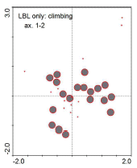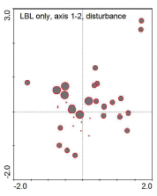
Fig. 38. Climbing attribute plot – Lilly Bluffs face data only
(Axis 1, 2)

Fig. 39. Disturbance attribute plot – Lilly Bluffs face data only
(Axis 1, 2)

There is a significant effect of disturbance at Lilly Boulders (faces only), and disturbance is highly correlated with climbing in that analysis. However, the effect of disturbance/climbing at Lilly Boulders is not convincing simply because there are two few data points. The small sample size, in conjunction with low eigenvalues, seems to suggest that climbing is not an important factor there.
The eigenvalues for North Clear Creek are much higher and disturbance and climbing, which have a correlation of 1 (meaning they are exactly the same), are significant. However, the attribute plots for North Clear Creek for the climbing/disturbance variable are unconvincing (fig. 40 and 41). There are two climbed transects and one unclimbed, and the three transects are spaced equally apart. The factor that separates the transects may be unrelated to climbing.

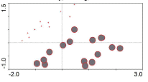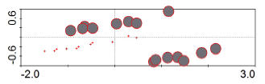
Fig. 40. Climbing attribute plot – North Clear Creek face data only
(Axis 1, 2)

Fig. 41. Climbing attribute plot – North Clear Creek face data only
(Axis 1, 3)

With three transects, there is a two in three chance that the unclimbed one will lie on either end, rather than in the middle, resulting in significance in the analysis. In the climbing attribute plot for axis 1 vs. axis 3, the transects still separate out clearly, but the unclimbed transect falls in the middle instead of on one end. This renders the significance of climbing unconvincing for the North Clear Creek site.
Although climbing was not significant for the South Clear Creek site according to the forward selection results, it is highly correlated with disturbance, which was the second most important variable driving variation in the cliff-face vegetation at South Clear Creek. The attribute plots for climbing and disturbance look nearly identical (fig. 42 and 43). However, the patterns in the attribute plot diagrams for South Clear Creek do not indicate any clear effect of climbing on the vegetation. The plots from each transect are lined up across the diagrams, but the disturbed/climbed transects are spaced as far

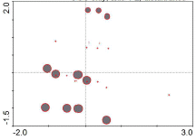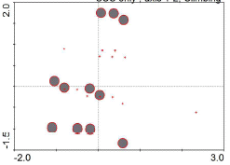
Fig. 42. Disturbance attribute plot – South Clear Creek face data only
(Axis 1, 2)

Fig. 43. Climbing attribute plot – South Clear Creek face data only
(Axis 1, 2)

apart from each other as they are from the undisturbed/unclimbed transects. This pattern could be an effect of any other unmeasured factor correlated with the location of the transect.
Climbing was also significant for the Obed Wall site analysis. The attribute plots for climbing at the Obed Wall contain three groups of sample plots (fig. 44 and 45). The groups on either end consist entirely of climbed plots and the three unclimbed transects align in the middle. This leaves the effect of climbing somewhat questionable. However, it could be argued that there is a real effect of climbing, since the climbed plots spread out all over the ordination space, but the unclimbed plots are closer together. This indicates that the climbed quadrats are more heterogeneous. In any case, there is no clear and definite trend with respect to climbing at the Obed Wall.

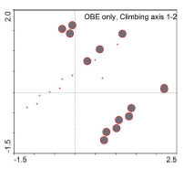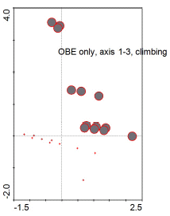
Fig. 44. Climbing attribute plot – Obed Wall face data only
(Axis 1, 2)

Fig. 45. Climbing attribute plot – Obed Wall face data only
(Axis 1, 3)

The Y12 site is similar to the Obed Wall site with respect to the climbing attribute plots: the largest group of plots in the ordination diagram are unclimbed and there are two groups of climbed plots that are spaced far apart (fig. 46 and 47). However, one of these two groups is disturbed and the other is not (see fig. 48), indicating that there is a significant effect of both climbing and disturbance at the Y12 site. Among the individual site analyses, the results for Y12 present the strongest case for arguing that climbing has an effect on the vegetation.

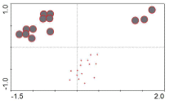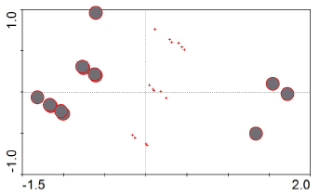
Fig. 46. Climbing attribute plot – Y12 face data only
(Axis 1, 2)

Fig. 47. Climbing attribute plot – Y12 face data only
(Axis 1, 3)

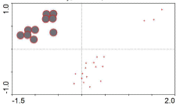
Fig. 48. Disturbance attribute plot – Y12 face data only
(Axis 1, 2)

Conclusions and Implications for Management

The Obed River gorge system is known for its high level of plant diversity. That diversity is reflected in the results of this study. One of the most important things we discovered during the course of this research is that cliff vegetation is highly heterogeneous and varies greatly from site to site, even when those sites are relatively close to one another. Due to the time-consuming nature of the field work required to study cliff vegetation, only three climbed and three unclimbed transects were measured at most of the six sites. Although 415 total plots were sampled, the individual site analyses, which were conducted because of the high level of variation in vegetative composition among sites, would benefit from a larger sample size at each site.
Another interesting and prevalent feature of the Obed cliffs is the presence of large overhangs or roofs. These areas are sought out by skilled climbers due to the challenges they present. The results of this study consistently show lower species richness for all vegetation types on the cliff faces beneath these overhangs. The lack of vegetation there is probably an effect of very low light and moisture levels, though these were not measured in this study. This finding suggests that, in terms of impact on vegetation, climbing should be of little concern in these areas.
Disturbance was a significant factor accounting for the distribution of vegetation in the talus area. The talus vegetation is visibly trampled in most areas of the six sites sampled. Since talus areas were disturbed throughout the sampling sites, regardless of the climbing status of the transect, it may be worthwhile to conduct vegetation surveys in talus areas elsewhere in the park, located away from climbing routes and hiking trails, in order to observe the truly undisturbed state of talus vegetative communities in the park.
The cliff edge habitat was found to have the most unique community assemblages. Due to the thin soils and harsh environment, many interesting plants, vascular and non-vascular, may be found there. Among them is the Tennessee state threatened plant Talinum teretifolium, the round-leaf fameflower, which grows on the edge at Lilly Bluffs. The edge environment was also quite sensitive to disturbance, but it appears that the no top-out policy is working since there was absolutely no effect of climbing in the edge habitat, and disturbed areas were relatively infrequent.
Although there seems to be a slight shift in lichen species composition on the cliff faces in response to climbing, it remains unclear exactly what that shift is. Other than that observation, we cannot confidently conclude that there is a significant effect of rock climbing on the Obed cliff vegetation as a whole. We believe this to be related to the fact that, while the Obed cliffs harbor some very interesting plant species, they are not heavily vegetated overall. However, due to the high variability among sites within the gorge and the fairly small sample sizes within each site, we cannot completely rule out the effects of climbing for all sites. We suggest that the effects of climbing are probably site-specific, since the vegetation and the amount of climbing traffic are site-specific as well, and that larger sample sizes would allow us to make a statistically sound conclusion about the impact of climbing at each site. Of the individual site analyses, the Obed Wall site and the Y12 site present the strongest evidence for an effect of climbing on the vegetation. This is interesting since these are the most remote sites included in the study and appeared to be less disturbed when compared to some of the other climbing areas.

References

Anderson, LE, HA Crum, and WR Buck. List of mosses of North America. The Bryologist. 448-499.

Bowman, K. 2003. A survey of Bryophytes in Fall Creek Falls State Park. Master’s thesis, Dept. of Botany, University of Tennessee, Knoxville, TN.

Caplenor,C.D. 1955. An annotated list of the vascular plants of the gorges of the Fall Creek Falls State Park, Tennessee, J. Tenn. Acad. Sci. 30:93-106.

Caplenor, C.D. 1979. Woody plants of the gorges of the Cumberland Plateau and adjacent Highland Rim. J. Tenn. Acad. Sci. 54:139-145.

Clark, R.C. 1966. The vascular flora of the Fiery Gizzard gorges in South Central Tennessee. M.A. Thesis. University of North Carolina, Chapel Hill. 89 p.

Fenneman, N.M. 1938. Physiography of eastern United States. McGraw-Hill Book Co., New York. 712 p.

Heiman, 1999

Holtzclaw, F.W., Jr. 1977. Floristic survey of spring flowering herbs at Frozen Head State Park, Morgan County, Tennessee. J. Tenn. Acad. Sci. 52: 5-9.

Hubbard, E.H., B.L. Mattzer, M.E. Austin, S.R. Bacon, and K.V. Goodman. 1950. Soil Survey of Cumberland County, Tennessee. U.S.D.A., Agricultural Research Administration, Washington, D.C. 107 p.

Kirk, P.M. 2003. www.indexfungorum.org. CABI Bioscience website

Larson, D.W., U. Matthes, J.A. Gerrath, N.W.K. Larson, J.M.. Gerrath, J.C. Nekola, G.L. Walker, S. Porembski, A. Charlton. 2000. Journal of Biogeography, 27: pp. 319-331.

Mayfield, Michael W. 1979. Runoff in the Obed-Emory river basin of Tennessee, Southeastern Geographer 19:54-65.

Mayfield, Michael W. 1984. Variations in streamflow among watersheds of the Cumberland Plateau, Tennessee. Ph.D. Dissertation, UT Knoxville, Knoxville, Tennesse.

Newcombe Jr., Roy, and O. Smith Jr. 1958. Groundwater resources of the Cumberland Plateau in Tennessee, State of Tennessee Department of Conservation, Division of Water Resources, Nashville, TN.

Patrick, T.S. 1979. Final report: Upper Cumberland River flora project. Processed report prepared for Tennessee Heritage Program and Ohio Basin Commission. Botany Department, The University of Tennessee, Knoxville. 75 p.

Patrick T.S., B.E. Wofford, and D.H. Wbb. 1983. State records and other recent noteworthy collections of Tennessee plant. IV. Castanea 48:109-116.

Plezewski, R. 2003. Microarthropod Fauna on Cliff Faces in the Linville Gorge Wilderness Area. Master’s Thesis, Dept. of Biology, Appalachian State University.

Radford, AE, HE Ahles, CR Bell. 1968. Manual of the Vascular Flora of the Carolinas. University of North Carolina Press, Chapel Hill, NC. 1183 pp.

Risk, A.C. 1999. Bryophytes of the Obed Wild and Scenic River, Cumberland and Morgan Counties, Tennessee. Final Report for the Nature Conservancy, Contract Number 057916.

Schmalzer, PA., TS Patrick, HR DeSelm. 1985. Vascular flora of the Obed Wild and Scenic River, Tennessee. Castanea 50:71-88.

Springer, M.E. and J.A. Elder. 1980. Soils of Tennessee. University of Tennessee Agricultural Experimental Station Bulletin 596. University of Tennessee, Knoxville.

Stotler, R., and B Crandall-Stotler. 1977. A checklist of the liverworts and hornworts of North America. The Bryologist. 405-428.

Tennessee Natural Heritage Program. 1982. The State of Tennessee’s official list of rare plants. State of Tennessee, Department of Conservation. Nashville. 8 p.

Thornthwaite, C.W. 1948. An approach toward a rational classification of climate. Geogr. Rev. 38:55-94.

U.S.D.A., Soil Conservation Service. 1978. General soil map, Morgan County, Tennessee.

U.S. Dept. of the Interior. 1980. Endangered and threatened wildlife and plants: Review of plant taxa for listing as endangered or threatened species. Federal Register 45, No 242, 15 December1980, 82480-82569.

Walker, G.L. 1987. Ecology and Population Biology of Thuja occidentalis L. in its Southern Disjunct Range. Ph.D. Thesis, University of Tennessee, Knoxville, TN.

Watford, C. 1999. The Dixie Cragger’s Atlas: A Climber’s Guide to Tennessee, Alabama, and Georgia. Market Place Press, Roswell, GA. 478 pp.

Wofford, B.E., T.S. Patrick, L.R. Phillippe, and D.H. Webb. 1979. The vascular flora of Savage Gulf, Tennessee. Sida 8:135-151.

Wofford, B.E. 1989. Guide to the Vascular Plants of the Blue Ridge. University of Georgia Press, Athens, GA. 384 pp.

