General Services Administration January 24, 2008Washington, DC 20405
FEDERAL TRAVEL REGULATION
Amendment 2007-06
TO: Heads of Federal agencies
Subject: Amendment 2007-06, FTR Case 2007-306, RelocationAllowances—OCONUS Travel
- Purpose. This final rule will allow for the new mileagereimbursement rate to be applied worldwide. It will also allow for the use of actual expense for OCONUS relocations if theagency chooses to do so. The FTR and any corresponding documentsmay be accessed at GSA’s website at http://www.gsa.gov/ftr.
  - 2. Effective date: December 11, 2007.
  - Applicability date: This final rule is applicable toSeptember 25, 2007.
- Background. On June 27, 2007, GSA published a final rulespecifying that the Internal Revenue Service (IRS) StandardMileage Rate for moving purposes would be the rate at whichagencies will reimburse an employee for using a POV for CONUSrelocation.

The final rule, published in the Federal Register on June 27, 2007 (72 FR 35187) clearly limited the scope of the ruleto CONUS relocations. Research since that date, in response toan inquiry from the Department of Defense (DoD), has shown thatthis was a mistake. Therefore, this new final rule removes anyreference to CONUS from section 302-4.300 of the FTR and allows for this rate to be applied worldwide. The FTR also will authorize actual expense for these expenses.
This FTR rule was published in the Federal Register at 72 FR 70234, December 11, 2007.
4. Explanation of changes. This final rule:
• Corrects an inadvertent error, and allows for thereimbursement of OCONUS relocation mileage to reflectthe IRS Standard Mileage Rate for relocation by POV at

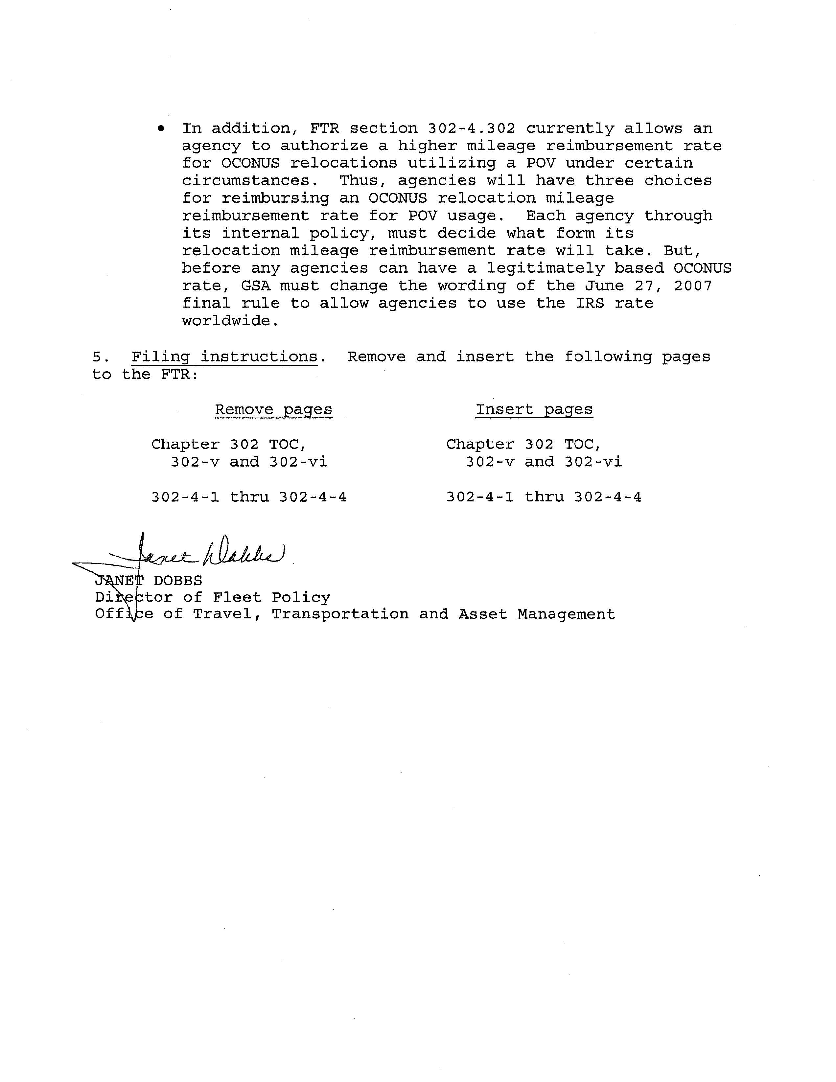
Chapter 302—Relocation Allowances CONTENTS
§302-3.423—If I separate from Government service upon completion of my TCS, what relocation expenses will my agency pay upon my separation?
§302-3.424—If I separate from Government service prior to completion of my TCS, what relocation expenses will my agency pay upon my separation?
§302-3.425—If I have been authorized successive temporary changes of station and reassigned from one temporary official station to another, what expenses will my agency pay upon completion of my last assignment or my separation from Government service?
—Permanent Assignment to Temporary Official Station §302-3.426—How is payment of my TCS expenses affected if I am permanently assigned to my temporary official station? §302-3.427—What relocation allowances may my agency pay when I am permanently assigned to my temporary official station? §302-3.428—If I am permanently assigned to my temporary official station, is there any limitation on the weight of household goods I may transport at Government expense to my official station? §302-3.429—Are there any relocation allowances my agency may not pay if I am permanently assigned to my temporary official station?
ﾠ§302-3.500—What governing policies and procedures must we establish for paying a relocation allowance ﾠ§302-3.501—Must we establish any specific procedures for paying a relocation allowance to new appointees? §302-3.502—What factors should we consider in determining whether to authorize a TCS for a long-term assignment?
—Service Agreements §302-3.503—Must we require employees to sign a service agreement? §302-3.504—What information should we include in a service agreement? §302-3.505—How long must we require an employee to agree to the terms of a service agreement? §302-3.506—May we pay relocation expenses if the employee violates his/her service agreement?
—New Appointees §302-3.507—Once we authorize relocation expenses for new appointees or student trainees what expenses must we pay? §302-3.508—What relocation expenses are not authorized for new appointees or student trainees?
—Overseas Assignment and Return §302-3.509—What policies must we follow when appointing an employee to an overseas assignment? §302-3.510—When must we pay return travel for immediate family members? §302-3.511—What must we consider when determining return travel for immediate family member(s) for compassionate reasons prior to completion of the service agreement? §302-3.512—How many times are we required to pay for an employee’s return travel?
—Overseas Tour Renewal Travel §302-3.513—May we allow a travel advance for tour renewal agreement travel? §302-3.514—Under what conditions must we pay for tour renewal agreement travel? §302-3.515—What special rules must we apply for reimbursement of tour renewal travel for employees stationed, assigned, appointed or transferred to/from Alaska or Hawaii?
—SES Separation for Retirement §302-3.516—What must we do before issuing payment for SES separation-relocation travel? §302-3.517—May we issue travel advances for separation relocation?
(Amendment 2007–03) 302-v
ﾠ
ﾠ
CONTENTS FEDERAL TRAVEL REGULATION
Subchapter C—Permanent Change of Station (PCS) Allowances for Subsistence and Transportation Expenses
ﾠ
ﾠ
§302-4.1—What is a permanent change of station (PCS)?
§302-4.2—Am I eligible for subsistence and transportation allowances for PCS travel under this part?
ﾠ
§302-4.100—What PCS travel expenses will my immediate family members receive? §302-4.101—Must my immediate family member(s) and I begin PCS travel at the old official station and end at the new official station?
ﾠ
§302-4.200—What per diem rate will I receive for en route relocation travel within CONUS? §302-4.201—How are my authorized en route travel days and per diem determined for relocation travel? §302-4.202—Are there any circumstances in which a per diem allowance for my immediate family members
is not allowed?
—Transferred Employees Only
§302-4.203—How much per diem will my spouse receive if he/she accompanies me while I am performing PCS travel? §302-4.204—If my spouse does not accompany me but travels unaccompanied at a different time, what per diem rate will he/she receive? §302-4.205—If my spouse and I travel on the same days along the same general route by using more than one POV, is my spouse considered unaccompanied? §302-4.206—How much per diem will my immediate family receive?
ﾠ
§302-4.300—What is the POV mileage rate for PCS travel?
§302-4.301—Do the rates in §302-4.300 apply if I am performing overseas tour renewal agreement travel?
§302-4.302—Are there circumstances that would allow me to receive a higher mileage rate OCONUS?
§302-4.303—For relocation within the continental United States (CONUS), may I use the actual expense
method of reimbursement instead of the POV mileage rate specified in §302-4.300? §302-4.304—For relocation outside the continental United States (OCONUS), may my agency allow actual expense reimbursement instead of the POV mileage rate for PCS travel?
ﾠ
§302-4.400—Will I be required to drive a minimum distance per day?
§302-4.401—Are there exceptions to this daily minimum?
§302-4.402—Will I be required to document the circumstances causing the delay?
§302-4.403—Does this exception require authorization by my approving official?
ﾠ
§302-4.500—If I am authorized to use more than one POV, what are the allowances? §302-4.501—If I use an additional POV that was not authorized for PCS travel, will I be reimbursed for the additional POV?
ﾠ
§302-4.600—May I request an advance of funds for per diem and mileage allowances for PCS travel?
ﾠ
§302-4.700—What governing policies must we establish for payment of allowances for subsistence and
transportation expenses? §302-4.701—What PCS travel expenses must we pay? §302-4.702—What PCS travel expenses must we pay for the employee’s immediate family members?
Chapter 302—Relocation Allowances Part 302-4—Allowances for Subsistence and Transportation §302-4.203
ﾠ
Authority: ﾠ
ﾠ
ﾠ
ﾠ
ﾠﾠ
ﾠ
ﾠ
ﾠ
ﾠ
ﾠ
Note to ﾠ: Use of pronouns “I”, “you”, and their variants throughout this subpart refers to the employee, unless otherwise noted.
ﾠ
ﾠ
A permanent change of station (PCS) is an assignment of a new appointee to an official station or the transfer of an employee from one official station to another on a permanent basis.
ﾠ
ﾠallowances for PCS travel under this part?
Yes, you are eligible for subsistence and transportation allowances for PCS travel if your agency specifically autho-rizes relocation expenses under this part and are:
- ﾠTransferred employees (within or outside CONUS);
- (b) New appointees (within or outside CONUS); and

ﾠAn employees assigned to posts of duty outside CONUS in connection with either overseas tour renewal agreement travel or return travel to places of residence for separation.
Note to §302-4.2: Also see tables at §§302-3.2 and 302-3.101.
ﾠ
ﾠ
ﾠfamily members receive?
Except as specifically provided in §302-4.202, the rules (for TDY travel) in ﾠ of this title will be used for payment of the travel expenses of your immediate family members.
ﾠ
ﾠ
begin PCS travel at the old official station and end at
the new official station?
No, if an alternate location is used, reimbursement is lim-ited to the allowable cost by the usually traveled route between your old and new official stations.
ﾠ
ﾠ
ﾠrelocation travel within CONUS?
Your per diem for en route relocation travel between your old and new official stations will be at the standard CONUS rate (see applicable FTR Per Diem Bulletins available on the Internet at http://www.gsa.gov/perdiem). You will be reim-bursed in accordance with §§301-11.100 through 301-11.102 of this title.
ﾠ
ﾠand per diem determined for relocation travel?
Your authorized en route travel days and per diem are determined as follows: The number of authorized travel days is the actual number of days used to complete the trip, but not to exceed an amount based on a minimum driving distance per day determined to be reasonable by your agency. The mini-mum driving distance shall be not less than an average of 300 miles per calendar day. An exception to the daily minimum driving distance may be made when delay is beyond control of the employee, such as when it results from acts of God or restrictions by Government officials; when the employee is physically handicapped; or for other reasons acceptable to the agency.
ﾠ
ﾠ
diem allowance for my immediate family members is
not allowed?
Yes, per diem for your immediate family members cannot be authorized if you are:
ﾠA new appointee;
- (b) Assigned to posts of duty outside CONUS returning to place of actual residence for separation; or
- ﾠBeing relocated under the Government Employees ﾠ
ﾠ

Transferred Employees Only
ﾠ
ﾠ
he/she accompanies me while I am performing PCS
travel?
The maximum amount your spouse may receive if he/she accompanies you while you are performing PCS travel is three-fourths of your daily per diem rate.
(Amendment 2007–03) 302-4-1
ﾠ
ﾠ
§302-4.204 FEDERAL TRAVEL REGULATION
ﾠ
ﾠ
travels unaccompanied at a different time, what per
diem rate will he/she receive?
If your spouse does not accompany you but travels unac-companied at a different time, he/she will receive the same per diem rate to which you are entitled.
ﾠ
ﾠ
along the same general route by using more than one
POV, is my spouse considered unaccompanied?
No; for per diem purposes, you and your spouse are con-sidered to be traveling together if you travel on the same days along the same general route by using more than one POV.
ﾠ
ﾠfamily receive?
Immediate family members age 12 or older receive three-fourths of your per diem rate, and children under 12 receive one-half of your per diem rate.
ﾠ
ﾠ
ﾠ
For approved/authorized PCS travel by POV, the mileage reimbursement rate is the same as the moving expense mile-age rate established by the Internal Revenue Service (IRS) for moving expense deductions. See IRS guidance available on the Internet at www.irs.gov. GSA publishes the rate for mile-age reimbursement in an FTR Bulletin on an intermittent basis. You may find the FTR Bulletins at www.gsa.gov/relo.
ﾠ
ﾠ§302-4.300 apply if I am performing overseas tour renewal agreement travel?
No, POV mileage must not be authorized for overseas tour renewal agreement travel.
ﾠ
ﾠto receive a higher mileage rate OCONUS?
Yes, your agency may authorize a higher mileage rate at a rate not to exceed the maximum rate prescribed in §301-11.303 of this title when:
- ﾠYou are expected to use the POV on official business at the new official station;
- (b) The common carrier rates for the facilities provided between the old and new official stations, the related con-structive taxicab fares to and from terminals, and the per diem allowances prescribed under this part justify a higher mileage rate as advantageous to the Government as determined by your agency; or
- ﾠThe costs of driving the POV to, from, or between offi-cial stations located outside CONUS justify a higher mileage rate as advantageous to the Government.

ﾠ
ﾠ
States (CONUS), may I use the actual expense method
of reimbursement instead of the POV mileage rate
specified in §302-4.300?
No, for a PCS relocation within CONUS involving POV usage, your agency will reimburse you at the standard mile-age rate specified in §302-4.300.
ﾠ
ﾠ
States (OCONUS), may my agency allow actual
expense reimbursement instead of the POV mileage
rate for PCS travel?
Yes, for an OCONUS relocation involving POV usage, your agency may allow reimbursement of certain actual expenses of using the POV (i.e., fuel plus the additional expenses listed in §301-10.304).
ﾠRequirements
ﾠ
ﾠdistance per day?
Yes, your agency may establish a reasonable minimum driving distance that may be more than, but not less than an average of 300 miles per calendar day.
ﾠ
ﾠ
Yes, your agency may authorize exceptions to the daily minimum driving distance when there is a delay beyond your control such as acts of God, restrictions by Governmental ﾠicap or special needs. Your agency must have a designated approving official authorize the exception.
ﾠ
ﾠcircumstances causing the delay?
Yes, you must provide a statement on your travel claim explaining the circumstances that caused the delay.
ﾠ
ﾠmy approving official?
Yes, authorization by your approving official is required for any exception to the daily minimum driving distance.
ﾠ
ﾠ
ﾠwhat are the allowances?
When you are authorized to use more than one POV, the allowances under §§302-4.300 and 302-4.302 apply for each POV.
Chapter 302—Relocation Allowances Part 302-4—Allowances for Subsistence and Transportation §302-4.705
ﾠ
ﾠauthorized for PCS travel, will I be reimbursed for the additional POV?
No, your agency must authorize you reimbursement of the use of more than one POV before you are entitled to reim-bursement.
ﾠ
ﾠ
ﾠdiem and mileage allowances for PCS travel?
You may request advance of funds for per diem and mile-age allowances for PCS travel, except for overseas tour renewal agreement travel.
ﾠ
Note to ﾠ: Use of pronouns “we”, “you”, and their variants throughout this subpart refers to the agency, unless otherwise noted.
ﾠ
ﾠpayment of allowances for subsistence and transportation expenses?
For payment of allowances for subsistence and transporta-tion expenses, you must establish policy and procedures gov-erning:
- ﾠHow you will implement the regulations throughout this part;
- (b) A reasonable minimum driving distance per day that may be more than, but not less than a average of 300 miles per calendar day when use of a POV is used for PCS travel and when you will authorize an exception;
- ﾠDesignation of an agency approving official who will authorize an exception to the daily minimum driving distance; and
- (d) When you will authorize the use of more than one POV for PCS travel.

ﾠ
ﾠ
Except as specifically provided in this chapter, PCS travel expenses you must pay are:
- ﾠPer diem;
- (b) Transportation costs; and

ﾠOther travel expenses in accordance with ﾠ
ﾠﾠ of this title.
ﾠ
ﾠthe employee’s immediate family members?
Except as specifically provided in this chapter, the reim-bursement limits in ﾠ of this title govern payment of travel expenses you must pay for the employee’s immedi-ate family members.
ﾠ
ﾠestablished minimum driving distance per day?
Per diem for an established minimum driving distance per day is computed based on the lodgings-plus per diem system as described in §§301-11.100 through 301-11.102 of this title.
ﾠ
ﾠper day?
Yes, you must establish a minimum driving distance not less than an average of 300 miles per day. However, an excep-tion to the daily minimum driving distance may be made when the delay is:
ﾠﾠof God or restrictions by Government officials;
- (b) Due to a physical handicap; or
- ﾠFor other reasons acceptable to you.

ﾠ
ﾠmore POVs than authorized?
If the employee uses more POVs than authorized, reim-bursement will be made as if all persons traveled in the num-ber of POVs that you authorized.
(Amendment 2007–06) 302-4-3 FEDERAL TRAVEL REGULATION
This page intentionally left blank.
302-4-4 (Amendment 2007–03)

