National Park Service  U.S. Department of the Interior | Theodore Roosevelt National Park |  | PO Box 7  Medora, ND 58645  701-623-4466 phone  701-623-4840 fax  www.nps.gov/thro
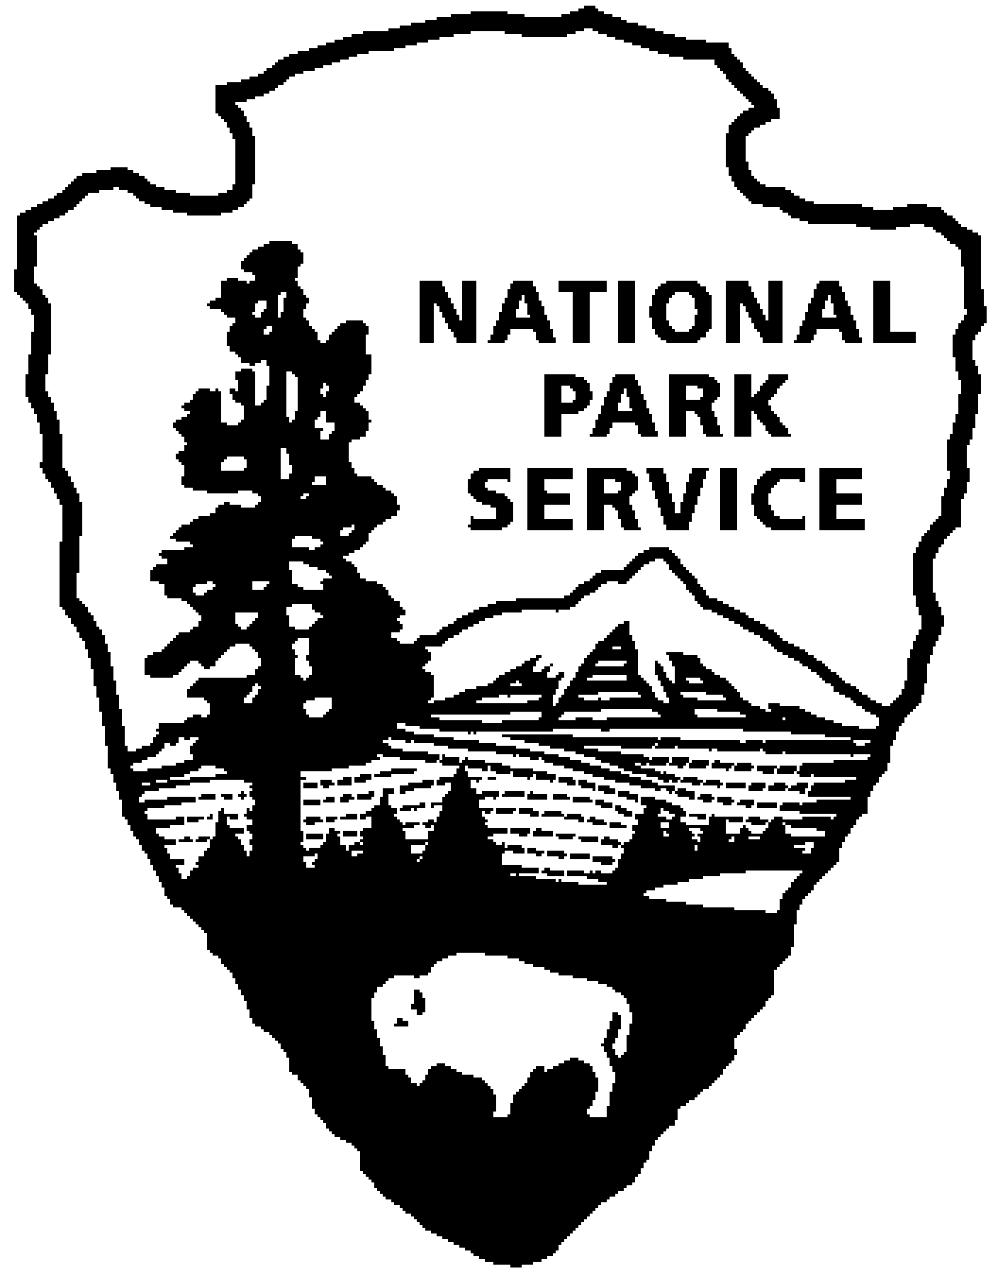
Theodore Roosevelt National Park
News Release
Immediate Release Valerie Naylor 701-623-4466

Date: October 7, 2008

Governor Proclaims Theodore Roosevelt Month and Day

Governor John Hoeven has proclaimed October as Theodore Roosevelt Month and October 27 as Theodore Roosevelt Day in North Dakota. October 27 is the 150th birthday of the 26th President.

“As we celebrate the birth and life of Theodore Roosevelt, we reflect on the pivotal role he played in shaping North Dakota’s rich history,” Hoeven said. “His time spent in our state not only paved his way to the presidency, but made him a legend whose footsteps can still be traced in North Dakota’s Badlands.”

Theodore Roosevelt National Park is celebrating TR’s birthday all year, and will be holding a special event and 150th birthday party on October 27. Events will include reading of the governor’s proclamation, a special U.S. postage stamp cancellation, special programs and activities as well as birthday cake. More details on the birthday activities will be released later in the month.

Theodore Roosevelt was an enthusiastic resident of Dakota Territory for significant periods between September 1883 and December 1887, and held ranching interests in the North Dakota Badlands from 1883-1898. The time that Roosevelt spent ranching and hunting in North Dakota was instrumental to his recovery from the deaths of his wife and mother. He often stated that he never would have been president had it not been for his experiences in North Dakota.

Many of Theodore Roosevelt’s views on conservation were formed during his time in the Dakota badlands. He became a leading advocate for the cause of conservation, creating the U.S. Forest Service, signing the Antiquities Act, and extending federal protection to almost 230,000 acres during his presidency. He also proclaimed 18 national monuments and signed five national parks into law.

“Theodore Roosevelt was a champion of national parks and monuments, and of the conservation and wise use of our natural resources,” said Superintendent Valerie J. Naylor. “Today, Theodore Roosevelt National Park honors the legacy of Theodore Roosevelt and preserves a portion of the lands where he ranched and hunted. The North Dakota badlands inspired Roosevelt, just as they inspire hundreds of thousands of visitors each year.”

--NPS--

