Experimental Evaluation of Retroreflective Markings on Rail Cars at Highway-Railroad Grade Crossings

by

Joseph Conti and Thomas B. Sheridan Jordan Multer
Human-Machine Systems Laboratory Operator Performance and Safety Analysis Division
Massachusetts Institute of Technology John A. Volpe National Transportation Center
Cambridge, MA 02139 Cambridge, MA 02139

Abstract
Every year in the United States, hundreds of accidents occur at grade crossings due to motor vehicles colliding with trains. Some of these accidents take place at night in rural areas. One proposed solution to prevent such accidents involves mounting retroreflective material on the sides of trains so that a vehicle’s headlights will illuminate the reflectors and make the train more conspicuous. The objective of this research was to determine which train mounted reflector pattern gives an approaching driver the best train recognition. Four reflector patterns were selected for this study, and a computer-based nighttime driving simulator was developed. The experiment involved a driving task in which the motorist encountered numerous grade crossings. The recognition distance between the train and subject’s position was recorded and analyzed.

Introduction
Defined as the intersection of a highway and railroad track, grade crossings exist at over 168,000 locations throughout the United States (Federal Railroad Administration, 1994). Unfortunately, many accidents occur at grade crossings involving the collision of motor vehicles and train consists. In 1996 there were over 1,183 motor vehicle run into train (RIT) accidents, 613 of which occurred during nighttime conditions (Federal Railroad Administration, 1996). Some of these accidents occur in rural areas where little ambient light exists except for the motorist’s headlights. In addition, the dark color of typical freight cars and the accumulation of dust and grime makes the task of train recognition even more difficult.

The Federal Railroad Administration (FRA) has sponsored studies exploring many methods to prevent such accidents including train mounted incandescent/strobe lights, paint schemes, and audible warning devices (Carroll, Multer, & Markos, 1995; Aurelius & Korobow, 1971; Carroll, Hitz, Knable and Passera, 1998). A promising alternative method involves mounting retroreflective material on the sides of train cars so that the motorist’s headlights will illuminate the reflectors giving the driver adequate knowledge that a train is passing through the grade crossing.

Prior Research
In 1996, the FRA sponsored a study conducted by the University of Tennessee to explore various reflector patterns (colors and configuration) to improve the nighttime conspicuity of trains. (Ford, Richards, & Hungerford, 1996). This study concluded that:

- A standardized retroreflector pattern is beneficial to train recognition.
- The pattern should be made of red and white reflectors.
- The pattern should not be confused with roadway signs or reflectors from other objects (i.e. trucks).
- The pattern should communicate the size of the rail car through outlining or an even distribution.

With that in mind the John A. Volpe National Transportation Systems Center (Volpe Center) proposed four reflector patterns to evaluate using a driving simulator. These four reflector patterns: massed outline, vertical bars, variable vertical bars, and horizontal bars are presented in Figures 1 and 2 on the hopper cars and flat cars, respectively. These patterns were chosen to represent a spectrum of reflector layout strategies; namely distributing the reflectors along the train car (horizontal bars and vertical bars), lumping them towards the ends (massed outline), or a combination of the two (variable vertical bars). In this study all four hopper car reflector patterns each used exactly 144 square inches of red reflector material and 144 square inches of white reflector material (see Figure 1). The flat car patterns each used exactly 72 square inches of red reflector material and 72 square inches of white reflector material (see Figure 2). The patterns in Figures 1 & 2 are all comprised of reflector strips 4 inches wide with varying length.

A preliminary "static" experiment was conducted to determine which of the four hopper/flat train reflector patterns described in Figures 1 & 2 gave the best train recognition. Participants were located at a fixed location, 500 feet from the grade crossing. Numerous scenes simulating a grade crossing and road intersection were presented. In some of these scenes, a truck or train passed through the intersection and the subjects were asked to identify the object. Each scene lasted 500 milliseconds and was followed by two questions asking what the subject saw and how confident they were of their decision. Data from the experiment were then analyzed using the receiver operating characteristic (ROC) curve from Signal Detection Theory. Comparing the ROC curve of the four different reflector styles yielded no notable difference in performance (Conti, 1998).

The objective of this experiment was to determine which of the four reflector patterns in both Figures 1 and 2 best facilitates the task of train recognition with the motorist and train in motion . The patterns were compared against patterns found on trucks, with which they might be confused. Currently, the U.S. Code of Federal Regulations requires that “not less than half of the length of the [truck] tractor trailer truck is covered [with reflectors] and the spaces are distributed as evenly as practicable” (49 USC 571.108). Figure 3 depicts the four truck reflector patterns utilized in this study. These truck reflector patterns were chosen to represent the typical patterns used by trucking companies and manufacturers.
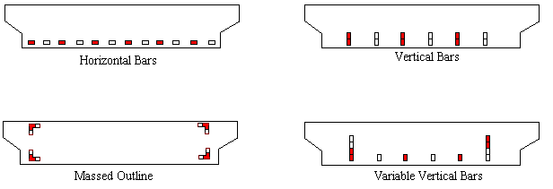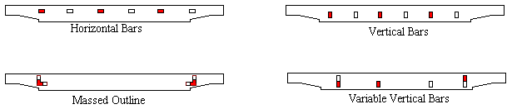

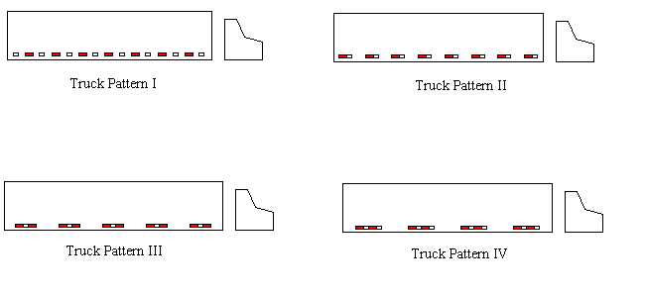
Figure 1. Hopper Car Reflector Patterns Figure 2. Flat Car Reflector Patterns

Figure 3. Truck Reflector Patterns

Driving Experiment

Objective
The purpose of this experiment was to determine which of the four reflector patterns described in Figures 1 & 2 gives the best train recognition under a normal driving task on a dark rural road. As the participants drove a car simulator, they encountered numerous objects (i.e. grade crossings, road intersections with trucks or cars, traffic lights, etc.) and subsequently reported what they recognized. Voice recognition software recorded the subject’s response, and the simulator software determined the distance of recognition.

Apparatus
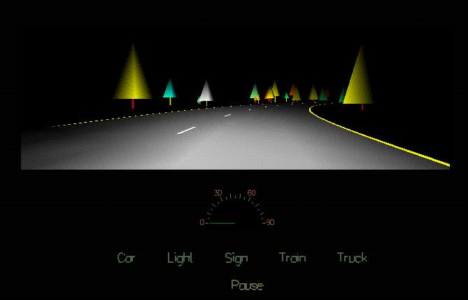
A driving simulator was created with the purpose of examining the different train reflector patterns. This desktop simulator included a personal computer for generating the vehicle dynamics and visual scenery, a steering wheel, pedal controls, and driving dynamics to simulate a vehicle traveling on a typical two-way American rural road. The road was approximately 40 miles long and contained 22 grade crossings; 20 of which had either flat cars or hopper cars passing through. In addition, road markings, speed limit signs, intersection signs, grade crossings signs, and traffic lights were rendered so that this road conformed to U.S. regulations. The posted speed limit was 50 mph and most subjects completed the driving task in about an hour. Each grade crossing contained the minimum sign requirements: a railroad warning sign and a crossbuck sign. No other grade crossing features such as flashing lights or reflectorized gates were included; this was done to minimize the conspicuity of the grade crossing. Also, a forest of trees was displayed on both sides of the road at all times so that the subjects were forced to use the scenery directly in front of them to recognize objects.

A sample screen output of the driving simulator is shown in Figure 4. A speedometer was displayed along with the special words the subjects could speak to signal what was seen. The experimental setup is displayed in Figure 5

Figure 4. View of Driving Simulator

Barco Projector
Silicon Graphics
Indigo2
CerealBox
A/D Converter

PC
15 feet
6x8 ft screen
Microphone
Ethernet
Serial Port
Subject

Figure 5. Experiment II Apparatus

Experimental Design
In this experiment, subjects drove a car for about one hour along a dark rural road. On this road were many objects including automobiles, lights, signs, trains, and trucks. When the subject recognized any of the aforementioned objects he or she would say the word car, light, sign, train or truck depending on what was recognized. Voice recognition software recorded the subject’s response and compared it with what objects were really in the road. The distances from these objects when the subject recognized them was also recorded. The subjects viewed 22 grade crossings (20 of which had trains passing through), 40 cars, 20 trucks, and 4 traffic lights in the experiment.

Independent Variable
The independent variable was the type of reflector pattern and train car thus giving ten possible combinations as shown in Table 1. The flat car used the same patterns as the hopper car, but only half the amount of material was used. Each of these variables was displayed to the subject twice; therefore, each subject viewed a total of 20 trains during the experiment.

Train Type |  | Reflector Pattern
Hopper Train | Flat Train | Reflector Pattern
1 | 6 | Massed Outline
2 | 7 | Vertical Bars
3 | 8 | Variable Vertical Bars
4 | 9 | Horizontal Bars
5 | 10 | Unreflectorized
Table 1. Experiment II: Independent Variables

Dependent Variable
The dependent variable was the distance at which the subject recognized the train and was measured using voice recognition software. If the subject did not recognize the train or incorrectly recognized the train as another object (i.e. truck or car ) an error was recorded.

Participants
A total of twenty-two people participated in the experiment, all of whom were licensed drivers with vision better than 20/40. The subject’s ages ranged from 18 to 60 years with a mean of 37 years and standard deviation of 13; 65% of the subjects were male. Seventeen of the twenty-two subjects were volunteers from the Volpe Center and the remaining participants were undergraduates paid $10 per hour to participate.

Instructions and Treatment of Subjects
The entire experiment for each subject lasted less than two hours. The subject first read a brief description of the experiment, and then the voice recognition software was trained to his or her voice. This involved the subject saying the words car, light, sign, train, and truck for about two minutes into a headset microphone. The subject then practiced driving for about 7 minutes without the microphone. A practice course allowed the subject to drive in an oval, get accustomed to the controls, and see the various objects present in the experiment. When the subject was comfortable with the driving task, he or she was given the microphone and subsequently practiced driving while speaking the various words. The subject continued this practice until he or she was ready to begin the experiment. On average, participants practiced this task for approximately ten minutes. During the experiment, the experimenter was in an adjacent room and could communicate with the subject using a walkie-talkie. Subjects were never told the purpose of the experiment.

Results

Figure 6 plots reflector pattern versus recognition distance. The recognition distances were computed by averaging the data from all twenty-two subjects in the experiment. The standard deviation is represented by the error bars in Figure 6. An analysis of variance indicated that the mean distance of the hopper car is significantly larger than the flat car (p < .001). A Newman-Keuls post-hoc comparison test with respect to the hopper reflector yielded a significant difference (p < .05) between the groups {Massed Outline, Vertical Bars, Horizontal Bars}, {Variable Vertical Bars, Horizontal Bars}, and {Unreflectorized} where the first group had the highest recognition distances. There was no significant difference within these groups. For the flat car, a significant difference (p < .05) existed between the groups {Vertical Bars, Horizontal Bars}, {Massed Outline, Variable Vertical Bars}, and {Unreflectorized} where the first group had the highest recognition distances, but there was no significant difference within these groups (p > .05).

Figure 6. Reflector Type versus Recognition Distance

The errors from the driving experiment are compiled in Table 2. The top row of the table indicates what object (truck, car, or nothing) the subject perceived the train as, and the first column indicates the type of train reflector pattern displayed when the error occurred.

Hopper Car Errors | Nothing | Car | Truck | Total
Massed Outline | 0 | 0 | 0 | 0
Vertical Bars | 0 | 0 | 0 | 0
Variable Vertical Bars | 0 | 0 | 0 | 0
Horizontal Bars | 0 | 0 | 2 | 2
Unreflectorized | 4 | 0 | 3 | 7
Total | 4 | 0 | 5 | 9

Flat Car Errors | Nothing | Car | Truck | Total
Massed Outline | 0 | 1 | 2 | 3
Vertical Bars | 0 | 0 | 0 | 0
Variable Vertical Bars | 0 | 0 | 0 | 0
Horizontal Bars | 0 | 0 | 1 | 1
Unreflectorized | 8 | 1 | 1 | 10
Total | 8 | 2 | 4 | 14

Table 2. Subject Errors

Discussion
Figure 6 along with the statistical analyses clearly indicates that reflectorized trains were recognized at farther distances than unreflectorized trains, for both the hopper and flat train cars. Furthermore, the Newman-Keuls comparison test shows that the reflector groups {Massed Outline, Vertical Bars, Horizontal Bars} and {Vertical Bars, Horizontal Bars} performed the best with respect to the hopper and flat cars. Common to both of these groups is the vertical bar and horizontal bar reflector patterns, which both have reflectors distributed along the base of the train car as opposed to the massed outline and variable vertical bars patterns which are lumped towards the ends (see Figures 1 and 2).

However, according to Table 2, three errors occurred with the horizontal bar pattern but none occurred with the vertical bar pattern. Moreover, these errors all involved subjects incorrectly identifying the train as a truck. Since the study by Ford et al. (1996) recommended a standardized train reflector pattern which minimizes confusion with other objects (i.e. truck), these results suggest that the vertical patterns may result in less confusion than the horizontal pattern.

Interestingly, in the debriefing questionnaire subjects responded favorably with the massed outline reflector pattern on the hopper car but unfavorably with the same pattern on the flat car. This agrees with the experimental results in which a comparison test placed the massed outline pattern in the group with the highest hopper recognition distance and lowest flat train recognition distance. Therefore, the massed outline reflector pattern only performed well with train cars having a substantial height dimension available for marking (i.e. hopper car).

Conclusion
The experiment based on a realistic nighttime driving simulator concluded that the vertical bar reflector pattern yielded better train recognition performance than the horizontal, massed outline, or variable vertical patterns. Moreover, a distributed pattern has better train recognition qualities than a massed pattern on the flat car. This does not hold true for the hopper car which introduces another dimension (height) available for mounting reflectors.

References
Aurelius, J. P. & Korobow, N. (1971). The Visibility and Audibility of Trains Approaching Rail and Highway Grade
Crossings, Report No. FRA-RP-71-2. Washington, DC: U.S. Department of Transportation, Federal Railroad
Administration.

Carroll, A., Hitz, J.S. Knable, N. & Passera, A.L. (1998). Guidelines for Highway-Railroad Grade Crossing Illumination. Washington, DC: U.S. Department of Transportation, Federal Railroad Administration

Carroll, A., Multer, J., & Markos, S. H. (1995). Safety of Highway-Railroad Grade Crossings: Use of Auxiliary
External Alerting Devices to Improve Locomotive Conspicuity, Report No. DOT-VNTSC-FRA-95-10.
Washington, DC: U.S. Department of Transportation, Federal Railroad Administration.

Conti, J. (1998). Experimental Evaluation of Retroreflective Markings on Trains at Grade Crossings. S.M. Thesis,

MIT.

Ford, R. E., Richards, S. H., & Hungerford, J.C. (1996). Evaluation of Retroreflective Markings To Increase Rail
Car Conspicuity. U.S. Department of Transportation , Volpe National Transportation Center.

U.S. Code of Federal Regulations, 49 Part 571.108, Section 5.7.1.4.2

Federal Railroad Administration, Office of Safety. Highway-Rail Crossing Accident/Incident and Inventory
Bulletin. (1996). Washington, DC: U.S. Department of Transportation.

Federal Railroad Administration, Office of Safety. Highway-Rail Crossing Accident/Incident and Inventory Bulletin
#60. (1994). Washington, DC: U.S. Department of Transportation

