    U.S. Department  of Transportation  Federal Railroad  Administration | Preview Information in Cab Displays for High-Speed Locomotives

Office of Research  and Development  Washington, DC 20590 | U.S. Department of Transportation  Research and Special Programs Administration  John A. Volpe National Transportation Systems Center  Cambridge, MA 02142
Human Factors in Railroad Operations
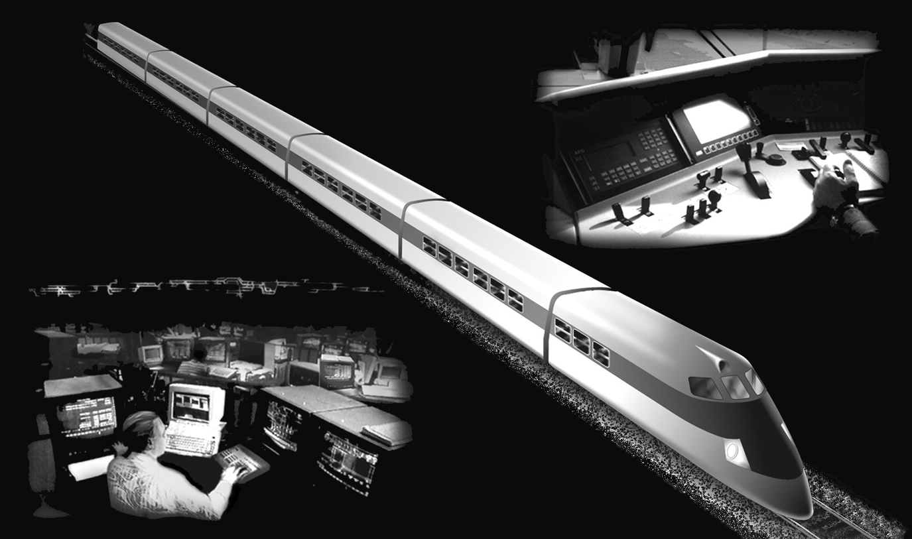
DOT/FRA/ORD-04/12 | Final Report  July 2005 | This document is available to the  public through the National Technical  Information Service, Springfield, VA 22161  This document is also available on  the FRA website at www.fra.dot.gov

Notice
This document is disseminated under the sponsorship of the Department of Transportation in the interest of information exchange. The United States Government assumes no liability for its contents or use thereof.
Notice
The United States Government does not endorse products or manufacturers. Trade or manufacturers’ names appear herein solely because they are considered essential to the objective of this report.

Report Documentation page |  |  |  |  | Form Approved  OMB No. 0704-0188
Public reporting burden for this collection of information is estimated to average 1 hour per response, including the time for reviewing instructions, searching existing data sources, gathering and maintaining the data needed and completing and reviewing the collection of information. Send comments regarding this burden estimate or any aspects of this collection of information , including suggestions for reducing this burden to Washington Headquarters Service, Directorate for information Operations and Reports. 1215 Jefferson Davis Highway, Suite 1204, Arlington, VA. 222202-4302, and to the Office of Management and Budget, Paperwork Reduction Project (0704-0188), Washington, DC 20503.
1. Agency Use Only (Leave blank) |  | - Report Date  July 2005 |  | - REPORT TYPE AND DATES COVERED  Final Report  September 1995-June 1997
- Title and subtitle  Preview Information in Cab Displays for High-Speed Locomotives |  |  |  |  | - FUNDING NUMBERS  R2103/RR204
- AUTHOR(S)
Jay Einhorn, Thomas Sheridan, and Jordan Multer
- PERFORMING ORGANIZATION NAME(S) AND ADDRESS(ES)  U.S. Department of Transportation  Research and Special Programs Administration  John A. Volpe National Transportation Systems Center  Cambridge, MA 02142-1093 |  |  |  |  | - PERFORMING ORGANIZATION  DOT-VNTSC-FRA-04-06
- SPONSORING/MONITORING AGENCY NAME(S) AND ADDRESS(ES)  U.S. Department of Transportation  Federal Railroad Administration  Office of Research and Development Mail Stop 20  1120 Vermont Avenue, NW  Washington, DC 20590 |  |  |  |  | - SPONSORING/MONITORING AGENCY REPORT NUMBER  DOT/FRA/ORD-04/12
- SUPPLEMENTARY NOTES
Safety of High-Speed Ground Transportation Systems series
12a. DISTRIBUTION/AVAILABILITY STATEMENT  This document is available to the public through the National Technical Information Service, Springfield, Virginia 22161. This document is also available on the FRA web site at www.fra.dot.gov. |  |  |  |  | 12b. DISTRIBUTION CODE
- ABSTRACT (Maximum 200 words)
This research examined the usefulness of preview information in the control of high-speed trains. Experiments were run on a human-in-the-loop locomotive simulator. The primary goal was to examine whether the proposed information-aiding displays improved safety and efficiency of train operation over an existing display. Safety was measured by monitoring speed control, signal adherence, and reaction time. Efficiency was measured by monitoring stopping accuracy and schedule deviation.
Locomotive engineers and student participants performed similarly with respect to signal adherence and speed control. Preview information was useful in both cases; Longer preview and variable preview displays provided the best results. The preview displays were detrimental to accurate station-stopping, as the displays provided an inadequate level of resolution to stop accurately. Although the locomotive engineers responded favorably to the preview displays, further work is needed to determine how the engineer allocates attention between information in the cab and information outside the cab.
- SUBJECT TERMS  attention allocation, automation, high-speed trains, human-in-the-loop simulation, intelligent railroad systems, situation awareness, supervisory control |  |  |  |  |  | - NUMBER OF PAGES  60  - PRICE CODE
- SECURITY CLASSIFICATION OF REPORT  Unclassified | - SECURITY CLASSIFICATION OF THIS PAGE  Unclassified |  | - SECURITY CLASSIFICATION OF ABSTRACT  Unclassified |  |  |  | - LIMITATION OF ABSTRACT

METRIC/ENGLISH CONVERSION FACTORS
ENGLISH TO METRIC |  |  |  |  | METRIC TO ENGLISH
LENGTH (APPROXIMATE) |  |  |  |  | LENGTH (APPROXIMATE)
1 inch (in) | = | 2.5 centimeters (cm) |  | 1 millimeter (mm) |  | = |  |  | 0.04 inch (in)
1 foot (ft) | = | 30 centimeters (cm) |  | 1 centimeter (cm) |  | = |  |  | 0.4 inch (in)
1 yard (yd) | = | 0.9 meter (m) |  | 1 meter (m) |  | = |  |  | 3.3 feet (ft)
1 mile (mi) | = | 1.6 kilometers (km) |  | 1 meter (m) |  | = |  |  | 1.1 yards (yd)
 |  |  |  | 1 kilometer (km) |  | = |  |  | 0.6 mile (mi)
AREA (APPROXIMATE) |  |  |  |  | AREA (APPROXIMATE)
1 square inch (sq in, in²) | = | 6.5 square centimeters (cm²) |  | 1 square centimeter (cm²) |  | = |  |  | 0.16 square inch (sq in, in²)
1 square foot (sq ft, ft²) | = | 0.09 square meter (m²) |  | 1 square meter (m²) |  | = |  |  | 1.2 square yards (sq yd, yd²)
1 square yard (sq yd, yd²) | = | 0.8 square meter (m²) |  | 1 square kilometer (km²) |  | = |  |  | 0.4 square mile (sq mi, mi²)
1 square mile (sq mi, mi²) | = | 2.6 square kilometers (km²) |  | 10,000 square meters (m²) |  | = |  |  | 1 hectare (ha) = 2.5 acres
1 acre = 0.4 hectare (he) | = | 4,000 square meters (m²)
MASS - WEIGHT (APPROXIMATE) |  |  |  |  | MASS - WEIGHT (APPROXIMATE)
1 ounce (oz) | = | 28 grams (gm) |  | 1 gram (gm) |  | = |  | 0.036 ounce (oz)
1 pound (lb) | = | 0.45 kilogram (kg) |  | 1 kilogram (kg) |  | = |  | 2.2 pounds (lb)
1 short ton = 2,000 pounds (lb) | = | 0.9 tonne (t) |  | 1 tonne (t) |  | =  = |  | 1,000 kilograms (kg)  1.1 short tons
VOLUME (APPROXIMATE) |  |  |  |  | VOLUME (APPROXIMATE)
1 teaspoon (tsp) | = |  | 5 milliliters (ml) |  | 1 milliliter (ml) |  | = |  |  | 0.03 fluid ounce (fl oz)
1 tablespoon (tbsp) | = |  | 15 milliliters (ml) |  | 1 liter (l) |  | = |  |  | 2.1 pints (pt)
1 fluid ounce (fl oz) | = |  | 30 milliliters (ml) |  | 1 liter (l) |  | = |  |  | 1.06 quarts (qt)
1 cup (c) | = |  | 0.24 liter (l) |  | 1 liter (l) |  | = |  |  | 0.26 gallon (gal)
1 pint (pt) | = |  | 0.47 liter (l)
1 quart (qt) | = |  | 0.96 liter (l)
1 gallon (gal) | = |  | 3.8 liters (l)
1 cubic foot (cu ft, ft³) | = |  | 0.03 cubic meter (m³) |  | 1 cubic meter (m³) |  | = |  |  | 36 cubic feet (cu ft, ft³)
1 cubic yard (cu yd, yd³) | = |  | 0.76 cubic meter (m³) |  | 1 cubic meter (m³) |  | = |  |  | 1.3 cubic yards (cu yd, yd³)
TEMPERATURE (EXACT) |  |  |  |  | TEMPERATURE (EXACT)
[(x-32)(5/9)] °F | = |  | y °C |  | [(9/5) y + 32] °C |  | = |  | x °F
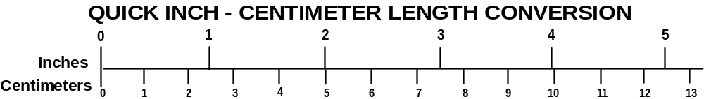
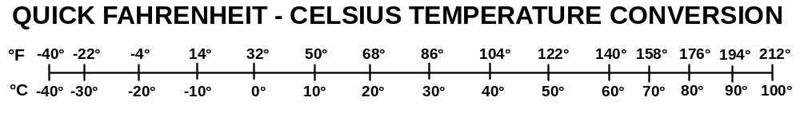
For more exact and or other conversion factors, see NIST Miscellaneous Publication 286, Units of Weights and Measures. Price $2.50 SD Catalog No. C13 10286
PREFACE
This research was performed as part of an ongoing program at the U. S. Department of Transportation's John A. Volpe National Transportation Systems Center (Volpe Center) in collaboration with the Human-Machine Systems Laboratory (HMSL) of the Massachusetts Institute of Technology (MIT). The Federal Railroad Administration’s (FRA) Office of Research and Development sponsored this study as part of its effort to support the safe and efficient operation of high-speed ground transportation.
As vehicle speed increases, the limits of human information processing remains fixed. High speeds increase the processing demand per unit time on the locomotive engineer, while also decreasing the available response time. One approach to this dilemma is to give the locomotive engineer information about the status of the upcoming track earlier in time. This report addresses whether preview information is helpful with regard to safe and efficient train operations.
ACKNOWLEDGMENTS
This report is the result of many people’s labor. We would like to thank Kari Kulaszewicz for her help and good nature; Steven Villareal for his help with the sound generation and the building of the locomotive cab; John Pollard for his help with many different aspects of the simulation, and Frank Sheelen for his technical expertise. Dr. Ed Lanzilotta wrote much of the code that the MIT/Volpe locomotive simulator is based on, and his guidance and effort will serve as a reminder of how people of faith and wisdom should act.
Many people from the railroads and locomotive manufacturers shared their knowledge and frank opinions with us. We thank Masahiko Horiuchi of East Japan Railway Company; Dick Bruss, Ron Berben, and Pat Kelley of Amtrak; Daniel Metaut and Philippe Mingasson of Alsthom; Bengt Lindwall of AdTranz; Howard Moody of the Association of American Railroads; and George Kuehn of the Illinois Institute of Technology Research Institute.
I would particularly like to acknowledge Steven Jones and Joe Arcuri of Amtrak for their help in finding locomotive engineers to participate. The participants themselves are owed a deep debt of gratitude for giving up their days off to help us with our work.
The Federal Railroad Administration sponsored this work as part of its activities to develop Intelligent Railroad Systems (Federal Railroad Administration, 2002).

LIST OF ACRONYMS
AAR – Association of American Railroads
ARES – Advanced Railroad Electronics System
ATC – Automatic Train Control
ATCS – Advanced Train Control System
ATP – Automatic Train Protection
BN – Burlington Northern Railroad (predecessor to BNSF)
BNSF – Burlington Northern Santa Fe Railroad
CIR – Computer Integrated Railroading
DB – Deutsche Bahn (German Railways)
FRA – Federal Railroad Administration
GE – General Electric
GM – General Motors
HMSL – Human-Machine Systems Laboratory
ICE – Inter-City Express
ITCS – Incremental Train Control System
JR – Japan Rail
MIT – Massachusetts Institute of Technology
OTW – Out-The-Window
PSI – Pounds per Square Inch
PTS – Positive Train Separation
RAC – Railway Association of Canada
SJ – Statens Jarnvager (Swedish State Railways)
SNCF – Société Nationale des Chemins de Fer Français (French National Railways)
TGV – Train à Grande Vitesse
UP – United Pacific Railroad
Volpe Center – John A. Volpe National Transportation Systems Center

TABLE OF CONTENTS
Section Page
EXECUTIVE SUMMARY ix
1. INTRODUCTION 1
1.1 Research Goals 2
2. LOCOMOTIVE CAB DISPLAYS IN HIGH-SPEED OPERATIONS 3
2.1 Sweden 3
2.2 Japan 5
2.3 France 7
2.4 Germany 8
2.5 North American Railroads 9
2.6 Amtrak 11
2.7 Summary 12
3. SIMULATOR EXPERIMENT 15
3.1 Overview 15
3.2 Locomotive Simulator 15
3.3 Experimental Design 16
3.4 Task 20
3.5 Participants 21
3.6 Training 21
4. RESULTS AND DISCUSSION 23
4.1 Speed Control 23
4.2 Signal Adherence 23
4.3 Brake Response Latency 25
4.4 Schedule Deviation 25
4.5 Station-Stopping Accuracy 26
4.6 Comparison Between Engineers and Students 27
5. SUMMARY 29
APPENDIX A: TRAIN SCHEDULE 33
APPENDIX B: EXIT QUESTIONNAIRE 35
APPENDIX C: FUTURE LOCOMOTIVE SIMULATOR CONSIDERATIONS 37
GLOSSARY 43
REFERENCES 45
LIST OF FIGURES
Figure Page
1. X2000 Instrument Panel 4
2. X2000 Fault Indication Panel 4
3. Shinkansen MON4 Display 6
4. Shinkansen MON10 Display 6
5. Interior of a TGV-PBKA Cab 7
6. ASTREE Cab Display (de Curzon, 1994) 8
7. Interior of an ICE Cab 9
8. AAR LSI (Train Control) Display 10
9. AAR ATCS (Track/Authority) Display 11
10. GE/Amtrak Genesis II Gauge Display 12
11. Simulated Locomotive Cab 16
12. Genesis II Locomotive Display 17
13. Preview Display 18

LIST OF TABLES
Table Page
Table 1. Askey's Display-Aiding Levels 1
Table 2. Shinkansen Power Car Characteristics 5
Table 3. Independent Variables 19
Table 4. Operating Disturbances 20
Table 5. Frequency of Speed Violations by Display Condition 23
Table 6. Signal Adherence by Preview Condition 24
Table 7. Stop Signal Overruns 25
Table 8. Mean Braking Response Latency(s) to Restricted Signal 25
Table 9. Schedule Deviation by Display Number for Trips without a Signal Change 26
Table 10. Mean Station-Stopping Accuracy (ft) by Group 27
Table 11. Mean Brake Response Time (s) by Group 28

EXECUTIVE SUMMARY
Introduction
High speeds increase the processing demand per unit time on the locomotive engineer, while also decreasing the available response time. Increasing train speed reduces the time available for the engineer to adjust train speed in anticipation of the upcoming track conditions. As trains travel faster, locomotive engineers must process more information in less time. Providing information far enough in advance to process and take action may enable the locomotive engineer to more safely operate the train at speeds above 79 mph. Traditionally, the locomotive engineer obtained visual information for making train control decisions by looking out the window. When available, wayside signals indicate whether the train can enter a block and indicate whether the train can operate at maximum speed authorized for that track section or whether it must operate at lower speed. When operating at high speeds, the locomotive engineer may not have sufficient time to brake after identifying the signal. One answer is to display this information in the locomotive cab. In the United States, trains traveling above 79 mph must display signals in the cab.
Information about the status of the track some distance ahead of the train is expected to aid locomotive engineers by partially compensating for the decreased signal processing time imposed by higher train speeds (above 79 mph). Such preview information may include the signal speed, the civil speed, track occupancy, and braking characteristics. Both Kuehn (1992) and Askey (1995) demonstrated that displays incorporating preview information increased safety and efficiency of train operation. The Advanced Train Control System (ATCS) guideline for preview information was based upon discussions with engineers. The current study seeks to answer the question, “How does preview distance affect locomotive engineer train handling performance?”
The current research seeks to build on this knowledge regarding “preview information” by specifically examining the length of preview on locomotive engineer performance. This information was included in an experimental display. This display was compared to the Genesis II display used in Amtrak locomotives. The Genesis II display shows in-cab signals, but does not provide preview information.
Prior to the development of a preview display, the development of train control systems and locomotive cab displays in countries with high-speed operations were reviewed. Based on this information, along with interviews with locomotive engineers, locomotive manufacturers, and railroads, a preview decision aid was developed and tested.
The literature review uncovered a wide variety of cab display paradigms used in the countries operating high-speed trains. The differences that exist include many important aspects of train control and cab display design. For instance, Japanese engineers favor linear speedometers, while American engineers favor circular speedometers. Each country has its own convention regarding how train control information (speed, traction and braking) is displayed. This raises the question, “To what extent does the way train control information is displayed (e.g., horizontal versus vertical, linear versus circular, etc.) affect how the engineer operates the train?” There also seems to be consensus among the railroads in the various countries operating trains at high speeds that the engineer needs information over and above the current block signal.
This experiment examined the differences in safety and efficiency of train operation that might arise by using displays with and without preview information. Information that is helpful to the engineer may include upcoming speed restrictions, location and velocity of nearby traffic, and upcoming distance cues (such as mileposts). This information was included in an experimental display. This display was compared to the Genesis II display used in Amtrak locomotives, a display that offers no preview information. The Genesis II display shows signals in the cab, but does not provide preview information.
To investigate these questions, an experiment was run on a human-in-the-loop locomotive simulator, using locomotive engineers and students. A second goal of the research was to compare the performance of engineers and non-engineers. Previous studies using the locomotive simulator were conducted using only students as participants. Can the results of these studies be applied to locomotive engineers? Evaluating performance for both groups allowed us to better understand the benefits and limitations of using students in a job that requires a high level of training to become proficient.
Method
The independent variables manipulated were preview distance and participant type. Two displays were used to show the different preview distances. This baseline display showed only the current block signal (no preview information) in the form of a location-coded signal and digital readouts of the civil and signal speed limits. There were three preview conditions: 1.4 mile, 3.4 mile, and variable preview. The preview display conditions were all variations of one experimental display that showed the same brake, traction, and warning information as the Genesis II display, but also contains speed-by-distance and traffic preview information.
The large window in the middle of the preview display showed the upcoming speed restrictions. If the white horizontal bar indicating the train’s current location was above the red line, the train was violating the effective speed limit. Mileposts, switches, and stations were indicated just below the speed preview window, above the track preview display (described below). The preview displays also displayed predictive full-service and emergency braking curves.
The following dependent measures were used to evaluate operator performance: speed control, signal adherence, brake reaction time latency, schedule deviation, and station-stopping accuracy. Speed control was monitored by collecting data on the train speed relative to the allowed speed. Locomotive engineers were expected to keep their trains within a certain range of acceptable values. Signal adherence was measured by recording whether the participant violated a signal (i.e., running past a red “stop” signal or passing a signal at a speed higher than permitted). Brake reaction time latency to failure scenarios (i.e., a car stuck in a grade crossing or a dropped signal) was monitored by recording reaction times to take action in response to a “failure” event (i.e., the distance between the train and the event, such as a signal or a car stuck in a crossing). Schedule deviation was measured by the difference between the expected arrival time at each station and the actual arrival time at each station. Station-stopping accuracy was measured by comparing the participant’s actual stopping location at each station relative to a pre-defined mark (the end of each station platform).

Three Amtrak locomotive engineers and six MIT students participated in this experiment. Each participant operated the locomotive simulator on a section of track modeled after a trip from South Station in Boston, Massachusetts to Attleboro, Massachusetts. The participant’s task was to operate the train, given the schedule constraints and operating conditions. The participant encountered a variety of disturbances such as unexpected signals, speed restrictions, and moving to a siding to allow another train to pass.
Results and Discussion
In this study, the preview displays improved performance on tasks where the locomotive engineer’s train control actions were made in advance of the visual information needed to support those actions. Routine speed control improved with the preview displays, although it was unclear whether this difference would exist for the locomotive engineers if they were more familiar with the territory and the train’s dynamics. The largest number of speed violations occurred in the no-preview display condition.
The number of signal overruns decreased with preview information compared to the no-preview condition. Among the preview displays, participants demonstrated an easier time making control decision in the variable preview condition. They exhibited the best braking performance using the variable preview display, when exposed to an expected (static) or unexpected (dynamic) signal. Participants using the 1.4-mile fixed preview display performed better when faced with an expected signal than when using the 3.4-mile fixed preview display. When faced with an unexpected signal, the opposite result occurred. Participants performed better using the 3.4-mile preview display than the 1.4-mile preview display.
Braking response time also improved with the preview information, particularly with the variable preview display. Response latencies were shorter with the preview displays than the no-preview condition. Participants performed best with the variable preview display followed by the 1.4-mile display and the 3.4-mile display. The response latency was considerably shorter for the variable display and the 1.4-mile display conditions.
Preview information did not seem to support station-stopping accuracy. However, participants also reported more problems using the preview displays for station-stopping, particularly the variable preview display.
Qualitative data from this study supports the quantitative data that long preview or preview that scales with speed (offering greater resolution at lower speeds) is preferable. When asked what preview distance would make the job easiest, most of the participants responded “as much as possible” or referred to either the 3.4-mile fixed preview or the variable preview, while one engineer responded “5 to 10 miles.”
The Amtrak engineers reacted favorably to the preview displays, particularly since they “helped learn the territory.” It is unclear whether the engineers would have found the preview displays as useful if they already knew the territory and the train’s dynamics. In low visibility conditions where locomotive engineers cannot rely on the normal visual cues, a preview display may prove beneficial. One engineer responded, “No preview is needed if you know the physical characteristics [of the train and track].”
In designing such information aids, particular attention needs to be paid to the engineer’s strategies for allocating attention. The engineers who operated the locomotive simulator liked the preview displays and performed well with them. One engineer indicated that the preview displays aided navigation in unfamiliar territory and was useful to see the rate of deceleration relative to distance.
However, two of the engineers stressed their need to focus attention out the window. One engineer complained about the amount of “electronic harassment” in modern locomotive cabs precluding engineers from focusing their attention out the window. That engineer said that the engineer’s attention is not necessarily needed to brake in time for a potential emergency, but rather to be able to blow the horn in time in such a case, or to accurately control the train when approaching a station platform. In fact, this participant related that many engineers “cut out” (turn off) the cab signaling and Automatic Train Protection (ATP) in low-speed territory to remove the “distraction” of the warnings and focus their attention on very fine control of the train’s speed. However, the danger is that they forget to cut it back in when they return to high-speed territory.
With regard to station stopping accuracy, there was evidence that the preview displays adversely affected performance, due to the lack of resolution at lower speeds. The best information to support station stopping is to look out the window. To aid station stopping, the preview display needs to show enough detail for a locomotive engineer to properly judge stopping distance.
Research is needed with regard to how this change of resolution should take place (e.g., continuously or discretely). One way to investigate this question is to allow the engineer to control the preview distance and record what is chosen as a function of speed. Future work should focus on how locomotive engineers allocate their attention, and on how to effectively incorporate decision aids and training for those aids into that attention allocation scheme.
The data indicate that the student and engineer groups exhibited similar behavior in a relatively limited range of conditions. The two groups exhibited similar behavior towards signal adherence and speed control. However, the engineers appeared to focus their attention outside the cab, which kept them from making full use of the preview display. This was supported by the engineers’ assertions that they need to focus their attention out the window. This data suggests that previous experiments using students as participants may give similar results using locomotive engineers under two conditions: When locomotive engineers are inexperienced and when the visual information engineers rely upon to make decisions is impoverished. Otherwise, the training and operating experience of experienced locomotive engineers results in behavior that differs from those of students and others who lack this experience.

INTRODUCTION
Trains, like ships, possess a considerable amount of inertia. There is a relatively long lag between when a locomotive engineer initiates a change in speed and that change affects the speed of the locomotive, compared to motor vehicles and airplanes. An engineer must respond to visual cues in the environment far in advance to safely operate a locomotive. These visual cues include a variety of track conditions such as grade, curvature, and track classification. Some of these cues are permanent features of the environment; others are temporary. Locomotive engineers spend considerable time learning the features of the territory over which they will operate before they are certified to operate on that territory. Increasing train speed reduces the time available for the engineer to adjust train speed in anticipation of the upcoming track conditions. In some territories, signals along the track indicate that a train may move at the maximum authorized speed over that section.
As trains travel faster, locomotive engineers must process more information in less time. At some point, the rate at which information needs to be processed exceeds the engineer’s abilities to respond in time. This limitation is reached sooner if information is displayed in a way that is difficult to access or understand. Providing information far enough in advance to process and take action may enable the locomotive engineer to more safely operate the train at speeds above 79 mph. Traditionally, the locomotive engineer obtained visual information for making train control decisions by looking out the window. From many years of operating experience, the engineer used landmarks along the territory to determine braking points. When available, wayside signals indicate whether the train can enter a block and indicate the speed limit. When operating at high speeds, the locomotive engineer may not have sufficient time to brake after identifying the signal. One answer is to display this information in the locomotive cab. In the United States, trains traveling above 79 mph must display signals in the cab.
Askey (1995) examined the effects of providing varying levels of information to the locomotive engineer on operator awareness, safety, and efficiency. This study examined whether this information overloads the operator to the point where the operator cannot react to an unexpected scenario or perform a secondary task in an acceptable manner. Askey created three decision aids that varied in the level of information, as described in Table 1. Performance improved with increasing levels of display aiding for the following measures: station-stopping accuracy, schedule adherence, and reaction time to unexpected signal changes. Moreover, the participants rated the most complex display as imposing the lowest overall workload and preferred it to any of the lower-level aiding displays.
Table 1. Askey’s Display-Aiding Levels
Basic | Preview | Predictor | Advisor
Current- and next-block signals | Effective speed limit information for a certain, multi-block preview distance | Maximum service and emergency braking curves, along with a future location prediction | Advises on the optimal speed trajectory to satisfy all speed and schedule constraints with the minimum fuel expenditure

Askey’s proposed decision aids were motivated by a desire to compensate for human limitations in signal detection and information processing. Kuehn (1992) examined the efficacy of the Advanced Train Control System (ATCS) displays with respect to safety and efficiency of operation in light of these same limitations. He concluded that the ATCS display, which incorporated a gradient, authority, and speed restriction preview for five miles ahead of the train, resulted in increased safety (as measured by the number of speed violations and red signal overruns). Participants in the ATCS group produced significant reduction in fuel consumption over the conventional paper warrant group.
Information about the status of the track some distance ahead of the train is expected to aid locomotive engineers by partially compensating for the decreased signal processing time imposed by higher train speeds (above 79 mph). Such preview information may include the signal speed, the civil speed, track occupancy, and braking characteristics. Providing the engineer with this information far enough in advance may allow the engineer to make better (i.e., safer and more efficient) decisions in the time available.
Both Kuehn (1992) and Askey (1995) demonstrated that displays incorporating preview information increased safety and efficiency of train operation. However, neither study focused on the amount of preview as a variable. The ATCS guideline for preview information was based upon discussions with engineers. The current study seeks to answer the question “how does preview distance affect locomotive engineer train handling performance.”

Research Goals
- This research was performed to examine whether preview information is useful, and if so, how far down the track should the engineer be able to “see.” These questions were investigated by measuring performance in a human-in-the-loop locomotive simulator.
- This study represents the first time locomotive engineers were used as participants in the locomotive simulator. Previous experiments were conducted using students. A second goal compared the performance of locomotive to students.
- A third goal was to solicit locomotive engineers’ feedback on the realism of the part-task simulator after making extensive upgrades. The simulator upgrades included adding a cabin environment; track, engine and alarm sounds; and more realistic control inputs.

LOCOMOTIVE CAB DISPLAYS IN HIGH-SPEED OPERATIONS
This section reviews the development of train control systems and locomotive cab displays in countries with high-speed operations. Based on this information, along with interviews with locomotive engineers, locomotive manufacturers, and railroads, a preview decision aid was developed and tested.
In North America, the railroads developed specifications for modern train control systems suitable for high-speed operations. The Association of American Railroads (AAR) and the Railway Association of Canada (RAC) cooperatively developed specifications for the development of positive train control systems. Individually, railroads developed their own requirements for train operation, driven internal needs. These railroads included Amtrak, Burlington Northern Railroad (BN), Swedish State Railways, the Japan Rail (JR) companies, Société Nationale des Chemins de Fer Français (SNCF, the French National Railways), and Deutsche Bahn AG (DB, German Railways). The manufacturers most directly involved in the development of the high-speed train control technology included: AdTranz (acquired by Bombardier); Bombardier; Alstom; General Electric (GE); and General Motors (GM).

Sweden
AdTranz manufactured Sweden’s high-speed trains, the X2000, the first of which was put into operation in 1990. Sweden’s rail network is characterized by numerous curves. The curves limit operating speeds due to tremendous lateral forces that degrade passenger comfort. Sweden’s sparse population made it uneconomical to construct dedicated high-speed guideways. Consequently, Statens Jarnvagar (SJ, also called Swedish State Railways) put its effort into redesigning the passenger car characteristics to increase speeds by up to 35 percent in curves (to 125 mph) and over 50 percent on straight track with no decrement in ride quality. The X2000 achieves these goals with two improvements over traditional railroad cars: A mechanism that tilts the cars inwards in curves (thereby decreasing centrifugal forces on passengers in the cars) and the improved running characteristics of the “soft” bogies (which allow the front and rear axles of each bogie to pivot, thereby decreasing rolling resistance around curves. The resulting smooth ride received good reviews (Wilner, 1994).
SJ implemented an incremental transponder-based automatic train control (ATC) system in operation over its entire network. This system displays the current and next block signals in the cab as shown in Figure 1. If the train’s speed exceeds 6 mph (10 km/hr) above the permitted speed, the on-board ATC computer will stop the train. The computer will also stop the train if the operator fails to reset the alerter at least once each minute, if the gates at a grade crossing are not lowered in time, or if the automated induction loop system detects a motor vehicle stuck in a grade crossing (FRA, 1991a). As all trains operated in Sweden are required to be compatible with SJ’s ATC system, the X2000 is differentiated from other locomotives with respect to cab displays only by its fault indication panel, which is designed to aid the engineer in understanding errors and avoiding unnecessary stops for minor faults.

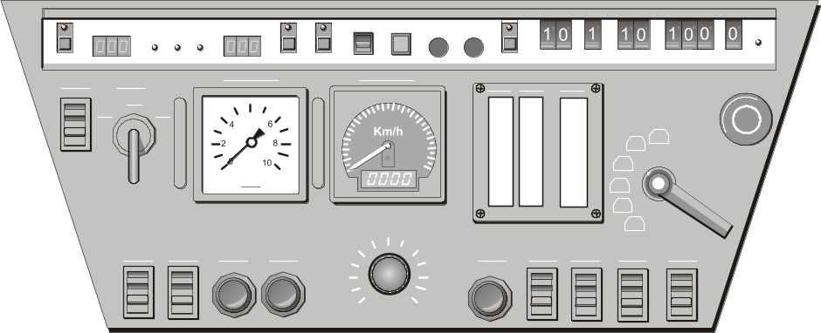
Figure 1. X2000 Instrument Panel
The X2000 cab displays include a combination of digital and analog formats. The brake pressure and current speed (the two largest displays on the instrument panel) are displayed on circular analog dials. The tractive effort and line voltage, displayed to the right of the speedometer and brake pressure gauge, are displayed on vertical linear gauges. For the ATC system to make its calculations properly, the engineer must enter the train’s length, maximum speed, braking capacity and brake delay via the thumbwheels located above and to the right of the line voltage gauge. The system indication panel to the left of the train control panel, shown in Figure 2, consists of twenty backlit, color-coded lamps, some of which must be interpreted in combination with information shown in the fault indication panel above the windscreen. The combination of display paradigms gives the impression of a system pieced together over time, and recent photographs of the X2000 cab look much like SJ cabs from the early 1980s.
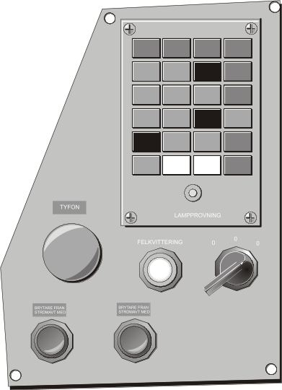
Figure 2. X2000 Fault Indication Panel
The item that stands out in comparison to other countries is the digital display of both the current and next block signal, in the upper left-hand portion of the display panel. Providing the next block’s signal allows the engineer more time to react to an upcoming signal change. However, the operator is still required to know the distance and time to the beginning of the upcoming block. The ATC system relies on engineer input of train characteristics, like the German system.

Japan
In Japan, high-speed trains (the Shinkansen) operate throughout the country on dedicated rights-of-way. There are five types of Shinkansen power cars in use and three different types of cab displays as shown in Table 2. The MON4 and MON10 displays are software-generated displays that give information regarding train location and speed, as well as a graphical representation of consist and brake status (see Figure 3 and Figure 4). The current speed limit is indicated by a lighted dot at the perimeter of the speedometer. Currently, the operator is given no information regarding braking distance, distance to the next block, grade, or other trains’ locations.
Table 2. Shinkansen Power Car Characteristics
Power Car | Production Date | Cab Display
200 | 1981 | MON1
400 | 1990 | MON4
E1 | 1993 | MON4
E2 | 1994 | MON10
E3 | 1994 | MON10

There has been a strong push for standardization of cab displays to improve the design and reduce operator confusion. Shinkansen guideways lack wayside signals. Instead, the current block signal is displayed on the dashboard. In 1995, JR East looked at how to best display the next block’s signal as well. JR East conducted extensive testing using surveys, simulations, and overlays of information in cabs in actual operation. JR East felt that giving the engineer more than two blocks of information was too much, as the engineer would not be able to use this information (Horiuchi, 1996). Consequently, they focused their efforts on how best to display the current and next block information.

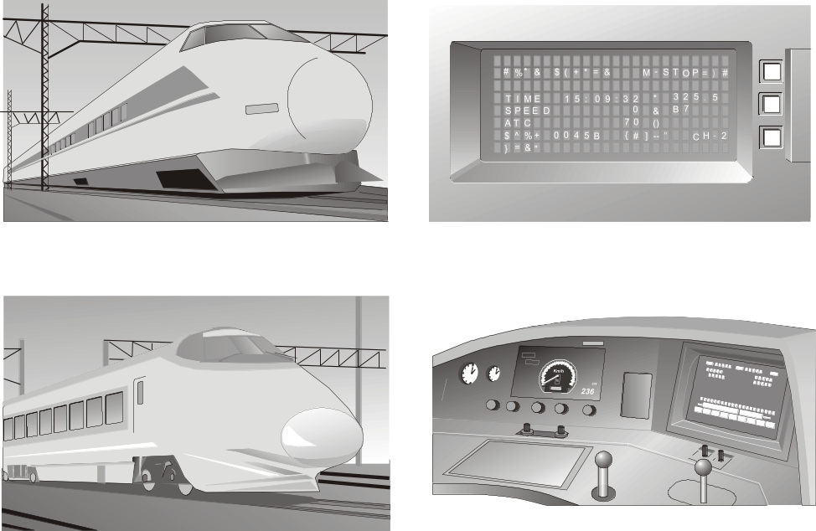

Figure 3. Shinkansen MON4 Display

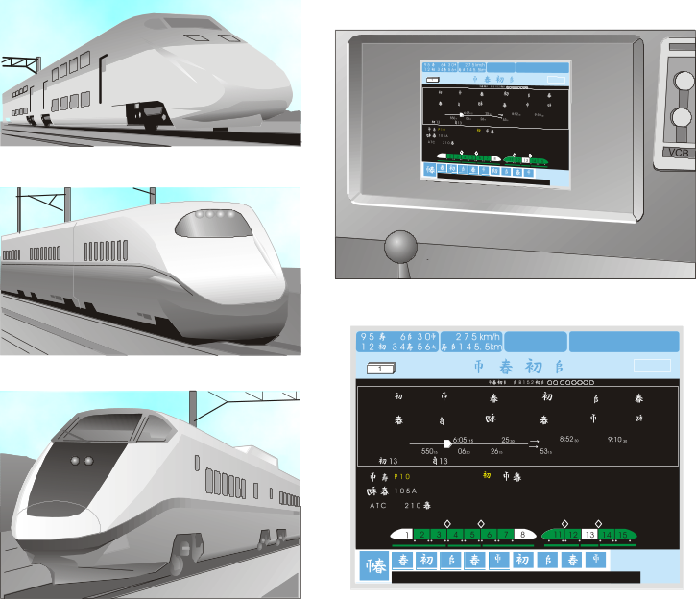

Figure 4. Shinkansen MON10 Display
Their preferred design does not show any block signals at all. Instead, the display contains a circular speedometer with a triangle around the perimeter that indicates the maximum speed for a given movement authority. The maximum speed will allow the operator to stop or decelerate so that the train remains within the limits of its authority for the next block. If the actual speed of the train is within a certain buffer range of this indicator, the signal turns yellow. If the actual speed exceeds the maximum safe speed, the signal becomes red and a penalty brake application is made. JR East also proposed a distance gauge that would show the distance between the operating train and the next train down the track.

France
In France, the Train à Grande Vitesse (TGV) high-speed trains operate partially on dedicated rights-of-way and partially on mixed-use guideways. The manufacturer of the TGV locomotives, Alstom, makes TGV-type locomotives for use in France and surrounding countries. Due to the differing operating environments, there are a several different cab environments on the TGV locomotives. The original TGV locomotives have a left-hand side operator’s position, while newer TGV locomotives have a central operator’s position originally designed to accommodate travel on foreign tracks where the traffic and signals may be either on the right-hand (e.g., Germany) or the left-hand (e.g., France and Belgium) side as shown in Figure 5. The SNCF locomotives use a wheel to control power output from the motors, while the locomotives for all other operators use a more conventional traction lever. The newer cabs with the central operator’s position have a much wider instrument panel area to accommodate the variety of signaling systems in use by the European railroads.
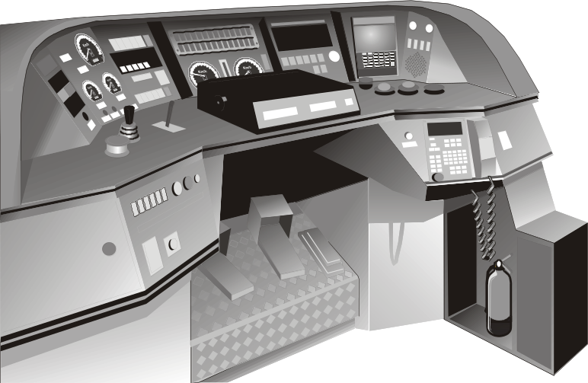
Figure 5. Interior of a TGV-PBKA Cab
Beginning with the TGV-A in 1988, TGV locomotives were equipped with an on-board data processing system for conducting train start-up tests, displaying equipment status, troubleshooting, or assisting with repairs. The data processing system interface consists of a recessed monitor and keyboard located to the right of and behind the traction control lever or wheel. Cab signals are displayed instead of wayside signals on the dedicated high-speed guideways. The cab signaling provides ten aspects. The engineer’s control task is made somewhat simpler by the fact that each block is of a uniform length (1¹/₃ miles or 2.1 km).
SNCF experimented with a “moving-block” train control system, named ASTREE, in which the train’s speed and location were calculated on-board and relayed to a central control area where the data is combined with those of other trains to calculate maximum safe (current) speeds. This project was halted and the data gathered were used, in part, to develop the European Train Control System (Jane’s World Railways, 1996). The ASTREE experiment focused more on the central control of the trains, rather than on the cab display of information to the operator. When it was developed, it represented one of the more complete implementations of advanced train control and data link communications. It included such items as a target speed, an updated schedule, and suggestions for energy savings (see Figure 6).
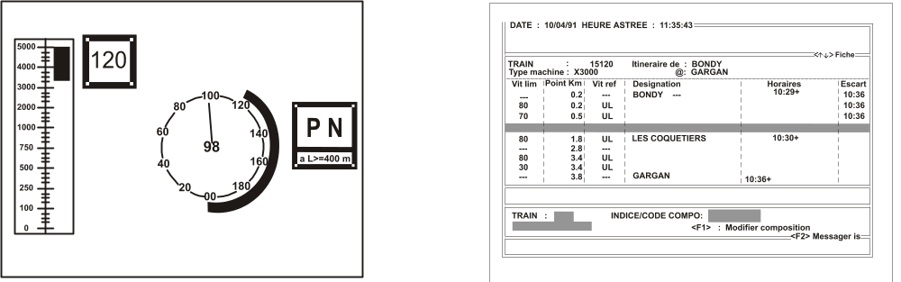
Figure 6. ASTREE Cab Display (de Curzon, 1994)

Germany
The German high-speed train system, the Inter-City Express (ICE), boasts the highest level of computer-aided support of any rail network, allowing manual control, partial computer-assisted speed control, and fully computer-assisted speed control (FRA, 1991b). During manual control, the train control system operates in the background. If the train reaches the nominal speed curve, a warning is given to the engineer. If the train reaches the monitored speed curve (i.e., that speed above which the train could not decelerate or stop in time), the emergency brakes are applied. Before each trip, the engineer must key in the train identification number, train length, and the status of the braking systems. During the trip, the engineer must input any changes in the braking capability of the train to allow the ATC system to make the necessary calculations accurately.
The cab displays consist of two analog circular gauges for speed and power in the middle of the dashboard with an angled software-generated display on either side (see Figure 7). One monitor provides braking information, while the other displays general diagnostic information.
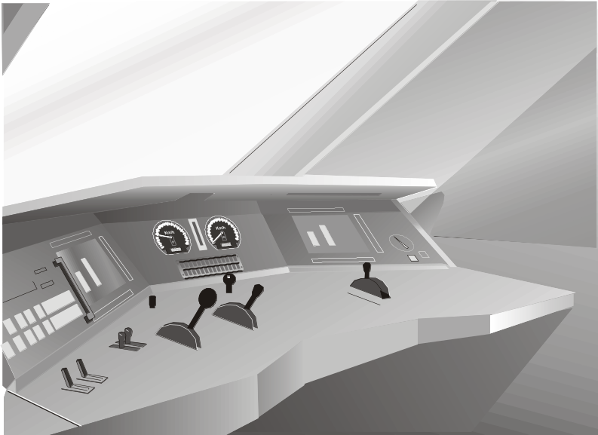
Figure 7. Interior of an ICE Cab
In 1991, DB instituted a new signaling scheme wherein the trackside signal displayed the aspect, the effective speed limit (in multiples of 10 km/hr), and the direction of divergence if approaching an interlocking. The signal indicated the status two blocks ahead of the train (Jane’s, 1996). Thus, the engineer was given greater time in which to react without transmitting any more information.
In 1995, DB began testing a high-capacity train control scheme based on fixed-block track. Computer Integrated Railroading (CIR) utilized shorter block lengths than used previously. Based on current train positions and speeds, a computer calculated minimum acceptable headways, which were then relayed to the cab of each respective train. No wayside signals were used.

North American Railroads
The AAR and RAC developed a comprehensive set of guidelines outlining their vision of positive train control called ATCS. ATCS used digital data communications and computers to manage and control the elements of the railroad. These elements included locomotives, track forces, field devices, the dispatch office, and railroad management systems (Moody, 1993). The goal of this system was to improve safety, efficiency, and customer service. These specifications were revised several times and several railroads implemented test beds of ATCS-style systems in various forms (Moody, 1990; Progressive Railroading, 1991).
One of the earliest examples was the Advanced Railroad Electronic System (ARES) developed by Burlington Northern Railroad (BN) in conjunction with Rockwell International and tested on the Minnesota Iron Range from 1987 to 1993. ARES was an ambitious train control project, encompassing automated traffic planning and assessment, computerized dispatching and record keeping, cab command and control, improved data links, automatic location and speed monitoring, and locomotive health and status monitoring (Ditmeyer and Smith, 1993; Moody, 1990). The ARES cab display, called the Train Situation Indicator, displayed route profile and alignment, grade crossing locations, sidings and other physical structures, and train movement authorities.
The FRA, Amtrak, the State of Michigan, and GE Harris-Harmon Electronics developed a system called Incremental Train Control System (ITCS) on a passenger corridor between Detroit and Chicago. The AAR, FRA, and the State of Illinois joined together to develop the North American Joint Positive Train Control System (NAJPTCP) for the Chicago – St. Louis, Illinois corridor. Lockheed Martin served as the contractor for this PTC system.
The ATCS guidelines provide for computer-assisted support of train control. While the locomotive engineer is nominally in control of the train, the computer-based train control system can override any engineer actions that would result in an unsafe situation. The ATCS specifications outline two types of cab displays. One display emphasizes train control parameters and the other displays track and movement authority information. These displays are shown in Figure 8 and Figure 9, respectively.
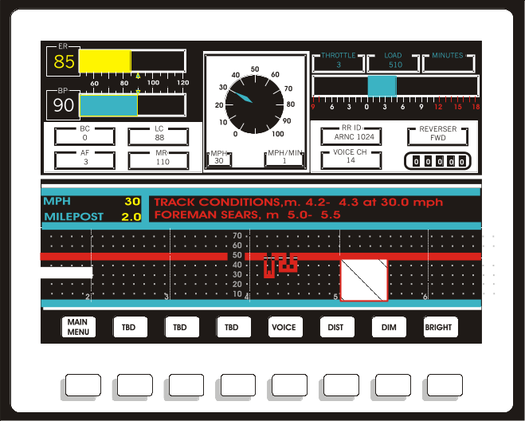
Figure 8. LSI (Train Control) Display
These guidelines designate what types of information are required and what information is optional. The guidelines discuss how these pieces of information should appear on the screen (see Figure 8 and Figure 9). The train control display indicates where each piece of information should appear on the screen and delineates an area for “optional” information, such as train control notices. The track authority display can be either graphical or text based. The suggested graphical track display incorporates many of the same concepts encompassed by Askey’s (1995) preview, predictor, and advisor displays.
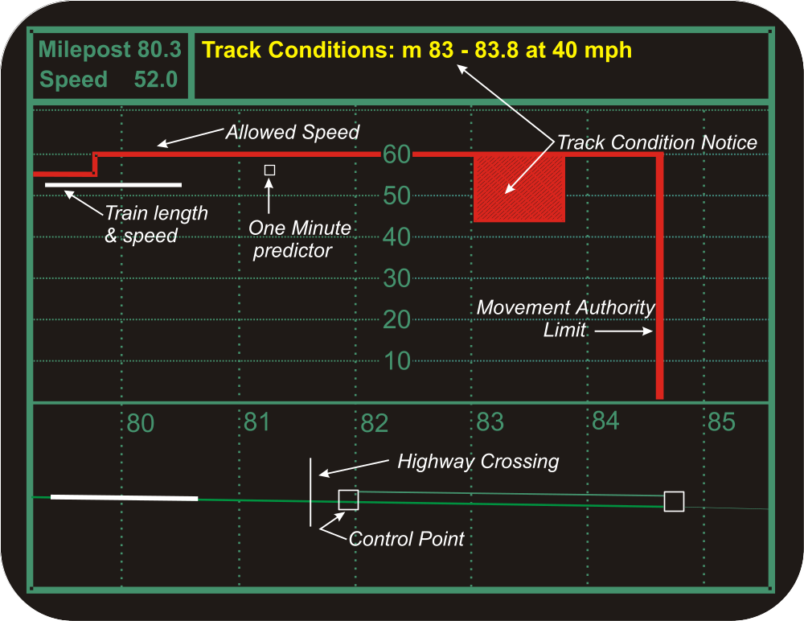
Figure 9. AAR ATCS (Track/Authority) Display

Tests performed at IITRI demonstrated increased safety and efficiency of train operation when the ATCS display was compared to the traditional paper warrants (Kuehn, 1992). These results show the promise of such decision aids.

Amtrak
Since the national 79 mph speed limit was instituted in 1947 (Wilner, 1994), the migration to higher speeds in the United States has been slow, consisting of incremental increases in maximum safe operating speeds. To travel above 79 mph, a train must be equipped with cab signaling or automatic train protection (ATP). Train control systems with ATP initiate a penalty brake application if the speed limit or movement authority is violated.

The Genesis Series II cabs, put into revenue service in 1995, marked the first use of software-generated displays used by Amtrak. The Genesis cab used a desktop style control stand and included three computer display screens (two for the engineer, and one for the conductor). The auxiliary function display is complex, with several menu-driven levels that can be selected using function keys. Figure 10 shows the primary display the engineers used in routine train control. The general response to both the cab and the display was positive. However, some engineers felt that the Series II displays were too “busy,” and that a circular speedometer (like the traditional circular analog gauges) was better than the linear version.

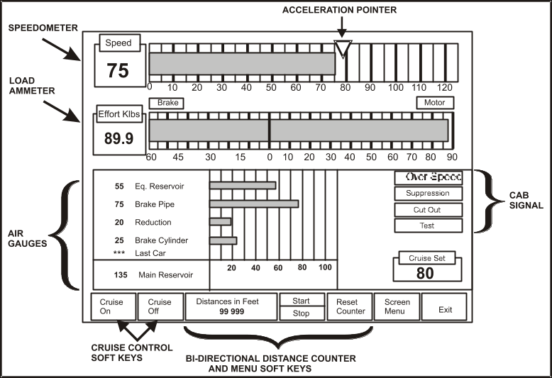
Figure 10. GE/Amtrak Genesis II Gauge Display

Summary
A wide variety of cab display paradigms were used in the countries operating high-speed trains. The differences that exist include many important aspects of train control and cab display design. The differences in information displayed include, but are not limited to: the kind of information provided (e.g., fault indication lights), the level or amount of information provided (e.g., one block or two blocks of signals), and the presentation of this information. For instance, Japanese engineers favor linear speedometers, while American engineers favor circular speedometers. Sweden presents the operator with the current and next block signals, while Japan and the United States only display the current block signal. Japanese and French railroads do not have wayside signals on high-speed corridors, while the United States and Swedish railroads do have wayside signals.
The variety of cab display conventions suggests a number of different avenues for research. Each country has its own convention regarding how train control information (speed, traction and braking) is displayed. This raises the question: to what extent does the way train control information is displayed (e.g., horizontal versus vertical, linear versus circular, etc.) affect how the engineer operates the train? Within a railroad, there is also variation within individual operators’ territory, with respect to signaling paradigms and display regimes. This variation has the potential to cause confusion among engineers who may have to operate a different locomotive (with different displays) on any given day. A uniform signaling system and as uniform a cab environment as possible would increase safety by reducing confusion and minimizing operator errors.
There also seems to be consensus among the railroads in the various countries operating trains at high speeds that the engineer needs information over and above the current block signal. However, nowhere is an engineer given any information about distance further ahead than the next block. The results of Kuehn (1992) suggests that preview information may be helpful not only for safety, but for efficiency as well. However, it remains unclear what level of preview, or how far down the track that information is provided, is most useful. The current research seeks to build on this knowledge regarding “preview information” by specifically examining the length of preview on locomotive engineer performance.

SIMULATOR EXPERIMENT

Overview
This experiment examined the differences in safety and efficiency of train operation that might arise by using displays with and without preview information. Information that is helpful to the engineer may include upcoming speed restrictions, location and velocity of nearby traffic, and upcoming distance cues (such as mileposts). This information was included in an experimental display. This display was compared to the Genesis II display used in Amtrak locomotives. The Genesis II display shows in-cab signals, but does not provide preview information.
To investigate these questions, an experiment was run on a human-in-the-loop locomotive simulator, using locomotive engineers and students. A second goal of the research was to compare the performance of engineers and non-engineers. Previous studies using the locomotive simulator were conducted using only students as participants. Can the results of these studies be applied to locomotive engineers? Evaluating performance for both groups allows better understanding of the benefits and limitations of using students in a job that requires a high level of training to become proficient.

Locomotive Simulator
The simulator consists of three networked Silicon Graphics computers and one Windows-based computer. When operating the train, the participant sat in a simulated locomotive cab, which included a 17-inch display monitor (showing the computer-generated instrument panel), one control box on either side of the monitor, and a window through which the participant viewed a computer-generated image of the out-the-window (OTW) view on a 6-by 4-foot screen. The participant communicated with the dispatcher by two-way radio. Track and engine noises tied to the simulation were broadcast via speakers in the cab. Figure 11 shows a photograph of the cab environment. The two control boxes on either side of the monitor governed the emergency brake, doors, cruise control, alerter, overspeed warnings, bell, horn, and circuit breakers. A separate workstation functioned as the dispatcher’s workstation, allowing the dispatcher to control all the switches and authorities. In these experiments, the experimenter performed the duties of the dispatcher. See (Lanzilotta, 1996) and (Askey, 1995) for further descriptions of the locomotive simulator.
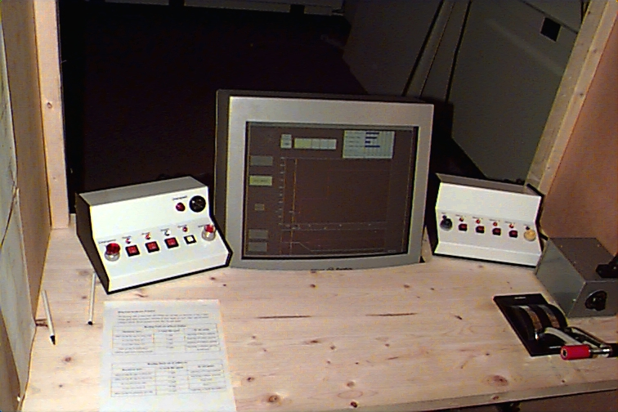
Figure 11. Simulated Locomotive Cab

Experimental Design

Independent Variables
The independent variables manipulated were preview distance and participant type. Two displays were used to show the different preview distances. The baseline display was a mock-up of the Genesis II display, shown in Figure 12. This display showed only the current block signal (no preview information) in the form of a location-coded signal and digital readouts of the civil and signal speed limits. The other display conditions were all variations of one experimental display that showed the same brake, traction and warning information as the Genesis II display, but also contains speed-by-distance and traffic preview information as shown in Figure 13.
The large window in the middle of the preview display showed the upcoming speed restrictions. The horizontal axis scaled with distance, while the vertical axis scaled with speed. The vertical white line in this portion of the display indicated the current train position, while the short horizontal white line emanating from the vertical white line indicated the train’s length as well as its speed. The horizontal and vertical red lines indicated the maximum allowable speed at that location.
If the white horizontal bar indicating the train’s current location was above the red line, the train was violating the effective speed limit. Mileposts, switches, and stations were indicated just below the speed preview window, above the track preview display (described on the next page).
The preview displays also displayed predictive full-service and emergency braking curves. The yellow curve indicated the speed profile for a full-service brake application. The red curve indicated the speed profile for an emergency brake application. The green curve indicated the speed profile for the coming 25 seconds given current grades and control input. As the amount of power or braking changed, the predicted trajectory changed accordingly.
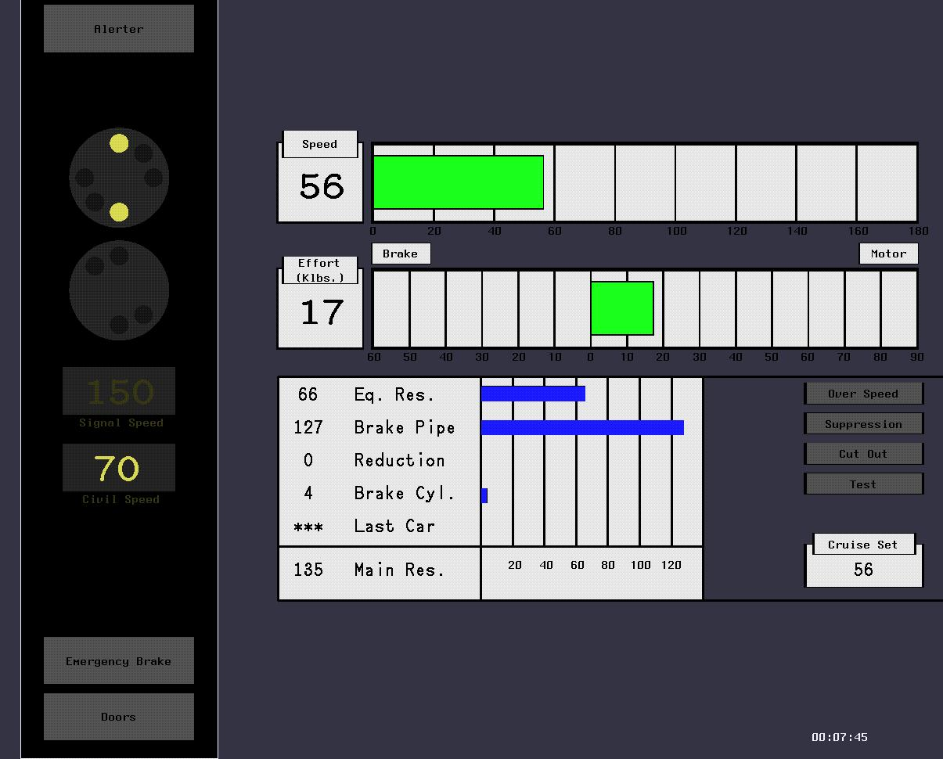
Figure 12. Genesis II Locomotive Display
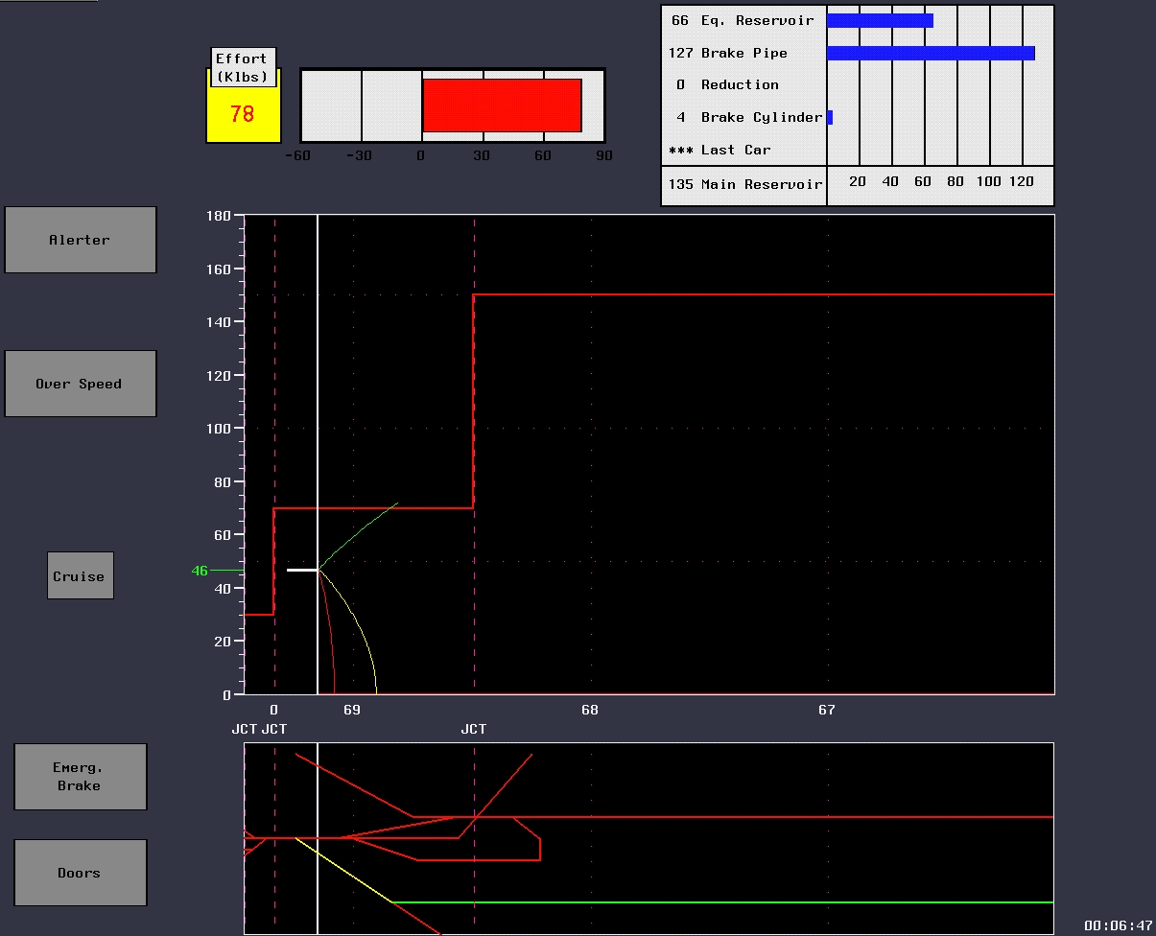
Figure 13. Preview Display
The smaller window below the speed preview window shows the upcoming track structure and authorities. Green indicated authority to move in that portion of track, while red indicated a lack of authority. The horizontal (distance) axis is on the same scale as the speed preview sub-display, and the same milepost, switch, and station indications apply.
Preview distance was controlled by varying the resolution of the horizontal (distance) axis on the speed and traffic preview sub-displays to control how far down the track the operator can “see.” One hypothesis was that the stopping distance is the most influential factor when considering how far down the track the engineer needs to be able to see. Thus, one preview condition (variable preview) was a function of stopping distance at full-service braking and “reaction plus decision” distance (approximately reaction time plus “decision time” multiplied by current speed, ignoring acceleration during that same time period). As the train’s speed increased, the preview distance provided to the engineer increased accordingly. The variable preview display always provided the status of the track at least some distance ahead of the end of the full-service braking predictive curve (i.e., the resolution of the horizontal axis decreased, as the display provided information about the status of the track further ahead of the train’s current location). This “variable preview” display had 1,640 feet as the minimum preview offered at low speeds. The other (fixed) preview distances (see Table 3) were zero, 1.4 miles (approximately two blocks, mimicking the level of information now available in Sweden), and 3.4 miles (which is higher than the longest variable preview distance expected at the top speed of 150 mph). Each preview display shows the track about 0.3 miles (1,640 feet) behind the train as well.

Table 3. Independent Variables
Participant | Preview Condition
Engineer | Current block only (no preview) | 1.4 miles (2.24 km) | 3.4 miles  (5.6 km) | Variable
Student | Current block only (no preview) | 1.4 miles (2.24 km) | 3.4 miles  (5.6 km) | Variable

Dependent Variables

Speed Control
Speed control was defined here as the ability to maintain or stay below the permitted speed, once that speed has been reached. A violation of this requirement could take place during a clear signal, when the civil limit must be obeyed, or it could take place during a restricted signal, once the speed required by that limit had been achieved.
Speed control was monitored by collecting data on the train speed relative to the allowed speed. Locomotive engineers were expected to keep their trains within a certain range of acceptable values. The operator was allowed to drive up to 4 mph above the speed limit without penalty. If the train operated more than 4 mph over the limit longer than 5 seconds, a penalty brake application (full-service brake application) was initiated by the train’s ATP system. Control of the train was not returned to the participant until the train’s speed was brought below the speed limit. The simulator automatically recorded the duration of any overspeed, as well as the number of penalty brake applications.

Signal Adherence
A task similar to speed control was signal adherence. Violating a movement authority (i.e., running past a red “stop” signal) or a missed signal (i.e., passing a signal at a speed higher than indicated by the signal) is also speed violation (i.e., the train speed is greater than the speed limit). Although the outputs (engineer actions) of these two control tasks were similar, the inputs and decision processes were different. When controlling the speed under a constant speed limit, the engineer must decide (based on the operating conditions) whether to apply the throttle or the brake. When adhering to an (upcoming) signal change, the engineer must decide at what point to apply the brakes. In the former (i.e., speed control) case, the engineer risks overshooting or undershooting the target speed. At most, the initial overshoot will be just greater than zero, as the train must first cross the speed limit before surpassing it. In the latter (i.e., signal adherence) case, the engineer is at risk of severely overshooting the upcoming signal if the brakes are not applied in time. The initial overspeed could be significant relative to the new speed limit.
Signal adherence was measured by the number of signal violations (i.e., entering a block with a speed greater than that block’s limit) and the magnitude of each violation.

Brake Reaction Time Latency
Brake reaction time latency to failure scenarios (i.e., a car stuck in a grade crossing or a dropped signal) was monitored by recording reaction times to take action in response to a “failure” event (i.e., the distance between the train and the event, such as a signal or a car stuck in a crossing). The time of the event was automatically recorded in the data log. If the response fell within the domain of predictable actions, it too was recorded. The reaction time was measured from the time between the event and the initiation of the participant’s response.

Schedule Deviation
Schedule deviation was measured by the difference between the expected arrival time at each station and the actual arrival time at each station.

Station-Stopping Accuracy
Station-stopping accuracy was measured by comparing the participant’s actual stopping location at each station relative to a pre-defined mark (the end of each station platform). In passenger operations, station-stopping accuracy is an important part of the engineer’s job. An inaccurate stop may require the conductors to perform extra work and may force the passengers to lug their bags to different exits.

Task
Each participant operated the locomotive simulator on a section of track modeled after a trip from South Station in Boston, Massachusetts to Attleboro, Massachusetts. The trip included two intermediate stations (Sharon and Foxboro). The time between each station averaged 12 minutes, bringing the total travel time to approximately 37 minutes. The participant’s task was to operate the train, given the schedule constraints and operating conditions. The participant encountered a variety of disturbances, as described in Table 4. The trip between Boston and Attleboro was divided into three legs (from Boston to Sharon, from Sharon to Foxboro, and from Foxboro to Attleboro). The participant encountered disturbances in two of these three legs.
Table 4. Operating Disturbances
Disturbance | Description
1 | Take a siding or crossover to a parallel track due to an unexpected train moving in the opposite direction.
2 | Respond to an unexpected change to a restricted signal (i.e., a “stop” signal).
3 | Respond to an unexpected change to a restricted signal (i.e., a stop signal due to a relay failure).
4 | Respond to a temporary speed restriction.

With four different values for the independent variable (no preview, variable preview, 1.4 miles, and 3.4 miles) and two disturbances per trip, each participant ran one trip with each display and saw eight disturbances: two on each display. With four different types of disturbances, each participant encountered each type of disturbance twice. Thus, each participant experienced four Boston-Attleboro trips (two round-trips), making each trip with a different cab display. After completing both trips, each participant completed a questionnaire and answered questions to collect opinions about the effectiveness of each display.

Participants
Three Amtrak locomotive engineers and six MIT students participated in this experiment. The locomotive engineers were three males with between 10 and 29 years of service as engineers. All engineers worked as passenger train engineers, with some freight experience mixed in. The youngest engineer was 45 years old. The six students consisted of four current MIT students and two recent graduates. The students were males between 19 and 23 years old. None of the students had any experience operating trains.
The presentation order of the displays and the disturbances was counterbalanced across participants. The experiment was originally designed to use an equal number of locomotive engineers and students. However, only three of the proposed six Amtrak engineers were able to participate in the time allotted to running experiments, due to scheduling difficulties. Therefore, the counterbalanced design was incomplete for the locomotive engineers.

Training
Due to the two groups’ varying experience with train control (greater for the engineers) and working with computers (greater for the students), the training regimens were different for the two groups. Training procedures for students were developed during the previous two experiments using the locomotive simulator (Askey, 1995; Lanzilotta, 1996).

Student Training
Each participant was given a written tutorial of train control and simulator operation issues to read before arriving for the first session. After reviewing the material, the participant answered 25 multiple-choice questions. After reviewing incorrect answers with the participant and answering any questions, the experimenter led the participant through one trip between South Station and Attleboro (lasting approximately 1 hour). The participant saw each of the displays to be used during the experiment. The experimenter demonstrated all train control modes, how to communicate with the dispatcher, and the meaning of each piece of information displayed on the monitor. After answering all questions, the participant practiced operating the train on five trips (lasting approximately 4 hours) between Boston and Attleboro. During the first leg, there were no disturbances. The next four legs had at least one of the disturbances.

The student’s performance with respect to schedule adherence, station-stopping, signal adherence and speed control was measured. If a student consistently performed at an acceptable level by the end of the second full round-trip, the training was terminated at the end of that trip and the experimental trials began. Four of the six student participants completed the training by
the end of the second full round trip. If the student performed at an unacceptable level by the final training trip, the student’s participation ended. All students completed the training successfully.

Engineers
Although the locomotive engineers had extensive experience operating locomotives, they still needed a significant amount of time to learn how to operate the locomotive simulator and become familiar with the operator interface. The locomotive engineers were given a short version of the tutorial to read. The locomotive engineers were given an opportunity to review the material with the experimenter and ask questions.
Each engineer’s participation lasted one full day. The engineers’ training sessions consisted of an instructional portion and a test portion. During the instructional portion, the participant saw each of the displays and each of the disturbances while being talked through the operation of the train by the instructor. The instructional portion lasted 1 hour. The engineer practiced operating the train on three trips with disturbances (lasting approximately 2 1/2 hours) to become familiar with train operation.

RESULTS AND DISCUSSION

Speed Control
Table 5 shows the frequency of speed violations by display condition. The student group averaged 1.66 instances of speeding (ten events), while the engineer group averaged 1.33 instances of speeding (four events). The largest number of speed violations occurred in the no-preview display condition. The number of speed violations in the no-preview condition was greater than with all preview displays, combined. This result suggests that speed control was more difficult using the no-preview display.
The minimum overspeed using three of the four displays was just over four mph. The ATP system in the locomotive simulator allowed a “buffer” zone of four mph over the effective speed limit before any warning or punishment was given.
Table 5. Frequency of Speed Violations by Display Condition
 | Preview Condition
 | None | 1.4 Mile | 3.4 Mile | Variable
Speed Violation Frequency | 8 | 2 | 3 | 1

In five of the six speed violations in the preview conditions, students were approaching the point where the civil speed limit increased and were accelerating before entering the block with the higher speed limit. These five violations lasted from 0.1 to 5.1 seconds, and the maximum speed violation reached as high as 12.7 mph above the speed limit. One possible conclusion to draw from this behavior is that they were anticipating the speed limit increase shown on the preview display. Participants may not have built up enough knowledge of the territory to know exactly how far away the point was from where the civil limit increases, whereas (in real train operation) locomotive engineers know that information readily.
The other eight instances of speeding occurred with the no-preview display. Routine speed control may be harder with the no-preview display than with the preview displays. Despite their practice runs, all of the engineers expressed difficultly in controlling the train without any previous knowledge of the train’s braking and acceleration characteristics. This difficulty was exacerbated when using the no-preview display.

Signal Adherence
Signal adherence here refers to the operator’s ability to control the train’s speed in response to unexpected signal changes. Table 6 shows the speed adherence performance of the two groups by display condition. Students and locomotive engineers performed similarly, with the most signal overruns in each group occurring in the no-preview display condition. Performance with regard to red (“stop”) signals, however, was nearly identical between the two groups and across the different display conditions.
Table 6. Signal Adherence by Preview Condition
 |  | Preview Condition
 |  | None | 1.4-mile | 3.4-mile | Variable
Students | Average Number of Signal Violations | 6.3 | 4.2 | 2.8 | 3.5
 | Average Length of Signal Overrun (ft) | 1943 | 1890 | 2318 | 1890
 | Average Initial Speed Deviation (mph) | 44.8 | 57.7 | 70.1 | 70.2
Locomotive Engineers | Average Number of Signal Violations | 7.3 | 5 | 4.6 | 1.66
 | Average Length of Signal Overrun (ft) | 1890 | 1352 | 2466 | 2091
 | Average Initial Speed Deviation (mph) | 32.4 | 48.5 | 59.1 | 68.1

The data indicated similar performance for the two groups with respect to signal adherence. Students violated an average of 16.8 signals while engineers violated an average of 18.6 signals. Both groups violated the most signals in the no-preview display condition.
The average speed of the signal violation was lowest with the no-preview display and the 1.4 mile fixed preview display. This result was surprising given the hypothesis that greater preview distance should give the operator time to respond to a signal change. One explanation is that the participants braked less aggressively with the longer preview displays because they could see the distance in which they had to slow down, whereas with the no-preview display, they did not know when the next more restrictive signal would come. Locomotive engineers knew what each signal indicated about the possible signal levels for the next block and adjusted their speed accordingly. For instance, if the signal for the current block was 45 mph (approach medium) for the current block and 30 mph (approach) for the next block, the engineer may not slow the train down immediately saving some trip time. However, the participants were not familiar enough with the block and signal locations in the simulation to exhibit this behavior.
One of the most dangerous situations in operating a train occurs when passing a red signal. Table 7 shows the average overrun by display condition. There were 17 red signal violations between both groups. The results were similar for the two groups. In every case, the signal turned red within the participant’s visual range. In every case, the participant was unable to stop the
train in time to comply with the signal. Overall, there was little difference between the preview and no preview displays.
Table 7. Stop Signal Overruns
 | Preview Condition
 | None | 1.4 Mile | 3.4 Mile | Variable
Mean Red Signal Overrun (ft) | 3623 | 3400 | 3487 | 3274

During the experiment, it became clear that the engineers did not treat signal limits as absolute. Railroad operating rules provide a margin for error so that the engineer could operate a few miles above the posted speed limit without being in violation of a movement authority. Operating a train at speeds greater than indicated by the signaling system was not viewed as a safety hazard or as a poor reflection of the operator’s abilities.

Brake Response Latency
Table 8 shows the time between the first restricted signal passed and initiation of braking for two signal conditions. In the static signal condition, the red signal was set from the beginning of the trip. In the dynamic signal condition, the signal was set when the train was within a few miles of the signal. Negative numbers indicate that braking was initiated before passing the signal while positive numbers indicate that braking was initiated after passing the signal. The more negative the number, the greater the “cushion” between the act of braking and the more restrictive speed required by the non-clear signal. Performance was not a function of preview distance. Response latencies were shortest with the preview displays than the no-preview condition.
Table 8. Mean Brake Response Latency (s) to Restricted Signal
 | Preview Condition
Signal Type | None | 1.4-mile | 3.4-mile | Variable
Static | 1.7 | -18.3 | -5.7 | -23.4
Dynamic | 1.87 | 1.32 | .03 | -2.51

Participants performed best with the variable preview display followed by the 1.4-mile display and the 3.4-mile display. Although the trend was the same for both static and dynamic signals, the preview displays offered fewer benefits in the dynamic signal condition. The response latency was considerably smaller for the variable display and 1.4-mile display conditions.

Schedule Deviation
Schedule adherence is one of the measures by which passengers judge railroad service. Table 9 shows the schedule deviations by display condition. Very few schedule delays occurred for trips
that lacked signal changes. Each participant arrived early at the next station almost every time. The early arrival was related to the time given to get to the next station. As the time given to get to the next station increased, the size of the early arrival increased. Although the participants knew that they would be penalized for arriving at a station too early, almost every trip without a signal change resulted in an early arrival. When a participant encountered a signal change, time was invariably lost, and the schedule could no longer be met, so those situations were not considered. The experimenter asked each participant to try to maintain the time differential between stations set by the schedule (e.g., “Always leave 13 minutes to get from Sharon to Foxboro, even if you are behind schedule.”) However, participants consistently did not follow this instruction. The participants may have misunderstood this instruction, forgot the instruction, or tried to make up for lost time.
The data were inconclusive with respect to the impact of preview information on schedule adherence.
Table 9. Schedule Deviation by Display Number for Trips without a Signal Change
 |  | Schedule Deviation (s)
 |  | Preview Condition
Track Segment | Schedule (s) | None | 1.4-mile | 3.4-mile | Variable
S. Station to Sharon | 420 | 28.2 | 66.6 | 9.0 | 31.2
Sharon to Foxboro | 780 |  | 25.2 | -3.0
Foxboro to Attleboro | 960 | 46.2 |  | 56.4 | 67.8
Loop | 90 | 18.0 | 21.0 | 17.4 | 19.8
Attleboro to Foxboro | 960 |  | 58.2 | 69.6
Foxboro to Sharon | 780 |  | -0.6 | 0.6
Sharon to S. Station | 480 | 31.8 |  |  | 34.8
Mean Absolute Deviation |  | 31.1 | 34.3 | 26.0 | 38.4

Station-Stopping Accuracy
The locomotive engineer must be able to accurately stop at a particular point in the station to allow passengers to get out at the correct door. The inability to achieve such a stop smoothly and on the first attempt may result in excess fuel consumption, passenger discomfort, aggravation, or all of above which reflects negatively on an engineer’s performance. The participants were instructed that deviations between –32.8 ft and +19.7 ft were acceptable, and that overshoots were penalized more than undershoots (the engineer can always inch the train forward, but backing up is much more difficult and sometimes prohibited). The locomotive engineers experienced more trouble stopping accurately at the stations than the students. They indicated that this was due to a lack of experience with the train handling characteristics (i.e., the braking and acceleration of the train) and the territory. Variation in performance between the displays
was low, as shown in Table 10. There was qualitative data both in favor of and against the preview displays regarding this task.
Table 10. Mean Station-Stopping Accuracy (ft) by Group
 | Preview Condition
Group | None | 1.4-mile | 3.4-mile | Variable
Student | 11.5 | 15.7 | 10.5 | 11.8
Engineer | 21.3 | 21.3 | 16.1 | 13.5

The data presented in Table 10 indicate that preview information has little or no effect on stopping accuracy. Some participants reported trouble stopping accurately with the preview displays. One locomotive engineer misjudged the braking distance to the end of a station platform by looking at the display and used the emergency brake. An emergency brake application in a non safety-critical situation would be considered poor operating practice. The participant was using the 3.4-mile fixed preview display, which offered poor resolution for accurate stopping at low speeds. Several other participants, both students and engineers, also reported trouble using the fixed-preview displays for accurate station stopping. These comments support the assertion that the preview displays were poorly suited for aiding accurate station stops. The variable preview display was also considered difficult to use. Several participants expressed their dislike for the constant recalculation of the scale on the variable-preview display. This observation suggests a display in which the display scale continually changes may be difficult to use.
One possible solution is to change the scale of the preview displays at lower speeds to show a smaller portion of the track in greater detail. Simply looking out the window may provide the best source of information to stop or control the train at very low speeds.

Comparison Between Engineers and Students
The performance between the students and locomotive engineers showed mixed results. The two groups performed similarly on speed control and signal adherence and differently on initiating a braking response to a restricted signal and station-stopping accuracy.
The students performed consistently better than the engineers with regard to station-stopping accuracy. The engineers said that their lack of experience with the train’s dynamics and the track features adversely affected their performance. The simulator’s train dynamics were modeled after the TGV, a locomotive with which the engineers were unfamiliar. The engineers operated locomotives like the General Motors SD40 that had braking and acceleration characteristics that were considerably different from the TGV locomotive. Locomotive engineers learn the characteristics of the territory over which they will operate over a considerable period. This knowledge is critical to successfully stopping a train at a station. However, the locomotive engineers had only an hour or two to become familiar with the train handling characteristics and the territory. The students received more training time to learn to operate the train and become familiar with the territory. These difficulties could be addressed by modeling the dynamics of a
train with which the engineers were familiar and displaying features in the out-the-window view that exist on the territory over which the engineers operate.
The engineers and students also differed in their initiation of braking in response to a restricted signal. Table 11 shows mean braking response latency for both groups. Negative numbers indicate that braking was initiated before passing the signal. Positive numbers indicate that braking was initiated after passing the signal. The more negative the number, the greater the “cushion” between the act of braking and the onset of the more restrictive speed. The students began braking earlier than the engineers in all of the preview display conditions and later in the no-preview condition.
Table 11. Mean Brake Response Time (s) by Group
 | Preview Condition
Group | None | 1.4-mile | 3.4-mile | Variable
 | Expected (Static) Signal
Engineers | 1.4 | -15.7 | -4.5 | -19.1
Students | 1.8 | -20.0 | -6.2 | -27.7
 | Unexpected (Dynamic) Signal
Engineers | 1.6 | 1.5 | 1.2 | -0.3
Students | 1.9 | 1.2 | -0.7 | -3.4

These differences may reflect differences in the attention allocation strategies between the two groups. The engineers obtain information by looking out the window to determine when to brake. Focusing their attention out the window is also important to look out for hazards such as trespassers and motor vehicles in grade crossings. With less experience operating trains, the students may have had more difficulty determining when to initiate braking in the no-preview condition. In the preview conditions, the students may have relied more heavily on the braking information supplied by the preview displays to determine when to brake.
The difference in the engineers’ reaction times between the no-preview and preview displays makes sense in light of the engineers’ expressed need to focus attention out the window, thus keeping their attention away from the tool that would allow them to react sooner. The students were not trained to focus their attention out the window and were able to more quickly respond to events in the cab.

SUMMARY
As trains travel faster, locomotive engineers must process more information in less time. Providing information far enough in advance to process and take action may enable the locomotive engineer to more safely operate the train at high speeds.
In this study, the preview displays improved performance on tasks where the locomotive engineer’s train control actions were made in advance of the visual information needed to support those actions. Preview information may prove most valuable to engineers learning to operate in an unfamiliar territory or in conditions such as poor weather where the visual information that the engineer normally relies upon is unavailable. One engineer said that, while he liked the preview display, the extra information provided would not have been necessary had he better known the “physical characteristics” of the train and territory.
More specific results include:
- Routine speed control under a static signal was improved with the preview displays, though again, it is unclear whether this difference would exist for the locomotive engineers if they were more familiar with the territory and train’s dynamics.
- The number of signal overruns decreased with preview information.
- Braking response time improved with the preview information, particularly with the variable preview display.
- Preview information did not seem to influence station-stopping accuracy, though the 1.4-mile (shorter) fixed preview display resulted in station stops that were more deviant than with the other displays. There was qualitative data supporting each of the types of display with respect to station stopping. All of the preview displays received high marks for providing good information regarding stopping distance from higher speeds, while the variable preview display also received praise for increasing the resolution at lower speeds, thereby allowing more accurate stops.
- Among the preview displays, performance with respect to signal overruns was poorest with the 3.4-mile fixed preview display.
- Participants demonstrated an easier time making control decisions in the variable preview condition. They exhibited the best braking performance using the variable preview display, when exposed to an expected (static) or unexpected (dynamic) signal. Participants using the 1.4-mile fixed preview display performed better when faced with an expected signal than when using the 3.4-mile fixed preview display. When faced with an unexpected signal, the opposite result occurred. Participants performed better using the 3.4-mile preview display than the 1.4-mile preview display.
Qualitative data from this study supports the quantitative data described above that long preview or preview that scales with speed (offering greater resolution at lower speeds) is preferable. As one participant put it:
The 3.4-mile preview display made control easiest. The reason I felt variable preview was a little less effective is because you (the operator) [sic] had to scale distances as a part of the interpretation. It took some getting used to. The 1.4-mile display was my least favorite of the preview displays because you could not see the entire predicted braking curves at high speeds.
When asked what preview distance would make the job easiest, most of the participants responded “as much as possible” or referred to either the 3.4-mile fixed preview or the variable preview, while one engineer responded “5 to 10 miles.” Another engineer responded, “No preview is needed if you know the physical characteristics [of the train and track],” though a much higher processing burden is then placed on the engineer, particularly in critical situations. In general, preview distance should be at least the minimum stopping distance plus some buffer distance to account for reaction time.
The Amtrak engineers reacted favorably to the preview displays, particularly since they “helped learn the territory.” It is unclear whether the engineers would have found the preview displays as useful if they already knew the territory and the train’s dynamics. In low visibility conditions where locomotive engineers cannot rely on the normal visual cues, a preview display may prove beneficial.
In designing such information aids, particular attention needs to be paid to how engineers allocate their attention. The engineers who operated the locomotive simulator liked the preview displays and performed well with them. One engineer indicated that the preview displays aided navigation in unfamiliar territory and were useful to see the rate of deceleration relative to distance.
However, two of the engineers stressed their need to focus attention out the window. One engineer complained about the amount of “electronic harassment” in modern locomotive cabs precluding engineers from focusing their attention out the window. That engineer said that the engineer’s attention is not necessarily needed to brake in time for a potential emergency, but rather to be able to blow the horn in time in such a case, or to accurately control the train when approaching a station platform. In fact, this participant related that many engineers “cut out” (turn off) the cab signaling and ATP in low-speed territory to remove the “distraction” of the warnings and focus their attention on very fine control of the train’s speed. However, the danger is that they forget to cut it back in when they return to high-speed territory.
With regard to station stopping accuracy, there was evidence that the preview displays adversely affected performance, due to the lack of resolution at lower speeds. The best information to support station stopping is to look out the window. To aid station stopping, the preview display needs to show enough detail for a locomotive engineer to properly judge stopping distance.
Research is needed with regard to how this change of resolution should take place (e.g., continuously or discretely). One way to investigate this question is to allow the engineer to control the preview distance and record what is chosen as a function of speed. Future work should focus on how locomotive engineers allocate their attention, and on how to effectively incorporate decision aids and training for those aids into that attention allocation scheme.
The data indicate that the student and engineer groups exhibited similar behavior in a relatively limited range of conditions. The two groups exhibited similar behavior towards signal adherence and speed control. This data suggests that previous experiments using students as participants may give similar results using locomotive engineers under two conditions: When locomotive engineers are inexperienced and when the visual information engineers rely upon to make decisions is impoverished. Otherwise, the training and operating experience of experienced locomotive engineers results in behavior that differs from those of students and others who lack this experience.

APPENDIX A: TRAIN SCHEDULE
The following page lists the train schedule used by the subjects in the preview display experiment.

Train Schedule
Time | Station
00:05:00 | Depart South Station
00:12:00 | Arrive Sharon
00:12:30 | Depart Sharon
00:25:30 | Arrive Foxboro
00:26:00 | Depart Foxboro
00:42:00 | Arrive Attleboro (southbound)
00:42:30 | Depart Attleboro (to loop)
00:44:00 | Arrive Attleboro (northbound)
00:44:30 | Depart Attleboro (for South Station)
01:00:30 | Arrive Foxboro
01:01:00 | Depart Foxboro
01:14:00 | Arrive Sharon
01:14:30 | Depart Sharon
01:22:30 | Arrive South Station

Note: If you are behind schedule, you still must keep the train doors open for at least 30 seconds at each stop.

APPENDIX B: EXIT QUESTIONNAIRE
The questionnaire on the following page was given to the experimental subjects after the test sessions had been completed. The answers provided on this questionnaire were used to determine the subjective evaluation of the instrument panels.
Exit Questionnaire
1. Rate the displays in order of preference by placing a mark in the appropriate box:
 | Liked very much | Liked | Neutral (didn’t like or dislike) | Didn’t like very much | Didn’t like at all
no preview
1.4 miles (fixed) preview
3.4 miles (fixed) preview
variable preview

2. Rate the displays according to how difficult/easy it was to control the train:
 | Controlling train was very easy | Controlling train was easy | Controlling train was not easy or hard | Controlling train was difficult | Controlling train was very difficult
no preview
1.4 miles (fixed) preview
3.4 miles (fixed) preview
variable preview

3. Do you feel that the training process provided adequate preparation for the test task?
____ adequate training
____ too little training Explain:
____ too much training Explain:
4. How much preview distance (if any) would make the task of train control easiest?
5. Any other comments? (Critical comments are appreciated. Feel free to make comments on the attached pictures.)
APPENDIX C: FUTURE LOCOMOTIVE SIMULATOR CONSIDERATIONS
One of the goals of this research project was to obtain feedback from Amtrak locomotive engineers about the realism of the locomotive simulator. Previous research with the simulator was done using MIT students as participants. Consequently, previous versions of the simulator utilized simplistic track networks and unrealistic control paradigms, such as an alerter whose time interval was independent of speed, fictitious signal systems, and penalty applications of the emergency brake.
Throughout the course of this study, two employees from the Volpe National Transportation Systems Center with prior rail experience and four Amtrak locomotive engineers operated the locomotive simulator. During and after each of these sessions, the participants’ reactions to various aspects of the simulation were collected. Some of these comments were acted upon immediately to improve the simulator’s realism. A plethora of comments, suggestions, and critiques resulting from these experiments, however, have not yet been acted upon. Many of these suggestions would significantly enhance future simulations by making them as realistic as possible.
In general, creating a track structure that more closely represents an actual environment in which locomotive engineers operate offers several benefits. First, less training would be required for the engineers. The engineers would need the same amount of time to learn the operation of the simulation itself, but would not have to learn braking points and other reference cues. Second, the closer the simulation is to an actual rail environment (with respect to both the physical fidelity as well as to the system response to control inputs) the closer a locomotive engineer’s actions will be to what they would be in the actual rail environment. One of the engineers indicated that he would have driven differently had he known the territory better (e.g., he would not have been focusing on the display, but rather on the out-the-window cues). Two engineers indicated that they preferred the preview displays over the no-preview display because it helped them better learn the unfamiliar territory.
Changes Needed to Improve the Physical Fidelity
According to one engineer, trains coast at idle, maintaining a constant speed, whereas the simulator loses a couple of miles per hour per second at top speeds, due to drag and (track) friction. Maintaining constant speed at idle does not seem probable, and it is likely that the engineer simply needs better feedback regarding acceleration and deceleration. Each of the engineers also said that the acceleration of the simulator was too slow. The train dynamics in the simulation were based on the TGV short train set. The acceleration and deceleration characteristics were tweaked after feedback from the first engineer, but the next two participants also indicated that these trains were still “sluggish.” Future simulations should use acceleration and braking rates based on one of the locomotives Amtrak uses, preferably those that will be put into service at 150 mph in the coming years.

As the engineers use landmarks for remembering braking and speed reference points, the wayside objects should be more distinctive. Furthermore, if the sponsors hope to mimic a particular portion of track, the actual reference point from that portion of track should be used. This includes not only the wayside objects, but also the block lengths and signals.
There are several discrepancies related to the wayside signaling system that need to be resolved:
- Signal boards with numbers on them indicate a “distant” signal (i.e., that the train is approaching an interlocking).
- A “stop” signal on such a board indicates “stop and proceed” (with no further instruction).
- When there is a number on a signal, the number should be associated with a milepost (to 0.1 of a mile), not a block number.
- The supervisor of the engineers expressed that most Amtrak divisions are using “color” signals rather than “location” signals (though he said that all engineers should know the location signals).
At a switch, the signal needs to be placed before the switch, not after it. Also, at any crossover, the signal for the block going in the same direction on the parallel track (i.e., the block coming into the section of parallel track into which the engineer’s train is crossing) needs to be set to “stop,” indicating that no train on the parallel track can proceed into the section of track that the participant is about to enter. Also, the track itself needs to be drawn differently at the crossover, depending on which way the “frog” (the section of track that allows the crossover to occur) is attached. At 30 mph or so, the engineer will visually recognize which way the switch is attached to determine which direction the train will go in.
Signals should be spaced more like those in the mimicked track; or, at the very least, they should be spaced farther apart than they are currently. To change the locations of the signals in the simulation, which now are based on where road segments begin and end, would be difficult. The only way to alter signal locations presently is to change the minimum block length for a signal to be drawn, and this would only change the number of signals drawn, not the signals’ locations. The signal locations could be read in from a file, similar to the mileposts, and if there is no file, they could default to the way they are drawn now. However, then the signal locations would not coincide with road segment ends, which is how authorities are calculated. A new paradigm for calculating and enforcing signal territories will likely be quite time-consuming.
Two engineers said that the “clickety-clack” sounded like “flat” (i.e., worn) wheels, though they admitted that they sounded somewhat like jointed rail. Welded rail apparently does not make that type of noise. This should be investigated and, if need be, re-recorded.
The equalizing reservoir pressure should read the same as the brake pipe during release. The brake pipe should “follow” the equalizing reservoir.
One engineer mentioned that it was “strange” that there were no other trains in the system, but none mentioned the lack of cars at the grade crossings.
Changes Needed to Improve Fidelity of Train Control
During the course of the experiments, we uncovered many ways in which the train control paradigm of our simulator diverged significantly from what the engineers were used to:
When encountering a signal that is more restrictive than the previous signal, the engineer needs to acknowledge that signal by depressing a button (either a dedicated “signal acknowledge” button, or the alerter), regardless of the train’s speed; if the train’s speed is above that of the new signal, the brake system must be suppressed (i.e., a certain minimum amount of brake pressure must be applied) to avoid a penalty application of the full-service brakes. This suppression level may vary from one train to the next between 14 and 26 psi reduction. This is an easy change to implement in the software and would be a good first task for someone trying to learn the simulation.
The engineer normally is required to wait until the rear of the train has cleared a less restrictive signal before accelerating beyond the old (more restrictive) signal limit. The train “length” needs to be defined, and the piece of code that checks the train’s speed against the effective limit should take this into account.
The engineer must wait some period of time after stopping to allow the brake system to “recharge,” or recompress adequate pressure in the brake pipe to stop the train. This recharging time may be less than a minute after a full-service application of the brakes, or more than a couple of minutes if an emergency application is given.
A train is not allowed to approach a bunker (the obstructing “pylon” at the end of a line) at more than 15 mph (civil limit). If there is no signal next to or above the bunker, the block approaching the bunker must be set to “restrict,” as the bunker represents an obstruction in the track. If there is a signal next to or above the bunker, the signal for the last block approaching the bunker can be set to either “restrict” or “approach,” either of which indicates that the engineer needs to be prepared to bring the train to a stop before the next signal. (The engineer who ran past the bunker may not have been helped by these restrictions, as he entered a 70 mph speed zone at 118 mph.) These changes should be made in the permanent road databases and in the dispatcher software, which controls the signals of all trains attached to it.
The cruise speed should be controllable by the participant. That is, the participant should be able to key in, or dictate in some other way, a speed to which the system would then accelerate or decelerate. This is already implemented in the software, but needs to be activated and explained in the tutorial. There are several other changes (e.g., the alerter penalizing with a full-service application of the brakes instead of a penalty application, the ATP giving a buffer zone above the limit and penalizing with a full-service application only until the effective limit is achieved, etc.) that were made to make the simulator mimic, as close as possible, what the Amtrak engineers are used to. In general, these changes were implemented with command-line software switches, leaving the previous options intact as well. Though this system allows maximum flexibility when running the software, the proper command-line options need to be learned. Refer to the simulator training manual (at the Volpe Center) for more details.
Ways the Engineers’ Behavior Differed From Expectations
The Amtrak engineers’ control decisions based on signal levels were quite different than what had been expected. The engineers expressed that they might not give any application of the brakes right away (or at least not a very heavy application) when encountering a more restrictive signal. They generally know the distance (and thus the time) to the next signal as well as how restrictive that next signal could possibly be (i.e., the worst-case scenario) and can set their speed accordingly. Thus, the engineer might purposefully put the train in an overspeed situation (to save time, or to keep some brake pressure in reserve) when encountering a more restrictive signal. Though the speed and control input are recorded at regular intervals and later can be reviewed, the locomotive foreman explained that such control behavior did not reflect poorly in any way on the engineers. In an overspeed situation such as the one described above (approaching a more restrictive signal at a speed above the speed indicated by the signal), the engineer has five seconds to apply the brakes (at any level) before a penalty full-service application of the brakes is given. If the engineer applies the brakes before the penalty is applied, the penalty is averted. Some of the engineers seemed to operate the train in this way (i.e., braking slowly despite being above the speed limit indicated by the signal), though others did not (i.e., they observed the speed limit indicated by the signal).
If a light “drops in your face” (i.e., turns to red when the signal is already in your range of visibility), it most likely indicates a failure of the track circuitry, and is thus not necessarily treated as a complete emergency. If the operator can see the track ahead of him for a distance equal to or greater than the train’s full-service stopping distance, he might just go to full-service braking, even if that would mean passing the red signal. However, if there is a siding or any other portion of the track that he cannot see, the engineer will go to emergency braking just to be sure.
As mentioned before, several of the engineers expressed that they tend not to use full-service braking unless the situation requires it, as they like to keep some pressure in reserve in case of an emergency. Thus, the engineer would begin decelerating farther in advance than a full-service application would allow, but at a lower rate (maybe 13 to 16 pounds of reduction). A couple of the participants had trouble stopping at the stations accurately at first, due to this aversion to providing a full-service application of the brakes, but two of the three engineers performed satisfactorily by the end of the training (i.e., after being instructed that the system was designed to require a full-service application of the brakes). One engineer suggested that having the full-service braking curve on the preview display would encourage risk-taking, and suggested having a “14-pound reduction” curve instead. The engineer who did not perform satisfactorily had to resort to the emergency brakes for three of the station stops, and actually crashed through the bunker at South Station at 20 mph.
The locomotive foreman suggested that we gather data on the acceleration and deceleration forces exerted on the train (as the IITRI simulator does) and penalize the participants accordingly, as this constitutes a major part of their training. In particular, the engineers are trained to avoid using full-service brakes when stopping at a station, to avoid jolting the passengers. Collecting this data is a straightforward task, but conveying the forces generated in braking and acceleration may be difficult if these characteristics are not what the engineers are used to.
General Suggestions
Several participants requested an indication of the “cruise set speed” on the preview displays when cruise control is active.
Participants’ performance might benefit from an audible indication of a change in the preview display status. The engineers are used to allocating their attention out the window (usually the side window), looking for reference points and thus need a cue to check the preview display more frequently. However, at least one of the engineers also expressed that he relies heavily on the cab signals and thus checks the cab displays relatively frequently.

GLOSSARY
Automatic continuous braking systems: Provide full-service braking power to each car in the event of a loss of power or a break-in-two.
Automatic train protection: Protects the train from over-speed or signal restriction violations by automatically applying the brakes when the speed limit is surpassed by a specified amount for a specified period of time, or when a signal restriction is not acknowledged.
Cab signaling: In-cab display of the wayside signals for the current block.
Consist: The combination of rail cars and locomotives that make up the train.
Interlocking: Protect areas around switches, railroad grade crossings, and crossovers by linking the signal aspect with the interlocking state and preventing unsafe routings.
Nominal speed curve: The speed above which a train cannot decelerate or stop in time for the next signal, using a full service brake application.

REFERENCES
Askey, Shumei. (1995). “Design and Evaluation of Decision Aids for Control of High-Speed Trains: Experiments and Model. Ph.D. thesis, MIT. Cambridge, MA.
Bainbridge, L. (1987). “Ironies of Automation.” Rasmussen, K. Duncan, and J. Leplat (eds.). New Technology and Human Error. New York: John Wiley and Sons.
De Curzon, E.P. (1994). “ASTREE Real-Time Train Supervision Will Complement ETCS Development.” Railway Gazette International (Vol. 150, 9).
Ditmeyer, S.R., & Smith, M.E. (1993, April). Data links and planning tools: Enhancing the ability to plan and manage train operations. Rail International, 69-77.
FRA. (1991a). “Safety Relevant Observations on the X2000 Tilting Train.”
FRA. (1991b). “Safety Relevant Observations on the ICE High-Speed Train.”
Federal Railroad Administration. (2002). A Vision for the Future: Intelligent Railroad Systems Five-Year Strategic Plan for Railroad Research, Development, and Demonstrations. Report No. FRA/RDV-02/02 Washington, DC: U.S. Department of Transportation.
Federal Railroad Administration. (1994). “Railroad Communications and Train Control: A Report to Congress.” Washington, D.C.: U.S. Department of Transportation, Federal Railroad Administration.
FRA. (1996). “Accident/Incident Bulletin No. 164, Calendar Year 1995.” 49 CFR. 225.
Haakinson, E. J., Rust, W. R., and Garrity, M. M. (1994). An Evaluation of the North American Train Control System. NTIA 94-312. Washington, D.C.: U.S. Department of Commerce.
Harvard Business School Case No. 191-122. (1991). “Burlington Northern: The ARES Decision (A).”
Hertenstein, J.H. and Kaplan, R.S. (1991). Burlington Northern: The ARES Decision (A). Harvard Business School Case No. 191-122. Boston: Harvard Business School.
Horiuchi, M. (1996). Personal Correspondence. April, 1996.
Jane’s World Railways. (1996). James B. Abbott, ed. Surrey, England: Sentinel House.
Judge, T. (1995). “Electronic Advances Keeping Railroads Rolling.” Progressive Railroading. 38 (12), 35-47.
Kuehn, G. (1992). Advanced Train Control System Evaluation: Final Report. Report No. FRA/ORD-92/32. Washington, D.C.: U.S. Department of Transportation, Federal Railroad Administration.
Lanzilotta, E. (1996). “Dynamic Risk Estimation: Development of the Safety State Model and Experimental Application to High-Speed Rail Operation.” Ph.D. thesis, MIT. Cambridge, MA.
Mashour, M. (1974). “Human Factors in Signaling Systems: Specific Applications to Railway Signaling.” Stockholm: Almquist & Wiksell. 1974.
Moody, H. (1990). “ATCS Components Start Giving Results.” Modern Railroads. 45 (3), 39-43.
Moody, H. (1993). “ATCS to Manage Railroads.” IEEE Vehicular Technology Society News.
Moody, H. (1996). Personal Correspondence.
Multer, J., Rudich, R., and Yearwood, K. (1998). Human Factors Guidelines for Locomotive Cabs. Report No DOT/FRA/ORD-98/03. Washington, D.C: U.S. Department of Transportation, Federal Railroad Administration.
Nock, O.S. (1987). “Historic Railway Disasters.” London: Ian Allan (4th Edition).
Progressive Railroading (1987). CP Advances in Train Control. Author. 30 (9), 24-34.
Progressive Railroading (1991). Electronics Increasing Role in Railroading. Author. 34 (12), 24-34.
Sheridan, T., Lanzilotta, E., and Yin, S. (1994). “Safety of High-Speed Guided Ground Transportation Systems. Human Factors Phase I: Function Analyses and Theoretical Considerations.” Report No. DOT/FRA/ORD-94/24. Washington, D.C.: U.S. Department of Transportation, Federal Railroad Administration.
Welty, G. (1993). “Control Systems Multiply, But Where is ATCS?” Railway Age. 194(10), 31-38.
Wilner, Frank N. (1994). The Amtrak Story. Omaha: Simmons-Boardman.

The earlier displays (series 200) used a linear speedometer display. At the engineers’ request, the next generation of displays (the MON4 in the series 400 and E1) contained circular speedometers. When the most recent displays were developed (the MON10 in the series E2 and E3), the engineers requested a return to a linear speedometer display. Amtrak experienced the opposite situation with the Genesis cab. The Genesis locomotive built by GE contained a linear speedometer. When the locomotive was purchased from GE for operation beginning in the fall of 1996, the engineers requested a return to a circular speedometer display like the ones used in the older control stand-style locomotive cabs.
Except for engineers operating Shinkansen trains, engineers are certified by track, not by locomotive. This means that engineers may be presented with an unfamiliar cab on any trip.
The Genesis II display contained a 60-second speed predictor; however, observations of its use indicated that its function was not smooth. Engineers interviewed as part of this study indicated that they did not trust it or understand it, and did not use it. The speed predictor was not included in the experiment.
Data excluded eight speed violations (three by engineers, five by students) in a crossover section, as these sections were only 50 feet.
Engineers talk about the amount of braking force applied to the wheels in terms of “pounds.” They are referring to the pounds per square inch, or psi, of brake pressure that is exhausted from the brake pipe during a brake application. A pressure equal to this “reduction” is applied to the brake shoes. The maximum possible service application of brakes varies between 24 and 29 pounds, depending on the train, with zero pounds (or “no reduction”) corresponding to no application of the brakes.

