PUBLIC NOTICE
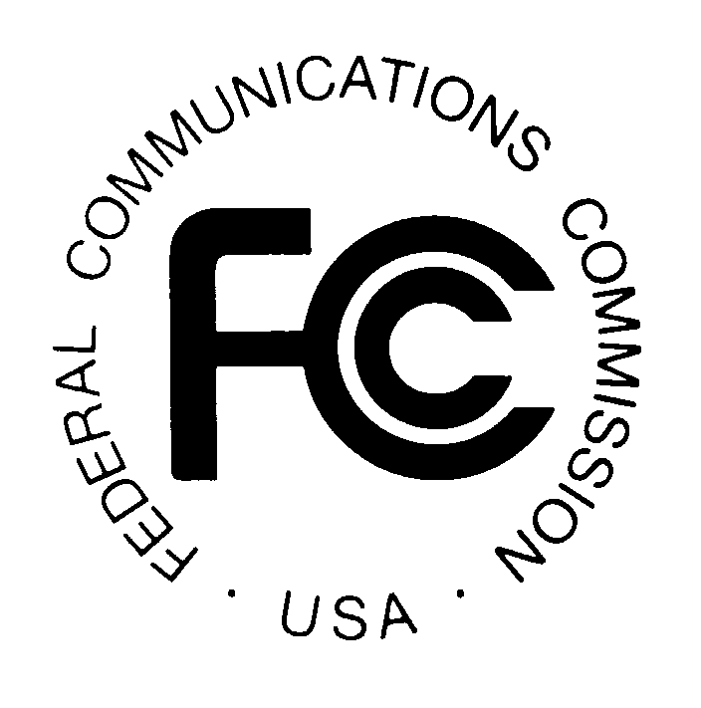
FEDERAL COMMUNICATIONS COMMISSION
445 - 12th Street, S.W.
WASHINGTON, D.C. 20554 DA 00-754

News media information 202/418-0500 Fax-On-Demand 202/418-2830 Internet: http://www.fcc.gov ftp.fcc.gov

Released: April 5, 2000

COMMON CARRIER BUREAU ANNOUNCES
A SERIES OF WORKSHOPS FOR
PHASE 2 OF THE
COMPREHENSIVE REVIEW OF
ACCOUNTING AND REPORTING REQUIREMENTS

The Common Carrier Bureau announces that it will hold a series of public workshops to solicit ideas on reform initiatives that can be undertaken in Phase 2 of its two-phase comprehensive review of the Commission's accounting rules and the reporting requirements of the Automated Reporting Management Information System (ARMIS) for common carriers. The goal of Phase 2 is to further examine the current accounting and reporting structure and address long-term changes needed as local exchange markets become competitive, and to assess what, if any, interim measures should be made as competitive milestones are reached.

At the public workshops, interested participants, including state, consumer, community, and industry representatives, will be given an opportunity to present their ideas on ways to achieve the goals in Phase 2. The first workshop will be held at the Commission’s Portals location, 445 12th Street, S.W., Washington, D.C., in Room 7B-516, beginning at 2:00 p.m. All other workshops will be held in Room 8-C245 (Conference Room #1) and will begin at 2:00 p.m.

The dates and agenda for the public workshops for Phase 2 are as follows:

April 11, 2000: Part 32 Chart of Accounts.

April 18, 2000: Affiliate Transaction Rules and Part 64 Issues.

April 26, 2000: Reporting requirements for financial reports - ARMIS 43-01 (Annual Summary Report), ARMIS 43-02 (USOA Report), ARMIS 43-03 (Joint Cost Report) and ARMIS 43-04 (Access Report).

May 9, 2000: Reporting requirements for non-financial reports - ARMIS 43-05 (Service Quality Report), ARMIS 43-06 (Customer Satisfaction Report), 43-07 (Infrastructure Report) and ARMIS 43-08 (Operating Data Report).

For purposes of the workshops, and to accommodate the ex parte requirements in any related proceedings, we request that parties making oral presentations submit a summary of the substance of the presentations (not merely a listing of the subjects discussed) and any written presentations to Ms. Debbie Byrd, Accounting Safeguards Division, Common Carrier Bureau, FCC Room 6-C316, 445 Twelfth Street, S.W., Washington, D.C. 20054. Copies of the participants’ presentations will be placed in the record of appropriate proceedings.

For further information, contact Tim Peterson at (202) 418-1575 (voice) or JoAnn Lucanik at (202) 418-0873 (voice), (202) 418-0484 (TTY).

