PUBLIC NOTICE
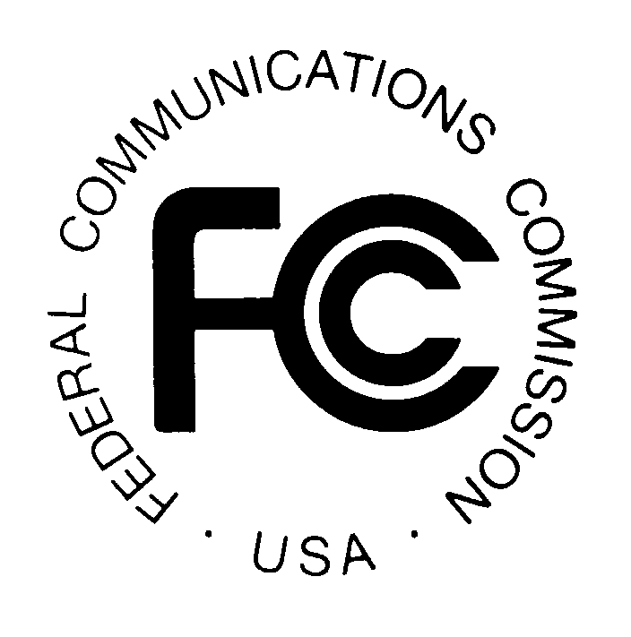

News media information 202 / 418-0500
Fax-On-Demand 202 / 418-2830
Internet: http://www.fcc.gov
TTY 202 / 418-2555

Federal Communications Commission
445 12th St., S.W.
Washington, D.C. 20554

January 31, 2000

COMMENTS INVITED ON U S WEST’S APPLICATION TO
DISCONTINUE OPERATION OF TELECOMMUNICATIONS FACILITIES
WITHIN EIGHT IDAHO EXCHANGES

NSD File No. W-P-D-452

Section 214 Application

Applicant: U S WEST Communications, Inc.

On December 17, 1999, U S WEST Communications, Inc. (U S WEST) filed an application requesting authority under section 214(a) of the Communications Act of 1934, 47 U.S.C. § 214(a), and section 63.71 of the Federal Communications Commission's rules, 47 C.F.R. § 63.71, to discontinue operation of its telecommunications facilities within eight small Idaho exchanges, without impairment or interruption of service to the public. U S WEST states it has agreed to transfer those facilities to Citizens Telecommunications Company of North Dakota (Citizens).

U S WEST states these eight exchanges collectively serve approximately 43,000 access lines; approximately 10,148 of these lines are physically located in Washington but are served out of an Idaho exchange. U S WEST also states that the planned transfer of the exchanges and the associated assets will have no known immediate or substantial effect on the service provided to customers within the eight exchanges. U S WEST anticipates that service will improve over time, because Citizens has substantial expertise in providing telecommunications services in rural communities and this experience will ultimately inure to the benefit of telecommunications subscribers within the eight exchanges.

U S WEST’s application appears to be complete. U S WEST states that it has notified all affected customers in Idaho and Washington by letter, of its proposed discontinuance and has submitted a copy of its application to the Secretary of Defense, the Idaho Public Utilities Commission, the Governor of Idaho, the Washington Utilities & Transportation Commission, and the Governor of Washington.

In accordance with 47 C.F.R. § 63.71(c), the application will be deemed to be automatically granted on the 60th day after the date of this public notice, without any Commission notification to the applicant, unless the Commission has notified the applicant that the grant will not be automatically effective. The FCC will normally authorize proposed discontinuances of service unless it is shown that customers or other end users would be unable to receive service or a reasonable substitute from another carrier, or that the public convenience and necessity is otherwise adversely affected.

Comments objecting to this application must be filed with the Commission by February 25, 2000. Such comments should refer to application file number W-P-D-452. Comments should include specific information about the impact of this proposed discontinuance on the commenter, including any inability to acquire reasonable substitute service. Comments should be sent to the Office of the Secretary, Federal Communications Commission, 445 12th Street, SW, Room TW-A325, Washington, DC 20554. Two copies of the comments should also be sent to the Network Services Division, 445 12th Street, SW, Room 6-A207, Washington, DC 20554. The application will be available for review and copying during regular business hours at the FCC Reference Center, Portals II, 445 12th Street, SW, Room CY-A257, Washington, DC 20554, (202) 418-0270.

For further information, contact Al McCloud, (202) 418-2499 (voice), amccloud@fcc.gov or Marty Schwimmer, (202) 418-2320 (voice), mschwimm@fcc.gov, of the Network Services Division, Common Carrier Bureau. The TTY number is (202) 418-0484.

-FEDERAL COMMUNICATIONS COMMISSION-

