PUBLIC NOTICE
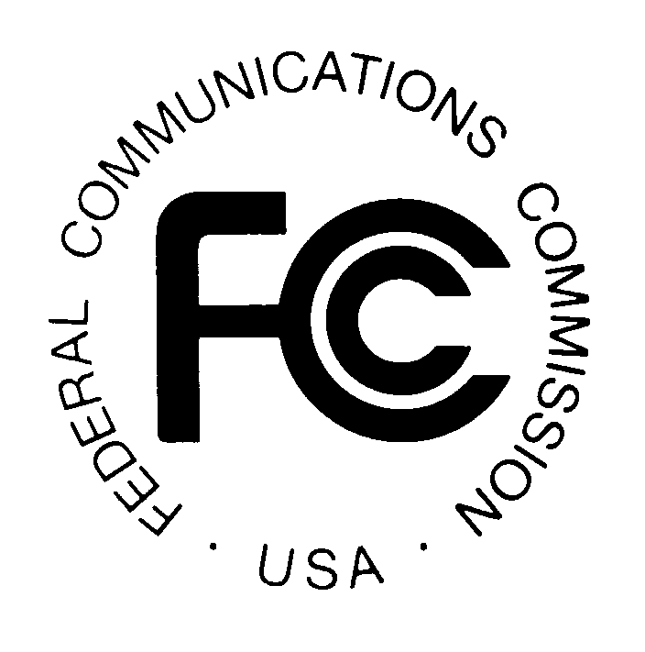

News media information 202 / 418-0500
Fax-On-Demand 202 / 418-2830
Internet: http://www.fcc.gov
TTY 202 / 418-2555

Federal Communications Commission
445 12th St., S.W.
Washington, D.C. 20554

DA 00-154
January 31, 2000

LNT Communications LLC Seeks Commission Determination of "Exempt Telecommunications Company" Status Under the Public Utility Holding Company Act of 1935, As Amended by Section 103 of the Telecommunications Act of 1996

NSD File No: ETC 00-01

Pleading Cycle Established

Comments Due: February 18, 2000 Reply Comments Due: March 3, 2000

On January 25, 2000, LNT Communications LLC (LNT), pursuant to Section 34(a)(1) of the Public Utility Holding Company Act of 1935 ("PUHCA"), as added by Section 103 of the Telecommunications Act of 1996, Pub. L. No. 104-104, filed an application requesting a Commission determination that it is an exempt telecommunications company ("ETC").

LNT is an Iowa limited liability company and will be a direct subsidiary of Alliant Energy Resources, Inc. and an indirect subsidiary of Alliant Energy Corporation, a public utility holding company registered pursuant to the PUHCA, as amended. LNT will be engaged, directly or indirectly, wherever located, through one or more “affiliates” and exclusively in the business of providing: (a) telecommunications services; (b) information services; (c) other services or products subject to the jurisdiction of the Federal Communications Commission (“FCC”); or (d) products or services that are related or incidental to the provision of such products described in (a), (b), and (c), within the meaning of Section 103 of the 1996 Act.

Specifically, LNT will provide local and long distance telephone services; internet access; data services, voice mail; paging services; cellular services; operator services; payphone services; private line services; mobile radio services; communications network maintenance services; telephone equipment sales, leasing; service and installation; video services; telemarketing services; and computer networking services. In the future, LNT may also provide other telecommunications services, information services, other services or products subject to FCC jurisdiction, or other related and incidental products or services, as permitted pursuant to Section 103 of the 1996 Act, when such opportunities arise and in a manner consistent with PUHCA, as amended, and other applicable laws and regulations. LNT will become an “associate company,” within the meaning of Section 2(a)(10) of the PUHCA, of Wisconsin Power and Light Company, South Beloit Water, Gas & Electric Company, IES Utilities Inc., and Interstate Power Company. In accordance with 47 C.F.R. § 1.5004, if the Commission does not issue an order denying LNT’s application within 60 days of receipt of this application, January 25, 2000, the application will be deemed granted as a matter of law. In accordance with 47 C.F.R. § 1.5003, a person applying in good faith for a Commission determination of ETC status is deemed to be an ETC from the date of receipt of the application, January 25, 2000, until the date of Commission action pursuant to 47 C.F.R. § 1.5004. In accord with 47 C.F.R. § 1.5005, the Secretary of the Commission is now notifying the Securities and Exchange Commission (SEC) that SCI is deemed to be an exempt telecommunications company. In the event that the Commission issues an order within 60 days of receipt of the application denying the application, the Secretary will so notify the SEC. Otherwise, the Commission will take no further action to grant this application.

This proceeding is considered a "permit but disclose" proceeding for purposes of the Commission's ex parte rules. See generally 47 C.F.R. §§ 1.1200 - 1.1206. Persons wishing to file comments, regarding the adequacy or accuracy of the SCI application requesting status as a ETC, must do so no later than February 18, 2000. All comments should also be served on the applicant. Reply comments must be filed no later than March 3, 2000.

Interested parties should file an original and four copies of their comments with the Office of the Secretary, Federal Communications Commission, 445 Twelfth St., SW, Room TW-A325, Washington, D.C. 20554. In addition, parties should send one copy to ITS, at 1231 20th Street, NW, Washington, D.C. 20036 and two copies to Al McCloud, Common Carrier Bureau, Network Services Division, FCC, 445 12th Street, SW, Room 6-A320, Washington, D.C. 20554. All filings concerning any of the matters referenced in this Public Notice should refer to NSD File No. ETC 00-01. The application will be available for public inspection Monday through Friday in the FCC Reference Center, Portals II, 445 12th Street, SW, Suite CY-A257, Washington, D.C., 20554, (202) 418-0267.

For further information, contact Al McCloud, (202) 418-2499 (voice), amccloud@fcc.gov or Marty Schwimmer, (202) 418-2320 (voice), mschwimm@fcc.gov, of the Network Services Division, Common Carrier Bureau. The TTY number is (202) 418-0484.

-FEDERAL COMMUNICATIONS COMMISSION-

