PUBLIC NOTICE
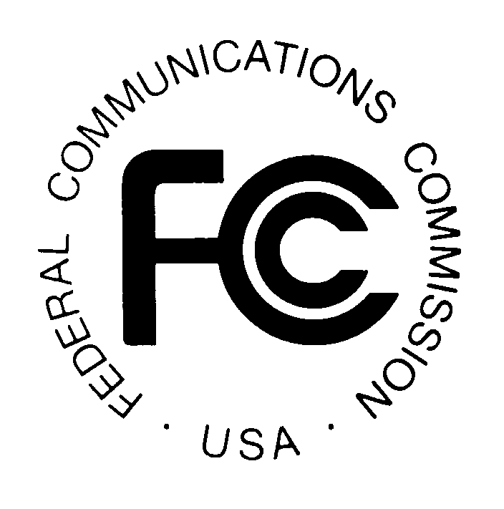

FEDERAL COMMUNICATIONS COMMISSION
445 12th STREET S.W.

WASHINGTON, DC 20554

DA 00-823

News media information 202/418-0500 Fax-On-Demand 202/418-2830 TTY 202/418-2555 Internet: http:/www.fcc.gov ftp.fcc.gov

Released: April 12, 2000

LEC Coalition Files A Petition for Stay and An Application for Review of the Common Carrier Bureau’s Order Directing the Four Largest Incumbent LECs in Wisconsin to File State Basic Payphone Rates with the FCC for Review
CCB/CPD No. 00-01

Pleading Cycle Established

OPPOSITIONS DUE DATE: May 12, 2000

REPLIES TO OPPOSITIONS DUE DATE: May 29, 2000

On April 3, 2000, the LEC Coalition filed an Application for Review and a Request for
a Stay of the March 2, 2000 Order of the Deputy Chief, Common Carrier Bureau (DA 00-347) directing the four largest incumbent local exchange companies in Wisconsin to submit copies of their currently effective tariffs for payphone service offerings that have not been determined by the Wisconsin Public Service Commission to comply with section 276 of the Communications Act of 1934, as amended (Act) and the Commission’s rules.

The LEC Application for Review and Request for Stay will be available for public inspection in the Commission's Reference Center, Room CY-A257, 445 12th Street S.W., Washington, DC 20554, (202) 418-0270. Copies can be purchased from International Transcription Services (ITS), the Commission's duplicating contractor, at its office at 1231 20th Street N.W., Washington, DC 20036, or by calling (202) 857-3800.

Interested parties may file Oppositions no later than May 12, 2000. Replies to Oppositions may be filed no later than May 29, 2000. When filing pleadings, reference file number CCB/CPD No. 00-01.

An original and four copies of all Oppositions and Replies to Oppositions must be filed with the Commission's Secretary, Magalie Roman Salas, Office of the Secretary, Federal Communications Commission, 445 - 12th Street S.W., TW-A325, Washington, DC 20554. In addition, one copy of each Opposition and Reply to Opposition must be filed with International Transcription Services (ITS), the Commission's duplicating contractor, at its office at 1231 20th Street N.W., Washington, DC 20036. One copy must also be filed with the Chief, Competitive Pricing Division, Common Carrier Bureau, 445 - 12th Street S.W., Room 5-A225, Washington, DC 20554.
This proceeding is a "permit-but-disclose" proceeding in accordance with the Commission's ex parte rules. See 47 C.F.R. §§ 1.1200, 1.1206. Persons making oral ex parte presentations are reminded that memoranda summarizing the presentations must contain summaries of the substance of the presentations and not merely a listing of the subjects discussed. More than a one or two sentence description of the views and arguments presented is generally required. See 47 C.F.R. § 1.1206(b). Other rules pertaining to oral and written ex parte presentations in permit-but-disclose proceedings are set forth in 47 C.F.R. § 1.1206(b).

For further information, contact Lynne Milne or Jon Stover, Competitive Pricing Division, Common Carrier Bureau, (202) 418-1520, TTY (202) 418-0484.

- FCC -

The members of the LEC Coalition are: Ameritech Corporation, the Bell Atlantic Telephone Companies, BellSouth Telecommunications, Inc., GTE Service Corporation, SBC Telecommunications, Inc., Wisconsin Bell and U S West Communications, Inc.
The four largest incumbent local exchange carriers in Wisconsin are: Wisconsin Bell (d/b/a Ameritech Wisconsin), GTE North Incorporated, the subsidiaries of Century Telephone Enterprises, Inc. and Telephone Data Systems, Inc.

