PUBLIC NOTICE
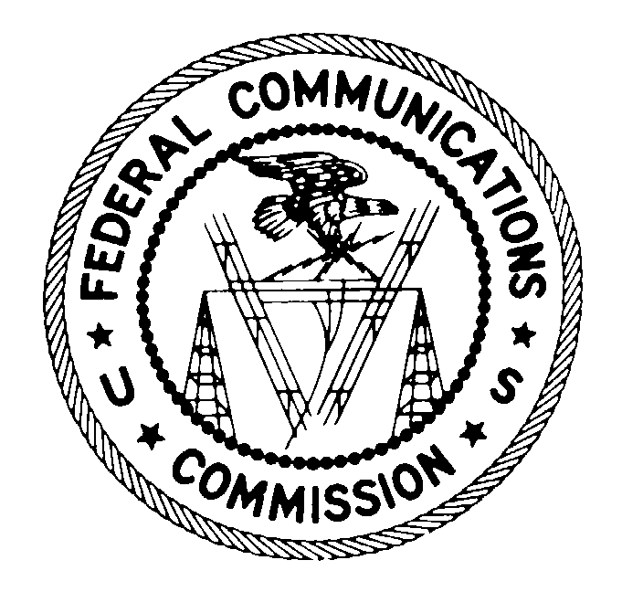
FEDERAL COMMUNICATIONS COMMISSION
445 12th STREET, S.W.
WASHINGTON, D.C. 20554 DA 99-2544

News media information 202/418-0500 Fax-On-Demand 202/418-2830 Internet: http://www.fcc.gov ftp.fcc.gov

PETITION OF CELLCO PARTNERSHIP D/B/A BELL ATLANTIC MOBILE FOR DESIGNATION AS AN ELIGIBLE TELECOMMUNICATIONS CARRIER

PLEADING CYCLE ESTABLISHED

CC Docket No. 96-45

Release Date: November 16, 1999

Comment Date: December 17, 1999
Reply Comment Date: January 7, 2000

On December 29, 1997, the Commission released a public notice establishing the
procedures the Commission will use to designate eligible telecommunications carriers pursuant
to section 214(e)(6) of the Communications Act of 1934, as amended. On September 8, 1999, Cellco Partnership d/b/a/ Bell Atlantic Mobile (Cellco) submitted a petition seeking designation by the Common Carrier Bureau (Bureau) as an eligible telecommunications carrier (ETC) for service areas comprising all of Delaware and parts of Maryland. Cellco contends that the Bureau should grant its petition because Cellco meets all of the requirements for designation, and it is not subject to the jurisdiction of a state commission.

Pursuant to sections 1.415 and 1.419 of the Commission's rules, 47 C.F.R. §§ 1.415, 1.419, interested parties may file comments on or before December 17, 1999, and reply comments on or before January 7, 2000. Comments may be filed using the Commission's Electronic Comment Filing System (ECFS) or by filing paper copies. See Electronic Filing of Documents in Rulemaking Proceedings, 63 Fed. Reg. 24,121 (1998). Comments filed through the ECFS can be sent as an electronic file via the Internet to <http://www.fcc.gov/e-file/ecfs.html>. Generally, only one copy of an electronic submission must be filed. If multiple docket or rulemaking numbers appear in the caption of this proceeding, however, commenters must transmit one electronic copy of the comments to each docket or rulemaking number referenced in the caption. In completing the transmittal screen, commenters should include their full name, Postal Service mailing address, and the applicable docket or rulemaking number. Parties may also submit electronic comments by Internet e-mail. To receive filing instructions for e-mail comments, commenters should send an e-mail to ecfs@fcc.gov, and should include the following words in the body of the message, "get form <your e-mail address." A sample form and directions will be sent in reply. Parties who choose to file by paper must file an original and four copies of each filing. If more than one docket or rulemaking number appears in the caption of this proceeding, commenters must submit two additional copies for each additional docket or rulemaking number. All filings must be sent to the Commission's Secretary, Magalie Roman Salas, Office of the Secretary, Federal Communications Commission, 445 12th Street, S.W., Washington, D.C. 20554.

Parties also must send three paper copies of their filing to Sheryl Todd, Accounting Policy Division, Common Carrier Bureau, Federal Communications Commission, 445 Twelfth Street S.W., Room 5-B540, Washington, D.C. 20554. In addition, commenters must send diskette copies to the Commission's copy contractor, International Transcription Service, Inc., 1231 20th Street, N.W., Washington, D.C. 20037.

Pursuant to section 1.1206 of the Commission's Rules, 47 C.F.R. § 1.1206, this proceeding will be conducted as a permit-but-disclose proceeding in which ex parte communications are permitted subject to disclosure.

For further information, contact Katherine Schroder, Accounting Policy Division, Common Carrier Bureau at (202) 418-7400, TTY (202) 418-0484.

Procedures for FCC Designation of Eligible Telecommunications Carriers Pursuant to Section (e)(6) of the Communications Act, Public Notice, FCC 97-419, 12 FCC Rcd 22497 (1997).

