PUBLIC NOTICE
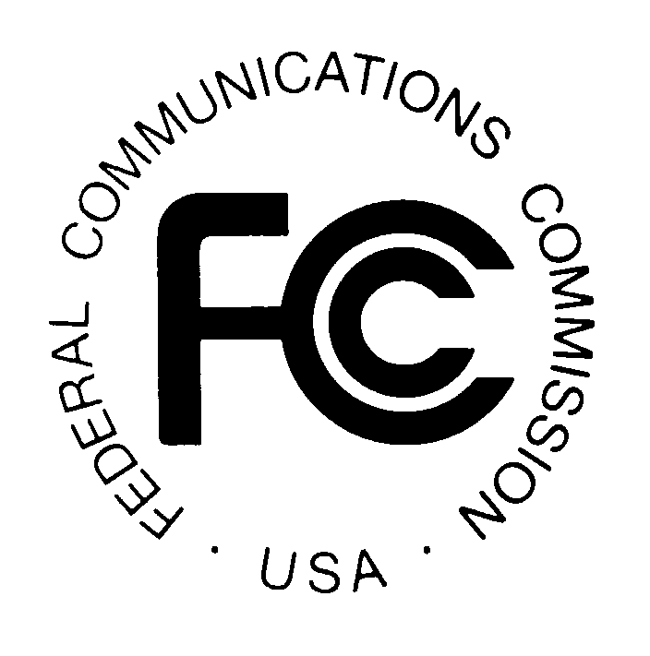

News media information 202 / 418-0500
Fax-On-Demand 202 / 418-2830
TTY 202 / 418-2555
Internet: http://www.fcc.gov
ftp.fcc.gov

Federal Communications Commission
445 12th St., S.W.
Washington, D.C. 20554

DA 99-3227

RELEASED: December 30, 1999

FCC ANNOUNCES THE NEXT MEETING OF THE
NORTH AMERICAN NUMBERING COUNCIL

(CC Docket No. 92-237)

The North American Numbering Council (NANC) has scheduled a meeting to be held Tuesday, January 18, 2000, from 8:30 a.m. to 5:00 p.m., and on Wednesday, January 19, from 8:30 a.m., until 12 noon. The meeting will be held at the Federal Communications Commission, Portals II, 445 Twelfth Street, SW, Room TW-C305, Washington, DC 20554.

FOR FURTHER INFORMATION CONTACT: Jeannie Grimes, Senior Paralegal, assisting the NANC at (202) 418-2320 or via the Internet at jgrimes@fcc.gov. The address is: Network Services Division, Common Carrier Bureau, Federal Communications Commission, 445 12th Street, SW, Suite 6-A207, Washington, DC 20554. The fax number is: (202) 418-2345. The TTY number is: (202) 418-0484.

SUPPLEMENTARY INFORMATION: This meeting is open to the members of the general public. The FCC will attempt to accommodate as many participants as possible. The public may submit written statements to the NANC, which must be received two business days before the meeting. In addition, oral statements at the meeting by parties or entities not represented on the NANC will be permitted to the extent time permits. Such statements will be limited to five minutes in length by any one party or entity, and requests to make an oral statement must be received two business days before the meeting. Requests to make an oral statement or provide written statement to the NANC should be sent to Jeannie Grimes at the address under “FOR FURTHER INFORMATION CONTACT,”stated above.

PROPOSED AGENDA:

Tuesday, January 18, 2000

- Approve November 16-17, and December 22, 1999 meeting minutes.

- North American Numbering Plan Administrator (NANPA) Report. Review of 1999 COCUS and NPA Exhaust Analysis in comparison to the 4Q99 and 1999 total assignments.

- Review of the Number Pooling Issue Management Group (IMG) Recommendation for a North American Numbering Council (NANC) North American Numbering Plan (NANP) Thousand Block Pool Administrator, and NeuStar’s response to the Requirements Document.

- North American Numbering Plan Administration Oversight Working Group Report.

- Numbering Resource Optimization (NRO) Working Group Report.

- Industry Numbering Committee (INC) Report.

- Local Number Portability (LNP) Working Group Report

Wednesday, January 19, 2000

- Steering Group Report.

- Cost Recovery Working Group Report. North American Billing and Collection (NBANC) Update.

- Telcordia Technologies, Inc., tutorial on code activation.

- Other Business.

