PUBLIC NOTICE
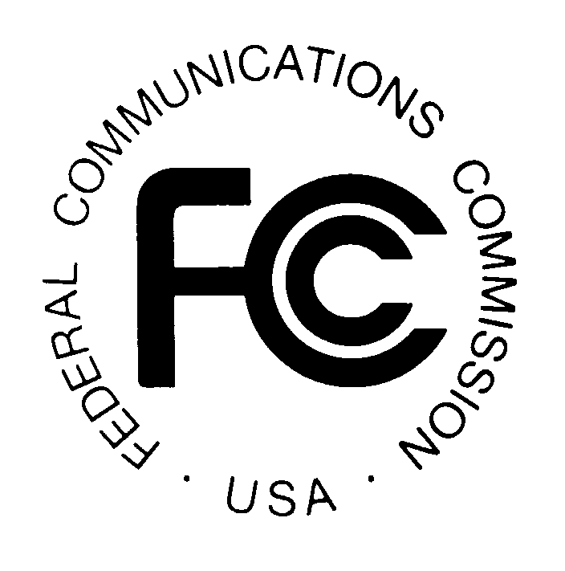
FEDERAL COMMUNICATIONS COMMISSION
445 12TH STREET, S.W.
WASHINGTON, D.C. 20554 DA 99-2661

News media information 202/418-0500 Fax-On-Demand 202/418-2830 Internet: http://www.fcc.gov ftp.fcc.gov

CABLE SERVICES BUREAU ACTION November 30, 1999

AT&T CORP. AND MEDIAONE GROUP, INC. FILE SUBMISSION
ON COMPLIANCE WITH NEW CABLE OWNERSHIP RULES
CS DOCKET NO. 99-251

Comments due: December 14, l999
Reply Comments due: December 21, l999
Ex Parte Meeting Schedule: January 3, 2000 through January 14, 2000

On July 7 and 15, l999, AT&T Corp. ("AT&T") and MediaOne Group, Inc. ("MediaOne") filed joint applications under Sections 214 and 310(d) of the Communications Act, 47 U.S.C. §§ 214, 310(d), requesting Commission approval of the transfer of control to AT&T of licenses and authorizations held by subsidiaries of MediaOne and entities controlled by MediaOne. This transfer of control would take place as the result of a proposed merger of AT&T and MediaOne, with AT&T becoming the parent company of MediaOne.

By letter dated October 26, 1999, the Cable Services Bureau requested that AT&T file a written submission demonstrating how AT&T’s proposed acquisition of MediaOne would fit under the Commission’s revised cable ownership rules, which were adopted in Implementation of the Cable Television Consumer Protection and Competition Act of 1992; Implementation of Cable Act Reform Provisions of the Telecommunications Act of 1996: Review of the Commission’s Cable Attribution Rules, Report and Order, CS Docket No. 98-82, CS Docket No. 96-85, FCC 99-288 (released October 20, 1999), and Implementation of Section 11(c) of the Cable Television Consumer Protection and Competition Act of 1992: Horizontal Ownership Limits, Third Report and Order, MM Docket No. 92-264, FCC 99-289 (released October 20, 1999). On November 24, 1999, after requesting a two-week extension of time, AT&T and MediaOne filed a written submission (the “AT&T and MediaOne Submission”) in response to the October 26 letter.

Interested parties may file comments on the AT&T and MediaOne Submission no later than December 14, 1999. Reply comments may be filed no later than December 21, 1999. All filings should reference the Cable Services docket assigned to this proceeding, CS Docket No. 99-251.

EX PARTE MEETING SCHEDULE

To the extent that parties wish to discuss issues related to the AT&T and MediaOne Submission, Commission staff will be available for meetings between January 3, 2000 and January 14, 2000. After this period, ex parte meetings will occur only at the request of Commission staff. Parties who wish to schedule meetings with Commission staff should call Sunil Daluvoy, Cable Services Bureau, at (202) 418-1032.

The public is reminded that this proceeding is being treated as a "permit-but-disclose" proceeding for purposes of the Commission's ex parte rules. See generally 47 C.F.R. §§ 1.1200-1.1216. As a "permit but disclose" proceeding, ex parte presentations will be governed by the procedures set forth in Section 1.1206 of the Commission's rules applicable to non-restricted proceedings.

Parties making oral ex parte presentations are reminded that memoranda summarizing the presentation must contain a summary of the substance of the presentation and not merely a listing of the subjects discussed. More than a one or two sentence description of the views and arguments presented is generally required. See 47 C.F.R. § 1.1206(b)(2), as revised. Other rules pertaining to oral and written presentations are set forth in Section 1.1206(b) as well. Interested parties are to file copies of any written ex parte presentations with the Commission Secretary, Magalie Roman Salas, 445 12th Street, S.W., TW B204, Washington, D.C.20554. Parties must also serve To-Quyen Truong, Associate Chief, Cable Services Bureau, 445 12th Street, S.W., 3-C488, Washington, D.C. 20554, Royce Dickens, Deputy Chief, Policy and Rules Division, Cable Services Bureau, 445 12th Street, S.W., 3-A729, Washington, D.C. 20554, Sunil Daluvoy, Cable Services Bureau, 445 12th Street, S.W., 4-A737, Washington, D.C. 20554, and International Transcription Service, Inc., 1231 20th Street, N.W., Washington, D.C. 20036.

GENERAL INFORMATION

Interested parties may file comments as indicated above regarding the AT&T and MediaOne Submission. While Commission staff does not foresee that the deadlines set forth in this Public Notice will pose any Year 2000 ("Y2K") preparedness problems, we will consider on a case-by-case basis any Y2K preparedness concerns raised by affected parties in any request for relief. An original and 4 copies of all comments, in accordance with Section 1.51(c) of the Commission's Rules, 47 C.F.R. §1.51(c), must be filed with the Commission's Secretary, Magalie Roman Salas, 445 12th Street, S.W., TW B204, Washington, D.C. 20554. One copy of each pleading also must be filed with other offices, as follows: (1) International Transcription Service, Inc., the Commission's duplicating contractor, at its office at 1231 20th Street, N.W., Washington, D.C. 20036, telephone (202) 857-3800; (2) To-Quyen Truong, Associate Chief, Cable Services Bureau, 445 12th Street, S.W., 3-C488, Washington, D.C. 20554; (3) Royce Dickens, Deputy Chief, Policy and Rules Division, Cable Services Bureau, 445 12th Street, S.W., 3-A729, Washington, D.C. 20554; (4) Frances Eisenstein, International Bureau, 445 12th Street, S.W., 6-C866, Washington, D.C. 20554; and (5) Walter Strack, Wireless Telecommunications Bureau, 445 12th Street, S.W., 3-C204, Washington, D.C. 20554. In addition, eight copies of each pleading must be filed with Sunil Daluvoy, Cable Services Bureau, 445 12th Street, S.W., 4-A737, Washington, D.C. 20554.

In addition to filing paper comments, parties may also file comments using the Commission's Electronic Comment Filing System (ECFS). See Electronic Filing of Documents in Rulemaking Proceedings, 63 Fed. Reg. 24,121 (1998). Comments filed through the ECFS can be sent as an electronic file via the Internet to <http://www.fcc.gov/e-file/ecfs.html>. Generally, only one copy of an electronic submission must be filed. In completing the transmittal screen, commenters should include their full name, Postal Service mailing address, and the applicable docket or rulemaking number. Parties may also submit an electronic comment by Internet e-mail. To get filing instructions for e-mail comments, commenters should send an e-mail to ecfs@fcc.gov, and should include the following words in the body of the message, "get form <your e-mail address>." A sample form and directions will be sent in reply.

Parties are also encouraged to file a copy of all pleadings on a 3.5 inch diskette in an IBM-compatible format using Microsoft Word for Windows software in a "read only" mode. Diskette submissions should be in addition to, and not a substitute for, the hard copy filing requirements reviewed above. All diskettes should be clearly labeled with (1) the party's name; (2) the name of the proceeding and docket number; (3) the type of filing submitted (e.g., comments or reply comments); and (4) the date of submission. The diskettes should be accompanied by a cover letter and filed with Sunil Daluvoy, Cable Services Bureau, 445 12th Street, S.W., 4-A737, Washington D.C. 20554.

Copies of the AT&T and MediaOne Submission and any comments filed in response to this public notice may be obtained from International Transcription Service, Inc., 1231 20th Street, N.W., Washington, D.C. 20036, telephone (202) 857-3800. An electronic version of the AT&T and MediaOne Submission will be available through the Commission’s Electronic Comment Filing System and is also available, without exhibits, through the FCC Cable Services Bureau's Internet Home Page (www.fcc.gov/csb). To the extent that parties file electronic versions of their comments, such filings also will be available through the Commission’s Electronic Comment Filing System. Copies of the AT&T and MediaOne Submission and comments filed in response to this public notice will also be available for public inspection and copying during normal reference room hours at the Commission's Reference Center, 445 12th Street, S.W., CYA-257, Washington, D.C. 20554.

Media contact: Michelle Russo (202) 418-2358
Cable Services Bureau Contact: Sunil Daluvoy at (202) 418-1032
TTY: (202) 418-7172

--FCC--

?An ex parte presentation is any communication (spoken or written) directed to the merits or outcome of a proceeding made to a Commissioner, a Commissioner's assistant, or other decision-making staff member, that, if written, is not served on other parties to the proceeding or, if oral, is made without an opportunity for all parties to be present. 47 C.F.R. Sec. 1.1201.

