U.S. GENERAL SERVICES ADMINISTRATION
FMR BULLETIN PBS-2007-B3
REDESIGNATIONS OF FEDERAL BUILDINGS

TO: Heads of Federal Agencies SUBJECT: Redesignations of Federal Buildings

1. What is the purpose of this bulletin? This bulletin announces the redesignations of (6) Federal Buildings.

2. When does this bulletin expire? This bulletin expires January 1, 2008. However, the building redesignations announced by this bulletin will remain in effect until canceled or superseded.

3. Redesignations. The former and new names of the redesignated buildings are as follows:
Former Name New Name
United States Courthouse 555 Independence Street Cape Girardiau, MO 63703

United States Courthouse 106 South Federal Plaza Santa Fe, NM 87501

Department of Education Building
400 Maryland Avenue, SW Washington, DC 20202

Clifford Davis Federal Building 167 North Main Street Memphis, TN 38103

Federal Building and United States Courthouse and Customhouse 515 West First Street Duluth, MN 55802

United States Courthouse 2500 Tulare Street Fresno, CA 93721
Rush Hudson Limbaugh, Sr. United States Courthouse 555 Independence Street
Cape Girardeau, MO 63703

Santiago E. Campos United States Courthouse 106 South Federal Plaza Santa Fe, NM 87501

Lyndon Baines Johnson Department of Education Building
400 Maryland Avenue, SW Washington, DC 20202

Clifford Davis and Odell Horton Federal Building 167 North Main Street
Memphis, TN 38103

Gerald W. Heaney Federal Building and United States Courthouse and Customhouse 515 West First Street
Duluth, MN 55802

Robert E. Coyle United States Courthouse 2500 Tulare Street
Fresno, CA 93721
4. Who should we contact for further information regarding redesiqnation of these Federal Buildinqs? U.S. General Services Administration, Public Buildings Service (P), Attn: Anthony E, Costa, 1800 F Street, NW, Washington, DC 20405, telephone number: (202) 501-1100, e-mail at anthony.costa@gsa.gov.

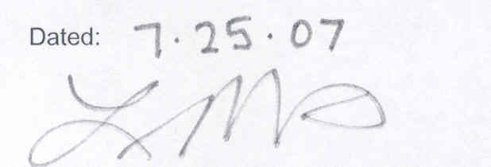

LURITA DOAN
Administrator of General Services

