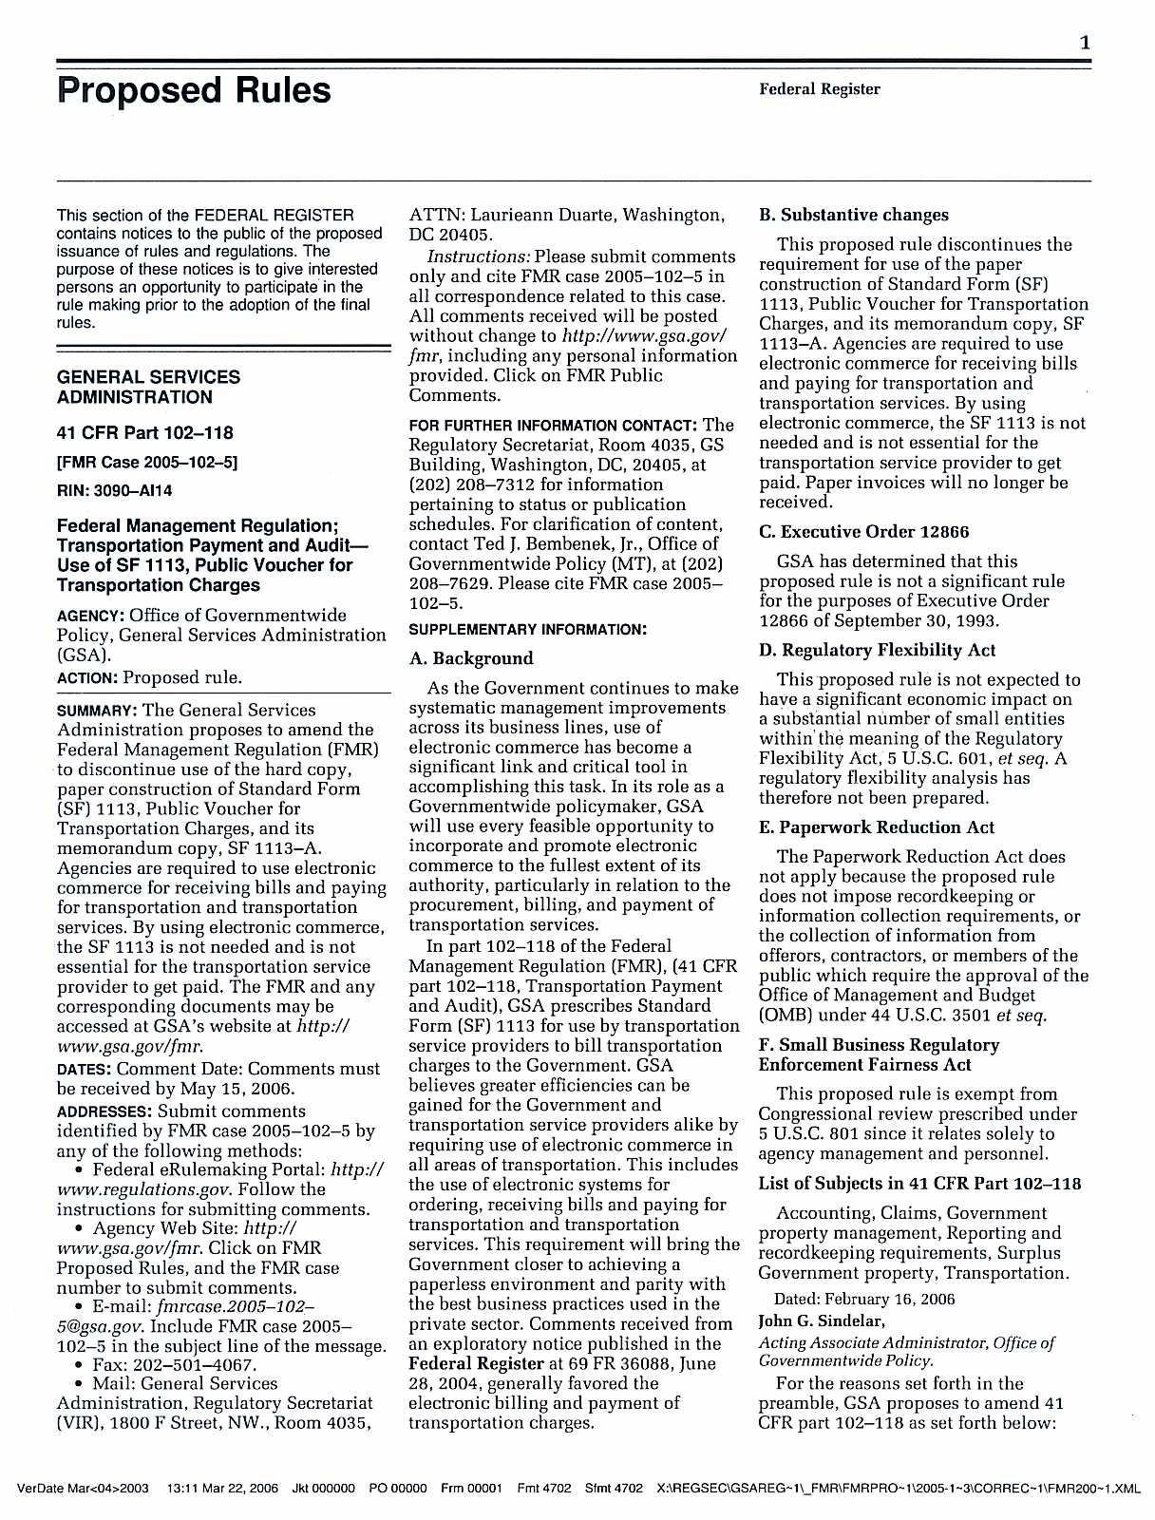

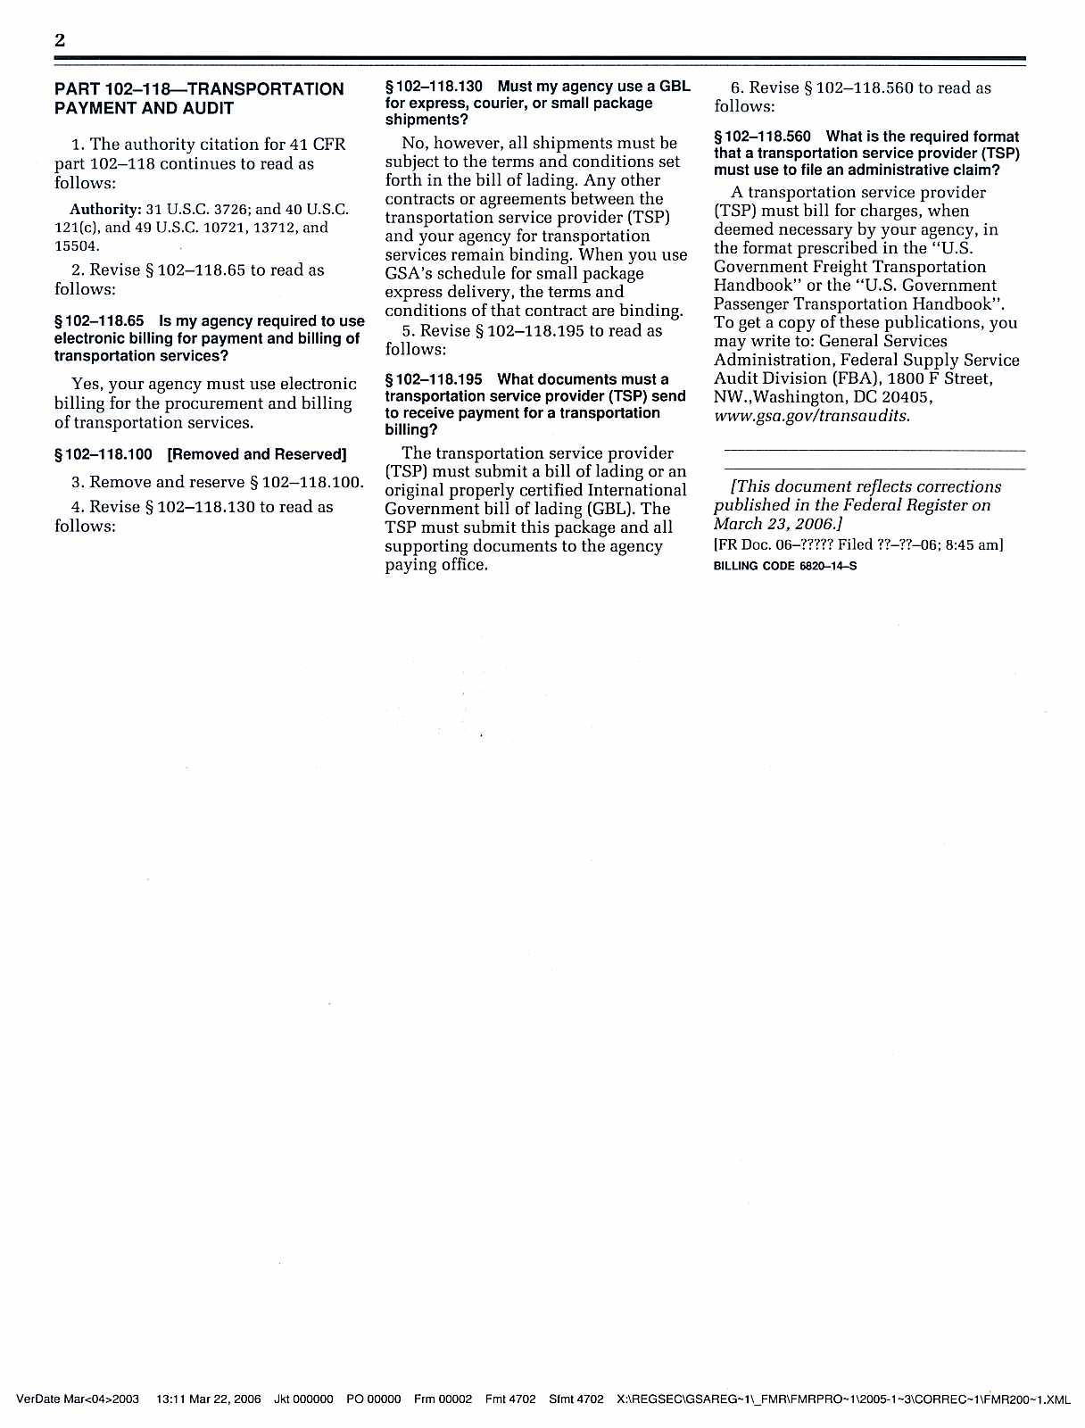

Federal Register / Vol. 71, No. 56 / Thursday, March 23, 2006 / Proposed Rules
14673

Authority: 42 U.S.C. 7401 et seq.
2. Section 63.1206 is amended by revising the first sentence of paragraph
(a)(1)(ii)(B)(1) and adding paragraph
(a)(1)(ii)(B)(3) to read as follows:

§ 63.1206 When and how must you comply with the standards and operating requirements?
(a) * * *
(1) * * *
(ii) * * *
(B) * * * (1) If you commenced construction or reconstruction of your hazardous waste combustor after April
20, 2004, you must comply with the new source emission standards under
§§ 63.1219, 63.1220, and 63.1221 and the other requirements of this subpart by the later of October 12, 2005 or the date the source starts operations, except
as provided by paragraphs (a)(1)(ii)(B)(2)
through (3) of this section. * * *
* * * * *
(3) If you commenced construction or reconstruction of a cement kiln after

(7) * * *
(i) Emissions in excess of 15.8 mg/ dscm (0.0069 gr/dscf) corrected to 7 percent oxygen; and
* * * * *
[FR Doc. 06–2703 Filed 3–22–06; 8:45 am]
BILLING CODE 6560–50–P

GENERAL SERVICES ADMINISTRATION

41 CFR Part 102–118
[FMR Case 2005–102–5] RIN 3090–AI14

Federal Management Regulation; Transportation Payment and Audit— Use of SF 1113, Public Voucher for Transportation Charges; Correction AGENCY: Office of Governmentwide Policy, General Services Administration
(GSA).
ACTION: Proposed rule; correction.

§ 102–118.195 What documents must a transportation service provider (TSP) send to receive payment for a transportation billing?
The transportation service provider
(TSP) must submit a bill of lading or an original properly certified International Government bill of lading (GBL). The TSP must submit this package and all supporting documents to the agency paying office.

§ 102–118.560 [Corrected]
4. On page 13064, in the third column, § 102–118.560 is corrected in the fourth line by removing ‘‘manner’’ and adding ‘‘format’’ in its place.
Dated: March 17, 2006.
Laurieann Duarte,
Supervisor, Regulatory Secretariat, General
Services Administration.
[FR Doc. E6–4189 Filed 3–22–06; 8:45 am]
BILLING CODE 6820–14–S

April 20, 2004, you must comply with the new source emission standard for
DEPARTMENT OF TRANSPORTATION
SUMMARY: The General Services

particulate matter under
§ 63.1220(b)(7)(i) by the later of [DATE OF PUBLICATION OF THE FINAL RULE IN THE Federal Register] or the date the source starts operations.
* * * * *
3. Section 63.1217 is amended by revising paragraph (b)(7) to read as follows:

§ 63.1217 What are the standards for liquid fuel boilers that burn hazardous waste?
* * * * *
(b) * * *
(7) For particulate matter, except for an area source as defined under § 63.2 or as provided by paragraph (e) of this section, emissions in excess of 20 mg/ dscm (0.0088 gr/dscf) corrected to 7 percent oxygen.
* * * * *
4. Section 63.1219 is amended by revising paragraph (b)(7) to read as follows:

§ 63.1219 What are the replacement standards for hazardous waste incinerators?
(b) * * *
(7) Except as provided by paragraph
(e) of this section, particulate emissions in excess of 3.7 mg/dscm (0.0016 gr/ dscf) corrected to 7 percent oxygen.
* * * * *
5. Section 63.1220 is amended by revising paragraph (b)(7)(i) to read as follows:

§ 63.1220 What are the replacement standards for hazardous waste burning cement kilns?
(b) * * *
Administration is issuing corrections to the proposed rule issued as FMR Case
2005–102–5, Transportation Payment and Audit—Use of SF 1113, Public Voucher for Transportation Charges. EFFECTIVE DATE: March 23, 2006.
FOR FURTHER INFORMATION CONTACT: Ms. Laurieann Duarte at (202) 208–7312, General Services Administration, Regulatory Secretariat, Washington, DC
20405.

Corrections
In the proposed rule document appearing at 71 FR 13063, March 14,
2006—
1. On page 13064, under the heading A. Background, second column, first paragraph, the third line is corrected by adding ‘‘and payment’’ after the word
‘‘billing’’.
2. On page 13064, third column,
§ 102–118.130 is corrected to read as follows:

§ 102–118.130 Must my agency use a GBL for express, courier, or small package shipments?
No, however, all shipments must be subject to the terms and conditions set forth in the bill of lading. Any other contracts or agreements between the transportation service provider (TSP) and your agency for transportation services remain binding. When you use GSA’s schedule for small package express delivery, the terms and conditions of that contract are binding.
3. On page 13064, third column,
§ 102–118.195 is corrected to read as follows:
National Highway Traffic Safety
Administration

49 CFR Part 571

[U.S. DOT Docket Number NHTSA–2005–
22655]

Federal Motor Vehicle Safety Standards; Steering Control Rearward Displacement

AGENCY: National Highway Traffic Safety Administration (NHTSA), U.S. Department of Transportation. ACTION: Denial of petition for rulemaking.

SUMMARY: On July 28, 2004, NHTSA received a petition for rulemaking from Honda Motor Company Ltd. requesting that the agency amend the applicability of Federal Motor Vehicle Safety Standard (FMVSS) No. 204, ‘‘Steering control rearward displacement.’’ Specifically, it petitioned to exempt vehicles that already comply with the unbelted frontal barrier crash requirements of FMVSS No. 208,
‘‘Occupant crash protection.’’ This notice denies this petition for rulemaking.
FOR FURTHER INFORMATION CONTACT: For non-legal issues: Christopher Wiacek, Office of Crashworthiness Standards, NVS–112, National Highway Traffic Safety Administration, 400 Seventh Street, SW., Washington, DC 20590. Telephone: (202) 366–4801. Fax: (202)
493–2290.
For legal issues: Christopher Calamita, Office of Chief Counsel, NCC–112,

VerDate Aug<31>2005 14:45 Mar 22, 2006 Jkt 208001 PO 00000 Frm 00017 Fmt 4702 Sfmt 4702 E:\FR\FM\23MRP1.SGM 23MRP1

