GENERAL SERVICES ADMINISTRATION Washington, DC 20405 February 11, 2008
FEDERAL MANAGEMENT REGULATION
Amendment 2008-01
TO: Heads of Federal agencies
SUBJECT: FMR Case 2007-102-3; Real Property Policies Update
- Purpose. This document includes pages that reflect amendments to Part 102-84 of the Federal Management Regulation(FMR).
  - 2. Background. On December 13, 2002, GSA published Federal Property Management Regulation (FPMR) Amendment D-99 as a final rule in the Federal Register (67 FR 76882), which removed all real property policy coverage from the FPMR and provided cross-references that directed readers to the coverage in the Federal Management Regulation (FMR).
  - On February 4, 2004, the President signed Executive Order13327, Federal Real Property Asset Management, requiring that the Administrator of General Services, in consultation with the Federal Real Property Council, establish and maintain a single, comprehensive database of all real property under the custody and control of all executive branch agencies, except when otherwise required for reasons of national security.
- Effective date. This rule was published in the Federal Register, at 73 FR 2167 and became effective on January 14, 2008.
- Explanation of changes. Part 102-84 is revised in its entirety to update the legal citations and to incorporate additional policy guidance in accordance with Executive Order 13327.

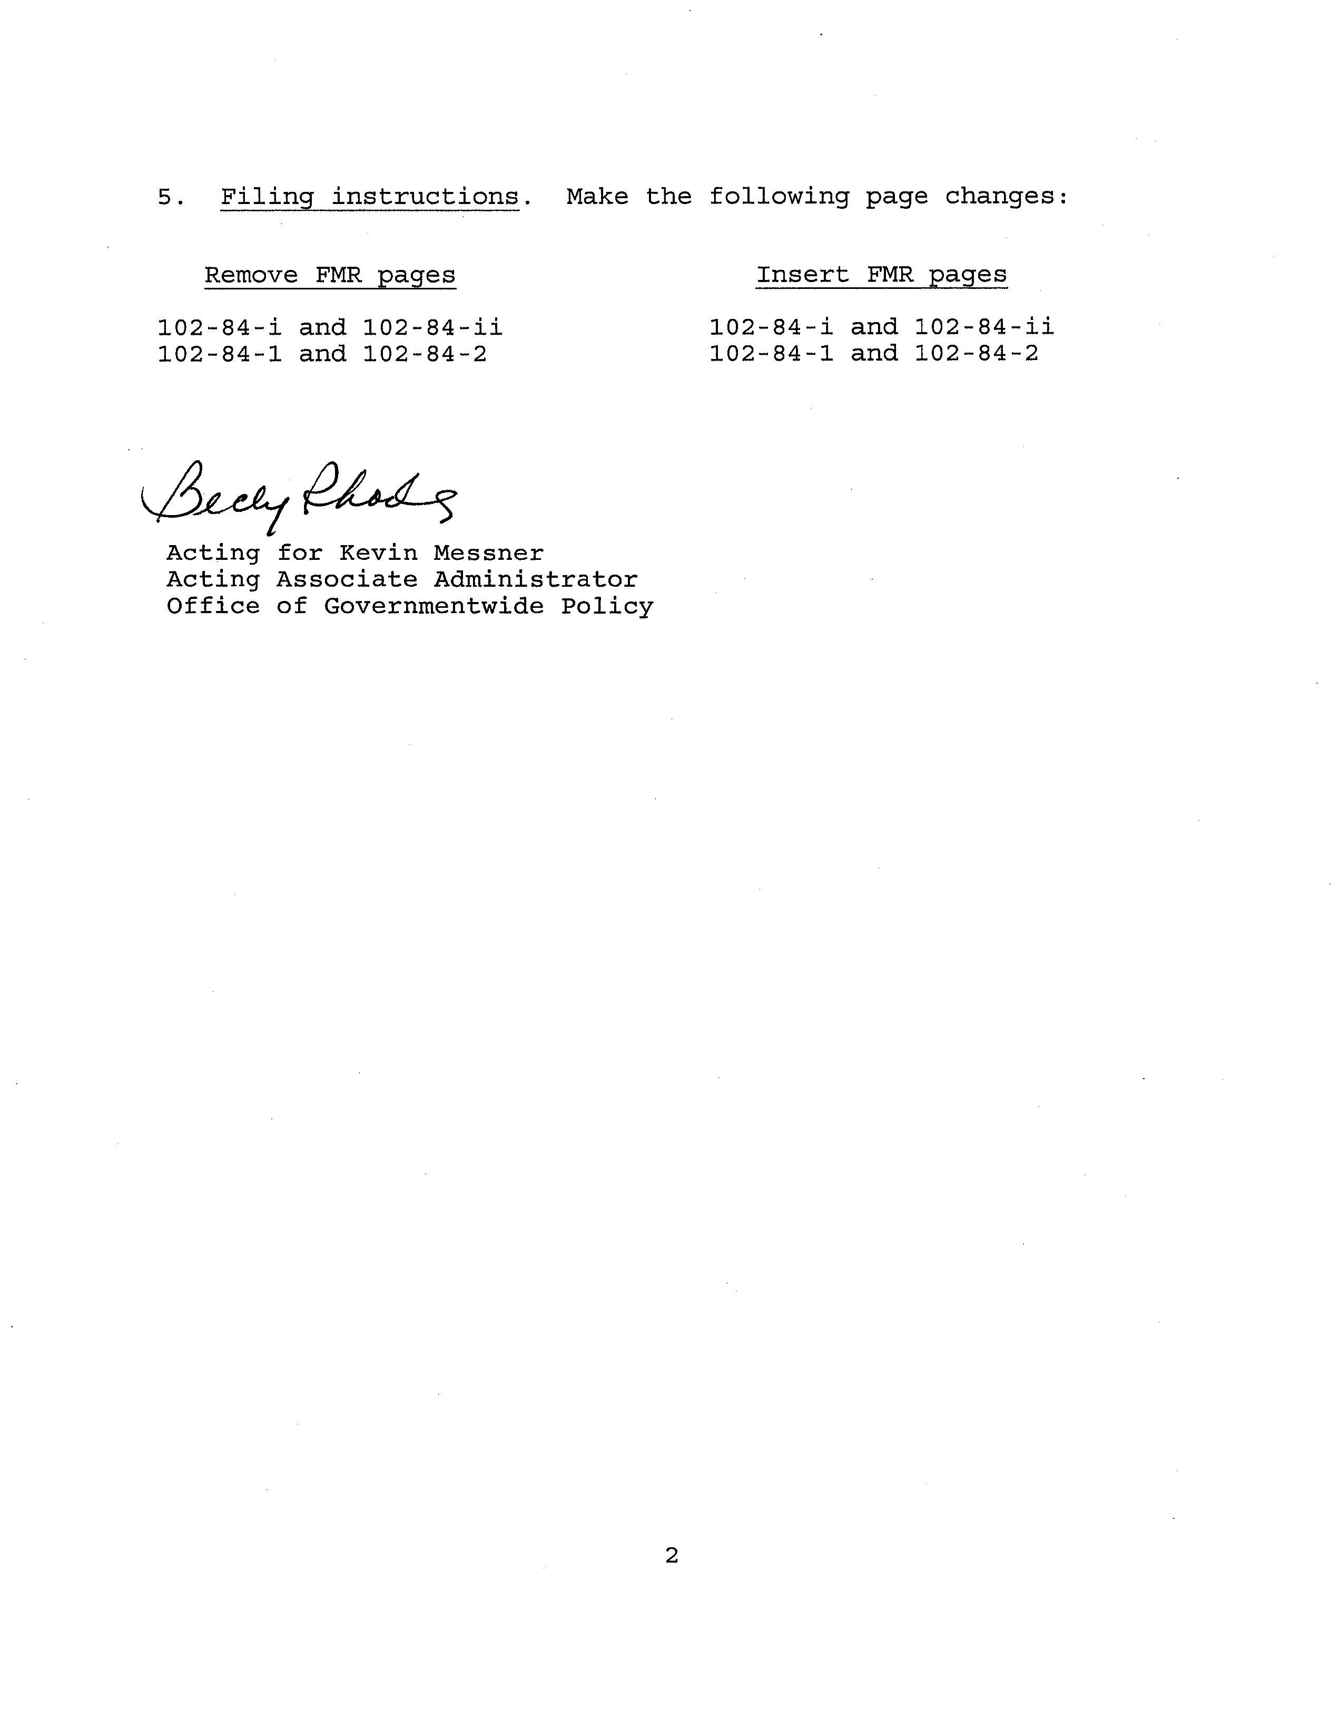
AMENDMENT 2008–01 JANUARY 14, 2008
PART 102-84—ANNUAL REAL PROPERTY INVENTORIES
Sec.
102-84.5— What is the scope of this part?
102-84.10—What is the purpose of the Annual Real Property Inventory Program?
102-84.15—Why must I provide information for the Annual Real Property Inventory?
102-84.20—Where should I obtain the data required to be reported for the Annual Real Property Inventory?
102-84.25— Is it necessary for my agency to designate an official to serve as the point of contact for the real property inventories?
102-84.30—Is it necessary for my agency to certify the accuracy of its real property inventory submission?
102-84.35—
102-84.40— 102-84.45—
102-84.50— 102-84.55—
Which agencies must submit a report for inclusion in the Annual Real Property Inventory? What types of real property must I report for the Annual Real Property Inventory? What types of real property are excluded from reporting for the Annual Real Property Inventory? May the GSA Form 1166 be used to report information? When are the Annual Real Property Inventory reports due?
102-84-i
FEDERAL MANAGEMENT REGULATION
This page intentionally left blank.
102-84-ii
AMENDMENT 2008–01 JANUARY 14, 2008
PART 102-84—ANNUAL REAL PROPERTY INVENTORIES §102-84.40
PART 102-84—ANNUAL REAL PROPERTY INVENTORIES
§102-84.5—What is the scope of this part?
GSA’s policies contained in this part apply to all Federal agencies. This part prescribes guidance that all Federal agencies must follow in preparing and submitting annual real property inventory information for real property owned, leased or otherwise managed by the United States. Detailed guidance implementing these policies is contained in the annual Guidance for Real Property Inventory Reporting, issued by the Federal Real Property Council and published by GSA.
§102-84.10—What is the purpose of the Annual Real Property Inventory Program?
The purpose of the Annual Real Property Inventory program is to:
- (a) Promote efficient and economical use of Federal real property assets.
- (b) Increase the level of agency accountability for asset management.
- (c) Allow for comparing and benchmarking across various types of real property assets.
- (d) Give decision makers the accurate, reliable data needed to make asset management decisions, including disposing of unneeded federal assets.

§102-84.15—Why must I provide information for the Annual Real Property Inventory?
You must provide information for the Annual Real Property Inventory because:
- (a) The Senate Committee on Appropriations requests that the Government maintain an Annual Real Property Inventory.
- (b) Executive Order 12411, Government Work Space Management Reforms, dated March 29, 1983 (48 FR 13391, 3 CFR, 1983 Comp., p. 155), requires that Executive agencies:
- (1) Produce and maintain a total inventory of work space and related furnishings and declare excess to the Administrator of General Services all such holdings that are not necessary to satisfy existing or known and verified planned programs; and
- (2) Establish information systems, implement inventory controls and conduct surveys, in accordance with procedures established by the Administrator of General Services, so that a governmentwide reporting system may be developed.
- (c) Executive Order 13327, Federal Real Property Asset Management, dated February 4, 2004, requires that the Administrator of General Services, in consultation with the Federal Real Property Council, establish and maintain a single, comprehensive and descriptive database of all real property under the custody and control of all executive branch

agencies, except when otherwise required for reasons of national security. The Executive Order authorizes the Administrator to collect from each Executive agency such descriptive information, except for classified information, as the Administrator considers will bestdescribe the nature, use, and extent of the real property holdings of the Federal Government.
§102-84.20—Where should I obtain the data required to be reported for the Annual Real Property Inventory?
You should obtain data reported for the Annual Real Property Inventory from the most accurate real property asset management and financial management records maintained by your agency.
§102-84.25—Is it necessary for my agency to designate an
official to serve as the point of contact for the real
property inventories?
Yes. You must designate an official to serve as your agency’s point of contact for the Annual Real Property Inventories. We recommend that you designate the same point of contact for the Federally-owned and leased real property inventory, although separate points of contact are permitted. You must advise the General Services Administration, Office of Governmentwide Policy, Office of Real Property (MP), 1800 F Street, NW, Washington, DC 20405, in writing, of the name(s) of these representative(s) and any subsequent changes.
§102-84.30—Is it necessary for my agency to certify the accuracy of its real property inventory submission?
Yes. Your agency’s official designated in accordance with §102-84.25 must certify the accuracy of the real property information submitted to GSA.
§102-84.35—Which agencies must submit a report for inclusion in the Annual Real Property Inventory?
Each agency that has jurisdiction, custody, control, or otherwise manages Federal real property or enters into leases, is responsible for submitting the real property inventory information. Additional information on the responsibility for reporting inventory data is contained in the annual Guidance for Real Property Inventory Reporting.
§102-84.40—What types of real property must I report for the Annual Real Property Inventory?
You must report for the Annual Real Property Inventory all land, buildings, and other structures and facilities owned by the United States (including wholly-owned Federal Government corporations) throughout the world, all real property leased by the United States from private individuals, organi
102-84-1
AMENDMENT 2008–01 JANUARY 14, 2008
§102-84.45 FEDERAL MANAGEMENT REGULATION
zations, and municipal, county, State, and foreign governments, and all real property otherwise managed by the United States where the ownership interest is held by a State or foreign government. Property to be reported includes, but is not limited to:
- (a) Real property acquired by purchase, construction, donation, eminent domain proceedings, or any other method;
- (b) Real property in which the Government has a long-term interest considered by the reporting agency as being equivalent to ownership. This would include land acquired by treaty or long-term lease (e.g., 99-year lease), and that your agency considers equivalent to Federally-owned land;
  - (c) Buildings or other structures and facilities owned by or leased to the Government, whether or not located on Government-owned land;
  - (d) Excess and surplus real property;
- (e) Leased real property (including leased land, leased buildings, leased other structures and facilities, or any combination thereof);
- (f) Real property leased rent free or for a nominal rental rate, if the real property is considered significant by the reporting agency; and
- (g) Real property where title is held by a State or foreign government, but rights for use have been granted to a Federal entity in an arrangement other than a leasehold.

§102-84.45—What types of real property are excluded from reporting for the Annual Real Property Inventory?
The following real property assets are excluded from Executive Order 13327 and reporting is optional:
(a) Land easements or rights-of-way held by the Federal Government.
- (b) Public domain land (including lands withdrawn for military purposes) or land reserved or dedicated for national forest, national park, or national wildlife refuge purposes, except for improvements on those lands.
- (c) Land held in trust or restricted-fee status for individual Indians or Indian tribes.
- (d) Land, and interests in land, that are withheld from the scope of Executive Order 13327 by agency heads for reasons of national security, foreign policy or public safety.

§102-84.50—May the GSA Form 1166 be used to report information?
No. Agencies must submit information in accordance with the electronic format outlined in the annual reporting instructions by either submitting an XML file in a predetermined format or by entering the data manually into the online Federal Real Property Profile system. For more information on format requirements, or any other information and guidance on the Annual Real Property Inventory, contact GSA’s Office of Governmentwide Policy, Office of Real Property (MP), 1800 F Street, NW., Washington, DC 20405, or by telephone at
(202) 501-0856.
§102-84.55—When are the Annual Real Property Inventory reports due?
You must prepare the Annual Real Property Inventory information prescribed in §102-84.50 as of the last day of each fiscal year. This information must be submitted electronically to the General Services Administration, Office of Governmentwide Policy, Office of Real Property (MP), 1800 F Street, NW., Washington, DC 20405, no later than December 15 of each year.
102-84-2

