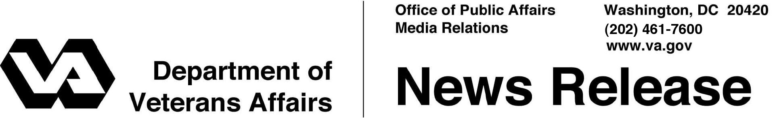

FOR IMMEDIATE RELEASE
April 2, 2009

VA Announces Recovery Spending
Includes $250 Payment to Eligible Veterans
WASHINGTON – The Department of Veterans Affairs (VA) will spend more than $1.4 billion as part of President Obama’s economic recovery plan to improve services to America’s Veterans. VA’s Internet site – www.va.gov/recovery – provides current information about VA’s work to deliver its portion of Recovery Act funds into the economy to benefit Veterans.
The American Recovery and Reinvestment Act (ARRA) enables the VA to improve medical facilities and national cemeteries, provide grants to assist states in acquiring or constructing state nursing homes and extended care facilities, and to modify or alter existing facilities to care for Veterans.
VA will dedicate ARRA funds to hire and train 1,500 temporary claims processors to speed benefits delivery to Veterans and pursue needed information technology initiatives for improved benefits and services. Funds will also be used to oversee and audit programs, grants, and projects funded under ARRA.
As part of the President’s Recovery plan, VA will also make one-time payments of $250 to eligible Veterans and survivors to mitigate the effects of the current economy. These payments will be issued as early as June 2009. VA estimates $700 million in payments will be made to eligible beneficiaries as part of this measure.
To be eligible for the $250 payment, VA beneficiaries must have received compensation, pension, dependency and indemnity compensation (DIC), or spina bifida benefits at any time between November 2008 and January 2009. Also, beneficiaries must reside within the United States or Puerto Rico, Guam, Northern Mariana Islands, American Samoa, or the U.S. Virgin Islands. No application is necessary. VA will use its existing payment records to determine eligibility for the $250 payment.

-More-
Stimulus Bill 2/2/2/2

Beneficiaries will receive their payments the same way they receive their monthly VA benefits (either by direct deposit or mail). VA will inform beneficiaries and the public when releasing the payments. This payment is not countable in determining eligibility for VA pension or Parents’ DIC. The law allows one $250 payment per individual. The payment is tax-free. VA beneficiaries who also receive benefits from the Social Security Administration or Railroad Retirement Board will be paid through those agencies, and will therefore not receive the payment from VA.
More details, including VA stimulus project timelines, will be available May 1, 2009.

# # #

