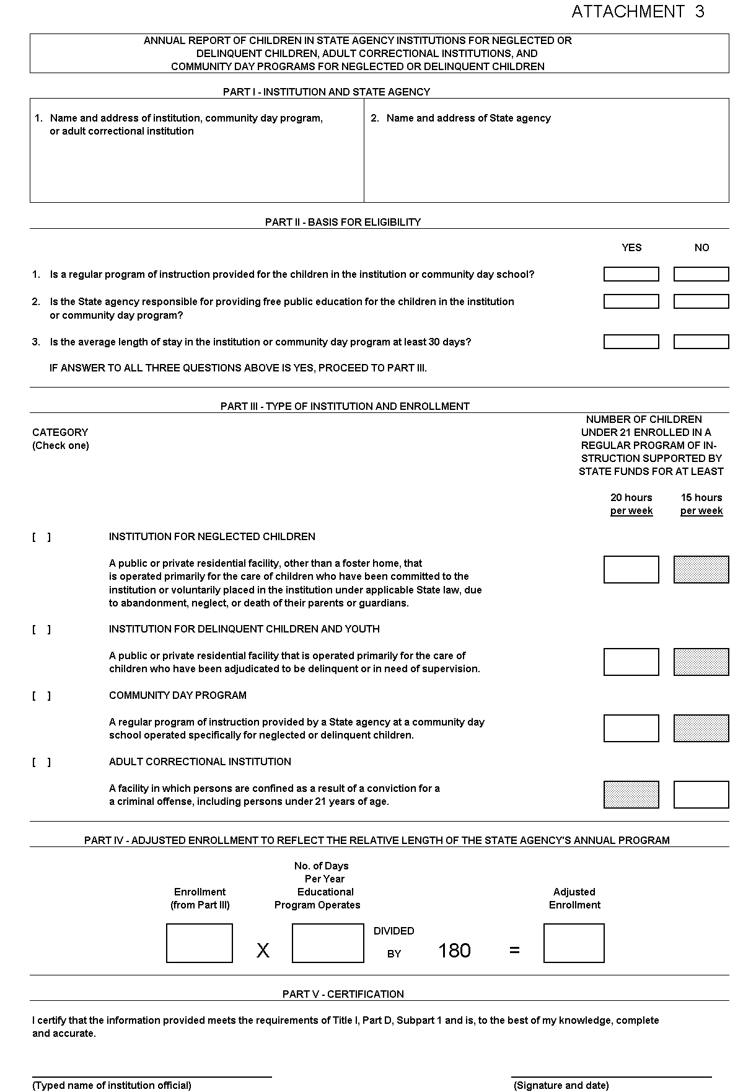

SAMPLE WORKSHEET INSTRUCTIONS

PART I - INSTITUTION AND STATE AGENCY

Enter the names of the institution and State agency. A separate form must be completed for each institution.

PART II - BASIS FOR ELIGIBILITY

Respond “yes” or “no” to each of the three questions. If the answer is no to any one of these questions, the institution or community day program does not qualify.

- In question 1 a “regular program of instruction” means an education program (not beyond grade 12) in an institution or a community day program for neglected or delinquent children that consists of classroom instruction in basic school subjects such as reading, mathematics, and vocationally oriented subjects, and that is supported by non-Federal funds. Neither the manufacture of goods within the institution nor activities related to institutional maintenance are considered classroom instruction.

- In question 2 a “State agency” means an agency of State government responsible for providing free public education for children in institutions for neglected or delinquent children, community day programs for neglected or delinquent children, and adult correctional institutions.

- In question 3 an “average length of stay” is calculated by determining the length of time each child entering the institution stays and dividing that number by the total number of children passing through that institution during a given year. The average length of stay for all children in the institution must equal at least 30 days. An individual child in an institution, however, would not necessarily have to stay for 30 days.

PART III - TYPE OF INSTITUTION AND ENROLLMENT

Category

Check the category that fits the definition of the institution. Do not report institutions that do not meet any of the four definitions.

Enrollment

For the category of institution checked, furnish the number of children under 21, through age 20, enrolled in a State-funded regular program of instruction on a date in calendar year 2006 specified by the State agency. The date specified by the State agency must be consistent for all institutions or community day programs operated by the Sate agency, and the date must represent a school day within calendar year 2006.

In order to be counted as enrolled, a child must be enrolled in a State-funded regular program of instruction for at least:

- 20 hours per week if in an institution for neglected or delinquent children or a community day program for neglected or delinquent children; or

- 15 hours per week if in an adult correctional institution.

PART IV - ADJUSTED ENROLLMENT TO REFLECT THE RELATIVE LENGTH OF THE STATE AGENCY’S ANNUAL PROGRAM

Multiply the enrollment determined in Part III by the number of days in the year that the educational program operates. Divide that number by 180 to determine the adjusted enrollment.

PART V - CERTIFICATION

The appropriate institution and State agency official should sign certifying that the information provided meets the requirements of Title I, Part D, Subpart 1, and is complete and accurate. (Note, because these data will generate Federal funds, they are subject to audit and must be supportable from documented records.)

