Slide 1: Federal Program Evaluation: Strengthening Historically Black Colleges and Universities

Slide 2: Federal Performance Measurement

How do we know if a federal program is:

Making progress and

Achieving results?

Slide 3: GPRA Drives the Federal Process

Government Performance and Results Act of 1993

Holds federal agencies accountable for achieving program results

Requires setting goals and public reporting

Seeks to reduce waste and inefficiency

Slide 4: Why Was GPRA Enacted?

Waste and inefficiency had undermined taxpayer confidence and reduced the government's ability to meet public needs

Inadequate goals and performance data impeded managers’ efforts to make programs work

Congress needed performance information

Slide 5: GPRA Requirements

All federal agencies must

Prepare:

Strategic Plans: Major long-term goals and objectives

Performance Plans: Annual program strategies and targets

Performance Reports: Annual performance and accountability reports

Make program information available to the public

Slide 6: The Department of Education’s Mission

To ensure equal access to education and to promote educational excellence

throughout the nation

Slide 7: The Department of Education’s Strategic Plan

Has six major goals

Postsecondary Education Goal:

Enhance the quality of, and access to, postsecondary and adult education

Slide 8: Postsecondary Education Objectives

Reduce gaps in college access and completion among different student populations while increasing educational attainment

Strengthen accountability of postsecondary education institutions

Strengthen minority-serving institutions

Establish effective funding mechanisms

Enhance literacy and employment skills of U.S. adults

Increase the capacity of institutions to teach world languages, area studies, and international issues

Slide 9: GPRA’s Impact Over Time

Over the past 10 years, GPRA results show steady, but uneven, progress

4 years ago, OMB developed the Program Assessment Rating Tool (PART) to systematically assess programs across federal agencies

Slide 10:What Is the PART?

The Program Assessment Rating Tool evaluates program performance in four main

areas:

Program Purpose and Design

Strategic Planning

Program Management

Program Results and Accountability

Slide 11: PART Goals

Increase focus on effectiveness (outcomes) and efficiency

Make program assessment evidence-based

Provide consistent measurement and evaluation across programs

Rate program performance

Improve public information

Slide 12: How Does the PART Evaluate Performance?

The PART is heavily weighted to focus on quantitative results (50% of score)

Outcome measures

Efficiency measures

Evidence-based program evaluation

Slide 13: In Other Words …

How well is the program doing what it is intended to do?

What is it costing to achieve the program’s purpose?

Do independent evaluations show that the program is effective and efficient?

Slide 14: Why Does PART Include a Cost Measure?

Assess a program’s ability to achieve results relative to resources

Demonstrate the ability of a program to use resources (e.g., time, effort, money) effectively

Slide 15: How Are PART Scores Used?

Identify program strengths and weaknesses

Promote program improvement and administrative changes

Inform Congress, the public, and other stakeholders

Make performance-based budgeting decisions

Slide 16: What is Performance-Based Budgeting?

Performance results inform resource allocation

The integration of a performance plan with a proposed budget

Basically, how dollars are expected to turn into results--For example, program dollars that fund day-to-day activities (counseling and tutoring) produce results (student graduation)

Slide 17: Overview of PART Scores

 | Federal | Education | Postsecondary Education
Programs assessed | 793 | 64 | 23
Effective | 15% | 3% | 0%
Moderately effective | 29% | 8% | 9%
Adequate | 28% | 31% | 30%
Ineffective | 4% | 9% | 9%
RND | 24% | 64% | 52%

Slide 18: Why a Results Not Demonstrated Rating?

New program measures were set last year

Targets were set for the new measures

Waiting for additional data to be collected, analyzed, and compared to targets

Waiting for results of independent evaluation

Slide 19: What are the Measures?

Performance outcome measures:

Undergraduate and graduate school enrollment

Postsecondary persistence

Completion rate

Cost per (undergraduate and graduate) degree

Slide 20: What Will Improve the PART Score?

Performance data must be

made publicly available

used to assess institutions’ effectiveness and set targets

used to make program improvements

Independent evaluation results

Slide 21: Study of the Strengthening Institutions Programs

Systematic study: Financial Health of Title III and Title V Postsecondary Institutions:

Is financial health improving?

Do enrollment, persistence, graduation rates affect financial health?

Is there a discernible impact of OPE programs on financial health?

Findings due in late 2007

Slide 22: How Can HBCUs Help?

Provide accurate, reliable, and on-time data reporting to IPEDS

Submit complete, accurate, reliable, and on-time annual and final performance reports

Assess the results of your use of program funds

Provide feedback to federal managers

Slide 23: ED’s Next Steps

Use program-wide assessments of individual grantees to help identify:

exemplary practices

cost efficient projects

opportunities for training and technical assistance

Improve the quality and completeness of data reported by grantees

Slide 24: Expanding HBCU Performance Analyses to Improve Feedback

Analyze data from multiple sources

Analyze multiple measures of grantee performance together

Provide grantees with results

Slide 25: Analyzing A Single Measure at the Institutional Level

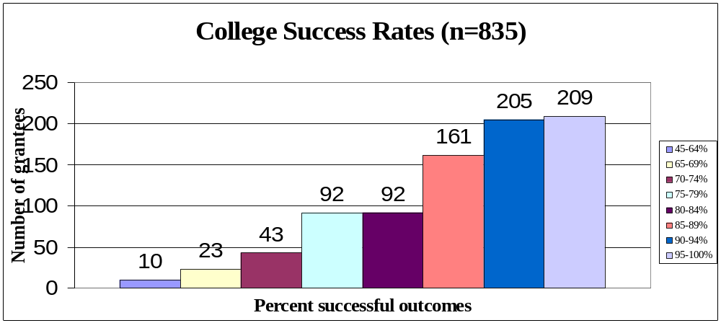

Slide 26: Analyzing Data from Multiple Sources

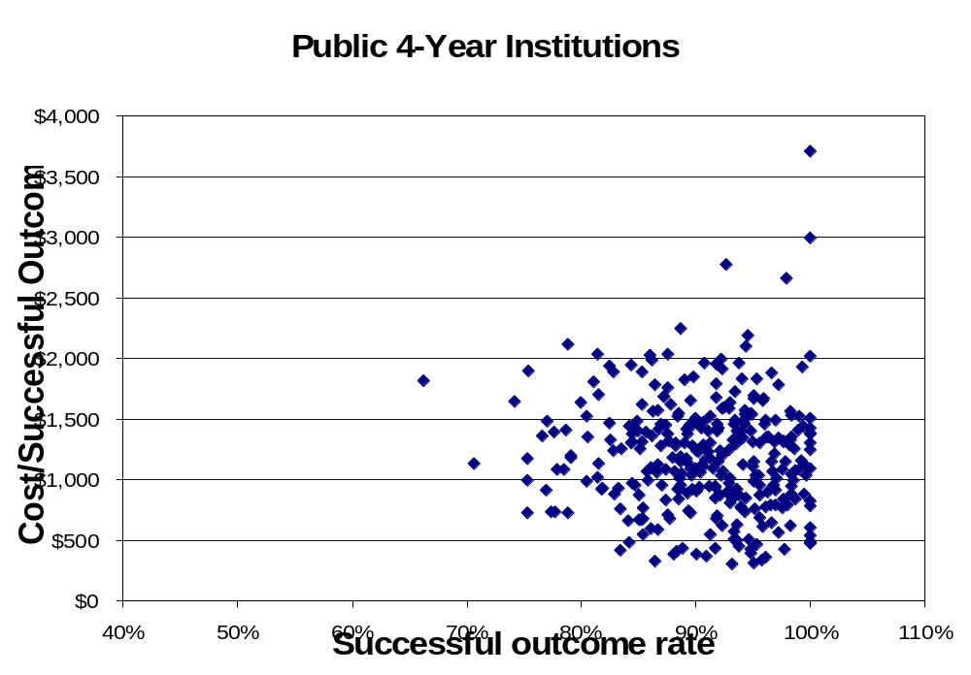

Slide 27: Analyzing Data from Multiple Sources by Multiple Categories

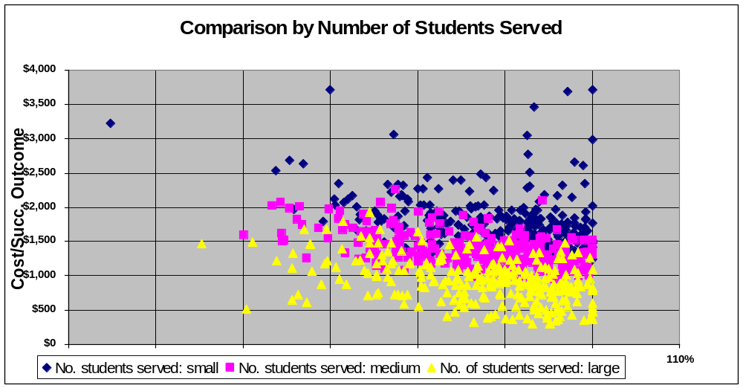

Slide 28: Providing Grantees with Performance Analyses

Individual performance and demographic data can be grouped with similar institutions for comparisons

For example, success rates can be grouped by:

Institutional type and control

Geographic location

Numbers of students served

Numbers of students receiving Pell Grants

Slide 29: How Can Institutions Use These Data?

Evaluate your performance relative to others based on multiple characteristics

Compare your performance to the national program averages for each category

Identify areas of strengths and weakness

Make data-driven decisions

Slide 30: Program Data Reviews

 | Community  College A | All Community Colleges | Difference
Success Rate | 97% | 84% | +13
Cost Per Success | $789 | $1,519 | -730
Other Factors | ? | ? | ?

Slide 31: When Will the Expanded Data Be Available?

Starting with programs being evaluated by OMB in 2006

The TRIO Programs are being used in pilot tests of the efficiency measure

Focusing on programs with Results Not Demonstrated ratings

Slide 32: Performance Measurement is Essential to Make Improvements

At national program level

At project/institutional level

Through systematic studies

Slide 33: HBCUs Are Performing in Measurable Ways

19 percent increase in enrollment from 2002-03 to 2005-06

One-year persistence rate (2005-06) is 65 percent

Percentage of entering students in four-year schools graduating within six years (2004-05): 39 percent

Slide 34: Achieving Results

Performance data show HBCUs are a significant force in minority education...

Although HBCUs represent only 3 percent of the nation’s postsecondary institutions...

...they graduate nearly one-quarter of Blacks who earn undergraduate degrees

12 percent of Black students that attend accredited two- and four-year postsecondary institutions attend HBCUs

Slide 35: Resources

PART Web site:

http://www.expectmore.gov/

IPEDS Web site:

http://nces.ed.gov/ipeds

ED Performance Web site:

http://www.ed.gov/about/reports/annual/index.html?src=pn

ED HBCU Program Web site:

http://www.ed.gov/programs/iduestitle3b/index.html

