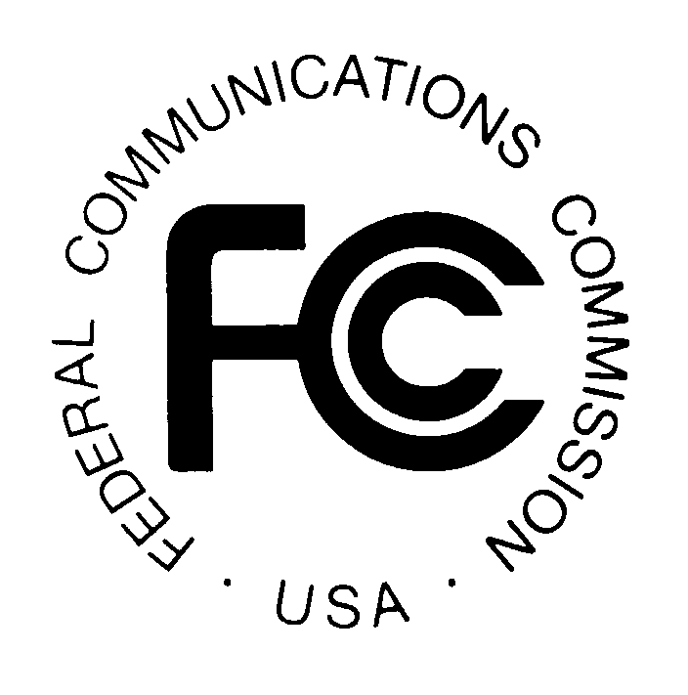PUBLIC NOTICE
FEDERAL COMMUNICATIONS COMMISSION
445 12th Street, S.W., TW-A325
WASHINGTON, DC 20554 DA 00-1581
News media information 202/418-0500 Fax-On Demand 202/418-2830 Internet: http://www.fcc.gov ftp.fcc.gov

Released: July 17, 2000

GTE CORPORATION AND SBC COMMUNICATIONS INC. SEEK FCC CONSENT TO TRANSFER CONTROL OF WIRELESS LICENSES

WT Dkt. No. 00-81

PLEADING CYCLE ESTABLISHED

Petitions/Comments: August 16, 2000
Replies/Oppositions: August 23, 2000

GTE Corporation (“GTE”) and SBC Communications Inc. (“SBC”) filed applications pursuant to Sections 214 and 310(d) of the Communications Act of 1934, as amended, 47 U.S.C. §§ 214, 310(d), seeking Commission approval of the transfer of control to SBC of licenses currently controlled by subsidiaries and affiliates of GTE. As listed below, these applications pertain to licenses for Cellular Radiotelephone Service, Personal Communications Services, Fixed Microwave Services, and International 214 Authorizations.

This transaction is related to the proposed U.S. wireless joint venture between SBC and Bell South Corporation (“BSC”). On May 4, 2000, SBC and BSC filed applications seeking consent to transfer control of most of their domestic mobile wireless authorizations to a newly created joint venture. Assuming that the transfer of control applications for the licenses listed below are granted, SBC intends to contribute these licenses to the joint venture, Alloy LLC. The applications listed below will be considered part of WT Dkt. No. 00-81, which relates to the transfer of control of licenses and authorizations to Alloy LLC. Interested parties are invited to comment also on the transfer of control of these licenses to Alloy LLC.

The following applications have been filed for consent to transfer control of the licenses listed below and have been assigned the file numbers indicated.

STREAMLINED INTERNATIONAL SECTION 214 APPLICATION

Part 63—International Service (47 C.F.R. § 63.18)

The application listed below for consent to transfer control to SBC, and potentially to Alloy LLC, of international Section 214 authority held by affiliates or subsidiaries of GTE has been found, upon initial review, to be acceptable for filing and subject to the streamlined processing procedures set forth in Section 63.12 of the Commission’s rules, 47 C.F.R. § 63.12. This application is for authority under Section 214 of the Communications Act, 47 U.S.C. § 214, to transfer control of a global international Section 214 authorization, to the extent specified below. This application can be removed from streamlined processing only in the sound discretion of Commission staff. The filing of comments or of petitions to deny will not necessarily result in the application being deemed ineligible for streamlined processing.

Streamlined grant of this application is conditioned upon the Applicants' agreement not to transfer these authorizations unless and until the Commission grants the underlying wireless license transfer applications listed below. Streamlined grant would in no way prejudge the outcome of the pending license transfers in WT Docket No. 00- 81.

File Number | Authorization Holders | Authorization Number
ITC-T/C-20000713-00397  Request for transfer of control of authorization to resell the international switched services of unaffiliated U.S. carriers on a nondominant basis. | GTE Wireless Seattle LLC, GTE Wireless Victoria LLC, GTE Mobilnet of Austin Limited Partnership, GTE Mobilnet of Texas RSA #11 Limited Partnership, GTE Mobilnet of Texas RSA #16 Limited Partnership, and Texas RSA 10B3 Limited Partnership | ITC-95-561

SECTION 310 APPLICATIONS

Licensees Holding Authorizations in the Part 22 Cellular Radiotelephone Services, Part 24 Personal Communications Services and/or Part 101 Fixed Microwave Services

File Number | Licensee | Lead Call Sign
0000182389 | GTE Wireless Seattle LLC | KNLF247
0000181822 | GTE Mobilnet of Austin Limited Partnership | KNKA302
0000182390 | GTE Wireless Victoria LLC | KNKA546
0000181823 | Texas RSA 10B3 Limited Partnership | KNKN888
0000181824 | GTE Mobilnet of Texas RSA #11 Limited Partnership | KNKN538
0000181825 | GTE Mobilnet of Texas RSA # 16 Limited Partnership | KNKN608

Final action on the applications filed pursuant to Section 310(d) will not be taken on these applications earlier than 31 days following the date of this Public Notice. See 47 U.S.C. § 309(b). Interested parties may file comments or petitions to deny no later than August 16, 2000. Replies to such pleadings may be filed no later than August 23, 2000. All filings concerning matters referenced in this Public Notice should refer to DA-00-1581 and WT Docket No. 00-81, as well as the specific file numbers of the individual applications or other matters to which the filings pertain.

GENERAL INFORMATION

The transfer of control applications referenced herein have been found, upon initial review, to be acceptable for filing. The Commission reserves the right to return any application if, upon further examination, it is determined to be defective and not in conformance with the Commission’s rules or policies.

Pursuant to 47 C.F.R. § 1.1200(a), which permits the Commission to adopt modified or more stringent ex parte procedures in particular proceedings if the public interest so requires, we announce that this proceeding will be governed by permit-but-disclose ex parte procedures that are applicable to non-restricted proceedings under 47 C.F.R. § 1.1206.

An original and four copies of all pleadings must be filed with the Commission’s Secretary, Magalie Roman Salas, 445 Twelfth Street, S.W., TW-A325, Washington, D.C. 20554, in accordance with Section 1.51(c) of the Commission’s Rules, 47 C.F.R. § 1.51(c). In addition, one copy of each pleading must be delivered to each of the following locations: (1) the Commission’s duplicating contractor, International Transcription Services, Inc. (“ITS”), 445 12th Street, S.W., Room CY-B402, Washington, D.C. 20554; (2) Office of Media Relations, Reference Operations Division, 445 12th Street, S.W., Room CY-A257, Washington, D.C. 20554; (3) Lauren Kravetz, Commercial Wireless Division, Wireless Telecommunications Bureau, 445 12th Street, S.W., Room 4-A163, Washington, D.C. 20554; (4) Michael Samsock, Commercial Wireless Division, Wireless Telecommunications Bureau, 445 12th Street, S.W., Room 4-A131, Washington, DC 20554; (5) Jamison Prime, Public Safety and Private Wireless Division, Wireless Telecommunications Bureau, 445 12th Street, S.W., Room 4-A737, Washington, D.C. 20554; and (6) Justin Connor, Telecommunications Division, International Bureau, 445 12th Street, S.W., Room 6-A832, Washington, D.C. 20554.

Copies of the applications and any subsequently filed documents in this matter may be obtained from ITS. The applications and documents are also available for public inspection and copying during normal reference room hours at the following Commission office: Office of Media Relations, Reference Operations Division, 445 12th Street, S.W., Room CY-A257, Washington, D.C. 20554. In addition, the applications are available electronically through the Wireless Telecommunications Bureau’s Universal Licensing System, which may be accessed on the Commission’s Internet web site at http://www.fcc.gov.
For further information, contact Lauren Kravetz, Commercial Wireless Division, Wireless Telecommunications Bureau, at (202) 418-7240, Michael Samsock Commercial Wireless Division, Wireless Telecommunications Bureau (Parts 22 and 24), Jamison Prime, Public Safety and Private Wireless Division, Wireless Telecommunications Bureau, at
(202) 418-0680 (Part 101); and Justin Connor, Telecommunications Division, International Bureau, at (202) 418-1476 (international Section 214 authorizations).

-FCC-

See Public Notice, SBC Communications Inc. and BellSouth Corporation Seek FCC Consent to Transfer Control of, or Assign, Licenses to Joint Venture, WT Dkt. No. 00-81, DA 00-1120 (rel. May 19, 2000).

