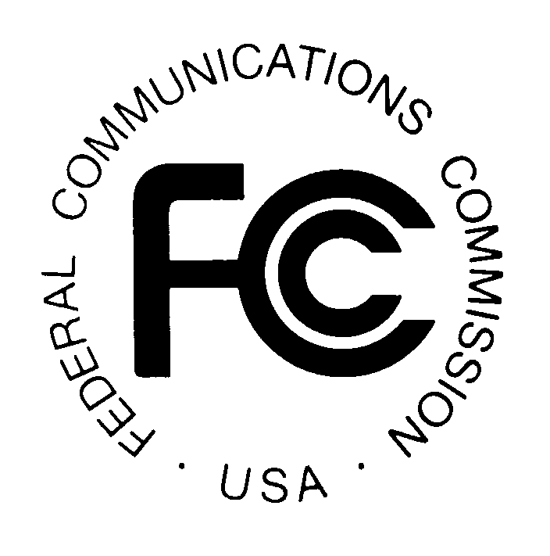PUBLIC NOTICE
FEDERAL COMMUNICATIONS COMMISSION
445 12th Street, S.W., TW-A325
WASHINGTON, DC 20554 DA 00-1972
News media information 202/418-0500 Fax-On Demand 202/418-2830 Internet: http://www.fcc.gov ftp.fcc.gov

Released: August 28, 2000

WIRELESS TELECOMMUNICATIONS BUREAU GRANTS CONSENT TO BELL ATLANTIC CORPORATION AND SBC COMMUNICATIONS INC. FOR TRANSFER OF CONTROL OF WIRELESS LICENSES

Pursuant to sections 4(i) and 310(d) of the Communications Act of 1934, as amended, 47 U.S.C. §§ 154(i), 310(d), and section 0.331 of the Commission’s rules, 47 C.F.R. § 0.331, the Wireless Telecommunications Bureau approves the applications requesting Commission consent to transfer control of licenses currently controlled by Bell Atlantic Corporation to SBC Communications, Inc. (“SBC”). These applications pertain to certain cellular, PCS, and microwave licenses. No comments or petitions to deny were received in response to the Acceptance Public Notice.

The transactions contemplated by these applications would eliminate certain wireless market overlaps created by the recent combination of the U.S. wireless properties of GTE Corporation, Bell Atlantic, and Vodafone AirTouch Plc, consistent with these parties’ commitments to the Commission and their consent decree with the United States Department of Justice. Because this transaction is related to divestitures required by competitive concerns, we do not believe that the Applicants should be permitted to continue to hold the properties for 180 additional days, as would otherwise be permitted under the Commission’s rule regarding time for consummation. Instead, we permit the Applicants 60 days from the date of release of this Public Notice to consummate these transactions.

Pursuant to section 1.103 of the Commission’s rules, 47 C.F.R. § 1.103, the consent granted herein is effective upon release of this Public Notice. Pursuant to sections 1.106(f) and 1.115(a) of the Commission’s rules, 47 C.F.R. §§ 1.106(f), 1.115(a), petitions for reconsideration and applications for review may be filed within thirty days of the release of this Public Notice.

For further information, contact Lauren Kravetz, Wireless Telecommunications Bureau, Commercial Wireless Division, at (202) 418-7240 (Parts 22 and 24), or Jamison Prime, Wireless Telecommunications Bureau, Public Safety and Private Wireless Division, at (202) 418-0680 (Part 101).

-FCC-

Control of the current licensees was transferred to Bell Atlantic on June 30, 2000, pursuant to Commission approval. See In re Application of GTE Corporation, Transferor, and Bell Atlantic Corporation, Transferee, For Consent to Transfer Control of Domestic and international Sections 214 and 310 Authorizations and Application to Transfer Control of a Submarine Cable Landing License, CC Docket No. 98-184, Memorandum Opinion and Order, FCC 00-221 (rel. June 16, 2000).
As stated in the public notice accepting these applications for filing, the transfer of control of related international 214 authorizations was processed pursuant to the International Bureau’s streamlined procedures. See GTE Corporation and SBC Communications Inc. Seek FCC Consent to Transfer Control of Wireless Licenses, Public Notice, DA 00-1581 (WTB/IB, rel. July 17, 2000) (“Acceptance Public Notice”).
Final Judgment, U.S. v. Bell Atlantic Corp., Civ. No. 1:99CV01119(LFO) (D.D.C. Apr. 18, 2000).
See 47 C.F.R. § 1.948(d).

