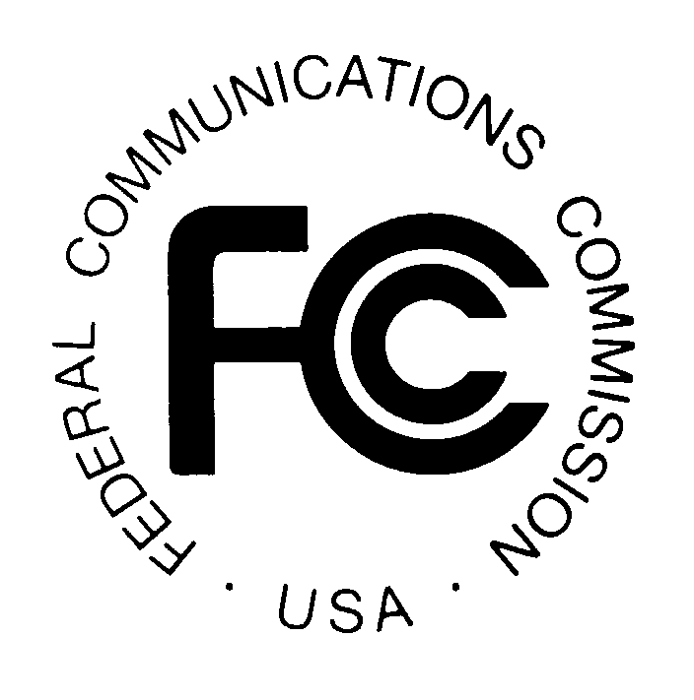PUBLIC NOTICE
FEDERAL COMMUNICATIONS COMMISSION News media information 202/418-0500
445 12th St., SW Fax-On-Demand 202/418-2830
WASHINGTON, D.C. 20554 Internet: http://www.fcc.gov ftp.fcc.gov

DA 00-1881

Released: August 17, 2000

SBC COMMUNICATIONS INC., THROUGH ITS AFFILIATES RADIOFONE, INC. AND BATON ROUGE CELLULAR TELEPHONE COMPANY, AND ALLTEL COMMUNICATIONS, INC. SEEK FCC CONSENT TO TRANSFER CONTROL OF WIRELESS LICENSES

WT Dkt. No. 00-81

PLEADING CYCLE ESTABLISHED

Petitions/Comments: September 18, 2000

Replies/Oppositions: September 28, 2000

SBC Communications Inc. (“SBC”) through its affiliates Radiofone, Inc. and Baton Rouge Cellular Telephone Company (“Radiofone”), and ALLTEL Communications, Inc. (“ALLTEL”) have filed applications pursuant to Section 310(d) of the Communications Act of 1934, as amended, 47 U.S.C. § 310(d), seeking Commission approval of the transfer of control to ALLTEL of licenses and authorizations currently controlled by subsidiaries and affiliates of SBC. As listed below, these applications pertain to Cellular Radiotelephone Service, Paging Services, Satellite Earth Stations, and Fixed Microwave Services.

This transaction is related to the proposed U.S. wireless joint venture between SBC and BellSouth Corporation (“BSC”). On May 4, 2000, SBC and BSC filed applications seeking consent to transfer control of most of their U.S., domestic mobile wireless authorizations to a newly created joint venture, Alloy LLC (“Alloy”). The transaction that is the subject of the applications listed herein is intended to resolve certain impermissible overlaps that would exist between SBC’s and BSC’s CMRS licenses after the creation of Alloy. Assuming that the transfer of control applications for the licenses listed below are granted and the contemplated transctions are subsequently consummated, Alloy will comply with the Commission’s cellular cross interest rule in the New Orleans cellular geographic service area.

Because of the relationship of this transaction to the creation of Alloy, the applications listed below will be considered part of WT Dkt. No. 00-81, which relates to the transfer of control of licenses and authorizations to Alloy. Interested parties are invited to comment also on the transfer of control of these licenses to Alloy.

Final action will not be taken on these applications earlier than 31 days following the date of this Public Notice. See 47 U.S.C. § 309(b). Interested parties may file comments or petitions to deny no later than September 18, 2000. Replies to such pleadings may be filed no later than September 28, 2000. All filings concerning matters referenced in this Public Notice should refer to DA 00-1881 and WT Docket No. 00-81, as well as the specific file numbers of the individual applications or other matters to which the filings pertain.

The following applications have been filed for consent to transfer control of the licenses and authorizations listed below and have been assigned the file numbers indicated.

SECTION 310 APPLICATIONS

Licensees Holding Authorizations in the Part 22 Cellular Radiotelephone Services, Part 22 Paging Services, Part 90 Paging Services, and/or Part 101 Fixed Microwave Services

File Number | Licensee | (Lead) Call Sign
0000197278 | Radiofone, Inc. | KKO349
 |  | KNNG392
0000195531 | Baton Rouge Cellular Telephone Company | KNKA361

Licensees Holding Authorizations in the Part 25 Satellite Earth Station Service

File Number Licensee (Lead) Call Sign
SES-T/C20000731-01372 Radiofone, Inc. E930457

GENERAL INFORMATION

The transfer of control applications referenced herein have been found, upon initial review, to be acceptable for filing. The Commission reserves the right to return any application if, upon further examination, it is determined to be defective and not in conformance with the Commission’s rules or policies.

Pursuant to 47 C.F.R. § 1.1200(a), which permits the Commission to adopt modified or more stringent ex parte procedures in particular proceedings if the public interest so requires, we announce that this proceeding will be governed by permit-but-disclose ex parte procedures that are applicable to non-restricted proceedings under 47 C.F.R. § 1.1206. Pursuant to the requirements of 47 C.F.R. § 1.927(i), ex parte notifications filed by the applicants must be served on all parties to the proceeding.

An original and four copies of all pleadings must be filed with the Commission’s Secretary, Magalie Roman Salas, 445 Twelfth Street, S.W., TW-A325, Washington, D.C. 20554, in accordance with Section 1.51(c) of the Commission’s Rules, 47 C.F.R. § 1.51(c). In addition, one copy of each pleading must be delivered to each of the following locations: (1) the Commission’s duplicating contractor, International Transcription Services, Inc. (“ITS”), 445 12th Street, S.W., Room CY-B402, Washington, D.C. 20554; (2) Office of Media Relations Reference Operations Division, 445 12th Street, S.W., Room CY-A257, Washington, D.C. 20554; (3) Lauren Kravetz, Commercial Wireless Division, Wireless Telecommunications Bureau, 445 12th Street, S.W., Room 4-A163, Washington, D.C. 20554; (4) Michael Samsock, Commercial Wireless Division, Wireless Telecommunications Bureau, 445 12th Street, S.W., Room 4-A131, Washington, D.C. 20554; (5) Jamison Prime, Public Safety and Private Wireless Division, Wireless Telecommunications Bureau, 445 12th Street, S.W., Room 4-A737, Washington, D.C. 20554; and (6) Jeanette Spriggs, Satellite and Radio Communications Division, International Bureau, 445 12th Street, S.W., Room 7-A455, Washington, D.C. 20554.

Copies of the applications and any subsequently filed documents in this matter may be obtained from ITS. The applications and documents are also available for public inspection and copying during normal reference room hours at the following Commission office: Office of Media Relations, Reference Operations Division, 445 12th Street, S.W., Room CY-A257, Washington, D.C. 20554. In addition, the applications under Parts 22, 24, 90 and 101 are available electronically through the Wireless Telecommunications Bureau’s Universal Licensing System, which may be accessed on the Commission’s Internet web site at http://www.fcc.gov.

For further information, contact Lauren Kravetz or Michael Samsock, Commercial Wireless Division, Wireless Telecommunications Bureau at (202) 418-7240 (Parts 22, 24, and 90), Jamison Prime, Public Safety and Private Wireless Division, Wireless Telecommunications Bureau, at (202) 418-0680 (Part 101), or Jeanette Spriggs, Satellite and Radio Communications Division, International Bureau at (202) 418-0727 (Part 25).

-FCC-

The parties state that Radiofone, Inc., a direct subsidiary of SBC, will be converted to a limited liability company before consummation of the transaction with ALLTEL, and a new intermediate holding company will be inserted between it and SBC. Baton Rouge Cellular Telephone Company is a partnership controlled and majority owned by Radiofone. The parties state in their applications that the transaction with ALLTEL does not include Radiofone Inc.’s Michigan cellular licenses, which the parties state will be moved to another SBC entity prior to closing.
The parties have also filed an application to transfer control of international 214 authority; this application will be processed separately by the International Bureau.
See Public Notice, SBC Communications Inc. and BellSouth Corporation Seek FCC Consent to Transfer Control of, or Assign, Licenses to Joint Venture, WT Dkt. No. 00-81, DA 00-1120 (WTB, rel. May 19, 2000).

