APPENDIX A: Sample Reports for Studies Not Requiring a DSMB

Table of Contents

INTRODUCTION

SAFETY REPORT OUTLINE

LIST OF TABLES/FIGURES

Table 1. Enrollment by Month of Study
Figure 1. Comparison of Target to Actual Enrollment by Month
Table 2. Overall Subject Status
Table 3. Subject Status Detail
Table 4. Race/Ethnic Characteristics
Table 5. Demographic and Key Baseline Characteristics by Group
Table 6. Treatment Duration for All Subjects
Table 7. Treatment Duration for Subjects Who Discontinued Therapy
Table 8. Adverse Events
Table 9. Serious Adverse Events
Table 10. Deaths
Table 11. Frequency of Specific Symptoms
Table 12. Observed Adverse Events by Body System
Table 13. Laboratory Data by Patient: Out of Range Values

Introduction

In general your monitoring plan should include the name and credentials of your Safety Officer (if approved prior to the writing of the plan) or what type of credentials your intended Officer will possess. The plan should list all information to be included in reports, with copies of the reports intended, and at what intervals throughout the trial the Safety Officer will receive trial updates. In addition, specific instructions as to whom each report will be sent [e.g., Safety Officer (only), NIDDK, FDA], and what procedures, if any, the PI or recipient(s) should follow (e.g., Safety Officer will forward the report void of patient-specific information to NIDDK) to ensure that pertinent parties receive these documents.

Safety Report Outline

The actual structure and content of the Safety Report will have to be adjusted to the type of study that is being performed. The following is an outline of the type of report the Safety Officer should receive:

I. Table of Contents
II. Narrative/ Trial Summary
A. Summary of Main Findings
B. Discussion of Issues or Problems
C. Report Preparation Procedures
III. Study Description
A. Project Organizational Chart, Personnel
B. Brief Statement of Purpose of Trial
C. Projected Timetable and Schedule
D. List of any Resource Centers
IV. Study Administration
A. Recruitment Status
1. Enrollment by Year or Month
2. Comparison of Targeted to Actual Enrollment
B. Retention Status
1. Overall Subject Status
2. Individual Subject Status
V. Study Data Reports/Tables or Figures
A. Generic Information
1. Enrollment (Table 1, Figure 1)
2. Status (Table 2 and 3)
3. Demographics (Table 4 and 5)
B. Safety Assessment
1. Treatment Duration for All Subjects (Table 6)
2. Treatment Duration for Subjects who Discontinue Treatment (Table 7)
3. Adverse Events (Table 8)
4. Serious Adverse Events (Table 9)
5. Deaths (Table 10)
6. Frequency of Specific Symptoms (Table 11)
7. Observed Adverse Events by Body System (Table 12)
8. Laboratory Data By Patient (Table 13)

Table 1. ENROLLMENT BY MONTH OF STUDY

Date: _________________________
Month | # Expected | # Screened | # Enrolled | # Withdrawn

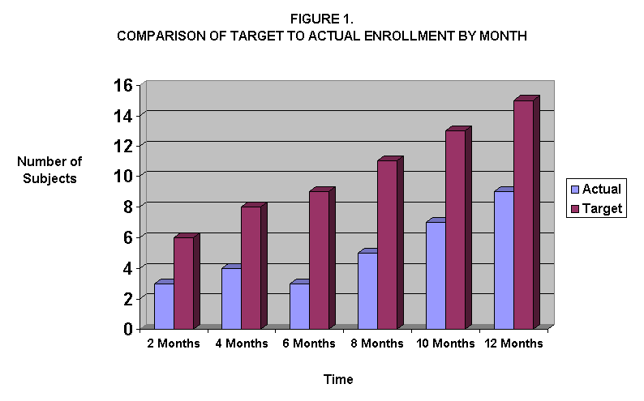

Table 2. OVERALL SUBJECT STATUS

Date: _________________________
 | Pt. Identification | Screened | Date Enrolled | Date Completed | Active | Terminated/ Dropped Out (reason)
1
2
3
4
N
Total

Table 3. SUBJECT STATUS-DETAIL*

Date: _________________________
Terminated Patients
 | Pt. | Active | Completed | Concurrent Illness | Drug Permanently Discontinued | Withdrawal of Consent | Adverse Event | Patient Stops Medication | Lost to Follow-Up
1
2
3
4
N
Total
*Note: It may be important to further capture information about patient withdrawal. Some suggested categories might be:

1) Permanent drug discontinuation (serious adverse event), patient continues follow up
2) Permanent drug discontinuation (serious adverse event), patient refuses follow up
3) Patient stops drug (a specific reason e.g. side effects, inconvenience), patient continues follow up
4) Patient stops drug (a specific reason e.g. moves, side effects), but refuses further follow up
5) Patient lost to follow up (no explanation given)

Table 4. RACE/ETHNIC CHARACTERISTICS

Date: _________________________

Total Enrollment Report: Number of Subjects Enrolled to Date by Ethnicity and Race
Ethnic Category | Sex/Gender
Ethnic Category | Females | Males | Unknown | Total
Hispanic or Latino
Not Hispanic or Latino
Unknown
Ethnic Category: Total of All Subjects
Racial Categories
American Indian/Alaska Native
Asian
Native Hawaiian/Other Pacific Islander
Black or African American
White
More than one race
Unknown or unreported
Racial Categories: Total All Subjects
HISPANIC ENROLLMENT REPORT: Number of Hispanics or Latinos Enrolled to Date
Racial Categories
American Indian/Alaska Native
Asian
Native Hawaiian/Other Pacific Islander
Black or African American
White
More than one race
Unknown or unreported
Racial Categories: Total All Subjects

Table 5. DEMOGRAPHIC AND KEY BASELINE CHARACTERISTICS BY GROUP

Date: _________________________
Characteristics | Group 1  N% | Group 2  N% | Total  N%
Gender
- Male
- Female

Ethnicity
Hispanic or Latino
Not Hispanic or Latino
Unknown

Race
- American Indian/Alaska Native
- Asian
- Native Hawaiian or Other Pacific Islander
- Black or African American
- White
- More than one race
- Unknown or not reported
Age
- Mean
- Median
- Minimum
- Maximum
Risk Factors
Clinical Features

Table 6. TREATMENT DURATION FOR ALL SUBJECTS

Date: _________________________
TIME IN STUDY | N | % | TOTAL
1 month or less
2-5 months
6-9 months
10-11 months
Completed study

Table 7. TREATMENT DURATION FOR SUBJECTS WHO DISCONTINUED THERAPY

Date: _________________________
Time in Study | N | % | Total
1 month or less
2-5 months
6-9 months
10-11 months
Completed study

Table 8. ADVERSE EVENTS

Date: _________________________

Subject | Adverse Event | Onset Date | Ending Date | *Severity | *Drug Related | *Action | *Outcome | Comments

CODES:
Severity: Drug Relatedness:
1 = Mild 0 = Definitely unrelated
2 = Moderate 1 = Unlikely
3 = Severe 2 = Possibly Related
4 = Life threatening** 3 = Probably Related
4 = Definitely Related

Action (taken): | Outcome:
0 = None | 1 = Resolved
1 = Dose modification | 2 = Recovered with minor sequelae
2 = Counteractive Medication | 3 = Recovered with major sequelae
(specify under comments) | 4 = Condition still present and under treatment
3 = Medical/surgical intervention | 5 = Condition continues to worsen
(specify under comments) | 6 = Patient died**
4 = Hospitalization**
5 = Drug permanently discontinued
6 = Other (specify under comments)
**Event is serious and explained in detail on SAE form

Table 9. SERIOUS ADVERSE EVENTS

Date: _________________________
Subject | Age | Treatment Date | Event | Onset Date | *Relationship | Description of Actions and Outcome  (e.g., hospitalization concomitant meds, study, status, etc.)

*RELATIONSHIP
0 = Definitely Unrelated
1 = Unlikely
2 = Possibly Related
3 = Probably Related
4 = Definitely Related

NOTE: Whether or not the event is “expected” might also be included in this table. “Expected” means the event is part of the natural course of the disease process or the event is a known consequence of the treatment as identified in the protocol or the investigator’s brochure. This may be important information if this study is using an investigational or IND drug.

Table 10. DEATHS

Date: _________________________
Patient ID# | DOB | Date Enrolled | Treatment Duration | Cause of Death | Date of Death

Table 11. FREQUENCY OF SPECIFIC SYMPTOMS

Date: _________________________
Symptoms  (depends on disease) | N%
Pain or Heaviness in Legs
Swelling in Legs
Pain or Heaviness in Chest
Headaches
Dizziness
Nausea
Abdominal Pain
Weakness
Fatigue
Muscle Aches
Urinary Frequency
Total

Table 12. OBSERVED ADVERSE EVENTS BY BODY SYSTEM

Date: _________________________

ADVERSE EVENT | SEVERITY |  | RELATIONSHIP TO DRUG
 | Mild/Mod | Severe | Related to Drug A Only | Related to Drug B Only | Related to Both | Not Related
Body System A:
Event 1
Body System B:
Event 1
Body System C:
Event 1

Table 13. LABORATORY DATA BY PATIENT: OUT OF RANGE VALUES

Date: _________________________
Pt. ID# | Visit # | HCT | WBC | PLT | Protein | Urine RBC | Creatinine | ALT | AST | Cholesterol | Amylase | BUN | CPK

