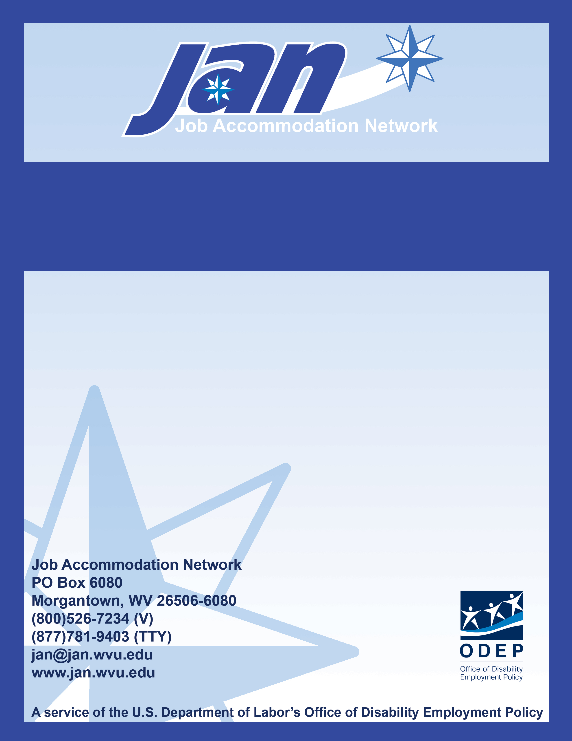
Fact Sheet Series

Accessibility under the Americans with Disabilities Act

JAN’S ACCOMMODATION FACT SHEET SERIES

Accessibility Under the
Americans with Disabilities Act

- ADAAG

- Americans with Disabilities Act Accessibility Guidelines
- Written and enforced by the U.S. Access Board
- Adopted by the U.S. Department of Justice as the design standards to be used for new construction and renovations under the ADA

What is the ADAAG?
The Americans with Disabilities Act (ADA) establishes design requirements for the construction and alteration of facilities in the private and public sectors. These requirements are known as the ADA Accessibility Guidelines or "ADAAG." ADAAG contains requirements for new construction and alterations. The Access Board develops the requirements as "guidelines" to serve as a basis for "standards" enforced by the Department of Justice (DOJ) and the Department of Transportation (DOT). ADAAG derives from an earlier Federal standard, the Uniform Federal Accessibility Standards (UFAS).

Where can I get a copy of the ADAAG?
The Access Board provides free copies of the ADAAG on its Web site at http://www.access-board.gov/adaag/html/adaag.htm or call the Access Board at (800) 872-2253 to order a free copy.

Where does the ADAAG apply?
Regulations issued by DOJ and DOT contain enforceable standards based on ADAAG. These regulations spell out what facilities are subject to the standards. It is important that the regulations be used along with the design standards they contain or reference because they provide important information on coverage. These regulations address different types of facilities:

- Title III: Places of public accommodation and commercial facilities are addressed by a DOJ regulation (28 CFR Part 36) that contains standards based on ADAAG.
- Title II: State and local government facilities are subject to a DOJ regulation (28 CFR Part 35) that currently allows use of the ADAAG-based standards issued for the private sector (with some exceptions) or UFAS. The regulation references, but does not contain, these standards.
- Title II: Public transportation facilities are addressed by a DOT regulation (49 CFR Part 37) that contains standards based on ADAAG.

For a copy of the regulations referenced above, see DOJ’s ADA Handbook at http://www.jan.wvu.edu/media/adahandbook/handbook.html.

Is my copy of the ADAAG current?
A copy of the original ADAAG-based standard as issued by DOJ is still pretty much usable as only two limited changes have been made to the standards to date:

- suspension of requirements in ADAAG 4.29 for detectable warnings at curb ramps, hazardous vehicular areas, and reflecting pools; and
- revision of ATM specifications for clear floor space and control heights in ADAAG 4.34.

The Board has issued supplements to ADAAG, but they are not yet part of the standards and thus are not enforceable at this time. These supplements cover:

- recreation facilities, including amusement rides, boating facilities, fishing piers and platforms, golf courses, miniature golf courses, sports facilities, swimming and wading pools, and spas;
- play areas, including play structures and equipment;
- building elements designed for children’s use, including drinking fountains, toilets, lavatories and sinks, and fixed seating and tables; and
- state and local government facilities, including courthouses and prisons.

While not yet enforceable, these guidelines can provide helpful guidance in the design of children’s environments and play areas, courthouses, correctional facilities, and various types of recreation facilities.

What is the status of the “new” ADAAG?
In July 2004, the Board completed a comprehensive update of the ADAAG, along with an update of its guidelines for federally funded facilities covered by the Architectural Barriers Act (ABA). However, these new guidelines are not enforceable or mandatory until the DOJ adopts them as ADA standards. To check the status of the new guidelines, visit http://www.access-board.gov/ada-aba/standards-update.htm. In the meantime, you must follow the original ADAAG.

What other guidelines is the Access Board developing?
The Board is developing new guidelines under the ADA that will cover outdoor developed areas and public rights-of-way.

Where can I get more information about the ADAAG?
The Access Board provides technical assistance at (800) 872-2253 or by e-mail at ta@access-board.gov or visit the Web site at:
http://www.access-board.gov/adaag/about/index.htm.

- Title III (Public Accommodations and Commercial Facilities)

New Construction:
- Follow ADAAG unless greater accessibility is provided

Renovation:
- Follow ADAAG unless technically infeasible
- Do not decrease accessibility

Title III of the ADA requires that any alterations to, or new construction of "commercial facilities," as well as places of public accommodation, made after January 26, 1992, must conform to the ADAAG (incorporated in DOJ’s Title III regulations). "Commercial facilities" are defined as any nonresidential facility whose operations affect commerce, including office buildings, factories and warehouses; therefore, the facilities of most employers will be subject to this requirement. An alteration is any change that affects the "usability" of a facility; it does not include normal maintenance, such as painting, roofing or changes to mechanical or electrical systems, unless the changes affect the "usability" of the facility.

Under Title III, all newly constructed public accommodations and commercial facilities for which the last building permit is certified after January 26, 1992, and which are occupied after January 26, 1993, must be accessible in accordance with the standards of the ADAAG. However, Title III does not require elevators in facilities under 3 stories or with less than 3000 square feet per floor, unless the building is a shopping center, mall, professional office of a health provider, or public transportation station.

Existing Facilities:
- Readily achievable barrier removal in all public accommodations

Title III of the ADA requires that places of public accommodation (such as banks, retail stores, theaters, hotels, and restaurants) make their goods and services accessible generally, to all people with disabilities. Under Title III, existing buildings and facilities of a public accommodation must be made accessible by removing architectural barriers or communications barriers that are structural in nature, if this is "readily achievable." If barrier removal is not "readily achievable," services must be provided to people with disabilities in some alternative manner if this is "readily achievable."

Where can I get more information about the requirements of Title III?
Contact the DOJ’s ADA Information Line for more information at (800) 514-0301, or visit DOJ’s ADA Home Page at http://www.ada.gov.

- Title II (State and Local Government)

New Construction:
- Follow ADAAG unless greater accessibility is provided

Renovation:
- Follow ADAAG unless technically infeasible
- Do not decrease accessibility

Under Title II, any alterations to, or new construction of, state or local government facilities made after January 26, 1992, must conform either with the ADAAG (however, the exception regarding elevators does not apply to State or local governments) or with the UFAS. Facilities under design on January 26, 1992, must comply with this requirement if bids were invited after that date.

Existing Facilities:
- Programs and activities, when viewed in their entirety, must be accessible and useable by people with disabilities, which might not require that every building be accessible
- Unless undue burden or fundamental alteration of the program or activity

Title II requires that state and local governments operate each service, program, or activity in existing facilities so that, when viewed in its entirety, it is readily accessible to and useable by persons with disabilities, unless this would cause a "fundamental alteration" in the nature of the program or service, or would result in "undue financial and administrative burdens." This means that state and local governments do not necessarily have to make every existing building accessible. Instead, they may be able to meet their program accessibility requirements by moving a program or activity to an accessible building as needed.

The obligation for state and local governments to provide "program accessibility" in existing facilities under Title II differs from their obligation to provide access as employers under Title I (see Title I discussion).

Where can I get more information about the requirements of Title II?
Contact the DOJ’s ADA Information Line for more information at (800) 514-0301, or visit DOJ’s ADA Home Page at http://www.ada.gov.

- Title I (Private Employers and State and Local Government Employers)

New Construction:
- Follow ADAAG unless greater accessibility is provided

Renovation:
- Follow ADAAG unless technically infeasible
- Do not decrease accessibility

Private employers that occupy commercial facilities or operate places of public accommodation and state and local governments must conform to more extensive accessibility requirements under Title III and Title II when making alterations to existing facilities or undertaking new construction.

Existing Facilities:
- Meet individual applicant’s or employee’s needs under reasonable accommodation obligation
- Unless undue hardship

Private employers with 15 or more employees and state and local government employers must provide reasonable accommodations for employees with disabilities, including accommodations related to accessibility. The employer's obligation under Title I is to provide access for an individual applicant to participate in the job application process, and for an individual employee with a disability to perform the essential functions of his/her job, including access to a building, to the work site, to needed equipment, and to all facilities used by employees. The employer must provide such access unless it would cause an undue hardship.

Under Title I, an employer is not required to make its existing facilities accessible until a particular applicant or employee with a particular disability needs an accommodation, and then the modifications should meet that individual's work needs. The employer does not have to make changes to provide access in places or facilities that will not be used by that individual for employment related activities or benefits.

Where can I get more information about the requirements of Title I?
The Equal Employment Opportunity Commission (EEOC) enforces Title I of the ADA. Contact the EEOC at (800) 669-4000 or visit the EEOC’s Web site at http://www.eeoc.gov.

You can also contact JAN for ADA information at (800) ADA-WORK (232-9675) (V) or (877) 781-9403 (TTY) or visit JAN’s Web site at http://www.jan.wvu.edu.

Updated 8/18/08.

This document was developed by the Job Accommodation Network, funded by a contract agreement from the U.S. Department of Labor, Office of Disability Employment Policy (DOL079RP20426). The opinions expressed herein do not necessarily reflect the position or policy of the U.S. Department of Labor. Nor does mention of trade names, commercial products, or organizations imply endorsement by the U.S. Department of Labor.

