Seattle, WA

LOCATION:
GSA – Jackson Federal Building
915 2nd Avenue
Seattle, WA 98174

HOTELS:

The hotels listed below participate in GSA’s governmentwide lodging program, FedRooms® – which provides Federal Travel Regulation (FTR) compliant hotel rooms at or below per diem rates for federal government travelers while on official business.

You may find program information and a current list of all FedRooms® preferred properties at: http://www.fedrooms.com (a non-federal website). Also, per diem rates may be found at: http://www.gsa.gov/perdiem

FedRooms® Rates are available using all booking channels: TMC, E-Gov Travel Service, FedRooms® website, and hotel reservation centers.

You MUST ASK for the FedRooms® Rate (NOT the government rate) when you contact the hotels. FedRooms® properties are listed by proximity to the Philadelphia location (closest to farthest).

CTRL + click on any highlighted property below to bring you to booking link:

CROWNE PLAZA SEATTLE 0.2 Miles
1113 SIXTH AVENUE
Seattle WA 98101

HILTON SEATTLE 0.2 Miles
1301 6TH AVENUE
Seattle WA 98101

THE FAIRMONT OLYMPIC HOTEL SEATTLE 0.2 Miles
411 UNIVERSITY ST
Seattle WA 98101
1-206-621-1700

GRAND HYATT SEATTLE 0.3 Miles
721 PINE STREET
Seattle WA 98101-1815

HOMEWOOD SUITES SEATTLE CONV CTR/PIKE ST 0.3 Miles
1011 PIKE STREET
Seattle WA 98101

HOTEL MAX 0.4 Miles
620 STEWART ST
Seattle WA 98101

SEATTLE RAMADA INN – DOWNTOWN 0.7 Miles
2200 5TH AVENUE
Seattle WA 98121

HAMPTON INN SUITES DOWNTOWN 1.7 Miles
700 FIFTH AVE NORTH
Seattle WA 98109

HOMEWOOD SUITES SEATTLE DOWNTOWN 1.6 Miles
206 WESTERN AVE WEST
Seattle WA 98119

HYATT REGENCY BELLEVUE 6.0 Miles
900 BELLEVUE WAY
Bellevue WA 98004

If you have any further questions please feel free to contact us for immediate assistance at:
FedRooms
Phone: 800-226-1741
E-mail: hotels@fedrooms.com

Updated: March 2009

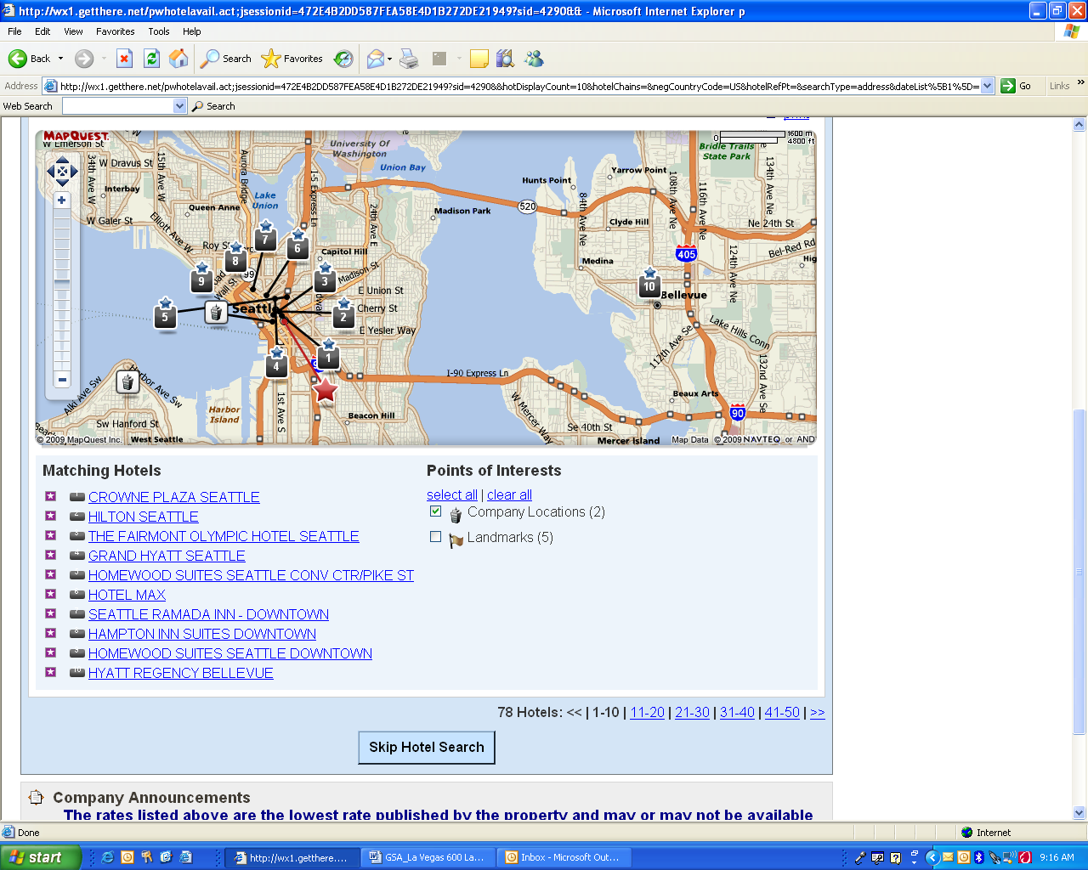

- CROWNE PLAZA SEATTLE
- HILTON SEATTLE
- THE FAIRMONT OLYMPIC HOTEL SEATTLE
- GRAND HYATT SEATTLE
- HOMEWOOD SUITES SEATTLE CONV CTR/PIKE ST
- HOTEL MAX
- SEATTLE RAMADA INN – DOWNTOWN
- HAMPTON INN SUITES DOWNTOWN
- HOMEWOOD SUITES SEATTLE DOWNTONW
- HYATT REGENCY BELLEVUE

