San Francisco, CA

LOCATION:
450 Golden Gate Avenue
San Francisco, CA 94102

HOTELS:

The hotels listed below participate in GSA’s governmentwide lodging program, FedRooms® – which provides Federal Travel Regulation (FTR) compliant hotel rooms at or below per diem rates for federal government travelers while on official business.

You may find program information and a current list of all FedRooms® preferred properties at: http://www.fedrooms.com (a non-federal website). Also, per diem rates may be found at: http://www.gsa.gov/perdiem

FedRooms® rates are available using all booking channels: TMC, E-Gov Travel Service, FedRooms® website, and hotel reservation centers.

You MUST ASK for the FedRooms® RATE (NOT the government rate) when you contact the hotels. FedRooms® properties are listed by proximity to the
San Francisco location (closest to farthest).

CTRL + click on any highlighted property below to bring you to booking link:

INTERCONTINENTAL SAN FRANCISCO 0.8 miles
888 Howard Street
San Francisco CA 94103

PARC 55 0.8 miles
55 CYRIL MAGNIN STREET
San Francisco CA 94108
1-800-595-0507

SERRANO 0.8 miles
405 TAYLOR STREET
San Francisco CA 94102

DIVA HOTEL 0.9 miles
440 GEARY STREET
San Francisco CA 94102
1-415-885-0200

HOTEL UNION SQUARE 0.9 miles
114 POWELL STREET
San Francisco CA 94102
1-415-397-3000

VILLA FLORENCE 0.9 miles
225 POWELL STREET
San Francisco CA 94102
1-415-397-7700

HOLIDAY INN GOLDEN GATEWAY 1.0 miles
1500 VAN NESS AVENUE
San Francisco CA 94109
1-415-441-4000 (ok)

KENSINGTON PARK 1.0 miles
450 POST STREET
San Francisco CA 94102
1-415-788-6400

SIR FRANCIS DRAKE 1.0 miles
450 POWELL STREET
San Francisco CA 94102

THE WESTIN ST. FRANCIS 1.0 miles
335 POWELL STREET
San Francisco CA 94102

If you have any further questions please feel free to contact us for immediate assistance at:

FedRooms
Phone: 800-226-1741
E-mail: hotels@fedrooms.com
Updated March 2009

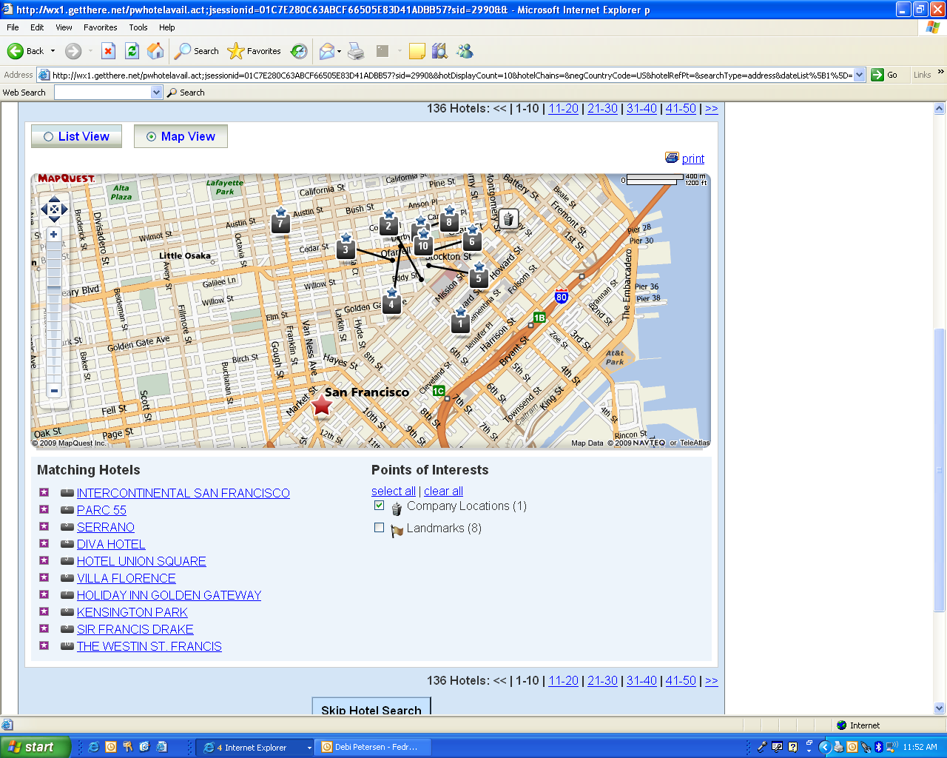

- Intercontinental San Francisco
- Parc 55
- Serrano
- Diva Hotel
- Hotel Union Square
- Villa Florence
- Holiday Inn Golden Gateway
- Kensington Park
- Sir Francis Drake
- The Westin St. Francis

