Boston, MA

LOCATION:
10 Causeway Street
Boston, MA 02222

HOTELS:

The hotels listed below participate in GSA’s governmentwide lodging program, FedRooms® – which provides Federal Travel Regulation (FTR) compliant hotel rooms at or below per diem rates for federal government travelers while on official business.

You may find program information and a current list of all FedRooms® preferred properties at: http://www.fedrooms.com (a non-federal website). Also, per diem rates may be found at: http://www.gsa.gov/perdiem

FedRooms® Rates are available using all booking channels: TMC, E-Gov Travel Service, FedRooms® website, and hotel reservation centers.

You MUST ASK for the FedRooms® Rate (NOT the government rate) when you contact the hotels. FedRooms® properties are listed by proximity to the Boston location (closest to farthest).

CTRL + click on any highlighted property below to bring you to booking link:

NINE ZERO HOTEL 0.0 miles
90 TREMONT STREET
Boston MA 02108
1-617-772-5800

OMNI PARKER HOUSE 0.0 miles
60 SCHOOL STREET
Boston MA 02108

CLUB QUARTERS BOSTON 0.2 miles
161 DEVONSHIRE STREET
Boston MA 02110

HOLIDAY INN BOSTON AT BEACON HILL 0.3 miles
5 BLOSSOM ST
Boston MA 02114

BULFINCH HOTEL 0.3 miles
107 MERRIMAC STREET
Boston MA 02114

HILTON BOSTON FINANCIAL DISTRICT 0.3 miles
89 BROAD STREET
Boston MA 02110

HYATT REGENCY BOSTON FINANCIAL DISTRICT 0.3 miles
1 AVE DE LAFAYETTE
Boston MA 02111

MILLENNIUM BOSTONIAN 0.3 miles
AT FANEUIL HALL MARKETPLACE
Boston MA 02109

THE ONYX 0.3 miles
155 PORTLAND STREET
Boston MA 02114
1-617-557-9955

INTERCONTINENTAL BOSTON 0.4 miles
510 ATLANTIC AVENUE
Boston MA 02210

If you have any further questions please feel free to contact us for immediate assistance at:
FedRooms
Phone: 800-226-1741
E-mail: hotels@fedrooms.com
Updated March 2009

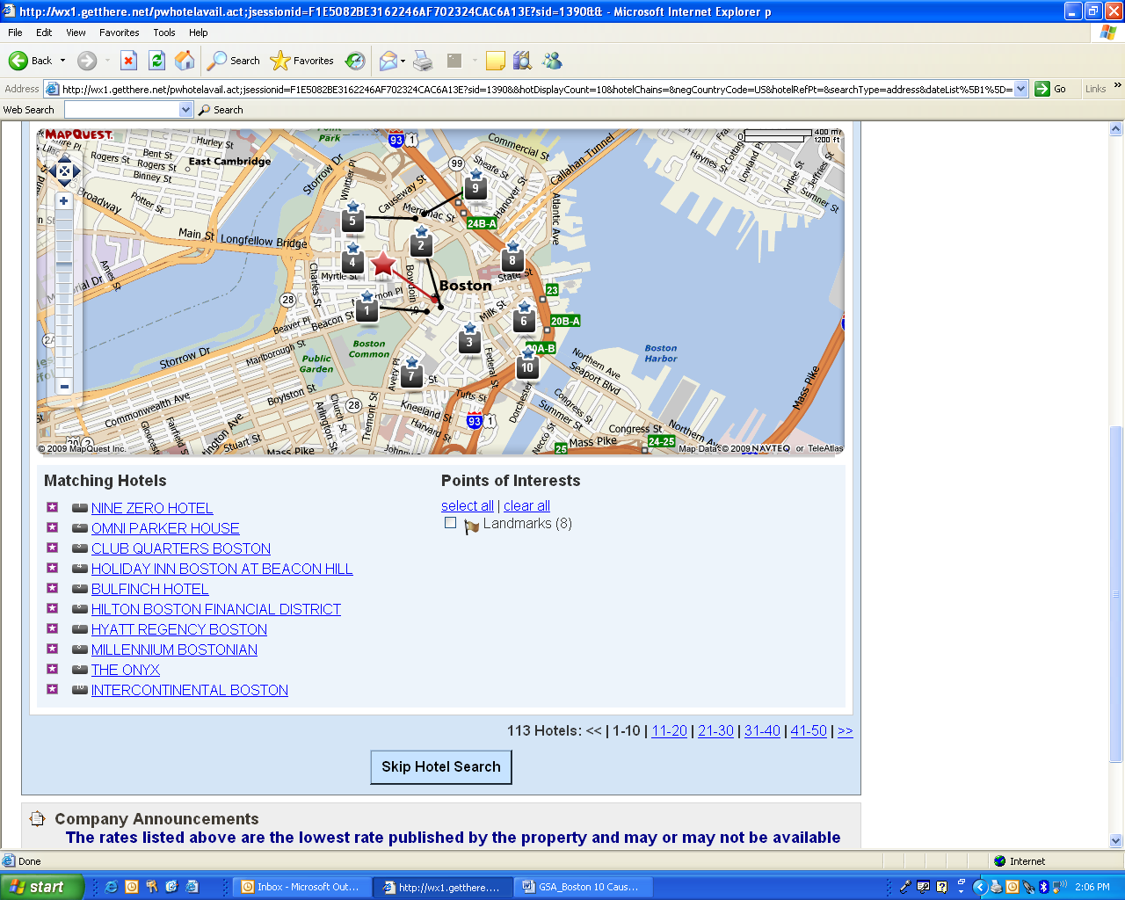

- NINE ZERO HOTEL
- OMNI PARKER HOUSE
- CLUB QUARTERS BOSTON
- HOLIDAY INN BOSTON AT BEACON HILL
- BULFINCH HOTEL
- HILTON BOSTON FINANCIAL DISTRICT
- HYATT REGENCY BOSTON
- MILLENNIUM BOSTONIAN
- THE ONYX
- INTERCONTINENTAL BOSTON

