

Address Information System Product


AIS VIEWER USER’S GUIDE

Address Management
National Customer Support Center
United States Postal Service
6060 Primacy Pkwy Ste 201
Memphis, TN 38188-0001
(800) 238-3150

COPYRIGHT© USPS 2005

TABLE OF CONTENTS

SYSTEM REQUIREMENTS 1
OVERVIEW Error! Bookmark not defined.
AIS VIEWER ORDER FORM 3
LICENSE AGREEMENT…………………………………………………………………4
AIS VIEWER CD-ROM INSTALLATION INSTRUCTIONS 6
AIS Viewer Usage 8
Customer Key Code 8
Address Matching Engine 9
MENU FUNCTIONS 9
File 10
View 11
Reports 11
Tools 12
Installation 12
ReadMe 13
Help 13
AIS VIEWER REPORTS 14
Report Print Options 14
Address Lookup 15
Example: Report Results from Sample Address 15
City/State/Delivery Type Retrieval 16
Example: City Option Lookup 16
Delivery Type Lookup Options 17
Example: Report Result from Sample Lookup 17
County Name Retrieval 18
Example: Sample lookup screen for county name retrieval 18
Delivery Statistics Retrieval 19
Example: Sample lookup screen for Delivery Statistics 19
ZIP + 4 Retrieval 20
ZIP + 4 Retrieval Lookup Options 20
Example: Street and ZIP Code Option 20
GLOSSARY 21

SYSTEM REQUIREMENTS

The minimum requirements to run the AIS Viewer Application are listed below:

  - 1.98 megabytes of available hard drive space
  - 32MB of RAM or higher (128 recommended)
  - Operating system Windows 95 or better

Note: The AIS Viewer Application will not operate on a Macintosh computer.

OVERVIEW

AIS Viewer is an interactive CD-ROM, which includes five different AIS products: City/State/Delivery Type; County Name Retrieval; Delivery Statistics Retrieval; ZIP + 4® Retrieval; and Address Lookup. The CD-ROM provides the ability to retrieve, view, and print hardcopy reports, on demand, at a 5-digit ZIP Code level. The CD-ROM is updated monthly and the data is valid for 105 days from the product (monthly) cycle date providing a significant improvement in the content, accuracy, and currency of information over the obsolete Publication 65, National Five-Digit ZIP Code and Post Office Directory. The data is encrypted and cannot be exported. Using the AIS Viewer with the "address lookup" option meets the 5-digit ZIP Code accuracy standard for addresses used on pieces in nonautomation Presorted rate First-Class Mail, Periodicals, Standard Mail, and Bound Printed Matter mailings.

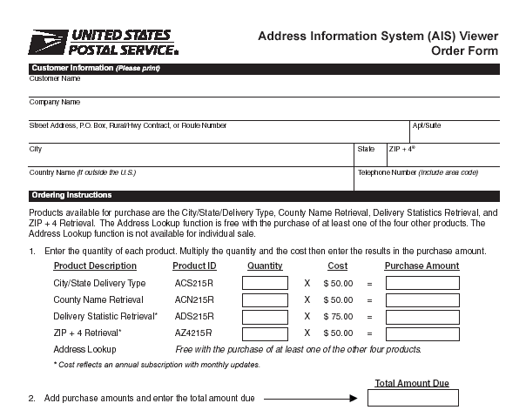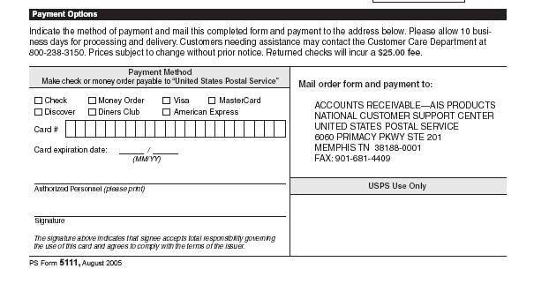

LICENSE AGREEMENT

To use this AIS software, you (the “End User”) must read the Agreement set forth below and agree to be bound by the terms of this Agreement between you and the United States Postal Service® (USPS®).

By proceeding to the next screen in this software/database package -- by clicking on “Enter” -- you will be agreeing to become bound by the terms of this Agreement. If you do not wish to be bound to the terms of this Agreement, do not click on Enter – do not proceed any further into this software package.

If you do not agree to the terms of this Agreement, promptly return this software and all items purchased with it (including written matter, binders or other containers and materials, if any are part of this purchase) to the place where you obtained them for a full refund.

References herein to this “Agreement” are also referencing the Disclaimer of Warranty set forth below which is part of this Agreement.

Note: Once processed by the USPS, this Agreement and the authorization constitutes the complete agreement between you and USPS.

As stated above, before clicking on “Enter” – before proceeding to the next screen in this software – you must read this Agreement and agree to its terms. By clicking on “Enter,” you will be agreeing to the terms of this Agreement.

USPS Software/Database License

1. GRANT OF LICENSE. In consideration of payment of a LICENSE fee, which is part of the price you paid for this product, USPS as LICENSOR, grants to you, the LICENSEE, a nonexclusive right to use and display this copy of USPS software program and/or database (hereinafter the “PRODUCT”) FOR YOUR INTERNAL CORPORATE OR PERSONAL USE on one computer at one location. If you use the PRODUCT, on a multi-user computer system, the license covers all users. USPS reserves all rights not expressly granted to LICENSEE.

2. OWNERSHIP OF PRODUCT. As the LICENSEE, you own the magnetic or other physical media on which the PRODUCT is originally or subsequently recorded or fixed, but USPS retains title and ownership of the PRODUCT recorded on the media and all subsequent versions of the PRODUCT, regardless of the form or media. This License is not a sale of the PRODUCT.

3. COPY OF RESTRICTIONS. This PRODUCT and the accompanying written materials are copyrighted. Unauthorized copying of the PRODUCT, including a PRODUCT that has been modified, merged or included with other software and/or data, or of the written material, is expressly forbidden. You may be held legally responsible for any copyright infringement that is caused or encouraged by your failure to abide by the terms of this License.

4. USE RESTRICTIONS. The PRODUCT may only be used within the boundaries of the United States and its territories. As the LICENSEE, you may physically transfer the PRODUCT from one computer to another provided that the PRODUCT is used on only one computer at a time. You may not electronically transfer the PRODUCT from one computer to another over a network nor may you distribute copies of the PRODUCT or accompanying written materials to others, nor may you modify, adapt, translate, or create derivative works based on the written materials. PRODUCT versions that are more than 105 DAYS OLD are NOT authorized for use by any USER.

5. TRANSFER RESTRICTIONS. This PRODUCT is licensed only to you, the LICENSEE. In no event may you transfer, assign, rent, lease, sell or otherwise dispose of the PRODUCT on a temporary or permanent basis except as expressly provided herein.

6. TERMINATION. This license is effective for one year from date of purchase of PRODUCT. This License will terminate automatically without notice from USPS if you fail to comply with any provision of this License. Upon termination you shall destroy the written materials and all versions of the PRODUCT.

Disclaimer of Warranty and Limited Warranty
THE PRODUCT AND ACCOMPANYING WRITTEN MATERIALS (INCLUDING INSTRUCTIONS FOR USE) ARE PROVIDED “AS IS” WITHOUT WARRANTY OF ANY KIND. FURTHER, USPS DOES NOT WARRANT, GUARANTEE, OR MAKE ANY REPRESENTATIONS REGARDING THE USE, OR THE RESULTS OF THE USE OF THE PRODUCT OR WRITTEN MATERIALS IN TERMS OR CORRECTNESS, ACCURACY, RELIABILITY, CURRENTNESS, OR OTHER QUALITIES.

USPS warrants to the original LICENSEE that (a) the media on which the PRODUCT is recorded is free from defects in materials and workmanship under normal use and service for a period of ninety (90) days from the date of delivery as evidenced by a copy of the receipt. Further, USPS hereby limits the duration of any implied warranty (ies) on the PRODUCT to the respective periods stated above. Some states do not allow limitations on duration of implied warranty, so the above limitation may not apply to you.

USPS’ entire liability and your exclusive remedy shall be, at USPS option, either (a) return of the purchase price or (b) replacement of the PRODUCT that does meet USPS Limited Warranty and which is returned to USPS with a copy of the receipt. If failure of the PRODUCT has resulted from accident, abuse, or misapplication, USPS shall have no responsibility to replace the PRODUCT or refund the purchase price. Any replacement will be warranted for the remainder of the original warranty period or thirty (30) days, which ever is greater.

Manufacturer
Manufacturer is United States Postal Service, 475 LENFANT PLZ SW, WASHINGTON, DC 20260-6803. Should you have any questions concerning this PRODUCT or Agreement, please call our Customer Support Department at 1-800-238-3150 or make contact in writing to:

CUSTOMER CARE DEPARTMENT
NATIONAL CUSTOMER SUPPORT CENTER
UNITED STATES POSTAL SERVICE
6060 PRIMACY PKWY STE 201
MEMPHIS TN 38188-0001

AIS VIEWER CD-ROM INSTALLATION INSTRUCTIONS

Note: Before you start the installation process, please close any open application(s).

- Insert the AIS Viewer CD into the CD-ROM drive.
- Click the Start button, and then choose Run.
- Type the letter of the CD-ROM drive plus: \setup.exe.

Example: D:\SETUP.EXE E:\SETUP.EXE
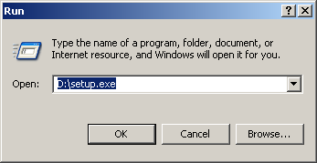

- Click OK.
- Follow the on-screen instructions.

Note: Complete installation may take several minutes depending on which Windows operating system your computer is using. Your system may reboot itself and then continue with the installation process. Please check “Yes” on the End User License Agreement Screen after reading and agreeing to the license. Continue to follow the instructions until you see the “Maintenance Completed” Screen. After clicking this, you will be returned to your desktop screen.

AIS Viewer Usage

- To open the AIS Viewer software, click the Start button. 
- Choose Programs, AIS Viewer, AIS Viewer Application or
3. Double click the AIS Viewer Application desktop Icon.

. The AIS Viewer Manager will appear on the screen to continue with the installation.

Customer Key Code
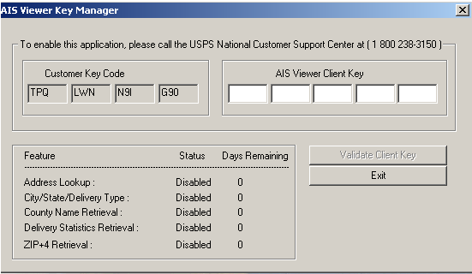

To continue with the installation of the AIS Viewer application, please contact our Customer Service Department at 800-238-3150 for the assigned AIS Viewer Client Key. This will enable the product and set the number of days the product is accessible.

Note: When the number of days remaining is 0, and the feature is disabled, call our Customer Service Department to re-order the product(s).

ADDRESS MATCHING ENGINE INSTALLATION INSTRUCTIONS

After the application has been completely installed, the Address Matching Engine installs automatically to the default CD-ROM drive.

Address Matching Engine
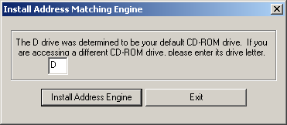

- Click Install Address Engine and the selected features will be enabled.

Note: Monthly reinstallation of the Address Matching Engine will be necessary to update your system with any current changes.

MENU FUNCTIONS

This section will help you navigate through the functions and reporting tools of the AIS Viewer Application Menu Bar. The Menu bar across the top of your screen contains the following functions: File, View, Tools, Installation and Help

Example: Menu Bar
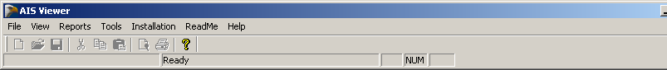

MENU FUNCTIONS

File

The toolbar File provides two options:

- Print Setup - allows you to select a printer, paper source and print orientation.

- Exit –closes AIS Viewer Application.

Example: File from the Menu Bar
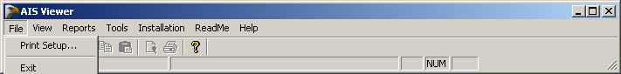

Example: Print Setup Option
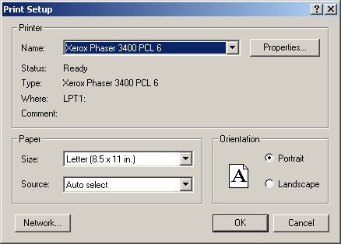
MENU FUNCTIONS

View

View provides the option to display the Toolbar or Status Bar.
Clicking on either will allow you to see the setting of the screen.

Example: View from the Menu bar
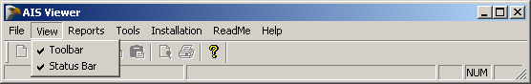

Reports

Reports lists the five different products available.
- Address Lookup
- City/State/Delivery Type Retrieval
- County Name Retrieval
- Delivery Statistics Retrieval
- ZIP+4 Retrieval

Note: For more information on Reports, please see the AIS Viewer Reports section of this guide.

Example: Reports from the Menu bar
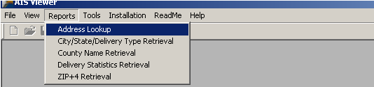

MENU FUNCTIONS

Tools

AIS Viewer Key Manager is used to retrieve the Customer Key Code when the product days have expired (0 days remaining) and the product is disabled, or to activate another product. Call Customer Service at 800-238-3150 to renew the subscription.

Previous Screen allows you to return to the previous screen from a report.

Example: Tools from the Menu bar
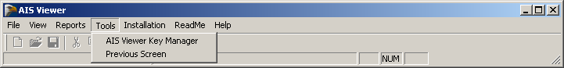

Installation

Reinstallation of the Address Matching Engine should be updated monthly when you receive the updated CD-ROM product.

Example: Installation from the Menu bar
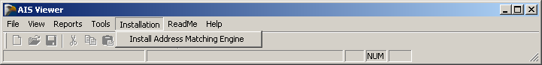

MENU FUNCTIONS

ReadMe
This function provides documentation on the installation and user friendly procedures for the AIS Viewer Application.

Help
Help provides the version number and United States Postal Service® copyright statement. Information to be added at a later date.

Example: Help on the Menu bar
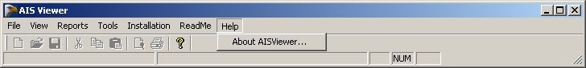

AIS VIEWER REPORTS
The report option on the Menu Bar list five options: Address Lookup, City/State/Delivery Type Retrieval, County Name Retrieval, Delivery Statistics Retrieval and ZIP+4 Retrieval. An optional sort routine is available to resort the output by sorting one header at a time. Click on a single column heading and the results can be sorted in alphabetical or numerical order.

Report Print Options
Below is an example of a printout of a report that contains 82,839 records to be printed on 2128 pages. You can select pages to be printed from the Print Review screen by clicking on the printer Icon and selecting the page(s) to print.

Example: Report Print Option sorted by the ZIP Code®
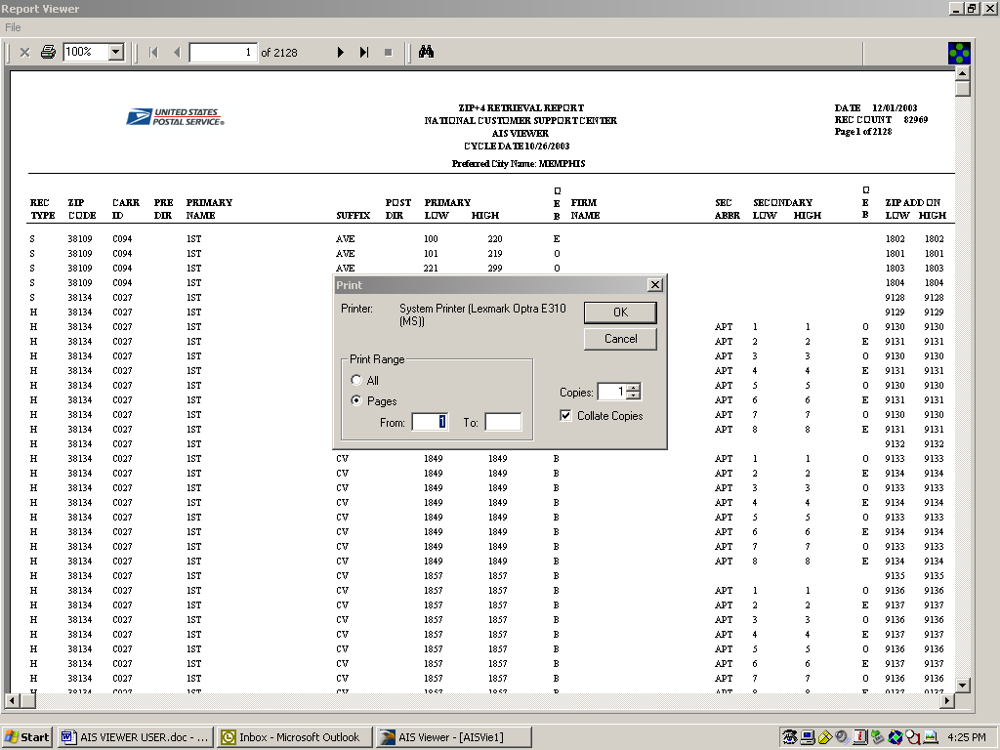

REPORTS

Address Lookup

Address Lookup is a quick way of looking up a ZIP + 4 for an individual address. This function is addressing-specific. To save time, you can key in a ZIP Code or a city/state after you have keyed in the address. The report also provides you with the carrier route number, county number, delivery point code, and check digit.

NOTE: The delivery point and check digit do not appear on multiple responses.

Example: Sample Address on Lookup Screen
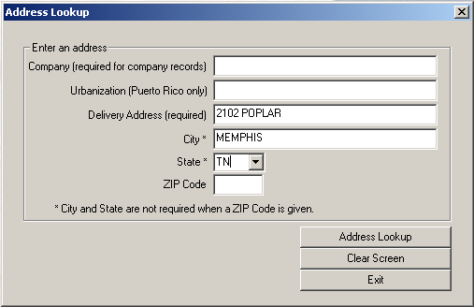

Example: Report Results from Sample Address

REPORTS

City/State/Delivery Type Retrieval

The city state portion is a comprehensive list of ZIP Codes and the city, county, and post office names associated with those ZIP Codes. It can be used to validate the city name and ZIP Code of a mailing address. You can search for information with the lookup options:
- City
- State
- City and State
- City Finance Number
- ZIP Code
- Delivery Type

Press Enter on the keyboard or click Generate Report on the report screen after the selected criteria has been entered. This will generate a report for viewing or printing. In order to view the entire report on screen, it will be necessary to use the scroll bars.

Example: City Option Lookup
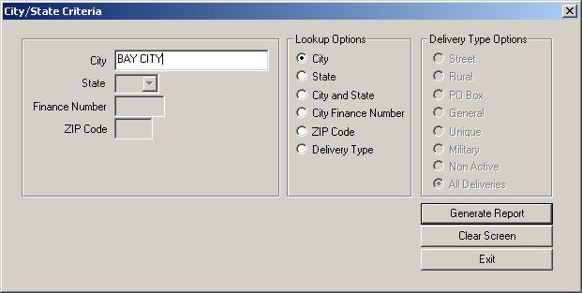

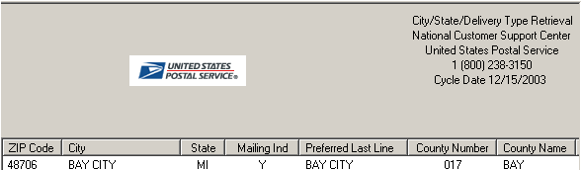
REPORTS

Delivery Type Lookup Options

Example: Delivery Type Lookup option
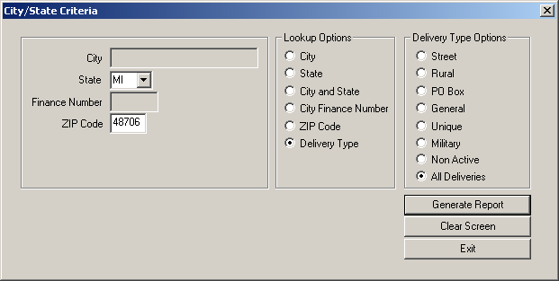

Example: Report Result from Sample Lookup
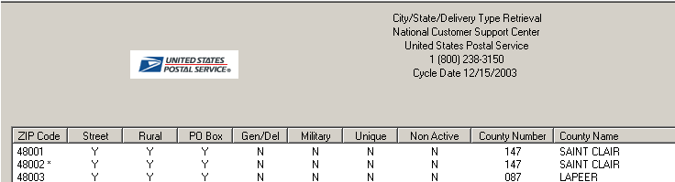

REPORTS

County Name Retrieval

Example: Sample lookup screen for county name retrieval
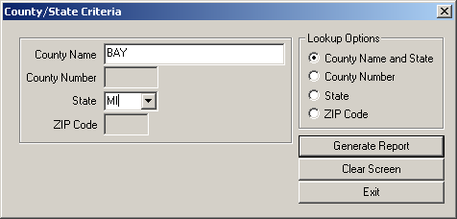

Sample: County Name and State Report
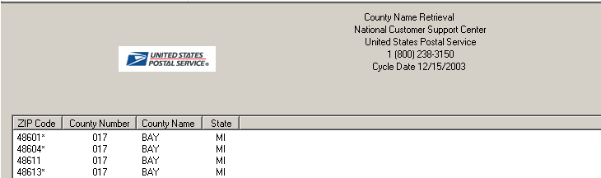
REPORTS

Delivery Statistics Retrieval

Example: Sample lookup screen for Delivery Statistics
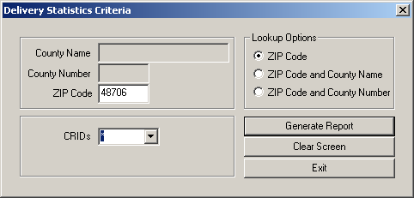

Example: Report result from sample lookup

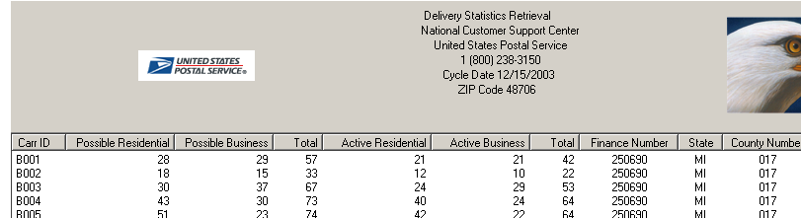
REPORTS

ZIP + 4 Retrieval

ZIP + 4 Retrieval is used when you want to search for specific data or individual street information. You can search for a specific street name or all streets by:
- Street and ZIP Code
- Street, City, and State
- City and State
- ZIP Code
After you have made your selection criteria, you will need to press Enter or Click Generate Report. This will generate a report for viewing or printing. In order to view the entire report on your screen, it will be necessary to use the scroll bars.

Note: For a definition of the column headers, please refer to the Glossary.

ZIP + 4 Retrieval Lookup Options

Note: When entering an address, do not enter the physical street number. Only enter the street name.

Example: Street and ZIP Code Option
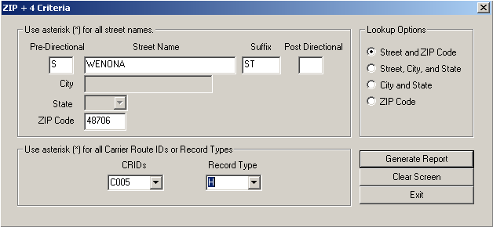
Example: Report Result from ZIP+4 Lookup screen
Rec Type | ZIP Code | Carr ID | Pre Dir | Street Name | Suffix | Post Dir | Prim Low | Prim High | OEB | Firm Name | Abbrev | Sec Low | Sec High | OEB | Add-on Low | Add-on High | County Number
H | 48706 | C005 | S | Wenona | St |  | 200 | 200 | E | Allen Medical | Ste | 194 | 195 | B | 8820 | 8820 | 017

GLOSSARY

Abbrev (Abbreviations)
Abbreviate directionals to the appropriate one or two character abbreviation.

Address Primary Name
Primary Name of a street without a directional or suffix.

Asterisk
The asterisk represents a wildcard to search by all carrier routes or all record types in the ZIP + 4 Retrieval option.

Carrier Route Delivery Number (Carr ID)
This is also referred to as a CRID which is assigned to a mail delivery or collection route within a 5-digit ZIP Code. There are five types:
B = PO Box
H = Highway contract
R = Rural route
C = City delivery
G = General Delivery

County Number
The Federal Information Processing Standards (FIPS) code assigned to a given county or parish within a state. In Alaska, it identifies a region within the state. If APO/FPO and the record type is “S”, “H”, or “F”, the county number will be blank.

Delivery Point
The Delivery Point Code is the finest depth of code to which a mail piece can be sorted by its address. It is usually the 11-digit numeric code formed from the ZIP+4 and represented by the delivery point barcode (DPBC).

Firm Name
The firm name is the name of firm or business.

Menu Options
This is the function that is displayed across the top of your screen. It includes: File, View, Reports, Tools, Installation, ReadMe, and Help. For a better understanding of these options, please see the section “Menu Functions”.

O/E/B
The abbreviation O/E/B indicates if a ranged number contains odd, even, or both odd and even numbers in the range of numbers.

Post Dir
Post Directional indicator for street directions. (N, SE, E, W, NE, NW, SE, SW)

Pre Dir
Pre-directional indicator for street directions. (N, S, E, W, NE, NW, SE, SW)

Prim Low (Primary Low)
The Primary Low is the low-end address in a range of addresses – often referred to as house number.

Prim High (Primary High)
The Primary High is the high-end address in a range of addresses – often referred to as house number.

Record Type
An alpha value that identifies the type of data in the record. Record type codes include the following:
F = Firm or business address
G = General delivery
H = High-rise
P = PO Box
R = Rural route/highway contact
S = Street

Sec Abbr
A descriptive code used to identify the type of secondary address. (Apt, Ste, F1, etc.)

Sec Low (Address Secondary Low)
Code that describes an apartment, room, suite, space, floor or other secondary addressing numeric or alphanumeric that follows a street address. The low-end secondary address component in a range of secondary addresses.

Sec High (Address Secondary High)
Code that describes an apartment, room, suite, space, floor or other secondary addressing numeric or alphanumeric that follows a street address. The high-end secondary address component is in a range of secondary addresses.

Status Bar
The status bar is the strip along the bottom of the screen that may include the current date and time, the position of the cursor on your screen, etc.

Street Name
The street name is the official name of a street as assigned by a local governing authority. The Street Name field contains only the street name and does not include directionals or suffixes.

Suffix
Suffix is a code that is the standard USPS abbreviation for the trailing designator in a street address. (ST, AVE, RD, etc)

Tool Bar
The tool bar is a horizontal strip of buttons near the top of a window that provides shortcuts for commonly used commands.

ZIP Add-On High
The ZIP add-on high number is the last four positions of a ZIP + 4 Code; the high end ZIP add-on of the last ZIP + 4 in a consecutive series of ZIP + 4 codes assigned to the delivery address.

ZIP Add-On Low
The ZIP add-on low is the last four positions of a ZIP + 4 code; the low-end ZIP add-on of the first ZIP + 4 in a consecutive series of ZIP + 4 codes assigned to the delivery address.

ZIP Code
A ZIP Code is a 5-digit code that identifies a specific geographic delivery area. ZIP Codes can represent an area within a state, an area that crosses state boundaries (unusual condition), or a single building or company that has a very high mail volume. ZIP is an acronym for Zone Improvement Plan.

