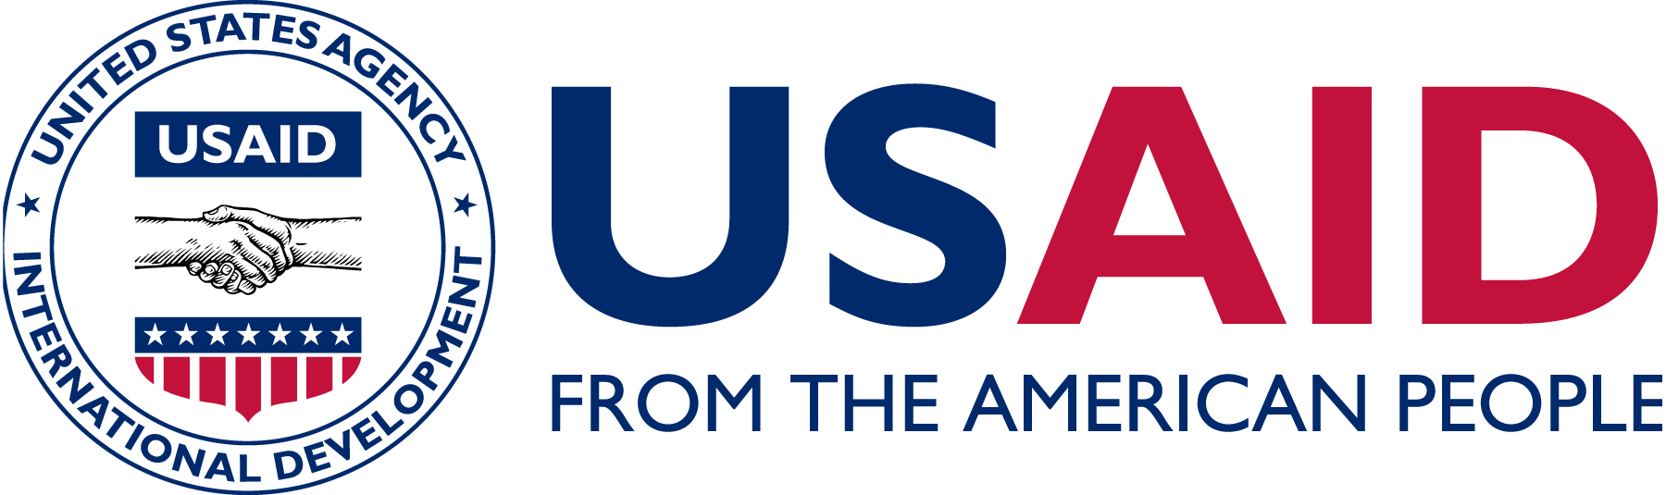

Tuition Assistance Program Reimbursement Agreement

Name:

Course Title:

Course Dates:

REIMBURSEMENT
In order to protect the interests of the Government, the following policies apply to this training. Failure to meet the requirements of successful program participation will require that the employee to reimburse the Government (USAID) for expenses associated with course participation. Reimbursement for tuition and other fees will be required under the following conditions. Employees will be required to reimburse the Government;

- Should the employee fail to receive a final grade of C or above (B or above for graduate level coursework).

- Should the employee drop or otherwise not successfully complete the course and the Government incurs costs.

- Should the employee register for a course that is not previously approved and the Government incurs cost.

I hereby certify that I have read the Tuition Assistance Program policies and understand the conditions under which reimbursement will be required. I will comply with all USAID TAP program policies and updates. I understand that any amounts which may be due to the agency as a result of any failure on my part to meet the terms of this agreement may be withheld from any monies owed me by the Government, or may be recovered by such other methods as are approved by law.

Signature: __________________________________ Date: _________________________

