
U.S. Department of Education
Office of Inspector General

________________________________

AGREED UPON PROCEDURES ATTESTATION ENGAGEMENT GUIDE
________________________________

Ensuring Continued Access to
Student Loans Act of 2008
(ECASLA)

Short–Term Purchase Program
for the 2007-2008 Academic Year

March 4, 2009
UNITED STATES DEPARTMENT OF EDUCATION
OFFICE OF INSPECTOR GENERAL
Washington, D.C.

March 4, 2009

Dear Colleague:

This letter transmits the U.S. Department of Education’s Agreed Upon Procedures (AUP) Attestation Engagement Guide for the Ensuring Continued Access to Student Loans Act of 2008 (ECASLA) Short-Term Purchase Program for the 2007-2008 Academic Year. This Guide provides the requirements for AUP engagements for a lender that has sold eligible loans for the 2007-2008 academic year to the U.S. Department of Education (the Department) under the Short-Term Purchase Program.

Under the ECASLA, for Federal Family Education Loan (FFEL) Program loans made under sections 428 (subsidized Stafford loans), 428B (PLUS loans), and 428H (unsubsidized Stafford loans) of the Higher Education Act (HEA), the Department has the authority to purchase FFEL Program loans. AUP attestation engagements are required under Section 5 of the Master Loan Sales Agreement 2007-2008 for the Short-Term Purchase Program. This Guide describes required coverage and procedures, reporting requirements, and report submission deadlines for the required AUP engagement.

Any questions regarding the application of this Guide should be sent to Hugh M. Monaghan, Director, Non-Federal Audits, by email to hugh.monaghan@ed.gov or by fax at 215-656-6397.

Sincerely,

/s/

Keith West
Assistant Inspector General for Audit

Table of Contents

Chapter 1 – General Requirements 1
1.1 Purpose and Background 1
1.2 Engagement Objectives 1
1.3 Engagement Scope 2
1.4 Professional Standards 2
1.5 Fraud or Other Illegal Acts 2
1.6 Confidential Commercial Information 3
1.7 Quality Control Reviews 3
1.8 References and Resources 4
1.9 Technical Assistance 4
1.10 Subsequent Editions of Guide 4
Chapter 2 – Planning the Engagement 5
2.1 Management Assertion 5
2.2 Engagement Letter 5
2.3 Engagement Methodology 6
2.4 Use of a Third Party Servicer 7
Chapter 3 – Agreed Upon Procedures for the Short-Term Purchase Program 8
3.1 Agreed Upon Procedures 8
3.2 Comparison of Loan Schedule and Bill of Sale 8
3.3 Eligibility – Loan Schedule 14
3.4 Eligibility – Loan Level 17
Chapter 4 – Reporting 33
4.1 Engagement Report Package Requirements 33
4.2 Reporting Package Submission 33
Attachments 35
Attachment 1 – Illustrative Agreed Upon Procedures Report for the Short-Term Purchase Program 35
Attachment 2 - Illustrative Agreed Upon Procedures and Results Section for the Short-Term Purchase Program 37
Attachment 3 – Summary of Loan Population and Sample Characteristics for the Short–Term Purchase Program 53
Attachment 4 – Bill of Sale Schedule for the Short-Term Purchase Program 54
Attachment 5 – Schedule of Findings for the Short-Term Purchase Program 55
Attachment 6 – Seller and Practitioner Information Sheet 56
Attachment 7 - Loan Level Testing Results for the Short-Term Purchase Program 57
Attachment 8 - Examples of Bill of Sale Package Documents for the Short-Term Purchase Program 58

___________________________________________
Acronyms
___________________________________________

Acronym Definition

AUP Agreed Upon Procedures

BOS Bill of Sale

ECASLA Ensuring Continued Access to Student
Loans Act of 2008

ED U.S. Department of Education

ELT Eligible Lender Trustee

FFELP Federal Family Education Loan Program

GAGAS Generally Accepted Government Auditing
Standards

HEA Higher Education Act of 1965,
as amended

IRB Interest Receivable from Borrower

LID Lender Identification Number

MLSA 2007-2008 Master Loan Sale Agreement 2007-2008

OIG Office of Inspector General

__________________________________________

Chapter 1 – General Requirements
_________________________________________

1.1 Purpose and Background
This Agreed Upon Procedures Attestation Engagement Guide (the Guide) provides the requirements for agreed upon procedures (AUP) engagements for a lender participating in the Federal Family Education Loan (FFEL) Short-Term Purchase Program authorized under section 459A of the Higher Education Act (HEA) of 1965, as amended by the Ensuring Continued Access to Student Loans Act (ECASLA) of 2008 (Pub. L. 110-227).

Ensuring Continued Access to Student Loans
Under the ECASLA, for the FFEL Program, the U.S. Department of Education (ED) will use its Short-Term Purchase Program to buy from sellers (i.e., lenders or beneficial holders) certain 2007-2008 academic year loans made under sections 428 (subsidized Stafford loans), 428B (PLUS loans), and 428H (unsubsidized Stafford loans) of the HEA. Purchases under this short-term program began on December 30, 2008, and will continue through March 9, 2009. Under the ECASLA Short-Term Purchase Program, ED will purchase up to $500 million in loans each week during this short-term period.

1.2 Engagement Objectives

The objective of the engagement is to perform procedures and report results and findings in order to assist ED in evaluating that loans purchased under the Short-Term Purchase Program meet program requirements.

The AUP engagement is required under Section 5 of the Master Loan Sale Agreement 2007-2008 (MLSA 2007-2008) for the Short-Term Purchase Program. This AUP engagement is to be conducted in accordance with the professional standards described below at Chapter 1, Section 4 (§1.4).

1.3 Engagement Scope

AUP Engagement:
One AUP is required for all of the seller’s Bills of Sale (BOS) consummated under the Short-Term Purchase Program. The engagement report must be submitted to ED no later than May 31, 2009.

1.4 Professional Standards
This AUP engagement must be conducted in accordance with Government Auditing Standards (commonly referred to as generally accepted government auditing standards [GAGAS]), July 2007, issued by the Comptroller General of the United States and the Attestation Standards of the American Institute of Certified Public Accountants (AICPA).

GAGAS must be used in conjunction with the AICPA Attestation Standards. GAGAS ¶6.05 identifies additional GAGAS standards for attestation engagements that go beyond the requirements in the AICPA Attestation Standards. Practitioners must comply with these additional GAGAS standards.

Practitioners must comply with applicable provisions of the public accountancy law(s) and the rules of the jurisdiction(s) in which the practitioner is licensed and where the engagement is conducted.

1.5 Fraud or Other Illegal Acts
The practitioner must be guided by GAGAS provisions covering fraud or other illegal acts, including GAGAS ¶6.13.

A practitioner must exercise reasonable care when pursuing any indication of fraud or other illegal acts and abuse, so that potential future investigations or legal proceedings are not compromised.

If any fraud or illegal act is suspected, the practitioner must report it immediately to the ED Office of Inspector General, Investigation Services (OIG/IS), by phone or fax at the numbers shown below, before further extending engagement steps and procedures:
Assistant Inspector General for Investigations
U. S. Department of Education
400 Maryland Avenue, SW
Washington, D.C. 20202-1510
Phone: (202) 245-6966
Fax: (202) 245-6990

The practitioner must promptly prepare a separate written report as instructed by ED-OIG/IS, and must submit the report to the address provided above, either within 30 days after the fraud or illegal act was discovered or within a time frame agreed to by ED-OIG/IS and the practitioner.

1.6 Confidential Commercial Information
The Freedom of Information Act (FOIA), 5 U.S.C. § 522, gives any person the right to request access to records or information. All agencies of the U.S. Government are required to disclose records upon receiving a written request for them, unless one of the exemptions to the FOIA applies. One of the FOIA exemptions applies to confidential commercial information, which, as defined by the FOIA, means trade secrets and commercial or financial information that is privileged or confidential, because disclosure could reasonably be expected to cause substantial competitive harm.

If you or your client believes that your AUP engagement documentation contains confidential commercial information, you must take appropriate steps to identify that information in your working papers, to protect its confidentiality. If you are asked to submit your AUP engagement documentation to us, and we subsequently receive a request under FOIA for information that you have designated as confidential commercial information, we will make an independent determination of whether that information meets the criteria for exemption from release.

We do not inform you or your client about FOIA requests we receive. However, if we receive a FOIA request for documentation you have identified as confidential commercial information, and we conclude that it should be released under FOIA, to the extent permitted by law; we will make a good faith effort to notify you and provide you, or your client, an opportunity to object, prior to releasing any documentation.

1.7 Quality Control Reviews
It is ED-OIG policy and practice to evaluate the quality of the AUP engagements. As part of such evaluations, the practitioner must make all AUP engagement documentation available to us or our representatives upon request. If we determine that an AUP engagement is substandard, we may:
- Refer the issue to the State Board of Accountancy where the AUP engagement was performed and/or the practitioner is licensed, and the American Institute of Certified Public Accountants (AICPA), or State Society of Certified Public Accountants, if the practitioner is a member; and/or
- Initiate action to suspend or debar the practitioner from conducting additional audits or attestation engagements for use by the Federal government.

Also, ED program officials may require the seller to obtain and submit another AUP engagement to replace the substandard one.

1.8 References and Resources
Guidance and criteria for the ECASLA Short-Term Purchase Program are provided on the Federal Student Aid Website at http://federalstudentaid.ed.gov/ffelp/.

1.9 Technical Assistance
Technical questions about applying the procedures in this Guide may be directed to Hugh M. Monaghan, Director, Non-Federal Audits, by email to hugh.monaghan@ed.gov or by fax at 215-656-6397.

1.10 Subsequent Editions of Guide
Subsequent editions of, and /or amendments to, this Guide may be issued to reflect revisions to the AUP and guidance issued by ED. The practitioner shall use the most recent edition of this Guide when conducting the AUP engagement. Practitioners should visit the OIG’s Non-Federal Audits webpage to determine if a subsequent edition of, and /or amendments to, this Guide have been issued. The OIG’s Non-Federal Audits webpage is: http://www.ed.gov/about/offices/list/oig/nonfed/sfa.html

_________________________________________

Chapter 2 – Planning the Engagement
__________________________________________

2.1 Management Assertion
This is an AUP engagement as defined in GAGAS ¶1.23. The seller must provide the practitioner with the management assertion detailed below. The practitioner will perform the procedures in Chapter 3, prepare the respective reporting package described in Chapter 4, and submit the respective reporting package to management of the seller.

Management Assertion For Short-Term Loan Purchase Program AUP Engagement:
For all Bills of Sale consummated during the period [MM/DD/YYY] through [MM/DD/YYYY], the loans which were sold to ED by [the seller] complied with the provisions of the ECASLA Short-Term Purchase Program and the MLSA 2007-2008.

2.2 Engagement Letter
An engagement letter between the lender (i.e., the seller under the Short-Term Purchase Program) and the practitioner must be executed and must include the following:
- A statement that the engagement is to be performed in accordance with GAGAS and AICPA Attestation Standards, and this Guide;
- A description of the scope of the engagement and the related reporting that will meet the requirements of this Guide;
- A statement that both parties understand that ED will use the practitioner's report to evaluate the propriety of sales of loans under the Short-Term Purchase Program;
- A statement that the lender must provide the practitioner all required representations and assertions;
- A statement that the lender shall provide, or shall cause its servicer to provide to the practitioner access to all agreements, documents, and electronic files pertinent to the scope of the engagement;
- A provision that the practitioner is required to provide the Secretary of Education, the ED Office of Inspector General, and their representatives, access to and photocopies of AUP engagement documentation, upon request; and
- A provision that the practitioner shall retain AUP engagement documentation and reports for a minimum of seven years after the date of issuance of the practitioner’s report(s) to the entity, unless a pertinent law or regulation provides for a longer retention period or the practitioner is notified in writing by ED to extend the retention period.

2.3 Engagement Methodology
This engagement requires attribute sampling for the AUP described in Chapter 3 §3.4. The AUP described in Chapter 3 §3.3 require a review of data records in the loan schedules via queries using database software.

Loan Schedule Testing Procedures:
The queries that are to be run for the Short-Term Purchase Program are described in Chapter 3 §3.3.

Loan Level Testing Procedures:
The loan level testing (Chapter 3 §3.4) requires that a random sample (using a random number generator) of loans be selected from the Loan Schedule(s) for BOS consummated during the AUP engagement period (defined in Chapter 1 §1.3). The practitioner must select loans using the following guidelines:
- An attribute sample must be used to estimate the frequency of occurrence of noncompliance with the specified eligibility requirements.
- The sampling unit is each individual loan.
- The sample size depends on the total cumulative dollar amount of all BOS consummated under the Short-Term Purchase Program for the Seller:
  - If the total cumulative dollar amount of all BOS consummated is $500,000,000 or less, the sample size must be 150 loans; however, if the population of loans is less than 150 loans, all loans shall be selected.
  - If the total cumulative dollar amount of all BOS consummated is greater than $500,000,000, the sample size must be 300 loans.
- The practitioner will apply the procedures, specified in Chapter 3 §3.4 to the sampled loans.
- The results of applying the procedures indicate whether each loan is in compliance with the specified eligibility requirements. A loan is considered to be noncompliant if it fails to meet one or more of the specified eligibility requirements. The count of noncompliant loans should match the number of loans, failing to meet one or more of the eligibility requirements, as detailed in the schedule of Loan Level Testing Results (Attachment 7).
- The practitioner must summarize the population and sample characteristics (e.g., number of errors and error rate) using the Summary of Loan Population and Sample Characteristics (Attachment 3).
- As required by certain AUP set forth in Chapter 3, the practitioner must report findings when exceptions are noted. These findings should be presented as illustrated in the Schedule of Findings (Attachment 5).

2.4 Use of a Third Party Servicer
Lenders may contract with third-party servicers to perform functions and/or maintain records for which they are responsible. Consequently, auditors may need to have access to third-party servicers in order to perform the procedures required by this Guide. In performing engagements under this Guide, practitioners shall consider such third-party servicer records or functions as if they were the lender’s.
___________________________________________

Chapter 3 – Agreed Upon Procedures for the Short-Term Purchase Program
___________________________________________

3.1 Agreed Upon Procedures
The AUP set forth in the sections of this Chapter must be performed on the seller’s BOS and related Loan Schedules consummated during the AUP engagement period (defined in Chapter 1 §1.3).

Sections 3.2 through 3.4 below provide the AUP to be performed for sellers participating in the Short-Term Purchase Program. The procedures detailed below in Chapter 3 §3.2 assist in preparing multiple Loan Schedule files for the application of procedures in §3.3 and §3.4.

3.2 Comparison of Loan Schedule and Bill of Sale

Compliance Requirements:
For each BOS consummated, a BOS package is created. Each BOS package must include the following documents, examples of which are contained in Attachment 8:
1) A BOS that specifies the Purchase Price and Purchase Date and provides the terms of the sale of loans (Attachment 8, Example A).
2) A Loan Schedule (i.e., Detail Loan Schedule, herein referred to as the Loan Schedule) that details the Eligible Loans that are to be sold to ED (Attachment 8, Example B). This schedule is prepared by the ED Servicer from data files provided by the seller or the seller’s servicer. The Loan Schedule is provided to the seller in an Adobe Acrobat (i.e., pdf) file format. The seller reviews and approves the Loan Schedule. The Loan Schedule contains the following fields.

Short-Term Purchase Program
Loan Schedule – Header Fields
Field | Definition
Deal | The loan sale identification number.
# of Loans* | The number of loans included in the Loan Schedule.
OLA* | The total original loan amount (OLA) is the total guaranty amount for the loans included in the Loan Schedule.
SUB PBO* | The total principal balance outstanding (PBO) for subsidized Stafford loans included in the Loan Schedule, as of the Loan Schedule’s report date.
UNSUB PBO* | The total principal balance outstanding for unsubsidized Stafford and PLUS loans included in the Loan Schedule, as of the Loan Schedule’s report date.
Estimated IRB as of Sale Date* | The total estimated interest receivable from the borrower (IRB) as of the sale date for loans included in the Loan Schedule.
1% Fee* | This field will be populated with “$0.00” (zero) for purchases under the Short-Term Purchase Program.
Loan Fee* | This field will be populated with “$0.00” (zero) for purchases under the Short-Term Purchase Program.
97% Purchase Price* | 97% of the Total amount, detailed below.
Total* | The sum of, for all loans included in the Loan Schedule, (1) the total PBO, (2) the total estimated IRB, (3) the total 1% fee [not applicable for the Short-Term Purchase Program], and (4) the total loan fee [not applicable for the Short-Term Purchase Program].
* The Loan Schedule – Header Fields also include fields providing summary information by Loan Type (i.e., subsidized Stafford, unsubsidized Stafford, and PLUS).
Loan Schedule – Loan Level Fields
Field | Definition
SOC NBR | The borrower’s Social Security Number.
Commonline ID & Seq # | A loan identifier used by some lenders. This field is optional.
Name | The borrower’s last and first name.
Status | The loan status (e.g., in school, in repayment, deferment).
OLA | The original loan amount (i.e., the guaranty amount as of the Loan Schedule’s report date).
SUB PBO | The principal balance outstanding for a subsidized Stafford loan, as of the Loan Schedule’s report date.
UNSUB PBO | The principal balance outstanding for an unsubsidized Stafford or PLUS loan, as of the Loan Schedule’s report date.

Estimated IRB as of Sale Date | The estimated interest receivable from the borrower as of the sale date.
LOAN PER BEG DT | The loan period begin date.
LOAN PERIOD END DT | The loan period end date.
INT RATE | The actual interest rate for the loan as charged to the borrower. The actual interest rates are based on the statutory rates and are net of permissible Eligible Borrower Benefits under the MLSA 2007-2008’s Section 3(F) and/or interest rate limitation under the Servicemembers Civil Relief Act, if applicable.
Loan Type | Specifies the type of loan. Eligible Loan types are: SF (subsidized Stafford), SU (unsubsidized Stafford), PL (PLUS for parent), or GB (PLUS for graduate/professional student).
1% Fee | This field will be populated with “$0.00” (zero) for purchases under the Short-Term Purchase Program.
Loan Fee | This field will be populated with “$0.00” (zero) for purchases under the Short-Term Purchase Program.
97% Purchase Price | 97% of the Total amount, detailed below.
Total | The sum of (1) the PBO, (2) the total estimated IRB, (3) the 1% fee [not applicable for the Short-Term Purchase Program], and (4) the loan fee [not applicable for the Short-Term Purchase Program].
Seller | The seller’s lender ID (LID). If the original lender is the seller, then this LID will be the same as the Original Lender’s LID.
Original Lender | The LID for the lender who made the initial disbursement of the loan to the borrower.
First Disbursement Date | The date of the first disbursement of the loan.
Last Disbursement Date | The date of the final disbursement of the loan.
3) A Final Loan Schedule Summary (i.e., BOS Attachment and Final Loan Schedule Summary of Loans Sold, herein referred to as the Final Loan Schedule Summary) that summarizes the loans that are to be sold to ED (Attachment 8, Example C).
4) A Security Release Certification for loans to be sold that are subject to any security interest, pledge or hypothecation for the benefit of any financing institution or third party (Attachment 8, Example D). Attached to the Security Release Certification must be a Schedule of Loans to which the Security Release applies. The Security Release Certification only applies for sales of loans with a security interest.

5) A Notice of Assignment and Designation of Payee for instances where the seller has assigned to the party holding the security interest the right to receive direct payment from ED (Attachment 8, Example E). The Notice of Assignment and Designation of Payee is submitted at the option of the seller.
If the seller chooses not to submit to ED a Notice of Assignment and Designation of Payee, the seller must provide ED with a notification of its payment to the party holding the security interest. The notification must include the date, amount, and form of such payment.
Complete details about the BOS Package are specified in ED’s Electronic Announcements #36, dated November 26, 2008; #38, dated December 3, 2008; and #39, dated December 11, 2008. (Available at: http://federalstudentaid.ed.gov/ffelp/)

Required Procedures:

3.2(A). Obtain each BOS package covered by the AUP engagement from the ED Servicer. Contact information for the ED Servicer is as follows:
ED Servicer Contact Information
Name | Susan Manlove
Phone | (310) 847-5198
Email Address | Susan.Manlove@ACS-Inc.com
Note: In order to obtain the BOS Package and other loan information from the ED Servicer, the practitioner may be required to execute an agreement regarding the use and safeguarding of the information provided. ED intends to issue an Electronic Announcement with details on the security agreement and other instructions for obtaining information from the ED Servicer. (The Electronic Announcement may be available at: http://federalstudentaid.ed.gov/ffelp/)

Inspect each BOS package, which will include electronic copies of the Loan Schedules supporting the BOS, and perform the following procedures:
- Compare the number/amounts described for the fields specified in the table below (that are contained in each BOS, accompanying Loan Schedule, and accompanying Final Loan Schedule Summary; examples of each document are provided in Attachment 8) and see that the number/amounts all agree. Report any discrepancies as a finding in the Schedule of Findings (Attachment 5).
Item | Loan Schedule  (Header Fields) | Final Loan Schedule Summary | BOS
A | 97% Purchase Price  (Att. 8, Ex. B, Item A) | Total Final Purchase Price  (Att. 8, Ex. C, Item A) | Purchase Price  (Att. 8, Ex. A, Item A)
B | # of Loans  (Att. 8, Ex. B, Item B) | Total Number of Loans  (Att. 8, Ex. C, Item B) | Not Applicable
C | SUB PBO (see Loan Type Summary)  (Att. 8, Ex. B, Item C, Row “SF”) | Outstanding Principal Balance at Purchase Date for FFEL Stafford Subsidized  (Att. 8, Ex. C, Item C) | Not Applicable
D | UNSUB PBO for unsubsidized Stafford (see Loan Type Summary)  (Att. 8, Ex. B, Item D, Row “SU”) | Outstanding Principal Balance at Purchase Date for FFEL Stafford Unsubsidized  (Att. 8, Ex. C, Item D) | Not Applicable
E | UNSUB PBO for PLUS (see Loan Type Summary)  (Att. 8, Ex. B, Item E, Row “GB & PL”) | Outstanding Principal Balance at Purchase Date for FFEL PLUS  (Att. 8, Ex. C, Item E) | Not Applicable
F | Estimated IRB as of Sale Date  (Att. 8, Ex. B, Item F) | Total Accrued Unpaid Interest at Purchase Date  (Att. 8, Ex. C, Item F) | Not Applicable

2) Count the number of the Loan Level records (i.e., the number of loans) contained in each Loan Schedule (Att. 8, Ex. B).
3) Compute the total of all the individual amounts for the Loan Level records contained in each Loan Schedule (Att. 8, Ex. B) for the following fields:
a) OLA
b) SUB PBO for Loan Types of “SF” (i.e., subsidized Stafford)
c) UNSUB PBO for Loan Type of “SU” (i.e., unsubsidized Stafford)
d) UNSUB PBO for Loan Type of “GB” and “PL” (i.e., PLUS loans)
e) Estimated IRB as of Sale Date
f) 97% Purchase Price
g) Total
- Compare the total number from §3.2(A)(2) and total amounts from §3.2(A)(3), above, with the fields described in the table below and see that all agree. Report any discrepancies as a finding in the Schedule of Findings (Attachment 5).

Item | Loan Schedule  (Loan Level)  Amounts Computed  at §3.2(A)(2) and (3) | Loan Schedule  (Header) | Final Loan Schedule Summary
A | 97% Purchase Price  (§3.2(A)(3)(f)) | 97% Purchase Price  (Att. 8, Ex. B, Item A) | Total Final Purchase Price  (Att. 8, Ex. C, Item A)
B | Number of Records  (§3.2(A)(2)) | # of Loans  (Att. 8, Ex. B, Item B) | Total Number of Loans  (Att. 8, Ex. C, Item B)
C | SUB PBO  (§3.2(A)(3)(b)) | SUB PBO  (Att. 8, Ex. B, Item C) | Outstanding Principal Balance at Purchase Date for FFEL Stafford Subsidized  (Att. 8, Ex. C, Item C)
D | UNSUB PBO for Loan Type “SU”  (§3.2(A)(3)(c)) | UNSUB PBO for Loan Type “SU”  (Att. 8, Ex. B, Item D) | Outstanding Principal Balance at Purchase Date for FFEL Stafford Unsubsidized  (Att. 8, Ex. C, Item D)
E | UNSUB PBO for Loan Types “PL” and “GB”  (§3.2(A)(3)(d)) | UNSUB PBO for Loan Types “PL” and “GB”  (Att. 8, Ex. B, Item E) | Outstanding Principal Balance at Purchase Date for FFEL PLUS  (Att. 8, Ex. C, Item E)
F | Estimated IRB as of Sale Date  (§3.2(A)(3)(e)) | Estimated IRB as of Sale Date  (Att. 8, Ex. B, Item F) | Total Accrued Unpaid Interest at Purchase Date  (Att. 8, Ex. C, Item F)
G | OLA  (§3.2(A)(3)(a)) | OLA  (Att. 8, Ex. B, Item G) | Not Applicable
H | Total  (§3.2(A)(3)(g)) | Total  (Att. 8, Ex. B, Item H) | Total Amount Outstanding at Purchase Date  (Att. 8, Ex. C, Item H)
5) If the AUP engagement covers a single BOS, proceed to §3.2(A)(6). If the AUP engagement covers multiple BOS, merge the Loan Schedules for each separate BOS covered in the AUP engagement into a single file and then:
a) Before applying additional procedures, compare the total record count of the merged Loan Schedule to the total of the record counts of the individual Loan Schedules that were merged and be sure that they agree.
b) Before applying additional procedures, compare the total of the 97% Purchase Price (Loan Level record) of the merged Loan Schedule to the total of the 97% Purchase Price (Loan Level record) of the individual Loan Schedules that were merged and be sure that they agree.
c) Save the resulting merged Loan Schedule file.
6) The procedures specified in §3.3 and §3.4, are to be applied to this Loan Schedule file. This file will be a single Loan Schedule if the AUP engagement covers a single BOS, or a merged Loan Schedule if the AUP engagement covers multiple BOS.

3.2(B). List the total number of loans and the total purchase price amounts from the individual or merged Loan Schedule (i.e., §3.2(A)(6)) on the Short-Term Purchase Program Summary of Loan Population and Sample Characteristics (Attachment 3).

3.3 Eligibility – Loan Schedule

Compliance Requirements:
The seller can sell loans that meet the criteria in MLSA 2007-2008 Section 1 “Terms” and Section 3 “Definitions” (for Eligible Loan). In addition, pursuant to MLSA 2007-2008 Section 5 “Conditions Precedent to Purchase,” if any of the loans have been subject to any security interest, pledge, or hypothecation, such an interest must be relinquished by the secured party upon the purchase of the loans by ED.

Required Procedures:
3.3(A). Using database or audit software, query the Loan Schedule (i.e., from §3.2(A)(6)) to see that the Loan Type (Loan Level) codes contains only the following codes: SF (subsidized Stafford), SU (unsubsidized Stafford), PL (PLUS for parent), or GB (PLUS for graduate/professional student). Report as a finding in the Schedule of Findings (Attachment 5) all instances of loan type codes other than SF, SU, PL, or GB included on the Loan Schedule.

3.3(B). Obtain from the seller the MLSA 2007-2008’s Adoption Agreement that was signed by the seller, ED, and, if applicable, the ELT, and dated by ED. Report as a finding in the Schedule of Findings (Attachment 5) any Adoption Agreement that was not signed by all applicable parties (i.e., the seller, ED, and, if applicable, the ELT) and dated by ED.

3.3(C). Using database or audit software, query the Loan Schedule (i.e., from §3.2(A)(6)) to see that the Seller field (Loan Level) contains only those Lender Identification numbers (LIDs) specified in the seller’s MLSA 2007-2008 Adoption Agreement. Report as a finding in the Schedule of Findings (Attachment 5) any instances of LIDs other than those specified in the seller’s Adoption Agreement.

3.3(D). Using database or audit software, query the Loan Schedule (i.e., from §3.2(A)(6)) to see that the :
1) First Disbursement Date (Loan Level) is on or after May 1, 2007. Report as a finding in the Schedule of Findings (Attachment 5) any records with a First Disbursement Date on or before April 30, 2007.
2) The Loan Period meets one of the following conditions:
a) The LOAN PERIOD END DT (Loan Level) is on or before August 31, 2008; and the period from LOAN PER BEG DT (Loan Level) through the LOAN PERIOD END DT (Loan Level) includes July 1, 2007; or
b) The LOAN PER BEG DT (Loan Level) is on or after July 1, 2007, and the LOAN PERIOD END DT (Loan Level) is on or before August 31, 2008.
Report as a finding in the Schedule of Findings (Attachment 5) any records with a loan period that does not meet the conditions at §3.3(D)(4)(a) or (b).
3) INT RATE (Loan Level) is:
a) Less than or equal to 6.8% for Stafford subsidized and unsubsidized loans, or
b) For PLUS parent and graduate/professional loans, less than or equal to 8.5%.
Report as a finding in the Schedule of Findings (Attachment 5) any records containing interest rates outside of these ranges.
4) Total (Loan Level) times 97% is equal to 97% Purchase Price (Loan Level). Report as a finding in the Schedule of Findings (Attachment 5) any records where 97% Purchase Price is not equal to 97% of the Total.
5) The 1% Fee (Loan Level) and Loan Fee (Loan Level) fields contain no values other than zero or $0.00. Report as a finding in the Schedule of Findings (Attachment 5) any records where the 1% Fee (Loan Level) or Loan Fee (Loan Level) fields contain values other than zero or$0.00.

3.3(E). Inspect the BOS and MLSA 2007-2008’s Adoption Agreement to see that the seller’s BOS was/were consummated on or after the date that the MLSA 2007-2008’s Adoption Agreement was dated by ED. Report as a finding in the Schedule of Findings (Attachment 5) any BOS consummated before the Adoption Agreement was dated by ED.

3.3(F). For each BOS which indicates security interests have been granted to a secured lender, look for evidence that the secured lender has relinquished right, title, and interest it may have in the loans purchased by ED, as follows:
1) Obtain from the seller the following documents:
a) A copy of the Security Release Certification signed and dated by seller and the secured lender.
b) A copy of the Schedule of Loans attached to the Security Release Certification.
c) A copy of the Notice of Assignment and Designation of Payee signed and dated by the seller and creditor, if applicable.
d) If the Notice of Assignment and Designation of Payee was not submitted to ED, a copy of the notification of the seller’s payment to the secured lender holding the security interest. The notification must include the date, amount, and form of such payment.
e) Records indicating payment to the secured lender, such as:
i) An email from ED confirming payment to the secured lender, and/or
ii) Bank transaction records from the seller detailing payments made to the secured lender.
f) Ask the seller to determine if the secured lender perfected its security interest through the filing of a Uniform Commercial Code (UCC) Financing Statement (Form UCC1). If yes, obtain a copy of the stamped and dated acknowledgement from a Secretary of State (or applicable state government entity) of the filing of a UCC Financing Statement Amendment (Form UCC3) relinquishing the security interest.
2) Inspect the documents obtained in step (F)(1), above, and:
a) Look for evidence that a payment was made in the appropriate amount to the secured lender by ED and/or the seller by comparing the amount due the secured lender specified on the Security Release Certification to the records indicating payment to the secured lender obtained at §3.3(F)(1)(d) and (e).
b) If the secured lender had filed a UCC Financing Statement (Form UCC1) and a UCC Financing Statement Amendment (Form UCC3), look for evidence that the secured lender has relinquished right, title, and interest it may have in the loans purchased by ED by inspecting the UCC Financing Statement Amendment (Form UCC3) to see that it includes:
i) The name and addresses of the secured lender (i.e., item 9 on Form UCC3) and seller (i.e., item 6 on Form UCC3) from the Security Release Certification;
ii) A filing date on or after the date of payment to the secured lender;
iii) A termination with respect to a security interest (i.e., checked box 2 on Form UCC3) or partial release of collateral (i.e., item 8 includes a checked “deleted” box on Form UCC3); and
- A description of collateral (i.e., item 8 on Form UCC3) that includes the release of 2007-2008 student loans sold to ED and/or loans contained in the Schedule of Loans attached to the Security Release Certification.
Report as a finding in the Schedule of Findings (Attachment 5) if (i) any documents concerning the release of the security interest, specified at §3.3(F)(1)(a) through (e) were not obtained; (ii) no evidence of payment made to the secured lender was available; (iii) if a UCC Financing Statement (Form UCC1) was filed, but a UCC Financing Statement Amendment (Form UCC3) including the information specified at §3.3(F)(2)(b) was not available; or (iv) the amount paid to the secured lender appears to be inconsistent with information contained in the documents obtained at §3.3(F)(1).

3.3(G). Inspect each Final Loan Schedule Summary (Att. 8, Ex. C), contained in the BOS package(s) obtained at §3.2(A), and calculate the total average outstanding principal balance for the loans sold to ED (the total of Outstanding Principal Balance at Purchase Date (Att. 8, Ex. C, Item X) divided by the total of Number of Loans (Att. 8, Ex. C, Item B)). Report as a finding in the Schedule of Findings (Attachment 5) any instances where the BOS’s Final Loan Schedule Summary indicates that the total average outstanding principal balance for the loans sold to ED was less than $3,000.

3.4 Eligibility – Loan Level
Compliance Requirements:
The seller can sell loans that meet the criteria in MLSA 2007-2008 Section 1 “Terms” and Section 3 “Definitions” (for Eligible Loan). The seller must transfer Loan Documents to the Department (i.e., the ED Servicer) pursuant to the MLSA 2007-2008’s Section 4(B) and Section 5(B). Eligible Loans must have been made with due diligence and reasonable care and in compliance with the HEA and applicable regulations. Pursuant to the definition of an Eligible Loan in Section 3 of the MLSA 2007-2008, the seller must sell to ED all of the borrower’s other Eligible Loans, under the Short-Term Purchase Program, held by or on behalf of the seller. In addition, pursuant to MLSA 2007-2008 Section 5, if any of the loans have been subject to any security interest, pledge, or hypothecation, such an interest must be relinquished by the secured party upon the purchase of the loans by ED.

Required Procedures:
3.4(A). Request from the seller’s management a listing of the location(s) of documents, records, and servicing systems for the loans listed on the Loan Schedule. The seller or the seller’s servicer maintains this information.

3.4(B). Randomly select (using a random number generator) a sample of loans, pursuant to the guidelines contained in Chapter 2, §2.3, from one of the following populations:
1) For an AUP engagement covering a single BOS, include all loans in the individual Loan Schedule from §3.2(A)(6); or
2) For an AUP engagement covering multiple BOS, include all loans in the merged Loan Schedule from §3.2(A)(6).

3.4(C). Compute the total of the 97% Purchase Price amounts (Loan Level) for the sample population and report the amount on the Summary of Loan Population and Sample Characteristics (Attachment 3).

3.4(D). List the SOC NBR (Loan Level) and 97% Purchase Price amount (Loan Level) for each of the loans in the sample on the schedule of Loan Level Testing Results (Attachment 7).

3.4(E). For loans in the sample, obtain Loan Documents from the ED Servicer. Loan Documents may be hardcopy or electronic records. Inspect the Loan Documents to see that they include:
1) A copy of the signed promissory note;
2) A record of each disbursement;
3) If, at the time of purchase, the loan is in deferment status, evidence of the borrower’s eligibility for the deferment, which consists of:
a) A copy of the deferment form, if a written form was used for granting the deferment, or
b) For deferments not requiring a written form (e.g., in-school deferment based upon National Student Loan Data System information), the evidence provided in the loan history submission;
4) If, at the time of purchase, the loan is in forbearance status, the evidence required to support the exercise of forbearance, which consists of:
a) A copy of the forbearance form, if a written form was used for granting the forbearance, or
b) For forbearances not requiring a written form (e.g., granted based on an oral conversation with the borrower) the evidence provided in the loan history submission;
5) If, at the time of purchase, the loan has entered repayment, a payment history showing the date and amount of each payment received from or on behalf of the borrower, and that amount that was attributed to principal, interest, late charges, and other costs;
6) For loans in the sample that are delinquent at the time of purchase, (i) a collection history showing the date and subject of each communication between the seller and the borrower or endorser relating to the collection of a delinquent loan, (ii) each effort to locate a borrower whose address is unknown, and (iii) each request by the seller for default aversion assistance on the loan; and
7) If the promissory note was electronically signed by the borrower:
a) A statement identifying the name and location of the entity in possession of the original electronic promissory note, and
b) If different from step E(7)(a), above, contact information of the person who is able to provide the affidavit or certification regarding the creation and maintenance of electronic records as described in 34 C.F.R. § 682.414(a)(6)(i).
c) In lieu of (a) and (b), above, a seller may submit a “representative affidavit” with full supporting material. If the seller has submitted a representative affidavit, the procedures at §3.4(EE) shall be applied.

3.4(F). Based upon results from §3.4(E), mark an “X” in the “Loan Documents” row on the schedule of Loan Level Testing Results (Attachment 7) if any of the Loan Documents for a loan are missing. In addition, report the specific details of noncompliance as a finding in the Schedule of Findings (Attachment 5).

3.4(G). For loans in the sample, obtain from the seller or the seller’s servicer the loan certifications from the student’s school for loans in the sample. Compare the following information contained in, or referenced by, the loan certification to the Loan Schedule (i.e., from §3.2(A)(6)):
1) Loan Type (Loan Level),
2) Original Loan Amount (Loan Level),
3) Loan Period Begin Date (Loan Level), and
4) Loan Period End Date (Loan Level).

3.4(H). Based upon results from §3.4(G), mark an “X” in the “Loan Certification” row on the schedule of Loan Level Testing Results (Attachment 7) if any of the information for the loan contained in, or referenced by, the loan certification detailed in §3.4(G) does not agree to the Loan Schedule. In addition, report the specific details of the discrepancy as a finding in the Schedule of Findings (Attachment 5). Note: A finding is not always indicative of noncompliance. Upon review of the report, ED will assess whether noncompliance exists.

3.4(I). For loans in the sample, compare the following information contained in the Loan Documentation to the Loan Schedule (i.e., from §3.2(A)(6)):
1) SOC NBR (Loan Level),
2) Name (Loan Level),
3) Status (Loan Level),
4) OLA (Loan Level),
5) SUB, UNSUB, or PLS PBO (Loan Level),
6) First Disbursement Date (Loan Level),
7) Final Disbursement Date (Loan Level),
8) Loan Period Begin Date (Loan Level),
9) Loan Period End Date (Loan Level),
10) Loan Type (Loan Level),
11) Original Lender [LID] (Loan Level), and
12) Interest Rate (Loan Level).

3.4(J). Based upon results from §3.4(I), mark an “X” in the “Agreement With Loan Schedule” row on the schedule of Loan Level Testing Results (Attachment 7) if any of the information for the loan in the Loan Documentation detailed in §3.4 (I) above does not agree to the Loan Schedule. In addition, report the specific details of the discrepancy as a finding in the Schedule of Findings (Attachment 5). Note: A finding is not always indicative of noncompliance. Upon review of the report, ED will assess whether noncompliance exists.

3.4(K). For loans in the sample, inspect both the Loan Documentation and Loan Schedule (i.e., from §3.2(A)(6)) to see that the loan’s First Disbursement Date (Loan Level) is on or after May 1, 2007.

3.4(L). Based upon results from §3.4(K), mark an “X” in the “Disbursement Date” row on the schedule of Loan Level Testing Results (Attachment 7) if the loan’s First Disbursement Date is not on or after May 1, 2007. In addition, report the specific details of noncompliance as a finding in the Schedule of Findings (Attachment 5).

3.4(M). For loans in the sample, inspect the Loan Documentation to see that the Loan Period includes, or begins on or after, July 1, 2007, and ended on or before August 31, 2008.

3.4(N). Based upon results from §3.4(M), mark an “X” in the “Loan Period” row on the schedule of Loan Level Testing Results (Attachment 7) if the Loan Period does not include or begin on or after July 1, 2007, and end on or before August 31, 2008. In addition, report the specific details of noncompliance as a finding in the Schedule of Findings (Attachment 5).

3.4(O). For loans in the sample, match the loan’s Interest Rate (Loan Level) shown in the Loan Schedule (i.e., from §3.2(A)(6)) to the Loan Documentation and the applicable statutory interest rate (see table below) considering the following permissible reduction and/or limitation, if applicable:
1) A reduction in interest rates as detailed in a description of the Eligible Borrower Benefits applicable to the loan (see §3.4(U)(1));
and/or
2) A 6% limitation in interest rates for eligible borrowers under the Servicemembers Civil Relief Act (50 U.S.C. Appendix § 527).

Statutory Interest Rates
Loan Type | Grade Level | First Disbursement Date
Loan Type | Grade Level | May 1, 2007 Through  June 30, 2008 | On or After  July 1, 2008
Subsidized Stafford Loans (SF) | Undergraduate | 6.8% | 6.0%
Subsidized Stafford Loans (SF) | Graduate | 6.8% | 6.8%
Unsubsidized Stafford Loans (SU) | Undergraduate | 6.8% | 6.8%
Unsubsidized Stafford Loans (SU) | Graduate | 6.8% | 6.8%
PLUS Loans (PL or GB) | All | 8.5% | 8.5%
Note: The Actual Interest Rate reported on the Loan Schedule should be the actual interest rate on the loan as charged to the borrower. The Actual Interest Rates are based on the statutory rates and are net of permissible Eligible Borrower Benefits under the MLSA 2007-2008’s Section 3 and/or interest rate limitation under the Servicemembers Civil Relief Act, if applicable.

3.4(P). Based upon results from §3.4(O), mark an “X” in the “Interest Rate” row on the schedule of Loan Level Testing Results (Attachment 7) if the loan’s Interest Rate does not agree with the rate in the Loan Documentation and to the applicable statutory interest rate considering the permissible Eligible Borrower Benefits and/or limitations under the Servicemembers Civil Relief Act. In addition, report the specific details of noncompliance as a finding in the Schedule of Findings (Attachment 5).

3.4(Q). For loans in the sample, look for indications that the seller has sold to ED all of the borrower’s other Eligible Loans under the Short-Term Purchase Program (i.e., subsidized or unsubsidized Stafford and/or PLUS loans) as follows:
1) Using the borrower’s SOC NBR (Loan Level) query the Loan Schedule file (i.e., from §3.2(A)(6)) to see if it includes other loans for the borrower.
2) If step (1) identifies no other loans for the borrower, using the borrower’s Social Security Number, query the applicable loan servicing system for other subsidized or unsubsidized Stafford loans or PLUS loans for the borrower.
3) If step (2) identifies other subsidized or unsubsidized Stafford loans or PLUS loans for the borrower, for each loan identified, inspect the loan information contained in the applicable servicing system and answer the following questions:
a) Is the First Disbursement Date on or after May 1, 2007?
b) Does the Loan Period include, or begin on or after, July 1, 2007, and end on or before August 31, 2008?
[Step 3 (above) applies a test (a and b) to see if there are indications that the borrower’s other subsidized or unsubsidized Stafford loans or PLUS loans are Eligible Loans that should have been sold to ED. If, for a loan, the answer to each of the two questions (a and b) is yes; this indicates that the loan should have been sold to ED.]

3.4(R). Based upon results from §3.4(Q), mark an “X” in the “Inclusion Of All Borrower’s Loans” row on the schedule of Loan Level Testing Results (Attachment 7) if there are indications that the seller has not sold to ED all of the borrower’s other eligible subsidized or unsubsidized Stafford loans or PLUS loans. In addition, report the specific details as a finding in the Schedule of Findings (Attachment 5).

3.4(S). For any PLUS loans in the sample:
1) Obtain from the seller or the seller’s servicer the Loan Documentation regarding the borrower’s and, if applicable, the endorser’s credit history.
2) Inspect the Loan Documentation to see that it contains a credit report secured on each borrower and, if applicable, endorser.
3) If a credit report is included in the Loan Documentation, inspect the credit report to see whether it contains the following indications of an adverse credit history:
a) The credit report indicates the borrower or endorser, if applicable, is 90 or more days delinquent on the repayment of a debt, or
b) The credit report indicates that the borrower or endorser, if applicable, has been subject to a default determination, bankruptcy discharge, foreclosure, repossession, tax lien, wage garnishment, or write-off of a Title IV debt, during the five years preceding the date of the credit report.
4) If the credit report contains either of the items described in 3(a) or (b) that indicate an adverse credit history, inspect the Loan Documentation to see if it contains a record of the lender’s basis for determining that extenuating circumstances existed.

3.4(T). Based upon results from §3.4(S), mark an “X” in the “PLUS Documentation” row on the schedule of Loan Level Testing Results (Attachment 7) if the PLUS Loan Documentation does not contain (i) a credit report for each borrower and endorser, if applicable, or (ii), for borrowers with the indications of an adverse credit history described at §3.4(S)(3), a record of the lender’s basis for determining that extenuating circumstances existed (see §3.4(S)(4)). In addition, report the specific details of noncompliance as a finding in the Schedule of Findings (Attachment 5).

3.4(U). Ask seller officials if the seller provided borrower benefits for loans sold to ED. If the seller says it did not provide borrower benefits, proceed to §3.4(V). If the seller says it provided borrower benefits, proceed to step (U)(1), below.
1) Ask seller or servicer officials if their servicing system identifies borrower benefits. If the servicing system does not identify borrower benefits, proceed to §3.4(V).
2) If the servicing system identifies borrower benefits, proceed to step (U)(2)(a), below.
a) Obtain from the seller or its servicer a listing and description of the borrower benefit fields and/or codes used in the servicing system.
b) For loans in the sample, obtain the Plan Code applicable to each loan from the ED Servicer. The Plan Codes indicate the borrower benefits that have been assigned to the loan. Descriptions of the Plan Codes (i.e., DOE Plan Numbers) are detailed in the Borrower Benefit Listing, attached to Electronic Announcement #39, dated December 11, 2008. (Available at http://federalstudentaid.ed.gov/ffelp/)
c) For the loans in the sample:
i) Inspect the servicing system to see what borrower benefits fields and/or codes are applicable to each loan; and
ii) Compare the description of the applicable borrower benefits fields and/or codes obtained from the seller or its servicer to the Plan Code description contained in the Borrower Benefit Listing to see that they agree.

3.4(V). Based upon results from §3.4(U), mark a “NA” (i.e., not applicable) in the “Borrower Benefits” row on the schedule of Loan Level Testing Results (Attachment 7) if (i) the seller says it does not offer borrower benefits, (ii) the servicing system does not identify borrower benefits, or (iii) seller or its servicer did not provide the listing and description of the borrower benefit fields and/or codes used in the servicing system called for in §3.4(U)(1)(a). For this procedure, loans marked by the practitioner as “NA” are not considered as having an error (i.e., being noncompliant with the requirement tested).
If (i) the seller says it offers borrower benefits and (ii) the servicing system identifies borrower benefits, based upon the results from §3.4(U), mark an “X” in the “Borrower Benefits” row on the schedule of Loan Level Testing Results (Attachment 7) if the description of the applicable borrower benefits fields and/or codes for the loan obtained from the seller or its servicer do not appear to be similar to the Plan Code description for the loan contained in the Borrower Benefit Listing. In addition, report the specific details of noncompliance as a finding in the Schedule of Findings (Attachment 5).
If (i) the seller says it offers borrower benefits and (ii) the seller or its servicer says the servicing system identifies borrower benefits, but the seller or its servicer did not provide the listing and description of the borrower benefit fields and/or codes used in the servicing system called for in §3.4(U)(1)(a), report the specific details as a finding in the Schedule of Findings (Attachment 5).

3.4(W) Ask seller or servicer officials to specify which fields and codes in their servicing system (or other system) identify claims filed with a guaranty agency and the date of such filings. Examples of claims that lenders can file with guaranty agencies include, but are not limited to, bankruptcy claims, default claims, death claims, and disability claims. Obtain from the seller or its servicer a listing and description of these fields and claim codes used in the servicing system (or other system). For the loans in the sample, inspect the applicable fields and/or codes in the servicing system (or other system) to look for indications of claims filed with a guaranty agency prior to the consummation of the sale to ED.

3.4(X). Based upon results from §3.4(W), mark an “X” in the “Claims Filed” row on the schedule of Loan Level Testing Results (Attachment 7) if there is an indication that the seller has filed a claim with a guaranty agency on the loan. In addition, report the specific details of noncompliance as a finding in the Schedule of Findings (Attachment 5).

3.4(Y). Ask seller or servicer officials to specify which fields and codes in their servicing system (or other system) track the receipt of notices of bankruptcy filings by the borrower. For the loans in the sample, inspect the applicable fields and/or codes in the servicing system (or other system) to look for indications that the seller or servicer has received a notice of bankruptcy filing by the borrower prior to the consummation of the sale to ED.

3.4(Z). Based upon results from §3.4(Y), mark an “X” in the “Bankruptcy Notice” row on the schedule of Loan Level Testing Results (Attachment 7) if there are indications that the seller or servicer has received a notice of bankruptcy filing by the borrower prior to the consummation of the sale to ED. In addition, report the specific details of noncompliance as a finding in the Schedule of Findings (Attachment 5).

3.4(AA). For the loans in the sample, look for evidence that the seller or its servicer remitted to ED payment(s) received after the Loan Schedule’s report date, as follows:
1) Identify the applicable Loan Schedule report date (contained in the Loan Schedule report’s header) for each loan in the sample.
2) For each loan in the sample, inspect the servicing system to see if it indicates that the seller or servicer received a payment after the Loan Schedule’s report date. If the servicing system indicates that a payment was received, record the date and amount.
3) Obtain from the seller or its servicer the listing(s), submitted to ED, detailing the dates and amounts of payment(s) received on each loan. In addition, obtain a confirmation (e.g., bank record or email from ED) that the seller or servicer submitted the payment(s) and listing(s) to ED.
4) Compare the listing compiled by the practitioner (i.e., from §3.4(AA)(2)) to the listing(s) submitted to ED by the seller or its servicer (i.e., from §3.4(AA)(3)) to see if all payments identified at §3.4(AA)(2) are reflected in the listing(s) submitted to ED (i.e., from §3.4(AA)(3)). In addition, look for evidence that the seller or its servicer remitted the payments and listings to ED when or after they were required to do so. [The seller or its servicer is required to remit to ED all payments received, along with a listing identifying the loans for which such payments were received, within two business days following the date of receipt.]

3.4(BB). Based upon results from §3.4(AA), mark an “X” in the “Remit Payment” row on the schedule of Loan Level Testing Results (Attachment 7) if there are indications that seller or servicer has failed to remit the payments and listings to ED when or after they were required to do so. In addition, report the specific details of noncompliance as a finding in the Schedule of Findings (Attachment 5).

3.4(CC). For loans in the sample where the applicable BOS does not indicate security interests have been granted to a secured lender, look for indications that the loans were subject to a security interest, pledge, or hypothecation as of the date that the applicable BOS was consummated, as follows:
- Ask seller or servicer officials how their servicing system (or other system) indicates loans are subject to a security interest, pledge, or hypothecation. In addition, obtain from the seller or its servicer a listing and description of the fields and/or codes used in the servicing system (or other system) to indicate a security interest, pledge, or hypothecation.
- For loans in the sample where the applicable BOS (from §3.2(A)) does not indicate security interests have been granted to a secured lender, inspect the applicable fields and/or codes in the servicing system (or other system) for indications that the loan were subject to a security interest, pledge, or hypothecation.

3.4(DD). Based upon results from §3.4(CC)(1), report as a finding in the Schedule of Findings (Attachment 5) if the servicing system (or other system) does not contain fields and/or codes that indicate if loans are subject to a security interest, pledge, or hypothecation.
Based upon results from §3.4(CC)(2), mark an “X” in the “Security Interest” row on the schedule of Loan Level Testing Results (Attachment 7) if there are indications the loans were subject to a security interest, pledge, or hypothecation as of the date that the applicable BOS was consummated. In addition, report the specific details of noncompliance as a finding in the Schedule of Findings (Attachment 5).

3.4(EE). For loans in the sample where the promissory note was electronically signed by the borrower (see §3.4(E)(1)) ask officials at the seller if representative affidavit(s) and supporting material(s) have been submitted to the ED Servicer in lieu of the Loan Documents specified in §3.4(E)(8). If the representative affidavit(s) and supporting material(s) were not submitted to the ED Servicer, proceed to §3.4(FF). If the representative affidavit(s) and supporting material(s) have been submitted to the ED Servicer, proceed to steps (EE)(1) through (3) below:
1) Obtain from the seller a document identifying the applicable representative affidavit and supporting materials applicable to each loan in the sample where the promissory note was electronically signed by the borrower. [The applicable representative affidavit and supporting materials are submitted to the ED Servicer by the loan’s originating lender or its servicer, which may be different from the seller.]
2) Obtain from the ED Servicer copies of the representative affidavits and supporting materials specified in the document obtained from the seller (from §3.4(EE)(1)).
3) Inspect each representative affidavit and supporting materials to see that they contain the following:
a) The name and location of the entity in possession of any original electronic promissory notes.
b) A description of the steps followed by a borrower to execute the promissory note (such as a flow chart).
  - A copy of each screen as it would have appeared to the borrower when the borrower signed the note electronically.
  - A description of the field edits and other security measures used to ensure integrity of the data submitted to the originator electronically.
  - A description of how the executed promissory note has been preserved to ensure that it cannot be altered after it was executed.
  - Documentation supporting the lender's authentication and electronic signature process.
  - An indication of the seller’s capability and readiness to provide loan-specific affidavits for particular loans in the future.

3.4(FF). Based upon results from §3.4(EE), mark an “X” in the “Representative Affidavit” row on the schedule of Loan Level Testing Results (Attachment 7) if the representative affidavit and supporting materials do not contain the information described in §3.4(EE)(3). In addition, report the specific details of noncompliance as a finding in the Schedule of Findings (Attachment 5).
For loans in the sample where (i) the promissory note was not electronically signed by the borrower, or (ii) the applicable representative affidavit and supporting material have not been submitted to the ED Servicer, mark an “NA” (i.e., not applicable) in the “Representative Affidavit” row on the schedule of Loan Level Testing Results (Attachment 7). For this procedure, loans marked by the practitioner as “NA” are not considered as having an error (i.e., being noncompliant with the requirement tested).

3.4(GG). If the applicable representative affidavit and supporting material (i.e., from §3.4(EE)) have been submitted to the ED Servicer, proceed to §3.4(HH).
If the applicable representative affidavit and supporting material (i.e., from §3.4(EE)) have not been submitted to the ED Servicer, the practitioner shall perform the following:
For loans in the sample for which the promissory note was electronically signed by the borrower (see §3.4(E)(1) and (8)), look for indications that the seller or its servicer has a record evidencing the borrower’s electronic signature, as follows:
- From the loans in the sample (i.e., from §3.4(B)), select a sub-sample of loans. For AUP engagements where the sample size is 150 or fewer loans, the sub-sample shall consist of the first 25 loans in the sample for which the promissory note was electronically signed by the borrower. For AUP engagements where the sample size is 300 loans, the sub-sample shall consist of the first 50 loans in the sample for which the promissory note was electronically signed by the borrower. If the sample (i.e., from §3.4(B)) contains fewer than 25 loans (in cases where the sample size is 150 or fewer loans) or 50 loans (in cases where the sample size is 300 loans) for which the promissory note was electronically signed by the borrower, then the sub-sample shall consist of all loans for which the promissory note was electronically signed by the borrower.
- Obtain from seller or servicer officials a description of the essential steps completed by borrowers for the electronic signature transaction process(es) used by the seller or its servicer for the promissory notes associated with the sub-sample of loans from §3.4(GG)(1).
- Obtain from the seller or its servicer the session data for the borrower’s electronic signature of the promissory note associated with each loan in the sub-sample of loans from §3.4(GG)(1). The session data is data from the system that records the electronic signature transaction that indicates the date and time the borrower completed the essential steps (i.e., from §3.4(GG)(2)) for the electronic signature transaction.
- Compare the date of the borrower’s electronic signature contained in the session data for the promissory note associated with each loan (i.e., from §3.4(GG)(3)) to the date on the promissory note obtained from the ED Servicer (see §3.4(E)(1)).

3.4(HH). Based upon results from §3.4(GG), mark an “X” in the “E-Sign Session Data” row on the schedule of Loan Level Testing Results (Attachment 7) if (i) the seller or its servicer did not provide the electronic session data for the borrower’s electronic signature of the promissory note associated with the loan, or (ii) the date of the borrower’s electronic signature indicated in the session data is not the same as the date on the promissory note obtained from the ED Servicer. In addition, report the specific details of noncompliance as a finding in the Schedule of Findings (Attachment 5).
Mark an “NA” (i.e., not applicable) in the “E-Sign Session Data” row on the schedule of Loan Level Testing Results (Attachment 7) for loans that procedures at §3.4(GG) were not applied, because the loan is associated with an electronically signed promissory note that was not included in the sub-sample of loans from §3.4(GG)(1).
Mark an “RA” (i.e., representative affidavit) in the “E-Sign Session Data” row on the schedule of Loan Level Testing Results (Attachment 7) in cases where the applicable representative affidavit and supporting material (i.e., from §3.4(EE)) have been submitted to the ED Servicer by the seller.
Mark an “HC” (i.e., hard copy signature) in the “E-Sign Session Data” row on the schedule of Loan Level Testing Results (Attachment 7) for loans that procedures at §3.4(GG) were not applied, because the loan is associated with a promissory note that was signed in hard copy by the borrower, and therefore not included in the sub-sample of loans from §3.4(GG)(1).
For this procedure, loans marked by the practitioner as “NA,” “RA,” or “HC” are not considered as having an error (i.e., being noncompliant with the requirement tested).

3.4(II). For loans in the sample where the Loan Schedule’s Status field (Loan Level) specifies that the loan was in repayment status, look for indications that the loan is not 210 or more days delinquent as of the Purchase Date for the applicable BOS, as follows:
1) Inspect the applicable loan servicing system or Loan Documents (e.g., the repayment schedule, payment history) for the due date of the most recent missed payment, if any.
2) If a payment has been missed, calculate the number of days that have lapsed from (i) the day after the due date of the first missed payment that is not later made through (ii) the Purchase Date of the applicable BOS.

3.4(JJ). Based upon results from §3.4(II), mark an “X” in the “210 or More Days Delinquent” row on the schedule of Loan Level Testing Results (Attachment 7) if the number of days that have lapsed from the day after the due date of the first missed payment that is not later made through the Purchase Date of the applicable BOS is 210 or more days. In addition, report the specific details of noncompliance as a finding in the Schedule of Findings (Attachment 5).

3.4(KK). If the procedures specified in §3.4 (above), indicate noncompliance, the practitioner must report in the Summary of Loan Population and Sample Characteristics (Attachment 7) the loan level testing results and project such results, at the upper limit only, for the population of loans at a 90 percent confidence level. An upper-only limit yields estimation that the actual error rate for the population is less than the upper limit. An example of the practitioner’s statement on loan level testing results may be:

As part of the Agreed Upon Procedures, we randomly selected 150 loans with Purchase Amounts totaling [$375,000] from the population of [130,000] loans with Purchase Amounts totaling [$325,000,000]. We performed the specified procedures on these loans. Based upon the results of the specified procedures, [two] of the loans, or [1.33] percent, of the loans sampled failed to meet one or more of the specified eligibility requirements. Based upon statistical sampling procedures for attribute samples, at the 90 percent confidence level, it is estimated that no more than [3.5] percent of the loans in the population failed to meet one or more of the specified eligibility requirements.

___________________________________________

Chapter 4 – Reporting
___________________________________________

4.1 Engagement Report Package Requirements

The report package for must include:

- Agreed Upon Procedures Report and Results (Attachments 1 and 2);
- Summary of Loan Population and Sample Characteristics (Attachment 3);
- Bill of Sale Schedule (Attachment 4);
- Schedule of Findings (Attachment 5);
- Seller and Practitioner Information Sheet (Attachment 6);
- Loan Level Testing Results (Attachment 7);
- Any separate report on illegal acts submitted under the procedures described in Chapter 1 §1.5; and
- Any management letters issued to the lender concerning this engagement.

Note: The Attachments 5 and 7 of the report packages for the Short-Term Purchase Program submitted to ED contain, or may contain, personally identifiable information (i.e., SSNs) and therefore are, or may be, subject to the Privacy Act of 1974, as amended. The dissemination, distribution or providing these attachments, with personally identifiable information, to entities other than the practitioner, servicer, seller and ED is strictly prohibited.

4.2 Reporting Package Submission
The reporting package must be transmitted by May 31, 2009. The seller must submit the reporting package electronically, in a PDF format, as follows:

AUP Engagement | Send to | Enter as Email’s Subject
Short-Term Purchase Program | Aupaudits@ed.gov | Short-Term Sales AUP Audit

Note: In an Electronic Announcement, ED plans to announce that sellers will be required to submit a corrective action plan in response to the finding(s) identified through the AUP engagement and reported in the Schedule of Findings (Attachment 5). Sellers will be required to include the corrective action plan along with the report package, described in §4.1, for the AUP engagement. (The Electronic Announcement will be available at: http://federalstudentaid.ed.gov/ffelp/)

Questions about the reporting package submission process may be directed to Patricia Trubia, Acting Director, Financial Partner Eligibility & Oversight, by email to patricia.trubia@ed.gov.

Attachments
___________________________________________

Attachment 1 – Illustrative Agreed Upon Procedures Report for the Short-Term Purchase Program
___________________________________________

To: [Lender]

We have performed the procedures enumerated below, which were agreed to by the [Seller] and the U.S. Department of Education, as set forth in the Agreed Upon Procedures Attestation Engagement Guide for Ensuring Continued Access to Student Loans Act (ECASLA) Short-Term Purchase Program for the 2007-2008 Academic Year, which is required to be used per the Program’s Master Loan Sales Agreement 2007-2008 (MLSA 2007-2008). We performed the procedures solely to assist the specified parties in evaluating the Lender’s compliance with certain U.S. Department of Education requirements regarding the loans that were sold to the U.S. Department of Education under the ECASLA Short-Term Loan Purchase Program for the period [beginning date] through [ending date].

Management of the [Seller] is responsible for [Seller’s] compliance with those requirements. This agreed upon procedures engagement was conducted in accordance with the attestation standards established by the American Institute of Certified Public Accountants and applicable standards contained in Government Auditing Standards, issued by the Comptroller General of the United States. The sufficiency of the procedures is solely the responsibility of the U.S. Department of Education and the management of [Seller]. Consequently, we make no representation regarding the sufficiency of the procedures described below either for the purpose for which this report has been requested or for any other purpose.

[See Attachment 2 for an illustrative reporting format of the agreed-upon procedures performed and the results of those procedures.]

We were not engaged to and did not conduct an examination, the objective of which would be the expression of an opinion on [Seller’s] compliance with the program requirements of the ECASLA Short-Term Purchase Program . Accordingly, we do not express such an opinion. Had we performed additional procedures, other matters may have come to our attention that would have been included in this report. Our procedures do not provide a legal determination of the [Seller’s] compliance with the specified requirements.

This report is intended solely for the information and use of the U.S. Department of Education and the management of [Seller] and is not intended to be and should not be used by anyone other than these specified parties.

[CPA Firm Signature]
[Date]
___________________________________________

Attachment 2 - Illustrative Agreed Upon Procedures and Results Section for the Short-Term Purchase Program
___________________________________________

Agreed Upon Procedures | Results
3.2 Comparison of Loan Schedule and Bill of Sale

3.2(A). Obtain each BOS package covered by the AUP engagement from the ED Servicer. Inspect each BOS package, which will include electronic copies of the Loan Schedules supporting the BOS, and perform the following procedures:  1) Compare the number/amounts described for the fields specified in the table in §3.2(A)(1) (that are contained in each BOS, accompanying Loan Schedule, and accompanying Final Loan Schedule Summary); and see that the number/amounts all agree. |  | The numbers/amounts all agree.  Or  The numbers/amounts do not all agree. The number/amount for [specify item] specified in the BOS [dated] is [specify]; whereas the amount per the accompanying Loan Schedule is [specify] and the amount per the Final Loan Schedule Summary is [specify]. For specific details, see Schedule of Findings (Attachment5), Finding No. [specify].
2) Count the number of the Loan Level records (i.e., the number of loans) contained in each Loan Schedule (Att. 8, Ex. B).  3) Compute the total of all the individual amounts for the Loan Level records contained in each Loan Schedule (Att. 8, Ex. B) for the following fields:  a) OLA  b) SUB PBO for Loan Types of “SF” (i.e., subsidized Stafford)  c) UNSUB PBO for Loan Type of “SU” (i.e., unsubsidized Stafford)  d) UNSUB PBO for Loan Type of “GB” and “PL” (i.e., PLUS loans)  e) Estimated IRB as of Sale Date  f) 97% Purchase Price  g) Total  4) Compare the total number from §3.2(A)(2) and total amounts from §3.2(A)(3), above, with the fields described in the table in §3.2(A)(4) and see that all agree. |  | All amounts agree.  Or  Amounts do not all agree. The total of field [specify] is [specify], whereas the amount per the table is [specify]. For specific details, see Schedule of Findings (Attachment 5), Finding No. [specify].
5) Not applicable for this schedule.
6) Not applicable for this schedule.
3.2(B). Not applicable for this schedule.
3.3 Eligibility – Loan Schedule

3.3(A). Using database or audit software, query the Loan Schedule (i.e., from §3.2(A)(6)) to see that the Loan Type (Loan Level) codes contains only the following codes: SF (subsidized Stafford), SU (unsubsidized Stafford), PL (PLUS for parent), or GB (PLUS for graduate/professional student). |  | Loan types include codes SF, SU, PL, or GB only.  Or  Loan types include unallowable codes(s) of [specify]. [Specify count] records have unallowable codes. For specific details, see Schedule of Findings (Attachment 5), Finding No. [specify].
3.3(B). Obtain from the seller the MLSA 2007-2008’s Adoption Agreement that was signed by the seller, ED, and, if applicable, the ELT, and dated by ED. |  | The MLSA 2007-2008 Adoption Agreement was signed and dated by all applicable parties.  Or  The MLSA 2007-2008 Adoption Agreement was not signed and/or dated by the following applicable party/parties [specify]. For specific details, see Schedule of Findings (Attachment 5), Finding No. [specify].
3.3(C). Using database or audit software, query the Loan Schedule (i.e., from §3.2(A)(6)) to see that the Seller field (Loan Level) contains only those Lender Identification numbers (LIDs) specified in the seller’s MLSA 2007-2008 Adoption Agreement. |  | The Loan Schedule’s Seller loan level field contain only those LIDs specified in the seller’s MLSA 2007-2008 Adoption Agreement.  Or  We noted [specify number] instance(s) where the Seller field contained LIDs not specified in the seller’s MLSA 2007-2008 Adoption Agreement. For specific details, see Schedule of Findings (Attachment 5), Finding No. [specify].
3.3(D). Using database or audit software, query the Loan Schedule (i.e., from §3.2(A)(6)) to see that the:  1) First Disbursement Date (Loan Level) is on or after May 1, 2007. |  | First Disbursement Dates were on or after May 1, 2007.  Or  [Specify number of] records had First Disbursement Dates on or before April 30, 2007. For specific details, see Schedule of Findings (Attachment5), Finding No. [specify].
2) The Loan Period meets one of the following conditions:  a) The LOAN PERIOD END DT (Loan Level) is on or before August 31, 2008; and the period from LOAN PER BEG DT (Loan Level) through the LOAN PERIOD END DT (Loan Level) includes July 1, 2007; or  b) The LOAN PER BEG DT (Loan Level) on or after July 1, 2007, and the LOAN PERIOD END DT (Loan Level) is on or before August 31, 2008. |  | The Loan Period End Date is on or before August 31, 2008; and either (i) the period from the Loan Period Begin Date through Loan Period End Date includes July 1, 2007; or (ii) the Loan Period begin Date is on or after July 1, 2007.  Or  For [specify number] loans, the The Loan Period End Date is not on or before August 31, 2008; or the period from the Loan Period Begin Date through the Loan Period End Date does not include, or begin on or after July 1, 2007. For specific details, see Schedule of Findings (Attachment 5), Finding No. [specify].
3) INT RATE (Loan Level) is:  a) Less than or equal to 6.8% for Stafford subsidized and unsubsidized loans, or  b) For PLUS parent and graduate/professional loans, less than or equal to 8.5%. |  | The loans’ Interest Rates (INT RATE) are within the range of applicable interest rates.  Or  [Specify number] loans’ Interest Rates (INT RATE) are not within the range of applicable interest rates. For specific details, see Schedule of Findings (Attachment 5), Finding No. [specify].
4) Total (Loan Level) times 97% is equal to 97% Purchase Price (Loan Level). |  | Total (Loan Level) times 97% is equal to 97% Purchase Price (Loan Level).  Or  Total (Loan Level) times 97% is not equal to 97% Purchase Price (Loan Level). For specific details, see Schedule of Findings (Attachment 5), Finding No. [specify].
5) The 1% Fee (Loan Level) and Loan Fee (Loan Level) fields contain no values other than zero or $0.00. |  | The 1% Fee (Loan Level) and Loan Fee (Loan Level) fields contain no values other than zero or $0.00.  Or  The 1% Fee (Loan Level) and Loan Fee (Loan Level) [specify] fields contain values other than zero or$0.00. For specific details, see Schedule of Findings (Attachment 5), Finding No. [specify].
3.3(E). Inspect the BOS and MLSA 2007-2008’s Adoption Agreement to see that the seller’s BOS was/were consummated on or after the date that the MLSA 2007-2008’s Adoption Agreement was signed and dated by ED. |  | The seller’s BOS was/were consummated on or after the date that the MLSA 2007-2008’s Adoption Agreement was signed and dated by ED.  Or  The seller’s BOS [identify] was consummated before the date that the MLSA’s Adoption Agreement was signed and dated by ED. For specific details, see Schedule of Findings (Attachment 5, Finding No. [specify].
3.3(F). For each BOS which indicates security interests have been granted to a secured lender look for evidence that the secured lender has relinquished right, title, and interest it may have in the loans purchased by ED, as follows:  1) Obtain from the seller the following documents:  a) A copy of the Security Release Certification signed and dated by seller and the secured lender.  b) A copy of the Schedule of Loans attached to the Security Release Certification.  c) A copy of the Notice of Assignment and Designation of Payee signed and dated by the seller and creditor, if applicable.  d) If the Notice of Assignment and Designation of Payee was not submitted to ED, a copy of the notification of the seller’s payment to the secured lender holding the security interest. The notification must include the date, amount, and form of such payment.  e) Records indicating payment to the secured lender, such as:  i) An email from ED confirming payment to the secured lender, and/or  ii) Bank transaction records from the seller detailing payments made to the secured lender.  f) Ask the seller to determine if the secured lender perfected its security interest through the filing of a Uniform Commercial Code (UCC) Financing Statement (Form UCC1). If yes, obtain a copy of the stamped and dated acknowledgement from a Secretary of State (or applicable state government entity) of the filing of a UCC Financing Statement Amendment (Form UCC3). |  | All of these required documents were obtained from the seller.  Or  For BOS [identify], the seller did not provide all of these documents. For specific details, see Schedule of Findings (Attachment 5), Finding No. [specify].
2) Inspect the documents obtained in step (F)(1), above, and:  a) Look for evidence that a payment was made in the appropriate amount to the secured lender by ED and/or the seller by comparing the amount due the secured lender specified on the Security Release Certification to the records indicating payment to the secured lender obtained at §3.3(F)(1)(d) and (e). |  | Documents indicate that payment was made and amounts agree.  Or  For BOS [identify], documents indicate amounts do not agree and/or documents do not indicate that payment was made. For specific details, see Schedule of Findings (Attachment 5), Finding No. [specify].
b) If the secured lender had filed a UCC Financing Statement (Form UCC1) and a UCC Financing Statement Amendment (Form UCC3), look for evidence that the secured lender has relinquished right, title, and interest it may have in the loans purchased by ED by inspecting the UCC Financing Statement Amendment (Form UCC3) to see that it includes:  i) The name and addresses of the secured lender (i.e., item 9 on Form UCC3) and seller (i.e., item 6 on Form UCC3) from the Security Release Certification;  ii) A filing date on or after the date of payment to the secured lender;  iii) A termination with respect to a security interest (i.e., checked box 2 on Form UCC3) or partial release of collateral (i.e., item 8 includes a checked “deleted” box on Form UCC3); and  iv) A description of collateral (i.e., item 8 on Form UCC3) that includes the release of 2007-2008 student loans sold to ED and/or loans contained in the Schedule of Loans attached to the Security Release Certification. |  | The applicable UCC Financing Statement Amendment contains the specified elements.  Or  For BOS [identify], the applicable UCC Financing Statement Amendment did not contain the specified elements. For specific details, see Schedule of Findings (Attachment 5, Finding No. [specify].
3.3(G). Inspect each Final Loan Schedule Summary (contained in the BOS package(s) obtained at §3.2(A)) and calculate the total average outstanding principal balance for the loans sold to ED (the total of Outstanding Principal Balance at Purchase Date divided by the total of Number of Loans). |  | The Final Loan Schedule Summary indicates that the total average outstanding principal balance for loans sold to ED was $3,000 or greater.  Or  The Final Loan Schedule Summary [identify] indicates that the total average outstanding principal balance for loans sold to ED was [specify], which is less than $3,000. For specific details, see Schedule of Findings (Attachment 5, Finding No. [specify].
3.4 Eligibility – Loan Level

3.4(A). Not applicable for this schedule.
3.4(B). Not applicable for this schedule.
3.4(C). Not applicable for this schedule.
3.4(D). Not applicable for this schedule.
3.4(E). For loans in the sample, obtain Loan Documents from the ED Servicer. Loan Documents may be hardcopy or electronic records. Inspect the Loan Documents to see that they include:  1) A copy of the signed promissory note;  2) A record of each disbursement;  3) If, at the time of purchase, the loan is in deferment status, evidence of the borrower’s eligibility for the deferment, which consists of:  a) A copy of the deferment form, if a written form was used for granting the deferment, or  b) For deferments not requiring a written form (e.g., in-school deferment based upon National Student Loan Data System information), the evidence provided in the loan history submission;  4) If, at the time of purchase, the loan is in forbearance status, the evidence required to support the exercise of forbearance, which consists of:  a) A copy of the forbearance form, if a written form was used for granting the forbearance, or  b) For forbearances not requiring a written form (e.g., granted based on an oral conversation with the borrower) the evidence provided in the loan history submission;  5) If, at the time of purchase, the loan has entered repayment, a payment history showing the date and amount of each payment received from or on behalf of the borrower, and that amount that was attributed to principal, interest, late charges, and other costs;  6) For loans in the sample that are delinquent, at the time of purchase, (i) a collection history showing the date and subject of each communication between the seller and the borrower or endorser relating to the collection of a delinquent loan, (ii) each effort to locate a borrower whose address is unknown, and (iii) each request by the seller for default aversion assistance on the loan; and  7) If the promissory note was electronically signed by the borrower:  a) A statement identifying the name and location of the entity in possession of the original electronic promissory note, and  b) If different from step E(7)(a), above, contact information of the person who is able to provide the affidavit or certification regarding the creation and maintenance of electronic records as described in 34 C.F.R. § 682.414(a)(6)(i).  c) In lieu of (a) and (b), above, a seller may submit a “representative affidavit” with full supporting material. If the seller has submitted a representative affidavit, the procedures at §3.4(EE) shall be applied. | The practitioner obtained all of the specified Loan Documents from the ED Servicer.  Or  For [specify number of] loans, the ED Servicer did not provide all of the specified Loan Documents. For specific details, see Schedule of Findings (Attachment 5), Finding No. [specify].
3.4(F). Not applicable for this schedule.
3.4(G). For loans in the sample, obtain from the seller or the seller’s servicer the loan certifications from the student’s school for loans in the sample. Compare the following information contained in, or referenced by, the loan certification to the Loan Schedule (i.e., from §3.2(A)(6)):  1) Loan Type (Loan Level),  2) Original Loan Amount (Loan Level),  3) Loan Period Begin Date (Loan Level), and  4) Loan Period End Date (Loan Level). | The loan certifications support (i.e., agree to) the data contained in the Loan Schedule.  Or  [Specify number of] loans did not have loan certifications that support (i.e., agree to) the data contained in the Loan Schedule. For specific details, see Schedule of Findings (Attachment 5), Finding No. [specify].
3.4(H). Not applicable for this schedule.
3.4(I). For loans in the sample, compare the following information contained in the Loan Documentation to the Loan Schedule (i.e., from §3.2(A)(6)):  1) SOC NBR (Loan Level),  2) Name (Loan Level),  3) Status (Loan Level),  4) OLA (Loan Level),  5) SUB, UNSUB, or PLS PBO (Loan Level),  6) First Disbursement Date (Loan Level),  7) Final Disbursement Date (Loan Level),  8) Loan Period Begin Date (Loan Level),  9) Loan Period End Date (Loan Level),  10) Loan Type (Loan Level),  11) Original Lender [LID] (Loan Level), and  12) Interest Rate (Loan Level). | For the specified information, the Loan Documentation supports (i.e., agrees to) the data contained in the Loan Schedule.  Or  For [specify number of] loans the Loan Documentation did not support (i.e., agree to) the data contained in the Loan Schedule. For specific details, see Schedule of Findings (Attachment 5), Finding No. [specify].
3.4(J). Not applicable for this schedule.
3.4(K). For loans in the sample, inspect both the Loan Documentation and Loan Schedule (i.e., from §3.2(A)(6)) to see that the loan’s First Disbursement Date (Loan Level) is on or after May 1, 2007. | First Disbursement Dates were on or after May 1, 2007.  Or  [Specify number of] records had First Disbursement Dates on or before April 30, 2007. For specific details, see Schedule of Findings (Attachment 5), Finding No. [specify].
3.4(L). Not applicable for this schedule.
3.4(M). For loans in the sample, inspect the Loan Documentation to see that the Loan Period includes, or begins on or after, July 1, 2007, and ended on or before August 31, 2008. | The Loan Periods include, or begin on or after July 1, 2007, and ended on or before August 31, 2008.  Or  [Specify number] loans did not have a Loan Period that includes, or begins on or after July 1, 2007, and ended on or before August 31, 2008. For specific details, see Schedule of Findings (Attachment 5), Finding No. [specify].
3.4(N). Not applicable for this schedule.
3.4(O). For loans in the sample, match the loan’s Interest Rate (Loan Level) shown in the Loan Schedule (i.e., from §3.2(A)(6)) to the Loan Documentation and the applicable statutory interest rate (see table in §3.4(O)) considering the following permissible reduction and/or limitation, if applicable:  1) A reduction in interest rates as detailed in a description of the Eligible Borrower Benefits applicable to the loan (see §3.4(U)(1));  and/or  2) A 6% limitation in interest rates for eligible borrowers under the Servicemembers Civil Relief Act (50 U.S.C. Appendix § 527). | The loans’ Interest Rates as shown in the Loan Schedule matched the rates shown in the Loan Documents and the applicable statutory interest rate net of permissible reductions and/or rate limitations.  Or  For [specify number] loans, the Interest Rates as shown in the Loan Schedule did not match the rates shown in the Loan Documents and the applicable statutory interest rate, net of permissible reductions and/or rate limitations. For specific details, see Schedule of Findings (Attachment 5), Finding No. [specify].
3.4(P). Not applicable for this schedule.
3.4(Q). For loans in the sample, look for indications that the seller has sold to ED all of the borrower’s other Eligible Loans under the Short-Term Purchase Program (i.e., subsidized or unsubsidized Stafford and/or PLUS loans) as follows:  1) Using the borrower’s SOC NBR (Loan Level) query the Loan Schedule file (i.e., from §3.2(A)(6)) to see if it includes other loans for the borrower.  2) If step (1) identifies no other loans for the borrower, using the borrower’s Social Security Number, query the applicable loan servicing system for other subsidized or unsubsidized Stafford loans or PLUS loans for the borrower.  3) If step (2) identifies other subsidized or unsubsidized Stafford loans or PLUS loans for the borrower, for each loan identified, inspect the loan information contained in the applicable servicing system and answer the following questions:  a) Is the First Disbursement Date on or after May 1, 2007?  b) Does the Loan Period include, or begin on or after, July 1, 2007, and end on or before August 31, 2008?  [Step 3 (above) applies a test (a and b) to see if there are indications that the borrower’s other subsidized or unsubsidized Stafford loans or PLUS loans are Eligible Loans that should have been sold to ED. If, for a loan, the answer to each of the two questions (a and b) is yes; this indicates that the loan should have been sold to ED.] | The results of applying the procedures did not indicate any other Eligible Loans not sold to ED that should have been sold to ED.  Or  The results of applying the procedures disclosed indications of [specify number] Eligible Loans not sold to ED that should have been sold to ED. For specific details, see Schedule of Findings (Attachment 5), Finding No. [specify].
3.4(R). Not applicable for this schedule.
3.4(S). For any PLUS loans in the sample:  1) Obtain from the seller or the seller’s servicer the Loan Documentation regarding the borrower’s and, if applicable, the endorser’s credit history.  2) Inspect the Loan Documentation to see that it contains a credit report secured on each borrower and, if applicable, endorser.  3) If a credit report is included in the Loan Documentation, inspect the credit report to see whether it contains the following indications of an adverse credit history:  a) The credit report indicates the borrower or endorser, if applicable, is 90 or more days delinquent on the repayment of a debt, or  b) The credit report indicates that the borrower or endorser, if applicable, has been subject to a default determination, bankruptcy discharge, foreclosure, repossession, tax lien, wage garnishment, or write-off of a Title IV debt, during the five years preceding the date of the credit report.  4) If the credit report contains either of the items described in 3(a) or (b) that indicate an adverse credit history, inspect the Loan Documentation to see if it contains a record of the lender’s basis for determining that extenuating circumstances existed. | For PLUS loans, the Loan Documentation contains a credit report for each borrower and, for borrowers with the specified indications of an adverse credit history, a record of the lender’s basis for determining that extenuating circumstances existed.  Or  For [specify number] PLUS loans, the Loan Documentation did not contain a credit report for each borrower or, for borrowers with the specified indications of an adverse credit history, a record of the lender’s basis for determining that extenuating circumstances existed. For specific details, see Schedule of Findings (Attachment5), Finding No. [specify].
3.4(T). Not applicable for this schedule.
3.4(U). Ask seller officials if the seller provided borrower benefits for the loans sold to ED. If the seller says it did not provide borrower benefits, proceed to §3.4(V). If the seller says it provided borrower benefits, proceed to step (U)(1), below. | The seller said it provided borrower benefits for the loans sold to ED.  Or  The seller said it did not provide borrower benefits for the loans sold to ED.
1) Ask seller or servicer officials if their servicing system identifies borrower benefits. If the servicing system does not identify borrower benefits, proceed to §3.4(V).  2) If the servicing system identifies borrower benefits, proceed to step (U)(2)(a), below. | The seller or its servicer said the servicing system identifies borrower benefits.  Or  The seller or its servicer said the servicing system does not identify borrower benefits.  Or  Not applicable – The seller said it did not provide borrower benefits for the loans sold to ED.
a) Obtain from the seller or its servicer a listing and description of the borrower benefit fields and/or codes used in the servicing system. | The seller or its servicer provided the kind of listing called for in the procedure.  Or  The seller or its servicer did not provide the kind of listing called for in the procedure. For specific details, see Schedule of Findings (Attachment 5), Finding No. [specify].  Or  Not applicable – The seller said it did not provide borrower benefits for the loans sold to ED.  Or  Not applicable - The seller or its servicer said the servicing system does not identify borrower benefits.
b) For loans in the sample, obtain the Plan Code applicable to each loan from the ED Servicer. The Plan Codes indicate the borrower benefits that have been assigned to the loan. Descriptions of the Plan Codes (i.e., DOE Plan Numbers) are detailed in the Borrower Benefit Listing, attached to Electronic Announcement #39, dated December 11, 2008. (Available at http://federalstudentaid.ed.gov/ffelp/)  c) For the loans in the sample:  i) Inspect the servicing system to see what borrower benefits fields and/or codes are applicable to each loan; and  ii) Compare the description of the applicable borrower benefits fields and/or codes obtained from the seller or its servicer to the Plan Code description contained in the Borrower Benefit Listing to see that they agree. | For loans in the sample, the description of the applicable borrower benefits fields and/or codes contained in the servicing system agreed with the Plan Code description contained in the Borrower Benefit Listing.  Or  For loans [specify number], the description of the applicable borrower benefits fields and/or codes contained in the servicing system did not agree with the Plan Code description contained in the Borrower Benefit Listing. For specific details, see Schedule of Findings (Attachment 5), Finding No. [specify].  Or  Not applicable – The seller said it does not provide borrower benefits.  Or  Not applicable - The seller or its servicer said the servicing system does not identify borrower benefits.
3.4(V). Not applicable for this schedule.
3.4(W). Ask seller or servicer officials to specify which fields and codes in their servicing system (or other system) identify claims filed with a guaranty agency and the date of such filings. Examples of claims that lenders can file with guaranty agencies include, but are not limited to, bankruptcy claims, default claims, death claims, and disability claims. Obtain from the seller or its servicer a listing and description of these fields and claim codes used in the servicing system (or other system). For the loans in the sample, inspect the applicable fields and/or codes in the servicing system (or other system) to look for indications of claims filed with a guaranty agency prior to the consummation of the sale to ED. | The results of applying the procedures disclosed no indications of claims filed with a guaranty agency prior to the consummation of the sale to ED.  Or  The results of applying the procedures disclosed [specify number] loans for which there were indications that claims were filed with a guaranty agency prior to the consummation of the sale to ED. For specific details, see Schedule of Findings (Attachment 5), Finding No. [specify].
3.4(X). Not applicable for this schedule.
3.4(Y). Ask seller or servicer officials to specify which fields and codes in their servicing system (or other system) track the receipt of notices of bankruptcy filings by the borrower. For the loans in the sample, inspect the applicable fields and/or codes in the servicing system (or other system) to look for indications that the seller or servicer has received a notice of bankruptcy filing by the borrower prior to the consummation of the sale to ED. | The results of applying the procedures disclosed no indications that the loans’ seller or servicer had received a notice of bankruptcy filing by the borrower prior to the consummation of the sale to ED.  Or  The results of applying the procedures disclosed that for [specify number] loans, there were indications that the seller or servicer had received a notice of bankruptcy filing by the borrower prior to the consummation of the sale to ED. For specific details, see Schedule of Findings (Attachment 5), Finding No. [specify].  Or  Unable to perform this procedure – Seller or servicer officials said that there were not fields or codes in the servicing system (or other system) that reflect notices of bankruptcy filings.
3.4(Z). Not applicable for this schedule.
3.4(AA). For the loans in the sample, look for evidence that the seller or its servicer remitted to ED payment(s) received after the Loan Schedule’s report date, as follows:  1) Identify the applicable Loan Schedule report date (contained in the Loan Schedule report’s header) for each loan in the sample.  2) For each loan in the sample, inspect the servicing system to see if it indicates that the seller or servicer received a payment after the Loan Schedule’s report date. If the servicing system indicates that a payment was received, record the date and amount.  3) Obtain from the seller or its servicer the listing(s), submitted to ED, detailing the dates and amounts of payment(s) received on each loan. In addition, obtain a confirmation (e.g., bank record or email from ED) that the seller or servicer submitted the payment(s) and listing(s) to ED.  4) Compare the listing compiled by the practitioner (i.e., from §3.4(AA)(2)) to the listing(s) submitted to ED by the seller or its servicer (i.e., from §3.4(AA)(3)) to see if all payments identified at §3.4(AA)(2) are reflected in the listing(s) submitted to ED (i.e., from §3.4(AA)(3)). In addition, look for evidence that the seller or its servicer remitted the payments and listings to ED when or after they were required to do so. [The seller or its servicer is required to remit to ED all payments received, along with a listing identifying the loans for which such payments were received, within two business days following the date of receipt.] | The results of applying the procedures indicate that payments received after the Loan Schedule’s report date were remitted to ED in the manner specified in the procedure.  Or  The results of applying the procedures indicate that [specify number] loans had payments received after the Loan Schedule’s report date that were not remitted to ED in the manner specified in the procedure. For specific details, see Schedule of Findings (Attachment 5), Finding No. [specify].
3.4(BB). Not applicable for this schedule.
3.4(CC). For loans in the sample where the applicable BOS does not indicate security interests have been granted to a secured lender, look for indications that the loans were subject to a security interest, pledge, or hypothecation as of the date that the applicable BOS was consummated, as follows:  - Ask seller or servicer officials how their servicing system (or other system) indicates loans are subject to a security interest, pledge, or hypothecation. In addition, obtain from the seller or its servicer a listing and description of the fields and/or codes used in the servicing system (or other system) to indicate a security interest, pledge, or hypothecation.  - For loans in the sample where the applicable BOS (from §3.2(A)) does not indicate security interests have been granted to a secured lender, inspect the applicable fields and/or codes in the servicing system (or other system) for indications that the loan were subject to a security interest, pledge, or hypothecation. | The results of applying the procedures disclosed no indications that loans were subject to a security interest, pledge, or hypothecation as of the date that the applicable BOS was consummated.  Or  The results of applying the procedures disclosed indications that [specify number] loans were subject to a security interest, pledge, or hypothecation as of the date that the applicable BOS was consummated. For specific details, see Schedule of Findings (Attachment 5), Finding No. [specify].  Or  Unable to perform this procedure – [Explain why.] For specific details, see Schedule of Findings (Attachment 5), Finding No. [specify].
3.4(DD). Not applicable for this schedule.
3.4(EE). For loans in the sample where the promissory note was electronically signed by the borrower (see §3.4(E)(1)) ask officials at the seller if representative affidavit(s) and supporting material(s) have been submitted to the ED Servicer in lieu of Loan Documents specified in §3.4(E)(8). If the representative affidavit(s) and supporting material(s) were not submitted to the ED Servicer, proceed to §3.4(FF). If the representative affidavit(s) and supporting material(s) have been submitted to the ED Servicer, proceed to steps (EE)(1) through (3) below:  1) Obtain from the seller a document identifying the applicable representative affidavit and supporting materials applicable to each loan in the sample where the promissory note was electronically signed by the borrower. [The applicable representative affidavit and supporting materials are submitted to the ED Servicer by the loan’s originating lender or its servicer, which may be different from the seller.]  2) Obtain from the ED Servicer copies of the representative affidavits and supporting materials specified in the document obtained from the seller (from §3.4(EE)(1)).  3) Inspect each representative affidavit and supporting materials to see that they contain the following:  a) The name and location of the entity in possession of any original electronic promissory notes.  b) A description of the steps followed by a borrower to execute the promissory note (such as a flow chart).  - A copy of each screen as it would have appeared to the borrower when the borrower signed the note electronically.  - A description of the field edits and other security measures used to ensure integrity of the data submitted to the originator electronically.  - A description of how the executed promissory note has been preserved to ensure that it cannot be altered after it was executed.  - Documentation supporting the lender's authentication and electronic signature process.  - An indication of the seller’s capability and readiness to provide loan-specific affidavits for particular loans in the future. | The representative affidavit(s) and supporting material(s) were submitted to the ED Servicer.  Or  [Specify number] loans with an electronically signed promissory note did not have the required representative affidavit(s) and supporting material(s) submitted to the ED Servicer. For specific details, see Schedule of Findings (Attachment 5), Finding No. [specify].  Or  Not applicable – The sample contained no loans for which the promissory note was electronically signed by the borrower.  Or  Not applicable – The sample contained electronically signed promissory notes for which the seller submitted the Loan Documents specified in §3.4(E)(8)(1) and (2).
3.4(FF). Not applicable for this schedule.
3.4(GG). If the applicable representative affidavit and supporting material (i.e., from §3.4(EE)) have been submitted to the ED Servicer, proceed to §3.4(HH).  If the applicable representative affidavit and supporting material (i.e., from §3.4(EE)) have not been submitted to the ED Servicer, the practitioner shall perform the following:  For loans in the sample for which the promissory note was electronically signed by the borrower (see §3.4(E)(1) and (8)), look for indications that the seller or its servicer has a record evidencing the borrower’s electronic signatures, as follows:  - From the loans in the sample (i.e., from §3.4(B)), select a sub-sample of loans. For AUP engagements where the sample size is 150 or fewer loans, the sub-sample shall consist of the first 25 loans in the sample for which the promissory note was electronically signed by the borrower. For AUP engagements where the sample size is 300 loans, the sub-sample shall consist of the first 50 loans in the sample for which the promissory note was electronically signed by the borrower. If the sample (i.e., from §3.4(B)) contains fewer than 25 loans (in cases where the sample size is 150 or fewer loans) or 50 loans (in cases where the sample size is 300 loans) for which the promissory note was electronically signed by the borrower, then the sub-sample shall consist of all loans for which the promissory note was electronically signed by the borrower.  - Obtain from seller or servicer officials a description of the essential steps completed by borrowers for the electronic signature transaction process(es) used by the seller or its servicer for the promissory notes associated with the sub-sample of loans from §3.4(GG)(1).  - Obtain from the seller or its servicer the session data for the borrower’s electronic signature of the promissory note associated with each loan in the sub-sample of loans from §3.4(GG)(1). The session data is data from the system that records the electronic signature transaction that indicates the date and time the borrower completed the essential steps (i.e., from §3.4(GG)(2)) for the electronic signature transaction.  4) Compare the date of the borrower’s electronic signature contained in the session data for the promissory note associated with each loan (i.e., from §3.4(GG)(3)) to the date on the promissory note obtained from the ED Servicer (see §3.4(E)(1)). | For loans in the sub-sample, the seller or its servicer provided the electronic session data for the borrower’s electronic signature of the promissory note associated with the loan.  Or  For [specify number] loans in the sub-sample of [specify number] loans, the seller or its servicer did not provide the electronic session data for the borrower's electronic signature of the promissory note associated with the loan. The sub-sample consisted of [specify number] of loans. For specific details, see Schedule of Findings (Attachment 5), Finding No. [specify].  Or  Not applicable - The applicable representative affidavit and supporting material have been submitted to the ED Servicer  Or  Not applicable – The sample contained no loans for which the promissory note was electronically signed by the borrower.
3.4(HH). Not applicable for this schedule.
3.4(II). For loans in the sample where the Loan Schedule’s Status field (Loan Level) specifies that the loan is in repayment status, look for indications that the loan was not 210 or more days delinquent as of the Purchase Date for the applicable BOS, as follows:  1) Inspect the applicable loan servicing system or Loan Documents (e.g., the repayment schedule, payment history) for the due date of the most recent missed payment, if any.  2) If a payment has been missed, calculate the number of days that have lapsed from (i) the day after the due date of the first missed payment that is not later made through (ii) the Purchase Date of the applicable BOS. | For loans in the sample that were in repayment status, loans were not 210 or more days delinquent as of the Purchase Date for the applicable BOS.  Or  [Specify number] loans in repayment, were 210 or more days delinquent as of the Purchase Date for the applicable BOS. For specific details, see Schedule of Findings (Attachment 5), Finding No. [specify].  Or  Not applicable – The sample contained no loans in repayment status.
3.4(JJ). Not applicable for this schedule.
3.4(KK). Not applicable for this schedule.

__________________________________________

Attachment 3 – Summary of Loan Population and Sample Characteristics for the Short–Term Purchase Program
__________________________________________

Summary Of Loan Population and Sample Characteristics

 | Number of Loans | Total 97% Purchase Price Amount | Number of Loans With Errors | Error Rate | Upper Limit Error Rate
Population
Characteristics
Sample
Characteristics
Note: For purpose of this Guide, an “error” is a loan considered to be noncompliant with one or more of the specified eligibility requirements. The sample’s “error rate” is the number of errors divided by the sample size.

Note: This schedule must also include the reporting required by Chapter 3, §3.4(KK), if applicable.

___________________________________________

Attachment 4 – Bill of Sale Schedule for the Short-Term Purchase Program
___________________________________________
Bills of Sale
For Which Agreed Upon Procedures Were Applied

Bill of Sale Date | Number of Loans | Total 97% Purchase Price

___________________________________________

Attachment 5 – Schedule of Findings for the Short-Term Purchase Program
___________________________________________

Note: The information contained in this Attachment may be subject to the Privacy Act of 1974, as amended. The disseminating, distributing or providing this Attachment, with personally identifiable information, to entities other than the practitioner, servicer, seller and ED is strictly prohibited.

Certain AUP in this Guide require the reporting of findings in a Schedule of Findings when exceptions are noted. For such instances, the practitioner is to develop and report the condition of the finding as required by GAGAS ¶ 6.17. Where the finding (condition) pertains to individual loans, the condition must be described as it pertains to each individual loan.

For example:

Finding No. 1 – For 2 of 150 sampled loans, Original Loan Amounts per the Loan Documents differed from the amounts per the Loan Schedule.

Condition: Application of AUP §3.4 disclosed that the information in the Loan Documents did not agree with the information in the Bill of Sale for 2 of the 150 sampled loans selected. Specifically:

- Original Loan Amounts (OLA) differed from the Loan Schedule for the following loans:

Loan #12
OLA per Loan Documents: $3,900
OLA per Bill of Sale: $3,600
Difference: $ 300

Loan #106
OLA per Loan Documents: $3,600
OLA per Bill of Sale: $4,000
Difference: $ 400

Note: For these engagements, the auditor is not required to develop and present other elements of a finding included in GAGAS ¶6.16 (criteria), ¶6.18 (cause), and ¶6.19 (effect or potential effect); however, such elements may be included.
___________________________________________

Attachment 6 – Seller and Practitioner Information Sheet
___________________________________________
Seller Information

Lender ID Number(s):
AUP Engagement Period:
Telephone Number:
Fax Number:
President:
Contact Person & Title:
Audit Firm Information

Partner In Charge:
Email Address:
License Number: (Home State):
(Out of State):
Firm’s Name:
Street:
City, State, Zip:
Telephone Number:
Fax Number:

________________________________________________________________

Attachment 7 - Loan Level Testing Results for the Short-Term Purchase Program
________________________________________________________________

Note: The information contained in this Attachment is subject to the Privacy Act of 1974, as amended. The dissemination, distribution or providing this Attachment, with personally identifiable information, to entities other than the practitioner, servicer, seller and ED is strictly prohibited.

LOAN LEVEL SAMPLING RESULTS SUMMARY
Loan Sample  AUP §3.4(D) | Sample Number | 1 | 2 | . . . 150
Loan Sample  AUP §3.4(D) | SOC NBR | 111-22-3333 | 444-55-6666 | 777-88-9999
Loan Sample  AUP §3.4(D) | 97% Purchase Price | $2,000.00 | $3,000.00 | $4,000.00
Loan Eligibility Requirements That Were Not Met (AUP From Section 3.4)
AUP §3.4(F) | Loan Documents
AUP §3.4(G) | Loan Certification
AUP §3.4(J) | Agreement With Loan Schedule
AUP §3.4(L) | Disbursement Date
AUP §3.4(N) | Loan Period
AUP §3.4(P) | Interest Rate
AUP §3.4(R) | Inclusion of All Borrower’s Loans
AUP §3.4(T) | PLUS Documentation
AUP §3.4(V) | Borrower Benefits
AUP §3.4(X) | Claims Filed
AUP §3.4(Z) | Bankruptcy Notice
AUP §3.4(BB) | Remit Payment
AUP §3.4(DD) | Security Interest
AUP §3.4(FF) | Representative Affidavit
AUP §3.4(HH) | E-Sign Session Data
AUP §3.4(JJ) | 210 or More Days Delinquent

______________________________________________

Attachment 8 - Examples of Bill of Sale Package Documents for the Short-Term Purchase Program
______________________________________________

Examples:

- BOS
- Loan Purchase Detail Loan Schedule (Loan Schedule)
- BOS Attachment and Final Loan Schedule Summary of Loans Sold (Final Loan Schedule Summary)
- Security Release Certification
- Notice of Assignment and Designation of Payee

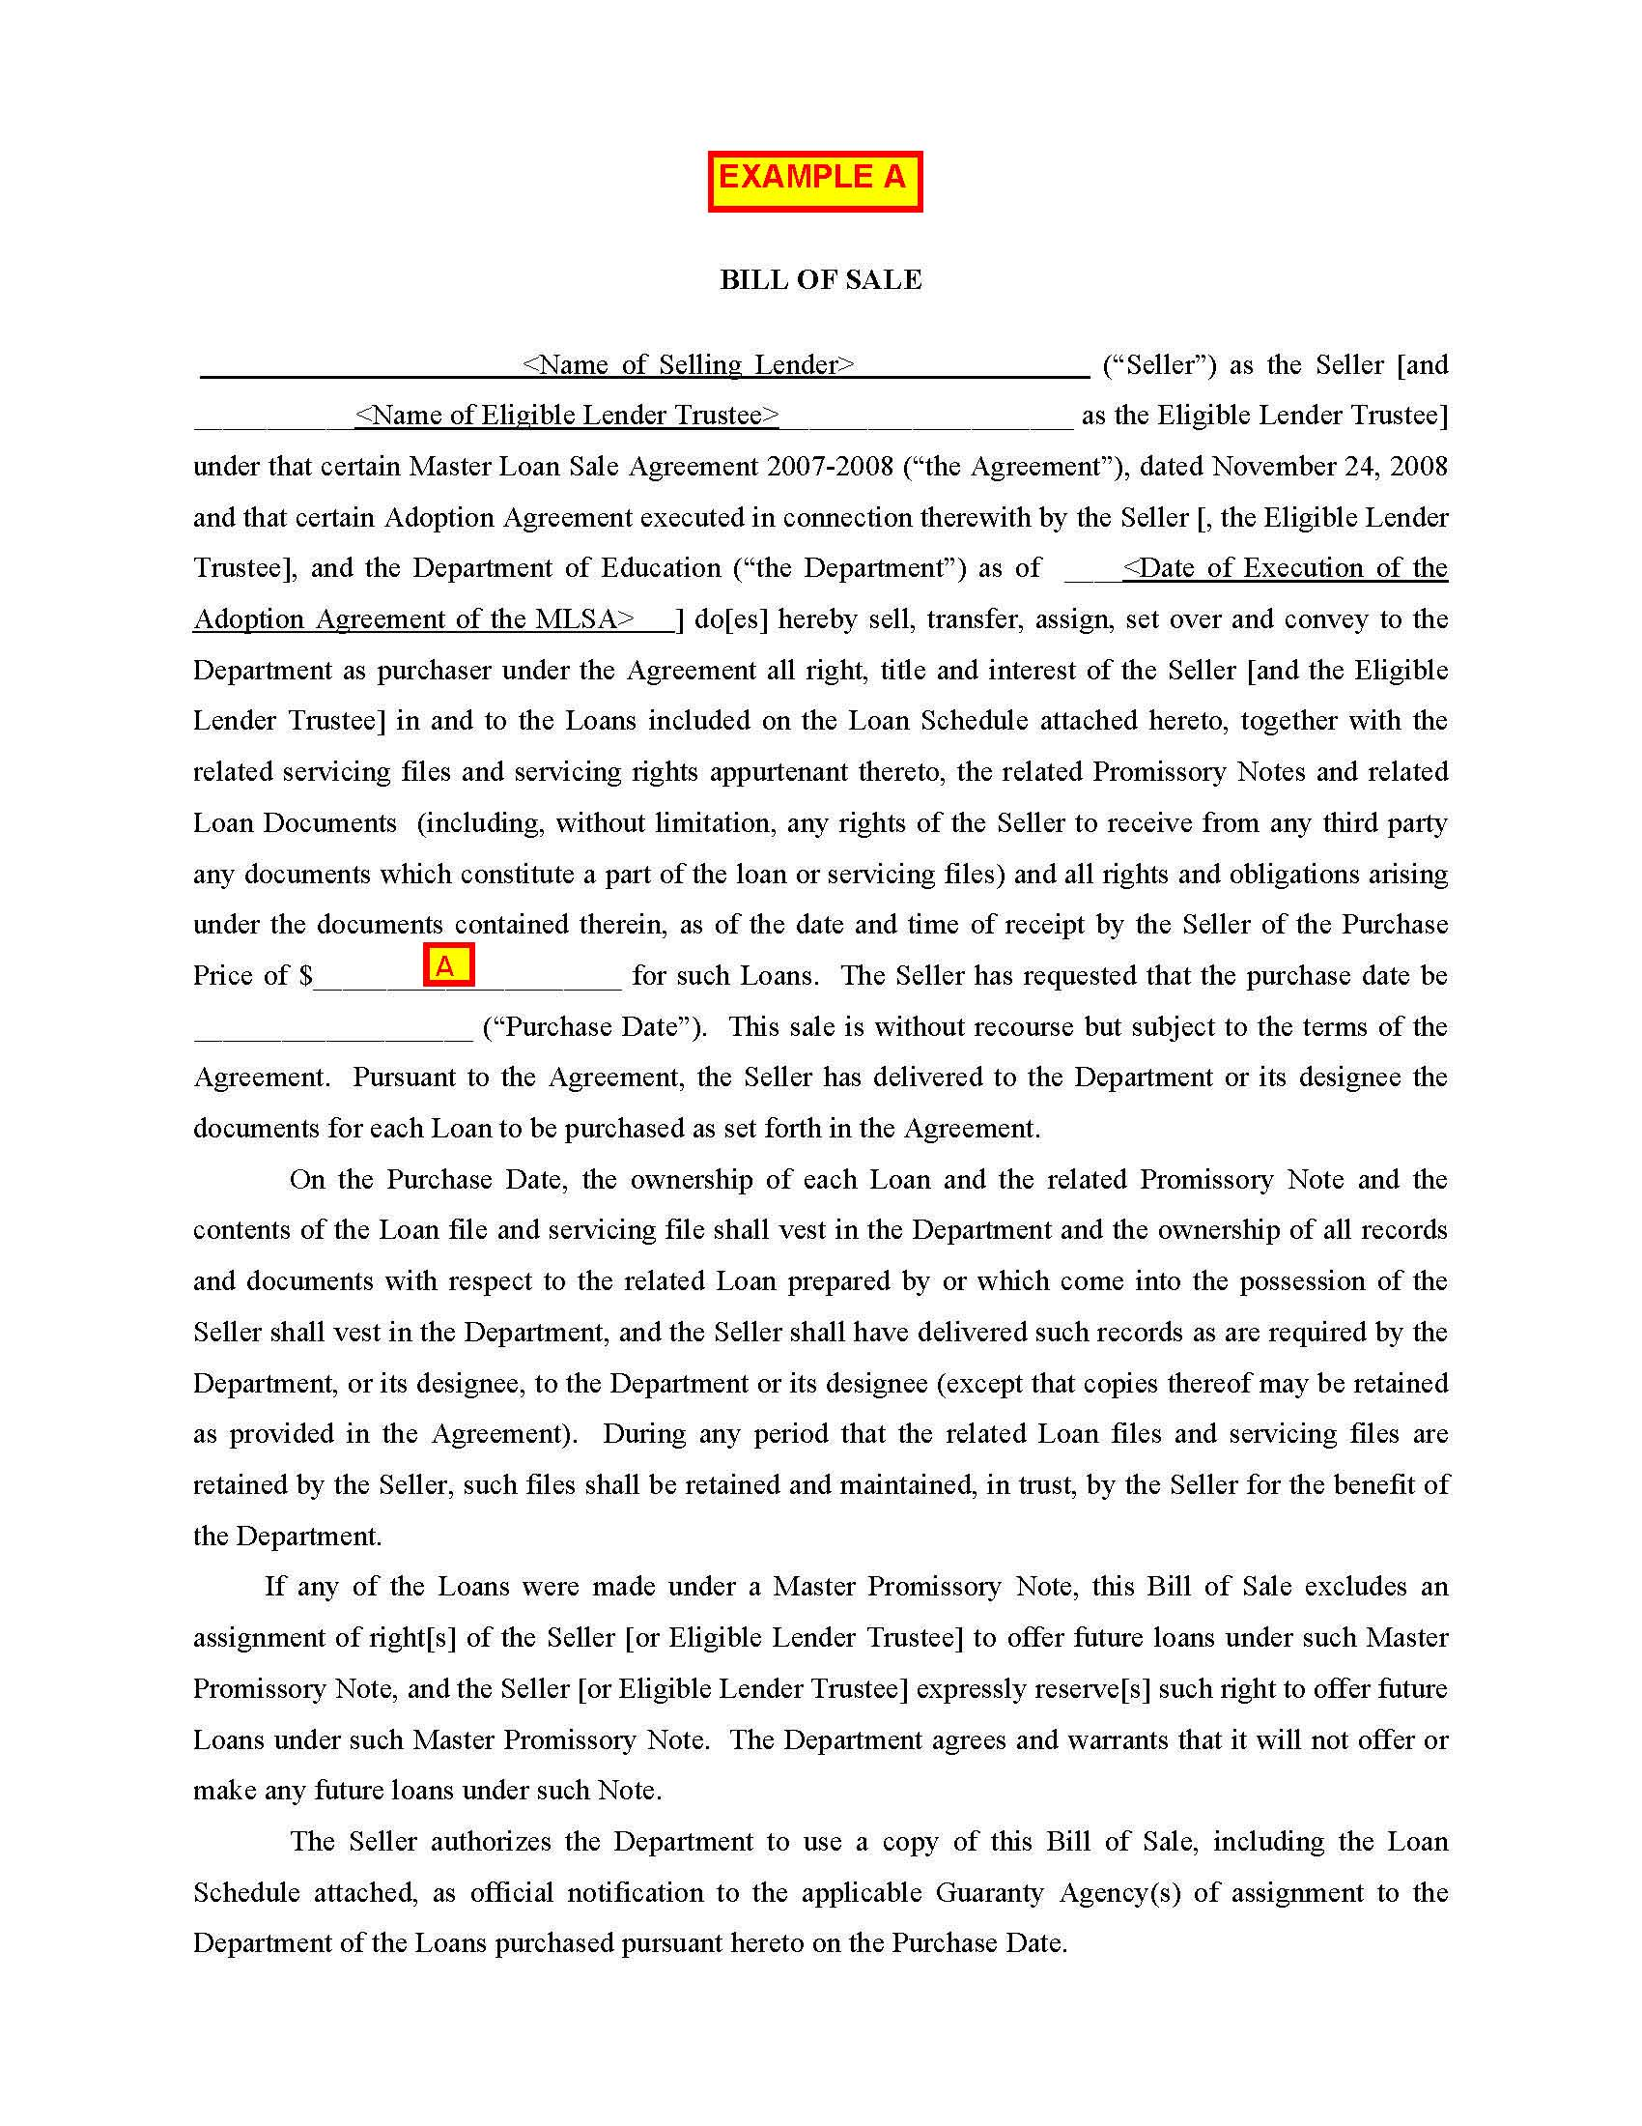



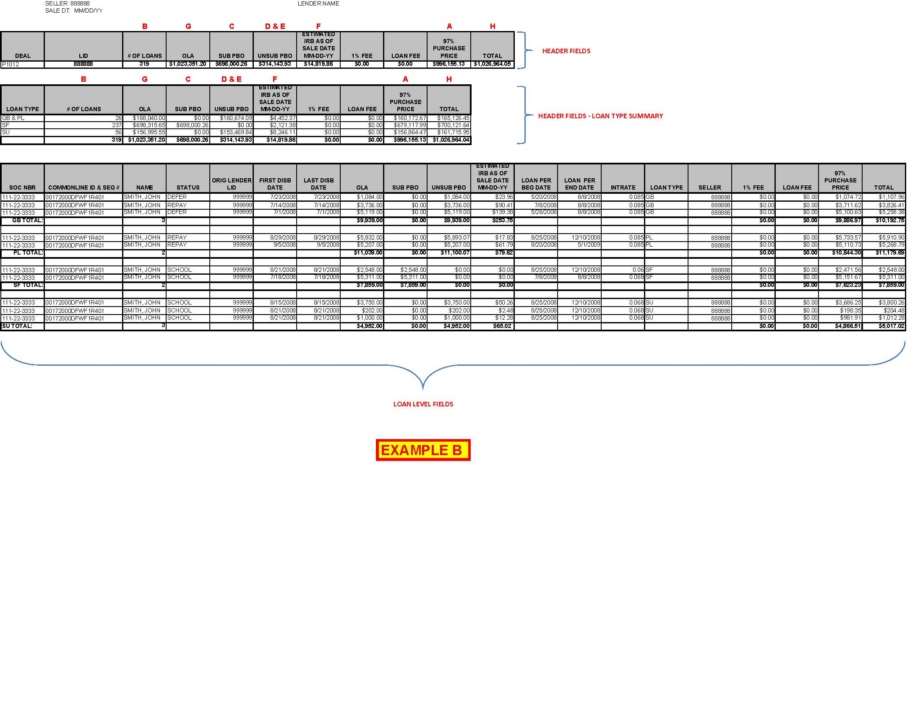
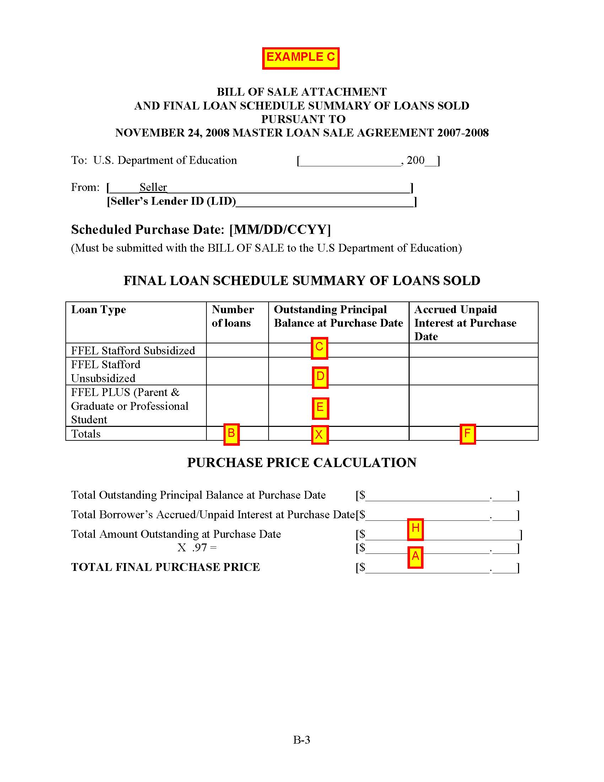

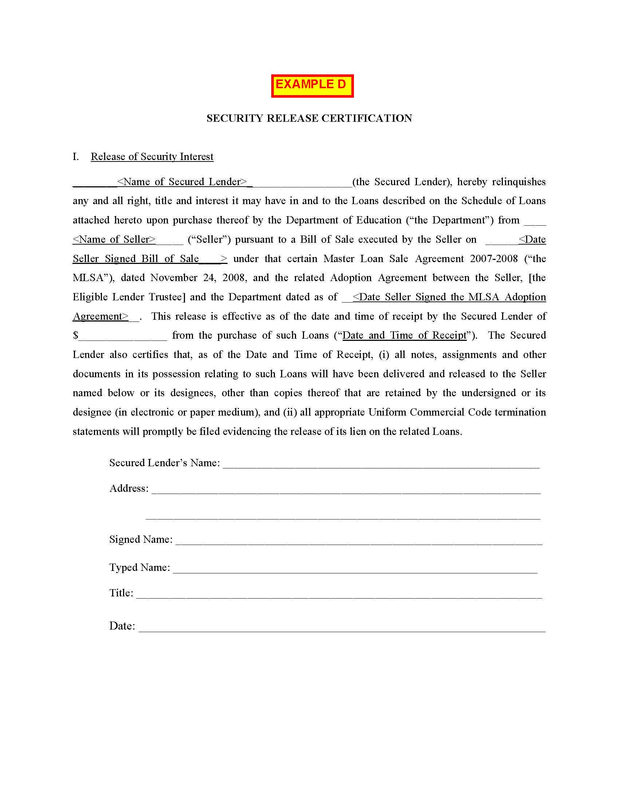

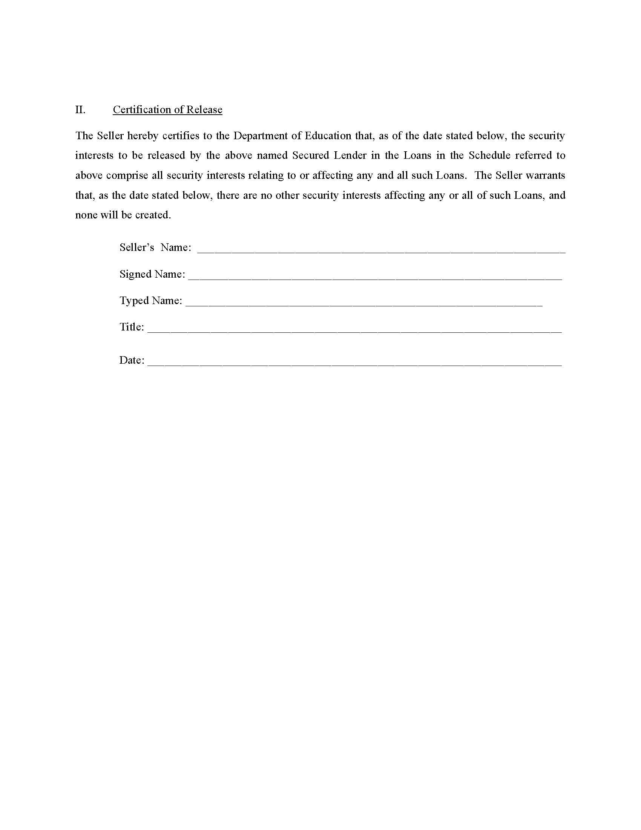

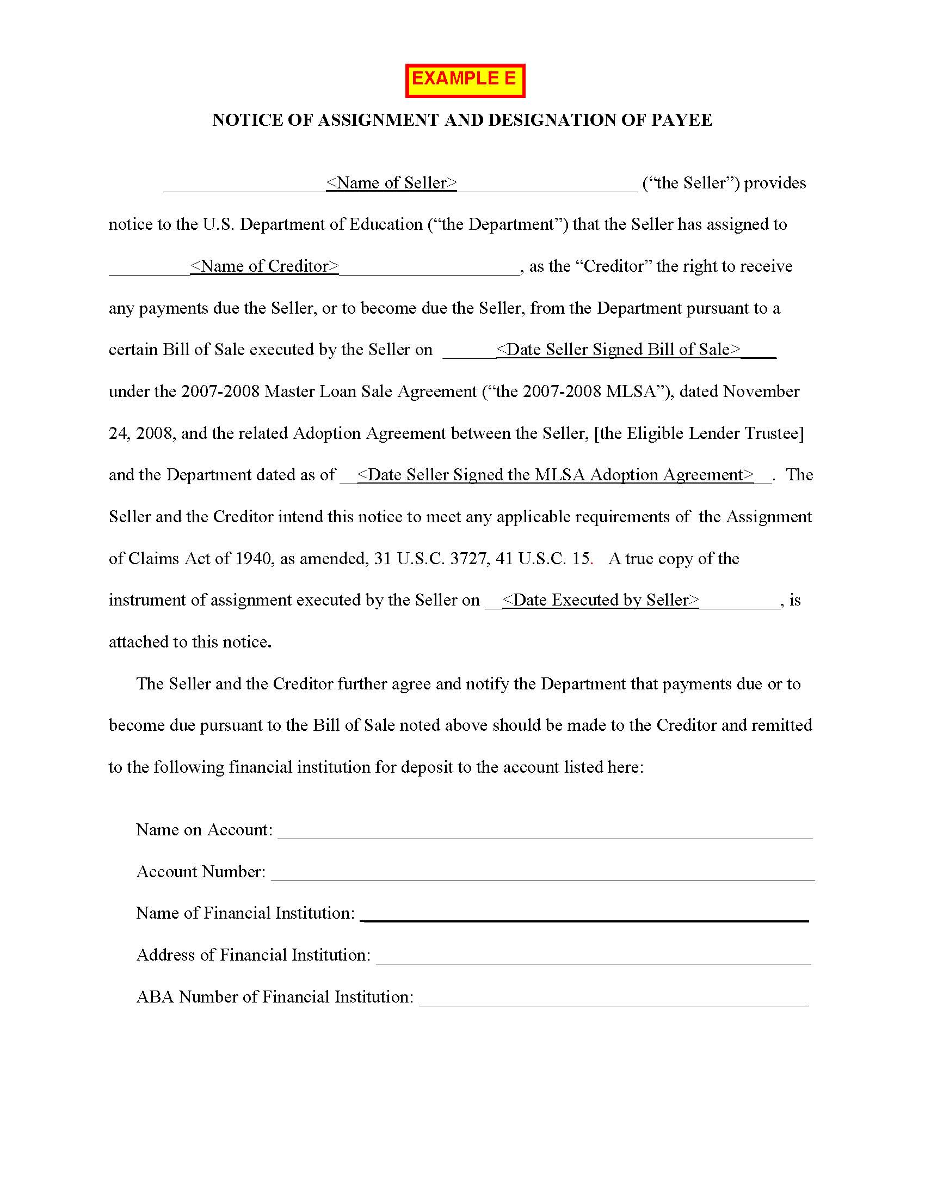

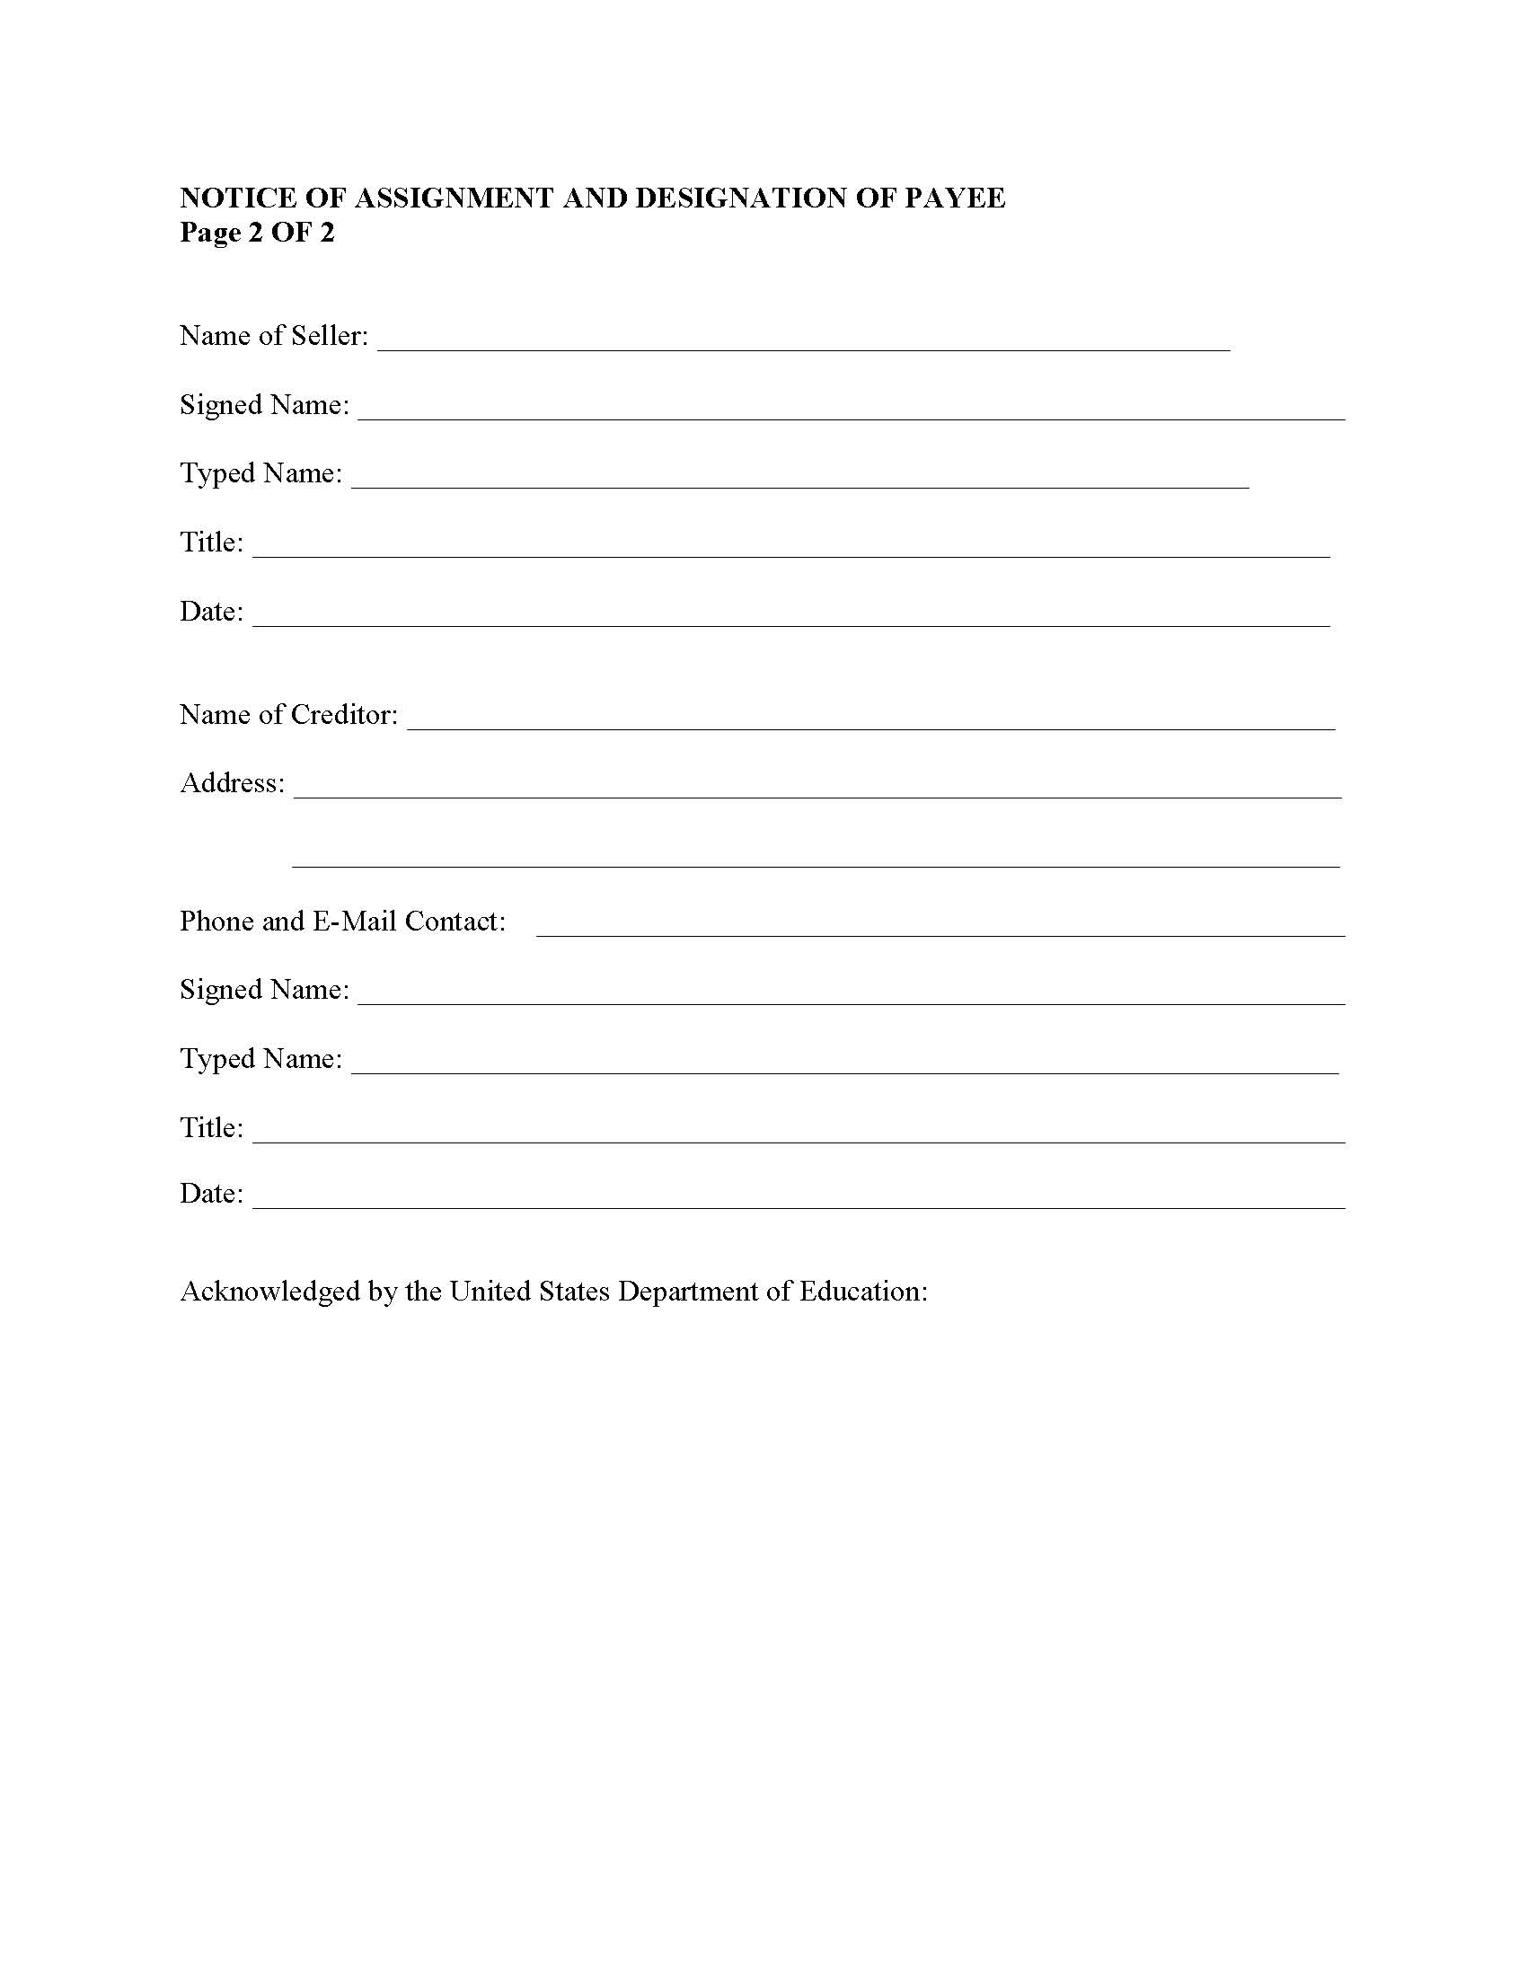

Electronic Announcement #36, dated November 26, 2008, exhibits the MLSA 2007-2008. (Available at: http://federalstudentaid.ed.gov/ffelp/)
For purposes of this Guide, a BOS is consummated when the seller receives payment from ED for the purchase of the loans.
For purpose of this Guide, an “error” is a loan considered to be noncompliant with one or more of the specified eligibility requirements. The sample’s “error rate” is the number of loans with one or more errors divided by the sample size.
The ED Servicer is a contractor that processes the loan sale on behalf of ED and assumes the servicing of loans sold to ED.
Hypothecation is the pledging of property to secure a loan. The title of the property does not transfer, but the right to sell the property in case of default is transferred to the financing party.
In performing the engagement, the practitioner will make two requests for information from the ED Servicer. First, for the BOS package(s) specified in §3.2(A). Second, after the sample of loans is selected at §3.4(B), the practitioner is required to obtain from the ED Servicer copies of loan level documentation specified in §3.4(E), (U), and (EE). The practitioner shall rely upon the information obtained from the ED Servicer and is not expected to perform on-site procedures at the ED Servicer.
Indicated on page 2 of the BOS.
Pursuant to the Security Release Certification (Attachment 8, Example D), a secured lender is to release any right, title, and interest in a loan upon its receipt of payment. The secured lender may receive payment either (1) from the seller or (2) from ED if the seller submits a Notice of Assignment and Designation of Payee (Attachment 8, Example E) as part of the BOS package.
Attestation documentation for this step may include an email or letter from the seller or a record of conversation prepared by the practitioner.
Contact information for the ED Servicer is detailed in §3.2(A). In performing the engagement, the practitioner will make two requests for information from the ED Servicer. First, for the BOS package(s) specified in §3.2(A). Second, after the sample of loans is selected at §3.4(B), the practitioner is required to obtain from the ED Servicer copies of loan level documentation specified in §3.4(E), (U), and (EE). The practitioner shall rely upon the information obtained from the ED Servicer and is not expected to perform on-site procedures at the ED Servicer.
A school must certify information that it provides in connection with a loan. 34 C.F.R. § 682.603(a) The school’s certification may be a hardcopy or electronic record.
As used in Chapter 3, Loan Documentation consists of the (i) Loan Documents obtained from the ED Servicer and (ii) hardcopy or electronic records obtained from the seller or the seller’s servicer.
If, in response to query specified at §3.4(U), the seller states that they do not provide borrower benefits, the loans in the sample should not be subject to the reduction in interest rates.
The Servicemembers Civil Relief Act establishes a maximum interest rate of 6% on debts incurred by a servicemember, or the servicemember and the servicemember’s spouse jointly, before the servicemember enters military service. In order for a debt of the servicemember to be subject to the 6% interest rate limitation, the servicemember shall provide to the lender a written notice and a copy of the military orders calling the servicemember to military service and any orders further extending military service. The effective date of the interest rate limitation is the date on which the servicemember is called to military service.
The information on the borrower’s loan will be contained in a loan servicing system maintained by the seller or the seller’s servicer.
Id.
Lenders are required to review the credit history of each PLUS loan borrower and, if applicable, endorser. Borrowers with an adverse credit history may obtain a PLUS Loan with an endorser who has been determined to not have an adverse credit history. 34 C.F.R. § 682.201(c)(1)(vii)
Attestation documentation for this step may be written communication between the practitioner and the seller or its servicer or a record of conversation prepared by the practitioner.
In general, borrower benefits include, but are not limited to, fee reductions, interest rate reductions, repayment options, or other benefits provided to borrowers by the lender. The MLSA 2007-2008’s Section 3(F) specifies the eligible borrower benefits for loans sold to ED under the Short-Term Purchase Program.
Attestation documentation for this step may be written communication between the practitioner and the seller or its servicer or a record of conversation prepared by the practitioner.
This evidence must be included in the attestation documentation for the engagement.
Contact information for the ED Servicer is detailed in §3.2(A).
Attestation documentation for this step may be written communication between the practitioner and the seller or its servicer or a record of conversation prepared by the practitioner.
This evidence must be included in the attestation documentation for the engagement.
Attestation documentation for this step may be written communication between the practitioner and the seller or its servicer or a record of conversation prepared by the practitioner.
Pursuant to MLSA 2007-2008 Section 8(A), within two business days following the receipt of a payment, the seller shall remit to ED any such payment along with a listing identifying the loans, the payment amount, and the date each payment was received.
This is indicated by a BOS Package that does not indicate and include a Security Release Certification. (Attachment 8, Examples A and D.)
This evidence must be included in the attestation documentation for the engagement. Attestation documentation for this step may be written communication between the practitioner and the seller or its servicer or a record of conversation prepared by the practitioner.
Complete details about representative affidavits and supporting materials pertaining to electronically signed promissory notes are specified in Section 5(B)(iii)(4) of the MLSA 2007-2008. The representative affidavit and supporting materials may cover multiple loan sales if the process described in the affidavit and supporting materials are reliably associated with specific cohorts of loans that were sold to ED.
Attestation documentation for this step may be written communication between the practitioner and the seller or its servicer or a record of conversation prepared by the practitioner.
This evidence must be included in the attestation documentation for the engagement.
Contact information for the ED Servicer is detailed in §3.2(A).
This evidence must be included in the attest documentation for the engagement.
Delinquency on a loan begins on the first day after the due date of the first missed payment that is not later made. 34 C.F.R. § 682.411(b)
The information on the borrower’s loan will be contained in a loan servicing system maintained by the seller or the seller’s servicer.
The loan eligibility requirements that are tested under the AUP engagement are specified in Chapter 3 §3.4 for the Short-Term Purchase Program.
Identify noncompliance with loan eligibility requirements for each loan by placing an “X” in the applicable row.

