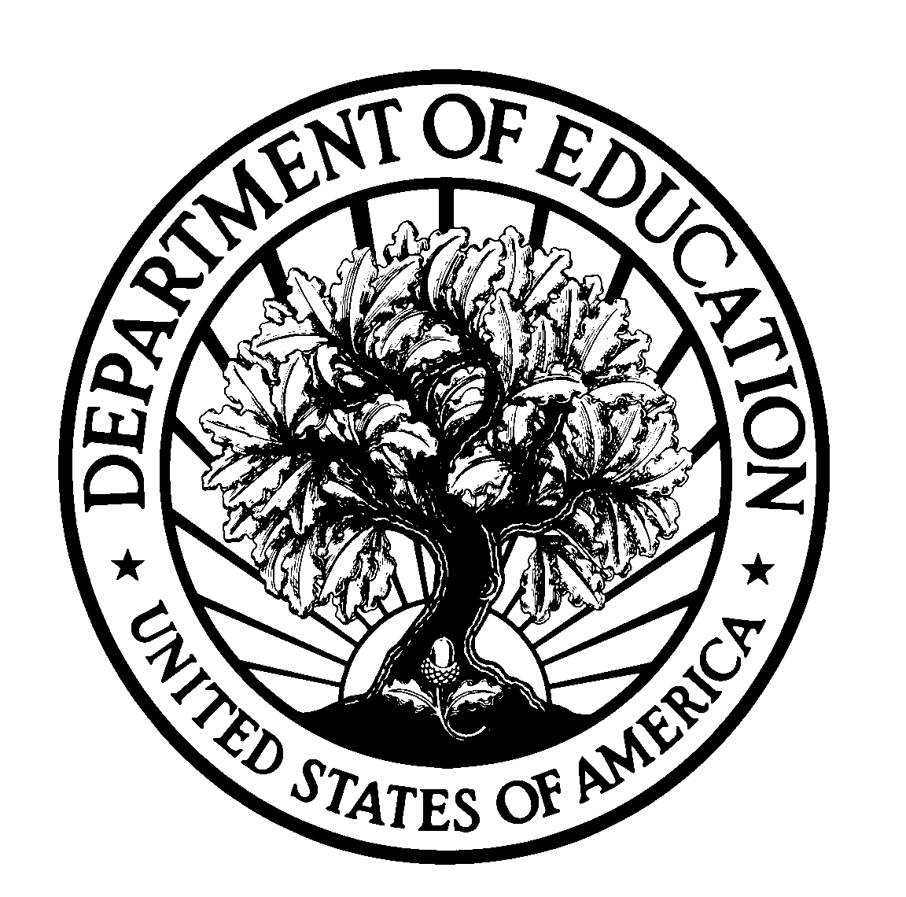
UNITED STATES DEPARTMENT OF EDUCATION Office of the Chief Financial Officer

Memorandum to ED Discretionary Grantees

You are receiving this memorandum to remind you of Federal requirements, found in Parts 74 and 80 of the Education Department General Administrative Regulations (EDGAR), regarding cash drawdowns under your grant account.

For any cash that you draw from your Department of Education grant account, you must:

- draw down only as much cash as is necessary to meet the immediate needs of the grant project;
- keep to the minimum the time between drawing down the funds and paying them out for grant activities; and
- return to the Government the interest earned on grant funds deposited in interest-bearing bank accounts (except for a small amount of interest earned each year that your entity is allowed to keep to reimburse itself for administrative expenses).

In order to meet these requirements, you are urged to:

- take into account the need to coordinate the timing of drawdowns with prior internal clearances (e.g., by boards, directors, or other officials) when projecting immediate cash needs so that funds drawn down from ED do not stay in a bank account for extended periods of time while waiting for approval;
- monitor the fiscal activity (drawdowns and payments) under your grant on a continuous basis;
- plan carefully for cash flow in your grant project during the budget period and review project cash requirements before each drawdown; and
- pay out grant funds for project activities as soon as it is practical to do so after receiving cash from the Department.

Keep in mind that the Department monitors cash drawdown activity for all grants on a weekly basis. Department staff will contact grantees who appear to have drawn down excessive amounts of cash under one or more grants during the fiscal quarter to discuss the particular situation. For the purposes of drawdown monitoring, the Department will contact grantees who have drawn down 50% or more of the grant in the first quarter, 80% or more in the second quarter, and/or 100% of the cash in the third quarter of the budget period. However, even amounts less than these thresholds could still represent excessive drawdowns for your particular grant activities in any particular quarter. Grantees determined to have drawn down excessive cash will be required to return the excess funds to the Department, along with any associated earned interest, until such time as the money is legitimately needed to pay for grant activities. You can find the procedures for returning funds and interest in the ED User's Guide, which is located on the Web at the following URL:

http://e-grants.ed.gov
(select the link for 'e-Payments')

Grantees who do not follow Federal cash management requirements and/or consistently appear on the Department's reports of excessive drawdowns could be:

- designated "high-risk" grantees [EDGAR 74.14, 80.12], which could mean being placed on a "cash-reimbursement" payment method (i.e., a grantee would experience the inconvenience of having to pay for grant activities with its own money and waiting to be reimbursed by the Department afterwards);
- subject to further corrective action;
- denied selection for funding on future ED grant applications [EDGAR 75.217(d)(3)(ii)]; and/or
- debarred or suspended from receiving future federal awards from any executive agency of the federal government.

Depending on which type of entity your organization is, you are urged to read either §74.22 or §80.21 of EDGAR to learn more about Federal requirements related to grant payments. If you are a state or local educational agency with a grant covered by Part 80, please check with the ED staff person named in Block 3 of your Grant Award Notification to determine how to apply these requirements to any subgrantees. You are urged to make copies of this memorandum and share it with all affected individuals within your organization.

