Texas
http://www.tea.state.tx.us

School and Teacher Demographics

Per pupil expenditures | $6,539
(CCD, 2000-01)

Number of Districts | 1,040
(CCD, 2001-02)

Number of Charter Schools | 241
(CCD, 2001-02)

Number of Public Schools
(CCD)

 | 1993-94 | 2001-02
Elementary | 3,366 | 3,870
Middle | 1,293 | 1,533
High | 1,056 | 1,384
Combined | 348 | 813
Total | 6,063 | 7,600

Number of FTE Teachers
(CCD)

 | 1993-94 | 2001-02
Elementary | 108,043 | 131,750
Middle | 50,827 | 64,643
High | 55,763 | 73,754
Combined | 6,806 | 8,195
Total | 221,439 | 278,342

Percentage of teachers with a major in the main subject taught, grades 7-12 (SASS)

 | 1994 | 2000
English | 71% | 64%
Math | 65 | 57
Science | 70 | 57
Social Studies | 67 | 60

Sources of Funding
District Average
(CCD, 2000-01)
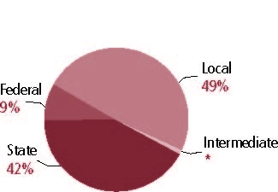

Student Demographics
Public school enrollment
(CCD)

 | 1993-94 | 2001-02
Pre-K | 120,446 | 170,101
K-8 | 2,560,607 | 2,846,113
9-12 | 927,209 | 1,147,233
Total (K-12) | 3,487,816 | 3,993,346

Race/ethnicity (CCD)

 | 1993-94 | 2001-02
American Indian/Alaskan Natives | * | *
Asian/Pacific Islander | 2% | 3%
Black | 14 | 14
Hispanic | 36 | 42
White | 48 | 41
Other | - | -

Students with disabilities | 1993-94 | 2001-02
(OSEP) | 11% | 11%

Students with limited | 1993-94 | 2000-01
English proficiency | 12% | 14%
(ED/NCBE)

Migratory students | 1993-94 | 2001-02
(OME) | 3% | 5%
All schools by percent of students eligible to participate in the Free and Reduced-Price Lunch Program† (CCD, 2001-02)
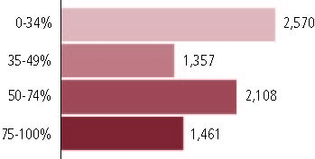

†150 schools did not report.

Statewide Accountability Information

(Collected from states, January 2002 for 2001-02 school year.)

Statewide Goal for Schools on State Assessment
Above 50 percent passing on assessment for all racial and ethnic groups and low-income students. (Pass=70 percent correct in reading and math).

Expected School Improvement on Assessment
Pass rate increases 5 percent per year for each group.

Title I Adequate Yearly Progress (AYP) for Schools
Same as statewide goal.

Title I 2001-02

(ED Consolidated Report, 2001-02)

 | Schoolwide  Programs | Targeted Assistance | Total
Number of schools | 3,970 | 589 | 4,559
Number of schools | 87% | 28% | 100%
Schools meeting AYP Goal | 3,725 | 505 | 4,230
Schools meeting AYP Goal | 88% | 12% | 93%
Schools identified for Improvement | 62 | 10 | 72
Schools identified for Improvement | 86% | 14% | 2%

Title I Allocation | $786,011,631
(Includes Basic, Concentration, and LEA grants, Capital Expenditures, Even Start, Migrant Education, and Neglected and Delinquent, ED, 2000-2001)

NAEP State Results
 | Grade 4 | Grade 8

Reading, 2003
Proficient level and above | 27% | 26%
Basic level and above | 60 | 71

Math, 2003
Proficient level and above | 33% | 25%
Basic level and above | 82 | 69

Texas

Student Achievement 2001-02

Assessment:
Texas Assessment of Academic Skills.

State Definition of Proficient:
Score of 70 or above on Texas Learning Index.

Elementary School
Grade 4
Reading
Students in: | Partially Proficient | Proficient | Advanced
All schools | 9% | 54% | 37%
Title I schools | 11 | 58 | 31
Economically Disadvantaged Students | 14 | 64 | 22
Students with limited  English proficiency | 21 | 66 | 13
Migratory students | 18 | 66 | 16
Students with Disabilities | 13 | 61 | 27

Grade 4
Mathematics
Students in: | Partially Proficient | Proficient | Advanced
All schools | 6% | 84% | 10%
Title I schools | 8 | 85 | 8
Economically Disadvantaged Students | 10 | 85 | 5
Students with limited  English proficiency | 13 | 83 | 3
Migratory students | 10 | 86 | 4
Students with Disabilities | 10 | 84 | 6

Student Achievement Trend
Reading 4th grade Meets or Exceeds Proficient
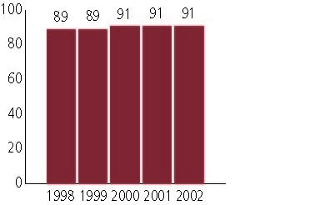

Middle School
Grade 8
Reading
Students in: | Partially Proficient | Proficient | Advanced
All schools | 6% | 64% | 30%
Title I schools | 8 | 68 | 24
Economically Disadvantaged Students | 11 | 73 | 16
Students with limited  English proficiency | 36 | 62 | 2
Migratory students | 15 | 73 | 13
Students with Disabilities | 16 | 75 | 9

Grade 8
Mathematics
Students in: | Partially Proficient | Proficient | Advanced
All schools | 8% | 79% | 14%
Title I schools | 10 | 80 | 10
Economically Disadvantaged Students | 13 | 81 | 7
Students with limited  English proficiency | 29 | 68 | 2
Migratory students | 14 | 80 | 6
Students with Disabilities | 19 | 78 | 3

Student Achievement Trend
Mathematics 8th grade Meets or Exceeds Proficient
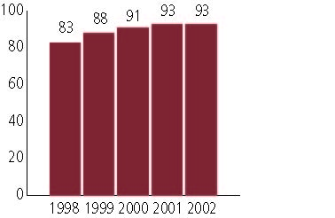

High School
Grade 10
Reading
Students in: | Partially Proficient | Proficient | Advanced
All schools | 6% | 72% | 22%
Title I schools | 8 | 76 | 16
Economically Disadvantaged Students | 11 | 79 | 10
Students with limited  English proficiency | 34 | 65 | 1
Migratory students | 15 | 79 | 7
Students with Disabilities | 20 | 75 | 5

Grade 10
Mathematics
Students in: | Partially Proficient | Proficient | Advanced
All schools | 8% | 82% | 10%
Title I schools | 10 | 83 | 6
Economically Disadvantaged Students | 14 | 82 | 4
Students with limited  English proficiency | 29 | 69 | 2
Migratory students | 14 | 83 | 4
Students with Disabilities | 28 | 71 | 1

High School Indicators | 1993-94 | 2000-01
High school dropout rate (CCD, event) | n/a% | 4%
 | 1994-95 | 2000-01
Postsecondary enrollment  (NCES, High school grads enrolled in college) | 50% | 53%

