Missouri
http://www.dese.state.mo.us

School and Teacher Demographics

Per pupil expenditures | $6,667
(CCD, 2000-01)

Number of Districts | 524
(CCD, 2001-02)

Number of Charter Schools | 21
(CCD, 2001-02)

Number of Public Schools
(CCD)

 | 1993-94 | 2001-02
Elementary | 1,177 | 1,244
Middle | 314 | 376
High | 482 | 494
Combined | 26 | 106
Total | 1,999 | 2,220

Number of FTE Teachers
(CCD)

 | 1993-94 | 2001-02
Elementary | 26,009 | 30,916
Middle | 9,764 | 12,321
High | 14,939 | 17,394
Combined | 375 | 2,470
Total | 51,087 | 63,101

Percentage of teachers with a major in the main subject taught, grades 7-12 (SASS)

 | 1994 | 2000
English | 81% | 64%
Math | 89 | 52
Science | 70 | 70
Social Studies | 84 | 80

Sources of Funding
District Average
(CCD, 2000-01)
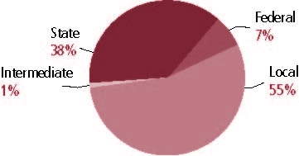

Student Demographics
Public school enrollment
(CCD)

 | 1993-94 | 2001-02
Pre-K | 23,597 | 20,503
K-8 | 601,691 | 620,200
9-12 | 241,874 | 264,729
Total (K-12) | 843,565 | 884,929

Race/ethnicity (CCD)

 | 1993-94 | 2001-02
American Indian/Alaskan Natives | * | *
Asian/Pacific Islander | 1% | 1%
Black | 16 | 18
Hispanic | 1 | 2
White | 82 | 81
Other | - | -

Students with disabilities | 1993-94 | 2001-02
(OSEP) | 11% | 13%

Students with limited | 1993-94 | 2000-01
English proficiency | 1% | 1%
(ED/NCBE)

Migratory students | 1993-94 | 2001-02
(OME) | * | 1%
All schools by percent of students eligible to participate in the Free and Reduced-Price Lunch Program† (CCD, 2001-02)
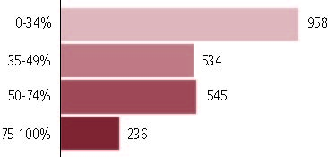

†1 school did not report.

Statewide Accountability Information

(Collected from states, January 2002 for 2001-02 school year.)

Statewide Goal for Schools on State Assessment
Increase in top two achievement levels and decrease in bottom two achievement levels in all five of the Missouri Assessment Program subjects in the respective grades. Reduce the gap in the majority and minority student performances.

Expected School Improvement on Assessment
Three percent increase in students scoring in top two achievement levels and 3 percent decrease in bottom two achievement levels OR a Missouri Assessment Program Index change reflecting improvement of students throughout the distribution.

Title I Adequate Yearly Progress (AYP) for Schools
Five percent increase in students at highest level and 5 percent decrease in lowest level or 5 percent or less in lowest level.

Title I 2001-02

(ED Consolidated Report, 2001-02)

 | Schoolwide  Programs | Targeted Assistance | Total
Number of schools | 393 | 932 | 1,325
Number of schools | 30% | 28% | 100%
Schools meeting AYP Goal | 367 | 921 | 1,288
Schools meeting AYP Goal | 28% | 72% | 97%
Schools identified for Improvement | 26 | 11 | 37
Schools identified for Improvement | 70% | 30% | 3%

Title I Allocation | $150,588,984
(Includes Basic, Concentration, and LEA grants, Capital Expenditures, Even Start, Migrant Education, and Neglected and Delinquent, ED, 2000-2001)

NAEP State Results
 | Grade 4 | Grade 8

Reading, 2003
Proficient level and above | 34% | 35%
Basic level and above | 68 | 80

Math, 2003
Proficient level and above | 30% | 28%
Basic level and above | 79 | 71

Missouri

Student Achievement 2001-02

Assessment:
Missouri Assessment Program.

State Definition of Proficient:
See apendix A.

Elementary School
Grade 3
Communication Arts
Students in: | Step 1 | Progressing | Nearing Proficient | Proficient | Advanced
All schools | 6% | 20% | 38% | 34% | 2%
Title I schools | 12 | 30 | 38 | 20 | 1
Economically Disadvantaged Students | 11 | 28 | 39 | 21 | 1
Students with limited  English proficiency | 27 | 33 | 29 | 11 | 1
Migratory students | 21 | 35 | 29 | 15 | 1
Students with Disabilities | 11 | 30 | 39 | 21 | 1

Grade 3
Mathematics
Students in: | Step 1 | Progressing | Nearing Proficient | Proficient | Advanced
All schools | 3% | 18% | 41% | 30% | 8%
Title I schools | 5 | 30 | 44 | 19 | 3
Economically Disadvantaged Students | 5 | 28 | 44 | 20 | 3
Students with limited  English proficiency | 13 | 32 | 38 | 14 | 3
Migratory students | 6 | 29 | 49 | 15 | 1
Students with Disabilities | 2 | 28 | 43 | 23 | 5

Student Achievement Trend
Reading 3rd grade Meets or Exceeds Standards
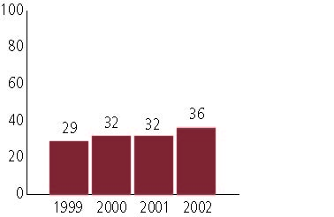

Middle School
Grade 7
Communication Arts
Students in: | Step 1 | Progressing | Nearing Proficient | Proficient | Advanced
All schools | 13% | 22% | 33% | 30% | 2%
Title I schools | 26 | 31 | 29 | 14 | 1
Economically Disadvantaged Students | 23 | 30 | 31 | 16 | 1
Students with limited  English proficiency | 48 | 26 | 14 | 11 | 1
Migratory students | 35 | 30 | 29 | 6 | 0
Students with Disabilities | 18 | 34 | 30 | 17 | 1

Grade 8
Mathematics
Students in: | Step 1 | Progressing | Nearing Proficient | Proficient | Advanced
All schools | 20% | 34% | 32% | 13% | 1%
Title I schools | 37 | 37 | 20 | 5 | 1
Economically Disadvantaged Students | 35 | 38 | 21 | 5 | 1
Students with limited  English proficiency | 46 | 30 | 16 | 7 | 1
Migratory students | 31 | 44 | 19 | 5 | 2
Students with Disabilities | 29 | 39 | 25 | 7 | 1

Student Achievement Trend
Mathematics 8th grade Meets or Exceeds Standards
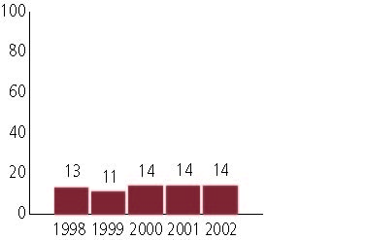

High School
Grade 11
Communication Arts
Students in: | Step 1 | Progressing | Nearing Proficient | Proficient | Advanced
All schools | 17% | 18% | 42% | 23% | 1%
Title I schools | 35 | 22 | 33 | 10 | 1
Economically Disadvantaged Students | 31 | 23 | 35 | 11 | 11
Students with limited  English proficiency | 63 | 18 | 17 | 2 | 0
Migratory students | 44 | 6 | 44 | 6 | 0
Students with Disabilities | 25 | 19 | 38 | 18 | 1

Grade 10
Mathematics
Students in: | Step 1 | Progressing | Nearing Proficient | Proficient | Advanced
All schools | 25% | 34% | 30% | 10% | 1%
Title I schools | 50 | 31 | 16 | 4 | 0
Economically Disadvantaged Students | 44 | 35 | 18 | 3 | 0
Students with limited  English proficiency | 59 | 30 | 11 | 1 | 0
Migratory students | 36 | 25 | 36 | 3 | 0
Students with Disabilities | 27 | 47 | 22 | 4 | 1

High School Indicators | 1993-94 | 2000-01
High school dropout rate (CCD, event) | 7% | 4%
 | 1994-95 | 2000-01
Postsecondary enrollment  (NCES, High school grads enrolled in college) | 51% | 53%

