Indiana

http://www.doe.state.in.us

Districts and schools

Number of districts (CCD) | 1993-94 | 2003-04
 | 294 | 294

Number of public schools (CCD) | 1993-94 | 2003-04
Elementary | 1,180 | 1,153
Middle | 292 | 335
High | 348 | 337
Combined | 32 | 84
Other | 9 | 2
Total | 1,861 | 1,911

Number of charter schools (CCD) | 2003-04
 | 15

Finances

Total current expenditures  (CCD, in thousands of dollars, adjusted for inflation to 2002-03) | 1993-94 | 2002-03
Instructional | $3,977,018 | $4,951,003
Noninstructional | 282,746 | 330,153
Support | 2,193,657 | 2,807,529
Total | 6,453,421 | 8,088,685

Per-pupil expenditures  (CCD, adjusted for inflation to 2002-03) | 1993-94 | 2002-03
 | $6,683 | $8,057

Sources of Funding
(CCD, 2002-03)

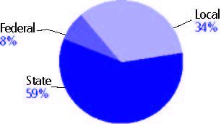

Title I allocation 2002-03 (ED; Includes Title I, Part A) | $156,540,820

Students

Public school enrollment (CCD) | 1993-94 | 2003-04
Pre-K | 3,971 | 5,542
K-8 | 669,978 | 710,195
9-12 | 281,898 | 293,393
Total (K-12) | 951,876 | 1,003,588

Race/ethnicity (CCD) | 1993-94 | 2003-04
American Indian/Alaskan Native | * | *
Asian/Pacific Islander | 1% | 1%
Black, non-Hispanic | 11 | 12
Hispanic | 2 | 5
White, non-Hispanic | 86 | 82

Students with disabilities (OSEP) | 1993-94 | 2003-04
 | 11% | 14%

Students with limited  English proficiency (NCELA) | 1993-94 | 2003-04
 | 1% | 3%

Migrant students (OME) | 1993-94 | 2003-04
 | 1% | 2%

Eighth-grade students enrolled in Algebra I for high school credit (NAEP) | 1996 | 2003
 | 21% | 24%

Students eligible to participate in the Free or Reduced-Price Lunch Program, 2003-04 (CCD) | 348,111

All schools by percent of students eligible to participate in the Free or Reduced-Price Lunch Program, 2003-04† (CCD)
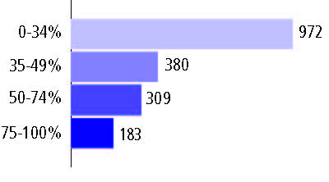
† 67 schools did not report

Staff

Number of FTE teachers (CCD) | 1993-94 | 2003-04
Elementary | 25,672 | 27,796
Middle | 9,854 | 11,685
High | 15,977 | 16,015
Combined | 1,112 | 2,354
Other | 561 | 15
Total | 53,176 | 57,865

Number of FTE non-teacher staff (CCD) | 1993-94 | 2003-04
Instructional aides | 13,633 | 18,289
Instructional coordinators | 1,293 | 1,662
Administrators | 3,611 | 4,065
Other | 40,248 | 46,592
Total | 58,785 | 70,608

Percentage of teachers with a major in the main subject taught, grades 7-12 (SASS) | 1994 | 2000
English | 76% | 87%
Mathematics | 81 | 72
Science | 78 | 77
Social Studies | 89 | 79

Percentage of core courses taught by highly qualified teachers, 2003-04 (As defined and reported by states, collected by ED)

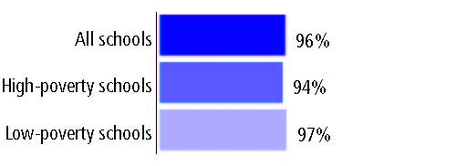

Outcomes

 | 1993-94 | 2000-01
High school dropout rate (NCES) | - | -
Avg. freshman graduation rate (NCES) | 76% | 72%
College-going rate (IPEDS/NCES) | 55 | 60

NAEP state results
Reading, Grade 4 | 1994 | 2005
Proficient level or above | 33% | 30%
Basic level or above | 66 | 64
Math, Grade 8 | 1996 | 2005
Proficient level or above | 24% | 30%
Basic level or above | 68 | 74

Statewide Accountability Information:

State Accountability Website: http://www.doe.state.in.us/istep/2003/summary.html

State assessment for NCLB accountability: Indiana Statewide Testing for Educational Progress Plus

State student achievement levels: Did Not Pass, Pass, Pass Plus

 |  | 2001-02  Annual measurable  objective starting point | Target  2003-04
Grade 3 | English language arts | 58.8% | 58.8%
 | Mathematics | 57.1 | 57.1
Grade 8 | English language arts | 58.8 | 58.8
 | Mathematics | 57.1 | 57.1
High school | English language arts | 58.8 | 58.8
 | Mathematics | 57.1 | 57.1

2003-04 NCLB accountability results, applied to 2004-05 school year
AYP outcomes and consequences | Title I schools |  | All schools |  | All districts
Made AYP | 628 | 80% | 1,405 | 76% | 136 | 46%
Identified for improvement:
Year 1 | 26 | 3% | 26 | 1% | 23 | 8%
Year 2 | 23 | 3% | 23 | 1% | 0 | 0
Corrective action | 18 | 2% | 18 | 1% | 0 | 0
Restructuring | 10 | 1% | 10 | 1% | 0 | 0
Exited improvement status (made AYP twice after missing twice or more, includes total “made” above) | 27 | 3% | 27 | 1% | 0 | 0

Other indicator, 2003-04 | State target | State outcome
Elementary Indicator: Attendance | Meet or progress toward 95% | Met
Middle Indicator: Attendance | Meet or progress toward 95% | Met
High School Indicator: Graduation rate | Meet or progress toward 95% | Met

NCLB choice participation | Number of Title I students | Percent of eligible students
Title I school choice: | 1,199 | 3%
Supplemental educational services: | 3,064 | 19%

Student Achievement 2003-04

Indiana Statewide Testing for Educational Progress Plus, used for NCLB accountability
Grade 3

English or language arts
Proficient Level or above for:
All students | 74%
Economically disadvantaged students | 61
Migrant students | #
Students with disabilities | 44
Students with limited English proficiency | 52
Black, non-Hispanic students | 54
Hispanic students | 58
White, non-Hispanic students | 78

Student achievement trend: English or language arts percent proficient level or above

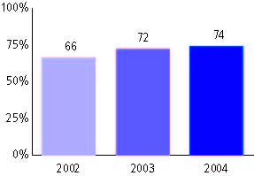

Indiana Statewide Testing for Educational Progress Plus, used for NCLB accountability
Grade 3

Mathematics
Proficient Level or above for:
All students | 71%
Economically disadvantaged students | 60
Migrant students | #
Students with disabilities | 40
Students with limited English proficiency | 47
Black, non-Hispanic students | 54
Hispanic students | 60
White, non-Hispanic students | 75

Student achievement trend: Mathematics percent proficient level or above

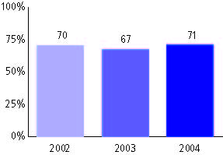

Indiana Statewide Testing for Educational Progress Plus, used for NCLB accountability
Grade 4

English or language arts
Proficient Level or above for:
All students | n/a
Economically disadvantaged students | n/a
Migrant students | n/a
Students with disabilities | n/a
Students with limited English proficiency | n/a
Black, non-Hispanic students | n/a
Hispanic students | n/a
White, non-Hispanic students | n/a

Trend Data Not Available

Indiana Statewide Testing for Educational Progress Plus, used for NCLB accountability
Grade 4

Mathematics
Proficient Level or above for:
All students | n/a
Economically disadvantaged students | n/a
Migrant students | n/a
Students with disabilities | n/a
Students with limited English proficiency | n/a
Black, non-Hispanic students | n/a
Hispanic students | n/a
White, non-Hispanic students | n/a

Trend Data Not Available

Indiana Statewide Testing for Educational Progress Plus, used for NCLB accountability
Grade 5

English or language arts
Proficient Level or above for:
All students | n/a
Economically disadvantaged students | n/a
Migrant students | n/a
Students with disabilities | n/a
Students with limited English proficiency | n/a
Black, non-Hispanic students | n/a
Hispanic students | n/a
White, non-Hispanic students | n/a

Trend Data Not Available

Indiana Statewide Testing for Educational Progress Plus, used for NCLB accountability
Grade 5

Mathematics
Proficient Level or above for:
All students | n/a
Economically disadvantaged students | n/a
Migrant students | n/a
Students with disabilities | n/a
Students with limited English proficiency | n/a
Black, non-Hispanic students | n/a
Hispanic students | n/a
White, non-Hispanic students | n/a

Trend Data Not Available

Indiana Statewide Testing for Educational Progress Plus, used for NCLB accountability
Grade 6

English or language arts
Proficient Level or above for:
All students | 69%
Economically disadvantaged students | 53
Migrant students | #
Students with disabilities | 27
Students with limited English proficiency | 47
Black, non-Hispanic students | 45
Hispanic students | 53
White, non-Hispanic students | 74

Student achievement trend: English or language arts percent proficient level or above

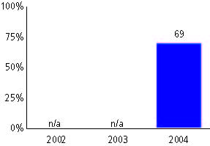

Indiana Statewide Testing for Educational Progress Plus, used for NCLB accountability
Grade 6

Mathematics
Proficient Level or above for:
All students | 72%
Economically disadvantaged students | 57
Migrant students | #
Students with disabilities | 35
Students with limited English proficiency | 56
Black, non-Hispanic students | 43
Hispanic students | 58
White, non-Hispanic students | 78

Student achievement trend: Mathematics percent proficient level or above

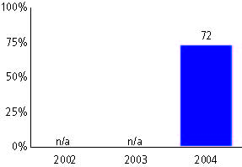

Indiana Statewide Testing for Educational Progress Plus, used for NCLB accountability
Grade 7

English or language arts
Proficient Level or above for:
All students | n/a
Economically disadvantaged students | n/a
Migrant students | n/a
Students with disabilities | n/a
Students with limited English proficiency | n/a
Black, non-Hispanic students | n/a
Hispanic students | n/a
White, non-Hispanic students | n/a

Trend Data Not Available

Indiana Statewide Testing for Educational Progress Plus, used for NCLB accountability
Grade 7

Mathematics
Proficient Level or above for:
All students | n/a
Economically disadvantaged students | n/a
Migrant students | n/a
Students with disabilities | n/a
Students with limited English proficiency | n/a
Black, non-Hispanic students | n/a
Hispanic students | n/a
White, non-Hispanic students | n/a

Trend Data Not Available

Indiana Statewide Testing for Educational Progress Plus, used for NCLB accountability
Grade 8

English or language arts
Proficient Level or above for:
All students | 65%
Economically disadvantaged students | 45
Migrant students | #
Students with disabilities | 20
Students with limited English proficiency | 40
Black, non-Hispanic students | 38
Hispanic students | 47
White, non-Hispanic students | 69

Student achievement trend: English or language arts percent proficient level or above

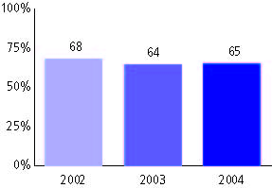

Indiana Statewide Testing for Educational Progress Plus, used for NCLB accountability
Grade 8

Mathematics
Proficient Level or above for:
All students | 71%
Economically disadvantaged students | 51
Migrant students | #
Students with disabilities | 29
Students with limited English proficiency | 51
Black, non-Hispanic students | 39
Hispanic students | 55
White, non-Hispanic students | 76

Student achievement trend: Mathematics percent proficient level or above

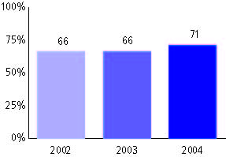

Indiana Statewide Testing for Educational Progress Plus, used for NCLB accountability
High school

English or language arts
Proficient Level or above for:
All students | 69%
Economically disadvantaged students | 48
Migrant students | #
Students with disabilities | 22
Students with limited English proficiency | 26
Black, non-Hispanic students | 39
Hispanic students | 44
White, non-Hispanic students | 75

Student achievement trend: English or language arts percent proficient level or above

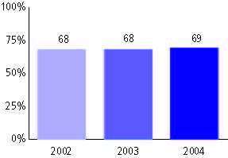

Indiana Statewide Testing for Educational Progress Plus, used for NCLB accountability
High school

Mathematics
Proficient Level or above for:
All students | 67%
Economically disadvantaged students | 46
Migrant students | #
Students with disabilities | 27
Students with limited English proficiency | 41
Black, non-Hispanic students | 33
Hispanic students | 46
White, non-Hispanic students | 73

Student achievement trend: Mathematics percent proficient level or above

