PUBLIC NOTICE
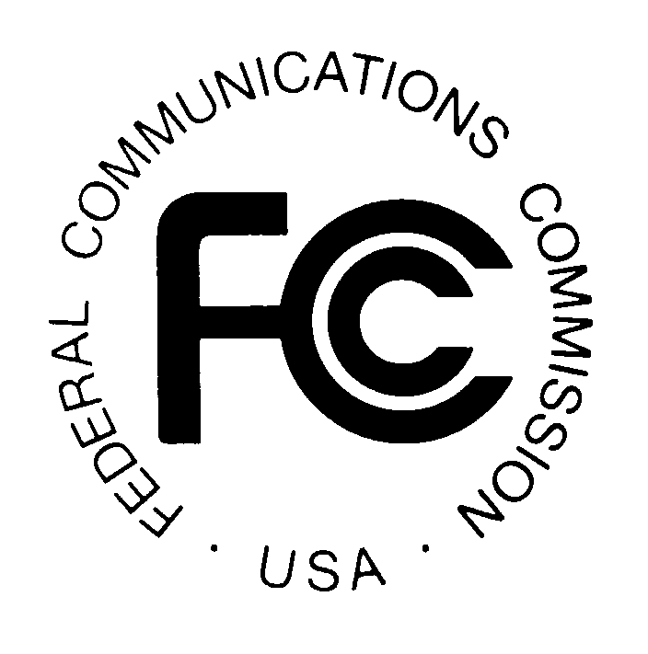

FEDERAL COMMUNICATIONS COMMISSION News Media Information: (202) 418-0500
445 12th STREET, S.W. Fax-On-Demand: (202) 418-2830

WASHINGTON, D.C. 20554 Internet: http://www.fcc.gov

ftp.fcc.gov

DA 99-2585
November 19, 1999

AM Auction Filing Window and Application Freeze

Notice and Filing Requirements Regarding January 24 – 28, 2000 Window for Certain AM Construction Permits; Notice Regarding Freeze on the Acceptance of AM Minor Change Construction Permits from December 24, 1999 to January 21, 2000.

The Mass Media Bureau (“MMB”) and the Wireless Telecommunications Bureau (“WTB”) announce an auction filing window for certain AM station construction permit applications. The filing window will open on January 24, 2000 and close on January 28, 2000. The Commission will not accept AM minor change construction permit applications between December 24, 1999 and January 21, 2000 and, with certain exceptions explained below, during the filing window.

Scope: The window is available for proposals for new AM stations and major modifications to authorized AM facilities. This includes those new AM station and major modification applications that were received on or before November 26, 1997 but for which no “A” cut-off list had been released by that date (“Frozen AM Applications”). Also on file are a number of new AM station and AM major modification applications filed after November 26, 1997 with “freeze waiver” requests (“Freeze Waiver Applications”). These applicants also may participate in the auction filing window. Freeze Waiver Applications have not been protected from subsequently filed minor change applications during the freeze, and this policy will continue through December 23, 1999. Accordingly, Freeze Waiver Applications must protect fully all minor change applications filed on or before December 23, 1999 in order to be considered in the upcoming window, the same requirement that will apply generally to new station and major change proposals submitted for the first time in the window. The window will not be available for new AM expanded band stations or for major changes in existing AM expanded band stations.

The window also will be available for any minor change that is contingent on the grant of a pending license application for WOWO, Fort Wayne, Indiana (File No. BL-981230AE) (the “WOWO Application”) or mutually exclusive with any such contingent proposal on file by the close of the window. At least one major change and six minor change applications have been filed that are contingent on the grant of the WOWO Application. It appears that certain of these applications are mutually exclusive. Each is subject to dismissal pursuant to Section 73.3517. MMB will retain on file all applications that are contingent on the grant of the WOWO license application provided that they are on file by the close of business on the date of release of this Public Notice. However, it will treat these applications as having been filed during the window, i.e., will not accord first come-first served cut-off rights to any of these plainly unacceptable modification applications. This procedure will promote orderliness and fairness in the Commission’s application procedures. We are particularly concerned about the rights of those potential applicants that have chosen to adhere to the Commission’s procedural and substantive rules, and accordingly, have not filed applications contingent on the grant of the WOWO Application. These potential applicants must follow the window filing procedures set forth below in order to be considered.

Minor Change Application Freeze. The Competitive Bidding NPRM freeze was limited to new station and major change applications and MMB has continued to process minor change applications under its first come-first served processing rules during the past two years. However, the Commission will not accept applications for construction permits for minor changes in authorized AM facilities between December 24, 1999 and January 21, 2000. The timing of this limited freeze provides existing AM stations an additional opportunity to file minor change applications prior to the window. The freeze also will eliminate the risk that a potential window filer’s proposal is blocked by the filing of a mutually exclusive minor change application immediately prior to the window.

Participation. Those wishing to participate in the auction must:

- File electronically a short form application (FCC Form 175) by 5:30 p.m. Eastern Standard Time, January 28, 2000. See Attachments A, B, and C for more information regarding the completion of Form 175, including information on bidding credits and designated entities.
- If a Form 301 application is not currently on file: File in triplicate with the Secretary of the Commission Section I and the Tech Box of Section III-A of FCC Form 301 (May 1999 version). A printed copy of Form 175 should be attached to the Form 301 submission. The Form 301, with the attached Form 175, is due to the Commission in hard copy by 5:30, Eastern Standard Time, January 28, 2000. No fee is required. See Attachment A for more information regarding the completion of Form 301. Note: If a Form 301 application is currently pending, no filing with the Secretary is required. However, applicants should specify, if known, the file number of the application in Form 175, Exhibit E (“Miscellaneous Information”).
- Comply with all provisions outlined in this Public Notice and applicable rules of the Commission.

The failure of any applicant to timely file a Form 175 for any pending application within the scope of this auction filing window will result in the dismissal of such application. No consideration will be given any proposal for which the required engineering information is not on file by the close of the window.

For additional information, contact Peter Doyle, James Bradshaw or Lisa Scanlan at the Audio Services Division, Mass Media Bureau at (202) 418-2700.

List of Attachments:

Attachment A: Pre-Auction Procedures
Attachment B: Guidelines for Completion of FCC Form 175 and Exhibits
Attachment C: Eligibility for New Entrant Bidding Credit; Ownership Disclosure Requirements; Consortia and Joint Bidding Arrangements
Attachment D: Electronic Filing and Review of the FCC Form 175
Attachment E: Accessing the FCC Network Using Windows 95/98

See Implementation of Section 309(j) of the Communications Act -- Competitive Bidding for Commercial Broadcast and Instructional Television Fixed Service Licenses, First Report and Order, MM Docket No. 97-234, GC Docket No. 92-52 and GEN Docket No. 90-264, 13 FCC Rcd 15920 (1998) ("Broadcast First Report and Order") (granting Bureaus delegated authority to hold separate auctions for each type of broadcast service).
See Implementation of Section 309(j) of the Communications Act – Competitive Bidding for Commercial Broadcast and Instructional Fixed Service Licenses, Notice of Proposed Rulemaking, 12 FCC Rcd 22363, 22409 (1997) (establishing freeze on the filing of applications for construction permits for new stations and for major changes to existing facilities in all commercial broadcast services) (the “Competitive Bidding NPRM”).
Frozen AM Applications that were technically acceptable at the time of filing will be entitled to consideration with any subsequently filed and mutually exclusive minor change application. New and major change applications may be filed during the window that are in conflict, either directly or indirectly, with a Frozen AM Application and such applications will be considered under our competitive bidding procedures. A minor change proposal in conflict with a Frozen AM Application must be filed by December 23, 1999.
See Memorandum Opinion and Order, 14 FCC Rcd. 8724, 8741 n. 45.
Minor change applications filed during the window that are not within this category will be dismissed.
These include applications for Station KMYL, Tolleson, Arizona (File No. BP-990713AC); Station KEX, Portland, Oregon (File No. BP-990624AB); Station KDAO, Marshalltown, Iowa (File No. BP-990601AB); Station KKOJ, Jackson Minnesota (File No. BP-990525AB); and Station WNWC, Sun Prairie, Wisconsin (File No. BP- 990521BH). By separate action the MMB is simultaneously granting reconsideration of its action dismissing the application for Station KPHN, Kansas City, Missouri for the sole purpose of permitting its consideration with and under the same conditions as these other listed applications.
Minor change applications filed after the release of this Public Notice and prior to the opening of the window will be dismissed.
As explained below, the failure to file FCC Form 175 for a pending application that is contingent on the grant of the WOWO Application will result in the dismissal of such pending application.

