PUBLIC NOTICE
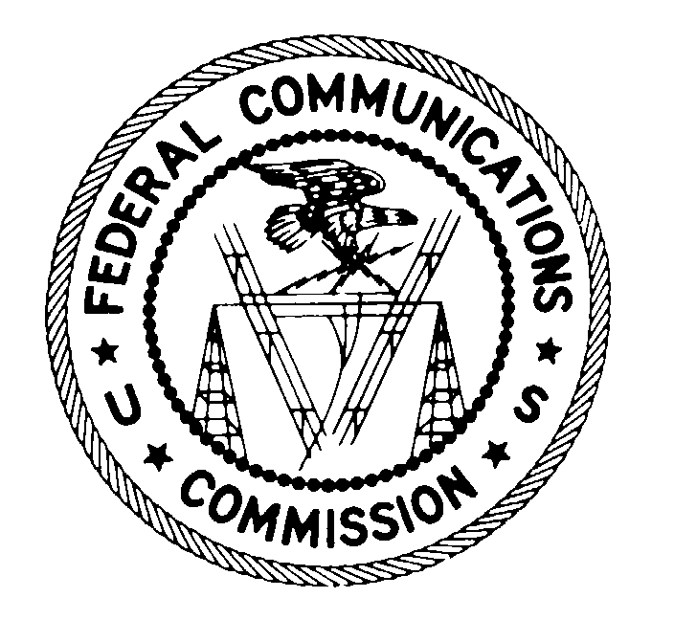
FEDERAL COMMUNICATIONS COMMISSION
445 12th STREET, S.W.
WASHINGTON, D.C. 20554 DA 99-2677

News media information 202/418-0500 Fax-On-Demand 202/418-2830 Internet: http://www.fcc.gov ftp.fcc.gov

FORMAL REQUEST FROM STATE MEMBERS OF
FEDERAL-STATE JOINT BOARD ON SEPARATIONS FOR
NOTICE AND COMMENT ON SEPARATIONS SIMULATION COST STUDY TOOL

PLEADING CYCLE ESTABLISHED

CC Docket No. 80-286

Release Date: December 1, 1999

Comment Date: December 17, 1999

On October 27, 1999, the State Members of the Federal-State Joint Board on Separations (State Members) filed a “Request for the FCC to Notice and Solicit Comment on their Separations Simulations Cost Study Tool.” The State Members request that the Commission seek comment on the proposed use of their separations simulation cost study analysis tool. The State Members state that the purpose of the cost study analysis tool is to assist the Federal-State Joint Board on Separations (Separations Joint Board) in evaluating the effects of separations rule changes proposed in response to the Commission’s Separations Reform NPRM.

The cost study analysis tool applies the FCC’s current Part 36 rules to an incumbent local exchange carrier’s (ILEC’s) Automated Reporting Management Information System (ARMIS) 43-04 information. The study develops a base case interstate and intrastate revenue requirement using company-specific information. An input sheet is included which allows the user to change various traffic factors, plant categorizations, tax rates, and the rate of return. The cost study tool calculates the adjusted interstate and intrastate revenue requirements and resultant cost shifts associated with the changes. The State Members are in the process of modifying the cost study analysis tool so that it can be utilized for the analysis of cost data for non-ARMIS companies. Pursuant to the State Members’ Request, the Commission seeks comment on the use of this tool by the Separations Joint Board to evaluate separations reform proposals.

Copies of the cost study analysis tool and an attached memorandum are available on the National Association of Regulatory Utility Commissioners’ (NARUC’s) webpage (http://www.naruc.org/Telecomm/separations_joint_board.htm). Once the cost study analysis tool is modified for utilization with data for non-ARMIS companies, a copy will be filed with the Commission and then posted to the NARUC web page. In addition, the results from different runs conducted by the Separations Joint Board utilizing the cost study analysis tool may be posted periodically to the NARUC webpage.

Procedure for Filing Comments

Pursuant to Sections 1.415 and 1.419 of the Commission's rules, interested parties may file comments on or before December 17, 1999. All filings should reference Jurisdictional Separations Reform and Referral to the Federal-State Joint Board, CC Docket No. 80-286, Comments on the Separation Simulation Cost Study Tool, and should include the FCC number shown on this Public Notice. Comments may be filed using the Commission's Electronic Comment Filing System (ECFS) or by filing paper copies.

Comments filed through the ECFS can be sent as an electronic file via the Internet to http://www.fcc.gov/e-file/ecfs.html. Only one copy of an electronic submission must be filed. In completing the transmittal screen, commenters should include their full name, Postal Service mailing address, and the applicable docket or rulemaking number. Parties may also submit electronic comments by Internet e-mail. To receive filing instructions for e-mail comments, commenters should send an e-mail to ecfs@fcc.gov, and should include the following words in the body of the message, "get form <your e-mail address>." A sample form and directions will be sent in reply. Parties who choose to file by paper must file an original and four copies of each filing. All filings must be sent to the Commission's Secretary, Magalie Roman Salas, Office of the Secretary, Federal Communications Commission, 445 12th Street, S.W., Washington, D.C. 20554.

Parties should also send paper copies of their filings to the individuals listed in the attached Service List. In addition, commenters must send diskette copies to the Commission's copy contractor, International Transcription Service, Inc., 1231 20th Street, N.W., Washington, D.C. 20037.

Pursuant to section 1.1206 of the Commission's Rules, this proceeding will be conducted as a permit-but-disclose proceeding in which ex parte communications are permitted subject to disclosure.

For further information, contact Andrew Firth, Accounting Policy Division, Common Carrier Bureau at (202) 418-7426, TTY (202) 418-2224, afirth@fcc.gov, or Will Cox, Accounting Policy Division, Common Carrier Bureau at (202) 418-2173, wcox@fcc.gov.
SERVICE LIST

The Honorable William E. Kennard, Chairman
Federal Communications Commission
445 12th Street, S.W.
Washington, DC 20554

The Honorable Susan Ness, Commissioner
Federal Communications Commission
445 12th Street, S.W.
Washington, DC 20554

The Honorable Michael K. Powell, Commissioner
Federal Communications Commission
445 12th Street, S.W.
Washington, DC 20554

The Honorable Diane Munns, Commissioner
Iowa Utilities Board
350 Maple Street
Des Moines, IA 50319-0069

The Honorable Joan H. Smith, Commissioner
Oregon Public Utility Commission
550 Capitol Street, N.E., Suite 215
Salem, OR 97310-2551

The Honorable Thomas L. Welch, Chairman
Maine Public Utilities Commission
State House Station #18
242 State Street
Augusta, ME 04333

Stephen Burnett
Federal Communications Commission
Common Carrier Bureau, Accounting Policy Division
445 12th Street, S.W.
Washington, DC 20554

Will Cox, Federal Joint Board Staff Chair
Federal Communications Commission
Common Carrier Bureau, Accounting Policy Division
445 12th Street, S.W.
Washington, DC 20554
Andy Firth
Federal Communications Commission
Common Carrier Bureau, Accounting Policy Division
445 12th Street, S.W.
Washington, DC 20554

Robert Loube
Federal Communications Commission
Common Carrier Bureau, Accounting Policy Division
445 12th Street, S.W.
Washington, DC 20554

Sheryl Todd
Federal Communications Commission
Common Carrier Bureau, Accounting Policy Division
445 12th Street, S.W., Room 5-B540
Washington, DC 20554

Sharon Webber, Deputy Division Chief
Federal Communications Commission
Common Carrier Bureau, Accounting Policy Division
445 12th Street, S.W.
Washington, DC 20554

Peter Bluhm
Vermont Public Service Board
Drawer 20
112 State St., 4th Floor
Montpelier, VT 05620-2701

Ingo Henningsen
Utah Public Service Commission
160 East 300 South, Box 146751
Salt Lake City, UT 84114-6751

Sandy Ibaugh
Indiana Utility Regulatory Commission
302 W. Washington, Suite E-306
Indianapolis, IN 46204

Lori Kenyon
Regulatory Commission of Alaska
1016 West 6th Ave, Suite 400
Anchorage, AK 99501-1963
Jonathan Lakritz
California Public Utilities Commission
Telecommunications Division
505 Van Ness Avenue, Room 3203
San Francisco, CA 94102

Samuel Loudenslager, State Joint Board Staff Chair
Arkansas Public Service Commission
1000 Center Street
Little Rock, AR 72201

David Lynch
Iowa Utilities Board
350 Maple Street
Des Moines, IA 50319-0069

J. Bradford Ramsay
National Association of Regulatory Utility Commissioners
P.O. Box 684
Washington, DC 20044-0683

Joel B. Shifman
Maine Public Utilities Commission
State House Station #18
242 State Street
Augusta, ME 04333

Fred Sistarenik
New York State Department of Public Service
Communications Division
3 Empire State Plaza
Albany, NY 12223

Cynthia Van Landuyt
Oregon Public Utility Commission
550 Capitol Street, N.E., Suite 215
Salem, OR 97310-2551

Letter from J. Bradford Ramsay, NARUC, to the Honorable William Kennard, FCC, State Member Request for the FCC to Notice and Solicit Comment on Cost Study Analysis Tool, dated October 27, 1999 (State Separations Tool Request).
A service list for the Separations Joint Board’s federal and state commissioners and staff is attached to this Public Notice.
See Jurisdictional Separations Reform and Referral to the Federal-State Joint Board, Notice of Proposed Rulemaking, CC Docket No. 80-286, 12 FCC Rcd 22120 (1997) (Separations Reform NPRM).
See 47 C.F.R. Part 36.
See State Separations Tool Request at p.1.
47 C.F.R. §§ 1.415, 1.419.
See Electronic Filing of Documents in Rulemaking Proceedings, 63 Fed. Reg. 24,121 (1998).
47 C.F.R. § 1.1206.

