U.S. Department of Justice
Law Enforcement Wireless Communications

FY 2008 Performance Budget
Congressional Submission

Table of Contents

I. Overview ….1

II. Summary of Program Changes ……5

III. Appropriations Language and Analysis of Appropriations Language .6

IV. Decision Unit Justification 7

A. Law Enforcement Wireless Communications (LEWC) 7
1. Program Description
2. Performance Tables
3. Performance, Resources, and Strategies

V. Exhibits 11

- Organizational Chart
- Summary of Requirements
- Program Increases by Decision Unit N/A
- Resources by DOJ Strategic Goal/Objective
- Justification for Base Adjustments
- Crosswalk of 2006 Availability
- Crosswalk of 2007 Availability
- Summary of Reimbursable Resources
- Detail of Permanent Positions by Category
- Financial Analysis of Program Increases/Offsets N/A
- Summary of Requirements by Grade
- Summary of Requirements by Object Class
M. Status of Congressionally Requested Studies, Reports, and Evaluations…..N/A
I. Overview for Law Enforcement Wireless Communications (LEWC) [Formerly Narrowband] Appropriations

For FY 2008, the Wireless Management Office (WMO) requests 19 positions, 19 FTE, and $81,353,000 in two-year funding to support maintenance, consolidation, enhancement and replacement of tactical radio communication systems for the ATF, DEA, FBI, OIG and USMS. This represents a current services level budget based on a FY 2007 anticipated appropriation. The budget request for FY 2008 is an IT budget request as the Department’s radio systems are Information Technology projects. Beginning in FY 2007, electronic copies of the Department of Justice’s congressional budget justifications and Capital Asset Plan and Business Case exhibits can be viewed or downloaded from the Internet using the Internet address: http://www.usdoj.gov/jmd/2008justification/.

The mission of the WMO is to provide secure, interoperable and reliable wireless communication services required by the Department of Justice (DOJ) law enforcement components (ATF, DEA, FBI, FBOP, OIG, and USMS) and all federal Agents and Officers engaged in the conduct of law enforcement, protective services, homeland defense and disaster response missions. The WMO manages the Departmental Wireless program in partnership with the Departments of Homeland Security and the Treasury (DHS & Treasury) and coordinates its efforts with state and local law enforcement agencies.

Having a unique combination of oversight and system implementation roles, the WMO has demonstrated the potential to maximize scarce fiscal and radio spectrum resources through consolidation of legacy communication systems; implementation of new multi-agency systems, such as the Integrated Wireless Network (IWN) system deployed in the State of Washington; and deployment of multi-agency interoperability solutions, such as those deployed through our 25 Cities Program. These efforts have yielded noteworthy returns on investment. For example, the Washington State IWN system allowed DOJ to reduce the amount of radio spectrum it uses by up to 50%; reduce radio transmission sites by 40%; eliminate duplicate systems; and consolidate infrastructure to expand coverage beyond any single agency’s current capability. The consolidated acquisitions of radio equipment have resulted in discounts of up to 36%. Since consolidation of the U.S. Marshals onto existing FBI radio systems beginning in 2002, there has been an operations and maintenance (O&M) cost savings of more than $3M.

IWN Program Drivers

The overarching mission of the WMO is to fulfill the tactical communication requirements of the agents working in the field. Now more than ever, federal law enforcement agents need the ability to securely and reliably communicate with their agency counterparts, as well as with fellow agents and officers from other federal, state and local law enforcement agencies. Furthermore, to address the increasing sophistication of criminals and terrorists, DOJ agents require technology enhanced communication tools (e.g. portable devices that transmit voice, pictures, video, maps, and enable queries of criminal databases) for conducting surveillance, investigating crime and making arrests, all of which help law enforcement to save lives, protect their own and keep dangerous criminals off the streets. Finally, in order to collaborate with all law enforcement and homeland security partners, DOJ components require a capability to interoperate across law enforcement, counter-terrorism and public safety communities.

DOJ’s wireless program must replace the antiquated and deficient radio systems with modern, flexible and standards compliant communication tools. Most of the Department’s legacy systems are now over 15 years old and are approaching the end of useful life. Some of these communication systems have failed during operations thereby inhibiting the missions, and also jeopardizing the safety of those agents. As an example, the DEA reports that operations are being compromised because radios, operating on its legacy system, lose encryption codes forcing the agents to break from surveillance and find a secluded location to re-code the radio.

The O&M costs on the legacy systems continue to escalate, as do costs needed to repair failing systems. Furthermore, legacy systems cannot leverage the power of the Internet Protocol; cannot comply with the National Telecommunications and Information Administration (NTIA) “narrowband” mandate; and cannot facilitate implementation of the emerging standards or technologies and strategies for interoperability required by federal law enforcement agents.

IWN Program Achievements

The WMO understands the Department’s law enforcement operational requirements and has been investing available funds into deploying a consolidated and interoperable network with infrastructure capable of meeting immediate and emerging communication needs for the foreseeable future. The WMO has successfully deployed an initial version of the IWN in Washington State. At present, the system supports the daily operations of over 500 federal law enforcement agents and officers and is enabling secure, reliable and interoperable communication services. DOJ law enforcement components plan to provide this type of capability to all field offices as the IWN is deployed across the nation. In addition to DOJ components, agencies such as the Department of Commerce, Homeland Security, Interior and Treasury, as well as the Social Security Administration are utilizing this system. Some notable attributes of the system include:

- The consolidated coverage approach used by the WMO allowed deployment of fewer sites than those of the previous systems while still providing coverage equal to or greater than the previous systems. This effort has resulted in the reduction of lease expenses by more than $120K annually.
- Trunking technology reduced the number of frequencies required to support users by 65% over the previous environment.
- The consolidated infrastructure and trunking technology provide coverage beyond any single component’s coverage from their previous systems. It also allows for large volume system usage without the temporary borrowing of frequencies from other components.
- O&M costs overall, and most specifically for each component, have been reduced through the use of a combined technician pool and shared cost agreement.
The Washington State IWN system has been shown to improve law enforcement operations. An example of this is Operation Falcon II which began in April 2006. In the Seattle area, seven federal agencies (ATF, DEA, FBI, ICE, SSA-OIG, WA-OIG, and USMS) were operating together on the same radio system during this multi-agency fugitive round-up. The IWN was patched to the King County and Snohomish County Radio Systems. The end result was over 100 officers from 17federal, state, and local agencies representing three different counties that were seamlessly operating and communicating with central dispatch and command. Over 170 arrests were made in one week as a result of this operation. Some other successful operations in the Northwest supported by the Wireless program and IWN include:
Operation Community Shield
◦ ICE, USMS, State and Local PDs; Gang takedown
Operation Kitsap Cleanup
◦ ATF, OIG, USMS, ICE, NCIS, Corrections, State/ Local PDs; IWN Interoperability; 50 + arrests
Terrorist Escort
◦ Ahmed Ressam; High Visibility/Nationwide news coverage; ATF, FBI, USMS, State/ Local PDs
DOJ’s law enforcement components have identified and ranked in order of priority five critical areas of the country in which the IWN is to be implemented next. These priority implementation areas are: Florida, California, a section of the Midwest bounded by the cities of Chicago, St. Louis and Detroit, the National Capital region and southern half of Texas (see figure 1). (NOTE: The States of Louisiana, Mississippi, Alabama and Arkansas are being covered by a joint effort initiated in response to severe damage caused by Hurricanes Katrina and Rita in 2005.)

Figure 1
DOJ IWN Implementation Priorities and Existing Wireless Networks
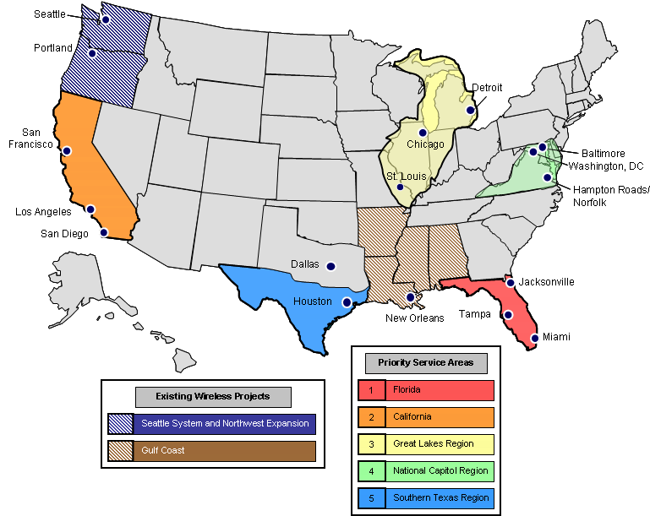

Cognizant of the multi-year time frame needed to fully implement IWN services, the WMO has been addressing immediate interoperable communication needs in 25 high-risk metropolitan U.S. cities (see figure 2). As an extension of the IWN program, the 25 Cities Program has deployed interoperability solutions that have been used by federal, state and local agencies on a daily basis. These solutions were used during national events and emergencies such as the 2006 Super Bowl in Detroit, MI, and the National Labor Relations Board hostage incident of 2006 in Phoenix, AZ. In implementing this program, the Department leveraged federal resources in many of the metropolitan areas to deploy inter-system communications between federal agencies. Additionally, DOJ worked with key agencies to facilitate federal, state, and local connectivity.

The WMO has identified additional opportunities to implement interoperable solutions in several major cities, including, but not limited to, Richmond, VA, Las Vegas, NV, and Milwaukee, WI.

Figure 2
DOJ 25 Cities Program
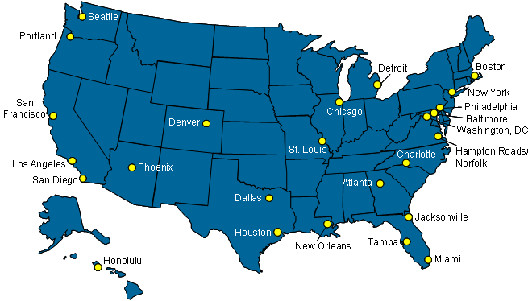

Through the IWN acquisition, the WMO has also positioned the Department to be able to implement the IWN at an accelerated pace as funding becomes available. In March 2007, the WMO will select a systems integrator to implement IWN services under a performance based contract. This IWN contracting process has succeeded in stimulating maximum competition for goods and services from a variety of vendors from the IT industry, as well as obtaining creative technical and business proposals.

Spectrum Relocation - $800,000

In December 2004, the Congress passed and the President signed the Commercial Spectrum Enhancement Act (CSEA, Title II of P.L. 108-494), creating the Spectrum Relocation Fund (SRF) to streamline the relocation of Federal systems from certain spectrum bands to accommodate commercial use by facilitating reimbursement to affected agencies of relocation costs. The Federal Communications Commission has auctioned licenses for reallocated Federal spectrum, which will facilitate the provision of Advanced Wireless Services to consumers. Funds are made available to agencies in fiscal year 2007 for relocation of communications systems operating on the affected spectrum. These funds are mandatory and will remain available until expended, and agencies will return to the SRF any amounts received in excess of actual relocation costs.
Explanation of FY 2008 Request
The FY 2008 request for the DOJ Law Enforcement Wireless Communications program is comprised of: 1) continued O&M of DOJ component’s existing legacy and IWN systems; 2) a small program management office to coordinate law enforcement wireless communications across the Department and other government entities; 3) law enforcement wireless communication enhancements and modernization targeted to address priority needs. Requested resources will be allocated as follows:
Legacy and IWN O&M $60M
Program Management $ 5M
Modernizing Law Enforcement Wireless Communications $16M
Total $81M

The O&M and program management costs will maintain current communication services. O&M costs are primarily related to site leases, communication services linking the existing 3,000+ radio sites, fees to NTIA for radio spectrum licenses, and maintenance contracts on existing equipment. Program management costs pay the salaries and expenses of the 19 federal staff in the WMO, as well as support contractors used to provide specialty skills to the program (security, spectrum, engineering, etc.).

Funds for modernizing law enforcement wireless communications will be focused on implementing new, consolidated wireless services in the five priority areas noted in figure one as well as expanding the Washington State system. Approximately 52% of these funds will be used to buy radios and related network equipment (routers, firewalls, etc.), and the remainder will be used to pay for services needed to implement the equipment.

FY 2008 system investments represent a small percentage of the funds needed to meet DOJ field agents’ communication needs for fighting crime and preventing terrorism. Based on proposals received through the IWN acquisition, over $1 billion is needed over the next five to seven years to deploy an IWN capability to satisfy minimum mission requirements. If funds are not made available, this unique opportunity will be lost to provide a cost-effective tool essential to the nation’s fight against terrorism and violent crime. Without a Department-wide wireless communications program, DOJ components are likely to resort to ad hoc communication services for their agents. Consequently, it will be difficult to address federal interoperability and to demonstrate innovative uses of technology to meet federal communication needs.

II. Summary of Program Changes
There are no program changes for 2008.

III. Appropriations Language and Analysis of Appropriations Language

Appropriations Language

For the costs of developing and implementing a nation-wide Integrated Wireless Network supporting federal law enforcement and homeland security missions, and for the costs of operation and maintenance of existing Land Mobile Radio legacy systems, $81,353,000, to remain available until September 30, 2009: Provided, That the Attorney General shall transfer to this account all funds made available to the Department of Justice for the purchase of portable and mobile radios: Provided further, That any transfer made under the preceding proviso shall be subject to section 605 of this Act.

Analysis of Appropriations Language

  - Narrowband communication refers to the act of reducing the amount of spectrum utilized for radio communications. The IWN not only reduces the amount of spectrum utilized for radio communications, but also enables interoperable communications between Federal, State and local law enforcement agencies, and other communications functionality needed by DOJ agents.

IV. Decision Unit Justification

A. Law Enforcement Wireless Communication (LEWC) [Formerly Narrowband]

Law Enforcement Wireless Communication (LEWC) [Formerly Narrowband] TOTAL (thousands) | Perm. Pos. | FTE | Amount
2006 Enacted w/Rescissions and Supplemental | 19 | 16 | 88,851
2007 Estimate | 19 | 19 | 81,180
Adjustments to Base and Technical Adjustments |  |  | 173
2008 Current Services |  |  | 81,353
2008 Program Increases | 0 | 0 | 0
2008 Request | 19 | 19 | 81,353
Total Change 2007-2008 | 0 | 0 | 0

1. Program Description
The Law Enforcement Wireless Communications (LEWC) account is an appropriation effectively serving a singular purpose: the provision of tactical communication services to the Department’s law enforcement components. This includes funding component’s legacy system O&M requirements and addressing component communications needs as they arise. Because of this singular purpose, there is no decision-unit structure. The WMO is increasingly under pressure to address component tactical communications requirements because of the increasing deterioration of the legacy systems.

Supporting Strategic Goals

Strategic Plan 2003-2008:

Strategic Goal 1. Prevent Terrorism and Promote the Nation’s Security.
- Strategic Objective 1.1. Prevent, disrupt, and defeat terrorist operations before they occur. Provide secure, tactical, interoperable communication capabilities to be used by front-line agents (FBI, ATF, DEA, USMS, Customs, Border Patrol), and by Joint Terrorism Task Forces (JTTF) (e.g. FBI-NYPD).

Strategic Goal 2. Enforce Federal Laws and Represent the Rights and Interests of the American People.
- Strategic Objective 2.2. Reduce the threat, trafficking, use and related violence of illegal drugs. Provide reliable tactical communications capabilities among the Department’s agents and officers, including those on Task Forces and by those participating in border enforcement operations.

Strategic Goal 3. Assist State, Local, and Tribal Efforts to Prevent or Reduce Crime and Violence.
- Strategic Objective 3.1. Improve the crime fighting and criminal justice system capabilities of state, tribal, and local governments. Providing for as-needed communications interoperability with our State and local partners. In order to achieve this most effectively and efficiently, the WMO is closely coordinating its 25-Cities Interoperability Project for the benefit of programs such as Project Safe Neighborhoods (PSN). Doing so ensures that the Department’s work is in lock step with State and local activities that have been utilizing federal grants to implement their own communications networks, and vice-versa.

Strategic Goal 4. Ensure the Fair and Efficient Operation of the Federal Justice System.
- Strategic Objective 4.1. Protect judges, witnesses, and other participants in Federal proceedings, and ensure the appearance of criminal defendants for judicial proceedings or confinement; and
- Strategic Objective 4.2. Ensure the apprehension of fugitives from justice. Wireless communications are used for logistical and safety purposes by those transporting defendants to and from judicial proceedings; by those protecting judges and the physical courthouse facilities; and by agents in pursuit of fugitives.

The Department’s IT Strategic Plan (July 2002):

- Development of Department-wide [wireless] infrastructure serving as the Department’s core tactical communications infrastructure;
- Participation in E-Gov Initiatives; and
- Implementing Common Solutions.

Addresses specific elements of the President’s Strategy for Homeland Security:

- Integrates information sharing across the Federal government;
- Improves public safety emergency communications;
- Improves cooperation in response to attacks
- Supports first responders; Enables an effective partnership with State and local governments (e.g., communications interoperability) and the private sector (e.g., market development of emerging communications technologies meeting functional requirements)
Aligned with the E-Gov goals of the President’s Management Agenda

- This joint effort provides for cost-avoidance opportunities by leveraging bulk buy procurements and sharing infrastructure that otherwise might not be realized.

Strategies for Achieving Efficiencies and Economies
There have been several lessons learned from the Northwest deployment which will be replicated as the WMO continues to modernize wireless communication systems:

1) There are many opportunities to leverage or share the cost of State and local public safety organizations investments in communications infrastructure.

2) Bulk buy cost negotiations accrue substantial savings for equipment commonly used by all agencies.

3) Emerging technologies will offer the government real alternatives to lower the unit cost of wireless communications while better meeting the mission needs of the field agents.

- The USMS consolidation onto FBI systems is a phased consolidation approach; this has caused a deviation from the target to the actual.
- St. Louis has not approved the WMO proposed solution as of this submission.
- The Washington, D.C. solution has been delayed because of multi-component coordinating issues and the St. Louis solution has not been officially vetted.

V. Exhibits

"In 1995 The National Telecommunications and Information Administration (NTIA) issued a mandate to all Federal Agencies to adopt new narrowband technologies that allow greater spectrum efficiency for all land mobile radios (LMRs) used by the federal government. This was done to allow for more efficient use of existing radio spectrum as demands on Federal communications expand causing increased congestion within the VHF and UHF spectrum bands."
The FY 2008 President’s Budget uses the FY 2007 President’s Budget language as a base so all language is presented as new.

