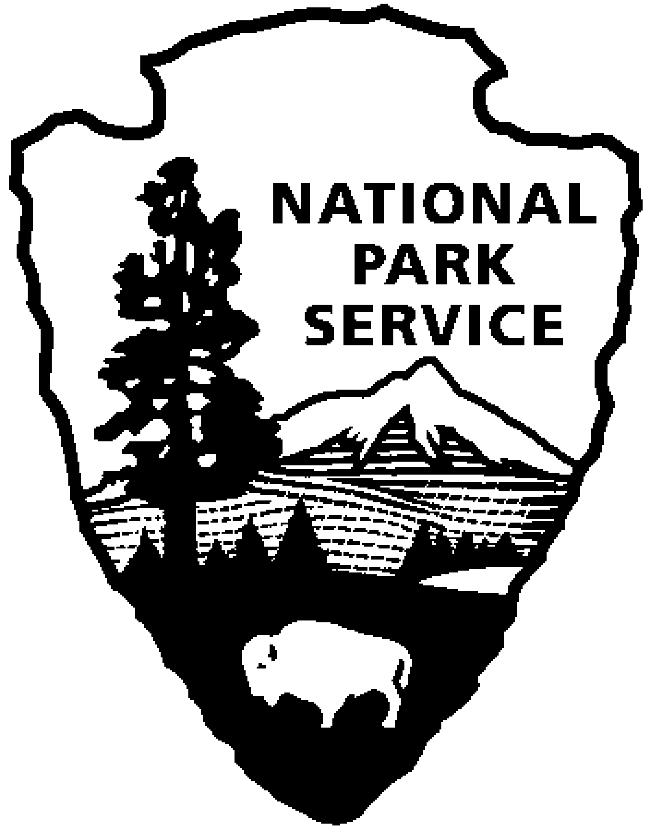  National Park Service  U.S. Department of the Interior | Catoctin Mountain Park |  | 6602 Foxville Road  Thurmont, MD 21788  (301) 663-9388 phone  (301) 271-2764 fax

Catoctin Mountain Park News Release

July 30, 2026
For Immediate Release
Debra Mills

Catoctin Mountain Park Announces Road Openings and Spring Activities Schedule

Park Central and Manahan Roads Reopen After Seasonal Closures

The closed portions of Park Central and Manahan Roads in Catoctin Mountain Park will reopen in March. These roads were closed to vehicle traffic in December making them available for winter recreation. Park Central Road will reopen on Friday, March 20. Manahan Road will reopen on Friday, March 27.

Park Central Road and Manahan Road will remain open after these dates until mid-December as weather conditions permit. Please direct questions regarding the status of park roads to the Visitor Center at (301) 663-9388, or visit our website at www.nps.gov/cato.

Women’s History Month Exhibit – at the Visitor Center during the month of March.

Enjoy an exhibit that tells the story of Bessie Darling and Mazie Bowman, two women who played important roles in the local tourism industry in the early 20th century. Learn how Bessie’s tragic death sparked local legend and haunted Mazie until her death half a century later.

Orienteering (Map and Compass Reading)-Saturdays, March 21 and 28, and Sundays, March 22 and 29 at 1:30 p.m. at the Visitor Center

Orienteering classes consist of an indoor slide program that introduces maps and their components as well as the orienteering compass that allows the user to determine the direction of travel. After learning how to use the compass in conjunction with the map, participants are given the opportunity to complete a short outdoor course. The outdoor course requires going off-trail in varied terrain so wear sturdy shoes and dress for the weather. Maps and compasses are provided for the day. The program is free but is recommended for ages 10 and older. Class size is limited so reservations are required. Please make your reservation by calling the Visitor Center at (301) 663-9388.

Fly-tying Demonstration – 11:00 a.m. until 1:00 p.m., Saturday, April 18 at the Visitor Center

Visit experienced local fly-fishers as they demonstrate the art of fly-tying at the Visitor Center from 11:00 a.m. until 1:00 p.m. They will explain how your knowledge of insects can increase your chances of fishing success. Learn how fur, feathers and found items can be transformed into imitation insects that can fool the smartest fish.

Junior Ranger Program for Kids –Saturday, April 25 at the Visitor Center

Help celebrate National Junior Ranger Day by becoming a Catoctin Junior Ranger. Children ages 9-11 are invited to join a National Park Service Ranger at the Visitor Center at10:00 a.m. to complete the requirements and become a Junior Ranger. A program for ages 6-8 will be offered at 1:00 p.m. Each session will last about 2 hours. A short hike is included so please wear sturdy shoes and dress for the weather. Topics to be covered include natural and cultural history. Children who complete the entire program will receive a Catoctin Mountain Park Junior Ranger Badge.

Spring Wildflower walks – Sundays, April 26 and, May 10 at 2:00 p.m. at the Owens Creek Picnic Area

Join a ranger at the Brown’s Farm Trail in Owens Creek Picnic Area at 2:00 p.m. on Sundays, April 26 or
May 10 for an interpretive wildflower walk. Together, you will explore an easy ½ mile trail that meanders through several types of habitat. The ranger will acquaint you with the flowers that are blooming, and will tell you why they are so particular about where they grow and when they flower.

Owens Creek Campground – Opens for family camping beginning April 15

Owens Creek Campground will open on a first-come, first-served basis at 12 noon on April 15. Each site is limited to one camping unit (tent or trailer) and a maximum of 5 people. Maximum tent size is 9’x12’. Trailers up to 22’ in length are accepted but there are no hookups. The fee is $20.00 per night.

Camp Misty Mount – Cabin rentals available April 10 through October 31

Cabins may be rented in historic Camp Misty Mount from April 10 through the end of October. Rustic chestnut cabins constructed by the Works Progress Administration are available to individuals, families and groups. Please call the Misty Mount office at (301) 271-3140 to make your reservation or for further information.

Catoctin Mountain Park is one of 391 units administered by the National Park Service, U.S. Department of the Interior. The park Visitor Center, located on State Route 77 three miles west of Thurmont, Maryland, is open daily from 10:00 a.m. until 4:30 p.m., and from 8:30 a.m. until 5:00 p.m. on Saturdays and Sundays. Correspondence should be addressed to: Superintendent, Catoctin Mountain Park, 6602 Foxville Road, Thurmont, MD 21788. Our website address is www.nps.gov/cato. General information can be obtained by calling the Visitor Center at (301) 663-9388.

-NPS-

EXPERIENCE YOUR AMERICA™
The National Park Service cares for special places saved by the American people so that all may experience our heritage.

