INTERIM REPORT
3G SPECTRUM STUDY
2500-2690 MHz BAND

APPENDICES

FOR

SECTION 1

APPENDIX 1.1

PLAN TO SELECT SPECTRUM
FOR THIRD GENERATION (3G) WIRELESS SYSTEMS
in the UNITED STATES
October 20, 2000

I. PRESIDENTIAL MEMORANDUM (PM)

President Clinton signed a memorandum dated October 13, 2000, (Attachment 1) that states the need and urgency for the United States to select radio frequency spectrum to satisfy the future needs of the citizens and businesses for mobile voice, high speed data, and Internet accessible wireless capability; the guiding principles to be used for the development of 3G wireless systems; and the direction to the Federal agencies to carry out the selection of spectrum.

In summary, the President directed

- the Secretary of Commerce in cooperation with the Federal Communications Commission (FCC) to:

- develop a plan by October 20, 2000, for the identification and analysis of possible spectrum bands for 3G services that would enable the FCC to select specific frequencies by July 2001 for 3G and complete the auction for licensing 3G wireless providers by September 30, 2002.
- issue an interim report by November 15, 2000, on the current spectrum uses, and the potential for the sharing or segmenting, of two of the bands identified at the World Radiocommunication Conference (WRC-2000) for 3G wireless use, 1755-1850 MHz and 2500-2690 MHz, about which the United States does not have sufficient knowledge at present to make a considered decision about allocation.
- work with government and industry representatives through a series of public meetings to develop recommendations and plans for identifying spectrum for 3G wireless systems.

- the Secretary of Defense, Secretary of the Treasury, Secretary of Transportation, Department of State and heads of any other executive department or agency that currently use any of the spectrum identified at the WRC-2000 for 3G systems to participate and cooperate with the government-industry group as established above by the Secretary of the Commerce.

- the Department of State to coordinate and present the evolving views of the United States to foreign governments and international bodies.

All of the above work is expected to lead to the issuance of a final report by March 1, 2001, that describes the potential use of all identified bands for 3G wireless applications.

The President encouraged the FCC to participate in the government-industry program being led by the Secretary of Commerce and complete rulemaking for spectrum allocation in full coordination with the Assistant Secretary of Commerce for Communications and Information (Administrator, National Telecommunications and Information Administration (NTIA)) by July 2001.

II. BACKGROUND

Over the past decade, there has been enormous worldwide growth in the use of mobile radios. Studies in the International Telecommunication Union (ITU) and elsewhere indicate that this growth in personal communications is likely to continue. First and second generations of personal communications service (PCS) are operating now. The 3G PCS will provide mobile and satellite-based broadband capabilities, and represent a path for the evolution of existing cellular and PCS. A summary of various administrations' spectrum usage (cellular and PCS) and planned 3G wireless is shown in Attachment 2.

The ITU Radiocommunication Sector has addressed the characteristics of a 3G system and has termed it International Mobile Telecommunications-2000 (IMT-2000). Key features of IMT-2000 include: a high degree of commonality of design worldwide; compatibility of services within IMT-2000; and high-quality worldwide use and roaming capability for multi-media applications (e.g. video-teleconferencing and high-speed Internet access). The following was considered by the ITU's 2000 WRC-2000: "review of spectrum and regulatory issues for advanced mobile applications in the context of IMT-2000, noting that there is an urgent need to provide more spectrum for the terrestrial component of such applications and that priority should be given to terrestrial mobile needs, and adjustments to the Table of Frequency Allocations as necessary"(1).

The 698-960 MHz, 1710-1885 MHz, 2500-2690 MHz and the 2700-2900 MHz bands were some of the bands that WRC-2000 considered for IMT-2000 terrestrial systems. The United States position for this conference was established among U.S. industry and government representatives, resulting in a proposal that the United States believed could be the basis for a compromise at the conference, given the conflicting positions of many of the other administrations. The United States and many ITU Region II administrations proposed no change to the allocations in the 2700-2900 MHz band. The United States also suggested three possible bands for terrestrial IMT-2000, including the 1710-1885 MHz band (favored by the Americas), the 2500-2690 MHz band (favored by Europe), and the 698-960 MHz band. At the conference, the United States stated that it would study the 1755-1850 MHz and 2500-2690 MHz bands domestically to (1) see if there are alternate bands to relocate the existing systems, (2) determine the costs of any required relocation, (3) identify who would pay for relocation, and (4) assess how long the transition would take. The United States proposed, and the WRC-2000 adopted, full regulatory flexibility, giving each administration the right to determine which band it may want to identify for IMT-2000, if it wants to do so at all. Administrations can identify these bands at any time. Also, the United States proposed to keep bands identified for IMT-2000 open to any technology that fits in the mobile service rather than specifying a technology or standard for use in the spectrum.

WRC-2000 identified the 806-960, 1710-1885, and 2500-2690 MHz bands for terrestrial IMT-2000. The 1525-1559, 1610-1660.5, 2483.5-2500, 2500-2520 and 2670-2690 MHz bands were identified for the satellite portion of IMT-2000. These bands are shown in Attachment 2. The conference also adopted a resolution pointing out that some countries may implement IMT-2000 in the 698-806 and 2300-2400 MHz bands. The WRC-2000 agreed that the identification of these bands does not preclude the use of these bands by any application of services to which they are allocated, and does not establish priority in the Radio Regulations. Administrations can implement any bands in any timeframe, for any service or technology, and may use any portion of the bands that they deem appropriate, based on national requirements. All of these bands are used at present. For those who may be required to relocate, additional spectrum may have to be found or other accommodations will have to be made to continue their operations.

The United States recognizes that discussions relative to spectrum for advancing mobile telecommunications systems are vital for administrations to plan their spectrum use, and for industry to plan how it will meet the marketplace needs of the future. The United States supports the development and implementation of advancing mobile telecommunications systems, such as IMT-2000, as critical components of the communications and information infrastructure of the future.

In addition to the three WRC-2000 bands, other bands that could be considered in the United States are: 698-746, 746-764, 776-794, 806-960 (includes the present U.S. cellular), 1710-1850, 1850-1990 (present PCS bands), 2110-2150, 2160-2165 and 2500-2690 MHz. A brief description of these bands is contained in Attachment 3. All these bands will be given full consideration in the formulation of the final allocation order. For some of these bands, no extensive studies are required to provide decision-makers with a factual basis for a decision. However, in order to achieve a full understanding of all the options available, the FCC and NTIA need to undertake studies of the frequency ranges of 1755-1850 MHz and 2500-2690 MHz. The studies' purpose is to determine whether, and under what conditions, these bands could be made available for 3G wireless systems and the costs and operating impacts to the incumbent users. These analyses are the subject of the study plan described below.

III. STUDIES

A. Overview

The NTIA will study the 1755-1850 MHz band, and the FCC will study the 2500-2690 MHz band. It is important that the studies be based on the same assumptions where applicable and address common spectrum options. The two studies will proceed along the same timelines and use similar assumptions to assure equal treatment for both.

The results of the two studies, relevant information regarding the other bands identified in Section II, above, (806-960, 1710-1755, 2110-2150, 2160-2165 MHz) and public comment generated either during the Secretary of Commerce's government-industry dialogue (see Section IV, "Outreach," below) or in response to the FCC's Notice of Proposed Rulemaking will be taken into consideration when reviewing the overall spectrum requirements and future plans for 3G. Among other things, there will be an evaluation of private sector plans to migrate their 1G and 2G systems to 3G in the existing bands they already have. National security and public safety will also be taken in account. In addition, among other factors, the U.S. will also have to consider the ramifications of the deployment of 3G elsewhere in the world with regard to possible spectrum harmonization that could lead to global roaming.

The analysis will also have to take into account the provisions of the FY 00 National Defense Authorization Act, which requires that before there can be any reallocation of spectrum where the Department of Defense is a primary user, which includes 1755-1850 MHz, certain conditions must be met: (1) NTIA, in consultation with the FCC, must identify and make available to the Department of Defense an alternative band or bands of frequencies as a replacement; and (2) the Secretary of Commerce, the Secretary of Defense, and the Chairman of the Joint Chiefs of Staff have jointly certified to specified committees of the Congress that the replacement band or bands of frequencies provides comparable technical characteristics to restore essential military capability that will be lost as a result of this reallocation. The same analysis will apply if the DoD is a primary user of a band selected as an alternate band in which to place incumbent users of the candidate bands.

B. Study Information Basic Requirements

1. 3G System Description. The study will describe 3G system requirements and include: (1) nature of proposed use; (2) system technical characteristic description (as a minimum, the necessary information to perform sharing studies with candidate band systems); (3) spectrum required including channeling bandwidths and overall spectrum plans (includes segmentation of candidate bands) to cover regions or nationwide; (4) timing requirements for identification of spectrum; (5) planned geographical deployments; (6) interference thresholds (ITU based if available); (7) potential relationship with other countries' deployment of 3G and global roaming; (8) potential alternate spectrum band plans including any band segmentation; and (9) any operational considerations that will have a bearing on the evaluation of the sharing/relocation options below. FCC will provide this description.

2. Candidate Band Incumbent System Description. The studies will describe incumbent systems in the candidate bands including: (1) nature of use (what it is used for); (2) system technical characteristics description (as a minimum, the necessary information to perform sharing studies with 3G systems); (3) spectrum currently used, including channeling bandwidths and overall spectrum to cover regions or nationwide; (4) current geographical deployments; (5) planned geographical deployments; (6) system life expectancy; (7) planned replacement systems; (8) interference thresholds (ITU based if available); (9) unique operational features (e.g., it has to be located in a specific location, area or elevation; or it has a special relationship with other frequency bands such as a set separation between uplinks and downlinks); and (10) any operational considerations including national security and public safety that will have a bearing on the evaluation of the sharing or relocation options above. If any of the above information is classified or non-releaseable under the Freedom of Information Act or any other legislation, it will not be released to the public or contained in any unrestricted report. This information and subsequent use will be contained in a separate report accessible only to those having the necessary security clearances and/or need-to-know. FCC will provide the report on the 2500-2690 MHz band and the NTIA will provide the report on the 1755-1850 MHz band.

3. Potential Alternate Bands. When selecting alternate bands for incumbent users of candidate bands, consideration should first be given to those bands in which no, or minimum, disruption would occur to the incumbents in those bands. Also, the potential alternate bands should afford candidate band incumbent systems that may require replacement spectrum the capability to function without loss of functionality or necessary interoperability in the alternate band(s). The study will describe the alternate bands as to: (1) existing rules and regulations that govern the use of the bands; (2) the changes in allocation rules and regulations that would be necessary to make them acceptable to the candidate band incumbent users; (3) the relocation of alternate band incumbents if necessary; (4) the operational constraints on the alternate band incumbents or on the candidate band systems; and (5) any other considerations, including national security and public safety, in the use of the alternate bands that would have a negative effect on candidate band incumbent users.

C. Spectrum Sharing/Relocation Options

Using the information above, the study will include a technical evaluation of the following sharing/relocation options:

1. System Sharing. An evaluation of the current and planned systems in the candidate bands to share with 3G systems.

2. Band/Channel Segmentation.

The studies will assess the feasibility of dividing the candidate bands into segments and/or channels and evaluating how the incumbent and 3G systems would share these segments and/or channels to meet their respective radiocommunication requirements. The FCC will propose possible segmentation plans for both 1755-1850 and 2500-2690 MHz bands to evaluate as part of the interim band studies. These options may also consider use of the 1710-1755 and 2110-2160 MHz segments. Additional segmentation possibilities may be evaluated later in the process. 3G alternate plans and 1G/2G migration could have a bearing on this option.

Studies for both sharing and segmentation will use generally-accepted interference protection criteria, where available, for determining unacceptable levels of interference. Studies will also consider possible operational methods to mitigate potential interference while retaining the capability to perform the same mission or service in light of current requirements.

3. Band/Channel Segmentation & Alternate Band Combination. If the candidate bands could not support all requirements of the incumbents and 3G simultaneously, identification of alternate bands to satisfy requirements would be required.

4. Alternate Bands Only. Relocate incumbents to other bands if necessary.

5. Other Options. Potential combination of the above.

For each of options above, the evaluation will consider implementation of the option by the end of 2003, 2006, 2010 or any other variant that is costed out above.

D. Cost and Benefits

1. Option Implementation Cost Estimates. For each of the options in C. above, a cost estimate will be provided to include a description of the costs to implement the option or any iterations thereof and any associated assumptions. The estimates will include implementing the option by the end of 2003, 2006, 2010, or at times where there is a potential cost advantage to do so (an example might be that an incumbent system is scheduled to relocate to a different band in the future and there would be no new cost to relocate the incumbent; or by stopping any further build-outs of systems thereby reducing the costs to relocate future incumbents).

2. Benefits. An estimate will be made of the benefits, if any, including potential auction receipts that could be potentially realized as a result of the auction of the spectrum selected for 3G as well as the economic benefits. The assumptions made in the estimates will also be described. There may be a number of band options to be estimated.

3. Cost and Benefits Analysis. Based on 1 and 2 above, OMB/FCC/NTIA will perform a cost and benefits analysis for each option and implementation timeframe. An independent audit may be appropriate to evaluate the cost estimates.

4. Costing Rules. Both the FCC and NTIA will use consistent cost standards. OMB may have to delineate the portions of the cost estimates that may be disallowed.

E. Schedule

1. 3G Description. FCC will provide the 3G description to NTIA so the options can be evaluated and reports completed as scheduled below.

2. Reports and Content.

a. Interim Report - Nov 15, 2000

(1) 3G description
(2) candidate band incumbent system description
(3) evaluation of system sharing and band segmentation options

b. Final Report - Mar 01, 2001

(1) information from Interim Report
(2) information on other bands
(3) description of alternate bands/relocation studies
(4) evaluation including costing and migration schedule for three time periods (2003, 2006, & 2010) for the two options in the interim report and the other options (segmentation & alternate band combination, alternate bands only, and other sharing/ segmentation/alternate band mixes)

c. Other Information - As required

IV. OUTREACH

The President's Memorandum instructs the Secretary of Commerce to work with government and industry representatives through a series of regular public meetings to develop recommendations and plans for identifying spectrum for 3G wireless systems. Additionally, it directs the Federal agencies that use the spectrum, and urges the FCC, to participate and cooperate with the government-industry group. NTIA, on behalf of the Secretary of Commerce, will act as the primary facilitator in the Department's outreach program. Each Federal agency will designate a person to represent the agency to attend these public meetings. The following activities are planned to carry out the President's direction:

A. Initial Ideas and Positions. NTIA will invite industry representatives to articulate their ideas and positions for selection of spectrum for 3G and to suggest industry initiatives to supplement this plan. Areas of discussion could include anticipated 3G spectrum requirements, band segmentation, 1G/2G/2.5G migration, alternate bands for incumbents, short and long range plans, and global roaming considerations. Representatives will be asked to submit their ideas and positions in writing. NTIA, on behalf of the Secretary of Commerce, will schedule an opportunity for industry representatives to explain their ideas and positions. Based on this initial information, subsequent meetings may be held.

B. Interim Reports. The FCC and NTIA will release their interim reports to the public on November 15. NTIA will ask industry for comments. Subsequent meetings may be held depending on the nature of the comments.

C. FCC Notice of Proposed Rulemaking (NPRM). The FCC plans to release a NPRM on 3G in December which will include information from the interim reports. The FCC will receive comments on the NPRM. The FCC and NTIA will hold joint information exchange meetings with industry representatives relative to the comments.

D. Final Report. The FCC and NTIA will release their final reports on March 1, 2001, describing all identified bands for 3G wireless use. Industry will be asked to comment on these reports.

V. FCC PROCESS DESCRIPTION AND PLAN

The FCC is responsible for allocating spectrum for non-government uses. The Commission allocates spectrum through the rule making process in accordance with the Administrative Procedures Act. The process generally begins when an organization or member of the public submits a petition for rule making requesting a change in the United States Table of Frequency Allocations contained in Section 2.806 of the FCC rules. The Commission issues a public notice inviting comment on such petitions. If the Commission finds that the petition has merit, it issues a Notice of Proposed Rule Making (NPRM). The public is afforded an opportunity to file comments which the Commission must consider before arriving at a final decision. The Commission then adopts a Report and Order that makes changes to the Table of Frequency Allocations as appropriate.

The Commission recently received two petitions for rule making requesting spectrum allocations for 3G mobile services. The Cellular Telecommunications Industry Association (CTIA) submitted a petition (RM-9920) asking the Commission to allocate spectrum for 3G terrestrial mobile services, and in particular to conduct studies to consider use of the 1755-1850 MHz and 2500-2690 MHz bands identified at WRC-2000. The Satellite Industry Association (SIA) submitted a petition (RM-9911) asking the Commission to allocate the 2500-2520 MHz and 2670-2690 MHz bands for the mobile satellite service for the mobile component of 3G services. Comments were filed on both petitions on September 12, 2000.

The Commission plans to initiate a Notice of Proposed Rule Making by the end of this year proposing spectrum allocations for fixed and mobile services that would be available for 3G terrestrial mobile services. It is anticipated that the Notice of Proposed Rule Making will consider the frequency bands identified in attachment 1. Further, the NPRM is expected to consider the future role of the cellular and PCS services in providing 3G services. The NPRM may consider other relevant frequency bands that may be used to serve the demand for 3G terrestrial services. A number of factors will be considered in developing proposed allocations, including the studies of 1755-1850 MHz and 2500 - 2690 MHz bands.

A Report and Order (R&O) is planned to be completed by July 2001 allocating spectrum for fixed and mobile services that will be available for 3G services. The allocation decisions will be based on the comments filed on the Notice of Proposed Rule Making and studies of the 1755 -1850 MHz and 2500 - 2690 MHz bands, and any other relevant information.

The Commission routinely coordinates frequency allocations that may affect government use of the spectrum with the NTIA. Because certain of the frequency bands of interest are allocated to the Federal Government, the Commission will closely coordinate both the NPRM and R&O with NTIA.

The spectrum allocation proceeding will be followed by another rule making proceeding to establish service rules. The service rule proceeding will be completed in time to complete auctions of the licenses by September 30, 2002.

VI. OVERALL SCHEDULE.

A. Oct 13, 2000 President signs Memorandum to set the major milestones and guidance to the Federal Agencies and FCC

B. Oct 20, 2000 Secretary of Commerce releases a plan to select spectrum for 3G to the public

C. Oct 20-Nov15, 2000 Industry shares its ideas, positions, & supplemental plans on 3G spectrum selection.

D. Nov 15, 2000 Secretary of Commerce and the FCC release their Interim band studies

E. Nov 15-30, 2000 Industry provides comments on Interim Reports.

F. Dec 31, 2000 FCC releases Notice of Proposed Rule Making (NPRM) to address 3G allocation issues.

G. Mar 1, 2001 Final FCC/NTIA band studies completed and final reports describing all identified bands for 3G wireless use made available for public comment

H. Mar 1 - Jun 15, 2001 NTIA/FCC will have information exchange meetings with industry.

I. Mar 1 - Jun 15, 2001 NTIA/FCC will meet regularly during the formulation of the allocation order, and final draft will be coordinated between them.

J. Jul 30, 2001 FCC issues an allocation order (specifies the bands selected for 3G) and a FNPRM on service & auction rules for allocated bands

K. Dec 15, 2001 FCC issues Service & Auction rules for allocated bands

L. Jun 15, 2002 FCC conducts the auction of 3G spectrum

M. Sep 30, 2002 Assignment of licences for 3G spectrum is completed.

Those items in "bold" are the major milestones that are contained in the President's Memorandum.

ATTACHMENT 1 TO APPENDIX 1.1

THE WHITE HOUSE

Office of the Press Secretary
_________________________________________________________________
For Immediate Release October 13, 2000

October 13, 2000

MEMORANDUM FOR THE HEADS OF EXECUTIVE DEPARTMENTS AND AGENCIES

SUBJECT: Advanced Mobile Communications/Third Generation Wireless Systems

The United States and the rest of the world are on the verge of a new generation of personal mobile communications, as wireless phones become portable high-speed Internet connections. The United States Government must move quickly and purposefully so that consumers, industry, and Government agencies all reap the benefits of this third generation of wireless products and services.

In less than 20 years, the U.S. wireless industry has blossomed from virtually nothing to one with 100 million subscribers, and it continues to grow at a rate of 25 to 30 percent annually. Globally, there are over 470 million wireless subscribers, a number expected to grow to approximately 1.3 billion within the next 5 years. It is an industry in which U.S. companies have developed the leading technologies for current and future systems. It is an industry whose products help people throughout the world communicate better and in more places, saving time, money, and lives.

Many saw the first generation of wireless -- cell phones -- as an extravagant way to make telephone calls. Yet as with all communications systems, the value of wireless communications increased as the number of users and types of use increased. Today's second generation wireless technology increased services and information offered to users and increased competition among providers. Digital "personal communications services" provide added messaging and data features, including such services as voice mail, call waiting, text messaging, and, increasingly, access to the World Wide Web. These first and second generation services increased productivity and reduced costs for thousands of businesses as well as Government agencies.

The next generation of wireless technology holds even greater promise. Neither the first nor the second generation of wireless technologies were designed for multi-media services, such as the Internet. Third generation wireless technologies will bring broadband to hand-held devices. Higher speeds and increased capability will lead to new audio, video, and other applications, which may create what many are calling "mobile-commerce" (m-commerce) that people will use in ways that are unimaginable today. Moreover, an international effort is underway to make it possible for the next generation of wireless phones to work anywhere in the world.

The Federal Government has always played a crucial role in the development of wireless services. To foster the development of cellular telephone service, the Federal Government made available radio frequency spectrum that had previously been used by other commercial and Government services. For the second generation -- digital PCS -- the Federal Government allocated spectrum in bands occupied by private sector users, and ensured competition by awarding numerous licenses, while maintaining technology neutrality.

The United States has also placed a high value on promoting Internet access. Government support for the development of third generation wireless systems will help combine the wireless revolution with the Internet revolution. As part of these efforts, radio spectrum must be made available for this new use. The United States has already been active by, among other things, participating at the World Radiocommunication Conference 2000 (WRC-2000) earlier this year. WRC-2000 adopted the basic principles of the U.S. position, which was negotiated by Govern-ment and industry stakeholders: (1) governments may choose spectrum from any one or all of the bands identified for third generation mobile wireless; (2) governments have the flexibility to identify spectrum if and when they choose; and (3) no specific technology will be identified for third generation services. This result will allow deployment of the best technologies and permit the United States to move forward with rapid deployment of third generation services in a way that advances all U.S. interests.

The spectrum identified by international agreement at WRC-2000, however, is already being used in the United States by commercial tele-communications, television, national defense, law enforcement, air traffic control, and other services. Similar difficulties in making spectrum available for third generation mobile wireless systems are evident in other parts of the world. Because different regions have already selected different bands, there almost certainly will be a few preferred bands rather than a single band for third generation services. In the United States, Federal Government agencies and the private sector must work together to determine what spectrum could be made available for third generation wireless systems.

Accordingly, I am hereby directing you, and strongly encouraging independent agencies, to be guided by the following principles in any future actions they take related to development of third generation wireless systems:

-- Third generation wireless systems need radio frequency spectrum on which to operate. Executive departments and agencies and the Federal Communications Commission (FCC) must cooperate with industry to identify spectrum that can be used by third generation wireless systems, whether by reallocation, sharing, or evolution of existing systems, by July 2001;

-- Incumbent users of spectrum identified for reallocation or sharing must be treated equitably, taking national security and public safety into account;

-- The Federal Government must remain technology-neutral, not favoring one technology or system over another, in its spectrum allocation and licensing decisions;

-- The Federal Government must support policies that encourage competition in services and that provide flexibility in spectrum allocations to encourage competition; and

-- The Federal Government must support industry efforts as far as practicable and based on market demand and national considera-tions, including national security and international treaty obligations, to harmonize spectrum allocations regionally and internationally.

I also direct the relevant agencies as follows:

1. I direct the Secretary of Commerce to work cooperatively with the FCC, as the agencies within the Federal Government with shared responsibility and jurisdiction for management of the radio frequency spectrum, to develop, by October 20, 2000, a plan to select spectrum for third generation wireless systems, and to issue, by November 15, 2000, an interim report on the current spectrum uses and potential for reallocation or sharing of the bands identified at WRC-2000 that could be used for third generation wireless systems, in order that the FCC can identify, in coordination with the National Telecommunications and Information Administration, spectrum by July 2001, and auction licenses to competing applicants by September 30, 2002.

2. I also direct the Secretary of Commerce to work cooperatively with the FCC to lead a government-industry effort, through a series of regular public meetings or workshops, to work cooperatively with government and industry representatives, and others in the private sector, to develop recommendations and plans for identifying spectrum for third generation wireless systems consistent with the WRC-2000 agreements, which may be implemented by the Federal Government.

3. I direct the Secretaries of Defense, the Treasury, Transportation, and the heads of any other executive department or agency that is currently authorized to use spectrum identified at WRC-2000 for third generation wireless services, to participate and cooperate in the activities of the government-industry group.

4. I direct the Secretary of State to participate and cooperate in the activities of the government-industry group, and to coordinate and present the evolving views of the United States Government to foreign governments and international bodies.

Furthermore, I strongly encourage the FCC to participate in the government-industry outreach efforts and to initiate a rule-making proceeding to identify spectrum for third generation wireless services that will be coordinated with the Assistant Secretary of Commerce for Communications and Information during the formulation and decisionmaking process with the goal of completing that process by July 2001, so that such spectrum can be auctioned to competing applicants for licenses by September 30, 2002.

WILLIAM J. CLINTON

##

ATTACHMENT 2 TO APPENDIX 1.1
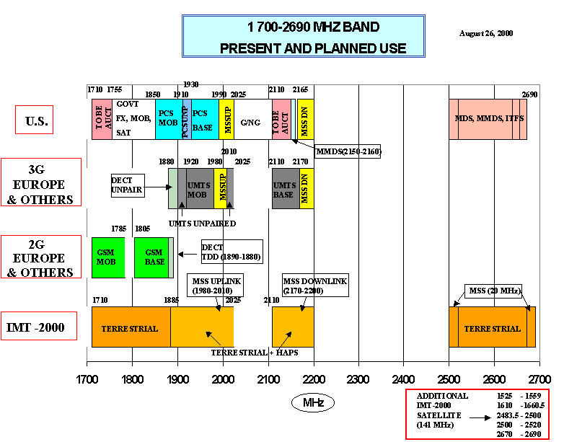
SPECTRUM CHARTS

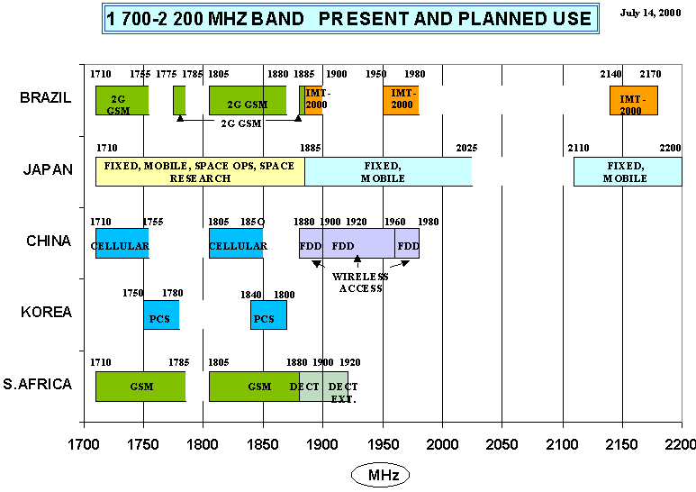
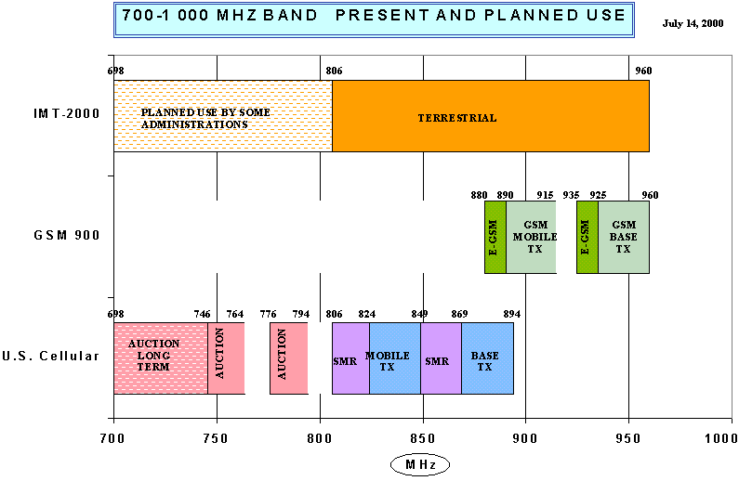
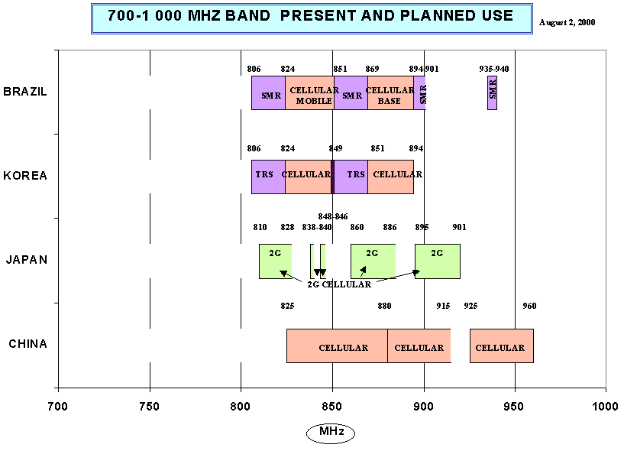
ATTACHMENT 3 TO APPENDIX 1.1
Spectrum Use Summary in the United States
(October 18, 2000)

1. 698-746 MHz (TV channels 52 - 59) Band. This spectrum is allocated in Region 2, which includes the United States, on a primary basis to the Broadcasting and on a secondary basis to the Fixed and Mobile Services. In addition, within the 698-746 MHz band segment, assignments may be made to television stations using frequency modulation in the Broadcasting-satellite Service subject to agreement between administrations concerned and those having services that might be affected. This spectrum is currently designated as TV channels 52-59 and is used by existing analog full service stations, Low Power TV stations, TV translator and booster stations, and new DTV television stations. In the United States, this band is allocated on a primary basis to the Broadcasting Service. This band is also allocated to the Fixed Service to permit subscription television operations. Further, TV broadcast licensees are permitted to use subcarriers on a secondary basis for both broadcast and non-broadcast purposes. The Balanced Budget Act of 1997 requires this spectrum to be reallocated and auctioned by September 30, 2002. Existing TV service and the service of new digital television (DTV) stations will continue on channel allotments in this band until at least December 31, 2006, when the transition to DTV service is scheduled to end and all television stations are to be located on channels in the DTV core spectrum (Channels 2-51). Television stations will cease operations on these channels at the end of the DTV transition, or possibly later on a market-by-market and channel-by-channel basis, depending on the availability of DTV television service and receivers. The rules for any new services on 698-746 MHz frequencies provide for the protection of those stations during the DTV transition. The WRC results recognize that some administrations may choose to provide for 3G services in this spectrum.

2. 746-806 MHz (TV Channels 60-69) Band. The Federal Communications Commission (FCC) has reallocated this spectrum in accordance with the 1997 Balanced Budget Act. Specifically, the 36 megahertz of spectrum at 746-764 MHz and 776-794 MHz (TV channels 60-62 and 64-66) was reallocated for fixed, mobile and new broadcast services for commercial uses. The 24 megahertz of spectrum at 764-776 MHz and 794-806 MHz (TV channels 63-64 and 68 - 69) were reallocated to the fixed and mobile services for use by public safety. Segments of the 746-764 MHz and 776-794 MHz bands, totaling 6 megahertz and referred to as the public safety guard bands, were recently auctioned. Cellular-type systems are prohibited in the guard bands in order to protect public safety operations against adjacent channel interference, and therefore this spectrum is not suitable for 3G systems. However, the remaining 30 megahertz of spectrum may be used for 3G services. This spectrum is planned for auction by March 6, 2001. The WRC results recognize that some administrations may choose to provide for 3G services in this spectrum.

3. 806-960 MHz Band. WRC 2000 adopted a footnote S5.XXX to the international table of frequency allocation stating that Administrations wishing to implement International Mobile Telecommunications-2000 (IMT-2000) may use those parts of the band 806-960 MHz which are allocated to the mobile service on a primary basis and are used or planned to be used for mobile systems (see Resolution 224 (WRC-2000)). The footnote also states that this identification does not preclude the use of these bands by any application of the services to which they are allocated and does not establish priority in the Radio Regulations. In keeping with its principle that existing mobile operators should be free to evolve to IMT-2000 and beyond as the market demands, any band available for 1st or 2nd generation systems is also available in the United States for IMT-2000 or other advanced communications applications. In the United States, these bands include 806-821 / 851-866 MHz for the Specialized Mobile Radio Services (SMRs) and 824-849 / 869-894 for the cellular radio service. The Commission's planned Notice of Proposed Rule Making is expected to consider the extent to which the existing SMR and cellular radio

services may meet the demand for 3G services. The Notice may also consider parts of the 806 - 960 MHz band that are used by other radio services.

4. 1710-1755 MHz Band. This band is currently allocated on a primary basis for Federal Government Fixed and Mobile Services. In addition, radio astronomy services may use the 1718.8-1722.2 MHz band segment on an unprotected basis. This band is currently used for Government point-to-point microwave communications, military tactical radio relay, and airborne telemetry systems. NTIA identified this spectrum for transfer to the FCC for non-government use, effective in 2004, to satisfy the requirements of the Omnibus Budget Reconciliation Act of 1993 (OBRA 93). NTIA indicates that, as required under OBRA 93, all microwave communication facilities in the 1710-1755 MHz band that are operated by Federal power agencies will continue to operate in the band and must be protected from interference. A list of exempted Federal power agency microwave systems, as well as 17 Department of Defense sites, is presented in Appendix E of the 1995 NTIA Spectrum Report. The Balanced Budget Act of 1997 (BBA 97) requires this spectrum to be assigned for commercial use by competitive bidding, with the auction to commence after January 1, 2001 and to be completed by September 30, 2002.

5. 1755-1850 MHz Band. The 1755-1850 MHz band supports four main Federal functions; space telecommand, tracking and control (TT&C, or space operations), medium capacity fixed microwave, tactical radio relay training, and aeronautical mobile applications such as telemetry, video and target scoring systems. This band is allocated on an exclusive basis to the Federal Government for fixed and mobile services, and in the 1761-1842 MHz portion, used for space operations. Fixed links are operated by federal agencies for voice, data, and/or video communications where commercial service is unavailable, excessively expensive, or unable to meet required reliability. Applications include law enforcement, emergency preparedness, supporting the National air space system, military command and control networks, and control links for various power, land, water, and electric-power management systems. Other specified fixed links include video relay, data relay, and timing distribution signals

Probably the most critical system in the band is the USAF Space Ground Link Subsystem (SGLS). This system, via Earth-to-space uplinks in the 1761-1842 MHz band, controls the U.S. military satellites, including telecommunications satellites, intelligence gathering satellites, the Global Positioning System (GPS) satellite constellation, and satellites of other Government agencies and U.S. allies. These satellites provide space-based capabilities that are critical to the execution of all US military operations. The satellites already in use that are associated with SGLS are not capable of being modified to operate to accommodate another frequency and would have to be replaced by new satellites. SGLS operations must continue to control these on-orbit assets for the duration of their life spans; which for some may extend beyond 2017.

Air Combat Training (ACT) systems are also used extensively in this band segment. ACT systems are more complex by the nature of their operations, as both fixed and aeronautical mobile equipment are used. Air Force and Navy operate ACT systems. The DoD has stressed that training support systems such as these are key elements in the military's effort to provide realistic simulation and combat preparedness for pilot training in a peacetime environment.

Fixed links are operated by federal agencies for voice, data, and/or video communications where commercial service is unuseable. Applications include law enforcement, emergency preparedness, support for the National air space system, military command and control networks, and control links for various power, land, water, and electric-power management systems. Other specified fixed links include video relay, data relay, and timing distribution signals.

The Mobile Subscriber Equipment is a multi-band, tactical line-of-sight microwave radio system, more accurately described as a "system-of-systems", because it is composed of several components which are fully operational systems. The individual components that make up the Mobile Subscriber Equipment are dependent upon several portions of the radio frequency spectrum (e.g., 30-88 MHz, 225-400 MHz, 1350-1850 MHz, and 14.5-15.35 GHz). The inability of any of these components to operate successfully would result in the failure of the overall Mobile Subscriber Equipment "system". One critical component of Mobile Subscriber Equipment, the AN/GRC-226(V)2 Radio, is dependent on the 1755-1850 MHz band. It is used to connect Radio Access Units (RAU) in the AN/TRC-190 series, to the Node Center Switch (AN/TTC-47) of the network. Operational use plans call for 465 units per Army Corps, giving a total of 2,325 units for 5 Corps.

6. 1850-1990 MHz Band (present PCS bands). RR S5.388, which was adopted at WRC-92, states that the band 1885-2025 MHz is intended for use, on a worldwide basis, by administrations wishing to implement IMT-2000, and that such use does not preclude the use of the band by other services to which it is allocated. In the United States the band 1850 - 1990 MHz is allocated for the Personal Communications Service (PCS). The Commission's planned Notice of Proposed Rule Making is expected to consider the extent to which the PCS may meet the demand for 3G services. The 1990 - 2025 MHz band was recently reallocated for mobile satellite services that are expected to partly satisfy the satellite component of 3G services.

7. 2110-2150 MHz Band. RR S5.388, which was adopted at WRC-92, states that the band 2110-2200 MHz is intended for use, on a worldwide basis, by administrations wishing to implement IMT-2000, and that such use does not preclude the use of the band by other services to which it is allocated. Domestically, the FCC has identified the 2110-2200 MHz band for reallocation from the fixed service for new emerging technologies. The 2165-2200 MHz segment of this band was recently reallocated for the mobile satellite service. BBA-97 requires reallocation of the 2110-2150 MHz band and assignment by competitive bidding by September 30, 2002.

8. 2500-2690 MHz Band. The two major services in the 2500-2690 MHz band are the Multichannel Multipoint Distribution System (MDS), and the Instructional Television Fixed Service (ITFS). There are currently thirty-three 6 MHz channels, or 198 MHz of spectrum, allocated to MDS and ITFS. MDS utilizes two channels in the 2150 to 2160 MHz band. MDS and ITFS share spectrum in the 2500 to 2686 MHz band.

MDS licensees transmit programming from one or more fixed stations, which is received by multiple receivers at various locations. Nation-wide, there are over 2500 licenses for MDS in the band. Licenses are granted on an area-wide basis, utilizing Basic Trading Areas. Formerly, MDS licensees used their channels to provide a multichannel video programming service, so-called "wireless cable." Approximately one million homes currently receive multichannel video programming service from MDS/ITFS-based wireless cable systems. However, the MDS frequencies, located in the 2.1 and 2.5-2.7 GHz bands, also are suited for the high-speed, high-capacity delivery of broadband access to data, voice and Internet service. The primary current and future uses of MDS will be to deliver this access. Rather than being hardwired like the local telephone companies and local cable systems, MDS uses microwave frequencies. Like broadcast television, MDS is transmitted from a broadcast tower, usually located on a mountain or tall building, to special antennas on residences or businesses throughout a local market. In the two-way environment, system configurations will be based on a "cellularized" plan, using series of hub and booster stations to link various main stations to individual subscribers and to relay transmissions throughout the system.

The other major service in the band is the ITFS, which is regulated under Part 74, Subpart I of the Commission's Rules. ITFS channels are from 2500 to 2596 MHz, and interleaved with MDS channels above 2644 MHz. Of the 31, six-megahertz channels in the MDS/ITFS spectrum band, the FCC licenses twenty of these channels to non-profit educational entities. ITFS stations are currently utilized for a wide variety of educational services by schools, hospitals and other educational facilities. In addition, ITFS unused channels can be used for the same kind of broadband services discussed above and excess capacity on those channels may be leased to MDS operators. Partnerships have developed between ITFS spectrum holders and MDS companies that provide expertise, revenue, and access to hardware and software to ITFS partners, to better enable them to build their distance learning programs.

In the last two years, the spectrum has undergone significant changes. In September 1998, the FCC amended its rules to facilitate the provision of two-way communication services by MDS and ITFS licensees. When MDS is used for two-way service, it becomes a viable broadband service delivery option. Implemented two-way systems can provide advanced, ultra-high speed, high-capacity broadband data and Internet services to households and business subscribers, as well as voice service to households in competition with local exchange carriers. The new rules still contemplate fixed service, even for two-way operations. The initial filing window for two-way service occurred from August 14, 2000 until August 18, 2000 and approximately 3,000 applications were received.

INTERIM REPORT
3G SPECTRUM STUDY
2500-2690 MHz BAND

APPENDICES

FOR

SECTION 2.0

APPENDIX 2.1

Table 2-A: Characteristics of IMT-2000 Mobile Stations

Parameter | CDMA-2000 | CDMA-2000 | UWC-136  (TDMA) | UWC-136  (TDMA)  GPRS/  EDGE | W-CDMA
Carrier Spacing | 1.25 MHz | 3.75 MHz | 30 kHz | 200 kHz | 5 MHz
Transmitter Power | 100 mW | 100 mW | 100 mW | 100 mW | 100mW
Antenna Gain | 0 dBi | 0 dBi | 0 dBi | 0 dBi | 0 dBi
Antenna Height | 1.5 m | 1.5 m | 1.5 m | 1.5 m | 1.5 m
Body Loss | 0 dB | 0 dB | 0 dB | 0 dB | 0 dBi
Access Techniques | CDMA | CDMA | TDMA | TDMA | CDMA
Data Rates Supported | 144 kbps | 384 kbps | 30 kbps  44 kbps | 384 kbps | 384 kbps
Modulation Type | QPSK/BPSK | QPSK/BPSK | π/4-DQPSK  8-PSK | GMSK  8-PSK | QPSK
Emission Bandwidth
-3 dB | 1.1 MHz | 3.3 MHz^{f} | 0.03 MHz | 0.18 MHz | 3 GPP
-20 dB | 1.4 MHz | 4.2 MHz | 0.03 MHz | 0.22 MHz | TS25.101
-60 dB | 1.5 MHz | 4.5 MHz | 0.04 MHz | 0.24 MHz
Receiver Noise Figure | 9 dB | 9 dB | 9 dB | 9 dB | 9 dB
Receiver Thermal Noise Level | -113. dBmª  -105 dBm^{b} | -109 dBmª  -100 dBm^{b} | -121 dBmª | -113 dBmª | -109 dBm in 384 kbps
Receiver Bandwidth
-3 dB | 1.10 MHz | 3.30 MHz | 0.03 MHz | 0.18 MHz | ?
-20 dB | 1.6 MHz | 4.7 MHz | 0.04 MHz | 0.25 MHz | ?
-60 dB | 3.7 MHz | 11 MHz | 0.09 MHz | 0.58 MHz | ?
E_{b}/N_{o} for P_{e} = 10⁻³ | 6.6 dB | 6.6 dB | 7.8 dB | 8.4 dB | 3.1 dB^{g}
Receiver Sensitivity^{c} | -107 dBm | -103dBm | -113 dBm | -104 dBm | -106 dBm
Interference Threshold 1^{d} | -119 dBm | -115 dBm | -127 dBm | -119 dBm | Not Needed
Interference Threshold 2e | -104 dBm | -100dBm | -111dBm | -103dBm | Not Needed
ª In bandwidth equal to data rate
^{b} In receiver bandwidth
^{c} For a 10⁻³ raw bit error rate, theoretical E_{b}/N_{o}
^{d} Desired signal at sensitivity, I/N = -6 dB for a 10 percent loss in range
^{e} Desired signal 10 dB above sensitivity, S/(I+N) for a 10⁻³ BER
^{f} Shaded values were estimated.
^{g} Assumes Eb/No for Pe = 10E-6 without diversity

Table 2-B: Characteristics of IMT-2000 Base Stations

Parameter | CDMA-2000 | CDMA-2000 | UWC-136  (TDMA) | UWC-136  (TDMA)  GPRS/EDGE | W-CDMA
Operating Bandwidth | 1.25 MHz | 3.75 MHz | 30 kHz | 200 kHz | 5 MHz
Transmitter Power | 10 W | 10 W | 10 W | 10 W | 10 W
Antenna Gain | 17 dBi per 120º sector | 17 dBi per 120º Sector | 17 dBi per 120º sector | 17 dBi per 120º sector | 17 dBi per 120º sector
Antenna Height | 40 m | 40 m | 40 m | 40 m | 40 m
Tilt of Antenna | 2.5º down | 2.5º down | 2.5º down | 2.5º down | 2.5º down
Access Techniques | CDMA | CDMA | TDMA | TDMA | CDMA
Data Rates Supported | 144 kbps | 384 kbps | 30 kbps  44 kbps | 384 kbps | 384 kbps
Modulation Type | QPSK/BPSK | QPSK/BPSK | π/4-DQPSK  8-PSK | GMSK  8-PSK | QPSK
Emission Bandwidth
-3 dB | 1.1 MHz | 3.3 MHz^{f} | 0.03 MHz | 0.18 MHz | 3 GPP
-20 dB | 1.4 MHz | 4.2 MHz | 0.03 MHz | 0.22 MHz | TS25.104
-60 dB | 1.5 MHz | 4.5 MHz | 0.04 MHz | 0.24 MHz
Receiver Noise Figure | 5 dB | 5 dB | 5 dB | 5 dB | 5 dB
Receiver Thermal Noise Level | -117dBmª  -109dBm^{b} | -113 dBmª  -104 dBm^{b} | -125 dBmª | -117 dBmª | -113 dBm in 384 kbps
Receiver Bandwidth
-3 dB | 1.10 MHz | 3.3 MHz | 0.03 MHz | 0.18 MHz | ?
-20 dB | 1.67 MHz | 4.7 MHz | 0.04 MHz | 0.25 MHz | ?
-60 dB | 3.7 MHz | 11 MHz | 0.09 MHz | 0.58 MHz | ?
E_{b}/N_{o} for P_{e} = 10⁻³ | 6.6 dB | 6.6 dB | 7.8 dB | 8.4 dB | 3.4 dB^{g}
Receiver Sensitivity^{c} | -111 dBm | -107 dBm | -117 dBm | -108.Bm | -110 dBm
Interference Threshold 1^{d} | -123dBm | -119dBm | -131 dBm | -123 dBm | Not Needed
Interference Threshold 2e | -108 dBm | -104 dBm | -115 dBm | -107dBm | Not Needed
ª In bandwidth equal to data rate
^{b} In receiver bandwidth
^{c} For a 10⁻³ raw bit error rate, theoretical E_{b}/N_{o}
^{d} Desired signal at sensitivity, I/N = -6 dB for a 10 percent loss in range
^{e} Desired signal 10 dB above sensitivity, S/(I+N) for a 10⁻³ BER
^{f} Shaded values were estimated.
^{g} Assumes Eb/No for Pe = 10E-6 without diversity

Table 2-C: IMT-2000 Traffic Model Characteristicsª

Parameter | Value
Traffic Environments | Rural  Vehicular  Pedestrian  In-building (Central business district)
Maximum Data Rates | Rural - 9.6 kbps  Vehicular - 144 kbps  Pedestrian - 384 kbps  In-building - 2 Mbps
Cell Size | Rural - 10 km radius  Vehicular - 1000 m radius  Pedestrian - 315 m radius  In-building - 40 m radius
Users per cell during busy hour | Rural - not significant  Vehicular - 4700  Pedestrian - 42300  In-building - 1275
Percent of total uplink traffic >64 kbps during busy hour | Rural - not significant  Vehicular - 34%  Pedestrian - 30%  In-building - 28%
Percent of total downlink traffic >64 kbps during busy hour | Rural - not significant  Vehicular - 78%  Pedestrian - 74%  In-building - 73%
Average number of users per cell per MHz during busy hour assuming frequency duplex operation | Rural - not significant  Vehicular  < 64 kbps - 16  > 64 kbps - 4  Pedestrian  < 64 kbps - 150  > 64 kbps - 64  In-building  < 64 kbps - 4  > 64 kbps - 2

ª Values in the table are for a mature network.

APPENDIX 2.2
International Use of 1710-1885 and 2500 – 2690 MHz Bands
[Charts Reproduced from Report ITU-R M.2024]

Current and Planned Utilization
Terrestrial Component Bands
1 710-1 785/1 805-1 885 MHz
CEPT* | 1 710-1 785/1 805-1 880 MHz: This band is also used in Europe for second generation mobile (GSM 1800). Availability of this band for IMT-2000 can only be made progressively in the longer term as current usage of the band decreases. The timetable availability of this band for IMT-2000 may differ on national basis.  On this basis, this band as a whole is also considered by CEPT to be a candidate for IMT-2000 expansion.  1 880-1 885 MHz: This band in Europe currently forms the lower part of the DECT band. The upper part of the DECT band (1 885–1 900 MHz) is already identified for IMT-2000.  The band 1 880–1 885 MHz is considered by CEPT as a candidate for IMT2000 expansion. The whole of the [Digital Enhanced Cordless Telecommunications] DECT band (1 880–1 900 MHz) can only be made available for IMT-2000 in the longer term however as DECT usage decreases.
U.S.A | 1 710-1 755 MHz – reallocated for mixed (government/non-government use after Jan. 1999) available for commercial use Jan. 2004. This band may be suitable for IMT-2000.  1 805-1 850 MHz – Satellite Ground Link System (SGLS). Exclusive government allocation. Not suitable or available for IMT-2000  1 755-1 805 MHz – Exclusive government allocations to FIXED, MOBILE and in parts of the band SPACE OPERATIONS. Not suitable or available for IMT-2000.  1 850-1 910/1 930-1 990 MHz: US PCS Band. Suitable for IMT-2000 as pre-IMT-2000 services evolve to IMT-2000.  1 910-1 930 MHz: Unlicensed Low-Power PCS. May be suitable for low power IMT-2000 applications as pre-IMT-2000 services evolve to IMT-2000.
Malaysia | DCS 1800  1 880-1 900 MHz DECT (FOR INDOOR USE ONLY)
Korea | These bands were assigned for land mobile service(using CDMA system)
China | 1 710-1 755/1 805-1 850 MHz: cellular system  1 880-1 900/1 960-1 980 MHz: Wireless access system of FDD mode  1 900-1 920 MHz: Wireless access systems of TDD mode
Japan | These bands were assigned for FIXED, MOBILE, SPACE RESERCH, and SPACE OPERATION service
Canada | 1 710-1 850 MHz: In Canada, this band is used for low capacity fixed systems Canada’s view is that fixed systems can be phased out at an appropriate time and this band has been identified by Canada as a candidate for IMT-2000.  1 850-1 885 MHz: This band forms part of the frequency range referred to as the PCS Band Plan and has also been identified as a candidate for ITM-2000.
Australia | Fixed/mobile: in extensive use
South Africa | 1 710-1785/1 805-1 880 MHz  1 880-1 900 MHz  1 900-1 920 MHz  1 885-2 025/2 110-2 200 MHz  1 980-2 010/2 170-2 200 MHz | DCS 1800  DECT  Extended DECT  (WARC-92) reserved for FPLMTS/UMTS  reserved for satellite component of FPLMTS/UMTS
Brazil | 1 710–1 850 MHz  1 850–1 885 MHz | In Brazil, this band is used for low capacity fixed systems. Parts of this band might be suitable for IMT-2000.  In Brazil, this band is used for low capacity fixed systems. It forms part of the frequency range referred to as the PCS Band Plan, although Brazil has not implemented it.  The bands 1 850-1 870/1 930-1 950 MHz are planned for introduction of Fixed Wireless Access systems.  Parts of this band might be suitable for  IMT-2000.
New Zealand | 1 706.5-1 880/ MHz  1 880-1 920 MHz | FS, Potentially suitable and available for  IMT-2000 extension  FS, PHS, DECT Potentially suitable but unavailable for IMT-2000 extension; clearance may be difficult

Current and Planned Utilization
Terrestrial Component Bands
2 500-2 690 MHz
CEPT* | This band is considered by CEPT as a prime candidate band for IMT-2000 expansion after phasing out of existing usage (fixed and ENG/OB). Geographical sharing (urban/rural) is one solution to facilitate the transition, or where sharing between services in the longer term is required.
U.S.A | Multipoint Distribution Service/Instructional Television Fixed Service, point to multipoint video links to homes, schools and businesses. Two way response use as well. This band is also assigned to the Broadcast Satellite Service. Coordination of the BSS service with additional satellite and terrestrial systems would be difficult. This band is currently not available for IMT-2000, however some licensees may choose to evolve to technologies and services, such as IMT-2000.
Malaysia | MMDS Application
Korea
Japan | This band is used for mobile satellite system and was assigned Broadcasting Satellite service.
China | 2 535-2 599 MHz : Multiple Microwave Distribute System (MMDS) of cable TV transmission system  Broadcasting-satellite service (audio).
Canada | This band has been identified for use for multipoint communications service  (2 500-2 596 MHz) and multipoint distribution service (Broadcasting)  (2 596-2 686 MHz. Canada has extensive licensing activity for MCS and MDS underway in this band. No other types of radio systems are currently being licensed in this range.
Australia | 2450 – 2690 MHz Electronic News Gathering (ENG)
South Africa | 2 690-2 700 MHz  2 520-2 593/2 597-2 670 MHz | MMDS / FS Radio Astronomy  FS
Brazil | 2 500-2 690 MHz | This band is used for multichannel multipoint distribution service. At this time Brazil is concluding an extensive licensing activity for MMDS in this band. No other types of radio systems are currently being licensed in this range. Not suitable for IMT-2000.
New Zealand | 2 498.5-2 690 MHz | FS, used extensively for ENG/OB. Suitable for IMT-2000 extension, but currently unavailable due to extensive ENG/OB applications.

Current and Planned Utilization
Satellite component
2 500-2 520/2 670-2 690 MHz
CEPT* | This frequency band could be made available for IMT-2000 in Europe, pending market demand.
U.S.A | Multipoint Distribution Service/Instructional Television Fixed Service, point to multipoint video links to homes, schools and businesses. Two way response use as well. Not suitable for IMT-2000.  Not allocated to MSS on a worldwide basis until 2005.
Malaysia | Frequencies have been filed by MEASAT for LEO/MEO use.
Korea | These bands were allocated for mobile satellite service at WARC-92. Any assignment for these bands is reserved until specific plans in Korea
China | Space Service
Japan | These bands are extensively used for Mobile-Satellite systems.
Canada | These bands have been identified for terrestrial services.
Australia | Current Australian usage of these bands would make usage by MSS in Australia difficult.
South Africa
Brazil | These bands are used for multichannel multipoint distribution service. At this time Brazil is concluding an extensive licensing activity for MMDS in these bands. No other types of radio systems are currently being licensed in this range. Not suitable for IMT-2000.
New Zealand

Current and Planned Utilization
Satellite component
2 520-2 535/2 655-2 670 MHz
CEPT* | These bands have been identified as possible candidate bands for the terrestrial component of IMT-2000, and are therefore not identified as suitable for satellite component. However, it is envisaged that these bands may be used for MSS in some areas, where the demand for satellite services is high.
U.S.A | 2 520-2 655 MHz:  Multipoint Distribution Service/Instructional Television Fixed Service, point to multipoint video links to homes, schools and businesses. Two way response use as well. This band is currently not available for IMT-2000, however some licensees may choose to evolve to technologies and services, such as IMT-2000.  2 655-2 670 MHz:  Multipoint Distribution Service/Instructional Television Fixed Service, point to multipoint video links to homes, schools and businesses. Two way response use as well. Also used for Radio Astronomy. This band is currently not available for IMT-2000, however some licensees may choose to evolve to technologies and services, such as IMT-2000.
Malaysia | Available
Korea | These bands were allocated for mobile satellite service at WARC-92. Any assignment for these bands is reserved until specific plans in Korea.
China | Space service
Japan | These bands are extensively used for Mobile-Satellite systems.
Canada | Currently identified for terrestrial services.
Australia | Current Australian usage of these bands would make usage by MSS in Australia difficult.
South Africa
Brazil | These bands are used for multichannel multipoint distribution service. At this time Brazil is concluding an extensive licensing activity for MMDS in these bands. No other types of radio systems are currently being licensed in this range. Not suitable for IMT-2000.

APPENDIX 2.3

IMT-2000 Spectrum Plans By Country
(Italics denote that the country has completed the licensing process)
Country | Frequency Bands | Amount of Spectrum | Licenses  Issued | Spectrum per License | License Award Date
Austria | TBD | 145 MHz | 4-6 | 12 frequency packages of 2x5 MHz  5 packages of 1x5 MHz | Q1 2001
Australia | 1885-2025 MHz  2110-2200 MHz | 140 MHz  (2x60 MHz paired  20 MHz unpaired) | TBD | TBD  (may be different based on region) | Dec. 2000
Belgium | 1900-1920 MHz  1920-1980 MHz  2010-2025 MHz  2110-2170 MHz | 155 MHz | 4 |  | Q4 2000
Brazil |  |  | 9 |  | 3 in Q4 2000  6 in 2001
Czech Republic | 1900-1920 MHz  1920-1980 MHz  2010-2025 MHz  2110-2170 MHz | TBD | 3 | 3 National licenses of 2 x 10-15 MHz  + 5 MHz | TBD
China | TBD |  | 4 |  | Sept. 2001
Denmark | 1900-1980 MHz 2010-2025 MHz 2110-2170 MHz | 155 MHz | 4 |  | Q4 2001
Finland | 1900-1920 MHz,  1920-1980 MHz  2010-2025 MHz,  2110-2170 MHz | 140 MHz | 4 | 4 licenses of 2 x 15 MHz + 5 MHz | March 1999
France |  | 140 MHz | 4 |  | Q1 2001
Germany | 1900-1920 MHz, 1920-1980 MHz,  2010-2025 MHz, 2110-2170 MHz | 145 MHz | 6 | Each license encompasses 2 slices of 2x5 MHz (2x10 MHz each) | Aug. 2000
Hong Kong | 1885-1920 MHz  1920-1980 MHz  2010-2025 MHz  2110-2170 MHz | 170 MHz | 4 |  | 4Q 2000
Ireland | 1900-1920 MHz  1920-1980 MHz  2010-2025 MHz  2110-2170 MHz | 155 MHz | 4 |  | Q2 2001
India |  |  | TBD |  | TBD
Israel | TBD but within 1700-2200 MHz | 175 MHz | TBD |  | TBD
Italy |  | 125 MHz | 5 | 5 licenses of 2x10 MHz + 5 MHz | Nov. 2000
Japan |  |  | 3 |  | June 2000
South Korea |  |  | 3 |  | Q4 2000
Latvia |  |  | TBD |  | Q4 2000
Netherlands |  | 145 MHz | 5 | 3 licenses of (2x10MHz + 5 MHz) and 2 licenses of (2x15MHz) | July 2000
Malaysia |  |  | 4 |  | July 2000
New Zealand | 1920-1980 MHz  2010-2025 MHz  2110-2170 MHz | 140 MHz  (one 2x15 MHz license is reserved for Maori trust) | 5 | 5 licenses of up to 2x15 MHz + 5 MHz | Q4 2000
Norway |  | 140 MHz | 4 |  | Q4 2000
Poland |  |  | 4-5 |  | Q1 2001
Portugal | 1900-1920 MHz  1920-1980 MHz  2110-2170 MHz | 140 MHz | 4 |  | Q1 2001
Russia |  |  | TBD |  | Q2 2001
Singapore |  |  | 4-6 |  | Q4 2000
Slovenia |  |  | 3 |  | Q4 2000
South Africa |  |  | 3 |  | Q2 2001
Spain | 1920-1980 MHz  2010-2025 MHz  2110-2170 MHz | 140 MHz | 4 | 4 licenses of 2x15 MHz + 5 MHz | March 2000
Sweden | 1900-1920 MHz 1920-1980 MHz  2010-2025 MHz  2110-2170 MHz | 140 MHz | 4 | 4 National licenses of 2x15 MHz + 5 MHz | Q4 2000
Switzerland | 1900-1920 MHz 1920-1980 MHz  2010-2025 MHz  2110-2170 MHz | 95 MHz (1/1/02)  140 MHz (1/1/06) | 4 |  | Q4 2000
Taiwan | TBD |  | Up to 5 |  | Q1 2001
United Kingdom | 1900-1920 MHz, 1920-1980 MHz,  2010-2025 MHz, 2110-2170 MHz | 140 MHz | 5 | 1 license of 2x15 MHz + 5 MHz, 1 license of 2x15 MHz, and 3 licenses of 2x10 MHz + 5 MHz | April 2000

Sources for Data in Appendix 2.3

3rd Generation, Cellular News, available at http://www.cellular-news.com/3G/index.htm (visited Aug. 21, 2000); 3G Wireless Licensing Process in Europe, TIA Europe, (Aug. 2000), available at http://www.tiaonline.org/international/regional/nis/europconnect-aug00.pdf (visited Aug. 21, 2000); Fifth Annual Report and Analysis of Competitive Market Conditions With Respect to Commercial Mobile Services, FCC 00-289 (rel. Aug. 18, 2000), available at http://www.fcc.gov/wtb/reports/fcc00289.doc (visited Aug. 21, 2000); William Boston, Germany's Wireless Bids Beat Forecasts: License Auction Reaches $11.43 Billion as Firms Crave the Big Market, The Wall Street Journal (Aug. 9, 2000); Telecommunications Industry Association, Europe Prepares for 3G, available at http://pulse.tiaonline.org/0300/text/euro3g.htm (visited, Aug. 21, 2000); Edmund L. Andrews, Costly Auction For German Phone Rights, New York Times (Aug. 19, 2000); France Outlines 3G license Award Process, Mobile & Satellite (Aug. 18, 2000); IMT-2000, Ericsson, available at http://www.ericsson.se/KR/english/imt2000/Licensing.htm (visited, Aug. 21, 2000); Asia-Pacific: Australia Faces 3G Hurdles, Roam, (May, 2000), available at http://www.totaltele.com/roam/news11.asp; Kenneth Neil Cukier, France's 3G Beauty Contest Looks Ugly All Around, Red Herring, (June 8, 2000) http://www.redherring.com/insider/2000/0608/tech-france3g060800.html (visited Aug. 21, 2000); Korean Gov't to Pick Three License Recipients for IMT-2000 Services, AsizBizTech, http://www.nikkeibp.asiabiztech.com/wcs/leaf?CID=onair/asabt/news/106104 (visited, Aug. 21, 2000); Kim Griggs, Yet Another Delay in New Zealand?, Wired, available at http://www.wired.com/news/business/0,1367,37268,00.html, visited (Aug. 21, 2000); 3G Licensing, Nokia, available at http://www.nokia.com/3g/licensing_upcoming#licences (visited Aug. 21, 2000); Radio Spectrum Auction Pages, [New Zealand] Ministry of Economic Development, available at http://auction.med.govt.nz/ (visited Aug. 21, 2000); Italy Confirms 3G Awards Process, Cellular News (June 22, 2000), available at http://www.cellular-news.com/2000/06_24_2000.htm (visited Aug. 21, 2000); Russia to Offer 3G Licenses in 2001, Cellular News (June 16, 2000), available at http://www.cellular-news.com/2000/06_17_2000.htm (visited Aug. 21, 2000); Slovenia to Open Tender for 3 UMTS Licenses, Total Telecom (Aug. 17, 2000), available at http://www.totaltele.com/view.asp?ArticleID=30001&pub=tt&categoryid=625; Brazil Decision Opens GSM Floodgates, Global Mobile 4 (July 19, 2000); Global Roundup of Mobile License Bids and Bidders, Global Mobile 11 (Aug. 2, 2000); UMTS: Einführung von Mobilfunk der dritten Generation in der Schweiz (April 1999), available at http://www.bakom.ch/ger/subsubpage/docs/688/688.pdf (visited Aug. 28, 2000); Public Digital 3rd Generation Mobile Networks, available at http://www.tst.dk/index_uk.htm (visited Aug. 28, 2000); Tentative Band Plan for IMT-2000, RSAC Paper 3/2000, available at http://www.ofta.gov.hk/index_eng.html (visited Aug. 28, 2000); Consulta Pública Sobre La Competencia En El Mercado De Los Servicios De Telefonía Móvil Disponible Al Público, available at http://www.cmt.es/cmt/centro_info/c_publica/index.htm (visited Aug. 29, 2000); L’Institut Belge Des Services Postaux Et Des Télécommunications, Plan des Fréquences, available at http://www.bipt.be/Pages/French/Telecoms/GestFreq/PlanFreq.htm (visited Sept. 1, 2000); Office of the Director of Telecommunications Regulation [Ireland], Extending Choice: Opening the Market for Third Generation Mobile Services (3G Mobile), Consultation Paper, available at http://www.odtr.ie/docs/odtr0052.doc (visited Sept. 1, 2000); ICP [Portugal] Opens Public Tender for UMTS licenses, Press Release, available at http://www.icp.pt/press/1999/not241uk.html (visited Sept. 5, 2000); Frequency allocation in the 900 MHz, 1800 MHz and 2 GHz bands, Post- och Telestyrelsen, (PTS), available at http://www.pts.se/generic_eng.asp?avdelning=generic _eng&uavdelning=generic_eng&u2avdelning=Tools%20for%20applicants1&lang=&header=Tools%20for%20applicants (visited Sept. 5, 2000); Neal Sandler, Israel to Issue 3G Tenders in October, Total Telecom, available at <http://www.totaltele.com/view.asp?ArticleID=31416&pub=tt&categoryid=625> (visited Sept. 14, 2000).

INTERIM REPORT
3G SPECTRUM STUDY
2500-2690 MHz BAND

APPENDICES

FOR

SECTION 3

APPENDIX 3.1

2483.5-2500  FIXED  MOBILE  MOBILE-SATELLITE  (space-to-Earth)  Radiolocation  S5.150 S5.371 S5.397 S5.398 S5.399 S5.400 S5.402 | 2483.5-2500  FIXED  MOBILE  MOBILE-SATELLITE  (space-to-Earth)  RADIOLOCATION  RADIODETERMINATION-  SATELLITE (space-to-  Earth) S5.398  S5.150 S5.402 | 2483.5-2500  FIXED  MOBILE  MOBILE-SATELLITE  (space-to-Earth)  RADIOLOCATION  Radiodetermination-satellite  (space-to-Earth) S5.398  S5.150 S5.400 S5.402 | 2483.5-2500  MOBILE-SATELLITE  (space-to-Earth) US319  RADIODETERMINATION-  SATELLITE (space-to-  Earth) S5.398  S5.150 753F US41 |  | 2483.5-2500  MOBILE-SATELLITE  (space-to-Earth) US319 RADIODETERMINATION-  SATELLITE (space-to-  Earth) S5.398  S5.150 753F US41 NG147 |  | ISM Equipment (18)  Satellite  Communications (25)  Private Land Mobile (90)  Fixed Microwave (101)
2500-2520  FIXED S5.409 S5.410  S5.411  MOBILE except aeronautical  mobile  MOBILE-SATELLITE  (space-to-Earth) S5.403  S5.405 S5.407 S5.408 S5.412 S5.414 | 2500-2520  FIXED S5.409 S5.411  FIXED-SATELLITE (space-to-Earth) S5.415  MOBILE except aeronautical mobile  MOBILE-SATELLITE (space-to-Earth) S5.403  S5.404 S5.407 S5.414 S5.415A |  |  |  | 2500-2655 |  | 2500-2655  FIXED S5.409 S5.411  US205  FIXED-SATELLITE  (space-to-Earth) NG102  BROADCASTING-  SATELLITE NG101 |  | Domestic Public Fixed  (21)  Auxiliary Broadcasting  (74)
2520-2655  FIXED S5.409 S5.410 S5.411  MOBILE except aeronautical  mobile  BROADCASTING-  SATELLITE S5.413 S5.416 | 2520-2655  FIXED S5.409 S5.411  FIXED-SATELLITE  (space-to-Earth) S5.415  MOBILE except aeronautical  mobile  BROADCASTING-  SATELLITE S5.413 S5.416 | 2520-2535  FIXED S5.409 S5.411  FIXED-SATELLITE  (space-to-Earth) S5.415  MOBILE except aeronautical  mobile  BROADCASTING-  SATELLITE S5.413 S5.416  S5.403 S5.415A
S5.339 S5.403 S5.405 S5.408 S5.412 S5.417 S5.418 | S5.339 S5.403 | 2535-2655  FIXED S5.409 S5.411  MOBILE except aeronautical  mobile  BROADCASTING-  SATELLITE S5.413 S5.416  S5.339 S5.418 | S5.339 US205 US269 |  | S5.339 US269

2655-3700 MHz (UHF/SHF) |  |  |  |  |  |  |  |  |  |  |  |  |  | Page 53
International Table |  |  |  |  |  | United States Table |  |  |  |  |  | FCC Rule Part(s)
Region 1 | Region 2 | Region 3 | Federal Government |  | Non-Federal Government
2655-2670  FIXED S5.409 S5.410 S5.411  MOBILE except aeronautical mobile  BROADCASTING- SATELLITE S5.413 S5.416  Earth exploration-satellite  (passive)  Radio astronomy  Space research (passive)  S5.149 S5.412 S5.417 S5.420 | 2655-2670  FIXED S5.409 S5.411  FIXED-SATELLITE  (Earth-to-space)  (space-to-Earth) S5.415  MOBILE except aeronautical mobile  BROADCASTING-  SATELLITE S5.413 S5.416  Earth exploration-satellite  (passive)  Radio astronomy  Space research (passive)  S5.149 S5.420 | 2655-2670  FIXED S5.409 S5.411  FIXED-SATELLITE  (Earth-to-space) S5.415  MOBILE except aeronautical  mobile  BROADCASTING-  SATELLITE S5.413 S5.416  Earth exploration-satellite  (passive)  Radio astronomy  Space research (passive)  S5.149 S5.420 | 2655-2690  Earth exploration-satellite  (passive)  Radio astronomy  Space research (passive) |  | 2655-2690  FIXED US205 NG47  FIXED-SATELLITE  (Earth-to-space) NG102  BROADCASTING-  SATELLITE NG101  Earth exploration-satellite  (passive)  Radio astronomy  Space research (passive)
2670-2690  FIXED S5.409 S5.410 S5.411  MOBILE except aeronautical mobile  MOBILE-SATELLITE  (Earth-to-space)  Earth exploration-satellite (passive)  Radio astronomy  Space research (passive)  S5.149 S5.419 S5.420 | 2670-2690  FIXED S5.409 S5.411  FIXED-SATELLITE (Earth- to-space) (space-to-Earth)  S5.415  MOBILE except aeronautical mobile  MOBILE-SATELLITE  (Earth-to-space)  Earth exploration-satellite  (passive)  Radio astronomy  Space research (passive)  S5.149 S5.419 S5.420 | 2670-2690  FIXED S5.409 S5.411  FIXED-SATELLITE (Earth- to-space) S5.415  MOBILE except aeronautical mobile  MOBILE-SATELLITE  (Earth-to-space)  Earth exploration-satellite (passive)  Radio astronomy  Space research (passive)  S5.149 S5.419 S5.420 S5.420A | US205 US269 |  | US269
2690-2700  EARTH EXPLORATION-SATELLITE (passive)  RADIO ASTRONOMY  SPACE RESEARCH (passive)  S5.340 S5.421 S5.422 |  |  |  |  |  | 2690-2700  EARTH EXPLORATION-SATELLITE (passive)  RADIO ASTRONOMY US74  SPACE RESEARCH (passive)  US246
2700-2900  AERONAUTICAL RADIONAVIGATION S5.337  Radiolocation  S5.423 S5.424 |  |  |  |  |  | 2700-2900  AERONAUTICAL RADIO-  NAVIGATION S5.337  METEOROLOGICAL AIDS  Radiolocation G2  S5.423 US18 G15 |  | 2700-2900  S5.423 US18

APPENDIX 3.2

DESCRIPTION OF Traditional ITFS Use
The Clark County School District in Las Vegas, NV (“Clark County”). Clark County has operated ITFS facilities to provide core educational programming to its students since 1968. As of 1997, Clark County was the tenth largest school district in the country, with a student population of 186,000. At that time, Clark County served 170 schools with ITFS programming. Over 80% of Clark County’s elementary school teachers reported using ITFS programming in the classroom each week, and 60% of secondary teachers reported such use. In the 1996-1997 school year, Clark County distributed approximately 240 hours per week of ITFS programming to more than 170 receive sites.

Clark County uses its licensed ITFS spectrum to offer many unique educational courses and supplemental learning programs. Over 75% of the Clark County’s teachers certified to teach English as a Second Language received their certification courses over ITFS from 1994-1997. In addition, due to a shortage of certified foreign language teachers, 100% of mandatory elementary Spanish language instruction in Clark County originates on ITFS. Furthermore, hundreds of at-risk children enrolled in, and successfully completed, remedial Algebra, English and World History courses delivered, in part, over ITFS. Latchkey children received homework assistance from certified teachers via an ITFS distributed Homework Hotline program that received over 12,000 calls in the 1997 school year. Moreover, Clark County, in cooperation with the local community college and university, has used ITFS to offer over 20 dual high school/college credit courses for Clark County students. These programs served hundreds of college bound students while reducing classroom overcrowding and improving student/faculty ratios.

Clark County has indicated that it plans to use its ITFS spectrum in the future to offer live interactive French classes, additional math programming, expanded science courses, adult continuing education courses, live and interactive professional development courses, expanded G.E.D. courses and live, interactive support staff programs. In addition, Clark County plans on carrying certain programming such as electronic field trips live instead of on a tape-delay basis.

The Archdiocese of New York operates one of the nation’s oldest and largest ITFS systems. The Archdiocesan ITFS transmits broadcasts programs to over 52,000 students, and carries more than 150 courses each year at the elementary, secondary, inservice and adult education levels. In addition, one channel is reserved for “Dial-A-Lesson,” permitting teachers to arrange for a particular program to be aired on a date and time of their choice. The Archdiocese operates two fully equipped production studios and offers students from area colleges and universities internships in video production.

In addition, the Catholic Television Network (CTN) operates one of the most successful ITFS programs throughout the country. CTN offers programs in all elementary and secondary school subject areas, as well as teacher in-service training and programs for senior groups, disabled persons, and health care agencies. Recent innovative ITFS distance learning programs offered by CTN have included: a videoconference with a panel of professional writers in Los Angeles and New York; an electronic field trip to the Smithsonian National Zoo to learn about a language project with orangutans, with students given the opportunity to ask questions of zoo scientists by telephone or e-mail; and a program exploring the inner workings of CNN News, allowing students meet the reporters, editors, and production staff. Notably, CTN plans on utilizing two-way technology to enhance its distance learning programs. CTN anticipates making interactive teleconferences more immediate by sending pictures, voice and data over air waves rather than telephone wires and anticipates providing its own connection to the Internet. Other typical ITFS educational systems include the following:

• Hampton Roads Educational Telecommunications Association. HRETA began in 1961 and has used ITFS technology for the past 15 years to deliver educational and public service information, including medical education to rural medical health facilities, televised college credit courses and educational programming service to 13 area secondary school systems for use in the classroom and media centers.

• Miami-Dade County Public Schools. Miami-Dade County Public Schools, the fourth largest school district in the United States, uses its ITFS channels to serve over 360,000 K - 12 students and over 140,000 adult students daily with over 10,000 hours of programming a year. The school district also utilizes its ITFS channels to train over 18,7000 teachers throughout the school system.

• Jefferson County Public Schools of Louisville, Kentucky. Jefferson County Public Schools of Louisville uses its ITFS system extensively, providing 160 hours of instructional programming per week to over 150 schools, in addition to four to six hours per week of professional development training.

• The Instructional Television Foundation. ITF is the licensee of seven stations located in Indianapolis, Philadelphia, Sacramento, Kansas City, Salt Lake City, Phoenix and Las Vegas. In Las Vegas, ITF transmits correctional facilities or alternative education sites that are unable to take advantage of conventional instructional resources.

• Network for Instructional TV, Inc. NITV holds licenses for 88 ITFS channels in 22 cities, in 13 states and the District of Columbia. NITV serves over one million teachers and students daily.

• St. Lucie County School District. St. Lucie County School District in Florida utilizes its ITFS channels to enhance its curriculum in the areas of science, reading and mathematics. Further, ITFS and distance learning have been an important tool in integrating Discipline-Based Art Education (DBAE) for its students. Art training workshops are transmitted on ITFS channels. Moreover, art aesthetics, criticism, history and production of visual arts, music, dance and drama are brought to the schools and community through distance learning. Teachers also participate in timely professional development workshops over ITFS channels.

In addition, Arizona State University offered 119 courses via ITFS in the year 2000. In addition, the University offered 116 Internet courses, which could be sent over two-way systems in the future. Enrollment in these courses delivered via these technologies totaled 4,679 students in 2000 and continues to increase. In addition, the University of California, Santa Barbara ITFS system is currently offering undergraduate course materials that compliment live courses in Anthropology, English, History, Law and Society, Political Science, Psychology, and Sociology.

California State University, Chico (“CSU, Chico”) has extensively used its ITFS spectrum to help educate its students. CSU, Chico is located in rural Northern California, 99 miles north of the state capital of Sacramento. In the late 1960’s and into 1970, the California Coordinating Council of Higher Education conducted a study on the needs of higher education in rural Northern California. A direct result of this report was the creation of an extensive ITFS system throughout Northern California. In 1975, an ITFS/Microwave link was established between CSU, Chico and the University of California at Davis (“UCD”), 92 miles south of Chico. The link was created to allow the Department of Computer Science at UCD to use CSU, Chico computer science courses for UCD’s developing doctoral program in Computer Science.

Throughout the years, the initial ITFS/Microwave system expanded to 16 sites throughout Northern California. The most distant ITFS receive site was located in Yreka, 173 miles north of campus. The eastern leg of the system extended 140 miles over the Sierra Nevada into the United States Sierra Army Depot. The eastern link provided courses to residents in Grass Valley (90 miles from campus), and the southwest leg extended 49 miles to Colusa. Each academic year 50 upper division courses generated approximately 1200 enrollments at the learning sites throughout California. A variety of bachelor’s degrees, program minors and certificate programs were delivered via this system. The courses were concurrently taught to regular on-campus students, and ITFS students paid the exact same fees as if they were attending class live in Chico.

Notably, CSU, Chico has delivered computer science courses, live via ITFS, to a Hewlett-Packard division in Roseville, California since 1981. The University has also been very active in producing various teleconferences for audiences in California and throughout the United States. Since 1985 CSU, Chico has produced and broadcast from this campus almost 100 teleconferences. One of the University’s first teleconferencing efforts was a program called Consider College, offered on October 8, 1985. This program, aimed at high school and community college students, parents and guidance personnel, dealt with admissions requirements, financial aid processes, considerations regarding housing, and special programs for community colleges.

The University of Maryland is another example of a school successfully integrating ITFS into its curriculum. The University of Maryland’s Instructional Television System (ITV) has become an integral part of the school, beaming its courses to classrooms located in Maryland, Virginia, Washington and over 400 locations throughout North America. Many classes are live and interactive. The University offers programs in computer science, business and professional development. Notably, many of the region’s most prestigious high-tech public and private organizations are regular subscribers to ITV’s classes, including IBM, NASA and the Naval Research Laboratory.

APPENDIX 3.3

Current and Planned two-way Deployment by Specific Carriers
WorldCom, Sprint, and Nucentrix are the three largest MDS licensees. They currently operate in 15 markets and cover approximately 80 percent of the MDS licensed areas. On July 11, 2000, the three companies entered into a voluntary spectrum management agreement regarding interference levels, which would allow interference levels among the participants to exceed those specified in the Two-Way Order. The agreement includes a preferred spectrum band plan outlining which frequencies operators would use to carry upstream and downstream traffic based on spectrum availability.

WorldCom. During 1999, WorldCom acquired four MDS licensees: CAI Wireless Systems, Inc., CS Wireless Systems, Inc., Wireless One, and PrimeOne Tele-TV. As a result, WorldCom’s MDS licenses cover 45 million households in 160 markets, from New York City, NY to Hoggards Mill, GA. WorldCom plans to use these licenses to offer fixed wireless high-speed Internet access and other broadband services to residential and small office/home office (“SOHO”) customers, particularly customers that are beyond the reach of wireline DSL. WorldCom is currently running trials of MDS high-speed Internet access in five cities: Boston, MA; Dallas, TX; Baton Rouge, LA; Jackson, MS; and Memphis, TN. On August 14, 2000, the company filed its initial applications to offer two-way fixed wireless broadband services in a total of 70 markets. The company plans to file two-way applications for the remaining 100 markets during later filing windows.

WorldCom is charging its residential trial customers $39.95 per month for two-way speeds of 310 kbps and businesses $300-$600 per month for speeds of 128 Kbps to 10 Mbps. By contrast, the typical cable modem offers speeds of greater than 256 Kbps to 3 Mbps. In addition to its commercial rollout plans, WorldCom announced in April 2000 that it would begin using MDS to deliver high-speed Internet access to schools, libraries, and community centers in four rural communities – Raleigh, NC; Houma, LA; Dothan, AL; and Hattiesburg, MS – during 2000.

Sprint. Since 1999, Sprint has acquired seven MDS licensees: People’s Choice TV, American Telecasting, WBS America LLC, Transworld Telecommunications Inc., Videotron USA, Wireless Cable of Florida, Inc., and Nashville Wireless Cable JV. Sprint’s MDS licenses cover over 30 million households in 83 markets.

Sprint is currently offering MDS broadband services in Phoenix, Tucson, Colorado Springs, Detroit, Houston, Oakland, and San Jose. Its service is called Sprint Broadband Direct and can deliver downstream speeds of 1 Mbps with burst rates of 5 Mbps. In the first phase of the Detroit rollout, Sprint estimates that about 40 percent of homes and businesses in the northeast portion of the metropolitan area will have access to the service. Over the next two years Sprint will extend service to more than 60 percent of homes and businesses in metropolitan Detroit. Notably, Sprint’s two-way service is currently available to more than 85 percent of the homes and businesses in Tucson, and Sprint has doubled its Phoenix subscriber base since May 8, 2000.

Sprint Broadband Direct costs $49.95 per month for residential customers or $199.95 for businesses. Customer connections are “instant” and “always-on,” thereby alleviating the need for users to dial into a modem bank multiple times to establish a connection. The one-time equipment charge varies with the terms of the service agreement. Customers who choose a two-year plan will receive equipment for $99. Equipment for a one-year plan costs $199, and month-to-month customers pay $299 for equipment.

Sprint has stated that it plans to launch MDS in 10-20 markets by the end of 2000. In August 2000, the company filed applications with the FCC to offer two-way service in 45 markets, and the company plans to file in additional markets in later filing windows.

Nucentrix. Nucentrix Broadband Networks, Inc. (“Nucentrix,” formerly Heartland Wireless Systems, Inc.) currently offers two-way high-speed Internet access using MDS spectrum in Austin and Sherman, TX, and is running a trial of the service in Amarillo, TX. Nucentrix plans to launch the service in 15-20 markets by the end of 2001. The company filed applications to offer two-way service in 70 markets during the July-August 2000 two-way filing window. Nucentrix holds licenses that cover approximately 9.4 million homes in 95 small and medium markets in Texas and the Midwest.

Other Operators. In addition to the three companies discussed above, several small companies have also begun using MDS to offer high-speed Internet access. See table attached as Appendix C for a complete list of their plans and current offerings.

In Mobile, AL, Advanced Wireless Systems, Inc. (“AWS”) offers one-way high-speed Internet access. In August 2000, AWS completed its purchase of Digital Wireless Systems, Inc. (“DWS”). DWS had been offering high-speed Internet access using MDS and leased ITFS spectrum in four cities – Baton Rouge, LA; Shreveport, LA; Reading, PA; and Clarksville, TN – and AWS has continued operations in these markets. AWS states that it primarily serves rural and outlying areas where the delivery of traditional land-based cable television service is impractical. However, AWS is focusing primarily on businesses and, to a lesser extent, individuals as potential customers for its high-speed Internet access service.

LMA Systems, Inc. (“LMA”) is offering high-speed Internet access in three mid-Atlantic markets: Sunbury, PA; Wilkes-Barre, PA; and Lynchburg, VA. LMA offers two-way access at 1.54 Mbps downstream and 768 kbps upstream, and is currently focusing on business customers.

World Wide Wireless Communications, Inc. (“WWWC”) currently offers high-speed Internet access in Concord, CA and in several cities outside the United States. WWWC plans to launch service in several additional U.S. cities: San Marcos, Ukiah, and San Diego, CA; South Bend, IN; Hot Springs, AR; Hilo, HI; Grand Rapids, MI; Aspen and Vail, CO; Key West, FL; Casper, WY; La Grange, OR; and Pierre, SD.

Sioux Valley Wireless (“SVW”), a subsidiary of Sioux Valley Southwestern Electric, has launched a two-way MDS Internet access service covering communities within a 30-mile radius of its transmission facilities at Sioux Falls and Colman, South Dakota. SVW offers several classes of wireless Internet service, from single home computer installations to large networked systems. The company’s basic wireless Internet service operates at 128 kbps. Recently, SVW’s wireless system was used to enable Internet users to watch a “streaming video” version of the Bob Burns Dakota Bowl between two Sioux Valley high schools. This was the first time that a South Dakota high school football game was transmitted live over the Internet.

Wireless First, Inc. (“Wireless First”) currently offers high-speed Internet access, called SpeedConnect, using MDS spectrum in Traverse City, MI and its surrounding five counties on the Upper Peninsula of Michigan (Grand Traverse, Leelanau, Benzie, Kalkaska, Antrim). Wireless First offers one- and two-way service to residential and business customers at a maximum speed of 256 kbps. Its MDS licenses (either leased or owned) currently cover 11 additional counties, and Wireless First plans to roll out service to those counties in the future. Wireless First plans to expand geographic reach of the service to Clare, Gartiot, Isabella, Manistee, Missaukee, Osceloa, Wexford, Otsego, Emmet, Cheboygan and Charlevoix counties.

Cache Valley AIRNET (“CVAIRNET”) currently offers two-way Internet access over MDS frequencies in the Cache Valley region of Northern Utah and Southeastern Idaho, including the communities of Logan, Smithfield, Hyrum, Preston, Wellsville, Richmond, Paradise and surrounding areas. From its transmission facilities on Little Mountain near Newton, Utah, CVAIRNET’s service is up to 347 times faster than 28.8 kbps modem, up to 78 times faster than ISDN, and up to 8 times faster than traditional T1 service. CVAIRNET offers service to both residential and business customers, providing the same rate speed connectivity to both.

Alaska Wireless Cable (“AWC”) has launched a two-way MDS Internet service, marketed as netSpeed, covering most of Fairbanks and a large portion of the North Pole, Ft.Wainwright, Eielson Air Force Base, and other Fairbanks North Start Borough areas. AWC’s service is available to both residential and business users at speeds up to 256 kbps and 512 kbps downstream.

Virginia Communications ESpeed (“VCE”) has launched two-way MDS Internet service in and around Prescott, Arizona, using the E-group channels downstream and channel MDS1 upstream. VCE’s service area encompasses approximately one-third of a large rural area around Prescott that has no cable or DSL service and, in some cases, no landline telephone service. In the Commission’s recent initial filing window for two-way MDS/ITFS applications, VCE filed for authority to construct three additional hubs and to use additional MDS frequencies. Those applications, once granted, will enable VCE to expand the reach of its service to additional rural areas that are similarly underserved. VCE also intends to file applications in the Commission’s next two-way filing window to launch service in Davenport, Cedar Rapids, Waterloo, and Iowa City, Iowa; Huntington, West Virginia; Portsmouth, Chillicothe, Zanesville and Athens, Ohio; and Erie, Pennsylvania.

Oxford Telecom recently launched two-way MDS Internet service in Portland, Maine, including Internet access, Virtual Private Networks, data vaulting and e-commerce applications. Similarly, Third-Rail Wireless Services has launched two-way MDS Internet service in Nashua, New Hampshire, offering Internet access, video conferencing, IP Telephony, and WAN-WAN connectivity.

W.A.T.C.H. TV Company (“WTC”), provides both multichannel video programming and Internet access in the Lima, OH. The company began providing one-way Internet access over a year ago and recently began using its MDS channels 1 and 2 for upstream transmissions. WTC has invested over $6.5 million dollars to digitize its channels and convert its subscribers to digital technology – a step necessary to free up spectrum for the two-way wireless Internet offering.

Over the past six months, WinBeam, Inc. (“WinBeam”), has been acquiring MDS and ITFS spectrum in southern New York State, western Pennsylvania, western Maryland, West Virginia and western Virginia in order to provide a regional Internet access service. WinBeam plans to submit numerous two-way applications when the rolling, one-day filing window begins and to begin construction soon after the applications are granted.

nTelos (formerly CFW Communications, Inc.) operates wireless cable systems in Charlottesville and the Shenandoah Valley of Virginia and controls MDS/ITFS channels in Richmond and Lynchburg, VA. The company and its affiliates submitted close to twenty applications for two-way authorizations during the August filing window. nTelos plans to aggressively roll-out Internet access service (and is looking at IP telephony) as its applications are granted and equipment becomes available.

Teton Wireless (“Teton”) operates analog wireless cable systems in Idaho Falls and Twin Falls, ID and Missoula, MT, and has smaller channel positions elsewhere in the Northwest. Teton is also in the process of acquiring a wireless cable system in Pocatello, ID. Teton submitted applications during the initial filing window to deploy two-way Internet access in 4 markets using MDS channels 1 and 2A. Teton is now exploring the various possible migration paths for converting its existing video services to digital technology in order to free spectrum in the 2.5 GHz band for Internet access. The company plans to begin offering service in late 2001.
APPENDIX 3.4

APPENDIX 3.5

Technical Characteristics of MDS/ITFS Stations
The technical characteristics of the MDS and ITFS stations can be summarized as follows. Tables 3-A and 3-B list the characteristics of stations used for traditional ‘one-way’ point-to-multipoint ITFS and MDS (also called MMDS) systems. These systems are used primarily for the distribution to educational institutions (ITFS systems) of instructional video programming and for the distribution to paying customers (MDS systems) of entertainment video programming.

Table 3-A Stations Table 3-B Stations Signal

Main Station Transmitter >>>>>>> Customer Receivers Downstream NTSC
(6 MHz channels)

Main Station Receiver <<<<<<<<< Customer Narrowband Upstream Audio
Response Transmitters (125 kHz channels)

Tables 3-C and 3-D list the characteristics of stations used for two-way ‘cellularized’ digital MDS and ITFS systems. These systems are used primarily for wireless internet access and other two-way wireless communications between fixed points by educational institutions (ITFS systems) and by paying customers (MDS systems).

Table 3-C Stations Table 3-D Stations Signal

Main/Booster Station >>>>>>>>>> Customer Response Downstream Digital
Transmitter Station Receivers 1-30 Mbps typical

Hub Station Receiver <<<<<<<<<< Customer Response Upstream Digital
Station Transmitters 250K-1 Mbps typical

TABLE 3-A
ITFS/MDS Point-to-Multipoint One-Way System Base Station Characteristics
(Main Station Transmitter; Main Station Receiver)
Parameter | Specification | Notes
Main Station Transmitter
Spectrum Available | 2150-2162 & 2500-2686 MHz
Signal Bandwidth | 6 MHz nominal | 1
Power Output | Not specified | 2
Antenna Gain | Not specified | 3
Antenna Beam Tilt | Permitted | 4
EIRP | ≤ 2000 Watts (33 dBW) | 5
Modulation Type | NTSC Composite Video/Audio | 7
Emission Bandwidth | @ -38 dB 6 MHz  @ -60 dB 7.5 MHz
Path Length | Up to 35 Miles
Free Space Path Loss | 135.5 dB @ 35 Miles
Main Station Receiver
Signal Spectrum | 2686-2690 MHz | 8
Signal Bandwidth | 125 kHz nominal
Emission Bandwidth | @ -35 dB 125 kHz  @ -60 dB 375 kHz
Modulation Type | AM or FM | 9
Antenna Gain | Not specified | 10
Signal Level (from individually-licensed  narrowband Response Stations) | Various | 11
Noise Figure | 5 Db
Noise Level | -107 dBm ≥ N ≥ -127 dBm (typical)
SNR | 60 ≥ SNR ≥ 40 dB (typical)
Interference Protection | None
Notes
1. Licensees are authorized one or more 6 MHz channels per station.
2. The rules do not restrict transmitter output, however the peak aural power must not exceed 10% of the peak visual power for standard NTSC composite video/audio signals.
3. The rules do not specify maximum or minimum permissible antenna gain. Licensees may use omnidirectional antennas and/or directional antennas as needed to achieve desired area coverage.
4. The rules do not restrict beam tilt, either mechanical or electrical, although the details of the tilted beam pattern must be specified on the station application form.
5. The maximum permissible EIRP per 6 MHz channel is 2000 watts (33 dBW) for MDS/ITFS Main stations in one-way systems utilizing an omnidirectional antenna (i.e. no azimuthal-plane directivity). For stations using directional (i.e. azimuthal-plane directivity) and sectorized antenna systems, the maximum EIRP per 6 MHz channel is given by the formula 33 dBW + 10 log (360/beamwidth), with an upper limit of 39 dBW permissible. See Rule Sections 21.904 (MDS) and 74.935 (ITFS).
6. Digital modulation for the transmission of one or more visual and composite aural signals, and/or for the transmission of data, is also permitted pursuant to the provisions of the Commissions Digital Declaratory Ruling, 11 FCC Rcd at 18840.
7. See Rule Sections 21.905 (MDS) and 74.936 (ITFS).
8. The 2686-2690 MHz spectrum available for individually-licensed Response Stations transmitting to Main Station receivers in one-way systems is subdivided into 31 channels of 125 kHz bandwidth each, with the center of the 1st channel at 2686.0625 MHz and the center of the 31st channel at 2689.8125 MHz. All 31 channels are available to ITFS licensees and 4 channels are available to MDS licensees on a shared basis with ITFS licensees. See Rule Sections 21.901(b) (MDS) and 74.939 (ITFS).
9. Digital emissions are also permissible pursuant to the to the provisions of the Commission’s Digital Declaratory Ruling, 11 FCC Rcd at 18840.
10. The Main Station receiving antennas in a one-way system are used for reception of signals transmitted by individually-licensed narrowband (125 kHz) Response Stations. Directional and/or omnidirectional Main Station receiving antennas, or a combination of both, are permissible.
11.This is dependant on path lengths from the individually-licensed narrowband response station transmitters to the Main Station, as well as the power level and the antennas in use.

TABLE 3-B
ITFS/MDS Customer Receive Stations and Individually-Licensed Customer
Narrowband Response Station Transmitters in One-Way Systems
(Customer Receiver; Customer Narrowband Response Transmitter, if used)
Parameter | Specification | Notes
Narrowband Response Station Transmitter
Spectrum Available | 2686-2690 MHz | 1
Signal Bandwidth | 125 kHz | 1
Power Output | 2 Watts (3 dBW) Maximum | 2
Antenna Gain | Gain Antenna Required | 3
Transmitted EIRP | ≤ 40 Watts (16 dBW) Maximum | 4
Modulation Types | AM, FM | 5
Emission Bandwidth | @ 35dB 125 kHz  @ 60 dB 375 kHz | 6
Path Length | Up to 35 Miles
Free Space Path Loss | 135.5 dB @ 35 Miles
Customer Receiver
Signal Spectrum | 2150-2162 & 2500-2686 MHz
Signal Bandwidth | 6 MHz nominal
Emission Bandwidth | @ -38 dB 6 MHz  @ -60 dB 7.5 MHz
Modulation Type (Rx) | NTSC Composite Video/Audio | 7
Antenna Gain | Directional Antenna Required | 8
Received Signal Level | -52.5 dBm | 9
Noise Figure | 5 dB
Noise Level | -100.2 dBm | 10
SNR | 47.7 dB | 11
Interference Protection | Service Area Protection; Registered Receive Site Protection | 12
Notes
1. See Rule Sections 21.901(b)(5) (MDS) and 74.949 (ITFS).
2. See Rule Sections 21.909(g)(2) (MDS) and 74.949(c)(2) (ITFS).
3. See Rule Section 21.949(e) (MDS) and 74.937(b) (ITFS).
4. See Rule Sections 21.904(a) (MDS) and 74.949(c)(3) (ITFS).
5. See Rule Sections 21.905 (MDS) and 74.936 (ITFS). Digital emissions are also permitted pursuant to the provisions of the Commission’s Digital Declaratory Ruling, 11 FCC Rcd at 18840.
6. See 21.909(j) (MDS) and 74.949(k) (ITFS).
7. The modulation type received at the customer receiver (from the Main Station transmitter in a one-way system) may also be digital, pursuant to the provisions of the Commission’s Digital Declaratory Ruling, 11 FCC Rcd at 18840.
8. See Rule Sections 21.906(d) (MDS) and 74.937(a) (ITFS).
9. + 63 dBm (Main/Booster Transmitter EIRP) – 135.5 dB (35 mi. PL) + 20 dBi (gain of assumed Rx antenna) = -52.5 dBm.
10. For thermal noise only, excluding interference; -106.2 dBm (kTB for 6 MHz) + 5 dB (NF) + 1 dB (cable loss) = -100.2 dBm.
11. –52.5 + 100.2 = 47.7.
12. Protection for Customer Receivers in most MDS one-way systems licensed in 1997 and later is primarily in the form of protection of the service area in which they are located. Specifically, at the service area boundary, all geograpically adjacent licensees must engineer their systems to limit the calculated free space power flux density at any shared border with the protected system to a maximum value of –73 dBW/m² (per 6 MHz bandwidth) as measured with an FCC reference antenna at a height of 10 meters. For pre-1997 MDS one-way systems and for all ITFS one-way systems, additional requirements for protection inside the service area are imposed in the form of permissible D/U ratios of 45 dB for cochannel interference and 0 dB for adjacent channel interference. See Rule Sections 21.902 (MDS), 21.909 (MDS), 21.913 (MDS), 74.903 (ITFS), 74.939 (ITFS) and 74.985 (ITFS).

TABLE 3-C
MDS/ITFS Point-to-Multipoint 2-Way System Base Station Characteristics
(Main/High Power Booster Transmitter; Hub Station Receiver)
Parameter | Specification | Notes
Main/Booster Station Transmitter
Spectrum Available | 2150-2162 & 2500-2690 MHz
Signal Bandwidth | 6 MHz nominal | 1
Power Output | Not specified | 2
Antenna Gain | Not specified | 3
Antenna Beam Tilt | Permitted | 4
EIRP | ≤ 2000 Watts (33 dBW) | 5
Access Techniques | TDMA/CDMA | 6
Modulation Types | QAM, VSB, COFDM | 7
Emission Bandwidth | @ -25 dB 6 MHz  @ -40 dB 6.5 MHz  @ -60 dB 12 MHz | 8
Path Length (Main/Booster Station to Response Station Receiver) | Up to 35 Miles | 9
Free Space Path Loss | 135.5 dB @ 35 Miles
Hub Station Receiver
Signal Spectrum | 2500-2690 MHz | 10
Signal Bandwidth | 6 MHz nominal | 11
Emission Bandwidth | @ -25 dB 6 MHz  @ -40 dB 6.5 MHz  @ -60 dB 12 MHz
Modulation Types | QAM, VSB, COFDM | 7
Antenna Gain | 10 dBi typical | 12
Signal Level (at Hub Station receiver from  Response Station transmitter) | -62.5 dBm | 13
Noise Figure | 2.5 dB
Noise Level | -102.7 dBm | 14
SNR | 40.2 dB | 15
Interference Protection | ≤ 1 dB Rx Noise Floor Degradation | 16
Notes
1. A licensee may be authorized one or more 6 MHz channels per station and may subdivide a 6 MHz channel into multiple smaller channels (subchannelization) and may itself, or in combination with one or more other licensees, aggregatge multiple contiguous 6 MHz channels into larger channels (superchannelization). See Rule Sections 21.905 (MDS) and 74.936 (ITFS).
2. The rules do not restrict Main/Booster transmitter power output.
3. The rules do not specify maximum or minimum permissible antenna gain. Licensees may use omnidirectional antennas and/or directional antennas as needed to achieve desired area coverage. Main and Booster Stations utilize multiple directional antennas to achieve sectorized coverage of the service area as a means of achieving frequency reuse. See Rule Sections 21.906(a) (MDS), 74.931(b)(3) (ITFS) and 74.937(b) (ITFS).
4. The rules do not restrict beam tilt, either mechanical or electrical, although the details of the tilted beam pattern must be specified on the station application form.
5. The maximum permissible EIRP per 6 MHz channel is 2000 watts (33 dBW) for stations utilizing an omnidirectional antenna (i.e. no azimuthal-plane directivity). For stations using directional (i.e. azimuthal-plane directivity) and sectorized antenna systems, the maximum EIRP per 6 MHz channel is given by the formula 33 dBW + 10 log (360/beamwidth), with an upper limit of 39 dBW permissible. Rule Sections 21.904 (MDS) and 74.935 (ITFS).
6. See Rule Sections 21.905 (MDS) and 74.936 (ITFS).
7. In addition, other forms of digital modulation are permitted if the applicant provides a showing that interference will not result from their use. See Rule Sections 21.905 (MDS) and 74.936 (ITFS).
8. Emission measurements are to be made in accordance with the formulas set out at Rule Section 21.908 (MDS and ITFS). Attenuations apply only at edges of 6 MHz channels, not to subchannels within a 6 MHz channel. For superchannels, attenuations apply only at the upper and lower edges of the superchannel, not to channels within the superchannel.
9. Path length from Main/Booster transmitter to Response Station receiver will depend on size of service area to be covered and the amount of ‘cellularization’ used, i.e. if a service area is served by multiple cells, the path lengths in each cell will be significantly shorter than if a single cell is used to cover the entire 35 mile radius of a typical service area.
10. The 6 MHz channels listed in Note 1, above, for point-to-multipoint use in the MDS and ITFS Services may also be used at Response (customer) stations for transmissions which are received by the Base Station receiver (“Hub Station”). MDS and ITFS licensees are permitted to allocate the channels assigned to their systems on a real-time basis for both downstream (point-to-multipoint) and upstream (multipoint-to-point) use without regard to which channels are used for which purpose so long as all interference protection criteria are met with respect to neighboring systems. Upstream and downstream bandwidths may be symmetrical or asymmetrical, with some or most systems utilizing greater bandwidth downstream than upstream. Downstream bit rates in a range of 1-30 Mbps are likely, with upstream bit rates likely in a range of 250 kbps- 1 Mbps.
11. The bandwidths of the signals transmitted from 2-Way System Response Stations which are received at the base station receiver (“Hub Station”) are determined by the licensee of the system on a real-time basis. (See Note 2, above.) The bandwidth may be 6 MHz, or a fraction thereof, or a multiple thereof.
12. Gain of a parabolic antenna with a half-power beamwidth of approximately 30 degrees. Twelve such sector antennas would be necessary to provide omnidirectional coverage at the Hub receiving Station.
13. + 63 dBm (EIRP) – 135.5 dB (35 mi. PL) + 10 dBi (Rx Ant Gain) = -62.5 dBm
14. For thermal noise only, excluding interference; –106.2 dBm (kTB for 6 MHz) + 2.5 dB (NF) + 1 dB (Cable Losses) = -102.7 dBm
15. –62.5 + 102.7 = 40.2
16. See Rule Sections 21.909(i) (MDS) and 74.939(i) (ITFS). See also Appendix D to the Report and Order in MM Docket 97-217, 13 FCC Rcd 19,112 (1998), at paragraphs 40-49.

TABLE 3-D
MDS/ITFS Response (Customer) Stations in 2-Way Systems
(Response Station Transmitter & Receiver)
Parameter | Specification | Notes
Response Station Transmitter
Spectrum Available | 2150-2162 & 2500-2690 MHz
Signal Bandwidth | 6 MHz nominal | 1
Power Output | 2 Watts (3 dBW) | 2
Antenna Gain | ≥ 0 | 3
EIRP | ≤ 2000 Watts (33 dBW) | 4
Access Techniques | TDMA/CDMA | 5
Modulation Types | QAM, VSB, COFDM | 6
Emission Bandwidth | @ -25 dB 6 MHz  @ -40 dB 6.25 MHz  @ -60 dB 12 MHz | 7
Path Length (Response Station Transmitter to Hub Station Receiver) | Up to 35 Miles
Free Space Path Loss | 135.5 dB @ 35 Miles
Response Station Receiver (from Main/Booster Station)
Signal Spectrum | 2500-2690 MHz | 9
Signal Bandwidth | 6 MHz nominal | 10
Emission Bandwidth | @ -25 dB 6 MHz  @ -40 dB 6.25 MHz  @ -60 dB 12 MHz | 7
Modulation Types | QAM, VSB, COFDM | 6
Antenna Gain | Directional Antenna Required | 11
Signal Level | -52.5 dBm | 12
Noise Figure | 5 dB
Noise Level | -100.2 dBm | 13
SNR | 47.7 dB | 14
Interference Protection | System Service Area Protected | 15
Notes
1. Response Station transmitters in 2-Way systems are not individually licensed. MDS/ITFS 2-Way system licensees are authorized one or more 6 MHz channels per system and may allocate the licensed bandwidth between and among Main, Booster and Response Station transmitters as needed on a real-time basis. A licensee may subdivide a 6 MHz channel into multiple smaller channels (subchannelization) and may, itself, or incombination with one or more other licensees, aggregate multiple contiguous 6 MHz channels into larger channels (superchannelization). See Rule Sections 21.905 (MDS) and 74.936 (ITFS).
2. See Rule Sections 21.909(g)(2) (MDS) and 74.939(g)(2) (ITFS)
3. See Rule Sections 21.909(g)(4) (MDS) and 74.939(g)(4) (ITFS)
4. See Rule Sections 21.909(g)(3) (MDS) and 74.939(g)(3) (ITFS)
5.See Rule Sections 21.905 (MDS) and 74.936 (ITFS)
6. In addition, other forms of digital modulation will be permitted if the applicant provides a showing that interference will not result from their use. See Rule Sections 21.905 (MDS) and 74.936 (ITFS).
7.Emission measurements are to be made in accordance with the formulas set out at Rule Section 21.908 (MDS and ITFS). Attenuations apply only at the edges of 6 MHz channels, not to subchannels within a 6 MHz channel. For superchannels, attenuations apply only at upper and lower edges of the superchannel, not to channels within the superchannel.
8. Path length from response station transmitter to Base Station receiver (Hub Station) will depend on size of service area to be covered and the amount of ‘cellularization’ used, i.e. if a service area is served by multiple cells, the path lengths in each cell will be significantly shorter than if a single cell is used to cover the entire 35 mile radius of a typical service area.
9. The 6 MHz channels listed in Note 1, above, for ‘upstream’ use for 2-Way systems in the MDS and ITFS Services are identical to those available for ‘downstream’ (Main/Booster transmitters to Response Station receivers) use in these services and such channels may be subchannelized and superchannelized to form channels or less or greater width, respectively.
10. The signal received by the Response Station receiver (transmitted from an MDS or ITFS Main or Booster Station) may be 6 MHz in bandwidth, or less than 6 MHz (if the 6 MHz channel has been divided into subchannels) or greater than 6 MHz (if 2 or more 6 MHz channels have been combined to form a superchannel). This bandwidth may vary dynamically, on a real-time basis, as needed by the system operator to adapt to system information transmission requirements.
11. There are no requirements for receiver antenna directivity; however, for interference calculations, it is assumed that the receiver antenna has, at a minimum, a directive pattern meeting the requirements of the FCC reference receiving antenna. See Rule Sections 21.906(d) (MDS), 21.909(g)(4) (MDS) and 74.937(a) (ITFS).
12. +63 dBm (Main/Booster Station EIRP) – 135.5 dB (35 mi. PL) + 20 dB (assumed gain of typical receiving antenna at Response Station) = -52.5 dBm
13. For thermal noise only, excluding interference; -106.2 dBm (kTB for 6 MHz) + 5 dB (NF) + 1 dB (Cable Loss) = -100.2 dBm
14. –52.5 + 100.2 = 47.7
15. Response Stations are not licensed individually, nor are their locations known in advance of installation and operation. Protection for response station receivers in most 2-way MDS systems is primarily in the form of protection of the service area in which they are located. Specifically, at the service area outer boundary, all geographically adjacent licensees must engineer their systems to limit the calculated free space power flux density at any shared border with the protected system to a maximum value of –73 dBW/m² (per 6 MHz bandwidth) as measured with an FCC reference antenna at a height of 10 meters. For pre-1997 MDS systems and for all ITFS systems, additional requirements for protection inside the service area are imposed in the form of permissible D/U ratios of 45 dB for co-channel interference and 0 dB for adjacent channel interference. See Rule Sections 21.902 (MDS), 21.909 (MDS), 21.913 (MDS), 74.903 (ITFS), 74.939 (ITFS) and 74.985 (ITFS).

INTERIM REPORT
3G SPECTRUM STUDY
2500-2690 MHz BAND

THERE ARE NO APPENDICES

FOR SECTION 4

INTERIM REPORT
3G SPECTRUM STUDY
2500-2690 MHz BAND

APPENDICES

FOR

SECTION 5

APPENDIX 5.1

TABLE 5-A: Planning Factors for Interference Protection
of MDS/ITFS Response Stations
Quantity | Value | Comment
Mid-frequency of 2500-2690 Band | 2595 MHz | Arithmetic mean for estimation of antenna aperture areas
Gain of Receiving Antennas of Response Stations | Factor of 100, or 20 dBi | See 47 C.F.R. §§ 21.939 and 74.937(a).
Antenna Aperture of Receiving Systems | 0.162 m² | (wavelength)² * (gain) / (4π)
Desired Signal Strength for Response Stations on Periphery of Protected Service Area | -83 dBW for 6 MHz channels | See 47 C.F.R. § 21.902(f)(6)(iii).
Desired Power Flux Density for Response Station on Periphery of Protected Service Area | -75 dBW/m² for 6 MHz channels | Value calculated from that given in 47 C.F.R. § 21.902(f)(6)(iii) and antenna aperture of 0.162 m².
Desired-to-undesired Signal Ratio for Co-channel Interference | 45 dB | See 47 C.F.R. §§ 21.902(f)(6)(iv) and 74.739(d)(3)(iv).
Power Flux Density of Co-channel Undesired Signals Causing Harmful Interference | -120 dBW/m² for 6 MHz channels | Calculated from D/U ratio, 45 dB.

TABLE 5-B: Planning Factors for Interference Protection
of MDS/ITFS Hubs
Quantity | Value | Comment
Transmitter Power of Response Stations (source of MDS/ITFS desired signals) | Maximum 18 dBW EIRP for 125 kHz channels | See 47 C.F.R. § 21.909(g)(3).  18dBW is approximately 63 W.
Desired Power Flux Density at MDS/ITFS Hub | -88 dBW/m² for 125 kHz channels | 63 watts EIRP from response station transmitter 35 miles away
Max. Undesired Co-channel Power Flux Density at ITFS Hub from Response Stations in Protected Service Area | -133 dBW/m² for 125 kHz channels | Calculated based on 45 dB D/U ratio.
Noise Floor of Hub Receiver | -150 dBW in 125 kHz channels | Calculated value of kTBF for hub receiver noise figure of F=2.5 dB and bandwidth B=125 kHz
Antenna Aperture of Hub Receivers | 0.0162 m² | Typical parabolic antenna with half-power beamwidth of 30° for mid-frequency of 2500-2690 MHz band
Incident Power Flux Density Equivalent to Noise Floor of Hub Receiver | -132 dBW/m² | Calculated from noise floor in watts and antenna aperture (line loss neglected)
Max. Increase in Undesired Co-channel Power Flux Density at ITFS Hub from Transmitter outside Protected Service Area | 0 dB | Specified in 47 C.F.R. §§ 21.909(i)(1) and 74.939(I)(1).
Max. Power Flux Density at ITFS Hub from Transmitter outside Protected Service Area, Relative to Noise Floor | 1 dB | Also specified in 47 C.F.R. §§ 21.909(i)(1) and 74.939(i)(1).
Max. Undesired Co-channel Power Flux Density at ITFS Hub from Transmitter outside Protected Service Area | -139 dBW/m² for 125 kHz channels | Calculated to produce 1 dB increase in undesired co-channel power flux density (¼ of undesired power already present). Within 1 dB of limit calculated similarly from noise floor criterion.

Table 5-C: Calculation of Co-channel Separation Distances
of a 500 watt 3G Base Station to ITFS/MDS¹ Stations
MDS/ITFS  System Parameters |  | 3G System Parameters |  |  | Bandwidth  Factor  (dB) | Maximum  Undesired  3G Power  Flux  Density²  (dBW/m²) | Minimum  Distance  Separation³
Protected  Receiver  Type | Bandwidth  (kHz) | Modulation  Type | EIRP  (dBW) | Bandwidth  (kHz) | Bandwidth  Factor  (dB) | Maximum  Undesired  3G Power  Flux  Density²  (dBW/m²) | km | mi
Hub | 125 | CDMA | 27 | 1250 | 10 | -129 | 160.9 | 100
 | 125 | CDMA | 27 | 3750 | 15 | -124 | 160.9 | 100
 | 125 | W-CDMA | 27 | 5000 | 16 | -123 | 160.9 | 100
 | 125 | TDMA | 27 | 30 | -6 | -145 | 160.9 | 100
 | 125 | TDMA | 27 | 200 | 2 | -137 | 160.9 | 100
Response  Station | 6000 | CDMA | 27 | 1250 | -7 | -127 | 160.9 | 100
 | 6000 | CDMA | 27 | 3750 | -2 | -122 | 160.9 | 100
 | 6000 | W-CDMA | 27 | 5000 | -1 | -121 | 160.9 | 100
 | 6000 | TDMA | 27 | 30 | -23 | -143 | 160.9 | 100
 | 6000 | TDMA | 27 | 200 | -15 | -135 | 160.9 | 100
¹ To calculate the required separation distance based on free space loss, the maximum undesired 3G power flux density that could be present at the ITFS/MDS receiver before interference would occur is determined. Then, the distance away from the 3G transmitter where that power flux density would be present is calculated. The calculations of required free space separation are made using the values in the columns headed "EIRP" and "Max Undesired 3G Power Flux Density." For example, to reduce the EIRP of 27 dBW (500 watts) to -129 dBW/m² (7.9 microwatts/m²), the 500-watts of power must be spread over the surface of a sphere with a total surface area of 500/(7.9x106) square meters. The free space column is the radius of a sphere with that surface area [distance = √(P_{transmit}/4πP_{received})].

² The values under “Max Undesired 3G Power Flux Density” are derived from the bottom row of the relevant planning factors table in Appendix 4, i.e., -139 dBW/m² for the 125 kHz channels of hub receivers, and -120 dBW/m² for the 6 megahertz channels of response station receivers. Bandwidth factors modify these –139 and –120 values. For example, -139 dBW/m² becomes –129 dBW/m² due to the 10 dB bandwidth factor for interference to ITFS/MDS 125-kHz hub receivers by CDMA 1250-kHz channel transmitters.

³ As a practical matter, interference will not occur beyond the radio horizon. The rules only require that an interference analysis be completed if the location of a proposed station is within 160.9 kilometers (100 miles) of an incumbent station. See 47 C.F.R. §§ 21.902 and 74.903. Therefore, any distance separation calculated beyond this limit is reduced to 160.9 kilometers (100 miles) in the table.

Table 5-D: Calculation of Co-channel Separation Distances
of a 10 watt 3G Base Station to ITFS/MDS Stations
MDS/ITFS  System Parameters |  | 3G System Parameters |  |  | Bandwidth  Factor  (dB) | Maximum  Undesired  3G Power  Flux  Density²  (dBW/m²) | Minimum  Distance  Separation³
Protected  Receiver  Type | Bandwidth  (kHz) | Modulation  Type | EIRP  (dBW) | Bandwidth  (kHz) | Bandwidth  Factor  (dB) | Maximum  Undesired  3G Power  Flux  Density²  (dBW/m²) | km | mi
Hub | 125 | CDMA | 10 | 1250 | 10 | -129 | 160.9 | 100
 | 125 | CDMA | 10 | 3750 | 15 | -124 | 160.9 | 100
 | 125 | W-CDMA | 10 | 5000 | 16 | -123 | 160.9 | 100
 | 125 | TDMA | 10 | 30 | -6 | -145 | 160.9 | 100
 | 125 | TDMA | 10 | 200 | 2 | -137 | 160.9 | 100
Response  Station | 6000 | CDMA | 10 | 1250 | -7 | -127 | 160.9 | 100
 | 6000 | CDMA | 10 | 3750 | -2 | -122 | 160.9 | 100
 | 6000 | W-CDMA | 10 | 5000 | -1 | -121 | 160.9 | 100
 | 6000 | TDMA | 10 | 30 | -23 | -143 | 160.9 | 100
 | 6000 | TDMA | 10 | 200 | -15 | -135 | 160.9 | 100
¹ To calculate the required separation distance based on free space loss, the maximum undesired 3G power flux density that could be present at the ITFS/MDS receiver before interference would occur is determined. Then, the distance away from the 3G transmitter where that power flux density would be present is calculated. The calculations of required free space separation are made using the values in the columns headed "EIRP" and "Max Undesired 3G Power Flux Density." For example, to reduce the EIRP of 10 dBW (10 watts) to -129 dBW/m² (7.9 microwatts/m²), the 10-watts of power must be spread over the surface of a sphere with a total surface area of 10/(7.9x106) square meters. The free space column is the radius of a sphere with that surface area [distance = √(P_{transmit}/4πP_{received})].

² The values under “Max Undesired 3G Power Flux Density” are derived from the bottom row of the relevant planning factors table in Appendix 4, i.e., -139 dBW/m² for the 125 kHz channels of hub receivers, and -120 dBW/m² for the 6 megahertz channels of response station receivers. Bandwidth factors modify these –139 and –120 values. For example, -139 dBW/m² becomes –129 dBW/m² due to the 10 dB bandwidth factor for interference to ITFS/MDS 125-kHz hub receivers by CDMA 1250-kHz channel transmitters.

³ As a practical matter, interference will not occur beyond the radio horizon. The rules only require that an interference analysis be completed if the location of a proposed station is within 160.9 kilometers (100 miles) of an incumbent station. See 47 C.F.R. §§ 21.902 and 74.903. Therefore, any distance separation calculated beyond this limit is reduced to 160.9 kilometers (100 miles) in the table.

Table 5-E: Calculation of Co-channel Separation Distances
of a 3G Mobile Station to ITFS/MDS Stations
MDS/ITFS  System Parameters |  | 3G System Parameters |  |  | Bandwidth  Factor  (dB) | Maximum  Undesired  3G Power  Flux  Density²  (dBW/m²) | Minimum  Distance  Separation³
Protected  Receiver  Type | Bandwidth  (kHz) | Modulation  Type | EIRP  (dBW) | Bandwidth  (kHz) | Bandwidth  Factor  (dB) | Maximum  Undesired  3G Power  Flux  Density²  (dBW/m²) | km | mi
Hub | 125 | CDMA | -10 | 1250 | 10 | -129 | 160.9 | 100
 | 125 | CDMA | -10 | 3750 | 15 | -124 | 148.1 | 92
 | 125 | W-CDMA | -10 | 5000 | 16 | -123 | 127.1 | 79
 | 125 | TDMA | -10 | 30 | -6 | -145 | 160.9 | 100
 | 125 | TDMA | -10 | 200 | 2 | -137 | 160.9 | 100
Response  Station | 6000 | CDMA | -10 | 1250 | -7 | -127 | 160.9 | 100
 | 6000 | CDMA | -10 | 3750 | -2 | -122 | 114.3 | 71
 | 6000 | W-CDMA | -10 | 5000 | -1 | -121 | 99.8 | 62
 | 6000 | TDMA | -10 | 30 | -23 | -143 | 160.9 | 100
 | 6000 | TDMA | -10 | 200 | -15 | -135 | 160.9 | 100
¹ To calculate the required separation distance based on free space loss, the maximum undesired 3G power flux density that could be present at the ITFS/MDS receiver before interference would occur is determined. Then, the distance away from the 3G transmitter where that power flux density would be present is calculated. The calculations of required free space separation are made using the values in the columns headed "EIRP" and "Max Undesired 3G Power Flux Density." For example, to reduce the EIRP of -10 dBW (100 milliwatts) to -129 dBW/m² (7.9 microwatts/m²), the 100-milliwatts of power must be spread over the surface of a sphere with a total surface area of 0.1/(7.9x106) square meters. The free space column is the radius of a sphere with that surface area [distance = √(P_{transmit}/4πP_{received})].

² The values under “Max Undesired 3G Power Flux Density” are derived from the bottom row of the relevant planning factors table in Appendix 4, i.e., -139 dBW/m² for the 125 kHz channels of hub receivers, and -120 dBW/m² for the 6 megahertz channels of response station receivers. Bandwidth factors modify these –139 and –120 values. For example, -139 dBW/m² becomes –129 dBW/m² due to the 10 dB bandwidth factor for interference to ITFS/MDS 125-kHz hub receivers by CDMA 1250-kHz channel transmitters.

³ As a practical matter, interference will not occur beyond the radio horizon. The rules only require that an interference analysis be completed if the location of a proposed station is within 160.9 kilometers (100 miles) of an incumbent station. See 47 C.F.R. §§ 21.902 and 74.903. Therefore, any distance separation calculated beyond this limit is reduced to 160.9 kilometers (100 miles) in the table.

Table 5-F: Calculation of Adjacent channel Separation Distances
of a 500 watt 3G Base Station to ITFS/MDS Stations
MDS/ITFS  System Parameters |  | 3G System Parameters |  |  | Bandwidth  Factor  (dB) | Maximum  Undesired  3G Power  Flux  Density²  (dBW/m²) | Minimum  Distance  Separation³
Protected  Receiver  Type | Bandwidth  (kHz) | Modulation  Type | EIRP  (dBW) | Bandwidth  (kHz) | Bandwidth  Factor  (dB) | Maximum  Undesired  3G Power  Flux  Density²  (dBW/m²) | km | mi
Hub | 125 | CDMA | 27 | 1250 | 10 | -129 | 101.4 | 63
 | 125 | CDMA | 27 | 3750 | 15 | -124 | 57.9 | 36
 | 125 | W-CDMA | 27 | 5000 | 16 | -123 | 51.5 | 32
 | 125 | TDMA | 27 | 30 | -6 | -145 | 160.9 | 100
 | 125 | TDMA | 27 | 200 | 2 | -137 | 160.9 | 100
Response  Station | 6000 | CDMA | 27 | 1250 | -7 | -127 | 160.9 | 100
 | 6000 | CDMA | 27 | 3750 | -2 | -122 | 160.9 | 100
 | 6000 | W-CDMA | 27 | 5000 | -1 | -121 | 160.9 | 100
 | 6000 | TDMA | 27 | 30 | -23 | -143 | 160.9 | 100
 | 6000 | TDMA | 27 | 200 | -15 | -135 | 160.9 | 100
¹ To calculate the required separation distance based on free space loss, the maximum undesired 3G power flux density that could be present at the ITFS/MDS receiver before interference would occur is determined. Then, the distance away from the 3G transmitter where that power flux density would be present is calculated. The calculations of required free space separation are made using the values in the columns headed "EIRP" and "Max Undesired 3G Power Flux Density." For example, to reduce the EIRP of 27 dBW (500 watts) to -129 dBW/m² (7.9 microwatts/m²), the 500-watts of power must be spread over the surface of a sphere with a total surface area of 500/(7.9x106) square meters. The free space column is the radius of a sphere with that surface area [distance = √(P_{transmit}/4πP_{received})].

² The values under “Max Undesired 3G Power Flux Density” are derived from the bottom row of the relevant planning factors table in Appendix 4, i.e., -139 dBW/m² for the 125 kHz channels of hub receivers, and -120 dBW/m² for the 6 megahertz channels of response station receivers. Bandwidth factors modify these –139 and –120 values. For example, -139 dBW/m² becomes –129 dBW/m² due to the 10 dB bandwidth factor for interference to ITFS/MDS 125-kHz hub receivers by CDMA 1250-kHz channel transmitters.

³ As a practical matter, interference will not occur beyond the radio horizon. The rules only require that an interference analysis be completed if the location of a proposed station is within 160.9 kilometers (100 miles) of an incumbent station. See 47 C.F.R. §§ 21.902 and 74.903. Therefore, any distance separation calculated beyond this limit is reduced to 160.9 kilometers (100 miles) in the table.

Table 5-G: Calculation of Adjacent channel Separation Distances
of a 10 watt 3G Base Station to ITFS/MDS Stations
MDS/ITFS  System Parameters |  | 3G System Parameters |  |  | Bandwidth  Factor  (dB) | Maximum  Undesired  3G Power  Flux  Density²  (dBW/m²) | Minimum  Distance  Separation³
Protected  Receiver  Type | Bandwidth  (kHz) | Modulation  Type | EIRP  (dBW) | Bandwidth  (kHz) | Bandwidth  Factor  (dB) | Maximum  Undesired  3G Power  Flux  Density²  (dBW/m²) | km | mi
Hub | 125 | CDMA | 10 | 1250 | 10 | -129 | 14.3 | 8.9
 | 125 | CDMA | 10 | 3750 | 15 | -124 | 8.2 | 5.1
 | 125 | W-CDMA | 10 | 5000 | 16 | -123 | 7.2 | 4.5
 | 125 | TDMA | 10 | 30 | -6 | -145 | 92.5 | 57.5
 | 125 | TDMA | 10 | 200 | 2 | -137 | 35.9 | 22.3
Response  Station | 6000 | CDMA | 10 | 1250 | -7 | -127 | 99.3 | 61.7
 | 6000 | CDMA | 10 | 3750 | -2 | -122 | 57.5 | 35.7
 | 6000 | W-CDMA | 10 | 5000 | -1 | -121 | 49.7 | 30.9
 | 6000 | TDMA | 10 | 30 | -23 | -143 | 160.9 | 100.0
 | 6000 | TDMA | 10 | 200 | -15 | -135 | 160.9 | 100.0
¹ To calculate the required separation distance based on free space loss, the maximum undesired 3G power flux density that could be present at the ITFS/MDS receiver before interference would occur is determined. Then, the distance away from the 3G transmitter where that power flux density would be present is calculated. The calculations of required free space separation are made using the values in the columns headed "EIRP" and "Max Undesired 3G Power Flux Density." For example, to reduce the EIRP of 10 dBW (10 watts) to -129 dBW/m² (7.9 microwatts/m²), the 10-watts of power must be spread over the surface of a sphere with a total surface area of 10/(7.9x106) square meters. The free space column is the radius of a sphere with that surface area [distance = √(P_{transmit}/4πP_{received})].

² The values under “Max Undesired 3G Power Flux Density” are derived from the bottom row of the relevant planning factors table in Appendix 4, i.e., -139 dBW/m² for the 125 kHz channels of hub receivers, and -120 dBW/m² for the 6 megahertz channels of response station receivers. Bandwidth factors modify these –139 and –120 values. For example, -139 dBW/m² becomes –129 dBW/m² due to the 10 dB bandwidth factor for interference to ITFS/MDS 125-kHz hub receivers by CDMA 1250-kHz channel transmitters.

³ As a practical matter, interference will not occur beyond the radio horizon. The rules only require that an interference analysis be completed if the location of a proposed station is within 160.9 kilometers (100 miles) of an incumbent station. See 47 C.F.R. §§ 21.902 and 74.903. Therefore, any distance separation calculated beyond this limit is reduced to 160.9 kilometers (100 miles) in the table.

Table 5-H: Calculation of Adjacent channel Separation Distances
of a 3G Mobile Station to ITFS/MDS Stations
MDS/ITFS  System Parameters |  | 3G System Parameters |  |  | Bandwidth  Factor  (dB) | Maximum  Undesired  3G Power  Flux  Density²  (dBW/m²) | Minimum  Distance  Separation³
Protected  Receiver  Type | Bandwidth  (kHz) | Modulation  Type | EIRP  (dBW) | Bandwidth  (kHz) | Bandwidth  Factor  (dB) | Maximum  Undesired  3G Power  Flux  Density²  (dBW/m²) | km | mi
Hub | 125 | CDMA | -10 | 1250 | 10 | -129 | 1.4 | 0.9
 | 125 | CDMA | -10 | 3750 | 15 | -124 | 0.8 | 0.5
 | 125 | W-CDMA | -10 | 5000 | 16 | -123 | 0.6 | 0.4
 | 125 | TDMA | -10 | 30 | -6 | -145 | 9.3 | 5.8
 | 125 | TDMA | -10 | 200 | 2 | -137 | 3.5 | 2.2
Response  Station | 6000 | CDMA | -10 | 1250 | -7 | -127 | 10.0 | 6.2
 | 6000 | CDMA | -10 | 3750 | -2 | -122 | 5.8 | 3.6
 | 6000 | W-CDMA | -10 | 5000 | -1 | -121 | 5.0 | 3.1
 | 6000 | TDMA | -10 | 30 | -23 | -143 | 64.2 | 39.9
 | 6000 | TDMA | -10 | 200 | -15 | -135 | 24.8 | 15.4
¹ To calculate the required separation distance based on free space loss, the maximum undesired 3G power flux density that could be present at the ITFS/MDS receiver before interference would occur is determined. Then, the distance away from the 3G transmitter where that power flux density would be present is calculated. The calculations of required free space separation are made using the values in the columns headed "EIRP" and "Max Undesired 3G Power Flux Density." For example, to reduce the EIRP of -10 dBW (100 milliwatts) to -129 dBW/m² (7.9 microwatts/m²), the 100-milliwatts of power must be spread over the surface of a sphere with a total surface area of 0.1/(7.9x106) square meters. The free space column is the radius of a sphere with that surface area [distance = √(P_{transmit}/4πP_{received})].

² The values under “Max Undesired 3G Power Flux Density” are derived from the bottom row of the relevant planning factors table in Appendix 4, i.e., -139 dBW/m² for the 125 kHz channels of hub receivers, and -120 dBW/m² for the 6 megahertz channels of response station receivers. Bandwidth factors modify these –139 and –120 values. For example, -139 dBW/m² becomes –129 dBW/m² due to the 10 dB bandwidth factor for interference to ITFS/MDS 125-kHz hub receivers by CDMA 1250-kHz channel transmitters.

³ As a practical matter, interference will not occur beyond the radio horizon. The rules only require that an interference analysis be completed if the location of a proposed station is within 160.9 kilometers (100 miles) of an incumbent station. See 47 C.F.R. §§ 21.902 and 74.903. Therefore, any distance separation calculated beyond this limit is reduced to 160.9 kilometers (100 miles) in the table.

APPENDIX 5.2
Feasibility Study on Spectrum Sharing between Fixed Terrestrial
Wireless Services and proposed Third Generation Mobile
Services in the 2500-2690 MHz Bands

George W. Harter, Director of Broadcast Engineering, MSI
for the Sprint Broadband Wireless Group, WorldCom Wireless Solutions,
Nucentrix Broadband Networks, and the Wireless Communications Association International.

(Used and reproduced with permission of the Wireless Communications Association International.)

Abstract

The frequency bands from 1710-1885 MHz and 2500-2690 MHz have been identified at WRC-2000 as spectrum for consideration in the implementation of proposed third generation (“3G”) mobile services internationally. However, it was recognized that full utilization of any identified band might not be possible because of domestic uses in certain countries. In the US, the bands 2150-2162 and 2500-2690 MHz are utilized extensively for fixed wireless services commonly know as Multichannel Multipoint Distribution Services (“MMDS”) and Instructional Television Fixed Services (“ITFS”). These point-to-multipoint services have been in existence for over 40 years and have numerous transmission and reception points throughout the country. Historically utilized for video distribution, these services have undergone important regulatory changes over the past several years to allow the industry to evolve into a bi-directional digital high speed Internet access service. The first regulatory filing period has now concluded and implementation of these broadband data services on a wide scale basis has begun.

Co-frequency utilization by existing and planned MMDS/ITFS services and proposed 3G services will not be possible because of unavoidable and unacceptable interference between the two services. Interference from 3G services into MMDS/ITFS will be severe because of (1) the sensitivity of the MMDS/ITFS receivers (both hub and CPE) based on the need to utilize higher order modulation techniques, (2) the commercial necessity of utilizing economical receive antennas and the inability to discriminate the mobile 3G services for interference isolation, (3) the already compromised interference environment created by existing levels of co-channel interference between neighboring markets and (4) the need for high degrees of frequency reuse within urban markets to meet the expected capacity demands. Likewise, interference from MMDS/ITFS services into 3G services will be severe because of (1) the use of omnidirectional mobile receive antennas with no ability to discriminate, (2) the high power levels of the fixed services at the hub broadcast over a wide or omnidirectional area, (3) the power levels of the CPE return path transmissions and (4) the high probability that 3G receivers will be in close proximity to either MMDS/ITFS hub or CPE sites.

MMDS/ITFS System Operation

The architectures for MMDS/ITFS systems vary based on the service offering, the population of the market and the terrain characteristics of the market area. Currently there are four basic service offerings: analog television, digital television, unidirectional digital data and bi-directional digital data. The architecture that will be utilized in many second and third tier markets to deliver all of these services is a single cell or “super cell” configuration. This architecture utilizes a single transmit site located on a high building or tower to cover a large area (up to 35 miles in radius.) This architecture may utilize an omnidirectional or broad beamwidth cardioid antenna with power levels as high as the FCC rules will allow. In certain markets where terrain or foliage is severe, repeaters may be used to fill in areas of poor coverage. These repeaters rebroadcast all channels on the same frequencies as they are received. Therefore, self-interference can only be controlled by isolation between service areas created by terrain or other obstructions.

Cellular architectures are being developed primarily for larger markets where the expected demand for broadband data can support the increased costs. This architecture utilizes existing buildings or towers located in close proximity to potential customer locations with the minimum height and power necessary to achieve the path reliability throughout the desired coverage area. Interference is controlled by careful frequency planning utilizing polarization, sector geometry and receive antenna isolation.

Analog Television

A majority of the analog television MMDS/ITFS implementations in the US utilize an architecture where a single high power transmitter is located on a tall transmit site in or near a populated area. In urban environments, this site is usually a tall building or tower in or near the center of population. The transmit antenna pattern will typically be omnidirectional or a wide cardioid. In more rural markets the transmit site may be removed from the population center in order to take advantage of high terrain feature or an existing tower and a more directional cardioid antenna would be utilized to concentrate coverage in the desired area. The maximum EIRP allowed by the FCC is 2000 watts peak analog power when an omnidirectional transmit antenna is utilized. Slightly higher power levels may be allowed in certain cases when cardioid antennas are utilized. Typical EIRP’s are in the 100 –1000 watt range. Either horizontal or vertical polarization is allowed.

Receive sites utilize directional antennas of various sizes and gains dependent upon distance from the transmit site and the quality of the propagation path to the transmit site. These antennas range in gain from 12 to 27 dBi and vary in size from approximately 0.2 – 1.2 meters in diameter. A copy of the antenna patterns for several representative antennas is attached as Attachment 1. The height of these antennas must be sufficient to achieve an unobstructed or very nearly unobstructed propagation path to the transmit site. Because of size and cost, the smaller antennas are practical for deployment on a broad scale at single family homes while the large antennas tend to be utilized at multi-dwelling units or businesses.

Analog television signals require a very high carrier-to-noise ratio (“C/N”) at the receive site in order to produce a high quality video signal. Degradations in received signal strength due to obstructed paths or interference will very quickly manifest themselves as degraded picture quality. Current FCC rules require the carrier-to-interference ratio (“C/I”) for incumbent stations to be maintained at 45 dB for co-channel stations operating in neighboring markets. This level of protection must be maintained at all unobstructed areas in a protected service area defined as a 35 mile radius circle around the desired transmit site. This level of co-channel interference protection will result in a subjective picture quality of grade 3 based on the ITU/R Recommendation 500 rating scale. This figure of merit categorizes the impairment caused by the interference as “slightly annoying.”

Digital Television

Digital television systems utilize the same supercell architecture as analog television systems with similar technical configurations for the transmit and receive site equipment. Transmit power limits remain the same but the EIRP is now referenced to average digital power. The major difference is in the practical interference protection requirement. Although the current FCC rules require the same 45 dB co-channel protection as analog systems, digital systems can tolerate more interference. The modulation technique employed in digital TV MMDS/ITFS systems is 64-QAM with forward error correction included. This modulation allows receivers to tolerate lower C/I than the 45 dB FCC analog television requirement.

Data Transmissions

Data systems will utilize one of two different architectures depending on the location of the market, the number of potential subscribers, and the desired service offerings. In second and third tier markets where the number of potential subscribers and the desired service offering can only support a single transmit site, a supercell architecture is employed. The technical configurations for the downstream transmissions are the same as an analog or digital television system as described above with the addition of sectorization at the antenna to improve frequency reuse and capacity. These systems currently utilize various modulation techniques including QPSK, 64-QAM, VOFDM and TDMA or CDMA multiplexing techniques.

Upstream transmissions are accomplished at a subscriber site through a transverter, typically utilizing the same antenna for transmission as reception. These antennas have the same gain range as described previously of 12 to 27 dBi. Many of the transverters and antennas are built as integrated units. The upstream receive antennas for integrated units will have typical gains in the 10 to 24 dBi range.

In larger markets where the potential subscriber base can support multiple cell sites, frequency reuse is necessary to meet the capacity demands. In order to implement an aggressive frequency reuse plan, a cellular architecture must be employed. The technical characteristics will be similar to those discussed previously with downstream and upstream power levels in the range of 1 – 100 watts EIRP.

Interference Into MMDS/ITFS Systems

The interference potential from 3G mobile units to the fixed receive sites of an MMDS/ITFS system operating in the same frequency band is real but difficult to predict. These mobile units will be deployed in mass with expected high densities of transmitters. A simulation methodology has to be created in order to estimate the amount of interference power a system could be generating in the area of MMDS/ITFS receive sites. The development of this simulation methodology is beyond the scope of this paper.

However, predicting the potential for interference from 3G hubs or base stations to MMDS/ITFS receivers is a more manageable task. This potential for interference can best be described by first calculating the predicted level of interference between typical 3G and MMDS/ITFS system configurations and then determining a minimum required separation distance between systems to reduce the predicted interference to manageable levels. MMDS/ITFS receive sites can exist at subscriber locations for downstream transmissions or at hub locations for upstream transmissions. If interference is predicted to be small, then the minimum separation distance will be small and systems can coexist. However, if the predicted interference is severe and the separation distance is predicted to be large, the potential for widespread interference is large and coexistence becomes impossible.

The above diagram depicts the potential for interference from a 3G hub to MMDS/ITFS receive sites. It is assumed from a practical standpoint that 3G hubs will be distributed around a market area in a way that is similar to the distribution of current PCS and cellular towers, resulting in 3G hubs being located in close proximity (i.e., on the order of 500 - 1000 feet) to many homes and businesses that are potential subscribers to services offered by MMDS/ITFS systems. As shown below, however, the calculated minimum tolerable separation distances for coexistence between 3G hubs and MMDS/ITFS receive locations is on the order of tens of miles which would result in significant potential for harmful interference to both analog and digital MMDS/ITFS services.

Analog Television Receive Sites

Assuming the maximum acceptable level of co-channel interference from a 3G mobile unit or hub to a MMDS/ITFS analog television receive site is 45 dB (C/I), the expected degree of interference to typical system configurations from one or more 3G hubs can be calculated. This level of interference protection is currently required by the Commission in the rules covering MMDS and ITFS operation.

Assume for the first scenario a typical MMDS/ITFS transmit site configuration with an omnidirectional transmit antenna operating with an EIRP of 100 watts. The transmit antenna height will be placed at 90 meters AGL. The MMDS/ITFS receive site will use a 12 dBi antenna and will be located 1 to 35 miles from the transmit site.

The 3G hub is assumed to be operating with 100 watts of average EIRP spread across a 4.5 MHz bandwidth. The 3G hub is also assumed to be broadcasting omnidirectional. This assumption may not be reasonable on a single frequency, however, if all of the frequencies used by the various 3G sectors are co-channel with the MMDS/ITFS frequencies then the study will represent a composite of all the potential for interference across the band. The 3G hub is assumed to be located approximately 8 miles away from the MMDS/ITFS hub. This distance is very conservative and presents a scenario where 3G services have the best chance of not creating interference to MMDS/ITFS services.

The results of the study are shown below in Figure 1. The various colored regions represent different levels of predicted interference. An area that meets or exceeds the 45 dB requirement appears on the figure in green. As the study shows, a majority of the 35 mile service area would receive harmful interference from a single 3G hub. This area of interference represents approximately 60% of the total MMDS/ITFS potential service area. In fact, a majority of the interference area experiences interference levels of 20 dB or greater.
Figure 1 - Interference from a single 3G hub to an MMDS/ITFS service area.

A minimum separation distance between a 3G transmitter and an MMDS/ITFS receive site can be calculated using the same assumptions regarding system operation specified above. Antenna discrimination will not be considered as there will certainly be locations oriented towards both the 3G and MMDS hub. The table below shows the required separation distances in order to reduce the interference shown above to acceptable levels. As one can see, the required separation distances are calculated to be in miles, not feet. In fact, all of the distances calculated are well beyond the radio horizon for normal 4/3 earth curvature. Therefore, the actual separations will be a function of the radio horizon and the excess path attenuation generated by terrain and obstruction blockage. Therefore, coexistence between 3G services and analog television services is impossible for this scenario.

Distance between MMDS Tx and Rx (miles) | Path Loss  (dB) | MMDS Rx LVL (dBm) | Required 3G Rx Lvl for 45 dB C/I (dBm) | Discrimination (dB) | Required Separation (miles)
1 | 104.9 | -54.9 | -99.9 | 0 | 177.8 **
2 | 110.9 | -60.9206 | -105.921 | 0 | 355.7 **
3 | 116.9 | -66.9412 | -111.941 | 0 | 711.3 **
4 | 123.0 | -72.9618 | -117.962 | 0 | 1422.6 **
16 | 129.0 | -78.9824 | -123.982 | 0 | 2845.2 **
32 | 135.0 | -85.003 | -130.003 | 0 | 5690.5 **

** These distances are beyond the radio horizon and will therefore be limited by the radio horizon.

Table 1. Required Separation Distance between 3G Base Station and MMDS/ITFS Analog Television Rx Sites

A similar prediction can be performed for multiple 3G hubs in the same 35 mile radius service area as shown in the Figure 2 below. These hubs are assumed to be operating on the same frequency as the MMDS/ITFS hub. This is a reasonable assumption since the hubs are separated by a relatively large distance. The interference levels become significantly worse, increasing the interference zone to 80-85% of the available service area.
Figure 2 - Interference from multiple 3G hubs to MMDS/ITFS Analog Television Rx Sites

Data Transmissions
Similar calculations can be performed for an MMDS/ITFS high-speed data system. Assume the same technical characteristics for the system as in the previous analysis with the exception of lowering the MMDS/ITFS hub site to 30 meters as might be the case in a cellularized digital data system. In addition, the service area will be reduced to 15 miles in radius. Also, the interference protection requirement will change based on the digital transmission and the modulation technique. The lower order modulation techniques will tolerate higher levels of interfering signal than the higher order techniques. Therefore, several different modulation techniques will be analyzed.

The current technologies being utilized in MMDS/ITFS data transmission systems utilize various modulation techniques and densities. The highest order modulation technique currently utilized is 64-QAM. This modulation technique requires a minimum C/I+N of 22-24dB. Lower order modulation techniques are possible as well, with a minimum C/I+N requirement of 9-11 dB. These C/I+N values represent theoretical limits and do not incorporate additional margins for practical equipment operation or system design margins.

Below is an area wide interference study for MMDS/ITFS data transmission and a single 3G hub. Again, the service area is significantly reduced because of the 3G hub interference into CPE receive sites. For the higher order modulation techniques such as 64-QAM, the area of unacceptable interference is approximately 60% of the total potential service area. While lower order modulation techniques would reduce the percentage somewhat, there would be a severe economic penalty in loss of capacity.

The table below shows the minimum separation distance requirements for QPSK through 64-QAM modulation techniques. The same assumptions regarding power levels were used as in the previous calculations. These calculations are applicable to supercell or cellular architectures. Again, the results show the required separation distances to be in miles, not feet.

Antenna discrimination could improve these conditions at MMDS/ITFS hub locations. However, the probability that MMDS/ITFS hubs and 3G hubs would have unobstructed propagation paths to each other is high. In these situations the ability to use discrimination will be diminished if not completely eliminated. Therefore, co-frequency operation is again not feasible between the two services.

Likewise, Figure 4 contains an interference study with multiple 3G hubs causing interference to a single MMDS/ITFS data reception system. For higher order modulation densities, the area of interference is approximately 85% of the total potential service area. Again, the area of interference could be reduced somewhat by use of lower order modulation techniques, but at a significant reduction in overall capacity.
Figure 3 - Interference from a single 3G hub to MMDS/ITFS data receive sites

.

Distance between MMDS Tx and Rx (miles) | Path Loss (dB) | MMDS Rx LVL @ Input to Antenna (dBm) | Required 3G Rx Lvl for Min C/I with FEC (dBm) |  |  |  | Rx Ant Discrim (dB) | Required Separation (miles)
 |  |  | QPSK | 16-QAM | 64-QAM | 256-QAM |  | QPSK | 16-QAM | 64-QAM | 256-QAM
1 | 104.9 | -54.9 | -63.9 | -71.2 | -77.2 | -83.2 | 0 | 2.8 | 6.5 | 13.0 | 26.0
2 | 110.9 | -60.9 | -69.9 | -77.2 | -83.2 | -89.2 | 0 | 5.6 | 13.1 | 26.1 | 52.0
4 | 116.9 | -66.9 | -75.9 | -83.2 | -89.2 | -95.2 | 0 | 11.3 | 26.1 | 52.1 | 104.0
8 | 123.0 | -73.0 | -82.0 | -89.3 | -95.3 | -101.3 | 0 | 22.5 | 52.3 | 104.3 | 208.0
16 | 129.0 | -79.0 | -88.0 | -95.3 | -101.3 | -107.3 | 0 | 45.1 | 104.5 | 208.5 | 416.0
32 | 135.0 | -85.0 | -94.0 | -101.3 | -107.3 | -113.3 | 0 | 90.2 | 209.0 | 417.0 | 832.1
Table 2. Required Separation Distance between 3G Base Station and MMDS/ITFS Data Rx Site

Figure 4 - Interference from multiple 3G hubs to MMDS/ITFS data receive sites.

Conclusions

The studies presented in this paper have shown that it is impossible for 3G services to coexist in the same frequency band with MMDS/ITFS fixed services. The level of co-channel interference from 3G hubs alone is sufficient to devastate the commercial operation of a MMDS/ITFS system. If the potential for interference from 3G hubs to MMDS/ITFS hubs and from 3G mobile units to MMDS/ITFS hubs and CPE’s is added into the equation, the MMDS/ITFS system will be completely unusable. In addition, the studies in this paper have been extremely conservative with regard to the operational characteristics of the postulated 3G system. For example, there typically would be significantly more 3G hubs in an area than the one to three used in these studies.

Attachment 1 to Appendix 5.3

Representative MMDS/ITFS Receive Antenna Pattern
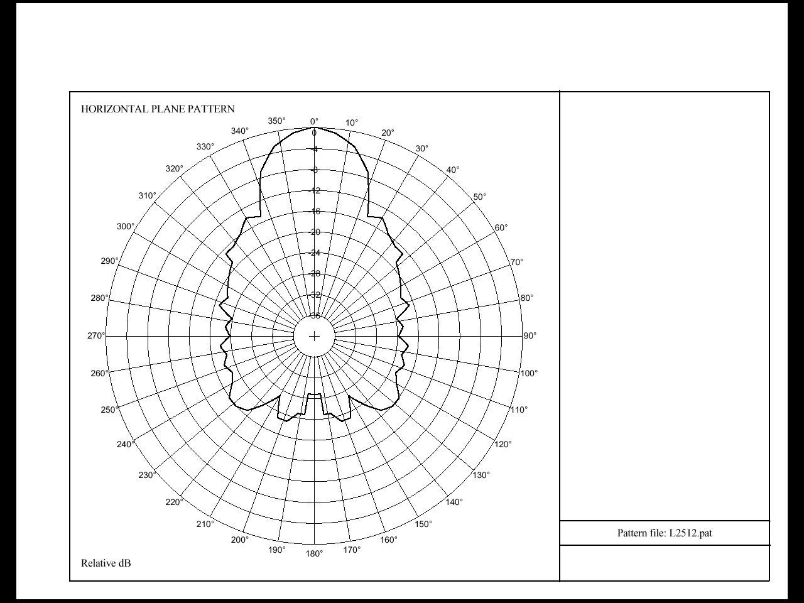

Representative MMDS/ITFS Omni Transmit Antenna Patterns
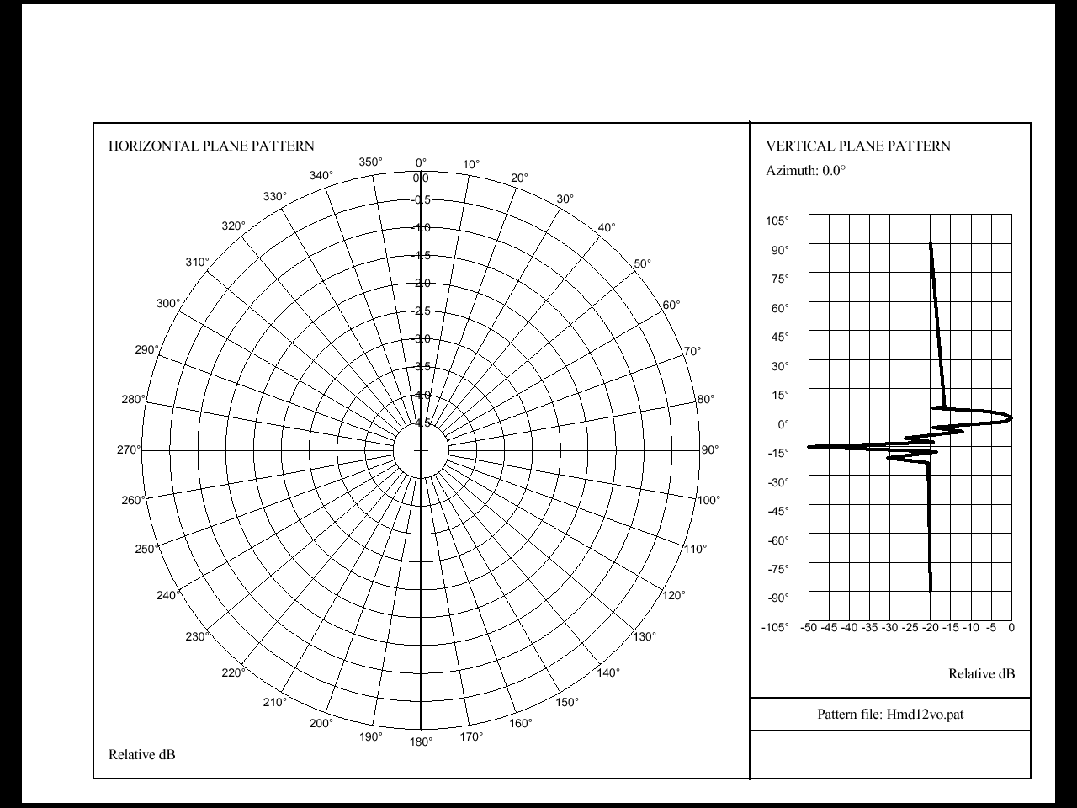
APPENDIX 5.3
MAPS OF ITFS and MDS CHANNEL ASSIGNMENTS

ITFS/MDS Channels in the 2500-2690 MHz band

Source of Assignment Data:

The maps shown in the Interim Report and Appendices were generated using data extracted from the Mass Media Bureau’s Broadband Licensing System (BLS) on November 6, 2000. Daily BLS extracts can be found at: <ftp://ftp.fcc.gov/Bureaus/Mass_Media/Databases/bls/bls.zip> (file size: 5.5 Mb). The data is updated daily at 11:45 PM.

Spectrum Analysis Tools:

Commission staff, in order to make use of web published assignment data, have written computer programs that: 1) convert web exported license and application data into a database (MS Access) format for conducting spectrum usage studies (CnvBls) and 2) map/plots license and application data (MffTools). These programs are available for downloading from Commission’s web site at <http://www.fcc.gov/oet/info/software/suss/>.

Map Key:

- Gray circle - represents the protected service area (PSA) of the main ITFS (or MDS) transmitter site on Channel Groups A, B, C, D or G.

- White circle - represents the PSA of the main MDS (or ITFS) transmitter site on Channel Groups E, F or H. Note: Main MDS transmitters associated with an auctioned BTA do not have PSAs.

- Gray shaded area - represents the auctioned BTAs for Channel Groups E, F and H.

- Red Line - represents the path between a main ITFS transmitter site and a registered receiver site.

- Blue Diamond – represents a main or booster ITFS or MDS transmitter site around which multiple unregistered receive sites are located.

- Green Diamond - represents an ITFS or MDS hub receiver site around which unregistered subscriber stations are located.

Note: License data shown on the maps includes both licenses and construction permits. Application data includes applications which have been accepted for filing and those that have been receive but have not yet been accepted for filing (tendered)

The first three maps show a composite of all licenses and applications across the entire
2500 – 2690 MHz band. The remaining 32 maps show only licenses on a channel by channel basis.

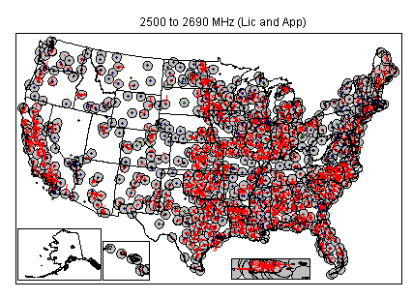
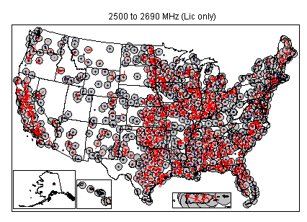
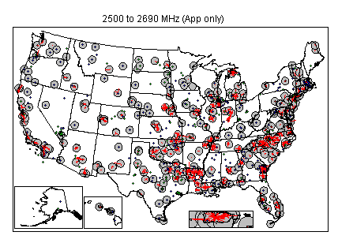
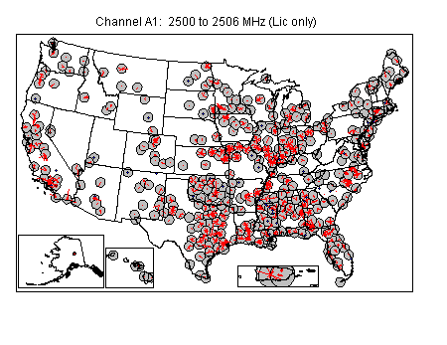
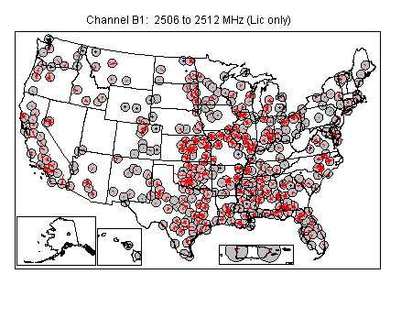

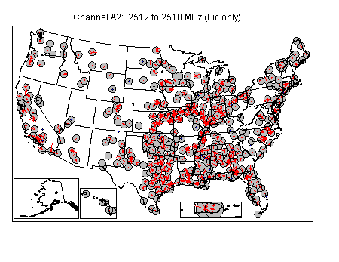
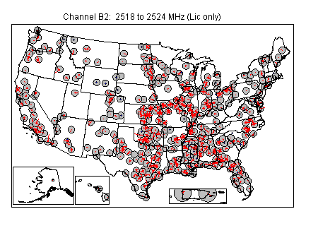
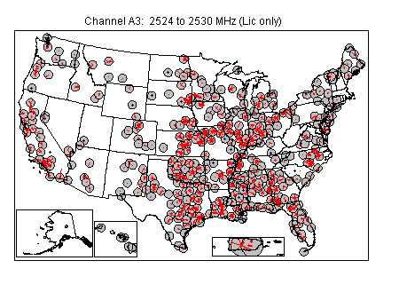
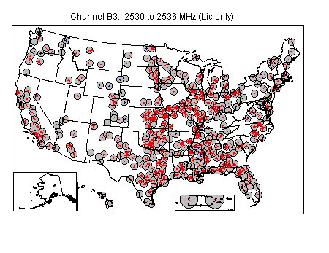
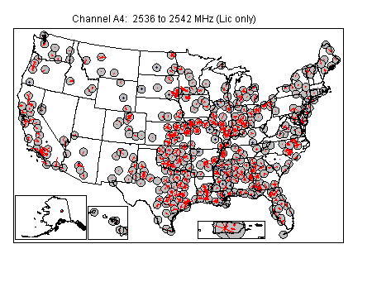
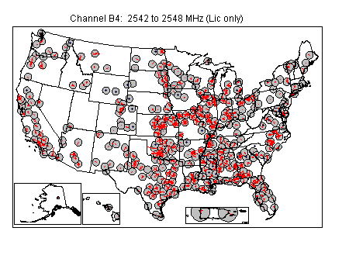
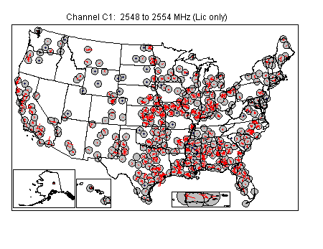
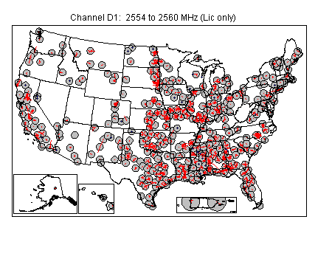
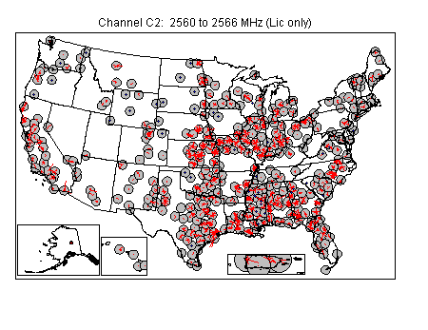
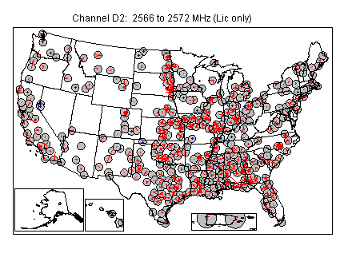
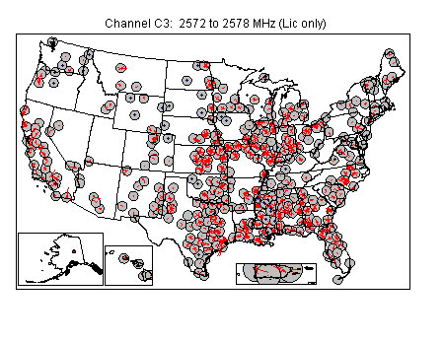
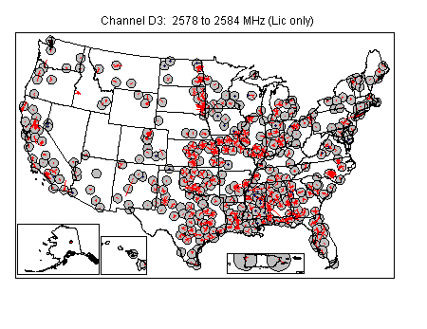
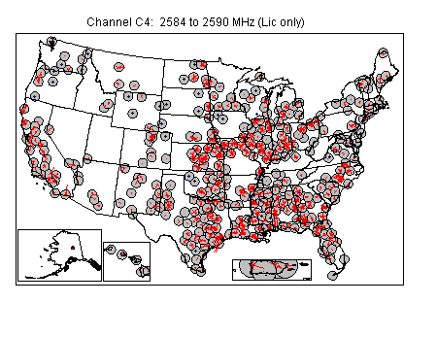
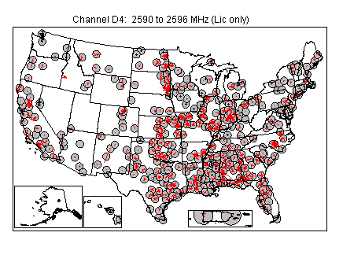
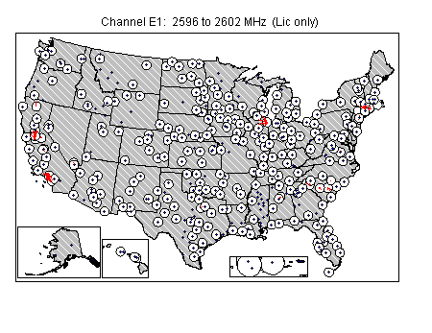
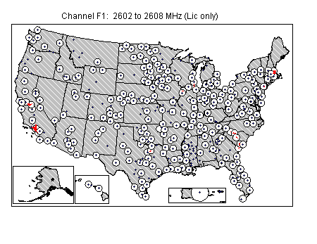
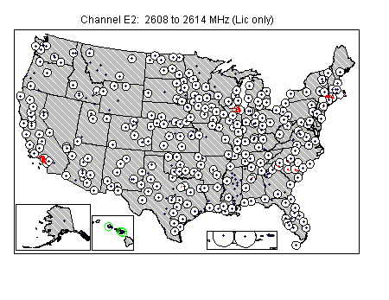
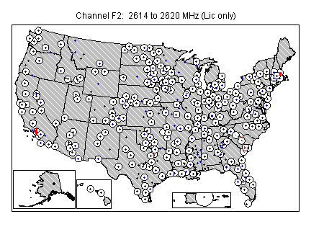
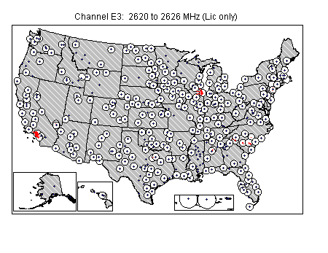
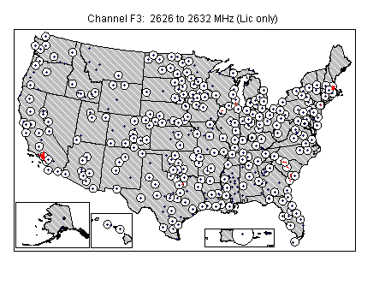
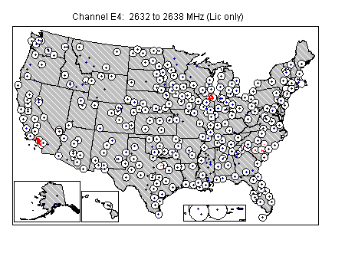
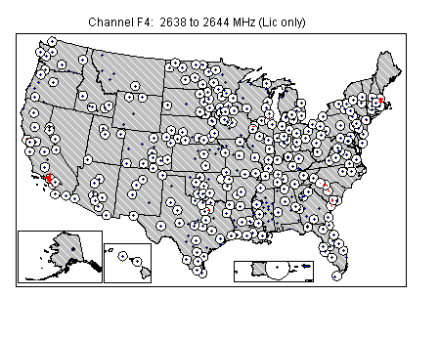
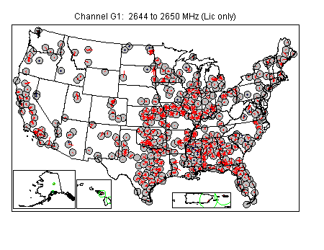
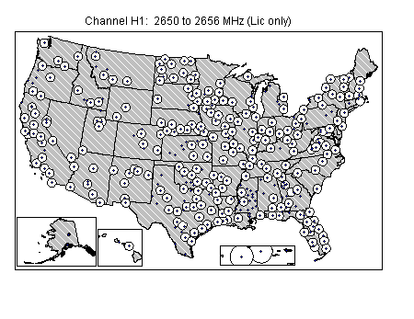
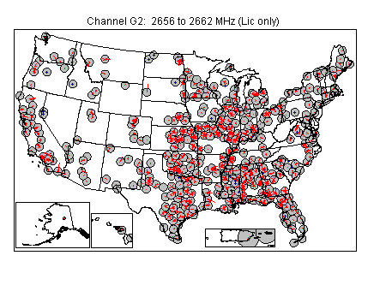
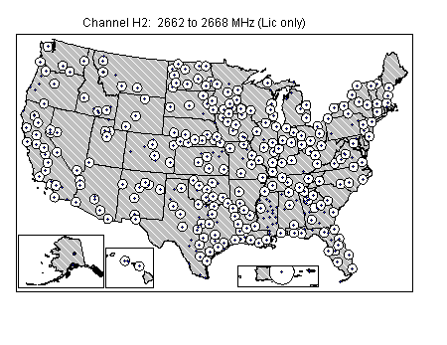
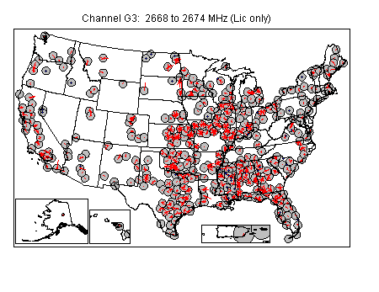
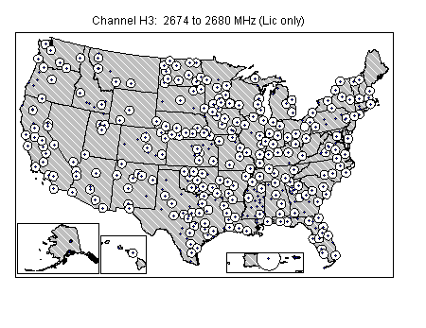
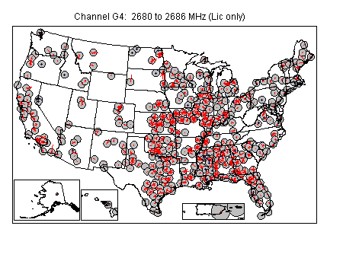
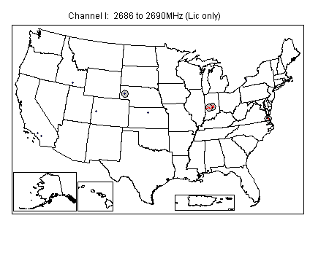

APPENDIX 5.4
ITFS/MDS ASSIGNMENTS FOR MAJOR METROPOLITAN AREAS

The following table indicates the licensed data for the 50 most populated major metropolitan areas within the United States. An “L” indicates that there is at least one licensed ITFS/MDS main stations located within 56.3 kilometers (35 miles) of the center city geographic coordinates. When the database contained no licensed main station that close to the center city coordinates, the closest licensed main station is noted by its distance in kilometers from the center city coordinates. A “T” indicates applications tendered for filing.

Channels | New York | Los Angeles | Chicago | Philadelphia | Detroit | Boston
1 | L | L | L | L | L | L
2/2A | L | L | L | L | L | L
A1 | L | L | L | L | L | L
A2 | L | L | L | L | L | L
A3 | L | L | L | L | L | 85 km
A4 | L | L | L | L | L | 85 km
B1 | L | L | L | L | L | L
B2 | L | L | L | L | L | L
B3 | L | L | L | L | L | L
B4 | L | L | L | L | L | L
C1 | L | L | L | L | L | L
C2 | L | L | L | L | L | L
C3 | L | L | L | L | L | L
C4 | L | L | L | L | L | L
D1 | L | L | L | L | L | L
D2 | L | L | L | L | L | L
D3 | L | L | L | L | L | L
D4 | L | L | L | L | L | L
E1 | L | L | L | L | L | L
E2 | L | L | L | L | L | L
E3 | L | L | L | L | L | L
E4 | L | L | L | L | L | L
F1 | L | L | L | L | L | L
F2 | L | L | L | L | L | L
F3 | L | L | L | L | L | L
F4 | L | L | L | L | L | L
G1 | L | L | L | L | 79 km | L
G2 | L | L | L | L | 79 km | L
G3 | L | L | L | L | L | L
G4 | L | L | L | L | L | L
H1 | L | L | L | L | L | L
H2 | L | L | L | L | L | L
H3 | L | L | L | 83 km | L | L

Channels | San  Francisco | Washington,  D.C. | Dallas-  Fort Worth | Houston | St. Louis | Miami
1 | L | L | L | L | L | L
2/2A | L | L | L | L | L | 89 km
A1 | L | 58 km | L | L | 104 km | L
A2 | L | 58 km | L | L | 104 km | L
A3 | L | 58 km | L | L | 104 km | L
A4 | L | L | L | L | 104 km | L
B1 | L | L | L | L | L | L
B2 | L | L | L | L | L | L
B3 | L | L | L | L | L | L
B4 | L | L | L | L | L | L
C1 | L | L | L | L | L | L
C2 | L | L | L | L | L | L
C3 | L | L | L | L | L | L
C4 | L | L | L | L | L | L
D1 | L | L | L | L | L | L
D2 | L | L | L | L | L | L
D3 | L | L | L | L | L | L
D4 | L | L | L | L | L | L
E1 | L | L | L | L | L | L
E2 | L | L | L | L | L | L
E3 | L | L | L | L | L | L
E4 | L | L | L | L | L | L
F1 | L | L | L | L | L | L
F2 | L | L | L | L | L | L
F3 | L | L | L | L | L | L
F4 | L | L | L | L | L | L
G1 | L | L | L | L | L | L
G2 | L | L | L | L | L | L
G3 | L | L | L | L | L | L
G4 | L | L | L | L | L | L
H1 | L | L | L | L | L | L
H2 | L | L | L | L | L | L
H3 | L | L | L | L | L | L

Channels | Pittsburgh | Baltimore | Minneapolis  St. Paul | Cleveland | Atlanta | San Diego
1 | L | L | L | L | L | L
2/2A | 74 km | L | L | 101 km | L | L
A1 | L | L | L | L | L | L
A2 | L | L | L | L | L | L
A3 | L | L | L | L | L | L
A4 | L | L | L | L | L | L
B1 | L | L | L | L | L | L
B2 | L | L | L | L | L | L
B3 | L | L | L | L | L | L
B4 | L | L | L | L | L | L
C1 | L | L | L | L | L | L
C2 | L | L | L | L | L | L
C3 | L | L | L | L | L | L
C4 | L | L | L | L | L | L
D1 | L | L | L | L | L | L
D2 | L | L | L | L | L | L
D3 | L | L | L | L | L | L
D4 | L | L | L | L | L | L
E1 | L | L | L | L | L | 72 km
E2 | L | L | L | L | L | 72 km
E3 | L | L | L | L | L | 72 km
E4 | L | L | L | L | L | 72 km
F1 | L | L | L | L | L | L
F2 | L | L | L | L | L | L
F3 | L | L | L | L | L | L
F4 | L | L | L | L | L | L
G1 | L | L | L | L | L | L
G2 | L | L | L | L | L | L
G3 | L | L | L | L | L | L
G4 | L | L | L | L | L | L
H1 | L | L | L | L | L | L
H2 | L | L | L | L | L | L
H3 | L | L | L | L | L | L

Channels | Denver | Seattle | Milwaukee | Tampa | Cincinnati | Kansas City
1 | L | L | L | L | L | L
2/2A | L | L | L | L | L | L
A1 | L | L | L | L | L | L
A2 | L | L | L | 53 km | L | L
A3 | L | L | L | 53 km | L | L
A4 | L | L | L | L | L | L
B1 | L | L | L | L | L | L
B2 | L | L | L | L | L | L
B3 | L | L | L | L | L | L
B4 | L | L | L | L | L | L
C1 | L | L | L | L | L | L
C2 | L | L | L | L | L | L
C3 | L | L | L | L | L | L
C4 | L | L | L | L | L | L
D1 | L | L | L | L | L | L
D2 | L | L | L | L | L | L
D3 | L | L | L | L | L | L
D4 | L | L | L | L | L | L
E1 | L | L | L | L | L | L
E2 | L | L | L | L | L | L
E3 | L | L | L | L | L | L
E4 | L | L | L | L | L | L
F1 | L | L | L | L | L | L
F2 | L | L | L | L | L | L
F3 | L | L | L | L | L | L
F4 | L | L | L | L | L | L
G1 | L | 124 km | L | L | 65 km | L
G2 | L | 124 km | L | L | 65 km | L
G3 | L | 124 km | L | L | 65 km | L
G4 | L | 124 km | L | L | 65 km | L
H1 | L | 97 km | L | L | 72 km | L
H2 | L | 97 km | L | L | 72 km | L
H3 | L | L | L | L | 72 km | L

Channels | Buffalo | Phoenix | San Jose | Indianapolis | New Orleans | Portland
1 | L | L | L | L | L | L
2/2A | L | L | L | L | L | L
A1 | L | L | L | L | L | L
A2 | L | L | L | L | L | L
A3 | L | L | L | L | L | L
A4 | L | L | L | L | L | L
B1 | L | L | L | L | L | L
B2 | L | L | L | L | L | L
B3 | L | L | L | L | L | L
B4 | L | L | L | L | L | L
C1 | L | L | L | L | L | L
C2 | L | L | L | L | L | L
C3 | L | L | L | L | L | L
C4 | L | L | L | L | L | L
D1 | L | L | 61 km | L | L | L
D2 | L | L | 61 km | L | L | L
D3 | L | L | 61 km | L | L | L
D4 | L | L | 61 km | L | L | L
E1 | L | L | L | L | L | L
E2 | L | L | L | L | L | L
E3 | L | L | L | L | L | L
E4 | L | L | L | L | L | L
F1 | L | L | L | L | L | L
F2 | L | L | L | L | L | L
F3 | L | L | L | L | L | L
F4 | L | L | L | L | L | L
G1 | L | L | L | L | L | L
G2 | L | L | L | L | L | L
G3 | L | L | L | L | L | L
G4 | L | L | L | L | L | L
H1 | L | L | L | L | L | L
H2 | L | L | L | L | L | L
H3 | L | L | 61 km | L | 81 km | L

Channels | Columbus | Hartford | San  Antonio | Rochester,  NY | Sacramento | Memphis
1 | L | L | L | L | L | L
2/2A | L | L | L | L | L | L
A1 | L | L | 62 km | L | L | L
A2 | L | L | 62 km | L | L | L
A3 | L | L | 62 km | L | L | L
A4 | L | L | 62 km | L | L | L
B1 | L | 53 km | L | L | L | 66 km
B2 | L | 53 km | L | L | L | 66 km
B3 | L | 53 km | L | L | L | 66 km
B4 | L | 53 km | L | L | L | 66 km
C1 | L | L | L | 119 km | L | L
C2 | L | L | L | 119 km | L | L
C3 | L | L | L | 119 km | L | L
C4 | L | L | L | 119 km | L | L
D1 | L | L | L | L | 75 km | 66 km
D2 | L | L | L | L | 75 km | 66 km
D3 | L | L | L | L | 56 km | 66 km
D4 | L | L | L | L | L | 66 km
E1 | L | L | L | 108 km | L | L
E2 | L | L | L | 108 km | L | L
E3 | L | L | L | 108 km | L | L
E4 | L | L | L | 108 km | L | L
F1 | L | L | L | L | L | L
F2 | L | L | L | L | L | L
F3 | L | L | L | L | L | L
F4 | L | L | L | L | L | L
G1 | L | L | L | L | L | L
G2 | L | L | L | L | L | L
G3 | L | 73 km | L | L | L | L
G4 | L | 73 km | L | L | L | L
H1 | L | L | L | L | L | L
H2 | L | L | L | L | L | L
H3 | L | L | L | L | L | L

Channels | Louisville | Providence | Salt Lake | Dayton | Birmingham | Bridgeport
1 | L | L | L | L | L | L
2/2A | L | L | L | L | L | L
A1 | 118 km | L | L | L | L | L
A2 | 118 km | L | L | L | L | L
A3 | 118 km | L | L | L | L | L
A4 | 118 km | L | L | L | L | L
B1 | L | L | L | L | L | L
B2 | L | L | L | L | L | L
B3 | L | L | L | L | L | L
B4 | L | L | VACANT | L | L | L
C1 | L | L | L | 68 km | L | 65 km
C2 | L | L | L | 68 km | L | 65 km
C3 | L | L | L | 68 km | L | L
C4 | L | L | L | 68 km | L | L
D1 | L | L | T-28 km | 60 km | L | L
D2 | L | L | T-28 km | 60 km | L | L
D3 | L | L | T-28 km | 60 km | L | L
D4 | L | L | T-28 km | 60 km | L | L
E1 | L | L | L | L | L | L
E2 | L | L | L | L | L | L
E3 | L | L | L | L | L | L
E4 | L | L | L | L | L | L
F1 | L | L | L | L | L | 63 km
F2 | L | L | L | L | L | 63 km
F3 | L | L | L | L | L | 63 km
F4 | L | L | L | L | L | 63 km
G1 | L | L | L | L | L | L
G2 | L | L | L | L | L | L
G3 | L | L | L | L | L | L
G4 | L | L | L | L | L | L
H1 | L | L | L | L | 36 km | 65 km
H2 | L | L | L | L | L | 65 km
H3 | L | L | L | L | L | L

Channels | Norfolk | Albany | Oklahoma  City | Nashville | Toledo | New Haven
1 | L | L | L | L | L | L
2/2A | L | L | L | L | L | L
A1 | L | L | L | L | L | L
A2 | L | L | L | L | L | L
A3 | L | L | L | L | L | L
A4 | L | L | L | L | L | L
B1 | L | L | L | L | L | L
B2 | L | L | L | L | L | L
B3 | L | L | L | L | L | L
B4 | L | L | L | L | L | L
C1 | L | L | L | 65 km | 93 km | L
C2 | L | L | L | 65 km | 93 km | L
C3 | L | L | L | 65 km | 93 km | L
C4 | L | L | L | L | 93 km | L
D1 | L | L | L | L | L | L
D2 | L | L | L | L | L | L
D3 | L | L | L | L | L | L
D4 | L | L | L | L | L | L
E1 | L | L | L | L | L | L
E2 | L | L | L | L | L | L
E3 | L | L | L | L | L | L
E4 | L | L | L | L | L | L
F1 | L | L | L | L | L | L
F2 | L | L | L | L | L | L
F3 | L | L | L | L | L | L
F4 | L | L | L | L | L | L
G1 | L | L | L | 65 km | L | L
G2 | L | L | L | 65 km | L | L
G3 | L | L | L | 65 km | L | L
G4 | L | L | L | 65 km | L | L
H1 | L | L | L | L | L | L
H2 | L | L | L | L | L | L
H3 | L | L | L | L | L | L

Channels | Honolulu | Jacksonville | Akron
1 | L | L | L
2/2A | L | L | L
A1 | L | L | L
A2 | L | L | L
A3 | L | L | L
A4 | L | L | L
B1 | L | 83 km | L
B2 | L | L | L
B3 | L | 83 km | L
B4 | L | L | L
C1 | L | L | L
C2 | L | L | L
C3 | L | L | L
C4 | L | L | L
D1 | L | L | L
D2 | L | L | L
D3 | L | L | L
D4 | L | L | L
E1 | L | L | L
E2 | L | L | L
E3 | L | L | L
E4 | L | L | L
F1 | L | L | L
F2 | L | L | L
F3 | L | L | L
F4 | L | L | L
G1 | L | L | L
G2 | L | L | L
G3 | L | L | L
G4 | L | L | L
H1 | L | L | L
H2 | L | L | L
H3 | L | L | L
INTERIM REPORT
3G SPECTRUM STUDY
2500-2690 MHz BAND

THERE ARE NO APPENDICES

FOR SECTION 6

Extracted from “Key Characteristics for the International Mobile Telecommunications – 2000 (IMT-2000) Radio Interfaces,” Recommendation ITU-R M.1455 (2000), International Telecommunication Union, and “Detailed Specification of the Radio Interfaces of International Mobile Telecommunications – 2000,” Recommendation ITU-R M.1457 (2000), International Telecommunication Union.
Extracted from “Key Characteristics for the International Mobile Telecommunications – 2000 (IMT-2000) Radio Interfaces,” Recommendation ITU-R M.1455 (2000), International Telecommunication Union, and “Detailed Specification of the Radio Interfaces of International Mobile Telecommunications – 2000,” Recommendation ITU-R M.1457 (2000), International Telecommunication Union.
Extracted in part from “Spectrum Requirements for International Mobile Telecommunications – 2000 (IMT-2000),” Report ITU-R M.2023 (2000), International Telecommunications Union.
“Summary of Spectrum Usage Survey Results,” Report ITU-R M.2024 (2000), International Telecommunication Union.
* Agreed and developed within European Radiocommunications Committee Task Group 1 of the Conférence Européenne des Administrations des Postes et des Télécommunications (CEPT ERC TG1).
* Agreed and developed within European Radiocommunications Committee Task Group 1 of the Conférence Européenne des Administrations des Postes et des Télécommunications (CEPT ERC TG1).
Developed from publically available sources. Believed to be accurate as of mid-September 2000.
See Coverage Map produced by WorldCom, Appendix B. In March 1996, the MDS spectrum was licensed pursuant to a geographical licensing system. At that time, the Commission auctioned additional spectrum for the provision of wireless cable services. The nation was divided into 493 basic trading areas (BTAs) as defined by the United States Department of Commerce for economic purposes, and these markets were auctioned to the highest bidders. Although a BTA holder has rights to broadcast throughout its authorized area, within any BTA, incumbent licensees, whose authorizations predate the 1996 auction, still continue to operate as before the auction. Upon adoption of the BTA system, the PSAs of incumbent licensees were expanded from a 15-mile radius to a 35-mile radius.
MMDS Operators Reach Wider Interference Accord for 2-Way Service, Communications Daily, July 11, 2000.
WorldCom, Inc., CAI Wireless Information (visited Jan. 27, 2000) <http://www.wcom.com/about_the_company/investor_relations/mergers+acquisitions/CAI_wireless/>.
Wireless One Completes Reorganization, Becoming MCI WorldCom Subsidiary, PR Newswire, Dec. 10, 1999. WorldCom also acquired Wireless One’s 50 percent interest in Wireless One of North Carolina, LLC, which owned MDS and WCS licenses in 13 North Carolina markets. Id.
MCIW’s Wireless Cable Plans Cover Wholesaling, Small Business, Communications Daily, July 14, 1999.
Bernie Ebbers, Merger Speech, National Press Club, Jan. 12, 2000, (visited Jan. 21, 2000) <http://www.worldcom-merger.com/press_room/ebbers_npc_speech.htm>.
In these three markets, Wireless One had previously offered two-way high-speed Internet access on a limited basis using both MDS and WCS spectrum, and WorldCom is also using both types of spectrum in its trials. Paul Kagan Associates, Inc., Wireless/Private Cable Investor, Mar. 9, 2000, at 1. In Jackson, WorldCom is also testing wireless LAN technology in a 300-unit apartment complex. Paul Kagan Associates, Inc., Wireless/Private Cable Investor, Mar. 9, 2000, at 1. MCI WorldCom to Test Fixed Wireless Service in Boston, News Release, WorldCom, Inc., Mar. 27, 2000; MCI WorldCom Adds Dallas to ‘Fixed Wireless’ Service Trials, News Release, WorldCom, Inc., Apr. 5, 2000. In Dallas, WorldCom will also be using WCS spectrum in its service trials. Mexico-U.S. Talks Heat Up on DARS Interference Concerns, Audio Week, Apr. 24, 2000.
WorldCom Seeks Broadband Fixed Wireless Authority, News Release, WorldCom, Inc., Aug. 14, 2000.
Paul Kagan Associates, Inc., Wireless/Private Cable Investor, Mar. 9, 2000, at 1.
Although cable offers speeds which can deliver data at speeds up to 100 times faster than telephone modems, cable was built as a one-way transmission pipe, and must be upgraded to handle two-way capacity. Estimates are that the cost for the upgrades can run up to $1,000 or more per home. Because of this cost, the buildout is progressing slowly and the service is not offered in many areas. Another drawback from the user’s standpoint is that it is a shared resource. The technology puts a group of nearby users served by the same node into what is essentially a network, with the bandwidth shared by all users online. As more users go online, there may be a reduction of throughput in data and consistent speed. Thus, the first user to sign on may find the speeds very fast, but they drop as soon as the next user signs on.
MCI WorldCom’s Wireless Internet to Help Bridge the Digital Divide, News Release, WorldCom, Inc., Apr. 26, 2000.
Sprint Closes Acquisition of American Telecasting, Inc., News Release, Sprint Corp., Sept. 23, 1999.
Sprint Completes Purchase of Videotron USA and Operating Units of WBS America, LLC, News Release, Sprint Corp., Oct. 26, 1999. Videotron USA was the wireless broadband subsidiary of Le Groupe Videotron Ltd., a Canadian company. Sprint Agrees to Acquire Videotron USA and Transworld Telecommunications Inc., News Release, Sprint Corp., May 3, 1999.
Sprint Completes Purchase of Videotron USA and Operating Units of WBS America, LLC, News Release, Sprint Corp., Oct. 26, 1999.
See Implementation of Section 6002(b) of the Omnibus Budget Reconciliation Act of 1993, Annual Report and Analysis of Competitive Market Conditions with Respect to Commercial Mobile Services, Fifth Report, FCC 00-289, at E-6 (rel. Aug. 18, 2000).
Sprint Launches Wireless High Speed Internet Access Service in Houston, News Release, Sprint Corp, Oct. 4, 2000; Sprint to Launch First Broadband Wireless Service for Residential and Small Business Customers in Bay Area, News Release, Sprint Corp., Oct. 24, 2000.
Sprint Brings High-Speed Wireless Internet Service to Detroit, Business Wire, Sept. 19, 2000; Sprint Rolls Out Wireless DSL in Phoenix, Communications Daily, May 9, 2000; Sprint Launches Second Broadband Market; Tucson Gains Independence from Slow Internet Connections, News Release, Sprint Corp., June 29, 2000.
Collins, Jonathan, WorldCom, Sprint Rethink their Wireless Last-Mile Plans, tele.com (July 31, 2000) (“We [Sprint] have not had to spend a single cent of advertising or marketing money . . . We’re actually afraid to spend money on advertising because we’ve already experienced a flood . . .of business.”).
Sprint to Launch First Broadband Wireless Service for Residential and Small Business Customers in Bay Area, News Release, Sprint Corp., Oct. 24, 2000.
Nancy Gohring, All Chips on MMDS, Telephony, Dec. 20, 1999.
Nucentrix Broadband Networks, Executive Summary.
Nucentrix Broadband Networks Reports Financial Results for its Quarter Ended September 30, 2000, News Release, Nucentrix Broadband Networks, Inc., Oct. 30, 2000.
Nucentrix Broadband Networks, Executive Summary.
Fred Dawson, Broadband Wireless Gets to the (Multi)Point, Interactive Week from ZDWire, Mar. 13, 2000, available in 2000 WL 4065337. ? Nucentrix Broadband Networks Announces Effectiveness of Shelf, Business Wire, Dec. 17, 1999. Nucentrix Broadband Networks, Executive Summary.
Advanced Wireless Systems, Inc., Form 10QSB, Aug. 25, 2000.
World Wide Wireless Communications, Inc., Form SB-2/A, Jun. 30, 2000; World Wide Wireless Communications, Inc., Form 10QSB, Aug. 21, 2000.
See <http://www.svswe.com>. SWV also provides traditional wireless cable service to nearly 6,000 subscribers in South Dakota, Iowa, Nebraska and Minnesota from its existing transmission facilities.
See <http://www.speedconnect.com>; Regional Wireless Operators Select Hybrid Networks’ 2-Way Today Solution To Launch Multiple Markets, PR Newswire, Jan. 10, 2000.
See <http://www.cvairnet.com>.
See <http://www.awcable.com>.
See <http://www.spikebroadband.net/press/pr/oxford_122099.html>.
See <http://www.third-rail.net>.

